Supplementary Materials

Table of Contents
Supplementary Tables 2
Table S1. Social Conflict, Resting Heart Rate, and NSSI 2
Table S2. Social Conflict, Resting Heart Rate, and SI 3
Supplementary Figures 4
Figure S1. Resting Heart Rate Moderates the Effect of Peer Conflict on NSSI 4
Missing Data 5
Figure S2. Missing Variable Percent. 5
Figure S3. Missing Variable Count. 5

Supplementary Tables

Table S1. Social Conflict, Resting Heart Rate, and NSSI
 | Negative Binomial |  |  | Zero-Inflation |  |  |  | Hurdle
Predictors | Log-Mean | Std. Error | P-Value | Log-Mean |  | Std. Error | P-Value | Log-Mean | Std. Error |  | P-Value
(Intercept) | -2.383 | 0.666 | <0.001 | 0.151 |  | 0.621 | 0.808 | -0.518 | 0.708 |  | 0.464
Peer Conflict (centered) | -2.395 | 1.227 | 0.051 | 2.283 |  | 1.173 | 0.052 | 2.290 | 1.383 |  | 0.098
Resting Heart Rate (centered) | 0.004 | 0.013 | 0.781 | 0.005 |  | 0.011 | 0.641 | 0.003 | 0.013 |  | 0.818
Family Conflict (centered) | 0.191 | 0.203 | 0.345 | -0.215 |  | 0.141 | 0.127 | -0.140 | 0.159 |  | 0.379
NSSI W1 | 0.515 | 0.087 | <0.001 | 0.119 |  | 0.068 | 0.082 | 0.090 | 0.072 |  | 0.211
PDS | 0.370 | 0.255 | 0.147 | 0.005 |  | 0.230 | 0.981 | 0.296 | 0.251 |  | 0.237
Peer Conflict x Resting Heart Rate | 0.232 | 0.091 | 0.010 | 0.388 |  | 0.099 | <0.001 | 0.325 | 0.106 |  | 0.002
Family Conflict x Resting Heart Rate | -0.006 | 0.012 | 0.607 | -0.020 |  | 0.009 | 0.031 | -0.014 | 0.010 |  | 0.154
Zero-Inflated Model
(Intercept) |  |  |  | 2.690 |  | 1.360 | 0.048 | -2.363 | 0.909 |  | 0.009
Peer Conflict (centered) |  |  |  | 8.557 |  | 3.393 | 0.012 | -5.374 | 2.060 |  | 0.009
Resting Heart Rate (centered) |  |  |  | 0.010 |  | 0.028 | 0.727 | -0.008 | 0.019 |  | 0.689
Family Conflict (centered) |  |  |  | -0.967 |  | 0.706 | 0.171 | 0.279 | 0.320 |  | 0.384
NSSI W1 |  |  |  | -1.395 |  | 0.400 | <0.001 | 0.997 | 0.194 |  | <0.001
PDS |  |  |  | -0.365 |  | 0.559 | 0.513 | 0.060 | 0.363 |  | 0.868
Peer Conflict x Resting Heart Rate |  |  |  | 0.192 |  | 0.244 | 0.430 | 0.114 | 0.137 |  | 0.404
Family Conflict x Resting Heart Rate |  |  |  | -0.027 |  | 0.037 | 0.465 | -0.002 | 0.020 |  | 0.908
Observations | 147 |  |  |  | 147 |  |  |  |  | 147
R² Nagelkerke | 0.478 |  |  |  | 0.647 / 0.626 |  |  |  |  | 0.552 / 0.526

Table S2. Social Conflict, Resting Heart Rate, and SI
 | Negative Binomial |  |  | Zero-Inflation |  |  |  | Hurdle
Predictors | Log-Mean | Std. Error | P-Value | Log-Mean |  | Std. Error | P-Value | Log-Mean | Std. Error |  | P-Value
(Intercept) | -1.898 | 0.578 | 0.001 | -0.256 |  | 0.369 | 0.487 | -0.209 | 0.364 |  | 0.566
Peer Conflict (centered) | -1.579 | 1.051 | 0.133 | 0.447 |  | 0.602 | 0.457 | 0.407 | 0.601 |  | 0.498
Resting Heart Rate (centered) | 0.009 | 0.012 | 0.420 | 0.015 |  | 0.007 | 0.044 | 0.013 | 0.007 |  | 0.070
Family Conflict (centered) | 0.203 | 0.194 | 0.294 | -0.112 |  | 0.102 | 0.271 | -0.126 | 0.098 |  | 0.202
SI W1 | 0.194 | 0.059 | 0.001 | 0.139 |  | 0.024 | <0.001 | 0.140 | 0.024 |  | <0.001
PDS | 0.623 | 0.240 | 0.010 | 0.388 |  | 0.138 | 0.005 | 0.375 | 0.140 |  | 0.007
Gender | 0.457 | 0.314 | 0.146 | 0.076 |  | 0.202 | 0.708 | 0.055 | 0.200 |  | 0.781
Peer Conflict x Resting Heart Rate | -0.006 | 0.081 | 0.944 | 0.084 |  | 0.042 | 0.047 | 0.086 | 0.044 |  | 0.053
Family Conflict x Resting Heart Rate | 0.005 | 0.012 | 0.661 | -0.005 |  | 0.005 | 0.387 | -0.003 | 0.006 |  | 0.546
Zero-Inflated Model
(Intercept) |  |  |  | 0.874 |  | 0.861 | 0.310 | -1.636 | 0.717 |  | 0.023
Peer Conflict (centered) |  |  |  | 2.333 |  | 1.578 | 0.139 | -2.000 | 1.346 |  | 0.137
Resting Heart Rate (centered) |  |  |  | 0.027 |  | 0.018 | 0.125 | -0.020 | 0.015 |  | 0.195
Family Conflict (centered) |  |  |  | -0.665 |  | 0.355 | 0.061 | 0.551 | 0.265 |  | 0.037
SI W1 |  |  |  | -0.129 |  | 0.095 | 0.178 | 0.147 | 0.086 |  | 0.088
PDS |  |  |  | -0.045 |  | 0.351 | 0.899 | 0.250 | 0.303 |  | 0.409
Gender |  |  |  | -1.104 |  | 0.470 | 0.019 | 1.082 | 0.400 |  | 0.007
Peer Conflict x Resting Heart Rate |  |  |  | 0.132 |  | 0.118 | 0.266 | -0.094 | 0.105 |  | 0.371
Family Conflict x Resting Heart Rate |  |  |  | -0.021 |  | 0.020 | 0.297 | 0.014 | 0.017 |  | 0.424
Observations | 147 |  |  |  | 147 |  |  |  |  | 147
R² Nagelkerke | 0.318 |  |  |  | 0.551 / 0.521 |  |  |  |  | 0.546 / 0.516

Supplementary Figures

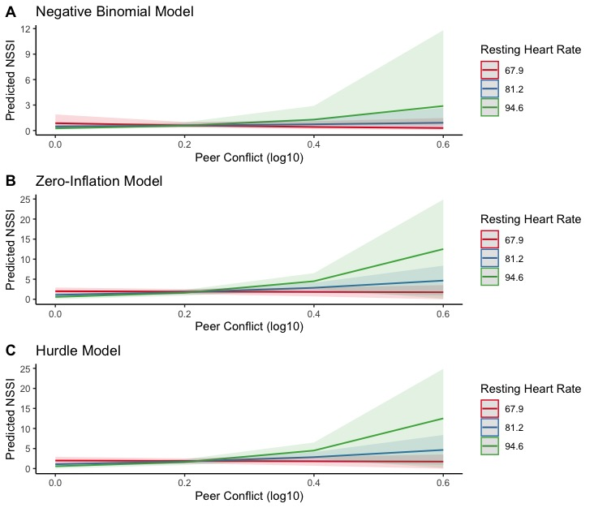

Figure S1. Resting Heart Rate Moderates the Effect of Peer Conflict on NSSI

Missing Data

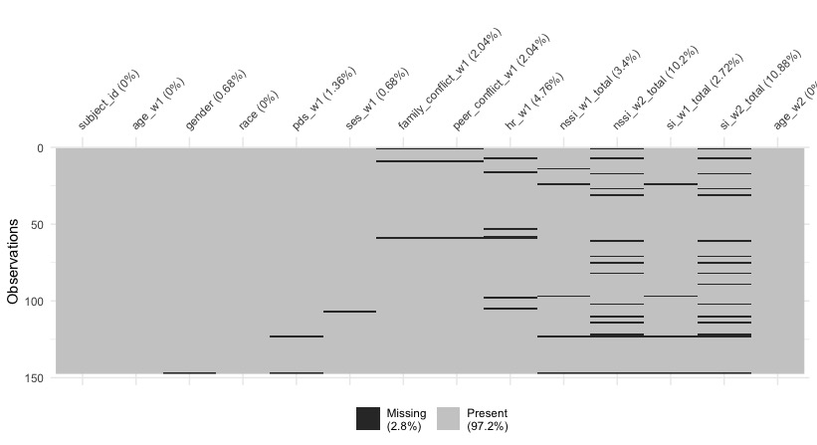

Figure S2. Missing Variable Percent.

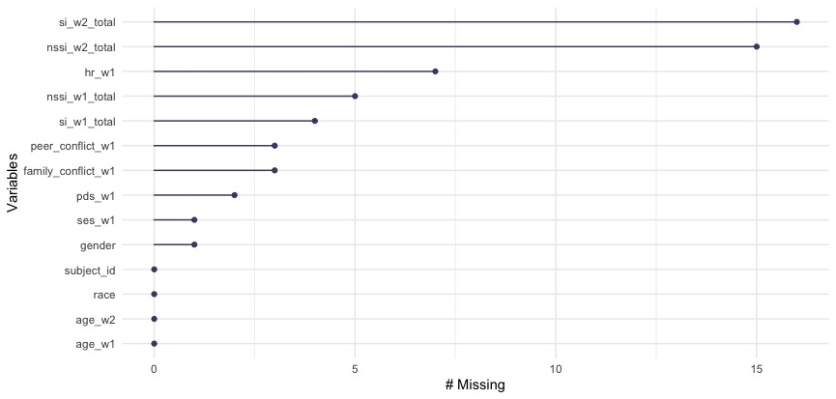

Figure S3. Missing Variable Count.

