Supplementary Material

CBCL attention problems

Ten items from the CBCL make-up the attention problems scale. These are statements that describe the child now or within the past 6 months and include: (1) acts too young for his/her age; (2) fails to finish things he/she started; (3) can’t concentrate, can’t pay attention for long; (4) cant’ sit still, restless or hyperactive; (5) confused or seems to be in a fog; (6) daydreams or gets lost in his/her thoughts; (7) impulsive or acts without thinking; (8) poor school work; (9) inattentive or easily distracted; and (10) stares blankly.

Household income

The primary respondent was asked: “What is your total combined family income for the past 12 months? This should include income (before taxes and deductions) from all sources, wages, rent from properties, social security, disability and/or veteran's benefits, unemployment benefits, workman's compensation, help from relative (include child payments and alimony), and so on.”. Ten income brackets were provided as outcomes: <$5,000; $5,000-11,999; $12,000-15,999; $16,000-24,999; $25,000-34,999; $35,000-49,999; $50,000-74,999; $75,000-99,999; $100,000-199,999; $200,000+. Household income in Cohort1 therefore refers to the household income bracket reflecting income from all sources and before deductions.

Parental Psychiatric History

Parental psychiatric history was reported by the primary caregiver (most often the biological mother) within a validated family history measure (Family History Assessment Module⁷⁵). A count variable was created of the following issues: (1) depression, (2) anxiety/nerves, (3) mania, (4) psychosis, (5) drug-use issues, (6) alcohol-use issues, (7) antisocial behavior, (8) suicidality, and (9) help-seeking and (10) hospitalization for mental health/substance issues. The exact wording for each of these items can be seen in Table S1. If both the mother and father had a history of depression, the family psychiatric history score would be 2. If the father had a history of both alcohol abuse and anxiety, but the mother reported no psychiatric history, the score would also be 2.

Table S1. Definitions of each mental health/substance issue
 | Has <parent>…
Depression | ...suffered from depression, that is, have they felt so low for a period of at least two weeks that they hardly ate or slept or couldn't work or do whatever they usually do?
Anxiety/Nerves | ...had any other problems with their nerves, or had a nervous breakdown?
Mania | ...had a period of time when others were concerned because they suddenly became more active day and night and seemed not to need any sleep and talked much more than usual for them?
Psychosis | ...had a period lasting six months when they saw visions or heard voices or thought people were spying on them or plotting against them?
Drug abuse | ...had any problems due to drugs, such as: marital separation or divorce; laid off or fired from work; arrests or DUIs; Drugs harmed their health; in a drug treatment program; suspended or expelled from school 2 or more times; isolated self from family, caused arguments or were high a lot.
Alcohol abuse | ...had any problems due to alcohol, such as: marital separation or divorce; laid off or fired from work; arrests or DUIs; alcohol harmed their health; in an alcohol treatment program; suspended or expelled from school 2 or more times; isolated self from family, caused arguments or were drunk a lot.
Antisocial behavior | …been the kind of person who never holds a job for long, or gets into fights, or gets into trouble with the police from time to time, or had any trouble with the law as a child or an adult?
Suicidality | ...attempted or committed suicide?
Help-seeking | ...been to a doctor or a counselor about any emotional or mental problems, or problems with alcohol or drugs?
Hospitalized | ...been hospitalized because of emotional or mental problems, or drug or alcohol problems?

Figure S1. Schematic diagram of prediction process. Within 1 loop, dataset is split into training, validation and test sets, coefficients and hyper parameters are optimized (training + validation set) and performance of the model is tested (test set R²). Dataset is split into train-validate-test sets again with new test set. When 5-fold validation is complete, 1 loop is complete (20 loops in total). Selection frequency and average coefficient strength for each predictor are extracted from 100 runs.
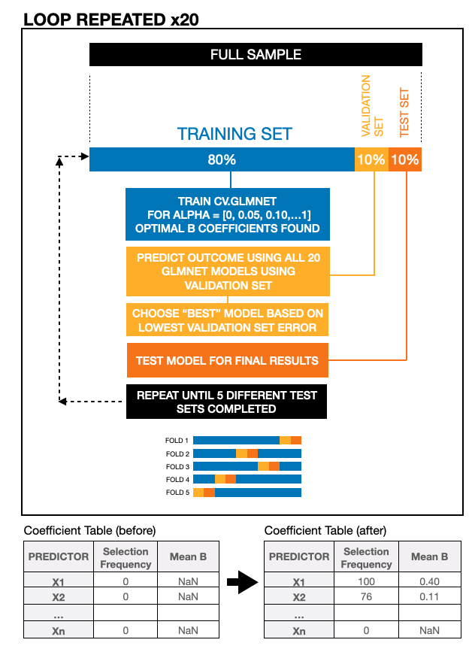

Table S2. Income-stratified analyses results
 | Low Income (n=2780) |  |  | Middle Income (n=2567) |  |  | High Income (n=3757)
 | Selection Freq. | B mean | B SD | Selection Freq. | B mean | B SD | Selection Freq. | B mean | B SD
Male sex | 100 | 1.18 | 0.14 | 100 | 0.59 | 0.11 | 100 | 0.67 | 0.13
Maternal drug-use | 100 | 0.51 | 0.15 | 100 | 0.97 | 0.24 | 100 | 0.58 | 0.20
Number of birth complications | 100 | 0.25 | 0.06 | 100 | 0.19 | 0.06 | 73 | 0.05 | 0.03
Maternal medication-use | 100 | 0.72 | 0.11 | 100 | 0.36 | 0.10 | 20 | 0.05 | 0.03
Hispanic race/ethnicity | 100 | -0.25 | 0.08 | 4 | -0.01 | 0.02 | 39 | 0.09 | 0.06
Paternal years <20 | 100 | 0.21 | 0.07 | 4 | -0.00 | 0.02 | 11 | -0.02 | 0.09
Number of pregnancy complications | 100 | 0.28 | 0.05 | 59 | 0.04 | 0.03 | 100 | 0.07 | 0.03
Anemia in pregnancy | 100 | 0.37 | 0.15 | 8 | 0.11 | 0.06 | 11 | 0.03 | 0.07
Maternal smoking | 100 | 0.53 | 0.09 | 84 | 0.17 | 0.09 | 69 | 0.15 | 0.09
Maternal alcohol-use | 100 | 0.33 | 0.11 | 93 | 0.14 | 0.07 | 11 | 0.02 | 0.02
UTI in pregnancy | 98 | 0.34 | 0.14 | 84 | 0.22 | 0.11 | 31 | 0.14 | 0.08
Other pregnancy complication | 98 | 0.53 | 0.24 | 21 | 0.10 | 0.06 | 24 | 0.09 | 0.04
Non-singleton birth | 51 | -0.18 | 0.14 | 100 | -0.53 | 0.13 | 100 | -0.29 | 0.10
Severe nausea in pregnancy | 35 | 0.10 | 0.08 | 99 | 0.33 | 0.13 | 17 | 0.07 | 0.03
Asian race/ethnicity | 15 | -0.27 | 0.24 | 58 | -0.22 | 0.15 | 95 | -0.25 | 0.12
Any variable with a selection frequency >=95% for any income bracket was included (indicated in bold)

Table S3. Race/ethnicity stratified analyses robust predictors and their coefficients (B).
 | White (n=5061) |  |  | Black (n=1508) |  |  | Hispanic (n=2121)
 | Selection Freq. | B mean | B SD | Selection Freq. | B mean | B SD | Selection Freq. | B mean | B SD
Male sex | 100 | 0.76 | 0.09 | 100 | 0.96 | 0.20 | 100 | 0.81 | 0.18
Non-singleton birth | 100 | -0.39 | 0.09 | 100 | -0.49 | 0.16 | 90 | -0.24 | 0.13
Number of pregnancy complications | 100 | 0.14 | 0.03 | 100 | 0.18 | 0.07 | 100 | 0.12 | 0.05
Number of birth complications | 100 | 0.14 | 0.04 | 100 | 0.32 | 0.11 | 95 | 0.10 | 0.05
UTI in pregnancy | 100 | 0.51 | 0.13 | 72 | 0.18 | 0.10 | 76 | 0.18 | 0.11
Maternal smoking | 100 | 0.74 | 0.11 | 100 | 0.71 | 0.16 | 31 | 0.09 | 0.07
Maternal medication-use | 100 | 0.33 | 0.06 | 94 | 0.39 | 0.20 | 57 | 0.16 | 0.08
Maternal drug-use | 100 | 0.77 | 0.18 | 100 | 0.66 | 0.20 | 78 | 0.30 | 0.13
Maternal years <20 | 99 | 0.21 | 0.07 | 100 | 0.16 | 0.06 | 14 | 0.03 | 0.02
Severe nausea in pregnancy | 99 | 0.40 | 0.10 | 63 | 0.14 | 0.10 | 11 | 0.07 | 0.03
Anemia in pregnancy | 75 | 0.24 | 0.15 | 97 | 0.49 | 0.17 | 12 | 0.15 | 0.07
Maternal cannabis-use | 16 | 0.24 | 0.12 | 15 | 0.17 | 0.08 | 100 | 0.71 | 0.26
Diabetes in pregnancy | 10 | 0.04 | 0.08 | 95 | -0.38 | 0.19 | 11 | 0.04 | 0.03
Any variable with a selection frequency >=95% for any race/ethnicity was included (indicated in bold)

Table S4. Parent psychiatric history stratified results
 | No History  (n=4597) |  |  | Average History  (n=2717) |  |  | Strong History  (n=2551)
 | Selection Freq. | B mean | B SD | Selection Freq. | B mean | B SD | Selection Freq. | B mean | B SD
Male sex | 100 | 0.66 | 0.13 | 100 | 0.87 | 0.19 | 100 | 1.09 | 0.15
Number of pregnancy complications | 100 | 0.11 | 0.04 | 45 | 0.03 | 0.02 | 100 | 0.26 | 0.06
UTI in pregnancy | 100 | 0.27 | 0.12 | 100 | 0.40 | 0.15 | 98 | 0.34 | 0.13
Non-singleton birth | 99 | -0.26 | 0.09 | 99 | -0.20 | 0.09 | 100 | -0.51 | 0.14
Maternal smoking | 98 | 0.19 | 0.08 | 86 | 0.16 | 0.08 | 100 | 0.33 | 0.09
Maternal drug-use | 98 | 0.36 | 0.16 | 100 | 0.67 | 0.21 | 100 | 0.54 | 0.14
Number of birth complications | 93 | 0.07 | 0.03 | 99 | 0.11 | 0.05 | 100 | 0.13 | 0.05
Severe nausea in pregnancy | 92 | 0.15 | 0.08 | 97 | 0.19 | 0.09 | 36 | 0.12 | 0.08
Maternal years <20 | 50 | 0.04 | 0.02 | 100 | 0.19 | 0.05 | 94 | 0.09 | 0.05
Slow heartbeat at birth | 24 | 0.13 | 0.07 | 99 | 0.71 | 0.20 | 9 | 0.16 | 0.07
Black race/ethnicity | 17 | 0.05 | 0.03 | 70 | 0.13 | 0.07 | 100 | 0.31 | 0.12
Any variable with a selection frequency >=95% for any level of parental psychiatric history was included (indicated in bold)

Table S5. Parent ADHD-stratified results

 | Low parental ADHD  (n=4921) |  |  | Moderate parental ADHD  (n=2891) |  |  | High parental ADHD  (n=2160)
 | Selection Freq. | B mean | B SD | Selection Freq. | B mean | B SD | Selection Freq. | B mean | B SD
Male sex | 100 | 0.67 | 0.12 | 100 | 0.71 | 0.16 | 100 | 1.13 | 0.29
Non-singleton birth | 100 | -0.33 | 0.10 | 90 | -0.25 | 0.14 | 99 | -0.44 | 0.17
Number of pregnancy complications | 100 | 0.11 | 0.05 | 100 | 0.10 | 0.04 | 100 | 0.12 | 0.04
Number of birth complications | 100 | 0.08 | 0.04 | 100 | 0.15 | 0.05 | 98 | 0.10 | 0.06
Maternal smoking | 100 | 0.27 | 0.08 | 84 | 0.13 | 0.08 | 100 | 0.48 | 0.14
Paternal years <20 | 99 | 0.18 | 0.08 | 78 | 0.12 | 0.07 | 51 | 0.08 | 0.05
Maternal cannabis-use | 99 | 0.58 | 0.25 | 11 | 0.15 | 0.06 | 25 | 0.12 | 0.08
Maternal years <20 | 93 | 0.09 | 0.04 | 98 | 0.13 | 0.06 | 84 | 0.09 | 0.05
Maternal drug-use | 91 | 0.36 | 0.18 | 100 | 0.78 | 0.21 | 82 | 0.15 | 0.10
UTI in pregnancy | 72 | 0.11 | 0.07 | 100 | 0.68 | 0.17 | 30 | 0.11 | 0.06
Black race/ethnicity | 56 | 0.06 | 0.05 | 98 | 0.28 | 0.11 | 67 | 0.15 | 0.09
Anemia in pregnancy | 15 | -0.03 | 0.13 | 79 | 0.23 | 0.13 | 98 | 0.45 | 0.19
Any variable with a selection frequency >=95% for any level of parental ADHD symptomatology was included (indicated in bold)

Table S6. Predictors of male ADHD symptoms with a selection frequency of >50%
 |  |  | 95% Confidence Interval
 | Selection Frequency (%) | Mean B | Lower | Upper
Maternal drug-use | 100 | 0.83 | 0.42 | 1.15
Maternal smoking | 100 | 0.59 | 0.35 | 0.78
UTI in pregnancy | 100 | 0.46 | 0.24 | 0.69
Maternal medication-use | 100 | 0.37 | 0.23 | 0.55
Other race/ethnicity | 100 | 0.31 | 0.15 | 0.51
Number of birth complications | 100 | 0.30 | 0.11 | 0.41
Number of pregnancy complications | 100 | 0.16 | 0.08 | 0.24
Maternal years <20 | 100 | 0.15 | 0.06 | 0.25
Non-singleton birth | 100 | -0.56 | -0.81 | -0.32
Asian race/ethnicity | 99 | -0.37 | -0.70 | -0.08
Anemia in pregnancy | 98 | 0.28 | 0.07 | 0.55
Severe nausea in pregnancy | 95 | 0.18 | 0.03 | 0.31
Paternal years <20 | 92 | 0.12 | 0.01 | 0.26
Maternal use of non-cannabis drug | 88 | 0.39 | 0.02 | 0.76
Other pregnancy complication | 88 | 0.18 | 0.02 | 0.34
Black race/ethnicity | 81 | 0.11 | 0.01 | 0.22
Placental issues in pregnancy | 73 | -0.21 | -0.45 | -0.02
Slow heartbeat at birth | 72 | 0.23 | 0.01 | 0.46
Lower birth weight | 55 | 0.04 | 0.00 | 0.11

Table S7. Predictors of female ADHD symptoms with a selection frequency of >50%
 |  |  | 95% Confidence Interval
 | Selection Frequency (%) | Mean B | Lower | Upper
Maternal drug-use | 100 | 1.00 | 0.42 | 1.27
Maternal smoking | 100 | 0.59 | 0.37 | 0.77
UTI in pregnancy | 100 | 0.43 | 0.22 | 0.65
Number of pregnancy complications | 100 | 0.20 | 0.09 | 0.27
Non-singleton birth | 100 | -0.42 | -0.58 | -0.22
Maternal years <20 | 99 | 0.09 | 0.01 | 0.16
Asian race/ethnicity | 98 | -0.38 | -0.71 | -0.10
Diabetes in pregnancy | 97 | -0.21 | -0.47 | -0.05
Severe nausea in pregnancy | 93 | 0.16 | 0.01 | 0.29
Paternal years <20 | 91 | 0.10 | 0.01 | 0.22
Other race/ethnicity | 87 | 0.11 | 0.02 | 0.27
Maternal medication-use | 84 | 0.11 | 0.01 | 0.25
Number of birth complications | 74 | 0.05 | 0.00 | 0.11
Anemia in pregnancy | 72 | 0.17 | 0.01 | 0.40
Maternal alcohol-use | 53 | 0.06 | 0.01 | 0.13

Figure S2. Unadjusted means for ADHD symptoms across racial/ethnic groups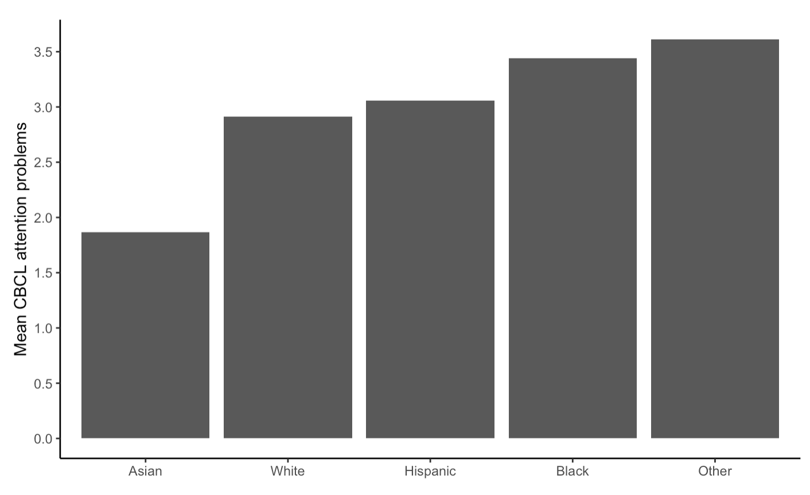

Figure S3. Descriptive statistics for a selection of pre/perinatal variables across different income levels: high (red), middle (green) and low (blue).
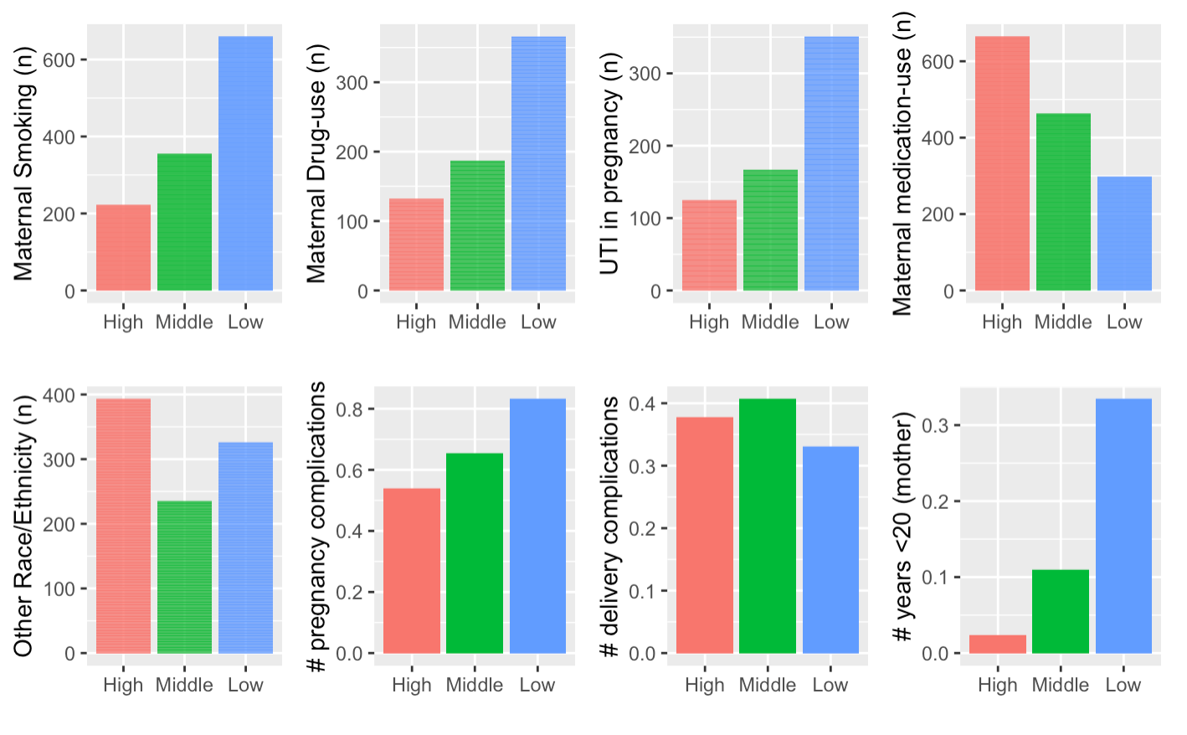

Figure S4. Robust pre/perinatal predictors of CBCL attention problems in order of strength (mean B coefficient) in the restricted sample (limited to participants with full data). Error bars indicate 95% confidence intervals (N = 7,429).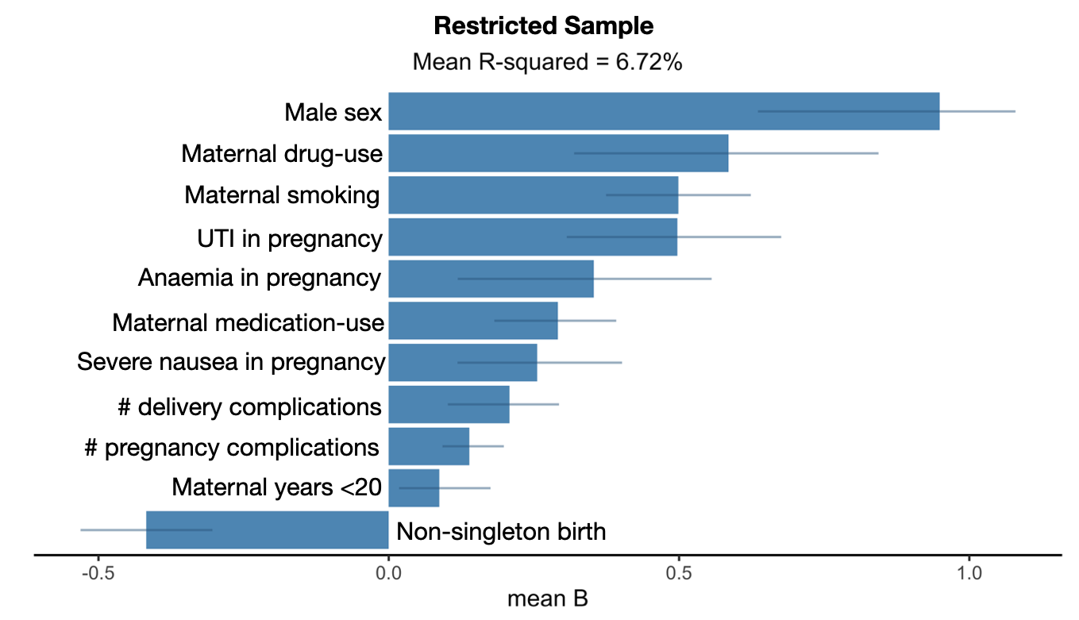

Figure S5. Robust pre/perinatal predictors of CBCL attention problems in order of strength (mean B coefficient) in a sub-sample where respondents were all biological mothers
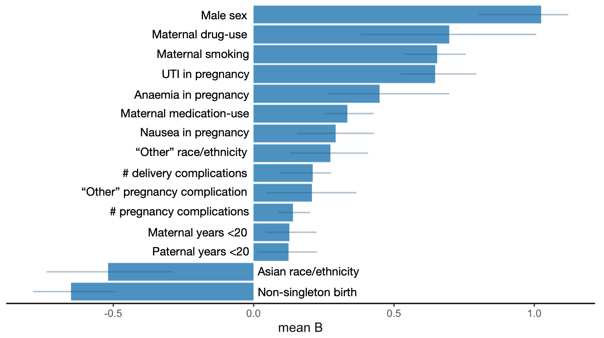

Figure S6. Heatmap of correlations between all possible predictors

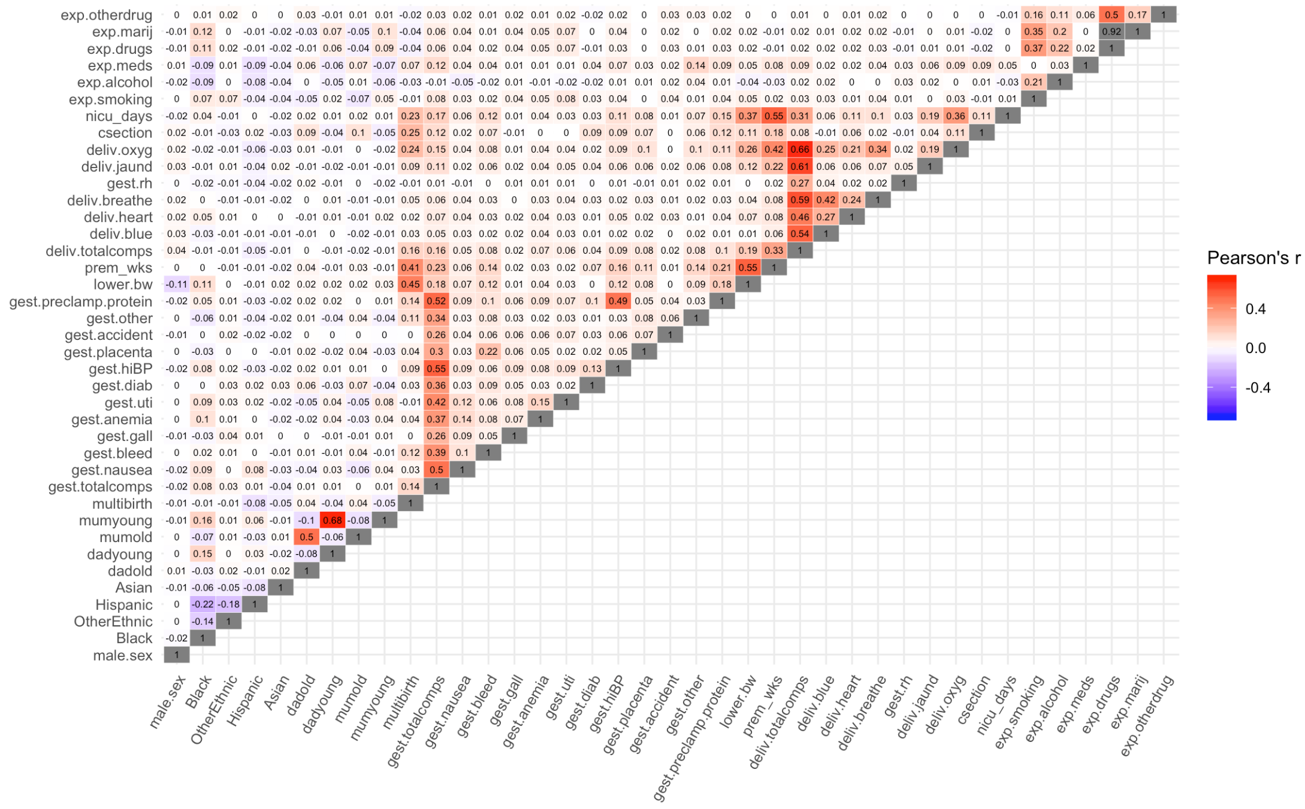

Table S8. Alpha and lambda values used in testing in full sample prediction.
Run | Fold | Test set N | Alpha | Lambda | Test set R²
1 | 1 | 998 | 1.00 | 0.05 | 7.45%
2 | 2 | 998 | 0.70 | 0.06 | 7.05%
3 | 3 | 998 | 0.05 | 0.60 | 6.53%
4 | 4 | 998 | 0.85 | 0.05 | 7.80%
5 | 5 | 998 | 0.05 | 0.30 | 7.16%
6 | 1 | 998 | 0.65 | 0.08 | 9.60%
7 | 2 | 998 | 0.30 | 0.15 | 8.03%
8 | 3 | 998 | 0.15 | 0.22 | 9.21%
9 | 4 | 998 | 0.40 | 0.08 | 7.72%
10 | 5 | 998 | 0.85 | 0.05 | 9.67%
11 | 1 | 998 | 0.10 | 0.42 | 7.81%
12 | 2 | 998 | 0.55 | 0.09 | 6.11%
13 | 3 | 998 | 0.90 | 0.08 | 7.25%
14 | 4 | 998 | 0.25 | 0.19 | 6.85%
15 | 5 | 998 | 0.50 | 0.12 | 6.70%
16 | 1 | 998 | 0.50 | 0.10 | 7.35%
17 | 2 | 998 | 0.50 | 0.10 | 9.20%
18 | 3 | 998 | 0.90 | 0.06 | 8.08%
19 | 4 | 998 | 1.00 | 0.08 | 9.00%
20 | 5 | 998 | 0.30 | 0.14 | 9.39%
21 | 1 | 998 | 0.00 | 0.64 | 8.59%
22 | 2 | 998 | 0.35 | 0.10 | 8.83%
23 | 3 | 998 | 0.35 | 0.15 | 9.40%
24 | 4 | 998 | 0.25 | 0.16 | 7.07%
25 | 5 | 998 | 0.30 | 0.15 | 6.82%
26 | 1 | 998 | 0.50 | 0.10 | 8.49%
27 | 2 | 998 | 0.50 | 0.14 | 7.08%
28 | 3 | 998 | 0.30 | 0.16 | 6.11%
29 | 4 | 998 | 0.60 | 0.09 | 10.48%
30 | 5 | 998 | 0.65 | 0.08 | 7.71%
31 | 1 | 998 | 0.40 | 0.11 | 8.30%
32 | 2 | 998 | 0.25 | 0.15 | 11.06%
33 | 3 | 998 | 0.05 | 0.71 | 8.21%
34 | 4 | 998 | 0.05 | 0.51 | 8.60%
35 | 5 | 998 | 0.90 | 0.05 | 8.30%
36 | 1 | 998 | 1.00 | 0.07 | 9.36%
37 | 2 | 998 | 0.35 | 0.14 | 8.17%
38 | 3 | 998 | 0.10 | 0.47 | 8.74%
39 | 4 | 998 | 0.10 | 0.27 | 6.68%
40 | 5 | 998 | 0.70 | 0.07 | 9.19%
41 | 1 | 998 | 0.65 | 0.09 | 7.67%
42 | 2 | 998 | 0.15 | 0.29 | 9.79%
43 | 3 | 998 | 0.90 | 0.08 | 5.09%
44 | 4 | 998 | 1.00 | 0.05 | 6.81%
45 | 5 | 998 | 0.10 | 0.45 | 7.36%
46 | 1 | 998 | 0.60 | 0.05 | 6.65%
47 | 2 | 998 | 0.85 | 0.08 | 9.02%
48 | 3 | 998 | 0.10 | 0.29 | 11.67%
49 | 4 | 998 | 0.80 | 0.04 | 8.68%
50 | 5 | 998 | 0.65 | 0.08 | 8.54%
51 | 1 | 998 | 0.20 | 0.20 | 9.09%
52 | 2 | 998 | 0.70 | 0.08 | 8.31%
53 | 3 | 998 | 0.45 | 0.11 | 6.94%
54 | 4 | 998 | 0.80 | 0.06 | 8.93%
55 | 5 | 998 | 0.20 | 0.22 | 6.85%
56 | 1 | 998 | 0.25 | 0.18 | 7.33%
57 | 2 | 998 | 0.75 | 0.08 | 7.31%
58 | 3 | 998 | 0.45 | 0.09 | 9.60%
59 | 4 | 998 | 0.15 | 0.30 | 3.43%
60 | 5 | 998 | 0.95 | 0.06 | 7.85%
61 | 1 | 998 | 0.40 | 0.10 | 11.70%
62 | 2 | 998 | 0.20 | 0.26 | 5.59%
63 | 3 | 998 | 0.05 | 0.61 | 8.81%
64 | 4 | 998 | 0.25 | 0.18 | 10.81%
65 | 5 | 998 | 0.35 | 0.15 | 5.84%
66 | 1 | 998 | 0.30 | 0.15 | 6.86%
67 | 2 | 998 | 0.40 | 0.09 | 9.40%
68 | 3 | 998 | 0.85 | 0.05 | 8.50%
69 | 4 | 998 | 0.75 | 0.08 | 9.07%
70 | 5 | 998 | 0.10 | 0.34 | 8.49%
71 | 1 | 998 | 0.10 | 0.37 | 6.58%
72 | 2 | 998 | 0.10 | 0.32 | 8.43%
73 | 3 | 998 | 0.35 | 0.19 | 9.30%
74 | 4 | 998 | 0.50 | 0.10 | 9.02%
75 | 5 | 998 | 0.55 | 0.10 | 5.64%
76 | 1 | 998 | 0.85 | 0.06 | 7.59%
77 | 2 | 998 | 0.55 | 0.04 | 12.15%
78 | 3 | 998 | 0.40 | 0.14 | 7.76%
79 | 4 | 998 | 0.55 | 0.10 | 9.18%
80 | 5 | 998 | 0.50 | 0.11 | 6.98%
81 | 1 | 998 | 0.00 | 0.84 | 8.39%
82 | 2 | 998 | 0.70 | 0.09 | 8.72%
83 | 3 | 998 | 0.15 | 0.25 | 6.36%
84 | 4 | 998 | 0.70 | 0.09 | 8.51%
85 | 5 | 998 | 0.45 | 0.10 | 7.69%
86 | 1 | 998 | 0.75 | 0.05 | 5.87%
87 | 2 | 998 | 0.05 | 0.69 | 8.14%
88 | 3 | 998 | 0.50 | 0.09 | 6.06%
89 | 4 | 998 | 0.15 | 0.31 | 10.15%
90 | 5 | 998 | 0.75 | 0.08 | 5.90%
91 | 1 | 998 | 0.85 | 0.07 | 11.24%
92 | 2 | 998 | 0.50 | 0.09 | 9.44%
93 | 3 | 998 | 0.40 | 0.12 | 9.04%
94 | 4 | 998 | 0.05 | 0.48 | 7.82%
95 | 5 | 998 | 0.90 | 0.06 | 7.51%
96 | 1 | 998 | 0.05 | 0.38 | 7.05%
97 | 2 | 998 | 0.85 | 0.08 | 9.09%
98 | 3 | 998 | 1.00 | 0.05 | 8.31%
99 | 4 | 998 | 0.60 | 0.09 | 8.43%
100 | 5 | 998 | 0.05 | 0.41 | 9.76%
Average | — | 998 | 0.46 | 0.18 | 8.13%
SD | — | — | 0.30 | 0.17 | 1.49%

Table S9. Details of missing data.
Variable | Missing (n) | Missing (%)
Maternal medication-use | 800 | 8.0
Number of days infant spent in incubator | 616 | 6.2
Maternal alcohol-use | 582 | 5.8
Paternal years >35 | 554 | 5.6
Paternal years <20 | 554 | 5.6
Birth weight | 446 | 4.5
UTI in pregnancy | 407 | 4.1
Maternal vitamin-use in pregnancy | 406 | 4.1
High blood pressure in pregnancy | 351 | 3.5
Nausea in pregnancy | 340 | 3.4
Anemia in pregnancy | 335 | 3.4
Rh Incompatibility | 342 | 3.4
Maternal marijuana-use | 329 | 3.3
Diabetes in pregnancy | 324 | 3.2
Placental issue in pregnancy | 313 | 3.1
Gall bladder attack in pregnancy | 296 | 3.0
Other pregnancy complication | 303 | 3.0
Preclampsia/proteinuria in pregnancy | 298 | 3.0
Slow neonatal heart beat at birth | 285 | 2.9
Bleeding during pregnancy | 284 | 2.8
Accident requiring treatment during pregnancy | 280 | 2.8
Blue neonate at birth | 268 | 2.7
Neonate not breathing at birth | 252 | 2.5
Neonate requiring oxygen at birth | 248 | 2.5
Maternal smoking | 253 | 2.5
Neonatal jaundice at birth | 243 | 2.4
Total number of pregnancy complications | 229 | 2.3
Maternal use of non-marijuana drug | 233 | 2.3
Maternal age >35 | 223 | 2.2
Maternal age <20 | 223 | 2.2
Maternal illicit drug-use | 153 | 1.5
Prematurity | 143 | 1.4
Total number of birth complications | 140 | 1.4
C-section | 128 | 1.3
Race/ethnicity | 14 | 0.1

Table S10. Differences on all variables between full sample and those with no missing data (used for Sensitivity Analysis 3).
 | Full Sample | No Missing Data Sample | Difference statistic | Significance
Dichotomous Variables | % | % | Chi-squared
Sex=Male | 52.7% | 52.9% | 0.05
Race/ethnicity=Black | 15.1% | 13.7% | 6.95 | **
Race/ethnicity=Hispanic | 21.3% | 21.1% | 0.12
Race/ethnicity=Asian | 2.3% | 2.0% | 2.09
Race/ethnicity=Other | 10.4% | 10.0% | 0.98
Non-singleton birth | 11.4% | 11.6% | 0.06
C-section | 35.3% | 34.6% | 1.12
Maternal smoking in pregnancy | 14.4% | 12.7% | 9.30 | ***
Maternal alcohol-use | 27.2% | 26.7% | 0.53
Maternal drug-use | 7.7% | 6.5% | 8.05 | **
Maternal medication-use | 16.6% | 16.3% | 0.18
Continuous Variables | Mean | Mean | t
CBCL attention problems | 3.07 | 2.88 | 3.60 | ***
Number of pregnancy complications | 0.67 | 0.65 | 1.10
Number of delivery complications | 0.37 | 0.36 | 1.19
Days in NICU | 0.88 | 0.81 | 1.17
Maternal years <20 | 0.16 | 0.13 | 2.59 | *
Maternal years >35 | 0.62 | 0.60 | 0.82
Paternal years <20 | 0.08 | 0.07 | 0.89
Paternal years >35 | 1.51 | 1.47 | 0.78
Birth weight (g over mean) | 0 | 0.02 | 2.29 | *
Gestational age (weeks preterm) | 0.72 | 0.67 | 1.79
* p < .05, ** p < .01, *** p < .001

