SUPPLEMENTARY MATERIALS
SUPPLEMENTARY METHODS
Infant BDNF DNAm analysis
We analyzed one target region of the BDNF gene containing 11 CpG sites (positions detailed in Supplementary Figure 1 and correspondence with previous work reported in Supplementary Table 1). Methylation levels were determined in DNA using bisulfite modification followed by PCR amplification and NGS. Genomic DNA was extracted from 0.2 ml of each sample using the GenElute Blood Genomic DNA kit (Sigma). Bisulfite conversion was performed on 500 ng of genomic DNA using the EZ DNA methylation kit (ZymoResearch, Inc., Irvine, CA, USA). Primers were designed using Bisulfite Primer Seeker. A specific tail was added to each primer in order to allow synthesis and sequencing of SureSelect-like libraries of methylated fragments. Primary PCR-amplification was performed on 20 ng of bisulfite-treated DNA using Taq Gold (Life Technologies, Inc.). Cycling comprised 5 min preactivation at 95°C, followed by 35 cycles of 94°C denaturation for 15 s, 58°C annealing for 20 s, 72°C elongation for 1.5 min. All PCR products were checked on 2% agarose gels and treated with Ilustra Exo Pro-STAR (GE Healthcare) to eliminate unincorporated primers. Secondary PCR was conducted on each sample using a SureSelect Custom Amplicon Index Kit (Agilent) containing eight forward (i5) and 12 reverse (i7) index primers. Optimal annealing temperature (68°C) and number of PCR cycles were experimentally determined. Cycling comprised 5 min pre-activation at 95°C, followed by 16 cycles of 94°C denaturation for 15 s, 68°C annealing for 20 s, 72°C elongation for 1 min. All PCR products were checked on 2% agarose gel, and approximately equimolar amounts of each product were purified using AMPure XP beads (Beckman Coulter) and pooled (up to 96 libraries/pool). The purified pooled libraries were quantified on a Bioanalyzer 2100 (Agilent) and sequenced on a NextSeq 500 (Illumina) using a v2 Reagent kit, 2x150 cycles. Paired ends reads from each sample were independently aligned to all the reference sequences by a parallel striped Smith–Waterman algorithm. Only paired reads that aligned coherently to the reference sequence were retained. Adaptors were trimmed with TrimGalore-0.6.6; alignment was performed using Bismark_v0.20.0; CpG methylation counting was conducted with IGVTools. At each CpG site in each sequence, the four base frequencies were evaluated and reported along with the C-to-T percentage. Average read depth was 28370 reads. Samples with less than 1000 reads were excluded.

SUPPLEMENTARY TABLES
Supplementary Table 1. Hg19 genomic coordinates for investigated CpG sites and correspondence with sites investigated in previous work.
CpG reference | Genomic Position (hg 19) | Kertes et al., 2017 | Braithwaite et al., 2015
CpG 01 | Chr11: 27,723,218-27,723,219 | CpG 14 – 244 | CpG 01
CpG 02 | Chr11: 27,723,214-27,723,215 | CpG 13 – 240 | CpG 02
CpG 03 | Chr11: 27,723,203-27,723,204 | CpG 12 – 229 | CpG 03
CpG 04 | Chr11: 27,723,190-27,723,191 | CpG 11 – 216 | CpG 04
CpG 05 | Chr11: 27,723,161-27,723,162 | CpG 10 – 187 | CpG 05
CpG 06 | Chr11: 27,723,159-27,723,160 | CpG 9 – 185 | --
CpG 07 | Chr11: 27,723,143-27,723,144 | CpG 8 – 169 | --
CpG 08 | Chr11: 27,723,137-27,723,138 | CpG 7 – 163 | --
CpG 09 | Chr11: 27,723,128-27,723,129 | CpG 6 – 154 | --
CpG 10 | Chr11: 27,723,125-27,723,126 | CpG 5 – 151 | --
CpG 11 | Chr11: 27,723,095-27,723,096 | CpG 4 - 121 | --

Supplementary Table 2. Bivariate correlations among study variables
 |  | 1 | 2 | 3 | 4 | 5 | 6 | 7 | 8 | 9 | 10 | 11 | 12 | 13
1 | Maternal trait anxiety
2 | BDNF DNAm at CpG 01 | .03
3 | BDNF DNAm at CpG 02 | -.08 | .22**
4 | BDNF DNAm at CpG 03 | .12* | .33** | .31**
5 | BDNF DNAm at CpG 04 | -.01 | .22** | .19** | .27**
6 | BDNF DNAm at CpG 05 | -.01 | .24** | .32** | .33** | .24**
7 | BDNF DNAm at CpG 06 | .13* | .17** | .21** | .23** | .18** | .19**
8 | BDNF DNAm at CpG 07 | .05 | .06 | .18** | .17** | .06 | .23** | .25**
9 | BDNF DNAm at CpG 08 | -.02 | .30** | .19** | .25** | .27** | .20** | .13* | .10
10 | BDNF DNAm at CpG 09 | .09 | .25** | .22** | .27** | .15* | .31** | .22* | .43** | .22**
11 | BDNF DNAm at CpG 10 | .05 | .44** | .31** | .34** | .23** | .38** | .23** | .24** | .23** | .42**
12 | BDNF DNAm at CpG 11 | -.12* | .25** | .35** | .35** | .29** | .38** | .28** | .35** | .32** | .36** | .36**
13 | NE at 3 months | .10 | .05 | -.03 | .02 | .11 | -.01 | -.01 | -.03 | .00 | -.02 | .02 | -.06
14 | NE at 6 months | .18* | .07 | .06 | .05 | .14* | .07 | .08 | .08 | .00 | .15* | .11 | .02 | .64**
* p<.05; **p<.01; Note. Bold values indicate significant (p<.05) results.

SUPPLEMENTARY FIGURES

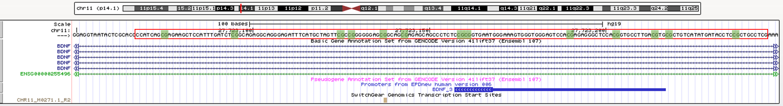

Supplementary Figure 1. Schematic representation of the BDNF gene with the target sequence investigated (chr11: 27,723,096–27,723,219; UCSC human genome browser GRCh37/hg19)

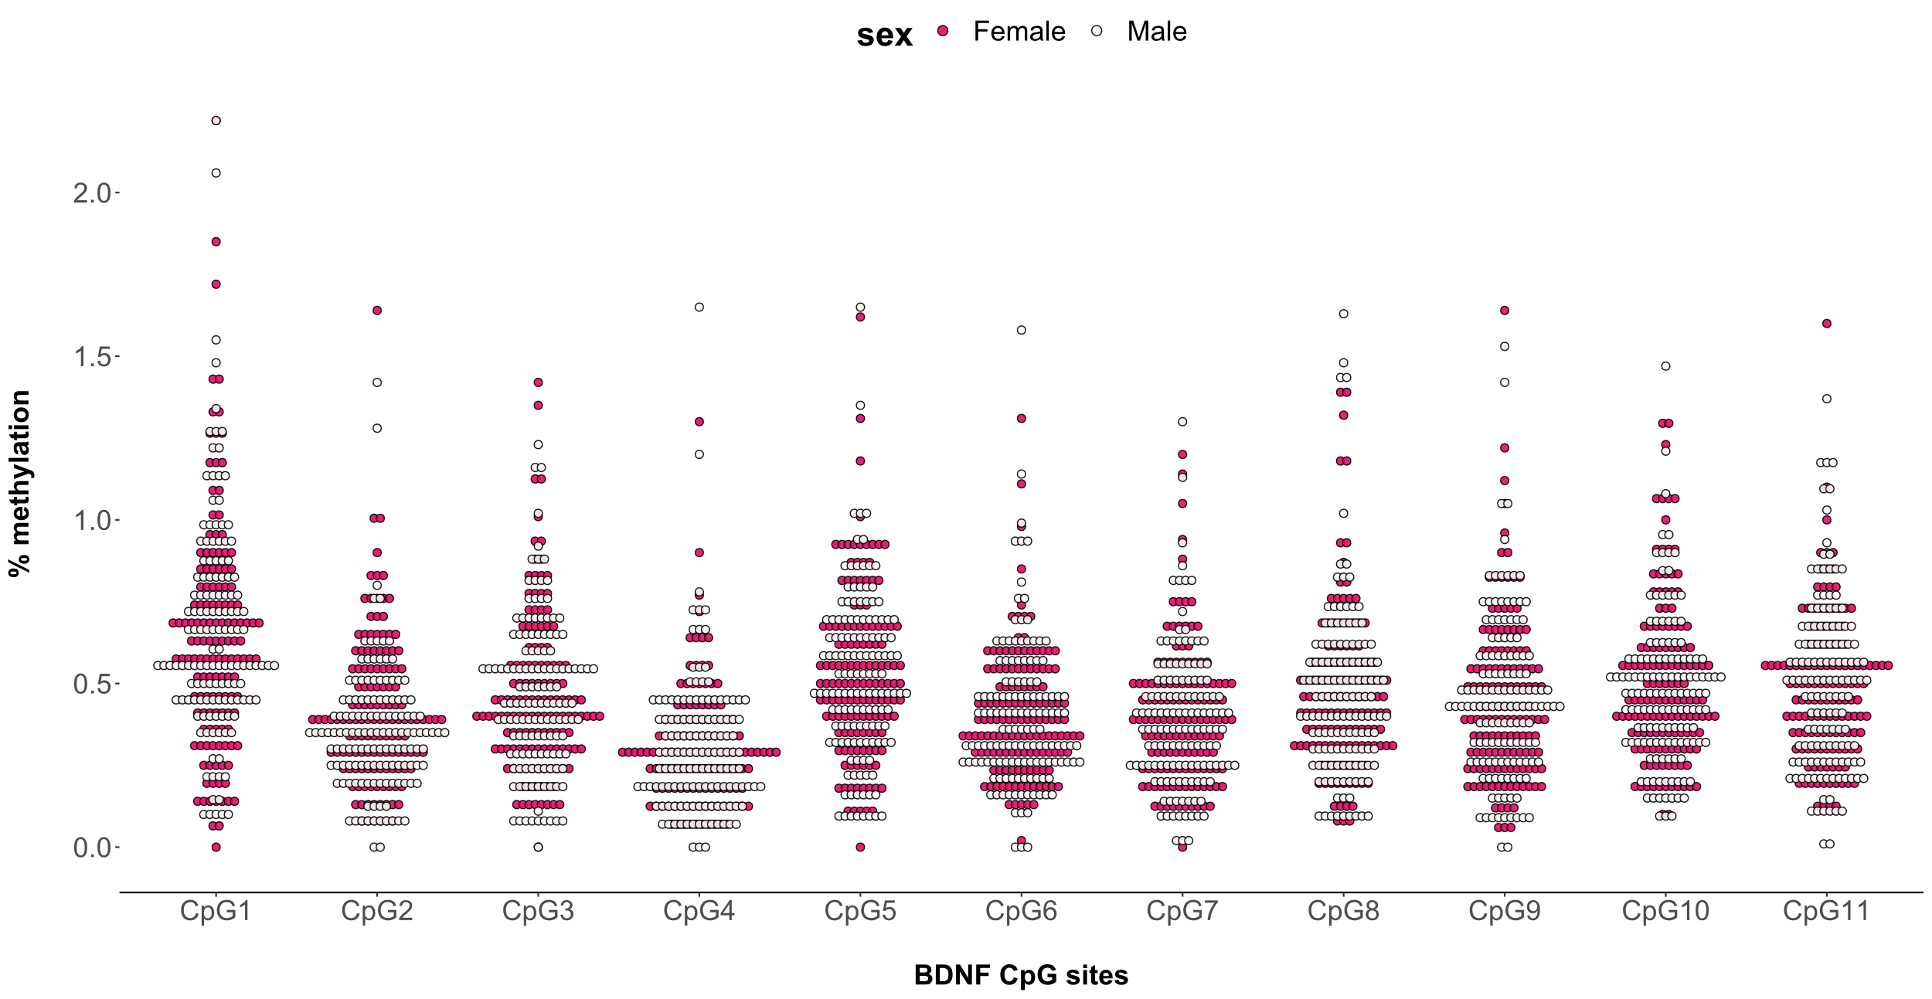
Supplementary Figure 2. Individual observed raw levels of methylation of the BDNF gene at the 11 selected CpG sites. Blank dot are for males, whereas red dots are for females.

