Supplementary Figure 1. Study design participant flow and current sample exclusions
Assessed for eligibility (N=1388)
Excluded from overall study (n= 324)
Not meeting inclusion criteria (n =149)
Did not complete baseline surveys (n =175)
Provided unreliable due date/ DOB (n = 6)
Did not provide due date or DOB (n = 32)
Miscarriage (n = 9)
Excluded from current sample
Completed IBQ later than 12 mo old (n = 10)
Did not complete IBQ (n = 20)
Completed baseline and postpartum surveys within 2 weeks (n = 114)
Preconception exposed (n = 23)

Lost to follow-up (n= 314)
Met eligibility and completed baseline surveys (N= 1017)
Completed postpartum assessment
(n = 694)
Final sample size for analyses
n = 527

Note. IBQ = Infant Behavior Questionnaire. DOB = date of birth.

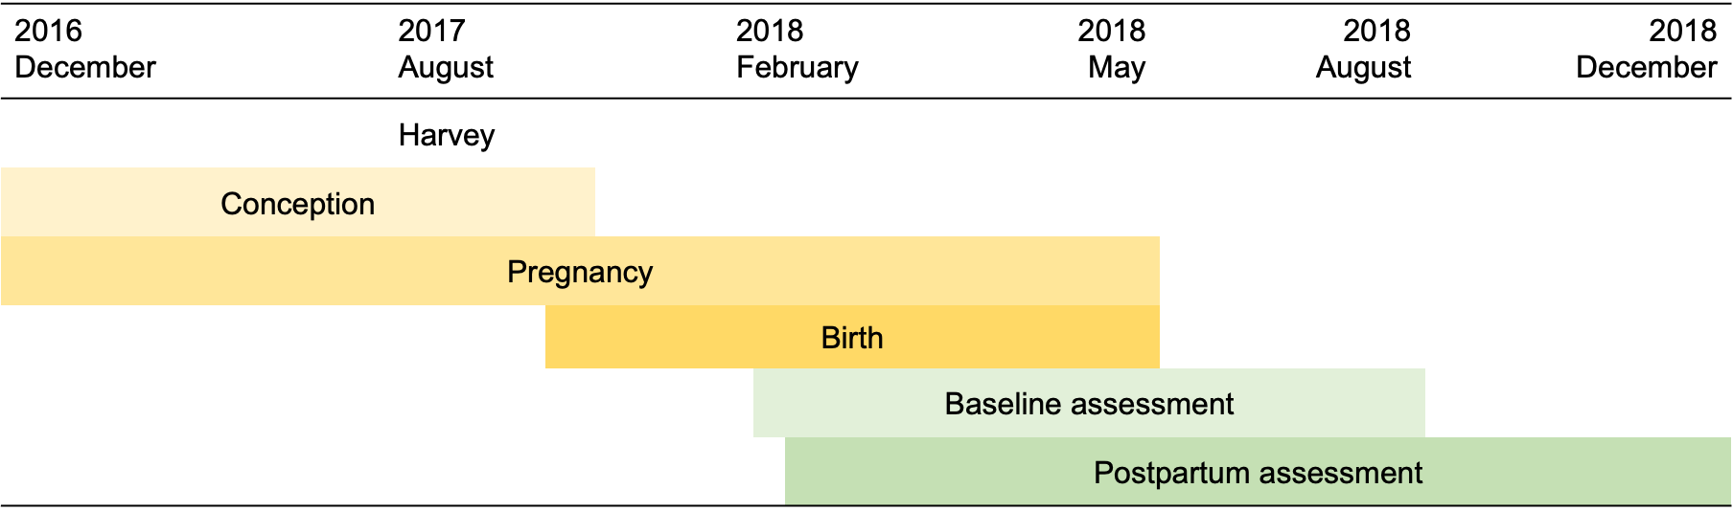
Supplementary Figure 2. Study Timeline

Note. Overview of study design from conception to birth. Yellow bars indicate months when mothers in the study conceived, were pregnant, and gave birth. Green bars indicate months for data collection of baseline and post-partum assessments. For temporal precedence in the analyses, data were only included if they were completed at least 2 weeks after the prior time point.

Supplementary Table 1a. Bivariate correlations between key study variables and all potential covariates.

 | 1 | 2 | 3 | 4 | 5 | 6 | 7 | 8 | 9 | 10 | 11 | 12 | 13 | 14
- Positive Affect/ Surgency | —
- Negative Affect | .24** | —
- Orienting/ Regulation | .42** | -.01 | —
- Objective Hardshipª | .10* | .09* | .10* | —
- Depression_{bas} | .00 | .11* | .03 | .38** | —
- Anxiety_{bas} | .06 | .07 | .03 | .25** | .64** | —
- Ill-Temper_{bas} | .01 | .11* | .00 | .30** | .69** | .57** | —
- PTS total | .09* | .10* | .12** | .48** | .56** | .49** | .46** | —
- PTS Intrusion | .08 | .08 | .10* | .48** | .54** | .45** | .43** | .96** | —
- PTS Avoidance | .08 | .09** | .13** | .43** | .46** | .39** | .38** | .89** | .75** | —
- PTS Hyperarousal | .10* | .10** | .11* | .42** | .56** | .53** | .47** | .93** | .89** | .72** | —
- Depression_{PP} | -.04 | .12** | .01 | .27** | .58** | .37** | .37** | .38** | .34** | .35** | .37** | —
- Anxiety_{PP} | .03 | .13** | -.02 | .22** | .40** | .47** | .29** | .38** | .34** | .35** | .37** | .64** | —
- Ill-Temper_{PP} | .02 | .17** | .03 | .20** | .40** | .24** | .45** | .29** | .25** | .28** | .28** | .70** | .54** | —
- Education level | .04 | .04 | .03 | .15** | .08 | .05 | .05 | .15** | .16** | .13** | .12** | .11* | .13** | .03
- Family Income ($) | .00 | -.03 | .00 | -.06 | -.11* | .02 | -.05 | -.05 | -.03 | -.09* | -.01 | -.13** | -.08 | -.06
- Maternal ethnicity | -.03 | .01 | -.05 | -.13** | -.03 | -.08 | .02 | -.16** | -.15** | -.17** | -.12** | -.07 | -.10* | -.05
- Stressful life events | .01 | .02 | -.02 | .22** | .22** | .14** | .13** | .13** | .12** | .13** | .11* | .24** | .08 | .14**
- Birthweight | -.02 | .00 | -.05 | -.12** | .01 | -.05 | .08 | -.02 | .00 | -.05 | .02 | -.01 | -.03 | .05
- Child age (months) | .12** | -.04 | -.06 | -.06 | -.02 | .00 | .06 | -.02 | -.02 | -.04 | .02 | -.03 | .04 | -.05
- Maternal age (years) | -.04 | -.04 | -.02 | -.12** | -.14** | -.19** | -.10* | -.20** | -.19** | -.20** | -.17** | -.10* | -.21** | -.09*
- Exposure Timing | -.02 | .00 | -.05 | .03 | .06 | .03 | .09* | .06 | .06 | .05 | .05 | .03 | .05 | .00
- Trimester of Exposure | -.03 | .01 | -.04 | .03 | .05 | .04 | .07 | .07 | .06 | .07 | .07 | .03 | .07 | .01
- Child sex | .00 | .03 | -.05 | .06 | .05 | .00 | .00 | .05 | .05 | .05 | .05 | .04 | .08 | -.01
- Pregnancy status | -.06 | -.10* | .00 | -.06 | .05 | .05 | .00 | -.03 | -.03 | -.05 | -.02 | -.02 | -.07 | -.01
- Race | .09* | .05 | -.01 | .19** | .12** | .11* | .10* | .18** | .15** | .19** | .17** | .12** | .12** | .05
- Time_{H-Baseline} | .12** | .07 | .02 | -.02 | -.07 | -.01 | -.04 | -.04 | -.04 | -.04 | -.03 | .01 | .07 | -.03
- Time_{H-PP} | .07 | -.01 | .02 | -.05 | -.06 | -.03 | -.07 | -.06 | -.06 | -.06 | -.04 | -.04 | -.03 | -.02
Note. * p < .05, ** p < .01

Subscale averages are used for Negative Affect, Orienting/Regulation Capacity, Positive Affect/Surgency. Inventory of Depression and Anxiety Symptoms subscale sum scores are used for maternal mental health variables. Point biserial correlation coefficients used for binary variables; ª Transformed scores are used for objective hardship; race: 0-White, 1-People of color; Pregnancy status: 0- Not pregnant at baseline, 1-Pregnant at baseline; Child sex: 0- Male, 1- Female; Ethnicity: 0- Hispanic, 1-Non-Hispanic; PTS = posttraumatic stress symptoms measured with IES-R. Time variables are calculated as the number of days between Harvey (Aug 25, 2017) and the assessment date of completion for each participant. PP = Postpartum assessment.
Supplementary Table 1b. Results from One-Way Analyses of Variance of Intervention Effects

Outcome | F | df_{num} | df_{den} | p
Orienting/Regulation | 1.04 | 2 | 524 | .35
Negative Affect | 1.16 | 2 | 524 | .32
Positive Affect/ Surgency | 1.85 | 2 | 524 | .16
Depression_{bas} | 0.02 | 2 | 524 | .98
Anxiety_{bas} | 0.53 | 2 | 524 | .59
Ill Temper_{bas} | 0.17 | 2 | 523 | .84
Depression_{PP} | 0.73 | 2 | 524 | .48
Anxiety_{PP} | 0.53 | 2 | 524 | .59
Ill Temper_{PP} | 0.45 | 2 | 524 | .64
Objective Hardship^{c} | 0.45 | 2 | 524 | .64
Results from one-way ANOVA with Intervention predicting key study variables. Intervention is coded as 0-Expressive Writing, 1- Control Writing, 2- No Writing Control. Subscale averages are used for Negative Affect, Orienting/Regulation Capacity, Positive Affect/Surgency. Inventory of Depression and Anxiety Symptoms subscale sum scores are used for maternal mental health variables. Bas = baseline assessment. PP = Postpartum assessment

