Supplementary Material for
The default mode network is associated with changes in internalizing and externalizing problems differently in adolescent boys and girls
Examination of the moderation effect of sex in change in internalizing and externalizing problems
The primary question we addressed in our study is: is symptom change associated with different brain regions in boys than it is in girls? In addressing the question, we identified brain regions that are associated with symptom change in boys, identified brain regions that are associated with symptom change in girls, by conducting MVPA separately in boys and girls, and then examined commonalities and differences in these two empirically derived sets of brain regions. We found that there was no overlap in the brain regions that predicted change in internalizing problems in boys and in girls; the brain regions that predicted change in externalizing problems in boys partially overlapped with regions found in girls, but the associations were in opposite directions.
A different, but related, question is whether brain networks or regions interact with gender to predict changes in symptoms; that is, does gender moderate the association of brain regions with change in symptoms in the full sample? This question requires a different analytic method, identifying brain regions that are associated with change in internalizing and/or externalizing problems in the full sample and then examining statistically whether these associations are moderated by gender.
To address this question, we conducted MVPA predicting change in internalizing and externalizing problems in the full sample and examined whether sex moderates the obtained associations. Thus, we used MVPA to identify brain regions that are associated with change in YSR internalizing and externalizing scores and computed FC between those regions. We found negative correlations between the MVPA-derived FC patterns and change in both internalizing and externalizing problems (Figure S1, below). Then we built separate regression models for internalizing and externalizing problems in which change in YSR scores was the dependent variable, brain FC was the independent variable, and sex was included as a moderator variable. These analyses indicated that, in the full sample, sex did not moderate the association of MVPA-derived FC with subsequent change in either internalizing (p=0.865) or externalizing (p=0.252) problems.

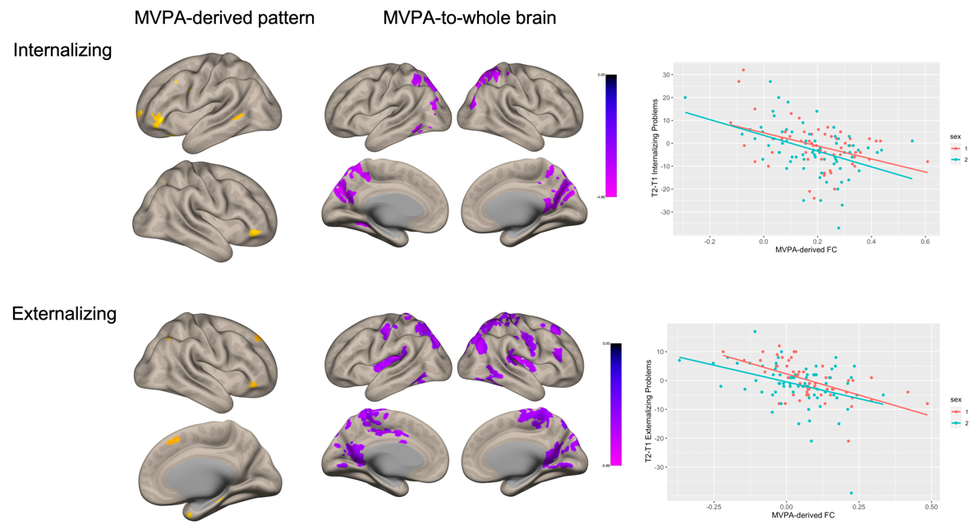

Examination of specificity of each FC pattern
To further examine whether the FC patterns that were derived separately in boys and girls are, in fact, sex-specific, we conducted post-hoc analyses by using each group’s FC patterns as ROIs for the other group. For example, we extracted MVPA-derived brain regions that predicted change in internalizing problems in girls as ROIs (left VLPFC and Precuneus/PHG), computed ROI-to-ROI FC values in boys, and used the obtained FC values in a linear regression model that predicts change in internalizing problems in boys. For the FC between left VLPFC and Precuneus/PHG to be sex-specific, it should predict change in internalizing problems in girls and not in boys. All of the MVPA patterns were found to be sex-specific, with the exception of boys’ MVPA pattern predicting change in internalizing problems (see figure below).
