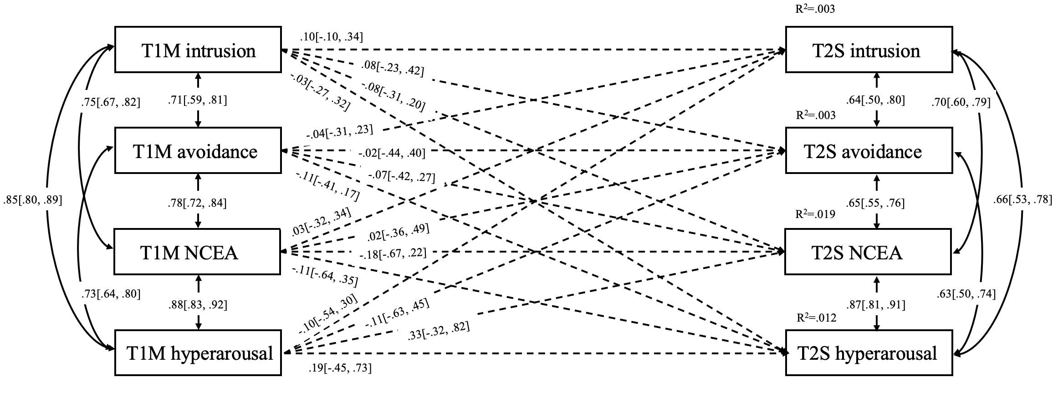
Supplementary Materials
Figure S1. Direct Model for Mother-Son Dyads.
Note. NCEA = negative cognitive and emotional alterations; M = Mother, S = Son; bootstrap 95%CI showed in the brackets; all parameters are standardized.
T1F intrusion
T1F hyperarousal
T1F avoidance
T1F NCEA
T2S intrusion
R²=.038
R²=.047
R²=.012
R²=.033
T2S hyperarousal
T2S avoidance
T2S NCEA
.01[-.54, .55]
.18[-.23, .57]
.06[-.65, .92]
-.08[-.48, .61]
.08[-.71, .68]
-.31[-.89, .34]
-.07[-.73, .53]
.21[-.20, .81]
-.24[-.77, .38]
.04[-.38, .59]
-.17[-.86, .36]
-.14[-.62, .29]
-.11[-.64, .29]
.07[-.56, .75]
.01[-.70, .49]
.89[.83, .93]
.77[.63, .86]
.84[.73, .92]
.85[.72, .92]
.85[.72, .94]
.86[.73, .94]
.76[.32, .93]
.71[.40, .87]
.81[.57, .93]
.76[.51, .88]
.71[.41, .88]
-.11[-.61, .63]
.70[.40, .87]

Figure S2. Direct Model for Father-Son Dyads.
Note. NCEA = negative cognitive and emotional alterations; F = Father, S = Son; bootstrap 95%CI showed in the brackets; all parameters are standardized.
T1F intrusion
T1F hyperarousal
T1F avoidance
T1F NCEA
T2D intrusion
R²=.101
R²=.028
R²=.042
R²=.080
T2D hyperarousal
T2D avoidance
T2D NCEA
-.08[-.65, .71]
.16[-.31, .91]
-.03[-.36, .52]
-.16[-.40, .22]
-.02[-.80, .68]
.34[-.13, 1.03]
-.01[-.72, .63]
.04[-.63, .87]
.24[-.20, .84]
.19[-.46, .73]
.05[-.49, .57]
.16[-.27, .80]
-.33[-.62, .05]
.12[-.68, .66]
.15[-.38, .72]
.68[.48, .83]
.84[.75, .91]
.79[.62, .89]
.70[.44, .85]
.68[.39, .85]
.91[.82, .95]
.75[.51, .85]
.57[.34, .74]
.87[.76, .93]
.62[.43, .74]
.62[.39, .77]
-.29[-.52, .05]
.73[.61, .82]

Figure S3. Direct Model for Father-Daughter Dyads.
Note. NCEA = negative cognitive and emotional alterations; F = Father, D = Daughter; bootstrap 95%CI showed in the brackets; all parameters are standardized.

