Investigating sensitivity through the lens of parents: validation of the
parent-report version of the Highly Sensitive Child scale
Supplementary material

21/10/2022

Contents
- Study 1 2
  - Missing data 2
  - Exploratory Parallel Analysis 3
  - CFA models on total sample with and without data imputation considering age
as the group variable (N = 1857) 4
  - Factor loadings and residual variances of the bi-factor model in the preschool
group 5
  - Factor loadings and residual variances of the bi-factor model in the school-age
group 7

- Study 2 9
2.1. Bivariate zero-order and partial associations without data imputation 10

Used R packages ………………………………………………………………. 11

1 Study 1
  - Missing data

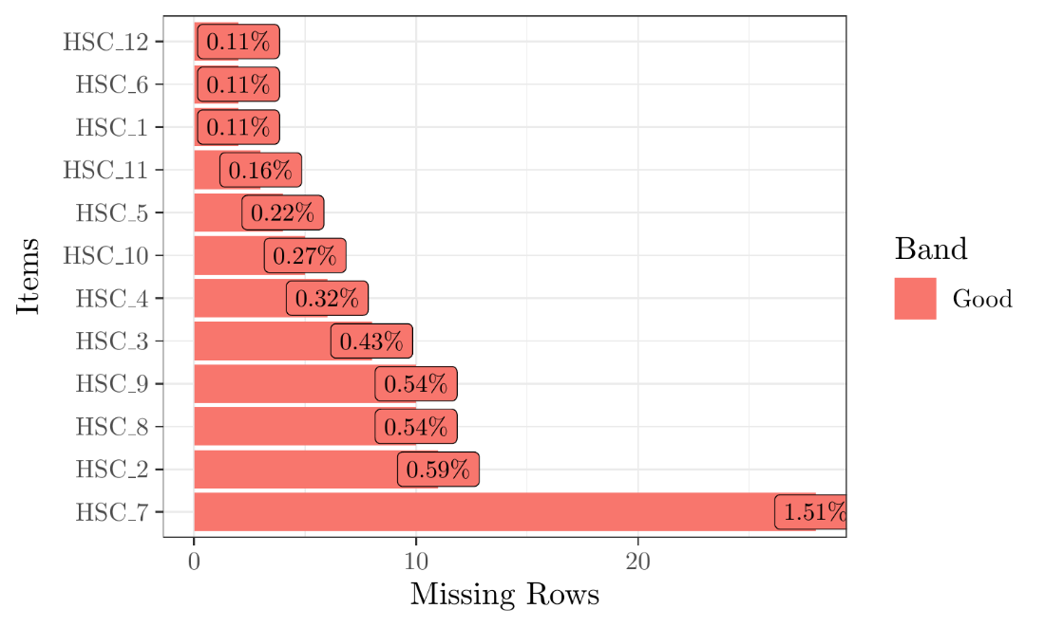
Figure S1: Frequency (and percentage) of missing values for each item.

The total sample is composed by 1857 subjects. In Figure S1 are represented the frequency and the percentage of missing values for each item of the HSC scale. Item 7 presented the highest percentage of missing values corresponding to 28 non responses; note that 27 of these non-responding subjects are in the preschool group.

Table S1 reports the frequency of missing values by subjects; there are only 84 subjects who did not complete the survey.

missing | subjects
0 | 1773
1 | 77
2 | 7

Table S1: Number of missing values by subject.

Given the low percentage of missing data, we decided to use a full information maximum likelihood approach for imputing missing data.

  - Exploratory parallel analysis

In Figure 1, results from an exploratory parallel analysis are reported. The three-factor solution seems to be a plausible solution.

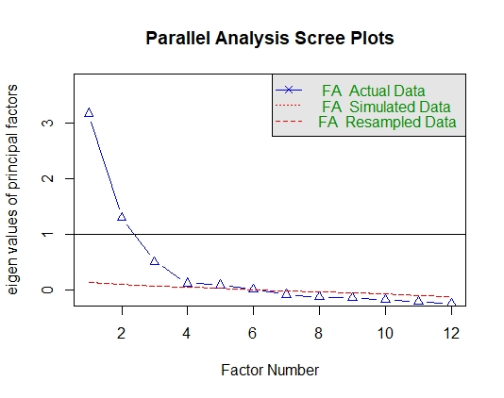
Figure 1. Exploratory parallel analysis

  - CFA models on total sample with and without data imputation considering age as the grouping variable (N = 1857)

In Table S2 are reported the fit indices obtained in the three compared models. On the top side, fit indices obtained by adopting the listwise deletion method are reported (N = 1773). On the bottom, fit indices obtained by imputing missing data with full information maximum likelihood approach (fiml) are reported. The bi-factor model showed the best fit indices and results obtained by adopting listwise and fiml are overall comparable.

Listwise | N | CFI | CFI Δ | TLI | RMSEA | SRMR
Bi-factor | 1773 | .95 |  | .92 | .07 [.06-.07] | .04
Three-factor | 1773 | .94 | .01 | .92 | .07 [.06-.07] | .05
One-factor | 1773 | .67 | .27 | .60 | .14 [.14-.15] | .12
With data imputation | N | CFI | CFI Δ | TLI | RMSEA | SRMR
Bi-factor | 1857 | .95 |  | .92 | .07 [.06 - .07] | .04
Three-factor | 1857 | .93 | .02 | .91 | .07 [.06 - .08] | .05
One-factor | 1857 | .67 | .26 | .59 | .15 [.14 - .15] | .11
Table S2. Fit indices and comparison of the CFA models on the total sample. On the top, fit indices without data imputation are showed. On the bottom, fit indices of CFA with data imputation using FIML are showed. N = sample size, CFI = Comparative fit index, CFI Δ = CFI difference, TLI = Tucker-Lewis index, RMSEA = Root mean square error of approximation [and 95% confidence interval], SRMR = standardized root mean square residual.

  - Factor loadings and residual variances of the bi-factor model in the preschool group
In boxes S1 (page 5) and S2 (page 6) are reported the factor loadings and the residual variances, respectively, of the bi-factor model for preschool group. For each estimated parameter are reported also the standard error (Std.Err), the z-value (z-value), the p-value (P(>|z|)). Important to note, a negative variance was found for item 7 limited to the preschool group.

Group 1 [1]:

Latent Variables:
Estimate Std.Err z-value P(>|z|)
EOEb =~
HSC_4 1.245 0.053 23.482 0.000
HSC_6 1.336 0.047 28.526 0.000
HSC_8 1.324 0.047 28.209 0.000
HSC_9 0.784 0.055 14.371 0.000
HSC_12 0.821 0.061 13.430 0.000
LSTb =~
HSC_2 0.032 0.022 1.428 0.153
HSC_7 -34.690 23.376 -1.484 0.138
HSC_11 0.021 0.015 1.337 0.181
AESb =~
HSC_1 0.669 0.058 11.534 0.000
HSC_3 0.873 0.050 17.511 0.000
HSC_5 0.786 0.053 14.762 0.000
HSC_10 0.947 0.051 18.444 0.000
HSPb =~
HSC_1 0.340 0.053 6.395 0.000
HSC_2 1.507 0.069 21.847 0.000
HSC_3 0.382 0.046 8.352 0.000
HSC_4 0.581 0.063 9.168 0.000
HSC_5 0.278 0.049 5.685 0.000
HSC_6 0.644 0.058 11.056 0.000
HSC_7 1.273 0.140 9.066 0.000
HSC_8 0.655 0.058 11.325 0.000
HSC_9 0.562 0.057 9.801 0.000
HSC_10 0.382 0.046 8.313 0.000
HSC_11 1.595 0.071 22.485 0.000
HSC_12 0.449 0.066 6.803 0.000

Box S1. Estimated factor loadings of the Bi-factor model, preschool group (N = 1066). Std.Err = Standard error, P(>|z|) = p-value.

Variances:
Estimate Std.Err z-value P(>|z|)
.HSC_4 1.531 0.084 18.333 0.000
.HSC_6 0.890 0.063 14.016 0.000
.HSC_8 0.934 0.064 14.524 0.000
.HSC_9 2.122 0.098 21.639 0.000
.HSC_12 2.734 0.125 21.920 0.000
.HSC_2 1.473 0.158 9.322 0.000
.HSC_7 -1200.124 1621.778 -0.740 0.459
.HSC_11 1.368 0.172 7.952 0.000
.HSC_1 2.085 0.101 20.659 0.000
.HSC_3 1.076 0.074 14.595 0.000
.HSC_5 1.589 0.085 18.693 0.000
.HSC_10 1.032 0.080 12.966 0.000
EOEb 1.000
LSTb 1.000
AESb 1.000
HSPb 1.000

Box S2: Estimated residual variances of the Bi-factor model, preschool group (N = 1066). Std.Err = Standard error, P(>|z|) = p-value.

  - Factor loadings and residual variances of the bi-factor model in the school group
In boxes S3 (page 7) and S4 (page 8) are reported the factor loadings and the residual variances, respectively, of the bi-factor model for school-age group. For each estimated parameter are reported also the standard error (Std.Err), the z-value (z-value), the p-value (P(>|z|)).

Group 2 [2]:

Latent Variables:
Estimate Std.Err z-value P(>|z|)
EOEb =~
HSC_4 0.776 0.108 7.173 0.000
HSC_6 1.080 0.103 10.432 0.000
HSC_8 1.070 0.117 9.114 0.000
HSC_9 0.008 0.130 0.065 0.948
HSC_12 -0.024 0.147 -0.163 0.871
LSTb =~
HSC_2 1.044 0.221 4.731 0.000
HSC_7 0.338 0.125 2.712 0.007
HSC_11 0.948 0.212 4.472 0.000
AESb =~
HSC_1 0.559 0.069 8.096 0.000
HSC_3 0.685 0.069 9.859 0.000
HSC_5 0.970 0.067 14.470 0.000
HSC_10 1.138 0.071 15.980 0.000
HSPb =~
HSC_1 0.113 0.070 1.620 0.105
HSC_2 0.808 0.089 9.070 0.000
HSC_3 0.307 0.067 4.597 0.000
HSC_4 1.139 0.090 12.705 0.000
HSC_5 0.334 0.068 4.915 0.000
HSC_6 1.074 0.103 10.462 0.000
HSC_7 0.748 0.098 7.624 0.000
HSC_8 1.260 0.103 12.235 0.000
HSC_9 1.035 0.075 13.838 0.000
HSC_10 0.300 0.066 4.525 0.000
HSC_11 1.159 0.085 13.684 0.000
HSC_12 1.090 0.089 12.313 0.000
Box S3. Estimated factor loadings of the bi-factor model, school-age group (N = 791). Std.Err = Standard error, P(>|z|) = p-value.

Variances:
Estimate Std.Err z-value P(>|z|)
.HSC_4 1.480 0.089 16.644 0.000
.HSC_6 0.961 0.101 9.533 0.000
.HSC_8 0.745 0.092 8.063 0.000
.HSC_9 1.720 0.137 12.508 0.000
.HSC_12 2.775 0.194 14.268 0.000
.HSC_2 2.153 0.447 4.817 0.000
.HSC_7 3.814 0.202 18.852 0.000
.HSC_11 1.222 0.357 3.425 0.001
.HSC_1 2.204 0.120 18.403 0.000
.HSC_3 1.954 0.115 17.002 0.000
.HSC_5 1.477 0.112 13.163 0.000
.HSC_10 1.069 0.132 8.104 0.000
EOEb 1.000
LSTb 1.000
AESb 1.000
HSPb 1.000
Box S4: Estimated residual variances of the Bi-factor model, school-age group (N = 791). Std.Err = Standard error, P(>|z|) = p-value.

- Study 2
2.1. Bivariate zero-order and partial associations without data imputation

In Table S3 (page 10) are reported bivariate zero-order and partial correlations adopting listwise deletion method among HSC-PR total scale and its factors and temperamental dimensions.

 | Mean (SD) | 1 | 2 | 3 | 4 | 5 | 6 | 7 | 8 | 9 | 10 | 11
1 HSC-PR | 4.58(.89) | —
2 HSC-PR – no item 7 | 4.51(.90) | .98 | —
3 HSC-EOE | 3.61(1.30) | .82 | .83 | —
4 HSC-LST | 4.53(1.55) | .79 | .72 | .46 | —
5 HSC-LST – no item 7 | 4.18(1.84) | .73 | .74 | .44 | .90 | —
6 HSC-AES | 5.82(.88) | .43 | .45 | .01 | .20 | .18 | —
7 CBQ-NA | 4.21(1.03) | .37 | .38 | .45 (.42) | .15 (-.07) | .13 | .09 (.06) | —
8 CBQ-EXTR | 4.60(.85) | -.28 | -.28 | -.23 (-.11) | -.28 (-.20) | -.32 | -.02 (.04) | .02 | —
9 CBQ-EC | 5.65(.76) | .35 | .35 | .08 (-.08) | .29 (.21) | .28 | .51 (.46) | .05 | -.24 | —
10 Gender |  | .13 | .12 | .05 | .08 | .06 | .18 | .06 | -.16 | .27 | —
11 Age |  | .10 | .09 | .07 | .14 | .13 | .00 | .03 | -.16 | .17 | .10 | —
Table S3. Bivariate zero-order and partial correlations (in brackets) adopting listwise deletion method (N = 204).
In brackets are showed partial correlations between HSC-PR subscales and temperament dimensions.
HSC-PR = Highly Sensitive Child scale Parent-Report Total Score; HSC-PR - no item 7 = Highly Sensitive Child scale Total Score excluding item 7; HSC-EOE = Ease of Excitation; HSC-LST = Low Sensitivity Threshold; HSC-LST – no item 7 = Low Sensitivity Threshold excluding item 7; HSC-AES = Aesthetic Sensitivity; CBQ-EC = Effortful Control; CBQ-EXTR = Surgency/Extraversion; CBQ-NA = Negative Affect. Gender: 1 = male, 2 = female. According to Cohen (1988, 1992): trivial associations: r lower than r =.10; moderate associations: r = 25-45; strong association: r equal to or higher than .50.

Used R packages

DataExplorer. Boxuan Cui (2020). DataExplorer: Automate Data Exploration and Treatment.
R package version 0.8.2. https://CRAN.R-project.org/package=DataExplorer
lavaan. Yves Rosseel (2012). lavaan: An R Package for Structural Equation Modeling. Journal of Statistical Software, 48(2), 1-36. URL https://www.jstatsoft.org/v48/i02/.
R. R Core Team (2020). R: A language and environment for statistical computing. R Foundation for Statistical Computing, Vienna, Austria. URL https://www.R-project.org/.
readxl. Hadley Wickham and Jennifer Bryan (2019). readxl: Read Excel Files. R package version 1.3.1. https://CRAN.R-project.org/package=readxl
xtable. David B. Dahl, David Scott, Charles Roosen, Arni Magnusson and Jonathan Swinton
(2019). xtable: Export Tables to LaTeX or HTML. R package version 1.84. https://CRAN.R-project.org/package=xtable

