Supplementary material

Table of Contents
Table S1. Symptom description, proportions and counts 2
Table S2. Correlation matrix for symptoms of psychopathology 5
Table S3. Estimates for latent variable indirect effects models for anxiety sensitivity 6
Table S4. Estimates for latent variable indirect effects models for negative thinking 8
Table S5. Estimates for latent variable indirect effects models for impulsivity 10
Table S6. Estimates for latent variable indirect effects models for sensation seeking 12
Table S7. Estimates for total effect estimates from correlated factor models 14
Additional structural models of psychopathology 15
Table S8. Fit indices for additional models of adolescent psychopathology (n=8,589) 15
Figure S1. Path diagrams for 2-bifactor model of adolescent psychopathology 16
Figure S2. Path diagrams for 2-bifactor model of adolescent psychopathology with correlated general factors 17
Figure S3. Path diagrams for 2-higher-order model of adolescent psychopathology 18
Figure S4. Path diagrams for Modified bifactor model of adolescent psychopathology with correlated specific factors 19
Table S9. Standardized Factor loadings on general and specific (fear, distress, alcohol use/harms, conduct/inattention) factors using WLSMV estimator and inter-factor correlations 20
Table S10. Reliability indices for additional structural models of psychopathology 22

Table S1. Symptom description, proportions and counts

 |  |  |  | CAP |  | CSC |  | ALL
Item ID | Item / description | Values | Value Labels | % | n | % | n | % | n
T1_SD2 | I am restless. I cannot stay still for long. | 0 | Not true | 36.4% | 591 | 53.0% | 3143 | 49.5% | 3734
T1_SD2 |  | 1 | Somewhat true or Certainly true | 63.6% | 1034 | 47.0% | 2783 | 50.5% | 3817
T1_SD3 | I get a lot of headaches, stomach-aches, or sickness. | 0 | Not true | 61.2% | 994 | 66.5% | 3938 | 65.3% | 4932
T1_SD3 |  | 1 | Somewhat true or Certainly true | 38.8% | 631 | 33.5% | 1987 | 34.7% | 2618
T1_SD5 | I get very angry and often lose my temper. | 0 | Not true | 52.0% | 845 | 63.2% | 3741 | 60.8% | 4586
T1_SD5 |  | 1 | Somewhat true or Certainly true | 48.0% | 780 | 36.8% | 2180 | 39.2% | 2960
T1_SD6 | I am usually on my own. I generally play alone or keep to myself. | 0 | Not true | 74.8% | 1215 | 71.7% | 4246 | 72.4% | 5461
T1_SD6 |  | 1 | Somewhat true or Certainly true | 25.2% | 410 | 28.3% | 1675 | 27.6% | 2085
T1_SD8 | I worry a lot. | 0 | Not true | 44.7% | 726 | 57.9% | 3424 | 55.1% | 4150
T1_SD8 |  | 1 | Somewhat true or Certainly true | 55.3% | 899 | 42.1% | 2488 | 44.9% | 3387
T1_SD10 | I am constantly fidgeting or squirming. | 0 | Not true | 57.8% | 940 | 64.4% | 3806 | 63.0% | 4746
T1_SD10 |  | 1 | Somewhat true or Certainly true | 42.2% | 685 | 35.6% | 2106 | 37.0% | 2791
T1_SD12 | I fight a lot. I can make other people do what I want. | 0 | Not true | 79.1% | 1285 | 83.8% | 4956 | 82.8% | 6241
T1_SD12 |  | 1 | Somewhat true or Certainly true | 20.9% | 340 | 16.2% | 957 | 17.2% | 1297
T1_SD13 | I am often unhappy, down-hearted, or tearful. | 0 | Not true | 74.8% | 1216 | 76.1% | 4498 | 75.8% | 5714
T1_SD13 |  | 1 | Somewhat true or Certainly true | 25.2% | 409 | 23.9% | 1415 | 24.2% | 1824
T1_SD15 | I am easily distracted. I find it difficult to concentrate. | 0 | Not true | 39.6% | 643 | 45.8% | 2707 | 44.4% | 3350
T1_SD15 |  | 1 | Somewhat true or Certainly true | 60.4% | 982 | 54.2% | 3207 | 55.6% | 4189
T1_SD16 | I am nervous in new situations. I easily lose confidence. | 0 | Not true | 38.2% | 620 | 45.8% | 2709 | 44.2% | 3329
T1_SD16 |  | 1 | Somewhat true or Certainly true | 61.8% | 1005 | 54.2% | 3206 | 55.8% | 4211
T1_SD18 | I am often accused of lying or cheating. | 0 | Not true | 65.7% | 1067 | 71.3% | 4208 | 70.1% | 5275
T1_SD18 |  | 1 | Somewhat true or Certainly true | 34.3% | 558 | 28.7% | 1697 | 29.9% | 2255
T1_SD19 | Often children or young people pick on me or bully me. | 0 | Not true | 81.5% | 1324 | 82.6% | 4880 | 82.4% | 6204
T1_SD19 |  | 1 | Somewhat true or Certainly true | 18.5% | 301 | 17.4% | 1028 | 17.6% | 1329
T1_SD23 | I get on better with adults than with people my own age. | 0 | Not true | 63.3% | 1029 | 58.4% | 3448 | 59.5% | 4477
T1_SD23 |  | 1 | Somewhat true or Certainly true | 36.7% | 596 | 41.6% | 2452 | 40.5% | 3048
T1_SD24 | 24. I have many fears. I am easily scared. | 0 | Not true | 59.4% | 965 | 63.5% | 3750 | 62.6% | 4715
T1_SD24 |  | 1 | Somewhat true or Certainly true | 40.6% | 660 | 36.5% | 2159 | 37.4% | 2819
T1_SD22 | I take things that are not mine from home, school or elsewhere. | 0 | Not true | 82.5% | 1341 | 87.5% | 4239 | 86.3% | 5580
T1_SD22 |  | 1 | Somewhat true or Certainly true | 17.5% | 284 | 12.5% | 604 | 13.7% | 888
T1_AUC1 | How often did you have a std alcoholic drink of any kind in the past 6 mths? | 0 | Never or less than monthly | 98.3% | 2222 | 97.0% | 2869 | 97.6% | 5091
T1_AUC1 |  | 1 | Once a month, 2-3 times a month, Weekly, Daily or almost daily | 1.7% | 38 | 3.0% | 88 | 2.4% | 126
T1_AUC2 | How often do you have 5+ std drinks in the past 6 mths? | 0 | Never or less than monthly | 98.3% | 2221 | 97.8% | 2518 | 98.0% | 4739
T1_AUC2 |  | 1 | Once a month, 2-3 times a month, Weekly, Daily or almost daily | 1.7% | 39 | 2.2% | 56 | 2.0% | 95
T1_AUC3 | In the past 6 mths, how many std drinks on a typical day? | 0 | None or 1-2 | 98.6% | 2229 | 98.1% | 2901 | 98.4% | 5130
T1_AUC3 |  | 1 | 3-4, 5-6,7-9, 10+ | 1.4% | 31 | 1.9% | 55 | 1.6% | 86
In the past 6 months how many times have you experienced the following as a consequence of drinking alcohol
T1_AH1 | Got into fights, acted bad, or did mean things. | 0 | Never | 56.6% | 1275 | 90.6% | 5710 | 81.6% | 6985
T1_AH1 |  | 1 | 1-2 times, 3-4 times, 5+6 times, More than 6 times | 43.4% | 979 | 9.4% | 592 | 18.4% | 1571
T1_AH2 | Caused shame or embarrassment to someone. | 0 | Never | 59.7% | 1345 | 92.4% | 5821 | 83.7% | 7166
T1_AH2 |  | 1 | 1-2 times, 3-4 times, 5+6 times, More than 6 times | 40.3% | 909 | 7.6% | 482 | 16.3% | 1391
T1_AH3 | Neglected my responsibilities. | 0 | Never | 56.9% | 1282 | 92.8% | 5844 | 83.3% | 7126
T1_AH3 |  | 1 | 1-2 times, 3-4 times, 5+6 times, More than 6 times | 43.1% | 972 | 7.2% | 455 | 16.7% | 1427
T1_AH4 | Felt that I need more alcohol than I used to in order to get the same effect. | 0 | Never | 51.0% | 1150 | 92.3% | 5815 | 81.4% | 6965
T1_AH4 |  | 1 | 1-2 times, 3-4 times, 5+6 times, More than 6 times | 49.0% | 1104 | 7.7% | 487 | 18.6% | 1591
T1_AH5 | Noticed a change in my personality. | 0 | Never | 78.5% | 1769 | 96.8% | 6100 | 92.0% | 7869
T1_AH5 |  | 1 | 1-2 times, 3-4 times, 5+6 times, More than 6 times | 21.5% | 485 | 3.2% | 202 | 8.0% | 687
T1_AH6 | Tried to cut down or quit drinking. | 0 | Never | 96.6% | 2177 | 98.3% | 6199 | 97.9% | 8376
T1_AH6 |  | 1 | 1-2 times, 3-4 times, 5+6 times, More than 6 times | 3.4% | 77 | 1.7% | 104 | 2.1% | 181
T1_AH7 | Suddenly found myself in a place that I could not remember getting to. | 0 | Never | 96.0% | 2163 | 98.2% | 6184 | 97.6% | 8347
T1_AH7 |  | 1 | 1-2 times, 3-4 times, 5+6 times, More than 6 times | 4.0% | 91 | 1.8% | 113 | 2.4% | 204
T1_AH8 | Felt I was going crazy. | 0 | Never | 82.7% | 1863 | 95.6% | 6025 | 92.2% | 7888
T1_AH8 |  | 1 | 1-2 times, 3-4 times, 5+6 times, More than 6 times | 17.3% | 391 | 4.4% | 276 | 7.8% | 667
In the last 4 weeks, about how often did you feel
T1_K61R | …nervous? | 0 | None of the time | 19.3% | 422 | 17.1% | 1046 | 17.7% | 1468
T1_K61R |  | 1 | A little of the time, some of the time, most of the time, all of the time | 80.7% | 1761 | 82.9% | 5075 | 82.3% | 6836
T1_K62R | … hopeless? | 0 | None of the time | 49.4% | 1079 | 51.5% | 3152 | 51.0% | 4231
T1_K62R |  | 1 | A little of the time, some of the time, most of the time, all of the time | 50.6% | 1104 | 48.5% | 2964 | 49.0% | 4068
T1_K63R | … restless or fidgety? | 0 | None of the time | 29.9% | 653 | 28.2% | 1722 | 28.7% | 2375
T1_K63R |  | 1 | A little of the time, some of the time, most of the time, all of the time | 70.1% | 1529 | 71.8% | 4384 | 71.3% | 5913
T1_K64R | … so depressed that nothing could cheer you up? | 0 | None of the time | 66.6% | 1453 | 68.7% | 4200 | 68.1% | 5653
T1_K64R |  | 1 | A little of the time, some of the time, most of the time, all of the time | 33.4% | 730 | 31.3% | 1912 | 31.9% | 2642
T1_K65R | … that everything was an effort? | 0 | None of the time | 33.1% | 722 | 35.6% | 2177 | 35.0% | 2899
T1_K65R |  | 1 | A little of the time, some of the time, most of the time, all of the time | 66.9% | 1461 | 64.4% | 3930 | 65.0% | 5391
T1_K66R | … worthless? | 0 | None of the time | 64.9% | 1416 | 64.2% | 3919 | 64.3% | 5335
T1_K66R |  | 1 | A little of the time, some of the time, most of the time, all of the time | 35.1% | 767 | 35.8% | 2190 | 35.7% | 2957

Table S2. Correlation matrix for symptoms of psychopathology

 | SD16 | SD24 | K61R | K63R | SD3 | SD8 | SD13 | K62R | K64R | K65R | K66R | AUC1 | AUC2 | AUC3 | AH1 | AH2 | AH3 | AH4 | AH5 | AH6 | AH7 | AH8 | SD2 | SD5 | SD10 | SD12 | SD15 | SD18 | SD22
SD16 | 1.000
SD24 | 0.552 | 1.000
K61R | 0.370 | 0.268 | 1.000
K63R | 0.283 | 0.235 | 0.578 | 1.000
SD3 | 0.414 | 0.429 | 0.264 | 0.297 | 1.000
SD8 | 0.586 | 0.546 | 0.419 | 0.332 | 0.507 | 1.000
SD13 | 0.527 | 0.542 | 0.250 | 0.316 | 0.572 | 0.659 | 1.000
K62R | 0.435 | 0.397 | 0.580 | 0.513 | 0.396 | 0.529 | 0.610 | 1.000
K64R | 0.383 | 0.384 | 0.440 | 0.425 | 0.474 | 0.504 | 0.693 | 0.734 | 1.000
K65R | 0.312 | 0.267 | 0.490 | 0.544 | 0.325 | 0.344 | 0.405 | 0.562 | 0.570 | 1.000
K66R | 0.426 | 0.392 | 0.482 | 0.464 | 0.422 | 0.514 | 0.689 | 0.822 | 0.799 | 0.578 | 1.000
AUC1 | 0.012 | -0.070 | -0.010 | 0.086 | 0.192 | 0.090 | 0.226 | 0.120 | 0.287 | 0.089 | 0.188 | 1.000
AUC2 | -0.070 | -0.030 | -0.066 | 0.136 | 0.184 | 0.022 | 0.236 | 0.107 | 0.292 | 0.083 | 0.222 | 0.908 | 1.000
AUC3 | -0.102 | -0.085 | 0.058 | 0.181 | 0.213 | -0.014 | 0.243 | 0.194 | 0.356 | 0.191 | 0.309 | 0.797 | 0.898 | 1.000
AH1 | 0.101 | 0.046 | 0.022 | 0.080 | 0.208 | 0.083 | 0.225 | 0.141 | 0.216 | 0.146 | 0.185 | 0.675 | 0.728 | 0.705 | 1.000
AH2 | 0.112 | 0.095 | 0.037 | 0.112 | 0.242 | 0.124 | 0.268 | 0.133 | 0.227 | 0.201 | 0.205 | 0.648 | 0.762 | 0.681 | 0.937 | 1.000
AH3 | 0.106 | 0.051 | 0.058 | 0.120 | 0.191 | 0.095 | 0.231 | 0.155 | 0.229 | 0.172 | 0.204 | 0.602 | 0.703 | 0.670 | 0.925 | 0.924 | 1.000
AH4 | 0.184 | 0.113 | 0.146 | 0.139 | 0.280 | 0.203 | 0.288 | 0.214 | 0.292 | 0.222 | 0.272 | 0.675 | 0.712 | 0.622 | 0.881 | 0.894 | 0.882 | 1.000
AH5 | 0.097 | 0.115 | 0.036 | 0.139 | 0.304 | 0.168 | 0.271 | 0.187 | 0.299 | 0.158 | 0.210 | 0.695 | 0.771 | 0.713 | 0.870 | 0.872 | 0.871 | 0.886 | 1.000
AH6 | 0.162 | 0.138 | -0.005 | 0.097 | 0.302 | 0.224 | 0.366 | 0.176 | 0.251 | 0.121 | 0.252 | 0.738 | 0.818 | 0.728 | 0.775 | 0.771 | 0.775 | 0.796 | 0.831 | 1.000
AH7 | 0.168 | 0.094 | 0.016 | 0.090 | 0.255 | 0.165 | 0.331 | 0.191 | 0.295 | 0.142 | 0.282 | 0.650 | 0.738 | 0.648 | 0.747 | 0.750 | 0.723 | 0.801 | 0.804 | 0.850 | 1.000
AH8 | 0.165 | 0.181 | 0.110 | 0.232 | 0.296 | 0.205 | 0.377 | 0.303 | 0.384 | 0.240 | 0.353 | 0.611 | 0.744 | 0.637 | 0.808 | 0.838 | 0.830 | 0.894 | 0.845 | 0.782 | 0.766 | 1.000
SD2 | 0.323 | 0.290 | 0.167 | 0.453 | 0.369 | 0.369 | 0.378 | 0.277 | 0.288 | 0.305 | 0.299 | 0.189 | 0.134 | 0.079 | 0.195 | 0.194 | 0.202 | 0.227 | 0.246 | 0.261 | 0.193 | 0.298 | 1.000
SD5 | 0.387 | 0.360 | 0.183 | 0.304 | 0.423 | 0.409 | 0.528 | 0.358 | 0.412 | 0.328 | 0.392 | 0.176 | 0.214 | 0.223 | 0.266 | 0.251 | 0.213 | 0.274 | 0.228 | 0.307 | 0.261 | 0.312 | 0.423 | 1.000
SD10 | 0.361 | 0.328 | 0.156 | 0.486 | 0.401 | 0.415 | 0.458 | 0.318 | 0.340 | 0.304 | 0.353 | 0.244 | 0.160 | 0.159 | 0.199 | 0.221 | 0.202 | 0.237 | 0.231 | 0.286 | 0.286 | 0.328 | 0.764 | 0.437 | 1.000
SD12 | 0.268 | 0.259 | 0.023 | 0.198 | 0.343 | 0.300 | 0.459 | 0.217 | 0.295 | 0.230 | 0.273 | 0.404 | 0.417 | 0.255 | 0.340 | 0.346 | 0.305 | 0.337 | 0.361 | 0.484 | 0.399 | 0.379 | 0.424 | 0.558 | 0.459 | 1.000
SD15 | 0.450 | 0.375 | 0.175 | 0.355 | 0.402 | 0.373 | 0.439 | 0.348 | 0.344 | 0.360 | 0.376 | 0.127 | 0.166 | 0.051 | 0.259 | 0.233 | 0.257 | 0.295 | 0.249 | 0.263 | 0.255 | 0.320 | 0.568 | 0.458 | 0.583 | 0.425 | 1.000
SD18 | 0.324 | 0.298 | 0.084 | 0.253 | 0.344 | 0.288 | 0.464 | 0.291 | 0.356 | 0.278 | 0.329 | 0.240 | 0.326 | 0.271 | 0.315 | 0.336 | 0.302 | 0.344 | 0.386 | 0.334 | 0.339 | 0.352 | 0.367 | 0.476 | 0.423 | 0.506 | 0.454 | 1.000
SD22 | 0.309 | 0.348 | 0.002 | 0.105 | 0.342 | 0.270 | 0.463 | 0.189 | 0.259 | 0.213 | 0.221 | 0.300 | 0.351 | 0.286 | 0.357 | 0.393 | 0.341 | 0.334 | 0.457 | 0.462 | 0.440 | 0.434 | 0.358 | 0.394 | 0.409 | 0.593 | 0.407 | 0.560 | 1.000

Table S3. Estimates for latent variable indirect effects models for anxiety sensitivity

 | Total Effect |  |  | Direct Effect |  |  | % accounted for by higher order factor(s)
Symptoms | b | se | p | b | se | p
Nervous in new situations | 0.366 | 0.010 | 0.000 | 0.139 | 0.014 | 0.000 | 62%
Many fears | 0.393 | 0.014 | 0.000 | 0.185 | 0.017 | 0.000 | 53%
Nervous | 0.189 | 0.016 | 0.000 | -0.064 | 0.019 | 0.001 | 100%
Restless or fidgety | 0.127 | 0.014 | 0.000 | -0.285 | 0.021 | 0.000 | 100%
Somatic symptoms | 0.262 | 0.015 | 0.000 | 0.048 | 0.016 | 0.002 | 82%
Worries | 0.368 | 0.012 | 0.000 | 0.165 | 0.014 | 0.000 | 55%
Unhappy | 0.312 | 0.017 | 0.000 | 0.021 | 0.017 | 0.234 | 93%
Hopeless | 0.265 | 0.016 | 0.000 | -0.034 | 0.015 | 0.022 | 100%
Depressed | 0.082 | 0.005 | 0.000 | -0.026 | 0.004 | 0.000 | 100%
Effort | 0.191 | 0.016 | 0.000 | -0.048 | 0.015 | 0.001 | 100%
Worthless | 0.242 | 0.015 | 0.000 | -0.101 | 0.014 | 0.000 | 100%
Frequency | 0.023 | 0.028 | 0.416 | -0.040 | 0.025 | 0.115 | 100%
Binge | 0.009 | 0.031 | 0.774 | -0.064 | 0.025 | 0.011 | 100%
Quantity | -0.037 | 0.030 | 0.221 | -0.105 | 0.027 | 0.000 | 100%
Shame/embarrassment | 0.061 | 0.020 | 0.003 | -0.013 | 0.016 | 0.417 | 100%
Neglected responsibilities | 0.059 | 0.020 | 0.003 | -0.011 | 0.015 | 0.448 | 100%
Tolerance | 0.105 | 0.023 | 0.000 | 0.039 | 0.019 | 0.042 | 63%
Personality change | 0.096 | 0.025 | 0.000 | 0.029 | 0.018 | 0.117 | 70%
Tried to cut down | 0.095 | 0.029 | 0.001 | 0.031 | 0.023 | 0.167 | 67%
Memory loss | 0.102 | 0.028 | 0.000 | 0.040 | 0.024 | 0.097 | 61%
Crazy | 0.119 | 0.027 | 0.000 | 0.053 | 0.020 | 0.007 | 55%
Restless | 0.196 | 0.013 | 0.000 | 0.001 | 0.014 | 0.964 | 99%
Temper | 0.209 | 0.013 | 0.000 | 0.024 | 0.014 | 0.095 | 89%
Fidgety | 0.190 | 0.015 | 0.000 | -0.030 | 0.012 | 0.018 | 100%
Fight a lot | 0.111 | 0.019 | 0.000 | -0.081 | 0.016 | 0.000 | 100%
Easily distracted | 0.229 | 0.013 | 0.000 | 0.048 | 0.012 | 0.000 | 79%
Lies or cheats | 0.185 | 0.017 | 0.000 | 0.005 | 0.016 | 0.736 | 97%
Steals | 0.169 | 0.021 | 0.000 | -0.007 | 0.019 | 0.730 | 100%
First-order factors
Alcohol use | 0.077 | 0.020 | 0.000 | -0.267 | 0.020 | 0.000 | 100%
Conduct/Inattention | 0.263 | 0.014 | 0.000 | -0.015 | 0.015 | 0.297 | 100%
Distress | 0.347 | 0.013 | 0.000 | 0.121 | 0.013 | 0.000 | 65%
Fear | 0.392 | 0.011 | 0.000 | 0.164 | 0.013 | 0.000 | 58%
Second-order factor
General psychopathology | 0.369 | 0.013 | 0.000 | - | - | - | -
Notes. Percentages accounted for by higher order factor(s) in bold indicate meaningful direct effects (ie. Statistically significant, percentage below 100% and no evidence of suppression effect).

Table S4. Estimates for latent variable indirect effects models for negative thinking

 | Total Effect |  |  | Direct Effect |  |  | % accounted for by higher order factor(s)
Symptoms | b | se | p | b | se | p
Nervous in new situations | 0.274 | 0.015 | 0.000 | 0.056 | 0.014 | 0.000 | 80%
Many fears | 0.256 | 0.016 | 0.000 | 0.065 | 0.015 | 0.000 | 75%
Nervous | 0.147 | 0.016 | 0.000 | -0.082 | 0.015 | 0.000 | 100%
Restless or fidgety | 0.211 | 0.016 | 0.000 | -0.044 | 0.019 | 0.019 | 100%
Somatic symptoms | 0.322 | 0.015 | 0.000 | -0.033 | 0.013 | 0.013 | 100%
Worries | 0.300 | 0.017 | 0.000 | -0.137 | 0.017 | 0.000 | 100%
Unhappy | 0.508 | 0.015 | 0.000 | 0.095 | 0.013 | 0.000 | 81%
Hopeless | 0.448 | 0.014 | 0.000 | -0.002 | 0.013 | 0.861 | 100%
Depressed | 0.490 | 0.015 | 0.000 | 0.063 | 0.011 | 0.000 | 87%
Effort | 0.329 | 0.015 | 0.000 | -0.045 | 0.016 | 0.005 | 100%
Worthless | 0.511 | 0.014 | 0.000 | 0.063 | 0.011 | 0.000 | 88%
Frequency | 0.251 | 0.028 | 0.000 | 0.063 | 0.027 | 0.020 | 75%
Binge | 0.276 | 0.033 | 0.000 | 0.057 | 0.032 | 0.074 | 79%
Quantity | 0.289 | 0.030 | 0.000 | 0.104 | 0.034 | 0.003 | 64%
Shame/embarrassment | 0.212 | 0.023 | 0.000 | -0.032 | 0.015 | 0.034 | 100%
Neglected responsibilities | 0.185 | 0.021 | 0.000 | -0.060 | 0.016 | 0.000 | 100%
Tolerance | 0.203 | 0.024 | 0.000 | -0.046 | 0.016 | 0.005 | 100%
Personality change | 0.216 | 0.030 | 0.000 | -0.023 | 0.022 | 0.302 | 100%
Tried to cut down | 0.255 | 0.028 | 0.000 | 0.040 | 0.025 | 0.104 | 84%
Memory loss | 0.228 | 0.038 | 0.000 | 0.015 | 0.031 | 0.639 | 93%
Crazy | 0.260 | 0.027 | 0.000 | 0.028 | 0.022 | 0.215 | 89%
Restless | 0.191 | 0.019 | 0.000 | -0.091 | 0.014 | 0.000 | 100%
Temper | 0.274 | 0.015 | 0.000 | 0.042 | 0.012 | 0.000 | 85%
Fidgety | 0.231 | 0.016 | 0.000 | -0.065 | 0.012 | 0.000 | 100%
Fight a lot | 0.249 | 0.016 | 0.000 | 0.029 | 0.015 | 0.048 | 88%
Easily distracted | 0.254 | 0.017 | 0.000 | 0.005 | 0.011 | 0.642 | 98%
Lies or cheats | 0.276 | 0.015 | 0.000 | 0.062 | 0.012 | 0.000 | 78%
Steals | 0.237 | 0.018 | 0.000 | 0.020 | 0.018 | 0.263 | 92%
First-order factors
Alcohol use | 0.258 | 0.021 | 0.000 | -0.180 | 0.031 | 0.000 | 100%
Conduct/Inattention | 0.340 | 0.018 | 0.000 | -0.067 | 0.013 | 0.000 | 100%
Distress | 0.538 | 0.016 | 0.000 | 0.268 | 0.013 | 0.000 | 50%
Fear | 0.319 | 0.018 | 0.000 | -0.076 | 0.014 | 0.000 | 100%
Second-order factor
General psychopathology | 0.514 | 0.017 | 0.000
Notes. Percentages accounted for by higher order factor(s) in bold indicate meaningful direct effects (ie. Statistically significant, percentage below 100% and no evidence of suppression effect).

Table S5. Estimates for latent variable indirect effects models for impulsivity

 | Total Effect |  |  | Direct Effect |  |  | % accounted for by higher order factor(s)
Symptoms | b | se | p | b | se | p
Nervous in new situations | 0.256 | 0.015 | 0.000 | 0.043 | 0.014 | 0.002 | 83%
Many fears | 0.253 | 0.014 | 0.000 | 0.073 | 0.016 | 0.000 | 71%
Nervous | 0.103 | 0.013 | 0.000 | -0.139 | 0.017 | 0.000 | 100%
Restless or fidgety | 0.245 | 0.014 | 0.000 | 0.044 | 0.016 | 0.006 | 82%
Somatic symptoms | 0.275 | 0.014 | 0.000 | 0.056 | 0.015 | 0.000 | 80%
Worries | 0.244 | 0.014 | 0.000 | -0.022 | 0.016 | 0.172 | 100%
Unhappy | 0.336 | 0.016 | 0.000 | 0.034 | 0.015 | 0.021 | 90%
Hopeless | 0.286 | 0.014 | 0.000 | -0.032 | 0.012 | 0.009 | 100%
Depressed | 0.298 | 0.016 | 0.000 | -0.022 | 0.012 | 0.071 | 100%
Effort | 0.289 | 0.015 | 0.000 | 0.065 | 0.014 | 0.000 | 78%
Worthless | 0.291 | 0.017 | 0.000 | -0.058 | 0.012 | 0.000 | 100%
Frequency | 0.269 | 0.027 | 0.000 | 0.007 | 0.024 | 0.776 | 97%
Binge | 0.294 | 0.032 | 0.000 | -0.012 | 0.027 | 0.655 | 100%
Quantity | 0.162 | 0.030 | 0.000 | -0.136 | 0.023 | 0.000 | 100%
Shame/embarrassment | 0.305 | 0.019 | 0.000 | -0.011 | 0.016 | 0.483 | 100%
Neglected responsibilities | 0.300 | 0.022 | 0.000 | -0.003 | 0.017 | 0.840 | 100%
Tolerance | 0.327 | 0.022 | 0.000 | 0.015 | 0.017 | 0.379 | 95%
Personality change | 0.343 | 0.027 | 0.000 | 0.041 | 0.017 | 0.017 | 88%
Tried to cut down | 0.330 | 0.037 | 0.000 | 0.046 | 0.028 | 0.099 | 86%
Memory loss | 0.318 | 0.031 | 0.000 | 0.041 | 0.027 | 0.121 | 87%
Crazy | 0.343 | 0.028 | 0.000 | 0.039 | 0.020 | 0.045 | 89%
Restless | 0.374 | 0.013 | 0.000 | -0.110 | 0.017 | 0.000 | 100%
Temper | 0.402 | 0.014 | 0.000 | -0.016 | 0.017 | 0.342 | 100%
Fidgety | 0.377 | 0.017 | 0.000 | -0.153 | 0.019 | 0.000 | 100%
Fight a lot | 0.443 | 0.016 | 0.000 | 0.101 | 0.018 | 0.000 | 77%
Easily distracted | 0.464 | 0.013 | 0.000 | 0.078 | 0.016 | 0.000 | 83%
Lies or cheats | 0.447 | 0.013 | 0.000 | 0.105 | 0.014 | 0.000 | 77%
Steals | 0.409 | 0.021 | 0.000 | 0.059 | 0.024 | 0.012 | 86%
First-order factors
Alcohol use | 0.341 | 0.023 | 0.000 | -0.088 | 0.024 | 0.000 | 100%
Conduct/Inattention | 0.572 | 0.013 | 0.000 | 0.270 | 0.013 | 0.000 | 53%
Distress | 0.368 | 0.013 | 0.000 | -0.059 | 0.013 | 0.000 | 100%
Fear | 0.293 | 0.013 | 0.000 | -0.150 | 0.017 | 0.000 | 100%
Second-order factor
General psychopathology | 0.544 | 0.015 | 0.000
Notes. Percentages accounted for by higher order factor(s) in bold indicate meaningful direct effects (ie. Statistically significant, percentage below 100% and no evidence of suppression effect).

Table S6. Estimates for latent variable indirect effects models for sensation seeking

 | Total Effect |  |  | Direct Effect |  |  | Percentage accounted for by higher order factor(s)
Symptoms | b | se | p | b | se | p
Nervous in new situations | -0.057 | 0.018 | 0.001 | 0.015 | 0.016 | 0.356 | 100%
Many fears | -0.181 | 0.014 | 0.000 | -0.170 | 0.014 | 0.000 | 6%
Nervous | -0.040 | 0.015 | 0.007 | 0.017 | 0.015 | 0.238 | 100%
Restless or fidgety | 0.056 | 0.016 | 0.000 | 0.164 | 0.017 | 0.000 | 100%
Somatic symptoms | 0.024 | 0.014 | 0.087 | 0.036 | 0.013 | 0.004 | 50%
Worries | -0.041 | 0.014 | 0.003 | -0.036 | 0.015 | 0.016 | 12%
Unhappy | -0.014 | 0.015 | 0.337 | -0.003 | 0.012 | 0.781 | 79%
Hopeless | -0.009 | 0.013 | 0.520 | 0.003 | 0.010 | 0.750 | 100%
Depressed | -0.027 | 0.014 | 0.065 | -0.018 | 0.011 | 0.091 | 33%
Effort | 0.027 | 0.015 | 0.080 | 0.039 | 0.012 | 0.002 | 44%
Worthless | -0.022 | 0.016 | 0.170 | -0.011 | 0.011 | 0.316 | 50%
Frequency | 0.189 | 0.023 | 0.000 | 0.039 | 0.020 | 0.048 | 79%
Binge | 0.174 | 0.027 | 0.000 | -0.006 | 0.025 | 0.817 | 100%
Quantity | 0.074 | 0.028 | 0.008 | -0.095 | 0.023 | 0.000 | 100%
Shame/embarrassment | 0.148 | 0.026 | 0.000 | -0.046 | 0.016 | 0.005 | 100%
Neglected responsibilities | 0.197 | 0.027 | 0.000 | 0.022 | 0.016 | 0.176 | 89%
Tolerance | 0.194 | 0.028 | 0.000 | 0.009 | 0.021 | 0.672 | 95%
Personality change | 0.200 | 0.030 | 0.000 | 0.018 | 0.017 | 0.281 | 91%
Tried to cut down | 0.215 | 0.032 | 0.000 | 0.046 | 0.023 | 0.043 | 79%
Memory loss | 0.186 | 0.032 | 0.000 | 0.019 | 0.025 | 0.455 | 90%
Crazy | 0.192 | 0.031 | 0.000 | 0.008 | 0.022 | 0.715 | 96%
Restless | 0.128 | 0.016 | 0.000 | 0.010 | 0.014 | 0.474 | 92%
Temper | 0.054 | 0.016 | 0.000 | -0.081 | 0.014 | 0.000 | 100%
Fidgety | 0.127 | 0.018 | 0.000 | -0.004 | 0.013 | 0.770 | 100%
Fight a lot | 0.167 | 0.020 | 0.000 | 0.066 | 0.016 | 0.000 | 60%
Easily distracted | 0.134 | 0.016 | 0.000 | 0.018 | 0.012 | 0.138 | 87%
Lies or cheats | 0.123 | 0.018 | 0.000 | 0.014 | 0.014 | 0.325 | 89%
Steals | 0.116 | 0.020 | 0.000 | 0.011 | 0.016 | 0.499 | 91%
First-order factors
Alcohol use | 0.203 | 0.025 | 0.000 | 0.182 | 0.025 | 0.000 | 10%
Conduct/Inattention | 0.162 | 0.018 | 0.000 | 0.141 | 0.013 | 0.000 | 13%
Distress | -0.013 | 0.013 | 0.288 | -0.117 | 0.012 | 0.000 | 100%
Fear | -0.088 | 0.015 | 0.000 | -0.170 | 0.017 | 0.000 | 93%
Second-order factor
General psychopathology | 0.073 | 0.016 | 0.000
Notes. Percentages accounted for by higher order factor(s) in bold indicate meaningful direct effects (ie. Statistically significant, percentage below 100% and no evidence of suppression effect).

Table S7. Estimates for total effect estimates from the four correlated factor models

Personality | Psychopathology Latent Variable | b | se | p
Anxiety Sensitivity | Alcohol use | 0.075 | 0.019 | .000
Anxiety Sensitivity | Conduct/inattention | 0.267 | 0.014 | .000
Anxiety Sensitivity | Distress | 0.351 | 0.013 | .000
Anxiety Sensitivity | Fear | 0.453 | 0.012 | .000
Impulsivity | Alcohol use | 0.331 | 0.022 | .000
Impulsivity | Conduct/inattention | 0.577 | 0.013 | .000
Impulsivity | Distress | 0.374 | 0.014 | .000
Impulsivity | Fear | 0.328 | 0.015 | .000
Negative Thinking | Alcohol use | 0.251 | 0.02 | .000
Negative Thinking | Conduct/inattention | 0.344 | 0.018 | .000
Negative Thinking | Distress | 0.553 | 0.016 | .000
Negative Thinking | Fear | 0.352 | 0.019 | .000
Sensation Seeking | Alcohol use | 0.195 | 0.024 | .000
Sensation Seeking | Conduct/inattention | 0.167 | 0.018 | .000
Sensation Seeking | Distress | -0.014 | 0.013 | .275
Sensation Seeking | Fear | -0.100 | 0.016 | .000

Additional structural models of psychopathology

In addition to the models described in the main text, a further four models were examined. Specifically, we explored a modified bifactor model, where the specific factors were permitted to correlate, and three ‘mid-tier’ models featuring two general factors, one representing internalizing and one representing externalizing, and four specific factors fear, distress, alcohol use, and conduct/inattention. We estimated a 2-bifactor, 2-higher-order and modified 2-bifactor (where the general factors were permitted to correlate). Path diagrams for each of these models are shown in Figures S1 to S4. The goodness-of-fit indices, standardized factor loadings and inter-factor correlations can be found in Table S7 and S8, respectively. Reliability indices are presented in Table S9.

The structures examining internalizing and externalizing general factors were proposed based on the observation that the general psychopathology factors in the models described in the main text were more heavily defined by fear and distress, rather than conduct/inattention and alcohol use, suggesting that the data may be better represented by two general/higher-order factors. Ideally, we would have examined the external validity of one of these models, as well as the model reported on in the main text. However, the complexity if these models and associated computational demands led to difficulties with model convergence, making the stability of the estimates unreliable. Furthermore, we encountered identification issues when assessing measurement invariance across the cohorts. Altogether, these convergence and identification issues suggested that the data were not well represented by a model with two general/higher-order factors.

Table S8. Fit indices for additional models of adolescent psychopathology (n=8,589)

 |  | WLSMV |  |  |  |  | MLR (Default integration) |  |  | MLR (Montecarlo(2000) integration)
Model | No. of parameters | χ² | df | CFI | TLI | RMSEA (90% CI) | AIC | BIC | SSABIC | AIC | BIC | SSABIC
2-Bifactor (general internalizing & general externalizing) | 87 | 11142.964 | 348 | 0.802 | 0.769 | 0.06 (0.059-0.061) |  | NA |  | 161612.5 | 162226.6 | 161950.1
2-Bifactor (correlated general factors) | 88 | 1926.553 | 347 | 0.971 | 0.966 | 0.023 (0.022-0.024) |  | NA |  | 159063.5 | 159684.6 | 159404.9
2-Higher-Order | 63 | 2633.846 | 372 | 0.958 | 0.955 | 0.027 (0.026-0.028) | 161050.557 | 161495.226 | 161295.024 | 161141.1 | 161585.8 | 161385.5
Modified Bifactor | 93 | 1933.024 | 342 | 0.971 | 0.965 | 0.023 (0.022-0.024) |  | NA |  | 158945.6 | 159602.1 | 159306.5

Figure S1. Path diagrams for 2-bifactor model of adolescent psychopathology

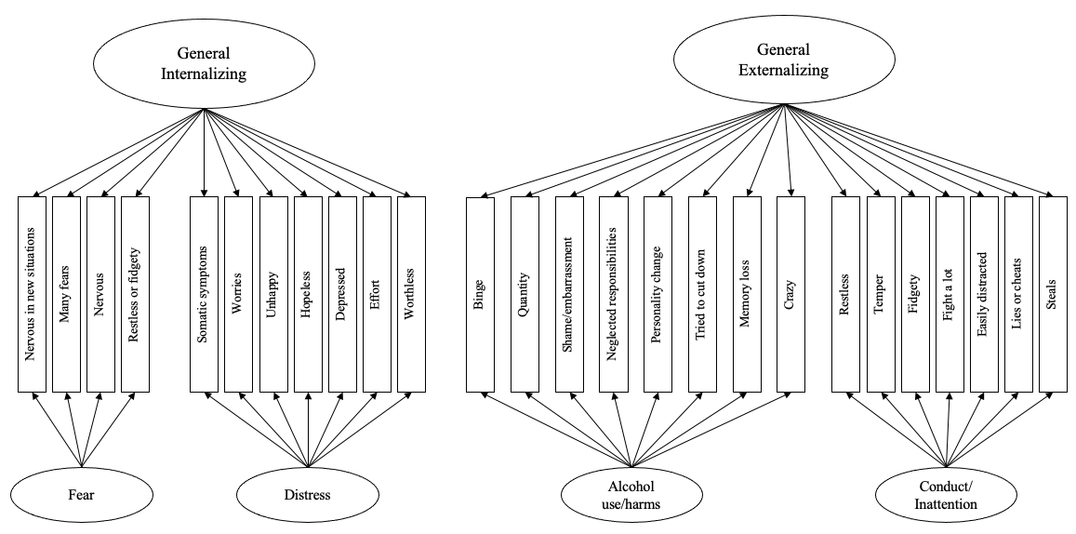

Figure S2. Path diagrams for 2-bifactor model of adolescent psychopathology with correlated general factors

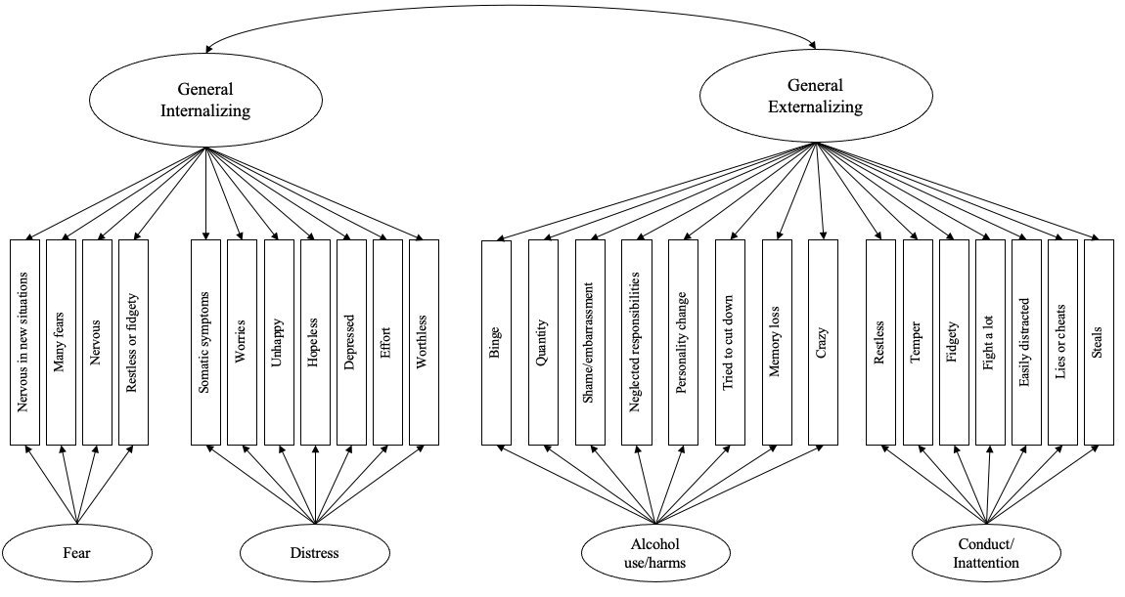

Figure S3. Path diagrams for 2-higher-order model of adolescent psychopathology

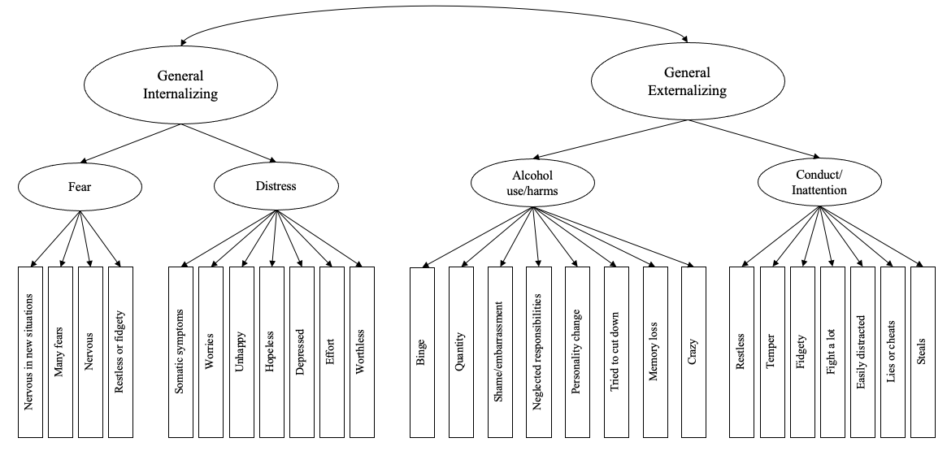

Figure S4. Path diagrams for Modified bifactor model of adolescent psychopathology with correlated specific factors

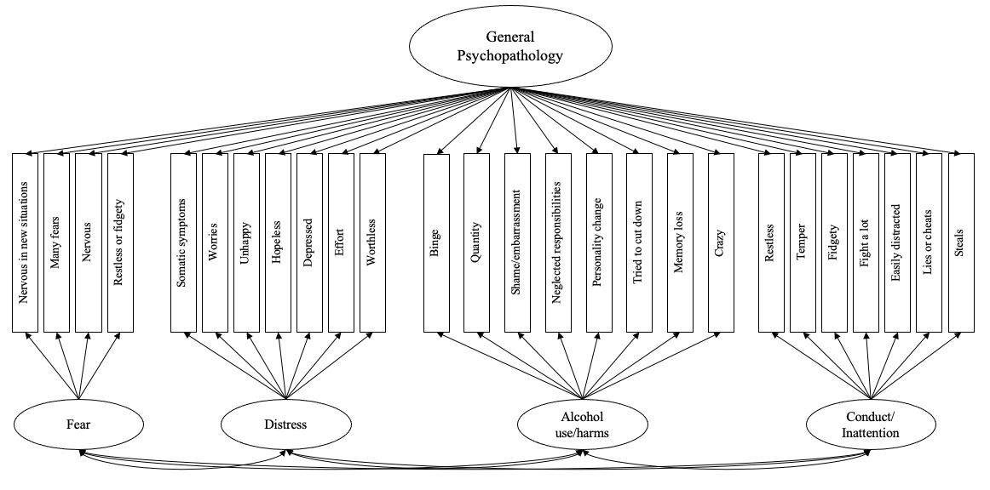

Table S9. Standardized Factor loadings on general and specific (fear, distress, alcohol use/harms, conduct/inattention) factors using WLSMV estimator and inter-factor correlations

 |  | 2-Bifactor |  |  |  | Modified 2-Bifactor (correlated general factors) |  |  |  | 2-Higher-order |  |  |  | Modified Bifactor
Symptom | Item ID | General Internalizing | General Externalizing | Specific Internalizing | Specific Externalizing | General Internalizing | General Externalizing | Specific Internalizing | Specific Externalizing | General Internalizing | General Externalizing | Specific Internalizing | Specific Externalizing | General | Specific
Fear
Nervous in new situations | SD16 | 0.654 |  | -0.267 |  | 0.662 |  | -0.193 |  |  |  | 0.669 |  | 0.538 | 0.368
Many fears | SD24 | 0.631 |  | -0.383 |  | 0.628 |  | -0.254 |  |  |  | 0.637 |  | 0.504 | 0.353
Nervous | K61R | 0.628 |  | 0.361 |  | 0.515 |  | 0.320 |  |  |  | 0.557 |  | 0.193 | 0.760
Restless or fidgety | K63R | 0.610 |  | 0.457 |  | 0.627 |  | 0.723 |  |  |  | 0.640 |  | 0.436 | 0.497
Distress
Somatic symptoms | SD3 | 0.617 |  | 0.005 |  | 0.687 |  | -0.114 |  |  |  | 0.643 |  | 0.573 | 0.266
Worries | SD8 | 0.811 |  | -0.116 |  | 0.759 |  | -0.045 |  |  |  | 0.721 |  | 0.567 | 0.415
Unhappy | SD13 | 0.783 |  | 0.183 |  | 0.847 |  | 0.099 |  |  |  | 0.842 |  | 0.690 | 0.456
Hopeless | K62R | 0.721 |  | 0.484 |  | 0.689 |  | 0.527 |  |  |  | 0.828 |  | 0.398 | 0.793
Depressed | K64R | 0.697 |  | 0.496 |  | 0.720 |  | 0.460 |  |  |  | 0.835 |  | 0.482 | 0.698
Effort | K65R | 0.567 |  | 0.305 |  | 0.583 |  | 0.289 |  |  |  | 0.642 |  | 0.393 | 0.523
Worthless | K66R | 0.706 |  | 0.634 |  | 0.711 |  | 0.627 |  |  |  | 0.881 |  | 0.451 | 0.795
Alcohol use/harms
Frequency | AUC1 |  | 0.354 |  | 0.748 |  | 0.297 |  | 0.771 |  |  |  | 0.819 | 0.254 | 0.787
Binge | AUC2 |  | 0.371 |  | 0.853 |  | 0.292 |  | 0.883 |  |  |  | 0.914 | 0.250 | 0.897
Quantity | AUC3 |  | 0.274 |  | 0.794 |  | 0.271 |  | 0.785 |  |  |  | 0.819 | 0.224 | 0.803
Acted bad | AH1 |  | 0.435 |  | 0.846 |  | 0.344 |  | 0.889 |  |  |  | 0.942 | 0.310 | 0.900
Shame/embarrassment | AH2 |  | 0.445 |  | 0.846 |  | 0.374 |  | 0.880 |  |  |  | 0.952 | 0.336 | 0.895
Neglected responsibilities | AH3 |  | 0.411 |  | 0.852 |  | 0.343 |  | 0.881 |  |  |  | 0.934 | 0.313 | 0.890
Tolerance | AH4 |  | 0.489 |  | 0.804 |  | 0.443 |  | 0.831 |  |  |  | 0.943 | 0.405 | 0.849
Personality change | AH5 |  | 0.517 |  | 0.767 |  | 0.440 |  | 0.813 |  |  |  | 0.927 | 0.394 | 0.837
Tried to cut down | AH6 |  | 0.570 |  | 0.669 |  | 0.478 |  | 0.731 |  |  |  | 0.877 | 0.433 | 0.758
Memory loss | AH7 |  | 0.535 |  | 0.652 |  | 0.442 |  | 0.712 |  |  |  | 0.844 | 0.407 | 0.735
Crazy | AH8 |  | 0.561 |  | 0.715 |  | 0.525 |  | 0.747 |  |  |  | 0.917 | 0.489 | 0.770
Conduct/inattention
Restless | SD2 |  | 0.446 |  | 0.750 |  | 0.678 |  | 0.543 |  |  |  | 0.734 | 0.747 | 0.309
Temper | SD5 |  | 0.612 |  | 0.216 |  | 0.742 |  | -0.145 |  |  |  | 0.729 | 0.705 | -0.152
Fidgety | SD10 |  | 0.500 |  | 0.717 |  | 0.730 |  | 0.486 |  |  |  | 0.794 | 0.808 | 0.303
Fight a lot | SD12 |  | 0.764 |  | 0.110 |  | 0.687 |  | -0.131 |  |  |  | 0.672 | 0.640 | -0.373
Easily distracted | SD15 |  | 0.548 |  | 0.434 |  | 0.716 |  | 0.156 |  |  |  | 0.732 | 0.731 | 0.051
Lies or cheats | SD18 |  | 0.701 |  | 0.099 |  | 0.685 |  | -0.186 |  |  |  | 0.667 | 0.635 | -0.336
Steals | SD22 |  | 0.784 |  | -0.005 |  | 0.673 |  | -0.218 |  |  |  | 0.652 | 0.602 | -0.483
First order factors
Fear |  | - | - | - | - | - | - | - | - | 0.942 |  | - | - | - | -
Distress |  | - | - | - | - | - | - | - | - | 0.947 |  | - | - | - | -
Alcohol Use |  | - | - | - | - | - | - | - | - |  | 0.432 | - | - | - | -
Conduct/inattention |  | - | - | - | - | - | - | - | - |  | 0.998 | - | - | - | -
Inter-factor correlations
Externalizing with Internalizing |  | 0.000 | - | - | - | 0.698 | - | - | - | 0.672 | - | - | - | - | -
Internalizing with Fear |  | 0.000 | - | - | - | 0.000 | - | - | - | 0.942 | - | - | - | - | -
Internalizing with Distress |  | 0.000 | - | - | - | 0.000 | - | - | - | 0.947 | - | - | - | - | -
Internalizing with Alcohol Use |  | 0.000 | - | - | - | 0.000 | - | - | - | 0.291 | - | - | - | - | -
Internalizing with Conduct/Inattention |  | 0.000 | - | - | - | 0.000 | - | - | - | 0.671 | - | - | - | - | -
Externalizing with Alcohol Use |  | - | 0.000 | - | - | - | 0.000 | - | - | - | 0.432 | - | - | - | -
Externalizing with Conduct/Inattention |  | - | 0.000 | - | - | - | 0.000 | - | - | - | 0.998 | - | - | - | -
Externalizing with Fear |  | - | 0.000 | - | - | - | 0.000 | - | - | - | 0.634 | - | - | - | -
Externalizing with Distress |  | - | 0.000 | - | - | - | 0.000 | - | - | - | 0.637 | - | - | - | -
Fear with Distress |  | - | - | 0.000 | - | - | - | 0.000 | - | - | - | 0.892 | - | 0.000 | 0.765
Fear with Alcohol Use |  | - | - | 0.000 | - | - | - | 0.000 | - | - | - | 0.274 | - | 0.000 | -0.111
Fear with Conduct/Inattention |  | - | - | 0.000 | - | - | - | 0.000 | - | - | - | 0.633 | - | 0.000 | 0.207
Alcohol use with Conduct/Inattention |  | - | - | - | 0.000 | - | - | - | 0.000 | - | - | - | 0.635 | 0.000 | -0.327
Alcohol use with Distress |  | - | - | - | 0.000 | - | - | - | 0.000 | - | - | - | 0.275 | 0.000 | 0.085
Conduct/inattention with Distress |  | - | - | - | 0.000 | - | - | - | 0.000 | - | - | - | 0.431 | 0.000 | -0.075
SD = SDQ, items from Strengths and Difficulties Questionnaire; AH = Alcohol Harms, items from Rutgers Alcohol Problem Index (RAPI); K6 = Kessler 6 Plus scale (K6+); AUC = Alcohol use, AUDIT-C items; WLSMV = weighted least square mean and variance adjusted. Factor loadings and correlations with a p value ≤ 0.05 are shown in bold.

Table S10. Reliability indices for additional structural models of psychopathology

Index | Factor | 2-Bifactor | 2-Bifactor  (correlated general factors) | 2-Higher-Order | Modified Bifactor  (correlated specific factors)
H | General Psychopathology | - | - | - | 0.93
 | General Internalizing | 0.91 | 0.91 | 0.92 | -
 | General Externalizing | 0.90 | 0.90 | 0.90 | -
 | Fear | 0.40 | 0.57 | 0.16 | 0.67
 | Distress | 0.59 | 0.59 | 0.32 | 0.84
 | Alcohol use | 0.95 | 0.96 | 0.96 | 0.97
 | Conduct/inattention | 0.73 | 0.47 | 0.01 | 0.45
Omega | General Psychopathology | - | - | - | 0.97
 | General Internalizing | 0.93 | 0.93 | 0.92 | -
 | General Externalizing | 0.97 | 0.97 | 0.97 | -
OmegaS | Fear | 0.78 | 0.78 | 0.72 | 0.76
 | Distress | 0.92 | 0.92 | 0.91 | 0.91
 | Alcohol use | 0.98 | 0.98 | 0.98 | 0.98
 | Conduct/inattention | 0.90 | 0.89 | 0.88 | 0.89
OmegaH | General Psychopathology | - | - | - | 0.63
 | General Internalizing | 0.87 | 0.87 | 0.86 | -
 | General Externalizing | 0.51 | 0.50 | 0.50 | -
OmegaHS | Fear | 0.00 | 0.04 | 0.08 | 0.44
 | Distress | 0.13 | 0.11 | 0.09 | 0.51
 | Alcohol use | 0.73 | 0.80 | 0.80 | 0.83
 | Conduct/inattention | 0.20 | 0.01 | 0.00 | 0.02
ECV_NEW | General Psychopathology | - | - | - | 0.39
 | General Internalizing | 0.76 | 0.75 | 0.89 | -
 | General Externalizing | 0.39 | 0.39 | 0.42 | -
ECV_S_NEW | Fear | 0.26 | 0.33 | 0.11 | 0.59
 | Distress | 0.23 | 0.22 | 0.10 | 0.57
 | Alcohol use | 0.74 | 0.81 | 0.81 | 0.85
 | Conduct/inattention | 0.32 | 0.16 | 0.00 | 0.17
Note. Results in bold indicate acceptable reliability. Indices for 2-higher-Order model cannot be calculated, indices presented are based on Schmid-Leiman transformed (SLT) model. ECV = Explained Common Variance, ECV_S = Explained Common Variance of specific factors, H = measure of construct replicability, Omega = internal reliability of general factor/s, OmegaS = internal reliability of specific factor/s, OmegaH = Omega Hierarchical, OmegaHS = Omega Hierarchical subscale, PUC = Percent of Uncontaminated Correlations, SLT = Schmid-Leiman transformation

