Supplementary Materials

Table of contents

Section 1: Childhood sexual abuse questions | 2
Section 2: Sample size available for analysis | 3
Section 3: Unadjusted prevalence | 4
Section 4: Supplementary Analyses
4.1 Effects of creating binary cut-offs for continuous variables | 6
4.2 Childhood sexual abuse-related outcomes at each assessment age | 8

Section 1: Childhood sexual abuse questions
Table S1 shows the wording of questions about types of contact sexual abuse asked when study members were 26. Study members could skip any questions they did not want to answer, or skip the section on unwanted childhood experiences entirely.

Table S1
Questions about types of contact childhood sexual abuse

Type of abuse | Question wording
 | Before you turned 16, did someone … when you didn’t want them to?
Genital touching | Touch your genitals
 | Get you to touch their genitals
Forced intercourse | Have anal intercourse with you [asked of males only]
 | Make you have sex with them/have sexual intercourse with you
Attempted intercourse | Try to have intercourse with you, but did not succeed

Section 2: Sample size available for analysis
Table S2 summarises the sample size available for analysis with each outcome.
Table S2
Sample size available for analysis

Outcomes | N¹
Physical
Health risk behaviours | 929
High systemic inflammation | 871
Metabolic syndrome | 904
Low lung function | 922
Poor oral health | 916
Mental
Externalising disorder | 929
Internalising disorder | 928
Thought disorder | 928
Suicide attempt | 937
Sexual
Sexual difficulties | 740²
Risky sex | 919
Sexually transmitted disease | 928
Interpersonal
High conflict relationship | 892
Not in a relationship | 928
Parenting difficulties | 669³
Economic
No formal qualifications | 891
Low socioeconomic status | 915
High benefit use | 897
Financial difficulties | 910
Antisocial
High delinquency | 928
Any criminal conviction | 926
Problems in ≥ 4 domains | 929
Notes. ¹Includes those who had data for childhood sexual abuse and the outcome of interest. For outcomes repeatedly assessed across multiple phases, participants were included in analyses if they had data for that specific outcome at two or more time points. ²Lower sample size for sexual difficulties is due to the lower number of study members who were eligible for the sexual difficulties questions at age 45 years (had sex in the past 12 months). ³Lower sample size for the parenting variable is because only those who were parents could be assessed.
Section 3: Unadjusted prevalence
To show the relative distributions of cumulative multi-domain problems by childhood sexual abuse exposure, Figure S1 displays the number of domains in which participants had at least one problem across adulthood. Those who reported childhood sexual abuse had problems in more domains. Note that our primary domain-level analyses focused on the percentage of participants in each group who had at least one problem in four or more domains.
problems in 4 or more domains
Figure S1. Number of domains (out of six) in which those who reported any versus no childhood sexual abuse had at least one problem across adulthood. Unadjusted prevalence is shown.

Table S3
Unadjusted prevalence of problems across adulthood by different definitions of childhood sexual abuse exposure

 | No childhood sexual abuse |  | Any childhood sexual abuse |  | Forced or attempted intercourse |  | Forced intercourse
 | N | % (95% CI) | N | % (95% CI) | N | % (95% CI) | N | % (95% CI)
Physical
Health risk behaviours | 749 | 46 (42, 49) | 180 | 61 (54, 68) | 99 | 66 (56, 75) | 57 | 72 (60, 84)
High systemic inflammation | 704 | 17 (14, 19) | 167 | 28 (21, 35) | 94 | 32 (22, 41) | 53 | 40 (26, 53)
Metabolic syndrome | 728 | 13 (10, 15) | 176 | 15 (10, 21) | 97 | 20 (12, 27) | 55 | 20 (9, 31)
Low lung function | 744 | 34 (30, 37) | 178 | 40 (33, 48) | 97 | 40 (30, 50) | 56 | 38 (25, 50)
Poor oral health | 736 | 29 (25, 32) | 180 | 42 (35, 49) | 99 | 47 (38, 57) | 57 | 49 (36, 62)
Mental
Externalising disorder | 749 | 26 (23, 30) | 180 | 37 (30, 44) | 99 | 40 (31, 50) | 57 | 46 (33, 59)
Internalising disorder | 748 | 30 (26, 33) | 180 | 51 (43, 58) | 99 | 57 (47, 66) | 57 | 63 (51, 76)
Thought disorder | 748 | 4 (3, 6) | 180 | 12 (7, 16) | 99 | 12 (6, 19) | 57 | 12 (4, 21)
Suicide attempt | 756 | 9 (7, 11) | 181 | 28 (21, 34) | 99 | 36 (27, 46) | 57 | 49 (36, 62)
Sexual
Sexual difficulties | 610 | 28 (24, 31) | 130 | 28 (21, 36) | 76 | 30 (20, 41) | 40 | 25 (12, 38)
Risky sex | 742 | 13 (11, 15) | 177 | 11 (7, 16) | 97 | 10 (4, 16) | 56 | 13 (4, 21)
Sexually transmitted disease | 748 | 20 (17, 23) | 180 | 32 (25, 38) | 99 | 33 (24, 43) | 57 | 32 (19, 44)
Interpersonal
High conflict relationship | 722 | 31 (28, 35) | 170 | 45 (37, 52) | 93 | 49 (39, 60) | 52 | 54 (40, 67)
Not in a relationship | 748 | 11 (9, 13) | 180 | 13 (8, 18) | 99 | 12 (6, 19) | 57 | 14 (5, 23)
Parenting difficulties | 539 | 35 (30, 39) | 130 | 28 (21, 36) | 70 | 33 (22, 44) | 38 | 39 (24, 55)
Economic
No formal qualifications | 720 | 12 (9, 14) | 171 | 17 (11, 23) | 93 | 17 (10, 25) | 52 | 23 (12, 35)
Low socioeconomic status | 741 | 18 (15, 21) | 174 | 21 (15, 27) | 96 | 25 (16, 34) | 54 | 26 (14, 38)
High benefit use | 724 | 25 (22, 28) | 173 | 40 (33, 47) | 96 | 43 (33, 53) | 54 | 48 (35, 61)
Financial difficulties | 736 | 25 (22, 28) | 174 | 37 (30, 45) | 96 | 43 (33, 53) | 54 | 48 (35, 61)
Antisocial
High delinquency | 748 | 23 (20, 26) | 180 | 37 (30, 44) | 99 | 42 (33, 52) | 57 | 47 (34, 60)
Any criminal conviction | 746 | 28 (25, 31) | 180 | 28 (21, 34) | 98 | 29 (20, 38) | 56 | 32 (20, 44)
Multi-domain
s
Problems in ≥ 4 domains | 749 | 40 (37, 44) | 180 | 57 (49, 64) | 99 | 63 (53, 72) | 57 | 67 (54, 79)
Note. Sample sizes do not always add to the total due to missing data for some variables.

Section 4: Supplementary Analyses

4.1 Effects of creating binary cut-offs for continuous variables

For the purposes of this omnibus study, we used binary cut-offs for each outcome to simplify the analyses and allow straightforward comparisons between different indicators. While many of the outcomes were established binary indicators (e.g., diagnosis of metabolic syndrome; mental health diagnosis), some are more often treated as continuous rather than categorical variables. Given that creating cut-offs for continuous variables can lose information about the relationships between two variables of interest, we conducted linear multiple regression analyses to further understand the relationships at age 45 between CSA and 11 continuous variables, after adjusting for all control variables (Table S4).
Consistent with our primary analyses, CSA was significantly associated with lower socioeconomic status, greater benefit use, more financial difficulties, and higher self-reported delinquency, and not significantly associated with positive parenting scores. In contrast to our primary analyses, the associations between CSA and oral health (caries) and relationship conflict were not statistically significant. However, CSA was significantly associated with higher levels of systemic inflammation, lower lung function, and lower socioeconomic status, indicating that those nonsignificant effects in the primary analyses may have been due to the lower power associated with binary measures, or because the supplementary linear analyses focused on age 45 and there were greater CSA-related differences in inflammation and socioeconomic status at age 45 than at earlier ages (see Figure S2).

Table S4
Linear comparisons for continuous outcomes: Group differences at age 45 by childhood sexual abuse exposure
 | Any CSA | No CSA | Adjusted group difference
Outcomes | M (SD) | M (SD) | Β (95% CI)
Physical
Systemic inflammation: high-sensitivity C-reactive protein  mg/L (higher is worse) | 3.91 (8.46) | 2.45 (4.85) | 1.17*¹  (1.03, 1.33)
Systemic inflammation: fibrinogen  g/L (higher is worse) | 3.17 (0.75) | 2.94 (0.66) | 1.05*¹  (1.01, 1.09)
Systemic inflammation: white blood cells  x10⁹/L (higher is worse) | 8.36 (1.99) | 7.55 (1.77) | 1.07**¹  (1.03, 1.12)
Lung function  % of age-predicted FEV₁ (lower is worse) | 94.46 (12.34) | 97.22 (12.93) | -2.39*  (-4.74, -0.04)
Oral health (cavities)  % tooth surfaces with decay (higher is worse) | 23.51 (23.86) | 18.05 (17.19) | 1.14¹  (0.96, 1.36)
Interpersonal
Relationship conflict  Score 0-48 (higher is worse) | 3.39 (5.66) | 2.54 (4.18) | 1.14¹  (0.96, 1.36)
Positive parenting  Score -3.7-20 (lower is worse) | 10.99 (4.65) | 10.58 (4.88) | 0.50  (-0.47, 1.47)
Economic
Socioeconomic status  Score 1-6 (lower is worse) | 3.49 (1.51) | 3.87 (1.42) | -0.33**  (-0.57, -.09)
Benefit days  Number of benefit days from age 38 to 46 | 344.51 (814.28) | 115.78 (434.92) | 1.74**¹  (1.17, 2.59)
Financial difficulties score  Z-score (higher is worse) | 0.16 (1.02) | -0.06 (0.81) | 1.12*¹  (1.00, 1.25)
Antisocial
Self-reported delinquency  Score 1-48 (higher is worse) | 1.37 (2.48) | 0.97 (1.50) | 1.17**¹  (1.06, 1.29)
Notes. Regression coefficients and 95% confidence intervals indicate group differences between those who reported any versus no childhood sexual abuse, after adjusting for all control variables (sex, childhood socioeconomic status, child harm adverse childhood experiences, household dysfunction adverse childhood experiences, and sexual assault in adulthood). For consistency with the primary analyses, these analyses excluded those with data for the outcome of interest at fewer than two phases between 26 and 45y (relevant to the repeated measures only, not positive parenting). ¹Regression conducted with log-transformed data to improve normality of the distribution; reported coefficients and confidence intervals are exponentiated. Bolded coefficients were statistically significant. †p < .06, *p < .05, **p < .01, ***p < .001

4.2 Childhood sexual abuse-related outcomes at each assessment age
To assess whether the observed relationships between CSA and problems across adulthood were evident at each of the four assessment points (ages 26, 32, 38, and 45), we calculated the prevalence of each problem at each age for those who reported any versus no CSA. As shown in Figure S2, after adjusting for all control variables in Poisson regressions with robust standard errors, the problems that were significantly more common among those who reported CSA in the primary cross-adulthood analyses also tended to be more common at individual assessment phases. However, the differences between groups varied in magnitude across the four assessment points and were not always statistically significant. For some problems, the largest differences were evident earlier in adulthood (health risk behaviours, externalising disorder, internalising disorder, thought disorder, financial difficulties, and high delinquency), while for others, the largest differences occurred later (poor oral health, low socioeconomic status, and high benefit use). Note that the cumulative variables (ever attempted suicide, parenting, lack of formal qualifications, and criminal convictions), which by definition were only available at one assessment point, are not shown here.

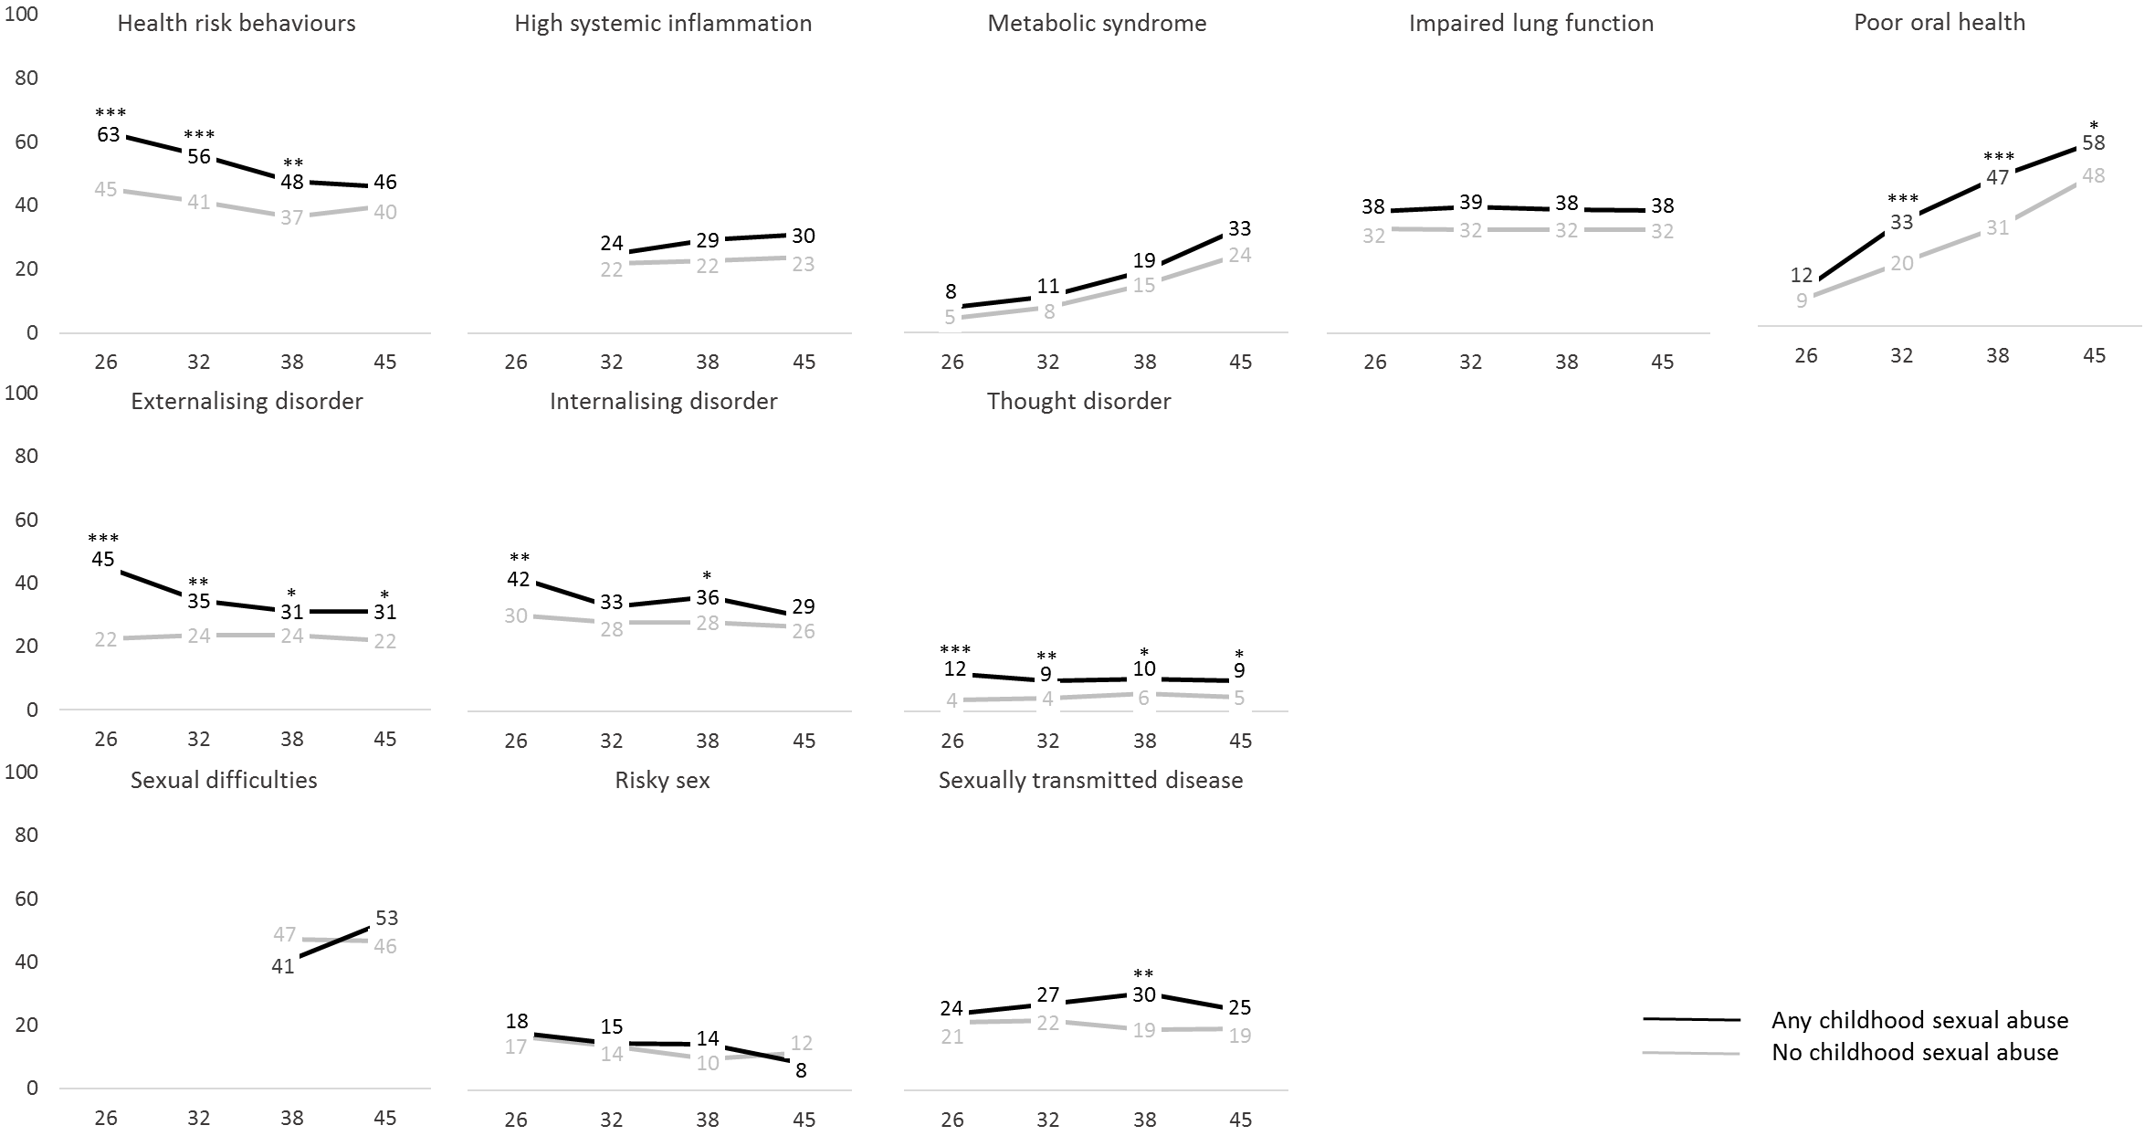
Physical

Mental
Sexual

Figure S2. Estimated prevalence (adjusted for all control variables: childhood socioeconomic status, adverse childhood experiences, and sexual assault in adulthood) of each problem at each assessment point (26, 32, 38, 45) for those who reported childhood sexual abuse compared with those who did not. Asterisks indicate statistical significance: *p < .05, **p < .01, ***p < .001. For consistency with the primary analyses, these analyses excluded those with data for the outcome of interest at fewer than two phases between 26 and 45y.

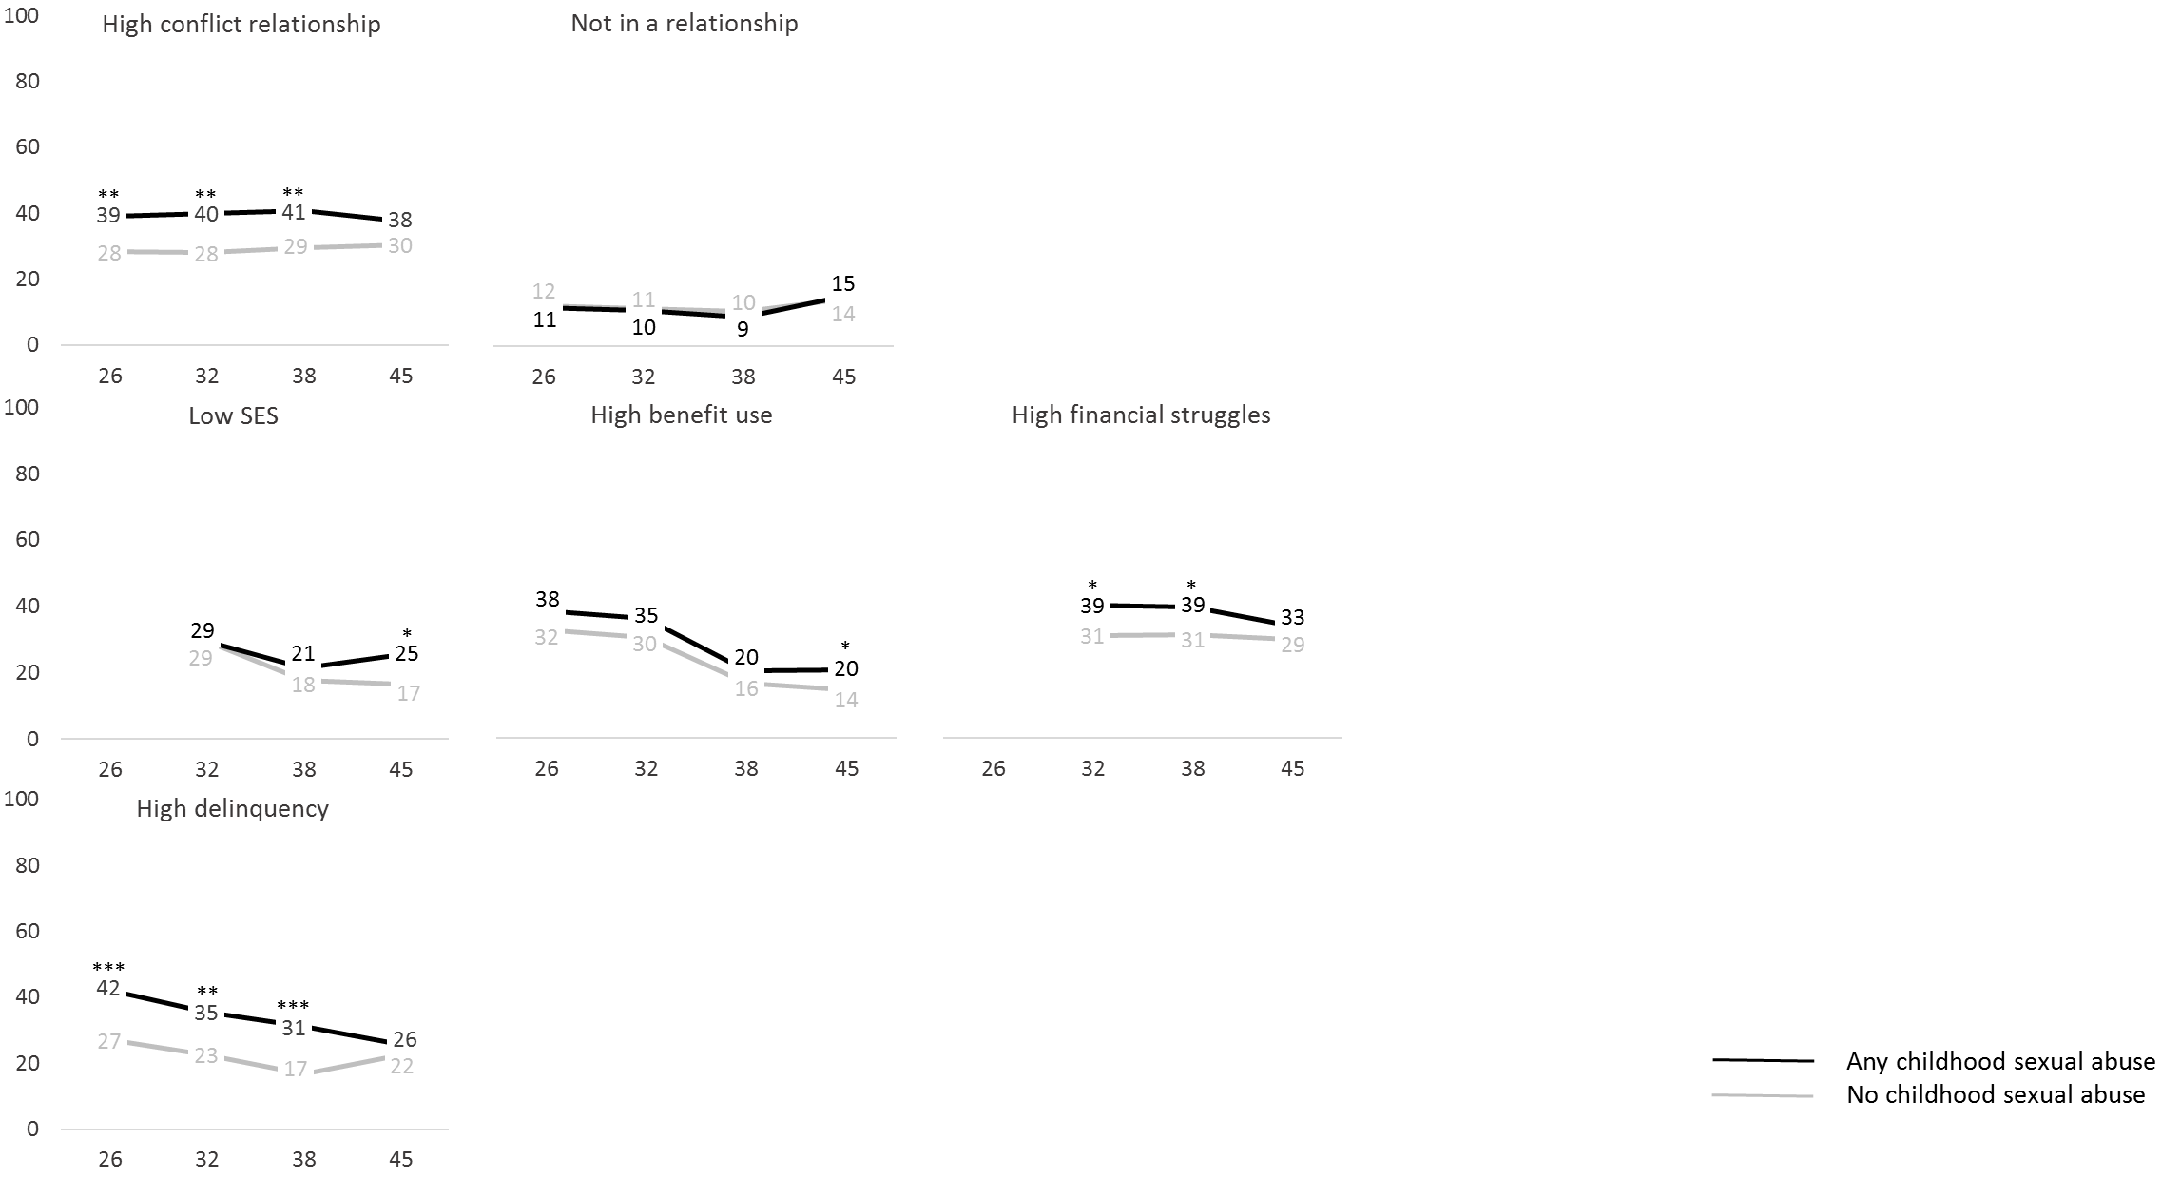
Interpersonal
Economic

Antisocial

Figure S2 cont. Estimated prevalence (adjusted for all control variables: childhood socioeconomic status, adverse childhood experiences, and sexual assault in adulthood) of each problem at each assessment point (age 26, 32, 38 and 45) for those who reported forced intercourse compared with all other participants. Asterisks indicate statistical significance: *p < .05, **p < .01, ***p < .001. For consistency with the primary analyses, these analyses excluded those with data for the outcome of interest at fewer than two phases between 26 and 45y.

