Understanding the prospective associations between neuro-developmental problems, bullying victimization, and mental health: Lessons from a longitudinal study of institutional deprivation

Supplementary file

Table 1. Completely standardized regression coefficients (both significant and nonsignificant)
Table 2. Completely standardized regression coefficients with model controlling for age 6 IQ on young adult outcomes
Figure 1. Path analysis model estimated using the Romanian sample only (n = 165)

Table 1. completely standardized regression coefficients (both significant and nonsignificant)
 | Outcome
 | Age 6
Predictor Variable | bullied | DSE | ADHD | ASD
Deprivation group | 0.22* | 0.38* | 0.32* | 0.27*
 | Age 11
Predictor Variable | bullied | DSE | ADHD | ASD
Bullied age 6 | 0.08 | -0.08 | 0.04 | -0.07
DSE age 6 | -0.06 | 0.38* | 0.23* | -0.07
ADHD age 6 | 0.36* | 0.16 | 0.41* | 0.33*
ASD age 6 | 0.02 | 0.04 | 0.13 | 0.43*
Deprivation group | 0.07 | 0.34* | -0.02 | 0.23*
 | Age 15
Predictor Variable | bullied | DSE | ADHD | ASD
Bullied age 11 | 0.37* | 0.13 | 0.12 | 0.00
DSE age 11 | 0.04 | 0.48* | 0.30* | 0.01
ADHD age 11 | 0.06 | 0.07 | 0.41* | 0.03
ASD age 11 | 0.22* | 0.12* | 0.05 | 0.71*
Deprivation group | 0.06 | 0.14 | 0.01 | 0.08
 | Age 22-25
Predictor Variable | Internalizing z-score |  | Functional outcome
Bullied age 15 | 0.39* |  | 0.13
DSE age 15 | 0.00 |  | 0.20
ADHD age 15 | 0.21 |  | 0.17
ASD age 15 | -0.07 |  | 0.23*
Deprivation group | 0.11 |  | 0.02
Note. * significant at p < .05
DSE Disinhibited social engagement symptoms; ASD autism spectrum disorder symptoms (social communications questionnaire); ADHD symptoms.

Table 2. Completely standardized regression coefficients with model controlling for age 6 IQ on young adult outcomes
 | Outcome
 | Age 6
Predictor Variable | bullied | DSE | ADHD | ASD | IQ age 6
Deprivation group | 0.22* | 0.38* | 0.32* | 0.27* | -0.49
 | Age 11
Predictor Variable | bullied | DSE | ADHD | ASD | -
Bullied age 6 | 0.08 | -0.08 | 0.04 | -0.07 | -
DSE age 6 | -0.06 | 0.38* | 0.23* | -0.07 | -
ADHD age 6 | 0.36* | 0.16 | 0.41* | 0.33* | -
ASD age 6 | 0.02 | 0.04 | 0.13 | 0.43* | -
Deprivation group | 0.07 | 0.34* | -0.02 | 0.23* | -
 | Age 15
Predictor Variable | bullied | DSE | ADHD | ASD | -
Bullied age 11 | 0.37* | 0.13 | 0.12 | 0.00 | -
DSE age 11 | 0.04 | 0.48* | 0.30* | 0.01 | -
ADHD age 11 | 0.06 | 0.07 | 0.41* | 0.03 | -
ASD age 11 | 0.22* | 0.12* | 0.05 | 0.71* | -
Deprivation group | 0.06 | 0.14 | 0.01 | 0.08 | -
 | Age 22-25
Predictor Variable | Internalizing z-score |  | Functional outcome |  | -
Bullied age 15 | 0.39* |  | 0.13 |  | -
DSE age 15 | 0.00 |  | 0.20 |  | -
ADHD age 15 | 0.21 |  | 0.17 |  | -
ASD age 15 | -0.07 |  | 0.23* |  | -
Deprivation group | 0.03 |  | -0.11 |  | -
IQ age 6 | -0.16 |  | -0.26* |  | -
Note. * significant at p < .05
DSE Disinhibited social engagement symptoms; ASD autism spectrum disorder symptoms
(social communications questionnaire); ADHD symptoms.
Model fit indices: CFI = 0.91, TLI = 0.79, RMSEA = 0.11, SRMR = 0.11.
IQ at age 6 was measured using McCarthy Scales of Children’s Abilities General Cognitive Index (1972)

Reference

McCarthy, D. (1972). McCarthy scales of children's abilities (MSCA). Psychological Corporation.

Figure 1. Path analysis model estimated using the Romanian sample only (n = 165)
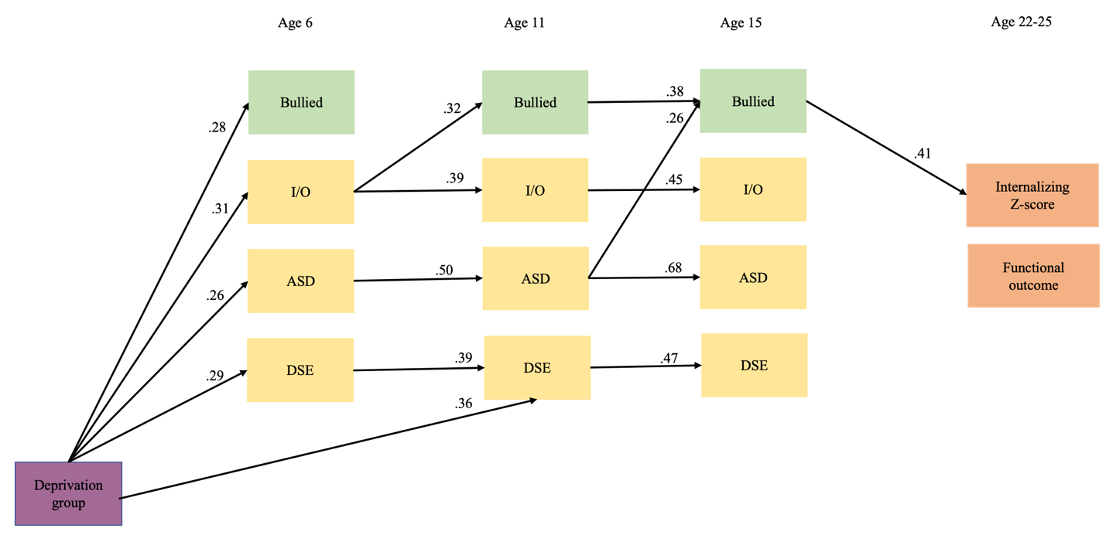

Note. Only significant paths are shown in the model. Contemporaneous associations, cross-lagged associations among NDCs, and the association between the endogenous variables are not included in the visual to reduce clutter.
DSE Disinhibited social engagement symptoms; ASD autism spectrum disorder symptoms
(social communications questionnaire); ADHD symptoms.

