Online Appendix A
Analytical path diagram of the conditional growth mixture model

PDS1
Xs
S

I
PDS3
PDS2
*
1
1
1
1
1

2
1
1
1
1
1

1
1
1
1
1
1

1
1
1
1
1
1

1
1
1
1
1
1

1
1
1
1
1
1

DV1
SE1
DP1
DV3
DV2
SE3
SE2
DP3
DP2

C

Note. PDS = Pubertal Developmental Scale. SE = self-esteem. DP = depressive symptoms. DV = deviant behavior. I = intercept. S = slope. C = latent class variable. Xs = sociodemographic factors and stressful life events. Solid arrows between Xs and C and between Xs and psychosocial variables represent statistical control for C and all psychosocial variables. The dotted arrow connecting C and psychosocial variables denotes that C moderates all cross-lagged paths in the psychosocial variables box.

Online Appendix B
Summary of descriptive statistics of contextual variables

Urbanization level of living area | n (%)
Aging township | 130 (9.5)
General township | 180 (13.2)
Small city | 397 (29)
Metropolis | 661 (48.3)
Father’s level of education
Uneducated | 4 (0.3)
Elementary school | 181 (13.2)
Junior high school | 347 (25.4)
Senior or vocational high school | 238 (17.4)
College | 425 (31.1)
Graduate school | 49 (3.6)
Mother’s level of education
Uneducated | 16 (1.2)
Elementary school | 215 (15.7)
Junior high school | 354 (25.9)
Senior or vocational high school | 456 (33.3)
College | 186 (13.6)
Graduate school | 17 (1.2)
Monthly household income (in New Taiwan Dollar)
< 30,000 (ca. US$965) | 228 (16.7)
30,000-49,999 (ca. US$966-US$1,610) | 262 (19.2)
50,000-69,999 (ca. US$1,611-US$2,250) | 363 (26.5)
70,000-99,999 (ca. US$2,251-US$3,220) | 212 (15.5)
100,000-149,999 (ca. US$3,221-US$4,830) | 127 (9.3)
> 150,000 (ca. US$4,831) | 49 (3.6)
Stressful life events
My parents were divorced or separated | 130 (9.5)
My parents ran out of money | 133 (9.7)
My parents were fighting each other | 122 (8.9)
My father or mother spent less and less time at home | 272 (19.9)
My father or mother was unemployed | 42 (3.1)
I fought with my parents more frequently | 93 (6.8)
I grieved over the passing of close relative(s) | 167 (12.2)
I broke up with my good friends | 330 (24.1)
I ranked lower in my academic performances | 690 (50.4)
I did not get along well with classmates | 355 (26)
I transferred to another school | 63 (4.6)
I got into trouble at school | 97 (7.1)
I was excluded from being part in school activities | 136 (9.9)
I started to wear glasses or braces | 423 (30.9)
I was seriously ill or injured | 127 (9.3)
I started to smoke, drink, or use drugs | 50 (3.7)
I grieved over the loss of my pet(s) | 125 (9.1)
Note. Cell entries are n (%). Variables were reported in W1.

Appendix C
Summary of odds ratio for the association between pubertal tempo class and sociodemographic backgrounds and stressful life events in 7th grade
Variables | Class 1 |  |  |  | Class 2
 | OR | SE | 95% CI |  | OR | SE | 95% CI
Sociodemographic background
Urbanization level of living area | 1.00 | 0.08 | [0.85, 1.17] |  | 1.05 | 0.13 | [0.81, 1.35]
Father’s education level | 0.86 | 0.09 | [0.72, 1.03] |  | 1.06 | 0.14 | [0.81, 1.39]
Mother’s education level | 1.17 | 0.13 | [0.91, 1.51] |  | 1.00 | 0.15 | [0.75, 1.34]
Monthly household income | 1.01 | 0.06 | [0.90, 1.14] |  | 0.86 | 0.08 | [0.74, 1.01]
Stressful life events
My parents were divorced or separated | 0.67 | 0.23 | [0.43, 1.05] |  | 1.18 | 0.46 | [0.48, 2.91]
My parents ran out of money | 0.94 | 0.28 | [0.54, 1.63] |  | 0.58 | 0.28 | [0.34, 1.00]
My parents were fighting each other | 0.97 | 0.33 | [0.51, 1.85] |  | 1.59 | 0.65 | [0.44, 5.68]
My father or mother spent less and less time at home | 0.96 | 0.21 | [0.64, 1.45] |  | 1.01 | 0.31 | [0.55, 1.85]
My father or mother were unemployed | 2.16 | 1.13 | [0.24, >15.00] |  | 0.30* | 0.31 | [0.16, 0.55]
I fight with my parents more frequently | 0.34** | 0.14 | [0.26, 0.45] |  | 0.28** | 0.20 | [0.19, 0.41]
I grieved over the passing of close relative(s) | 1.08 | 0.28 | [0.62, 1.87] |  | 0.83 | 0.32 | [0.44, 1.55]
I broke up with my good friends | 1.09 | 0.22 | [0.71, 1.68] |  | 0.46** | 0.15 | [0.34, 0.62]
I ranked lower in my academic performances | 0.75* | 0.13 | [0.58, 0.97] |  | 1.11 | 0.26 | [0.67, 1.85]
I did not get along well with classmates | 1.23 | 0.25 | [0.75, 2.01] |  | 1.81 | 0.47 | [0.72, 4.55]
I transferred to another school | 1.43 | 0.59 | [0.45, 4.55] |  | 0.15** | 0.16 | [0.11, 0.21]
I got into trouble at school | 0.52* | 0.22 | [0.34, 0.80] |  | 1.55 | 0.75 | [0.36, 6.74]
I was excluded from being part in school activities | 1.50 | 0.41 | [0.67, 3.35] |  | 1.38 | 0.54 | [0.48, 3.98]
I started to wear glasses or braces | 0.82 | 0.15 | [0.61, 1.10] |  | 0.77 | 0.20 | [0.52, 1.14]
I was seriously ill or injured | 1.31 | 0.40 | [0.60, 2.87] |  | 1.85 | 0.66 | [0.51, 6.74]
I started to smoke, drink, or use drugs | 0.37* | 0.27 | [0.22, 0.63] |  | 1.79 | 0.90 | [0.31, 10.45]
I grieved over the loss of my pet(s) | 1.24 | 0.38 | [0.59, 2.61] |  | 1.02 | 0.46 | [0.41, 2.51]
Note. Class 1 = late-onset with rapid catch-up. Class 2 = late-onset with slow catch-up. Reference group: Class 3 (average pubertal growth). OR = odds ratio.
* p< .05 ** p< .01

Online Appendix D

Estimated marginal mean of self-esteem, depressive symptoms, and deviant behavior, by class of pubertal tempo

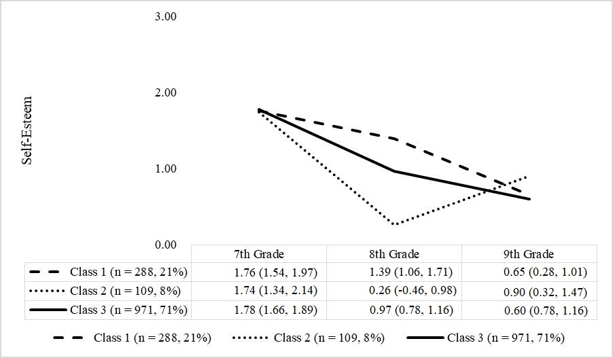
(A) Self-esteem

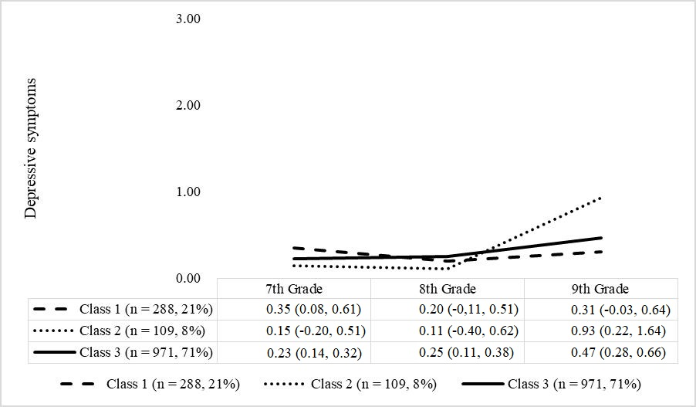
(B) Depressive symptoms

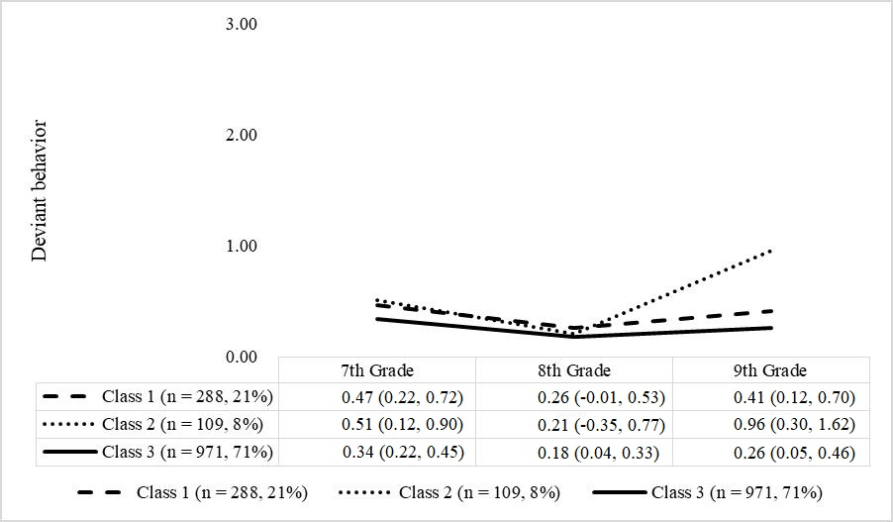
(C) Deviant behavior

Note. Class 1 = late-onset with rapid catch-up. Class 2 = late-onset with slow catch-up. Class 3 = average pubertal growth. Cell entries are mean (95% confidence interval).
Online Appendix E

Summary of path coefficients of psychosocial variables on contextual variables

Contextual factors (W1) | Psychosocial variables
 | SE-9th | DP-9th | DV-9th | SE-8th | DP-8th | DV-8th | SE-7th | DP-7th | DV-7th
Class 1: late onset with rapid catch-up
Urbanization level of living area | 0.03 | 0.02 | -0.03 | 0.03 | -0.02 | -0.02 | -0.03 | -0.02 | 0.02
Father’s education level | 0.04 | -0.08* | -0.01 | -0.01 | 0.03 | 0.004 | -0.06 | 0.06 | 0.02
Mother’s education level | 0.02 | 0.05 | -0.003 | -0.04 | -0.02 | -0.04 | 0.11** | -0.07 | -0.12*
Monthly household income | -0.02 | 0.003 | -0.01 | 0.05* | -0.001 | 0.01 | -0.03 | 0.01 | -0.01
Stressful life events
My parents were divorced or separated | -0.06 | 0.05 | -0.02 | -0.01 | 0.09 | -0.02 | -0.13 | -0.17* | 0.24
My parents ran out of money | -0.23* | -0.12* | -0.17 | 0.06 | 0.05 | 0.01 | -0.11 | -0.10 | -0.21
My parents were fighting each other | 0.09 | -0.18 | -0.09 | 0.03 | 0.06 | 0.09 | 0.16 | -0.02 | 0.11
My father or mother spent less and less time at home | 0.004 | 0.05 | 0.004 | 0.03 | 0.11 | 0.04 | 0.24* | 0.01 | -0.09
My father or mother were unemployed | 0.11 | 0.44 | 0.24 | 0.29 | -0.55* | 0.04 | -0.32 | 0.42 | 0.51
I fight with my parents more frequently | -0.31* | -0.22 | 0.03 | -0.22 | 0.21 | -0.18 | -0.15 | -0.19 | -0.19
I grieved over the passing of close relative(s) | -0.11 | 0.21** | 0.05 | 0.09 | -0.03 | 0.05 | 0.11 | -0.10 | 0.02
I broke up with my good friends | 0.05 | 0.21* | 0.04 | -0.05 | -0.04 | -0.01 | -0.06 | 0.07 | 0.06
I ranked lower in my academic performances | 0.05 | -0.10* | -0.04 | -0.11 | 0.04 | -0.04 | -0.15* | -0.02 | -0.05
I did not get along well with classmates | 0.05 | 0.06 | -0.01 | 0.04 | 0.05 | 0.02 | -0.17* | 0.24** | 0.05
I transferred to another school | -0.07 | 0.25 | 0.16 | -0.01 | 0.07 | 0.31* | 0.08 | -0.17 | 0.05
I got into trouble at school | 0.02 | -0.24 | 0.19 | 0.004 | 0.31 | 0.24 | -0.19 | -0.10 | 0.36
I was excluded from being part in school activities | -0.11 | 0.06 | 0.05 | 0.04 | -0.03 | 0.001 | 0.04 | 0.14 | 0.11
I started to wear glasses or braces | -0.04 | 0.11 | 0.002 | -0.09 | 0.06 | -0.10** | -0.07 | -0.04 | -0.001
I was seriously ill or injured | 0.03 | 0.34** | -0.09 | -0.26 | 0.08 | 0.02 | 0.12 | 0.27 | 0.12
I started to smoke, drink, or use drugs | 0.07 | -0.16 | -0.36 | -0.31 | -0.88** | 0.32 | 0.13 | 1.64** | 1.44*
I grieved over the loss of my pet(s) | 0.22* | -0.20* | -0.13 | -0.11 | 0.07 | -0.13 | -0.08 | 0.18* | 0.05
Class 2: late onset and slow catch-up
Urbanization level of living area | 0.07 | 0.09 | 0.06 | 0.16* | -0.001 | -0.03 | 0.14** | -0.03 | -0.05
Father’s education level | 0.11 | 0.03 | -0.08 | 0.08 | -0.15* | -0.07 | -0.03 | 0.25*** | 0.05
Mother’s education level | -0.12 | 0.01 | -0.13 | -0.02 | 0.14 | 0.07 | -0.03 | -0.22*** | -0.09
Monthly household income | 0.07 | 0.06 | 0.02 | -0.03 | -0.02 | 0.02 | -0.01 | -0.03 | 0.01
Stressful life events
My parents were divorced or separated | 0.04 | 0.12 | 0.56* | -0.27 | -0.21 | -0.05 | 0.38* | 0.004 | 0.33
My parents ran out of money | 0.04 | -0.36 | -0.10 | -0.31 | 0.07 | -0.15 | -0.18 | -0.08 | 0.22
My parents were fighting each other | -0.09 | 0.04 | 0.15 | 0.35 | -0.12 | 0.29 | -0.45 | 0.11 | 0.06
My father or mother spent less and less time at home | -0.12 | -0.17 | -0.13 | -0.15 | 0.27 | 0.30* | 0.12 | -0.08 | -0.26
My father or mother were unemployed | 0.58 | 0.22 | -0.50 | -0.69 | -0.08 | -1.04 | -0.99 | -1.17* | -2.29*
I fight with my parents more frequently | 0.55 | 0.14 | -0.32 | 0.17 | 0.25 | -0.19 | -0.10 | 0.51* | 0.10
I grieved over the passing of close relative(s) | 0.19 | 0.12 | 0.47 | 0.26 | -0.12 | -0.25* | 0.38 | 0.25 | 0.01
I broke up with my good friends | -0.02 | 0.003 | -0.20 | 0.17 | 0.15 | -0.20 | -0.16 | 0.02 | 0.20
I ranked lower in my academic performances | -0.12 | 0.13 | -0.01 | 0.10 | -0.10 | -0.01 | -0.24* | 0.14 | -0.03
I did not get along well with classmates | -0.06 | 0.14 | -0.28* | -0.10 | 0.05 | 0.01 | -0.27* | 0.30* | 0.11
I transferred to another school | 0.15 | 0.56 | -0.11 | -0.64 | 1.61 | -1.40 | -1.61** | -1.97** | -2.85**
I got into trouble at school | 0.17 | -0.10 | 0.22 | -0.20 | -0.27 | 0.11 | 0.03 | 0.002 | 0.46
I was excluded from being part in school activities | -0.02 | -0.18 | -0.01 | -0.04 | -0.10 | 0.06 | 0.13 | 0.30 | 0.10
I started to wear glasses or braces | 0.12 | 0.18 | -0.15 | -0.04 | 0.02 | -0.08 | 0.15 | -0.09 | -0.16
I was seriously ill or injured | 0.16 | 0.21 | 0.23 | -0.20 | 0.61*** | 0.09 | -0.57*** | 0.25 | -0.11
I started to smoke, drink, or use drugs | 0.13 | -0.43 | 0.28 | 0.47 | -0.92* | 0.66 | 0.65 | 0.59 | 1.57*
I grieved over the loss of my pet(s) | -0.27 | -0.04 | -0.27 | -0.20 | 0.10 | 0.02 | 0.45* | -0.31 | 0.13
Class 3: average pubertal growth
Urbanization level of living area | 0.01 | 0.03 | 0.01 | -0.002 | -0.003 | -0.04* | -0.004 | 0.03 | -0.01
Father’s education level | 0.01 | -0.02 | 0.003 | 0.04 | -0.01 | -0.02 | -0.01 | 0.01 | -0.06**
Mother’s education level | 0.001 | -0.001 | -0.02 | -0.01 | 0.02 | 0.01 | 0.02 | -0.03 | < 0.001
Monthly household income | 0.001 | 0.02 | 0.03* | 0.01 | 0.01 | -0.01 | 0.01 | 0.01 | 0.01
Stressful life events
My parents were divorced or separated | -0.02 | -0.11* | 0.12 | 0.03 | -0.06 | -0.003 | -0.14* | -0.14** | 0.04
My parents ran out of money | 0.06 | 0.03 | -0.01 | 0.02 | -0.02 | -0.07 | -0.07 | 0.07 | 0.01
My parents were fighting each other | -0.10 | 0.05 | -0.03 | 0.03 | -0.04 | 0.09 | -0.08 | 0.15* | -0.01
My father or mother spent less and less time at home | -0.06 | 0.06 | -0.03 | -0.12** | 0.08 | 0.04 | -0.11* | 0.08* | 0.04
My father or mother were unemployed | 0.15 | 0.14 | 0.14 | 0.15 | -0.09 | 0.02 | 0.26** | 0.14 | 0.08
I fight with my parents more frequently | -0.01 | -0.01 | -0.02 | -0.06 | 0.03 | -0.11* | -0.13 | 0.22** | 0.11
I grieved over the passing of close relative(s) | -0.01 | 0.10 | -0.02 | -0.06 | 0.03 | 0.01 | 0.01 | -0.05 | 0.07
I broke up with my good friends | -0.04 | 0.05 | 0.04 | -0.05 | 0.002 | 0.06 | -0.10* | 0.08* | 0.02
I ranked lower in my academic performances | < 0.001 | -0.04 | -0.02 | -0.02 | 0.02 | 0.01 | -0.04 | 0.04 | 0.05
I did not get along well with classmates | -0.01 | 0.08* | 0.02 | < 0.001 | 0.06 | 0.06 | -0.04 | 0.13** | -0.01
I transferred to another school | 0.03 | -0.09 | -0.15* | -0.003 | 0.04 | -0.17** | 0.05 | -0.01 | 0.21
I got into trouble at school | -0.06 | -0.06 | 0.09 | 0.08 | -0.01 | 0.32** | -0.08 | 0.32** | 0.32**
I was excluded from being part in school activities | 0.03 | 0.05 | 0.07 | -0.07 | -0.002 | -0.001 | -0.08 | -0.03 | -0.09
I started to wear glasses or braces | -0.002 | -0.01 | -0.06 | -0.01 | 0.03 | -0.04 | 0.08 | 0.01 | -0.04
I was seriously ill or injured | 0.09 | 0.05 | 0.001 | 0.02 | -0.01 | 0.01 | 0.03 | 0.08 | 0.05
I started to smoke, drink, or use drugs | -0.01 | -0.05 | 0.13 | -0.13 | -0.01 | 0.30* | -0.03 | 0.10 | 0.77***
I grieved over the loss of my pet(s) | -0.04 | 0.11 | 0.10 | 0.07 | -0.02 | -0.10* | 0.06 | 0.15 | 0.06
Note. Cell entries are regression coefficients. SE = self-esteem. DP = depressive symptoms. DV = deviant behavior. 7th = seventh-grade. 8th = eighth grade. 9th = ninth grade.
* p< .05 ** p< .01 *** p<.001

