Table S1ª. Comparison of baseline sample characteristics between analysis sample (n=974) and those without dating violence and mental health data (n=1146)
 | Analysis sample  (n=974) | Participants without dating violence and mental health data (n=1146) | p-value
Participant
Female, % | 53.2 | 45.6 | p<0.001
Caucasian ethnicity, % | 85.0 | 77.0 | p<0.001
Same sex, bisexual, or asexual, % | 9.1 | - | -
Peer victimization, M(SD) | 0.00 (0.1) | -0.00 (0.1) | 0.066
Internalizing symptoms, M(SD) | 0.00 (0.04) | -0.00 (0.04) | 0.471
Verbal IQ, M(SD) | 113.73 (13.8) | 112.67 (16.8) | 0.179
Parent
Maternal depressive symptoms, M(SD) | 1.37 (1.1) | 1.39 (1.1) | 0.607
Maternal anxiety, M(SD) | 1.33 (1.1) | 1.31 (1.2) | .068
Maternal exposure to physical or  psychological violence, % | 45.2 | 35.9 | p<0.001
Paternal depressive symptoms, M(SD) | 1.01 (1.0) | 0.99 (0.9) | 0.597
Family
Family functioning, M(SD) | 1.47 (1.0) | 1.54 (1.2) | 0.192
Socioeconomic status, M(SD) | -0.06 (0.9) | 0.06 (1.0) | 0.983
At-risk family status, % | 39.0 | 33.0 | 0.006
ª Data were compiled from the final master file of the Québec Longitudinal Study of Child
Development (1998-2015), © Gouvernement du Québec, Institut de la Statistique du Québec.

Table S2ª. Weighted correlations of dating violence and mental health with covariates
 | 1 | 2 | 3 | 4 | 5 | 6
1. Victimization 15 years
2. Victimization 17 years | 0.19*
3. Perpetration 15 years | 0.44* | 0.19*
4. Perpetration 17 years | 0.20* | 0.51* | 0.27*
5. Internalizing symptoms 15 years | 0.28* | 0.26* | 0.23* | 0.24*
6. Internalizing symptoms 17 years | 0.21* | 0.28* | 0.18* | 0.25* | 0.64*
Baseline characteristics
Sex | 0.10* | 0.15* | 0.14* | 0.15* | 0.42* | 0.38*
Ethnicity | -0.01 | -0.04 | -0.05 | 0.07* | -0.01 | -0.02
Sexuality | 0.06* | 0.04 | 0.01 | 0.10* | 0.10* | 0.13*
Peer victimization | 0.04 | 0.09* | 0.01 | 0.04 | 0.17* | 0.13*
Internalizing symptoms | 0.04 | 0.16* | 0.11* | 0.15* | 0.38* | 0.34*
Verbal IQ | 0.03 | -0.09* | -0.01 | -0.07* | 0.01 | 0.01
Maternal depressive symptoms | 0.04 | 0.10* | 0.06* | 0.13* | 0.09* | 0.11*
Maternal anxiety | 0.09* | 0.08* | 0.10* | 0.13* | 0.06* | 0.07*
Paternal depressive symptoms | 0.06* | 0.08* | 0.04 | 0.13* | 0.04 | 0.04
Maternal exposure to physical or psychological violence | 0.01 | 0.05* | 0.07* | 0.05 | 0.04 | 0.08*
Family functioning | 0.03 | 0.10* | 0.06* | 0.12* | 0.02 | 0.04
Socioeconomic status | -0.08* | -0.12* | -0.08* | -0.11* | -0.05* | -0.10*
At-risk family status | -0.00 | 0.02 | 0.02 | 0.04 | 0.04 | 0.03
ª Data were compiled from the final master file of the Québec Longitudinal Study of Child
Development (1998-2015), © Gouvernement du Québec, Institut de la Statistique du Québec.
*p<.05
Bolded baseline characteristics were included as covariates in adjusted cross-lagged models

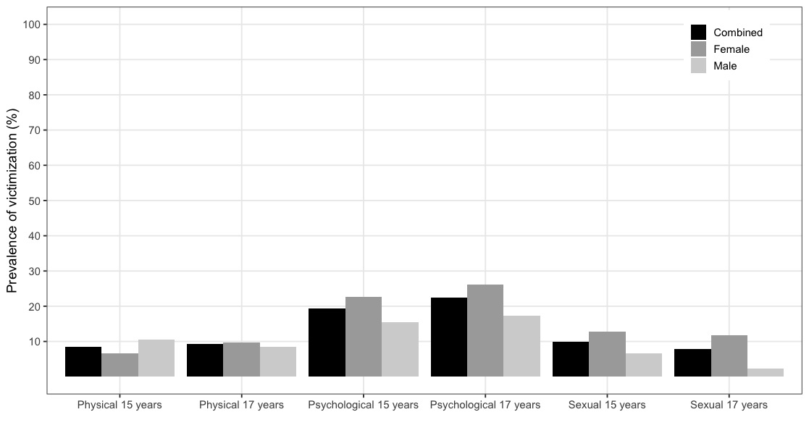
8.4
6.6
12.7
9.9
17.4
26.2
22.5
15.5
22.6
19.4
8.5
9.8
9.3
10.5
6.7
2.4
11.8
7.8
A

*

*

*

*

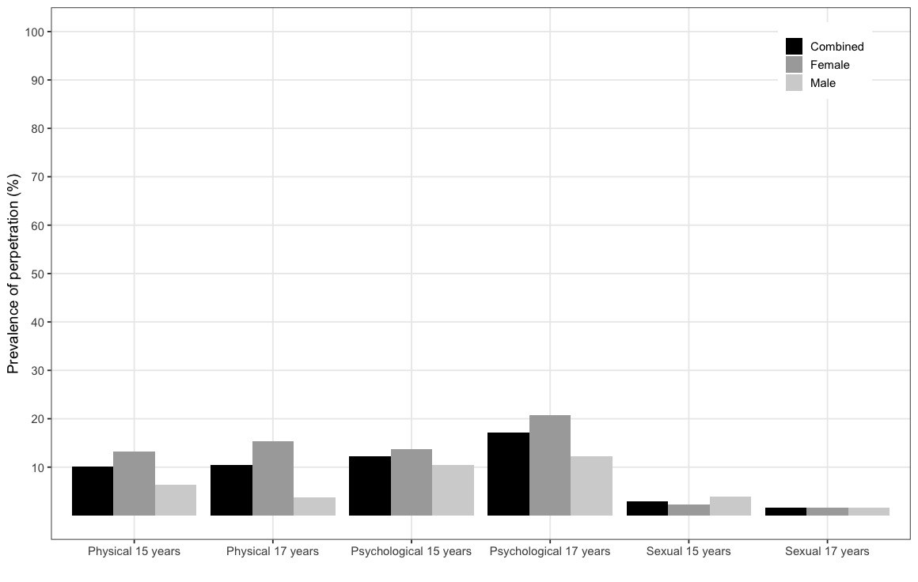
10.1
3.9
2.2
3.0
12.2
20.8
17.2
10.5
13.7
12.3
3.7
15.4
10.5
6.3
13.2
1.7
1.7
1.7
B

*

*

*

Figure S1ª. Prevalence of sub-types (physical, psychological, sexual) of dating violence victimization (panel A) and perpetration (panel B) at 15 and 17 years
ª Data were compiled from the final master file of the Québec Longitudinal Study of Child Development (1998-2015), © Gouvernement du Québec, Institut de la Statistique du Québec. * p < 0.05
Control variables and interaction term
Victimization
15 years
Internalizing symptoms
15 years
Victimization
17 years
Internalizing symptoms
17 years
0.10 [-0.06;0.25]
0.27 [0.14;0.40]
0.03 [-0.07;0.12]
0.59 [0.51;0.67]
A
0.23
0.28

Perpetration
15 years
Internalizing symptoms
15 years
Perpetration
17 years
Internalizing symptoms
17 years
B
0.23 [0.02;0.44]
0.24 [0.09;0.38]
0.02 [-0.12;0.17]
0.58 [0.50;0.67]
0.28
0.16

Control variables and interaction term

Figure S2ª. Cross-lagged associations between dating violence (victimization and perpetration) and internalizing symptoms adjusted for dating violence perpetration at 15 years (model A), dating violence victimization at 15 years (model B), and the interaction between them (models A and B). Single-headed arrows represent associations (standardized coefficients, β [95% confidence intervals]) and double-headed arrows represent correlations (r). Solid lines represent significant associations (p<0.05) and dashed lines represent non-significant associations (p≥0.05).
ª Data were compiled from the final master file of the Québec Longitudinal Study of Child
Development (1998-2015), © Gouvernement du Québec, Institut de la Statistique du Québec.
Control variables and interaction term
Victimization
15 years
Depression
15 years
Victimization
17 years
Depression
17 years
0.16 [0.01;0.30]
0.02 [-0.10;0.14]
0.00 [-0.11;0.11]
0.29 [0.22;0.37]
A
0.16
0.17

Perpetration
15 years
Depression
15 years
Perpetration
17 years
Depression
17 years
B
0.27 [0.07;0.47]
0.00 [-0.13;0.14]
0.06 [-0.07;0.20]
0.28 [0.20;0.36]
0.08
0.02

Control variables and interaction term

Figure S3ª. Cross-lagged associations between dating violence (victimization and perpetration) and depression adjusted for dating violence perpetration at 15 years (model A), dating violence victimization at 15 years (model B), the interaction between them (models A and B), and covariates listed in Table 1 (models A and B). Single-headed arrows represent associations (standardized coefficients, β [95% confidence intervals]) and double-headed arrows represent correlations (r). Solid lines represent significant associations (p<0.05) and dashed lines represent non-significant associations (p≥0.05).
ª Data were compiled from the final master file of the Québec Longitudinal Study of Child Development (1998-2015), © Gouvernement du Québec, Institut de la Statistique du Québec.

Control variables and interaction term
Victimization
15 years
Anxiety
15 years
Victimization
17 years
Anxiety
17 years
0.40 [0.03;0.76]
0.01 [-0.12;0.14]
-0.11 [-0.34;0.11]
0.29 [0.21;0.37]
A
0.04

0.05

Perpetration
15 years
Anxiety
15 years
Perpetration
17 years
Anxiety
17 years
B
0.28 [0.07;0.48]
0.09 [-0.03;0.22]
0.04 [-0.07;0.15]
0.31 [0.23;0.39]
0.09
0.06

Control variables and interaction term

Figure S4ª. Cross-lagged associations between dating violence (victimization and perpetration) and anxiety adjusted for dating violence perpetration at 15 years (model A), dating violence victimization at 15 years (model B), the interaction between them (models A and B), and covariates listed in Table 1 (models A and B). Single-headed arrows represent associations (standardized coefficients, β [95% confidence intervals]) and double-headed arrows represent correlations (r). Solid lines represent significant associations (p<0.05) and dashed lines represent non-significant associations (p≥0.05).
ª Data were compiled from the final master file of the Québec Longitudinal Study of Child Development (1998-2015), © Gouvernement du Québec, Institut de la Statistique du Québec.
Physical victimization
15 years
Internalizing symptoms
15 years
Physical victimization
17 years
Internalizing symptoms
17 years
0.19 [-0.31;0.68]
0.24 [0.08;0.41]
0.08 [-0.07;0.22]
0.52 [0.46;0.58]
A
0.29
0.13
Control variables and interaction term

Psychological victimization
15 years
Internalizing symptoms
15 years
Psychological victimization
17 years
Internalizing symptoms
17 years
0.07 [-0.09;0.23]
0.21 [0.07;0.35]
0.00 [-0.09;0.09]
0.51 [0.44;0.59]
B
0.23
0.22

Control variables and interaction term

Sexual victimization
15 years
Internalizing symptoms
15 years
Sexual victimization
17 years
Internalizing symptoms
17 years
0.09 [-0.06;0.25]
0.19 [0.01;0.37]
0.00 [-0.11;0.12]
0.52 [0.46;0.58]
C
0.12
0.20

Control variables and interaction term

Figure S5ª. Cross-lagged associations between sub-types of dating violence victimization (physical, psychological, and sexual) and internalizing symptoms adjusted for all sub-types of dating violence victimization and perpetration at 15 years (models A, B, and C), the interactions between physical dating violence victimization and perpetration at 15 years (model A), psychological dating violence victimization and perpetration at 15 years (model B), and sexual dating violence victimization and perpetration at 15 years (model C), and covariates listed in Table 1 (models A, B, and C). Single-headed arrows represent associations (standardized coefficients, β [95% confidence intervals]) and double-headed arrows represent correlations (r). Solid lines represent significant associations (p<0.05) and dashed lines represent non-significant associations (p≥0.05).
ª Data were compiled from the final master file of the Québec Longitudinal Study of Child Development (1998-2015), © Gouvernement du Québec, Institut de la Statistique du Québec.

Control variables and interaction term
Physical perpetration
15 years
Internalizing symptoms
15 years
Physical perpetration
17 years
Internalizing symptoms
17 years
0.14 [-0.06;0.34]
0.15 [0.02;0.29]
-0.02 [-0.13;0.09]
0.51 [0.44;0.58]
A
0.09
0.18

Psychological perpetration
15 years
Internalizing symptoms
15 years
Psychological perpetration
17 years
Internalizing symptoms
17 years
0.25 [0.06;0.44]
0.21 [0.04;0.37]
0.06 [-0.06;0.18]
0.52 [0.43;0.60]
B
0.16
0.18

Control variables and interaction term

Sexual perpetration
15 years
Internalizing symptoms
15 years
Sexual perpetration
17 years
Internalizing symptoms
17 years
0.03 [-0.44;0.51]
0.01 [-0.44;0.45]
0.00 [-0.30;0.30]
0.55 [0.46;0.63]
C
0.18
0.08

Control variables and interaction term

Figure S6ª. Cross-lagged associations between sub-types of dating violence perpetration (physical, psychological, and sexual) and internalizing symptoms adjusted for all sub-types of dating violence perpetration and victimization at 15 years (models A, B, and C), the interactions between physical dating violence victimization and perpetration at 15 years (model A), psychological dating violence victimization and perpetration at 15 years (model B), and sexual dating violence victimization and perpetration at 15 years (model C), and covariates listed in Table 1 (models A, B, and C). Single-headed arrows represent associations (standardized coefficients, β [95% confidence intervals]) and double-headed arrows represent correlations (r). Solid lines represent significant associations (p<0.05) and dashed lines represent non-significant associations (p≥0.05).
ª Data were compiled from the final master file of the Québec Longitudinal Study of Child Development (1998-2015), © Gouvernement du Québec, Institut de la Statistique du Québec.

