Supplemental Online Materials: Table of Contents
Table S1. Prediction of Missingness in Adulthood – p. 3
Table S2. Sample Size for Each Measure in Adolescents and Adults – p. 4-5
Table S3. Percentage of Sample in Each Category of Ordinal Variables – p. 6
Table S4. General Substance Use Factor Loadings in Adolescents and Adults – p. 7
Table S5. Multiple Regression Coefficients in Adolescents Ages 16-18 and Adults Ages 21-23 Compared to Full Sample– p. 8
Table S6. Phenotypic Cholesky Decomposition Parameters in Adolescents Ages 16-18 and Adults Ages 21-23 Compared to Full Sample – p. 9
Table S7. Substance-Specific Multiple Regression Coefficients in Adolescents and Adults – p. 10
Table S8. Substance-Specific Phenotypic Cholesky Decomposition Parameters in Adolescents and Adults – p. 11
Table S9. Adolescent Substance Use-Specific Influences on Adult Psychopathology
– p. 12
Supplemental Research Question 1 (SQ1): Are there common genetic and environmental influences on anxiety symptoms and substance use? – p. 13-17
Table S10. Adolescent and Adult Within-Trait Cross-Twin and Cross-Trait Cross-Twin Correlations – p. 18-19
Figure S1. Genetic (A), Shared Environmental (C), and Nonshared Environmental (E) influences on Internalizing, Externalizing, and Substance Use in Adolescents and Adults – p. 20-23
Table S11. Confidence Intervals for Genetic Cholesky Decomposition Parameters – p. 24-26
Table S12. Percentage of Variance of Psychopathology and Substance Use Variables Explained by Genetic, Shared Environmental, and Nonshared Environmental Influences – p. 27

Supplemental Online Materials: Table S1.
Prediction of Missingness in Adulthood
Adolescent CD to Adult Missingness | Adolescent MDD to Adult Missingness | Adolescent GAD to Adult Missingness | Adolescent SU to Adult Missingness
.08 / .05 | .23* / .11 | .13 / .08 | -.01 / .03
Note. Missingness in adulthood regressed on adolescent psychopathology/substance use and age. Standardized parameters (girls/boys) are reported here. CD = Conduct Disorder; MDD = Major Depressive Disorder; GAD = Generalized Anxiety Disorder; SU = Substance Use.
*p < .05.

Supplemental Online Materials: Table S2.
Sample Size for Each Measure in Adolescents and Adults
 | Adolescents  (girls/boys) | Adults  (women/men)
CD | 1438 / 1301
MDD | 1438 / 1301 | 1420 / 1222
GAD | 1438 / 1301 | 1420 / 1222
ASPD |  | 1418 / 1222
Tobacco use | 1373 / 1230 | 1416 / 1221
Alcohol use | 1373 / 1230 | 1416 / 1221
Cannabis use | 1373 / 1230 | 1416 / 1220
Other illicit drug use | 1373 / 1230 | 1415 / 1219
Note. CD = Conduct Disorder; ASPD = Antisocial Personality Disorder; MDD = Major Depressive Disorder; GAD = Generalized Anxiety Disorder.

Supplemental Online Materials: Table S3.
Percentage of Sample in Each Category of Ordinal Variables
 | CD/ASPD | MDD | GAD | Tobacco  (days used in the past 6 months) | Alcohol (days used in the past 6 months) | Cannabis (days used in the past 6 months) | Other illicit drug (days used in the past 6 months)
Adolescent girls  (n = 1461) | 0 - 70.0%  1 - 27.4%  2 - 1.1%  Missing - 1.6% | 0 - 64.8%  1 - 29.6%  2 - 4.0%  Missing - 1.6% | 0 - 63.0%  1 - 33.5%  2 - 2.0%  Missing - 1.6% | 0 - 74.4%  1-14 - 6.6%  15-89 - 3.1%  90+ - 9.9%  Missing -6.0% | 0 - 54.0%  1-6 - 25.8%  7-20 - 8.4%  21+ - 5.8%  Missing - 6.0% | 0 - 77.1%  1-6 - 9.9%  7-30 - 3.6%  31+ - 3.4%  Missing - 6.0% | 0 - 88.3%  1-3 - 2.9%  4+ - 2.7%  Missing - 6.0%
Adolescent boys  (n = 1309) | 0 - 56.8%  1 - 37.7%  2 - 4.8%  Missing - 0.6% | 0 - 69.4%  1 - 29.0%  2 - 1.0%  Missing - 0.6% | 0 - 69.8%  1 - 29.2%  2 - 0.4%  Missing - 0.6% | 0 - 66.7%  1-14 - 12.1%  15-89 - 5.1%  90+ - 10.1%  Missing -6.0% | 0 - 51.9%  1-6 - 25.9%  7-20 - 9.2%  21+ - 6.9%  Missing -6.0% | 0 - 73.6%  1-6 - 10.5%  7-30 - 4.1%  31+ - 5.8%  Missing -6.0% | 0 - 86.0%  1-3 - 4.1%  4+ - 3.8%  Missing -6.0%
Adult women  (n = 1428) | 0 - 56.0%  1 - 41.8%  2 - 1.8%  Missing - 0.5% | 0 - 70.1%  1 - 18.4%  2 - 10.9%  Missing - 0.5% | 0 - 85.1%  1 - 7.6%  2 - 6.7%  Missing - 0.5% | 0 - 69.1%  1-14 - 9.0%  15-89 - 3.6%  90+ - 18.0%  Missing - 0.3% | 0 - 16.8%  1-6 - 26.9%  7-20 - 24.1%  21+ - 31.9%  Missing - 0.3% | 0 - 77.9%  1-6 - 11.1%  7-30 - 4.6%  31+ - 6.1%  Missing - 0.3% | 0 - 87.3%  1-3 - 4.8%  4+ - 7.6%  Missing - 0.3%
Adult men  (n = 1227) | 0 - 37.2%  1 - 59.2%  2 - 3.1%  Missing - 0.5% | 0 - 80.0%  1 - 13.9%  2 - 5.6%  Missing - 0.5% | 0 - 89.7%  1 - 7.3%  2 - 2.4%  Missing - 0.5% | 0 - 45.1%  1-14 - 20.5%  15-89 - 6.6%  90+ - 27.8%  Missing - 0.1% | 0 - 11.5%  1-6 - 17.9%  7-20 - 21.5%  21+ - 49.0%  Missing - 0.1% | 0 - 64.2%  1-6 - 12.6%  7-30 - 8.1%  31+ - 14.9%  Missing - 0.1% | 0 - 81.3%  1-3 - 9.3%  4+ - 9.3%  Missing - 0.1%
Note. CD = Conduct Disorder; ASPD = Antisocial Personality Disorder; MDD = Major Depressive Disorder; GAD = Generalized Anxiety Disorder. For psychopathology variables, 0 = no symptoms; 1 = subthreshold symptoms (no diagnosis); 2 = met diagnostic criteria. For substance use variables, number of days used in the past month for each category are reported.

Supplemental Online Materials: Table S4.
General Substance Use Factor Loadings in Adolescents and Adults
 | Adolescent girls | Adolescent boys | Adult women |  | Adult men
Tobacco Use | .83 | .83 |  | .59 |  | .58
Alcohol Use | .81 | .85 |  | .50 |  | .61
Cannabis Use | .91 | .87 |  | .89 |  | .76
Other Use | .73 | .71 |  | .57 |  | .66
Note. Standardized factor loadings for the general substance use latent factor in adolescents and adults. p < .001
Model Fit for General Substance Use Factor
 | df | Chi-square (χ²) | RMSEA | CFI | p
Adolescent Noninvariant Model | 4 | 35.53 | .08 | .99 | < .001
Adolescent Invariant Model | 14 | 33.29 | .03 | .99 | < .001
Adolescent Difference Test | 10 | 12.65 | - | - | .244
Adult Noninvariant Model | 4 | 11.50 | .03 | .99 | < .001
Adult Invariant Model | 14 | 53.06 | .05 | .97 | .02
Adult Difference Test | 10 | 40.97 | - | - | < .001
Note. Bolded models were used in subsequent analyses.

Supplemental Online Materials: Table S5.
Multiple Regression Coefficients in Adolescents Ages 16-18 and Adults Ages 21-23 Compared to Full Sample
Adolescents (Girls / Boys)
Sample | Past-Year CD | Past-Year MDD |  | Past-Year GAD
Past-Year Substance Use in Full Sample (n = 2572) | .42* / .40* |  | .05 / .00 |  | -.15* / -.02
Past-Year Substance Use in Ages 16-18 (n = 1381) | .51* / .44* |  | .01 / .04 |  | -.15* / -.04
Adults (Women / Men)
Sample | Past-Year ASPD | Past-Year MDD |  | Past-Year GAD
Past-Year Substance Use in Full Sample (n = 2635) | .40* / .33* |  | .03 / .12* |  | .12* / .05
Past-Year Substance Use in Ages 21-23 (n = 1372) | .42* / .37* |  | .06 / .09* |  | .10* / .02
Note. CD = Conduct Disorder; MDD = Major Depressive Disorder; GAD = Generalized Anxiety Disorder; ASPD = Antisocial Personality Disorder.
*p < .05.

Supplemental Online Materials: Table S6.
Phenotypic Cholesky Decomposition Parameters in Adolescents and Adults in Full Sample Compared to Limited Age Sample
Adolescents (Girls / Boys)
Sample | F1 to | F2 to | F3 to | F4 to
Past-Year Substance Use in Full Sample (n = 2770) | .54* / .48* | -.12* / -.06 | -.18* / -.03 | .69* / .71*
Past-Year Substance Use in Ages 16-18 (n = 1382) | .60* / .52* | -.15* / -.02 | -.17* / -.05 | .76* / .85*
Adults (Women / Men)
Sample | F1 to | F2 to | F3 to | F4 to
Past-Year Substance Use in Full Sample (n = 2635) | .54* / .44* | .04 / .15* | .16* / .04 | .82* / .88*
Past-Year Substance Use in Ages 21-23 (n = 1379) | .56* / .48* | .09 / .09 | .11 / .00 | .82* / .87*
Note. Standardized parameters are reported. Factor 1 (F1) refers to influences on CD/ASPD, which also influence MDD, GAD, and substance use. F2 represents influences on MDD, GAD, and substance use, controlling for CD/ASPD. F3 represents influences on GAD and substance use, controlling for CD/ASPD and MDD. F4 represents influences unique to substance use.
*p < .05.

Supplemental Online Materials: Table S7.
Substance-Specific Multiple Regression Coefficients in Adolescents and Adults
Adolescents (Girls / Boys)
Substance Category | Past-Year CD |  | Past-Year MDD |  | Past-Year GAD
Past-Year Tobacco Use | .33* [.27 – .40] /  .32* [.26 – .38] | .04 [-.03 – .12] /  -.01 [-.08 – .06] |  | -.16* [-.24 – -.09] /  .00 [-.07 – .07]
Past-Year Alcohol Use | .34* [.28 – .39] /  .33* [.28 – .38] | .01 [-.06 – .07] /  -.02 [-.09 – .04] |  | -.12* [-.18 – -.06] /  -.04 [-.10 – .02]
Past-Year Cannabis Use | .39* [.33 – .46] /  .37* [.31 – .43] | .06 [-.02 – .14] /  .02 [-.08 – .11] |  | -.12* [-.21 – -.04] /  -.05 [-.14 – .04]
Past-Year Other Use | .35* [.26 – .44] /  .30* [.22 – .38] | .08 [-.02 – .18] /  .07 [-.34 – .18] |  | -.03 [-.14 – .09] /  .08 [-.03 – .18]
Adults (Women / Men)
Substance Category | Past-Year ASPD |  | Past-Year MDD |  | Past-Year GAD
Past-Year Tobacco Use | .36* [.30 – .42] /  .19* [.12 –.25] | .02 [-.05 – .09] /  .10* [.04 – .17] |  | .06* [.01 – 12] /  .08* [.02 – .14]
Past-Year Alcohol Use | .12* [.07 – .18] /  .16* [.10 – .22] | -.08* [-.14 – -.02] /  .00 [-.07 –.08] |  | .00 [-.05 – .06] /  -.03 [-.10 – .04]
Past-Year Cannabis Use | .30* [.24 – .39] /  .29* [.23 – .36] | .05 [-.02 – .12] /  .05 [-.01 – .12] |  | .10* [.03 – .16] /  .05 [-.01 – .12]
Past-Year Other Use | .24* [.17 – .32] /  .23* [.15 – .31] | .11* [.03 – .19]/  .17* [.10 –.23] |  | .16* [.08 – .22] /  .01 [-.05 – .09]
Note. 95% confidence intervals reported in brackets [Lower 2.5%, Upper 2.5%]. CD = Conduct Disorder; MDD = Major Depressive Disorder; GAD = Generalized Anxiety Disorder; ASPD = Antisocial Personality Disorder.
*p < .05.

Supplemental Online Materials: Table S8.
Substance-Specific Cholesky Decomposition Parameters in Adolescents and Adults
Adolescents (Girls / Boys)
Substance Category | F1 to | F2 to |  |  | F3 to |  |  | F4 to
Past-Year Tobacco Use | .42* [.33 – .49] /  .39* [.32 – .45] | -.10* [-.18 – -.02] / -.06 [-.16 – -.03] |  |  | -.19* [-.28 – -.10] / .01 [-.10 – .02] |  |  | .79* [.72 – .83] /  .81* [.77 – .85]
Past-Year Alcohol Use | .45* [.38 – .51] /  .44* [.37 – .50] | -.14* [-.22 – -.08]/  -.12* [-.22 – -.04] |  |  | -.16* [-.24 – -.09] / -.04 [-.15 – .05] |  |  | .86* [.82 – .90] /  .89* [.85 –.92]
Past-Year Cannabis Use | .54* [.47 – .60] /  .47* [.40 – .53] | -.10* [-.20 – -.02] / -.07 [-.19 – .02] |  |  | -.16* [-.26 – -.07] / -.06 [-.18 – .04] |  |  | .82* [.77 – .86] /  .88* [.84 – .92]
Past-Year Other Use | .51* [.41 – .62] /  .44* [.34 – .54] | -.01 [-.13 – .12] /  .12 [.00 – .25] |  |  | -.05 [-.19 – .10] /  .08 [-.08 – .23] |  |  | .86* [.79 – .92] /  .88* [.83 – .94]
Adults (Women / Men)
Substance Category | F1 to |  | F2 to |  | F3 to |  | F4 to
Past-Year Tobacco Use | .46* [.39 – .53] /  .26* [.19 – .34] |  | .01 [-.07 – .09] /  .14* [.05 – .24] |  | .08 [-.01 – .18] /  .10 [-.01 – .21] |  | .88* [.84 – .92] /  .72 [-.24 – 1.69]
Past-Year Alcohol Use | .13* [.06 – .20] /  .19* [.12 – .26] |  | -.11* [-.18 – -.04] / -.03 [-.12 – .07] |  | .01 [-.07 – .10] /  -.05 [-.18 – .07] |  | .98* [.96 – .99] /  .22 [-2.60 – 3.04]
Past-Year Cannabis Use | .40* [.33 – .48] /  .37* [.30 – .44] |  | .06 [-.02 – .15] /  .04 [-.05 – .14] |  | .12* [.01 – .23] /  .06 [-.06 – .14] |  | .90* [.87 – .94] /  .07 [-14.6 – 14.7]
Past-Year Other Use | .37* [.28 – .46] /  .33* [.24 – .41] |  | .18* [.08 – .27] /  .21* [.11 – .31] |  | .20* [.10 – .31] /  -.02 [-.16 – .12] |  | .89* [.85 – .93] /  .92* [.88 – .96]
Note. 95% confidence intervals reported in brackets [Lower 2.5% – Upper 2.5%]. Factor 1 (F1) refers to influences on CD/ASPD, which also influence MDD, GAD, and substance use. F2 represents influences on MDD, GAD, and substance use, controlling for CD/ASPD. F3 represents influences on GAD and substance use, controlling for CD/ASPD and MDD. F4 represents influences unique to substance use.
*p < .05.

Supplemental Online Materials: Table S9.
Adolescent Substance Use-Specific Influences on Adult Psychopathology
Sex | Adolescent SU-specific influences on Adult GAD | Adolescent SU-specific influences on Adult MDD | Adolescent SU-specific influences on Adult ASPD
Girls/Women | .26* [.16 – .36] | .21* [.11 – .30] | .31* [.22 – .40]
Boys/Men | .18* [.06 – .30] | .20* [.10 – .31] | .24* [.14 – .35]
Note. Phenotypic Cholesky decompositions examined adolescent SU-specific influences on adult psychopathology, controlling for adolescent psychopathology. Separate analyses were conducted for adulthood GAD, MDD, and ASPD, controlling for adolescent GAD, MDD, and CD, respectively. Standardized parameters are reported with 95% confidence intervals in brackets [Lower 2.5% – Upper 2.5%]. SU = Substance Use; MDD = Major Depressive Disorder; GAD = Generalized Anxiety Disorder; ASPD = Antisocial Personality Disorder.
*p < .01.

SQ1: Are there common genetic and environmental influences on anxiety symptoms and substance use?
The present study makes use of a genetically informative sample to explore the magnitude of common genetic and environmental influences on the associations between internalizing and externalizing symptoms and substance use. Twin studies utilize the genetic differences between monozygotic (MZ) twins, who share 100% of their genes, and dizygotic (DZ) twins, who on average share 50% of their genes by descent. The extent to which MZ and DZ twin correlations differ indicates the magnitude of genetic influences. If the DZ correlation is greater than half the MZ correlation, there is evidence of shared environmental influences (i.e., environmental influence leading to similarities among family members). Differences between MZ twins can be attributed to their non-shared environment (i.e., environmental influences leading to differences between members of the same family), which can help identify environmental influences on a phenotype. This same logic can be applied to cross-twin cross-trait correlations (e.g., the correlation between GAD in twin 1 and substance use in twin 2); if MZ correlations are greater than DZ correlations, one can infer common genetic influences, if the DZ correlation is greater than half the MZ correlation, one can infer common shared environmental influences, and if the phenotypic correlation is greater than the MZ correlation, common nonshared environmental influences are implicated.
Twin studies have provided consistent evidence for common genetic influences on externalizing symptoms and substance use (Eaton et al., 2015; Kendler, Prescott, Myers, & Neale, 2003; Krueger et al., 2002; Meyers & Dick, 2010; Young, Stallings, Corley, Krauter, & Hewitt, 2000). There is also evidence for common genetic influences on internalizing symptoms, particularly depressive symptoms, and substance use (Kendler et al., 1993; Niaura, Swan, Carmelli, & McCaffery, 2003). The literature lacks studies that specifically examine differential influences of depression and anxiety on substance use. The present study will contribute to the literature by examining the role of independent genetic influences on the association between anxiety symptoms and substance use, after controlling for externalizing and depression symptoms.
Results
Supplemental Online Materials Table S10 presents within-trait cross-twin and cross-trait cross-twin correlations for MZ and DZ twins. In adolescents, within-trait cross-twin MZ correlations were greater than DZ correlations for all variables (except MDD in boys), suggesting genetic influences on these phenotypes. In girls, cross-trait cross-twin correlations were greater for MZs than DZs for the CD-substance use and the MDD-GAD associations, suggesting genetic influences, whereas the cross-trait cross-twin correlations for the associations between CD-MDD and CD-GAD imply shared environmental influences. In boys, cross-trait cross-twin correlations were predominantly greater in MZs than DZs, with the exception of the MDD-substance use association, suggesting genetic influences on these associations. Constraining correlations to be equal between boys and girls significantly worsened model fit, 𝜒²(42) = 98.68, p < .01. Likewise, constraining DZ OS correlations to equal DZ boys or DZ girls both significantly worsened model fit (𝜒²(14) = 52.84, p < .01 and 𝜒²(14) = 28.92, p < .05, respectively). Also, constraining the variance of the latent substance use variable to be equal across girls and boys significantly worsened model fit (𝜒²(1) = 4.27, p < .05); therefore, DZ OS cross-trait cross-twin correlations are presented separately for the girl-boy OS twin pairs (e.g., correlation between girl twin’s GAD and boy twin’s substance use) and boy-girl twin pairs (e.g., correlation between boy twin’s GAD and girl twin’s substance use).
We found similar patterns of results in adult MZ and DZ twin correlations. Within-trait cross-twin MZ correlations were greater than DZ correlations for all variables except MDD in men, indicating genetic influences. Cross-trait cross-twin correlations were greater in MZ twins than DZ twins for all associations. These results imply genetic influences on the associations between psychopathology and substance use variables in men and women. Fixing variances to be equal in men and women did not significantly worsen model fit, 𝜒²(1) = 1.20, p = .27. When variances were equated by sex, correlations did not differ significantly between women and men, 𝜒²(28) = 32.96, p = .24, and DZ OS correlations could be constrained to equal DZ men and DZ women without significantly worsening model fit (𝜒²(14) = 20.83, p = .11 and 𝜒²(14) = 16.10, p = .31, respectively).
A multivariate genetic Cholesky decomposition estimated the magnitude of additive genetic (A), shared environmental (C), and nonshared environmental (E) influences on psychopathology and substance use variables and their associations (Supplemental Online Materials Figure S1). Significance of the parameters was determined by chi-square difference tests. In adolescents, shared environmental influences (C1) on CD significantly influenced substance use in both girls and boys. Genetic influences on CD (A1) significantly influenced substance use in boys only, and nonshared environmental influences (E1) on CD significantly influenced substance use in girls only. After controlling for CD, shared environmental (C2) influences on MDD had a significant positive influence on GAD in both girls and boys, and a significant negative influence on substance use in girls only. After controlling for CD and MDD, influences on GAD (A3, C3, and E3) had negative influences on substance use, as in the phenotypic analyses (with the exception of nonshared environmental influences in boys), but no parameters were statistically significant.
The same analyses were conducted in adults. Genetic influences on ASPD (A1) also significantly influenced substance use in both women and men, and nonshared environmental influences on ASPD (E1) significantly influenced substance use in women only. After controlling for ASPD, there were no genetic, shared environmental, or nonshared environmental influences on internalizing disorders that also influenced substance use. Parameters are displayed in Figure S1 of the Supplemental Online Materials. Confidence intervals for genetic Cholesky decomposition analyses are displayed in Table S11. Table S12 shows the percent of variance of psychopathology and substance use variables explained by A, C, and E in adolescents and adults.
Discussion
Evidence for shared environmental influences on the association between externalizing symptoms and substance use was limited to adolescence, whereas there was consistent evidence for genetic influences on this association across sexes in adults. These results are consistent with the general finding from the literature that shared environmental influences tend to decrease and genetic influences tend to increase with age, as individuals may have more opportunities to select environments consistent with their genetic predispositions.
After controlling for externalizing symptoms, shared environmental influences on internalizing symptoms protected against substance use during adolescence (significantly so in girls). In contrast, we did not find evidence for significant genetic, shared environmental, or nonshared environmental influences on the internalizing pathway to substance use in adults. We also did not find evidence for significant genetic, shared environmental, or nonshared environmental influences on the anxiety-specific protective effect on substance use in adolescent girls. Although phenotypic analyses showed a significant anxiety-specific pathway to substance use, genetic analyses were underpowered to detect whether this pathway was due to genetic, shared environmental, or nonshared environmental effects. Larger samples are needed to understand whether the protective effect of anxiety is influenced by genetic and/or environmental factors.

Supplemental Online Materials: Table S10.
Adolescent and Adult Within-Trait Cross-Twin and Cross-Trait Cross-Twin Correlations
Adolescent Within-Trait Cross-Twin
 | MZF | MZM | DZF | DZM | DZOS
CD | .64* | .64* | .53* | .21* | .33*
MDD | .62* | .79* | .55* | .79* | .50*
GAD | .68* | .84* | .58* | .74* | .55*
SU | .87* | .81* | .71* | .68* | .47*
Adolescent Cross-Trait Cross-Twin
 | MZF | MZM | DZF | DZM | DZOS  (F with M) | DZOS  (M with F)
CD/MDD | .39* | .46* | .40* | .24* | .23* | .23*
CD/GAD | .37* | .36* | .39* | .20* | .08 | .08
CD/SU | .53* | .51* | .38* | .42* | .38* | .21*
MDD/GAD | .60* | .80* | .52* | .78* | .54* | .54*
MDD/SU | .11 | .16* | .07 | .21* | -.02 | -.01
GAD/SU | .00 | .08 | .05 | .10 | -.13 | -.07

Adult Within-Trait Cross-Twin

 | MZF | MZM | DZF | DZM | DZOS
ASPD | .52* | .50* | .27* | .16 | .24*
MDD | .41* | .24* | .33* | .25 | .14
GAD | .35* | .26 | .30* | -.14 | .31*
SU | .59* | .72* | .38* | .42* | .57*
Adult Cross-Trait Cross-Twin
 | MZF | MZM | DZF | DZM | DZOS
ASPD/MDD | .27* | .20* | .24* | .11 | .04
ASPD/GAD | .27* | .36* | .21* | -.04 | .11
ASPD/SU | .46* | .38* | .12 | .14 | .21*
MDD/GAD | .34* | .42* | .21* | .12 | .15
MDD/SU | .20* | .22* | .10 | .11 | .12
GAD/SU | .38* | .29* | .12 | -.06 | .23*
Note. MZF = Monozygotic (Identical) Females; MZM = Monozygotic (Identical) Males; DZF = Dizygotic (Fraternal) Females; DZM = Dizygotic (Fraternal) Males; DZOS = Dizygotic Opposite Sex; CD = Conduct Disorder; MDD = Major Depressive Disorder; GAD = Generalized Anxiety Disorder; SU = Substance Use; ASPD = Antisocial Personality Disorder. Two adolescent DZOS correlations are shown because the variance of the latent substance use variable could not be constrained to be equal for girls and boys.
*p < .05.

Supplemental Online Materials: Figure S1.
Genetic (A), Shared Environmental (C), and Nonshared Environmental (E) Influences on Internalizing, Externalizing, and Substance Use in Adolescents and Adults
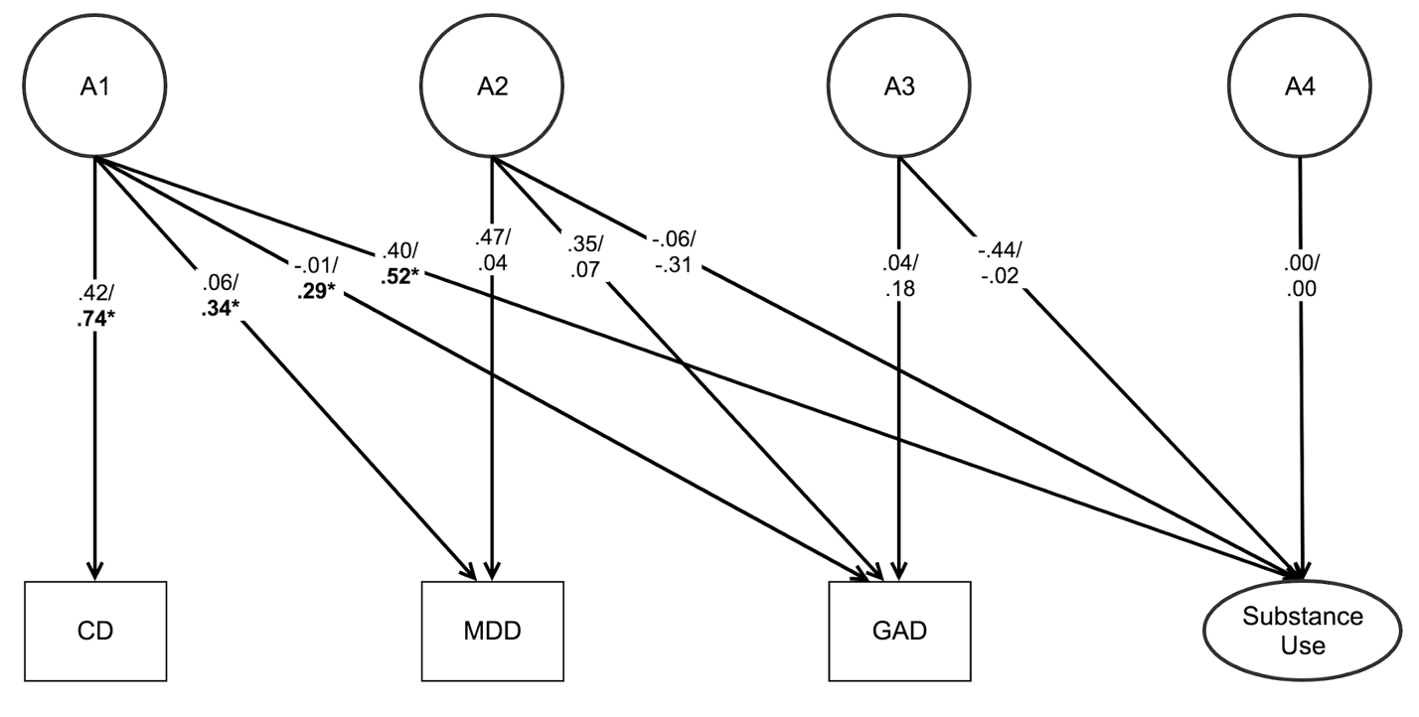
Adolescents (girls/boys) – Model fit: χ²(577)=661.99, RMSEA=.02, CFI=.99

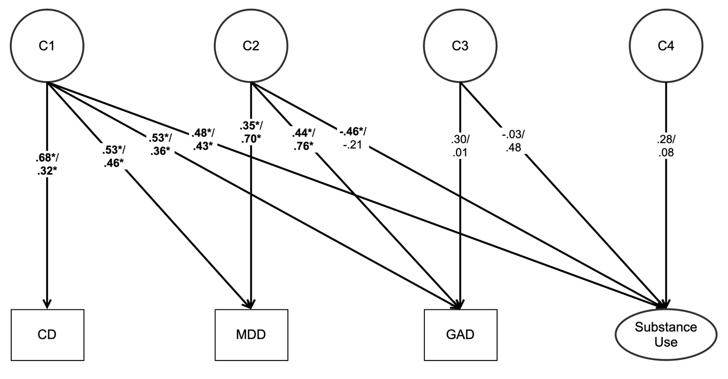
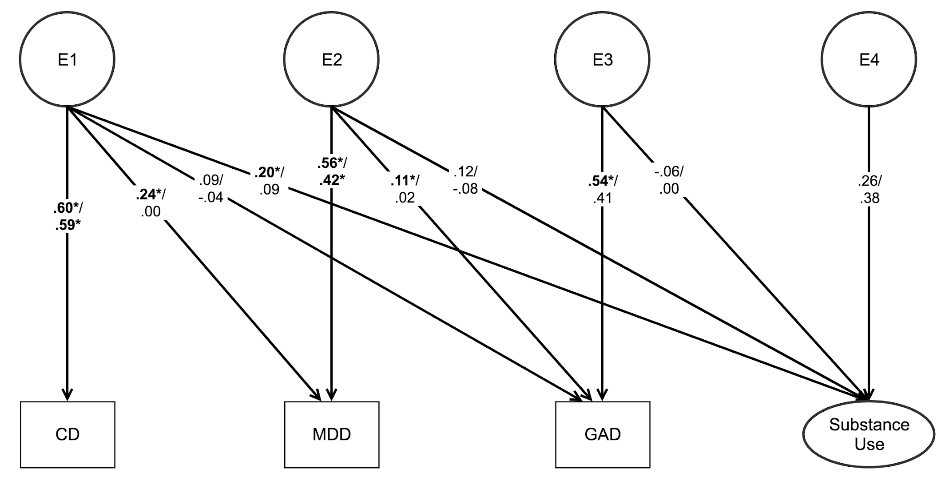

Adults (women/men) – Model fit: χ²(645)=797.22, RMSEA=.03, CFI=.96
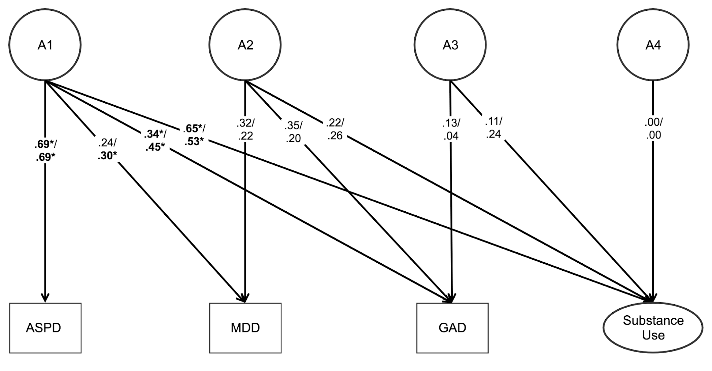
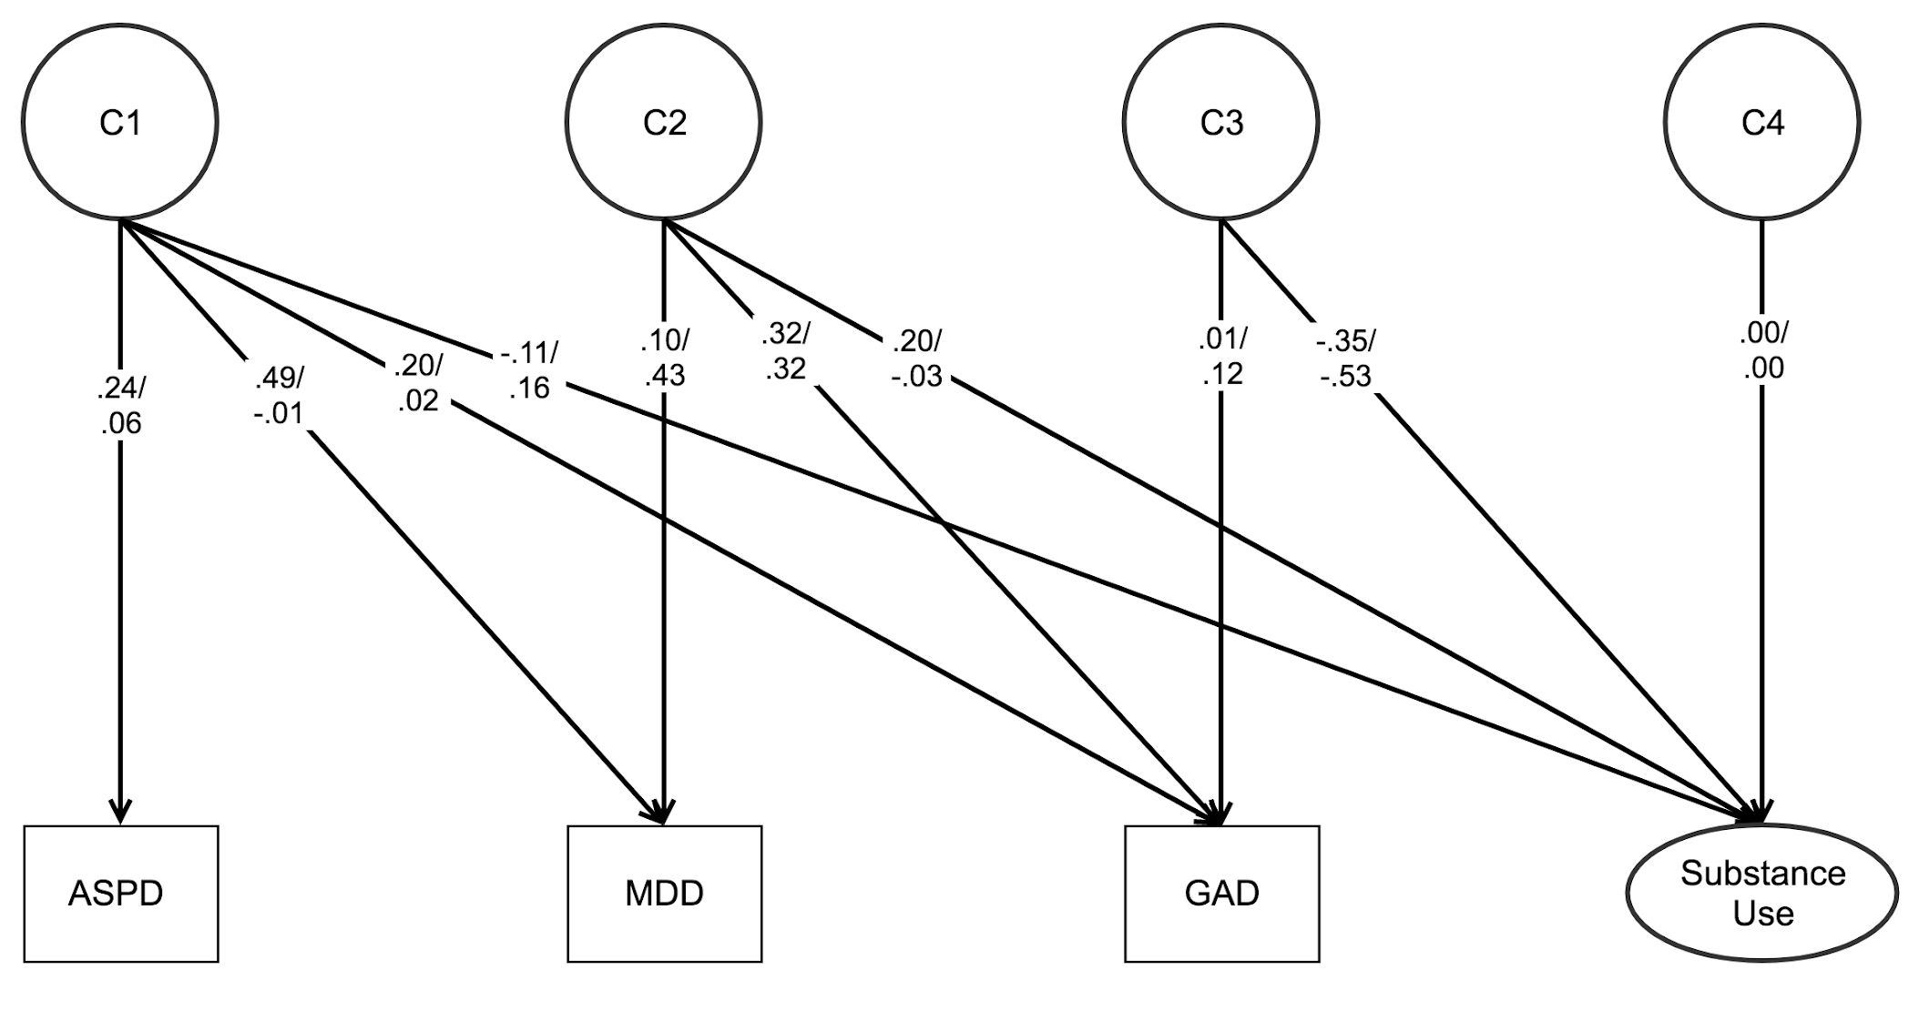
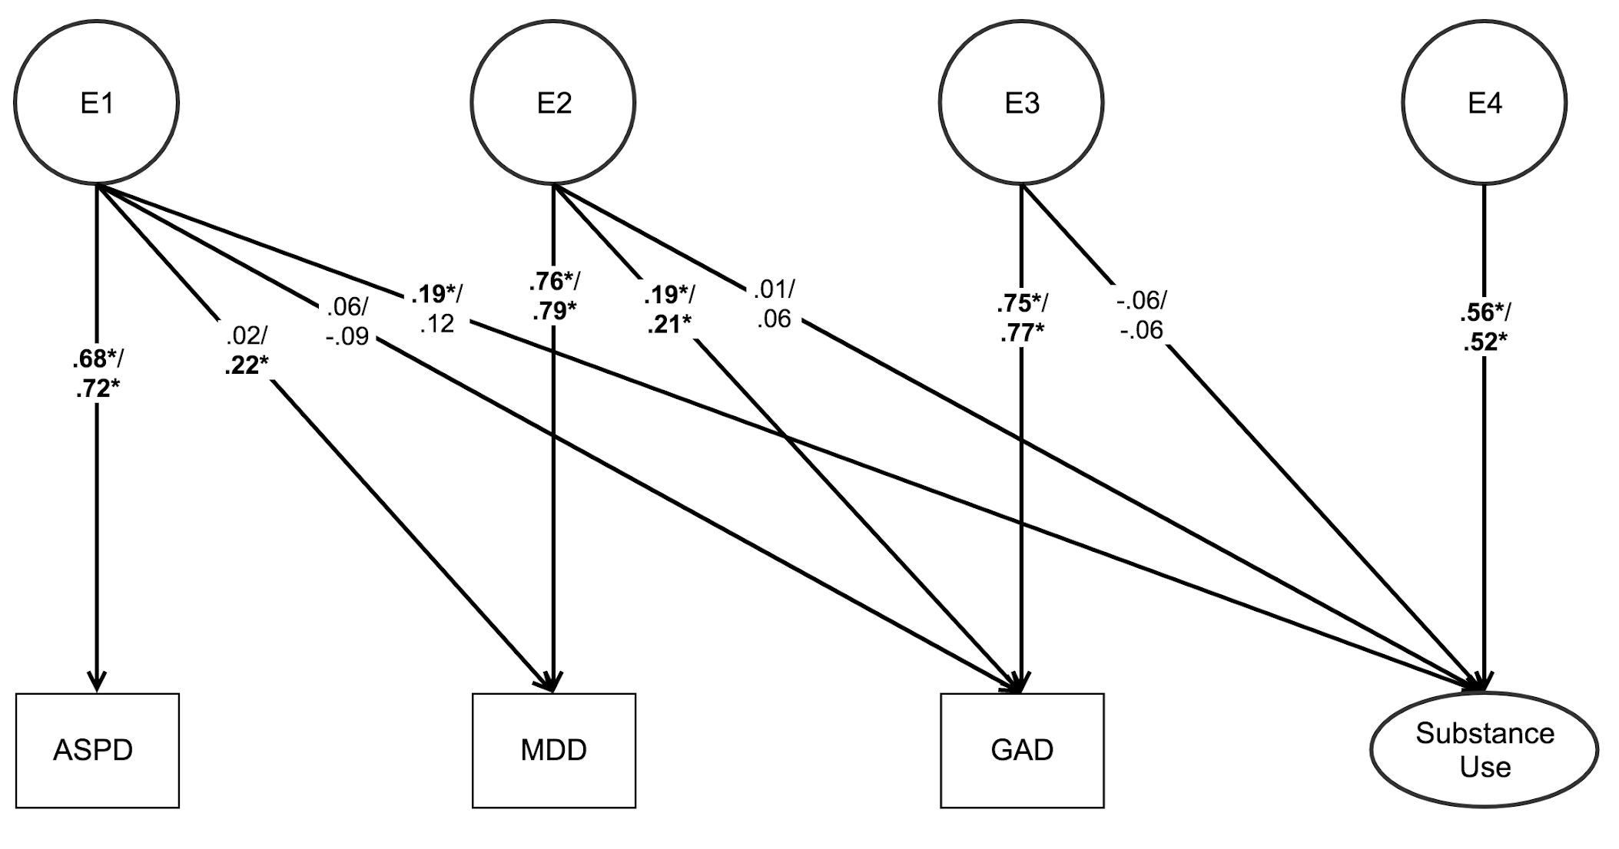
Note. Adolescent and adult genetic Cholesky decomposition models with estimates of additive genetic (A), shared environmental (C), and nonshared environmental (E) influences on associations between psychopathology and substance use. A1, C1, and E1 represent the genetic, shared environmental, and nonshared environmental influences on CD/ASPD that also influence MDD, GAD, and substance use. A2, C2, and E2 represent genetic, shared environmental, and nonshared environmental influences on MDD, GAD, and substance use, controlling for CD/ASPD. A3, C3, and E3 represent genetic, shared environmental, and nonshared environmental influences on GAD and substance use, controlling for CD/ASPD and MDD. A4, C4, and E4 represent influences unique to substance use. For the sake of clarity, A, C, and E are presented separately, and the measurement models for the adolescent and adult latent substance use factors are not displayed here. Standardized parameters after regressing out the effects of age are shown, separated by sex.
*p < .05.

Supplemental Online Materials: Table S11.
Confidence Intervals for Genetic Cholesky Decomposition Parameters
Adolescents (Girls / Boys)
 | A1 to | A2 to |  | A3 to |  | A4 to
CD | .42 [.03, .82] / .74* [.61, .86]
MDD | .06 [-.46, .59] / .34* [.14, .54] | .47 [.26, .69] /  .04 [-.64, .73]
GAD | -.01 [-.60, .59] / .29* [.05, .53] | .35 [.04, .66] /  .07 [-1.02, 1.15] |  | .04 [-.81, .89] / .18 [-.21, .58]
Substance Use | .40 [-.25, 1.05] / .52* [.30, .75] | -.06 [-.55, .44] /  -.31 [-.99, .37] |  | -.44 [-3.98, 3.11] / -.02 [-2.16, 2.11] |  | .00 / .00
 | C1 to | C2 to |  | C3 to |  | C4 to
CD | .68* [.46, .82] / .32* [.09, .56]
MDD | .53* [.28, .78] / .46* [.17, .76] | .35* [.08, .61] / .70* [.54, .86]
GAD | .53* [.21, .84] / .36* [.02, .71] | .44* [.18, .71] / .76* [.60, .92] |  | .30 [.08, .52] /  .01 [-.51, .52]
Substance Use | .48* [.09, .88] / .43* [.13, .72] | -.46* [-.84, -.07] / -.21 [-.57, .15] |  | -.03 [-1.06, 1.00] / .48 [-.46, 1.43] |  | .28 [-.12, .40] / .08 [-5.87, 6.02]
 | E1 to | E2 to |  | E3 to |  | E4 to
CD | .60* [.52, .69] / .59* [.52, .67]
MDD | .24* [.11, .38] / .00 [-.12, .13] | .56* [.48, .63] / .42* [.36, .48]
GAD | .09 [-.05, .23] /  -.04 [-.18, .11] | .11* [.01, .20] / .02 [-.10, .13] |  | .54* [.46, .63] / .41 [.31, .51]
Substance Use | .20* [.08, .32] / .09 [-.03, .21] | .12 [-.04, .28] /  -.08 [-.30, .14] |  | -.06 [-.23, .12] / .00 [-.28, .28] |  | .26 [.12, .40] /  .38 [.25, .52]
Adults (Women / Men)
 | A1 to | A2 to |  | A3 to |  | A4 to
ASPD | .69* [.49, .89] / .69* [.60, .79]
MDD | .24 [-.15, .64] / .30* [.12, .49] | .32 [-.28, .92] / .22 [-.10, .95]
GAD | .34* [.04, .64] /  .45* [.23, .67] | .35 [-.65, .1.34] /  .20 [-1.54, 1.95] |  | .13 [-1.77, 2.03] / .04 [-3.23, .3.30]
Substance Use | .65* [.39, .91] / .53* [.34, .72] | .22 [-.86, 1.29] /  .26 [-1.50, 2.03] |  | .11 [-3.54, 3.76] / .24 [-8.86, 9.35] |  | .00 / .00
 | C1 to | C2 to |  | C3 to |  | C4 to
ASPD | .24 [-.23, .71] / .06 [-.39, .52]
MDD | .49 [.13, .86] /  -.01 [-.66, .64] | .10 [-.68, .89] / .43 [-.10, .95]
GAD | .20 [-.44, .84] / .02 [-.71, .75] | .32 [-.27, .92] / .32 [-.43, 1.06] |  | .01 [-1.09, 1.10] / .12 [-1.10, 1.35]
Substance Use | -.11 [-.91, .48] / .16 [-.44, .75] | .20 [-.43, .84] /  -.03 [-.79, .74] |  | -.35 [-4.88, 4.18] / -.53 [-7.27, 6.22] |  | .00 / .00
 | E1 to | E2 to |  | E3 to |  | E4 to
ASPD | .68* [.60, .77] / .72* [.64, .80]
MDD | .02 [-.14, .17] / .22* [.03, .41] | .76* [.68, .85] / .79* [.67, .92]
GAD | .06 [-.11, .23] /  -.09 [-.32, .13] | .19* [.03, .35] / .21* [.01, .40] |  | .75* [.62, .88] / .77* [.60, .94]
Substance Use | .19* [.07, .32] / .12 [-.02, .26] | .01 [-.14, .15] /  .06 [-.08, .21] |  | -.06 [-.22, .10] /  -.06 [-.26, .14] |  | .56* [.40, .68] / .52* [.38, .65]
Note. Genetic Cholesky decomposition estimates of additive genetic (A), shared environmental (C), and nonshared environmental (E) influences on the associations between psychopathology and substance use. 95% confidence intervals reported in brackets [Lower 2.5%, Upper 2.5%]. CD = Conduct Disorder; MDD = Major Depressive Disorder; GAD = Generalized Anxiety Disorder; ASPD = Antisocial Personality Disorder.
*p < .05.

Supplemental Online Materials: Table S12.
Percentage of Variance of Psychopathology and Substance Use Variables Explained by Genetic, Shared Environmental, and Nonshared Environmental Influences
Adolescents (Girls / Boys)
Variable | % Variance explained by A | % Variance explained by C | % Variance explained by E
CD | 17.9 / 54.3 | 45.7 / 10.4 | 36.4 / 35.3
MDD | 22.8 / 11.9 | 40.0 / 70.5 | 37.3 / 17.6
GAD | 12.4 / 12.3 | 56.1 / 70.8 | 31.5 / 16.9
Substance Use | 35.4 / 37.2 | 51.9 / 46.5 | 12.8 / 16.3
Adults (Women / Men)
Variable | % Variance explained by A | % Variance explained by C | % Variance explained by E
ASPD | 47.3 / 54.3 | 5.8 / 10.4 | 46.9 / 35.3
MDD | 16.2 / 11.9 | 25.2 / 70.5 | 58.6 / 17.6
GAD | 25.2 / 12.3 | 14.5 / 70.8 | 60.2 / 16.9
Substance Use | 47.7 / 37.2 | 17.2 / 46.5 | 35.2 / 16.3
Note. Percent of variance explained by additive genetic (A), shared environmental (C), and nonshared environmental (E) influences in adolescents and adults. CD = Conduct Disorder; MDD = Major Depressive Disorder; GAD = Generalized Anxiety Disorder; ASPD = Antisocial Personality Disorder.

