Supplementary material for More Than a Feeling

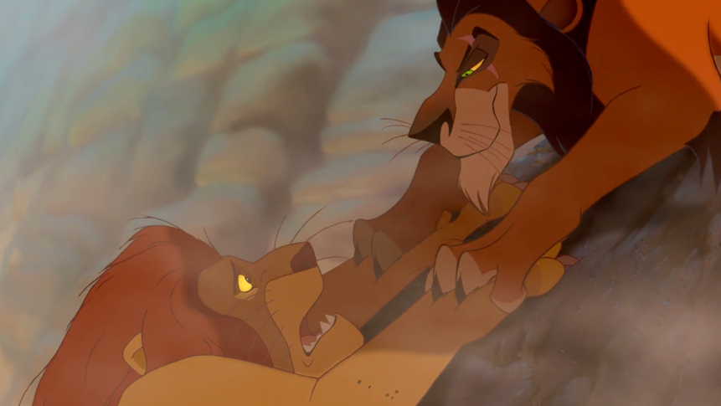
Figure 1. Example of emotional ROI (green) and distractor ROI (red).

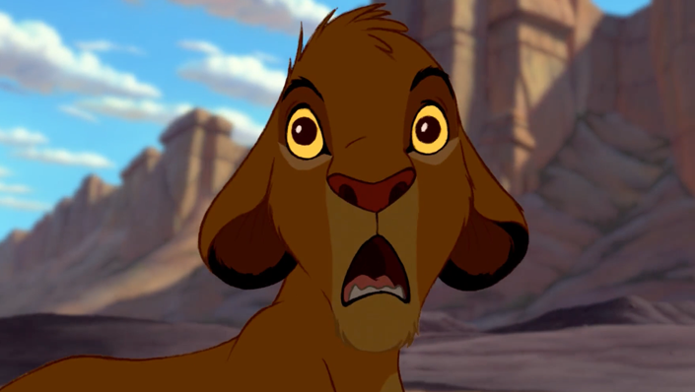
Figure 2. Fear Scene 1: Simba is staring at the wildebeest running towards him (0.33–0.35 seconds, frames: 770–851).

Figure 3. Fear scene 2: After rescuing Simba, Mufasa attempts an escape and is betrayed by Scar (3.01–3.20 seconds, frames: 4601–4788).

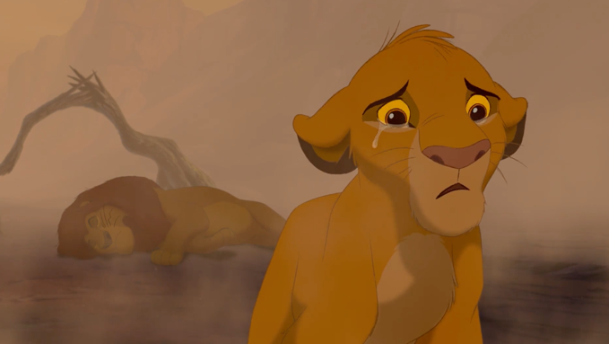

Figure 4. Sadness scene 1: Simba finds his father injured (308.876– 313.104 seconds, frames: 7285–7507).

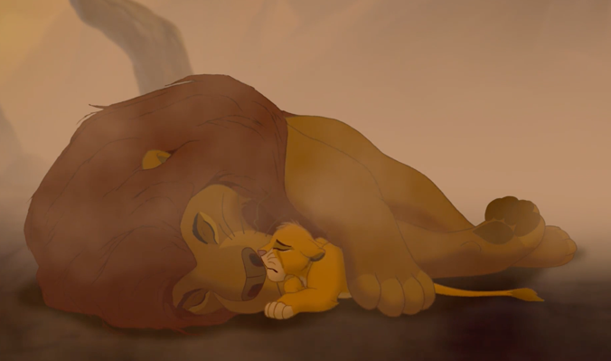
Figure 5. Sadness scene 2: Simba realizes that his father is dead (318.460–330.705 seconds, frames: 7635–7929).

