Supplementary materials: Vocalisation and physiological hyperarousal in infant-caregiver dyads where the caregiver has elevated anxiety.

Participant demographic details
This sample size was selected prior to the commencement of the study based on power calculations presented, and approved by peer review, in the funding application that supported this work (ESRC ES/N017560/1). Exclusion criteria included: complex medical conditions, skin allergies, heart conditions, caregivers below 18 years of age, and caregivers receiving care from a mental health organisation or professional..

Exclusion/outlier criteria
A consistent outlier-detection strategy was applied equally for all analyses, by excluding outliers that were >2 inter-quartile range (IQR) from the mean, to avoid violating the assumptions of the statistical tests being conducted.
- Autonomic data parsing

Autonomic ECG data parsing
ECG was recorded at 250Hz. Analysis of the interbeat intervals (IBIs) was performed using custom-built Matlab scripts. These scripts were designed through an extensive piloting process to be optimal for the ECG device used for this study. First, data were parsed using a simple amplitude threshold (see, e.g., Aurobinda et al., 2016 for a similar approach), with R peaks identified as moments where the raw ECG signal exceeded the threshold value. Initially, the threshold value was set high; the same process was then repeated at incrementally decreasing thresholds.

At each threshold value, the R peaks identified were automatically subjected to the following checks. Firstly, minimum temporal threshold check: does the R peak occur at a time interval of greater than 300 milliseconds since the previous R peak (corresponding to a heart rate of 200 BPM). Secondly, maximum temporal threshold check: does the R peak occur at a time interval of less than 850 milliseconds since the previous R peak (corresponding to a heart rate of 70 BPM). And thirdly, maximum rate of change check: when we calculate the R to R interval between this peak and the subsequent peak, and compare it with the R to R interval between this peak and the previous peak, is this difference less than 300 milliseconds? In setting these threshold values, careful attention was paid to visual inspection to determine the maximum and minimum ‘genuine’ heart rates observed in our infant data. In setting the maximum rate of change criterion, careful attention was paid to identify the maximum rate of vagally mediated heart rate changes in infants.

Figure S1 shows a sample screenshot from the Matlab processing algorithm that was used. Two separate types of artefacts are shown. The first, highlighted by the call-out figures a and d, are instances where the ECG signal for a particular beat was lower than the threshold, and a genuine beat was missed. It can be seen that, in both instances, the R peaks either side of this missing beat have been automatically identified, and excluded. These artefacts were identified based on the maximum temporal threshold criterion in example a and d, and additionally based on the maximum rate of change criterion in example d. The second, highlighted by the call-out figures b and c, are instances where the ECG signal exceeded the amplitude threshold, and an incorrect R peak was identified. In both instances, the incorrect beat has been identified based on the minimum temporal threshold criterion, and the R peaks either side of this incorrect beat have been identified and excluded. Of note, the sample below has been selected to demonstrate how the programme identified the most common artefacts in the data. Overall, the occurrence of both types of artefacts in our data is relatively rare, as is shown in Figure S2, below.

The three checks/criteria described here were applied separately to data after it had been parsed. Following this, at each threshold value, the proportion of candidate R peaks that was rejected was compared with the proportion of candidate R peaks that passed all three criteria. The threshold value with the lowest proportion of rejected candidate R peaks was chosen as the threshold used for that participant.

In addition, and as a further check, a trained coder who was naïve to study hypotheses double-coded a randomly selected subsample of 1000 beats for 20% of the participants, coding them as genuine or artefactual. Cohen’s kappa was calculated to measure inter-rater reliability between the manual coding and the automatic coding, based on the best-fitting threshold level. This was found to be 0.97, which is high (McHugh, 2012).
The same process was also performed with a second derivative of the raw ECG signal after it had been smoothed using the Matlab algorithm fastsmooth.m (see Figure S2). However, when applied to our data this process produced a higher rate of R peaks identified as artefactual compared with the parsing described above, and so it was not used.

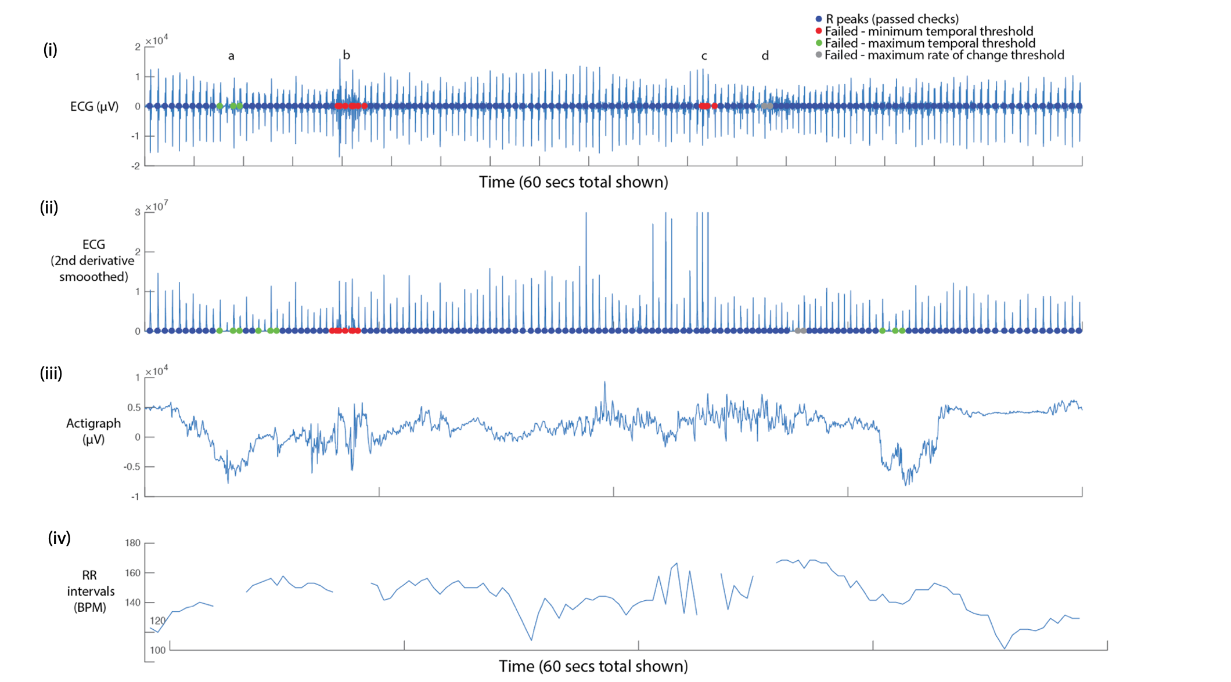

Fig. S1 Sample screenshot from ECG parsing algorithm. Sixty seconds’ data is shown. From top to bottom: (i) raw ECG signal. Coloured dots show the results of the three checks described in the text above (see also the Figure legend); (ii) smoothed second derivative of ECG signal. This measure was not used as our pilot analyses found it to be less effective than applying the processing to the raw signal; (iii) raw (unprocessed) actigraph data. This information was only used for visual inspection, and was not used in parsing; (iv) RR intervals (in BPM), with rejected data segments excluded.

Figure S2 below shows a histogram of the proportion of candidate R peaks rejected for each participant, based on the best-fitting threshold value. The median (SE) is 1.07 (0.36) percent data rejected. This relatively low figure was achieved through very close attention during the piloting phase to the selection and placement of the ECG electrodes, to the design of the device, and the gain settings on the recording device.

Fig. S2 Histogram showing the proportion of rejected R peaks (as identified using the three criteria described above).

Parsing of other autonomic variables

3.2.1 Heart-Rate Variability (HRV)
HRV was calculated using the PhysioNet Cardiovascular Signal Toolbox (Vest et al., 2018). In these scripts, which performed a completely separate analysis of the ECG data, a 60-second window with an increment of 60 seconds was implemented, and the default settings were used with the exception that the min/max interbeat interval was set at 300/750 milliseconds for the infant data and 300/1300 milliseconds for the adult data. The Root Mean Square of Successive Differences (RMSSD) measure was taken to index heart rate variability, but other frequency domain measures were additionally inspected and showed highly similar results, as expected (Vest et al., 2018).

3.2.2 Actigraphy
Actigraphy was recorded at 30Hz. To parse the actigraphy data we first manually inspected the data. Subsequently, we corrected artefacts specific to the recording device used, then applied a Butterworth low-pass filter with a cut-off of 0.1Hz to remove high-frequency noise, and then averaged from three dimensions into one. Actigraphy data were available for all participants tested.

Arousal composite
Previous research has shown significant patterns of tonic and phasic covariation between different autonomic measures collected from infants (Wass et al., 2016; Wass et al., 2015). Here, we include plots showing that the present dataset replicated and extended these results. The plots only show the sections of the data when participants were at home, comparing sections in which the infants were awake and asleep. Figure S3a shows cross-correlation plots examining the relationship between heart rate and movement. In both waking and sleeping sections the zero-lag correlation is 0.5. Figure S3c shows how these zero-lagged correlations vary on a per-participant basis. S3b shows an illustrative sample from a single participant. Sleeping sections show very low movement levels and lower heart rate. Of note, heart rate and movement do still inter-relate during the sleeping sections of the data (Figure S3c), albeit that the variability in heart rate and movement is lower. Figure S3d-f show similar relationships between heart rate and heart rate variability, illustrating the strong and consistent negative relationships that were observed between these variables, as predicted.

Fig. S3 Illustrating the relationship between the individual physiological measures included in the composite measure. (a) Cross-correlation of the relationship between heart rate and movement. (b) Scatterplot from a sample participant. Each datapoint represents an individual 60-second epoch of data. (c) Histograms showing the average zero-lagged correlation between 60-second epochs, calculated on a per-participant basis and then averaged. (d)-(f) Equivalent plots for heart rate and heart rate variability.
Extensive previous research has identified fractionation, and differentiation, within our autonomic nervous systems (Jänig & Habler, 2000; Kreibig, 2010; Lacey, 1967; Levenson, 2014; Quas et al., 2014) – suggesting, for example that the sympathetic and parasympathetic subdivisions operate, to an extent, in a non-additive manner (Samuels & Szabadi, 2008). Although indubitably true, these findings should not be seen as rendering incorrect our treatment here of autonomic arousal as a one-dimensional construct. Like many other arguments concerned with general versus specific factors, the question is rather one of the relative proportions of variance that can be accounted for by a single common factor in comparison with the variance accounted for by the sum of specific factors (Graham & Jackson, 1970; see also Calderon et al., 2016).

As a result of these considerations, the three autonomic measures were collapsed into a single composite measure. To do this, the actigraphy data was first subjected to a log transform (Thomas & Burr, 2008), to correct the raw results, which showed a strong positive skew (Wass et al., 2016; Wass et al., 2015). Second, all three variables were converted to z-scores. Third, the HRV data were inversed because of the overall negative relationships noted between HRV and the other two measures (see Figure S4). Fourth, the three z-scores were averaged.

On the occasions where heart rate data were excluded due to artefacts, data from actigraphy alone was used for the composite variable. Note that these occasions were relatively rare (accounting for a median ~1% of all data; see Figure S3), and that the zero-lag cross-correlation between movement and heart rate across all available data was high (~.5; see Figure S4).

3.3 Removal of autocorrelation from arousal data

Autonomic arousal time series are known to show autocorrelation (Wass et al., 2016). In order to preclude the possibility that differences in the autocorrelation may have influenced results, the autocorrelation was removed from the data prior to performing all calculations, using the following procedure. First, best-fit bivariate polynomials were calculated for the two time series independently, in order to remove linear and quadratic trends. The residuals obtained were subjected to the Dickey-Fuller test to check that they showed stationarity, which they did. Next, in order to remove the autocorrelation component from each time series independently, univariate autoregressive models were fitted to each time series, and the residuals were calculated (see, e.g., Feldman et al., 1999; Feldman et al., 2011; Jaffe et al., 2001; Suveg et al., 2016 for similar approaches). The residual values were used for all subsequent analyses.

Home/awake coding
Coding when participants were at home was performed using the global positioning system (GPS) monitors built into the recording devices. The position of the participant’s home was calculated based on the postcode data that they supplied, and any GPS samples within a circa 50m area of that location were treated as ‘home’ (corresponding to the accuracy of the GPS devices that we were using). To identify samples in which infants were sleeping, caregivers were asked to fill in a logbook identifying the times of infants’ naps during the day. This information was manually verified by visually examining the actigraphy and ECG data collected, on a participant-by-participant basis. Actigraphy, in particular, shows marked differences between sleeping and waking samples (see SM, Figure S3 and So et al., 2005), which allowed us to verify the caregiver reports with a high degree of accuracy.

Calculation of permutation-based temporal clustering analyses
To estimate the significance of the time-series relationships in the results, a permutation-based temporal clustering approach was used. This involved two different analytical techniques. One analysis (Method 1) looked at whether ‘peak’ reactions were observed relative to a known ‘Time=0’ moment (such as relative to a particular event). This method was used to test Hypotheses 1-3. The other analysis (Method 2) examined temporally contiguous patterns of change in instances where the centre-point of the expected response window was unknown, or unimportant (Maris & Oostenveld, 2007). This method was used to test Hypothesis 4.

Method 1: This analysis examines whether the significant clusterings of elevated values around time=0 are observed. To estimate this, the following procedure was used. If y is Time=0, then for the first time-interval (t=1) the observed data from y-1 to y+1 was excerpted (i.e., from 1 bin before to 1 bin after time=0). The proportional size of the excerpted data relative to the entire dataset was used to calculate a centile threshold (e.g., examining the central 10% of the data). The entire dataset was then rank ordered, and the highest 10% of the data was calculated. The proportion of highest data that was contained within the central segment of the data was calculated. The same calculation was then repeated for increasing values of t ranging from 1 to the total time window of the sample. Thus, for each value of t, if the observed data had been ‘perfectly’ ordered, with the highest value at time=0 and gradually decreasing values at increasing time lags, then the proportion of highest data contained within the central segment of data would always be 1.

In this way, we quantified whether higher values were more commonly observed around the time=0 point in the data. A thousand random datasets were then generated with the same dimensions as the original input data. To ensure that the same level of autocorrelation was present in the simulated data as in the original datasets, multivariate autoregressive models were fitted to each sample included in the original dataset using the Matlab function ARfit.m (Neumaier & Schneider, 2001), and the matching AR parameters were used to generate each of the random datasets using the Matlab function ARsim.m (Neumaier & Schneider, 2001).
For each random dataset, the same series of calculations as described above was performed. In this way we estimated how, for each of the random datasets, the proportion of highest data contained within the central segment of the data varied across increasing time windows from the time=0 point. The results obtained from the random datasets were used to generate a histogram, and the likelihood of observed results have been obtained by chance was calculated by comparing the observed values with the randomly generated values using a standard bootstrapping procedure. Thus, a p value of <.01 indicates that an equivalent pattern of temporally contiguous group differences was observed in 10 or fewer of the 1000 simulated datasets created.

Method 2: This analysis examines whether temporally contiguous patterns of change are observed in situations where the centre point of the expected response window is unknown. In each case, the test statistic is calculated independently for each time window. Series of significant effects across contiguous time windows are identified using an alpha level of 0.05. A thousand random datasets are then generated using the same procedures as described for Method 1, above. The same sequence of analyses is repeated, and the longest series of significant effects across contiguous time windows are identified. The results obtained from the random datasets are used to generate a histogram, and the likelihood of observed results being obtained by chance is calculated by comparing the observed values with the randomly generated values using a standard bootstrapping procedure. Thus, a p value of < 0.01 indicates that an equivalent pattern of temporally contiguous group differences was observed in 10 or fewer of the 1000 simulated datasets created.

Hypothesis 2 – further analyses

Fig. S4 Identical to Figure 3a in the main text, but examining the likelihood of low intensity vocalisations around caregiver arousal peaks.

Hypothesis 4 – arousal increases following caregiver vocalisations - differences contingent on caregiver anxiety – further analyses

In addition to the analyses presented in the main text, we also examined how the relationship between hyperarousal and vocalisations varied contingent on the level of caregiver anxiety. We conducted the same analyses in Hypothesis 4, but subdivided by a quartile split of the GAD-7 scores. For the sake of brevity, we have not included the control analyses (drawn as grey lines on Figure 4). Instead, we have only plotted the observed data. Thus, Figure S5a shows the black lines from Figures 4a (low GAD-7 group) and Figures 4b (high GAD-7 group) – but subdivided into four groups by GAD-7 score instead of two. For analyses we used an identical procedure to the permutation-based temporal clustering analyses used in the main text (see SM section 5). But instead of performing t-tests to examine group differences in each time window before correcting for multiple comparisons, we instead repeatedly performed a 1-way ANOVA in each time window before correcting for multiple comparisons.
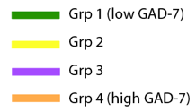
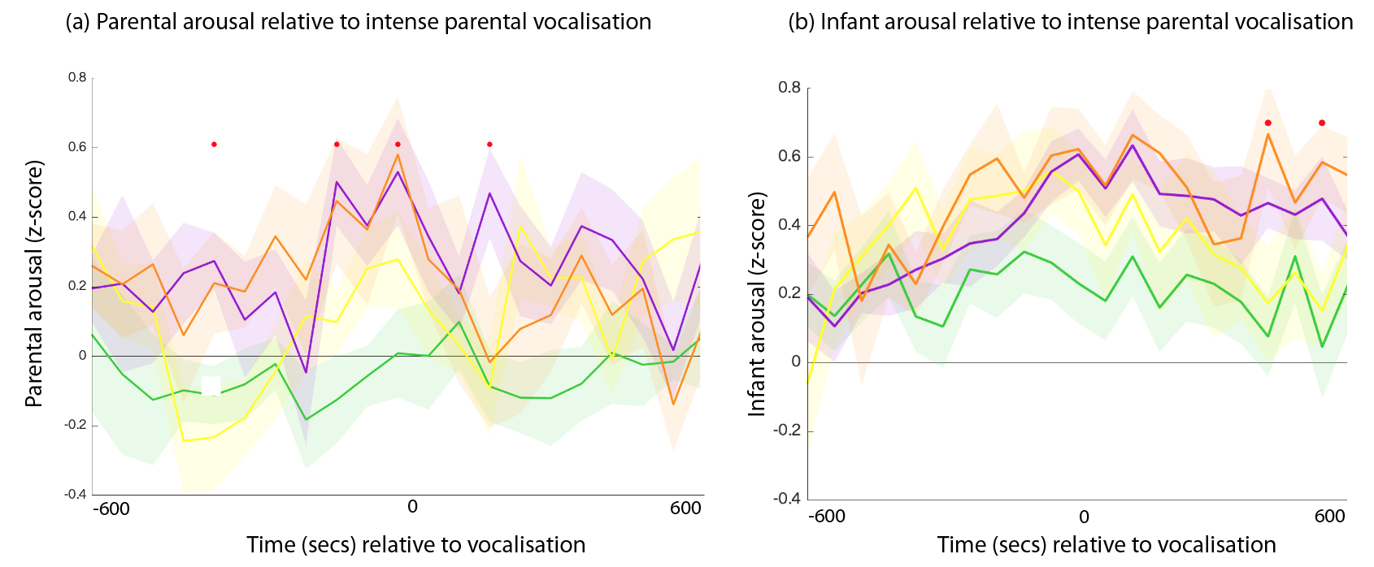

Fig. S5 Increases in (a) caregiver and (b) infant arousal at moments of high maternal vocal intensity, with maternal anxiety scores split by quartiles. The higher the anxiety level, the greater the hyperarousal. Red dots indicate significant group differences at the time bins indicated (all ps <.001).

References

A. Aurobinda, B. P. Mohanty, & M.N. Mohanty. (2016). R-peak detection of ECG using adaptive thresholding. 2016 International Conference on Communication and Signal Processing (ICCSP), 0284-0287.
de Barbaro, K., Clackson, K., & Wass, S. (2016). Stress reactivity speeds basic encoding processes in infants. Developmental Psychobiology, 58(5), 546-555.
Feldman, R., Greenbaum, C. W., & Yirmiya, N. (1999). Mother–infant affect synchrony as an antecedent of the emergence of self-control. Developmental psychology, 35(1), 223.
Feldman, R., Magori-Cohen, R., Galili, G., Singer, M., & Louzoun, Y. (2011). Mother and infant coordinate heart rhythms through episodes of interaction synchrony. Infant Behavior and Development, 34(4), 569-577.
Graham, F. K., & Jackson, J. C. (1970). Arousal systems and infant heart rate responses. In Advances in child development and behavior, 5, 59-117.
Jaffe, J., Beebe, B., Feldstein, S., Crown, C. L., Jasnow, M. D., Rochat, P., & Stern, D. N. (2001). Rhythms of dialogue in infancy: Coordinated timing in development. Monographs of the society for research in child development, i-149.
Jänig, W., & Häbler, H. J. (2000). Specificity in the organization of the autonomic nervous system: a basis for precise neural regulation of homeostatic and protective body functions. Progress in brain research, 122, 351.
Kreibig, S. D. (2010). Autonomic nervous system activity in emotion: A review. Biological psychology, 84(3), 394-421.
Lacey, J. I. (1967). Somatic response patterning and stress: Some revisions of activation theory. Psychological stress: Issues in research, 14-37.
Levenson, R. W. (2014). The autonomic nervous system and emotion. Emotion Review, 6(2), 100-112.
Maris, E., & Oostenveld, R. (2007). Nonparametric statistical testing of EEG-and MEG-data. Journal of neuroscience methods, 164(1), 177-190.
Neumaier, A., & Schneider, T. (2001). Estimation of parameters and eigenmodes of multivariate autoregressive models. ACM Transactions on Mathematical Software (TOMS), 27(1), 27-57.
Quas, J. A., Yim, I. S., Oberlander, T. F., Nordstokke, D., Essex, M. J., Armstrong, J. M., ... & Boyce, W. T. (2014). The symphonic structure of childhood stress reactivity: Patterns of sympathetic, parasympathetic, and adrenocortical responses to psychological challenge. Development and psychopathology, 26(4 0 1), 963-982.
Suveg, C., Shaffer, A., & Davis, M. (2016). Family stress moderates relations between physiological and behavioral synchrony and child self‐regulation in mother–preschooler dyads. Developmental psychobiology, 58(1), 83-97.
Vest, A. N., Da Poian, G., Li, Q., Liu, C., Nemati, S., Shah, A. J., & Clifford, G. D. (2018). An open source benchmarked toolbox for cardiovascular waveform and interval analysis. Physiological measurement, 39(10), 1-23.
Wass, S. V., Clackson, K., & de Barbaro, K. (2016). Temporal dynamics of arousal and attention in 12‐month‐old infants. Developmental psychobiology, 58(5), 623-639.
Wass, S. V., de Barbaro, K., & Clackson, K. (2015). Tonic and phasic co-variation of peripheral arousal indices in infants. Biological Psychology, 111, 26-39.
Wass, S. V. (2018). How orchids concentrate? The relationship between physiological stress reactivity and cognitive performance during infancy and early childhood. Neuroscience & Biobehavioral Reviews, 90, 34-49.

