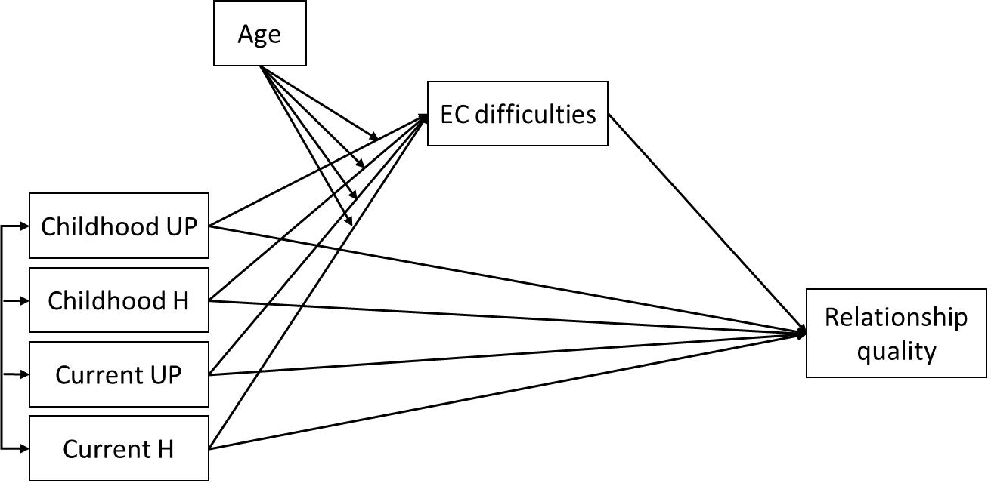
Figure S1. Conceptual moderated mediation model (Study 2). Covariates not depicted: gender, education. UP = Unpredictability, H = Harshness, EC = Emotional control.

