Online Supplemental Material
We present our rationale for choosing the four-class solution here. First, the four-class solution had the lowest AIC, BIC, and adjusted BIC values compared to other models (except for the five-profile solution), suggesting the best model fit. Second, models with three to five classes all yielded high entropy values (i.e., > .80), reflecting sufficient classification confidence (i.e., clearly distinguished classes). Third, LMR, VLMR and Bootstrapped LRT tests yielded inconsistent results. Whereas bootstrapped LRT tests were significant for all models (when N_{class} ≥ 2), LMR and VLMR LRT tests were only significant for the three-class but not four- or five-class solutions. In other words, although bootstrapped LRT tests favored class solution with more classes, LMR and VLMR LRT tests did not favor solutions with greater than equal to four classes. Fourth, an inspection of the cell sizes indicated that the smallest cell size for four- or five-class solutions were all above 5% (i.e., 14.9% for the four-class solution, and 10.2% for the five-class solution). Despite this, four of the five classes in the five-class solution had fairly small cell sizes (see Supplemental Material, Figure S2; 10.3%, 12.5%, 14.2%, 17.2%), limiting the power of statistical inferences (e.g., predictive utility). Fifth, comparing the profiles of three- vs four-class solutions, the former did not seem to capture the variability in abstract problem-solving within the sample (See Supplemental Material, Figure S1, all three classes showed similar levels of abstract problem-solving). In addition, comparing the four- vs. five-class solution, the latter seemed to identify classes with fairly similar patterns (e.g., class four and five both demonstrated low abstract and higher reward-oriented problem-solving; see Supplemental Material, Figure S2). Finally, the four-class solution identified four distinct patterns of children’s problem-solving that summarized the information from both abstract and reward-oriented problem-solving tasks. These profiles reflected four possible combinations of child problem-solving across the two-types of tasks (i.e., high vs. low abstract in conjunction with high vs. low reward-oriented problem-solving). Thus, we went with the four-class solution as our final solution for child problem-solving.

Table S1. Logistic regression coefficients for four-class solution with additional covariates (N = 226).
Class 4 (Low abstract-high RO) as comparison class
 |  | Coefficient (SE) | Z | p
Class 1  (High abstract- Low RO) | Neighborhood Crime | -0.81(0.41) | -2.00 | <.05*
 | Maternal Sensitivity | 0.05(0.14) | 0.33 | .74
 | Neighborhood Percentage Poverty | 0.01(0.02) | 0.36 | .72
 | Maternal Age | 0.02(0.07) | 0.21 | .84
 | Maternal Education | -0.11(0.14) | -0.73 | .47
Class 2  (Low abstract- Low RO) | Neighborhood Crime | -0.92(0.45) | -2.04 | .04*
 | Maternal Sensitivity | 0.19(0.19) | 0.98 | .33
 | Neighborhood Percentage Poverty | 0.03(0.03) | 1.24 | .21
 | Maternal Age | 0.002(0.08) | 0.02 | .99
 | Maternal Education | -0.14(0.16) | -0.85 | .40
Class 3  (High abstract- High RO) | Neighborhood Crime | -0.86(0.47) | -1.82 | .07†
 | Maternal Sensitivity | 0.39(0.18) | 2.18 | .03*
 | Neighborhood Percentage Poverty | 0.01(0.03) | 0.27 | .79
 | Maternal Age | 0.07(0.08) | 0.80 | .43
 | Maternal Education | -0.13(0.17) | -0.77 | .44
Class 3 (High abstract -High RO) as comparison class
Class 1  (High abstract- Low RO) | Neighborhood Crime | 0.04(0.41) | 0.10 | .92
 | Maternal Sensitivity | -0.34(0.15) | -2.27 | .02*
 | Neighborhood Percentage Poverty | 0.00(0.02) | 0.02 | .98
 | Maternal Age | -0.05(0.04) | -1.16 | .25
 | Maternal Education | 0.02(0.10) | 0.23 | .82
Class 2  (Low abstract- Low RO) | Neighborhood Crime | -0.06(0.45) | -0.14 | .89
 | Maternal Sensitivity | -0.20(0.18) | -1.13 | .26
 | Neighborhood Percentage Poverty | 0.02(0.03) | 0.94 | .35
 | Maternal Age | -0.06(0.05) | -1.18 | .24
 | Maternal Education | -0.01(0.11) | -0.10 | .92
Class 2 (Low abstract- Low RO) as comparison class
Class 1  (High abstract- Low RO) | Neighborhood Crime | 0.10 (0.39) | 0.26 | .79
 | Maternal Sensitivity | -0.14(0.17) | -0.84 | .40
 | Neighborhood Percentage Poverty | -0.02(0.02) | -1.06 | .29
 | Maternal Age | 0.01(0.05) | 0.27 | .79
 | Maternal Education | 0.03(0.10) | 0.34 | .74
Note. RO-problem-solving: reward-oriented problem solving.
Class 1: High Abstract and Low Reward-Oriented Problem-Solving; Class 2: Low Abstract and Low Reward-Oriented Problem-Solving; Class 3: High Abstract and High Reward-Oriented Problem-Solving; Class 4: Low Abstract and High Reward-Oriented Problem-Solving.

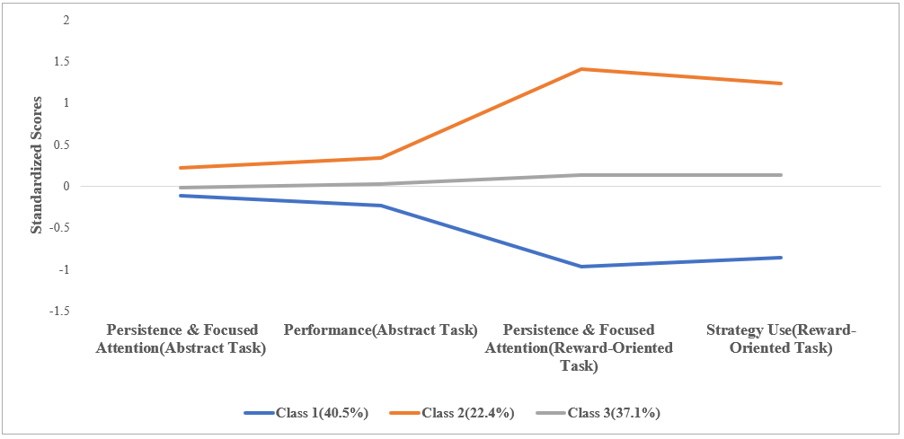
Figure S1. Latent Profiles of the three-class Solution.

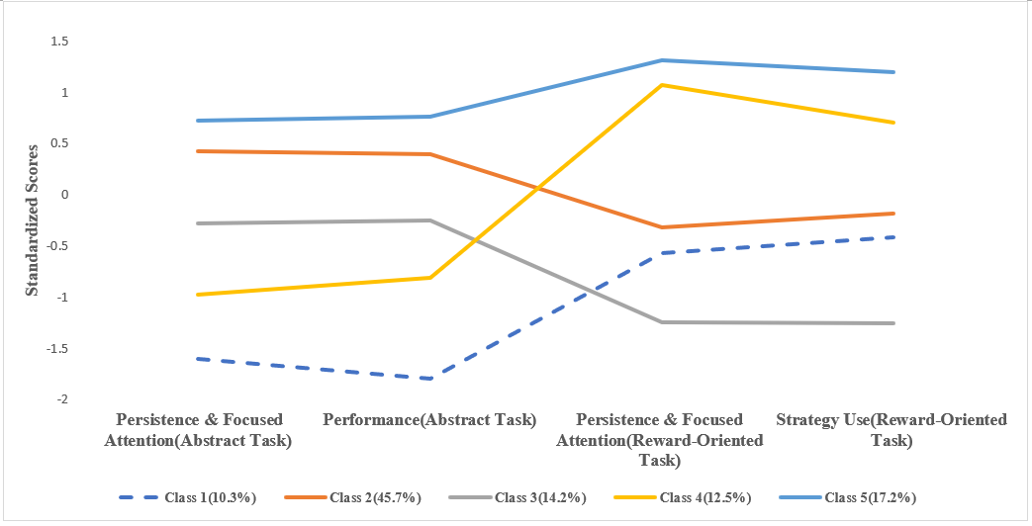
Figure S2. Latent Profiles of the Five-class Solution.

