Supplementary material file

Study 1

Regression models with two time points: before and during COVID-19 lockdown

DV: Externalizing behaviors
The model receiving more support according to Akaike weights comparison as described in the paper is Model 4
 | B | SE | t(df) | p
Model 1
Age | -0.017 | 0.022 | -0.740(71.135) | 0.462
Time | -0.003 | 0.031 | -0.119(66.925) | 0.905
Model 2
Age | 0.005 | 0.150 | 0.224(69.736) | 0.823
Time | -0.005 | 0.031 | -0.135(67.372) | 0.893
Parenting stress | 0.015 | 0.005 | 3.176(67.716) | 0.002
Fearful temperament | 0.043 | 0.032 | 1.330(66.970) | 0.188
Model 3
Age | -7.288e-05 | 2.190e-02 | -0.003(7.035e+01) | 0.997
Time | -1.349e-01 | 9.443e-02 | 1.428(6.483e+01) | 0.158
Parenting stress | 1.149e-02 | 5.219e-03 | 2.201(1.032e+02) | 0.030
Time X Parenting stress | 6.902e-03 | 4.728e-03 | 1.460(6.508e+01) | 0.149
Model 4
Age | 0.005 | 0.022 | 0.224(68.532) | 0.824
Time | 0.272 | 0.177 | 1.543(62.304) | 0.128
Parenting stress | 0.020 | 0.009 | 2.198(97.215) | 0.030
Fearful temperament | 0.177 | 0.121 | 1.460(95.987) | 0.148
Time X Parenting stress | -0.012 | 0.008 | -1.479(62.528) | 0.144
Time X Fearful temperament | -0.286 | 0.108 | -2.652(62.119) | 0.010
Parenting stress X Fearful temperament | -0.006 | 0.005 | -1.178(95.772) | 0.242
Time X Parenting stress X Fearful temperament | 0.013 | 0.005 | 2.847(62.079) | 0.006

Diagnostic statistics for Model 4. No violation was identified.
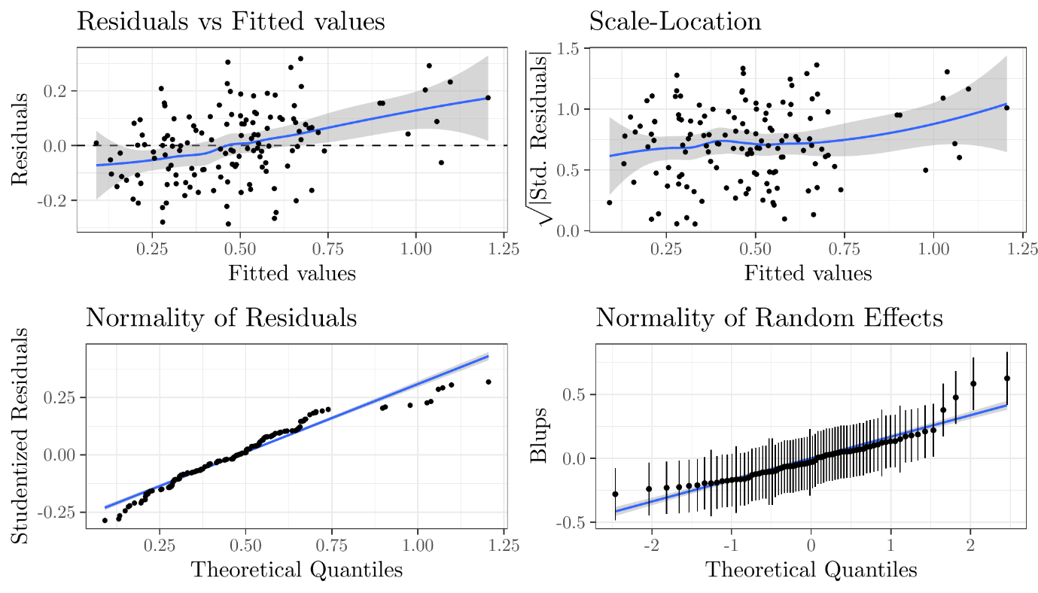

DV: Internalizing behaviors
The model receiving more support according to Akaike weights comparison as described in the paper is Model 3
 | B | SE | t(df) |  | p
Model 1
Age | -0.002 | 0.043 | -0.289(70.970) |  | 0.773
Time | 0.025 | 0.018 | 1.416(67.656) |  | 0.161
Model 2
Age | 0.006 | 0.0104 | 0.556(69.783) |  | 0.580
Time | 0.026 | 0.018 | 1.424(68.184) |  | 0.160
Parenting stress | 0.005 | 0.002 | 2.171(67.291) |  | 0.034
Fearful temperament | 0.033 | 0.015 | 1.804(66.382) |  | 0.076
Model 3
Age | 0.002 | 0.010 | 0.251(70.681) |  | 0.803
Time | -0.095 | 0.052 | -1.818(65.526) |  | 0.074
Parenting stress | 0.002 | 0.003 | 0.661(112.201) |  | 0.510
Time X Parenting stress | 0.006 | 0.003 | 2.434(65.815) |  | 0.018
Model 4
Age | 6.291e-03 | 1.042e-02 | 0.604(6.890e+01) |  | 0.548
Time | -6.199e-03 | 1.022e-01 | -0.06(6.295e+01) |  | 0.952
Parenting stress | 5.054e-04 | 4.396e-03 | 0.115(1.094e+02) | 0.909
Fearful temperament | 3.219e-02 | 5.936e-02 | 0.542(1.084e+02) |  | 0.589
Time X Parenting stress | 4.384e-03 | 4.615e-03 | 0.950(6.324e+01) |  | 0.346
Time X Fearful temperament | -6.561e-02 | 6.244e-02 | -1.051(6.272e+01) |  | 0.297
Parenting stress X Fearful temperament | 4.034e-04 | 2.528e-03 | 0.160(1.081e+02) |  | 0.874
Time X Parenting stress X Fearful temperament | 1.766e-03 | 2.654e-03 | 0.665(6.267e+01) |  | 0.508

Diagnostic statistics for Model 3. No violation was identified.

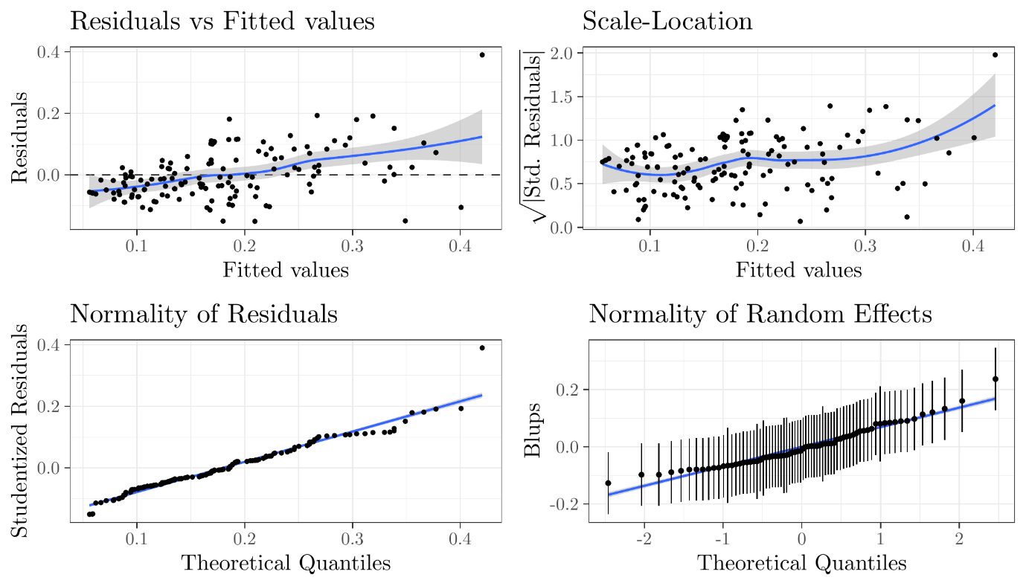

Regression models with three time points: before COVID-19, during COVID-19 lockdown and one month after the end of the lockdown

DV: Externalizing behaviors

 | B | SE | t(df) | p
Model 4
Age | 0.000 | 0.021 | 0.013(67.225) | 0.989
Time (T2) | 0.273 | 0.180 | 1.520(111.700) | 0.131
Time (T3) | 0.284 | 0.239 | 1.191(125.142) | 0.236
Parenting stress | 0.025 | 0.008 | 2.983(163.234) | 0.003
Fearful Temperament | 0.217 | 0.108 | 2.006(177.523) | 0.046
T2 X Parenting stress | -0.012 | 0.008 | -1.471(111.928) | 0.144
T3 X Parenting stress | -0.010 | 0.011 | -0.907(128.263) | 0.366
T2 X Fearful temperament | -0.283 | 0.110 | -2.580(111.553) | 0.011
T3 X Fearful temperament | -0.322 | 0.130 | -2.477(118.382) | 0.015
Parenting stress X Fearful temperament | -0.008 | 0.005 | -1.763(179.952) | 0.080
T2 X Parenting stress X Fearful temperament | 0.013 | 0.005 | 2.781(111.497) | 0.006
T3 X Parenting stress X Fearful temperament | 0.014 | 0.006 | 2.414(119.248) | 0.017

Diagnostic statistics for Model 4. No violation was identified.

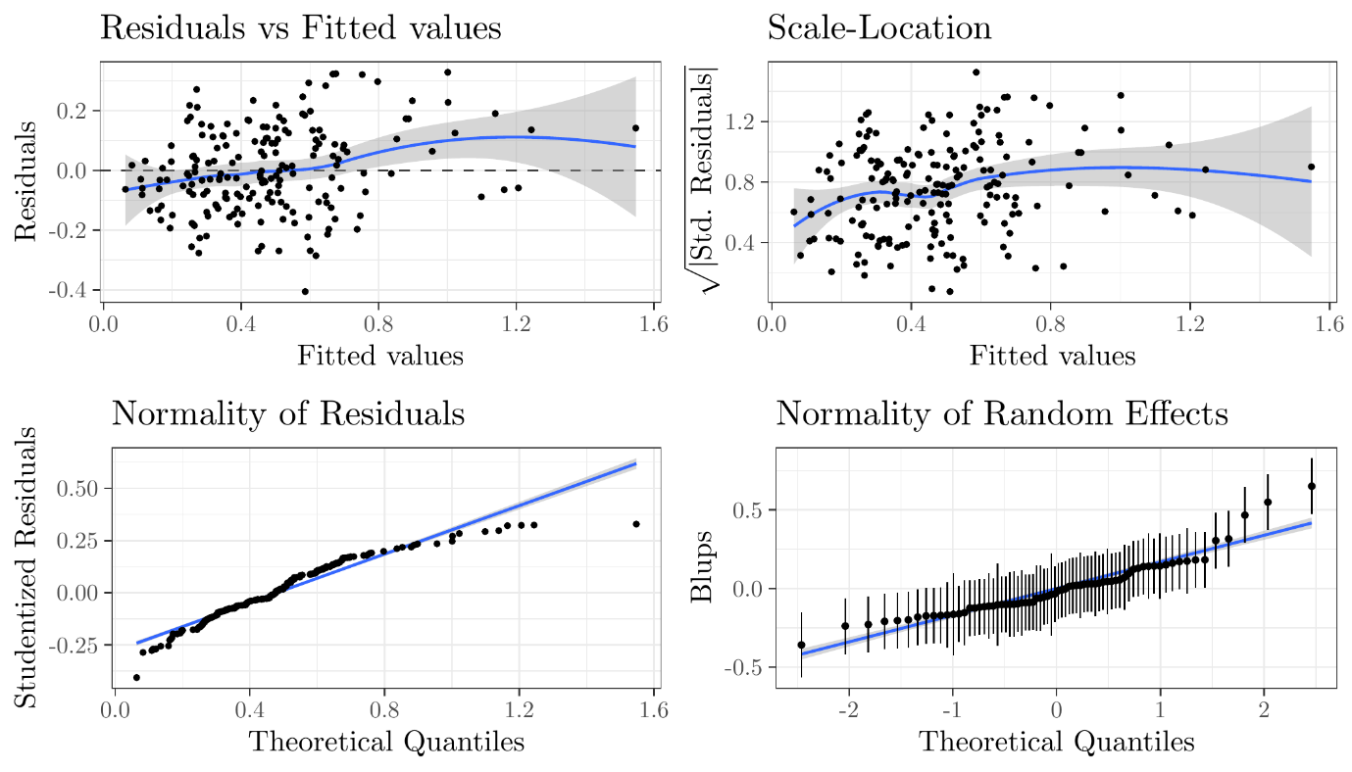

DV: Internalizing behaviors
 | B | SE | t(df) | p
Model 3
Age | -0.001 | 0.010 | -0.100(67.593) | 0.920
Time (T2) | -0.093 | 0.049 | -1.920(116.773) | 0.057
Time (T3) | -0.168 | 0.060 | -2.823(140.775) | 0.005
Parenting stress | 0.001 | 0.002 | 0.565(171.663) | 0.573
T2 X Parenting stress | 0.006 | 0.002 | 2.608(117.197) | 0.010
T3 X Parenting stress | 0.010 | 0.003 | 3.240(143.172) | 0.001

Diagnostic statistics for Model 3. No violation was identified.
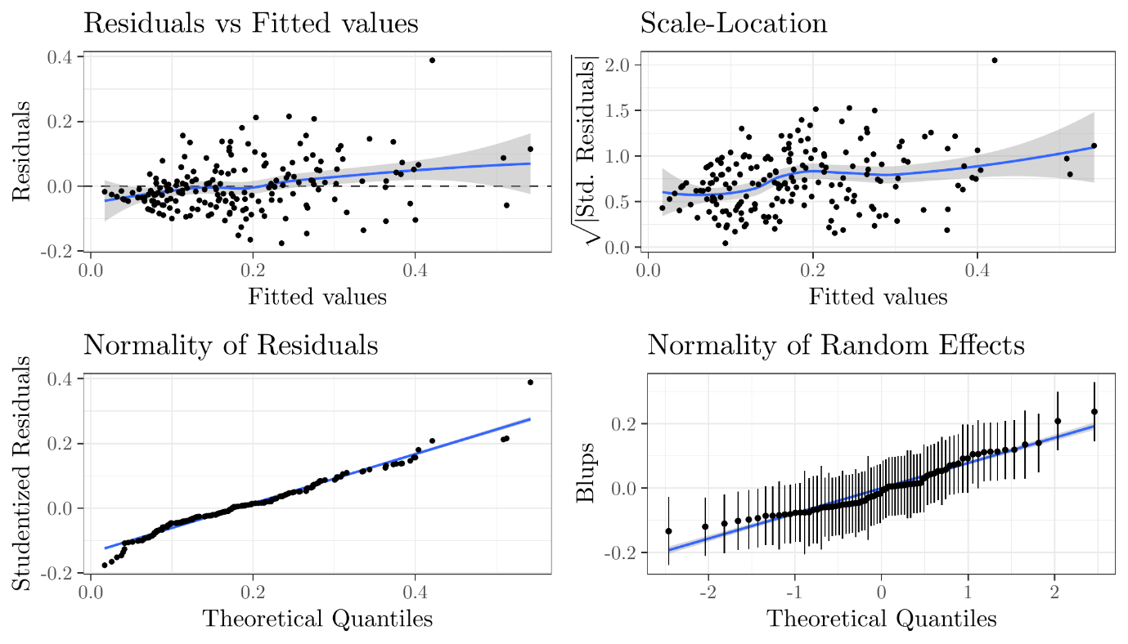

Diagnostics for missing data

For a more accurate exploration of the impact of missing data on findings, we imputed missing values 4,000 times and estimated model parameters. Density distributions below refer to these estimated parameters; black dots represent the value of the parameter based on the actual available data. Both for externalizing (3-way interaction model) and internalizing behaviors (2-way interaction model), the results with and without imputed data were overall stable.

DV: Externalizing behaviors.
Density plots represent the distribution of estimated parameters including imputed data for 4000 times; black points represent the estimated parameters on actual data (without imputation)

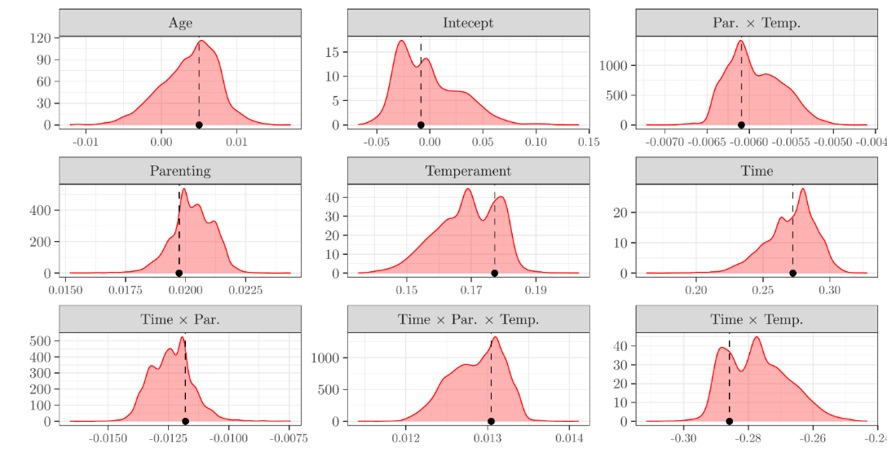
DV: Internalizing behaviors.
Density plots represent the distribution of estimated parameters including imputed data for 4000 times; black points represent the estimated parameters on actual data (without imputation).

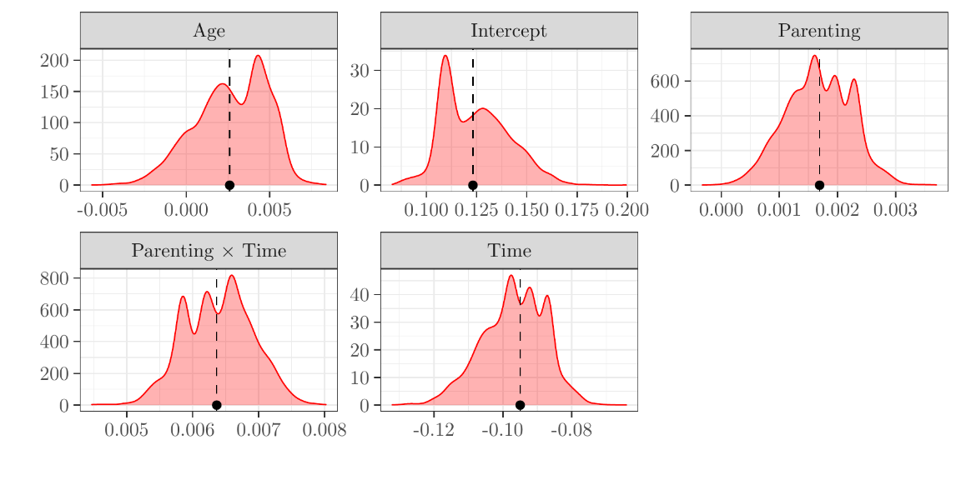

Study 2

Regression models with two timings: before COVID-19 and during COVID-19 lockdown

DV: Externalizing behaviors
The model receiving more support according to Akaike weights comparison and described in the paper is Model 3.
 | B |  | SE |  | t(df) |  |  | p
Model 1
Time | 0.195 |  | 0.057 |  | 3.404 (94.096) |  |  | .001
Model 2
Time |  | 0.195 |  | 0.057 |  | 3.405
Parental closeness |  | -0.429 |  | 0.140 |  | -3.065
Environmental Sensitivity (ES) |  | 0.030 |  | 0.061 |  | 0.483
Model 3
Time | 1.667 |  | 0.515 |  | 3.235 (92.690) |  |  | .002
Parental closeness | -0.241 |  | 0.154 |  | -1.565 (132.411) |  |  | .112
Time X Parental closeness | -0.370 |  | 0.129 |  | -2.873 (92.674) |  |  | .005
Model 4
Time | 2.625 |  | 2.294 |  | 1.144 (92) |  |  | .256
Parental closeness | 0.536 |  | 0.678 |  | 0.790 (132.965) |  |  | .431
 | 0.687 |  | 0.545 |  | 1.261 (133.464) |  |  | .210
Time X Parental closeness | -0.566 |  | 0.571 |  | -0.992 (91.670) |  |  | .324
Time X Environmental Sensitivity | -0.198 |  | 0.459 |  | -0.431 (91.817) |  |  | .667
Closeness x ES | -0.160 |  | 0.135 |  | -1.179 (132.390) |  |  | .240
Time X Closeness X ES | 0.040 |  | 0.114 |  | 0.353 (91.503) |  |  | .725

Diagnostic statistics, Model 3. No violation was identified.
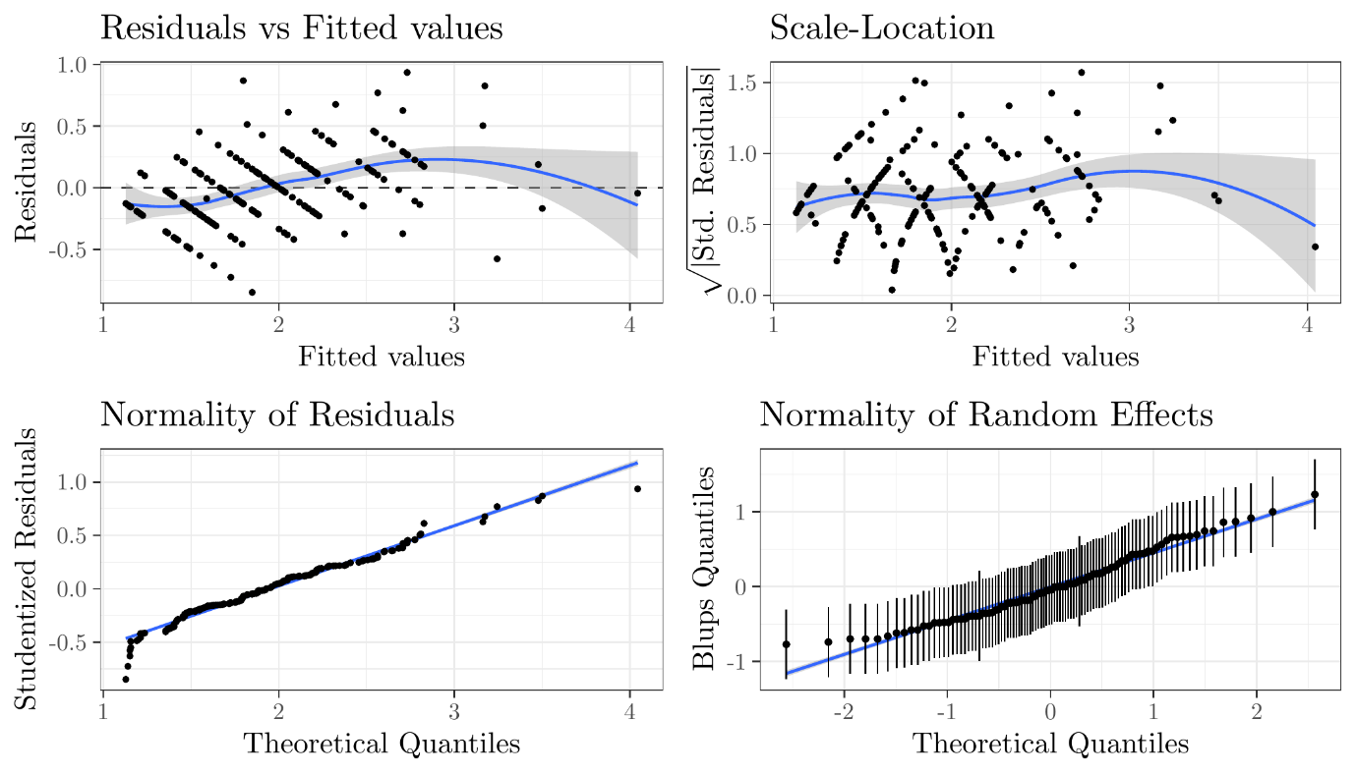
DV: Internalizing behavioural problems
The model receiving more support according to Akaike weights comparison and described in the paper is Model 4.
 | B | SE | t(df) | p
Model 1: Effect of time
Time | 0.014 | 0.087 | 0.157 (93.644) | .876
Model 2: Time X Closeness
Time | -0.106 | 0.821 | -0.129 (92.158) | .898
Closeness | -0.443 | 0.203 | -2.187 (151.382) | .030
Time X Closeness | 0.030 | 0.205 | 0.146 (92.137) | .884
Model 3: Time X Closeness X Environmental Sensitivity (ES)
Time | -6.712 | 3.513 | -1.910 (92) | .059
Closeness | -0.248 | 0.834 | -0.297 (155.806) | .767
ES | 0.526 | 0.670 | 0.785 (156.237) | .434
Time X Closeness | 1.847 | 0.875 | 2.112 (92.332) | .037
Time X ES | 1.353 | 0.703 | 1.925 (92.537) | .057
Closeness x ES | -0.044 | 0.167 | -0.263 (155.306) | .793
Time X Closeness X ES | -0.373 | 0.175 | -2.137 (92.097) | .035

Diagnostic statistics, Model 4. No violation was identified.
