Supplemental Table 1: Full Information Maximum Likelihood Multiple Group Path Analyses Estimating Pre-Pandemic Adolescent Psychological and Behavioral Adjustment on Maladaptive Behavior during the Pandemic
 | Increase in Internalizing Problems | Increase in Externalizing Problems | Change in Substance Use
 | b (SE) | b (SE) | b (SE)
China
Intercept | 0.15 (0.16) | -0.11 (0.18) | 0.29 (0.13)*
Externalizing Problems in Adolescence | -0.03 (0.05) | -0.01 (0.05) | 0.01 (0.05)
Internalizing Problems in Adolescence | 0.11 (0.04)* | 0.09 (0.05) | -0.06 (0.04)
Risk-taking Tendencies in Adolescence | -0.16 (0.05)** | -0.03 (0.04) | 0.09 (0.08)
Well-being in Adolescence | 0.1 (0.04)** | -0.07 (0.04) | -0.06 (0.03)*
Confidence in Government's Pandemic Response | -0.07 (0.04) | -0.12 (0.04)** | -0.04 (0.04)
Male | -0.66 (0.08)** | -0.28 (0.07)** | -0.1 (0.05)
Parental Education | 0.06 (0.04) | 0.01 (0.04) | 0.07 (0.03)*
Weeks since Schools Closed | -0.04 (0.06) | 0.09 (0.07) | 0.02 (0.06)
Colombia
Intercept | 0.39 (0.13)** | 0.17 (0.12) | 0.25 (0.12)*
Externalizing Problems in Adolescence | -0.03 (0.05) | -0.01 (0.05) | 0.01 (0.05)
Internalizing Problems in Adolescence | 0.11 (0.04)* | 0.09 (0.05) | -0.06 (0.04)
Risk-taking Tendencies in Adolescence | -0.16 (0.05)** | -0.03 (0.04) | -0.04 (0.03)
Well-being in Adolescence | 0.1 (0.04)** | -0.07 (0.04) | -0.06 (0.03)*
Confidence in Government's Pandemic Response | -0.07 (0.04) | -0.12 (0.04)** | -0.04 (0.04)
Male | -0.66 (0.08)** | -0.28 (0.07)** | -0.1 (0.05)
Parental Education | 0.06 (0.04) | 0.01 (0.04) | 0.07 (0.03)*
Weeks since Schools Closed | -0.04 (0.06) | 0.09 (0.07) | 0.02 (0.06)
Italy
Intercept | 0.13 (0.08) | 0.28 (0.09)** | -0.15 (0.08)*
Externalizing Problems in Adolescence | -0.03 (0.05) | -0.01 (0.05) | -0.25 (0.13)*
Internalizing Problems in Adolescence | 0.11 (0.04)* | 0.09 (0.05) | 0.26 (0.13)*
Risk-taking Tendencies in Adolescence | 0.04 (0.08) | -0.03 (0.04) | -0.04 (0.03)
Well-being in Adolescence | -0.21 (0.07)** | -0.07 (0.04) | -0.06 (0.03)*
Confidence in Government's Pandemic Response | -0.07 (0.04) | -0.12 (0.04)** | -0.04 (0.04)
Male | -0.66 (0.08)** | -0.28 (0.07)** | -0.1 (0.05)
Parental Education | 0.06 (0.04) | 0.01 (0.04) | 0.07 (0.03)*
Weeks since Schools Closed | -0.04 (0.06) | 0.09 (0.07) | 0.02 (0.06)
Jordan
Intercept | 0.02 (0.16) | 0.31 (0.12)** | 0.27 (0.07)**
Externalizing Problems in Adolescence | -0.03 (0.05) | -0.01 (0.05) | 0.01 (0.05)
Internalizing Problems in Adolescence | 0.11 (0.04)* | 0.09 (0.05) | -0.06 (0.04)
Risk-taking Tendencies in Adolescence | -0.16 (0.05)** | -0.03 (0.04) | -0.04 (0.03)
Well-being in Adolescence | 0.1 (0.04)** | -0.07 (0.04) | -0.06 (0.03)*
Confidence in Government's Pandemic Response | -0.07 (0.04) | -0.12 (0.04)** | -0.04 (0.04)
Male | -0.16 (0.19) | -0.28 (0.07)** | -0.1 (0.05)
Parental Education | 0.06 (0.04) | 0.01 (0.04) | 0.07 (0.03)*
Weeks since Schools Closed | 0.67 (0.23)** | 0.09 (0.07) | 0.02 (0.06)
Kenya
Intercept | 0.01 (0.18) | -0.22 (0.16) | -0.14 (0.18)
Externalizing Problems in Adolescence | -0.03 (0.05) | -0.01 (0.05) | 0.01 (0.05)
Internalizing Problems in Adolescence | 0.11 (0.04)* | 0.09 (0.05) | -0.06 (0.04)
Risk-taking Tendencies in Adolescence | -0.16 (0.05)** | -0.03 (0.04) | -0.04 (0.03)
Well-being in Adolescence | 0.1 (0.04)** | -0.07 (0.04) | -0.06 (0.03)*
Confidence in Government's Pandemic Response | -0.07 (0.04) | -0.12 (0.04)** | -0.04 (0.04)
Male | 0.03 (0.21) | -0.28 (0.07)** | -0.1 (0.05)
Parental Education | 0.06 (0.04) | 0.01 (0.04) | 0.07 (0.03)*
Weeks since Schools Closed | -0.04 (0.06) | 0.09 (0.07) | 0.02 (0.06)
Philippines
Intercept | 0.75 (0.12)** | -1.12 (0.47)* | -0.7 (0.18)**
Externalizing Problems in Adolescence | -0.03 (0.05) | -0.01 (0.05) | 0.01 (0.05)
Internalizing Problems in Adolescence | 0.11 (0.04)* | 0.09 (0.05) | -0.06 (0.04)
Risk-taking Tendencies in Adolescence | -0.16 (0.05)** | -0.03 (0.04) | -0.04 (0.03)
Well-being in Adolescence | 0.1 (0.04)** | -0.07 (0.04) | -0.06 (0.03)*
Confidence in Government's Pandemic Response | -0.07 (0.04) | -0.38 (0.08)** | -0.04 (0.04)
Male | -0.66 (0.08)** | -0.28 (0.07)** | -0.1 (0.05)
Parental Education | 0.06 (0.04) | 0.01 (0.04) | 0.07 (0.03)*
Weeks since Schools Closed | -0.04 (0.06) | -1.55 (0.63)* | 0.02 (0.06)
Sweden
Intercept | 0.14 (0.13) | 0.24 (0.13) | 0.1 (0.09)
Externalizing Problems in Adolescence | -0.03 (0.05) | -0.01 (0.05) | 0.01 (0.05)
Internalizing Problems in Adolescence | 0.11 (0.04)* | 0.09 (0.05) | -0.06 (0.04)
Risk-taking Tendencies in Adolescence | 0.22 (0.15) | -0.03 (0.04) | -0.04 (0.03)
Well-being in Adolescence | 0.1 (0.04)** | -0.07 (0.04) | -0.06 (0.03)*
Confidence in Government's Pandemic Response | -0.07 (0.04) | -0.12 (0.04)** | -0.04 (0.04)
Male | -0.66 (0.08)** | -0.28 (0.07)** | -0.1 (0.05)
Parental Education | 0.06 (0.04) | 0.01 (0.04) | 0.07 (0.03)*
Weeks since Schools Closed | -0.04 (0.06) | 0.09 (0.07) | 0.02 (0.06)
Thailand
Intercept | -0.43 (0.15)** | 1.53 (0.68)* | -0.07 (0.12)
Externalizing Problems in Adolescence | -0.03 (0.05) | -0.01 (0.05) | -0.77 (0.17)**
Internalizing Problems in Adolescence | 0.11 (0.04)* | 0.09 (0.05) | 0.41 (0.08)**
Risk-taking Tendencies in Adolescence | -0.16 (0.05)** | -0.03 (0.04) | -0.04 (0.03)
Well-being in Adolescence | 0.1 (0.04)** | -0.07 (0.04) | -0.06 (0.03)*
Confidence in Government's Pandemic Response | -0.07 (0.04) | -0.12 (0.04)** | -0.04 (0.04)
Male | -0.21 (0.18) | -0.28 (0.07)** | -0.1 (0.05)
Parental Education | 0.06 (0.04) | 0.01 (0.04) | 0.07 (0.03)*
Weeks since Schools Closed | -0.04 (0.06) | 2 (0.65)** | 0.02 (0.06)
United States
Intercept | 0.42 (0.1)** | 0.09 (0.09) | 0.27 (0.11)*
Externalizing Problems in Adolescence | -0.03 (0.05) | -0.01 (0.05) | 0.01 (0.05)
Internalizing Problems in Adolescence | 0.11 (0.04)* | 0.09 (0.05) | -0.06 (0.04)
Risk-taking Tendencies in Adolescence | 0.25 (0.1)** | -0.03 (0.04) | -0.04 (0.03)
Well-being in Adolescence | -0.27 (0.08)** | -0.3 (0.08)** | -0.06 (0.03)*
Confidence in Government's Pandemic Response | -0.07 (0.04) | -0.12 (0.04)** | -0.04 (0.04)
Male | -0.66 (0.08)** | -0.28 (0.07)** | -0.1 (0.05)
Parental Education | 0.06 (0.04) | 0.29 (0.09)** | 0.07 (0.03)*
Weeks since Schools Closed | -0.04 (0.06) | 0.09 (0.07) | 0.02 (0.06)
Fit Statistics
Chi Square (DOF), p-value | 60.55 (55), p=0.28 | 59.89 (59), p=0.44 | 61.94 (59), p=0.37
RMSEA | 0.03 | 0.01 | 0.02
CFI | 0.96 | 0.99 | 0.95
SRMR | 0.03 | 0.03 | 0.03
b=standardized coefficient. *p < .05, **p < .01.

Supplemental Table 2: Full Information Maximum Likelihood Multiple Group Path Analyses Estimating Moderation of Relations between Pre-Pandemic Adolescent Internalizing Problems and Maladaptive Behavior during the Pandemic by Confidence in Government’s Response
 | Increase in Internalizing Problems | Increase in Externalizing Problems | Change in Substance Use
 | b (SE) | b (SE) | b (SE)
China
Intercept | 0.16 (0.16) | -0.12 (0.18) | 0.31 (0.13)*
Externalizing Problems in Adolescence | -0.02 (0.05) | -0.01 (0.05) | 0.01 (0.05)
Internalizing Problems in Adolescence | 0.1 (0.04)* | 0.09 (0.05) | -0.08 (0.04)*
Risk-taking Tendencies in Adolescence | -0.21 (0.05)** | -0.03 (0.04) | 0.09 (0.08)
Well-being in Adolescence | 0.11 (0.04)** | -0.07 (0.04) | -0.06 (0.03)*
Confidence in Government's Pandemic Response | -0.08 (0.04)* | -0.12 (0.04)** | -0.05 (0.04)
Male | -0.66 (0.08)** | -0.27 (0.07)** | -0.1 (0.05)
Parental Education | 0.07 (0.04) | 0.01 (0.04) | 0.07 (0.03)*
Weeks since Schools Closed | -0.04 (0.06) | 0.09 (0.07) | 0.01 (0.06)
Internalizing*Government Confidence | -0.05 (0.03) | -0.01 (0.04) | 0.05 (0.03)
Colombia
Intercept | 0.35 (0.13)* | 0.16 (0.12) | 0.27 (0.12)*
Externalizing Problems in Adolescence | -0.02 (0.05) | -0.01 (0.05) | 0.01 (0.05)
Internalizing Problems in Adolescence | 0.1 (0.04)* | 0.09 (0.05) | -0.08 (0.04)*
Risk-taking Tendencies in Adolescence | 0.07 (0.14) | -0.03 (0.04) | -0.04 (0.03)
Well-being in Adolescence | 0.11 (0.04)** | -0.07 (0.04) | -0.06 (0.03)*
Confidence in Government's Pandemic Response | -0.08 (0.04)* | -0.12 (0.04)** | -0.05 (0.04)
Male | -0.66 (0.08)** | -0.27 (0.07)** | -0.1 (0.05)
Parental Education | 0.07 (0.04) | 0.01 (0.04) | 0.07 (0.03)*
Weeks since Schools Closed | -0.04 (0.06) | 0.09 (0.07) | 0.01 (0.06)
Internalizing*Government Confidence | -0.05 (0.03) | -0.01 (0.04) | 0.05 (0.03)
Italy
Intercept | 0.15 (0.08) | 0.28 (0.09)** | -0.15 (0.08)*
Externalizing Problems in Adolescence | -0.02 (0.05) | -0.01 (0.05) | -0.24 (0.12)
Internalizing Problems in Adolescence | 0.1 (0.04)* | 0.09 (0.05) | 0.25 (0.12)*
Risk-taking Tendencies in Adolescence | 0.03 (0.08) | -0.03 (0.04) | -0.04 (0.03)
Well-being in Adolescence | -0.23 (0.07)** | -0.07 (0.04) | -0.06 (0.03)*
Confidence in Government's Pandemic Response | -0.08 (0.04)* | -0.12 (0.04)** | -0.05 (0.04)
Male | -0.66 (0.08)** | -0.27 (0.07)** | -0.1 (0.05)
Parental Education | 0.07 (0.04) | 0.01 (0.04) | 0.07 (0.03)*
Weeks since Schools Closed | -0.04 (0.06) | 0.09 (0.07) | 0.01 (0.06)
Internalizing*Government Confidence | 0.11 (0.05)* | -0.01 (0.04) | 0.05 (0.03)
Jordan
Intercept | -0.04 (0.16) | 0.31 (0.12)** | 0.28 (0.07)**
Externalizing Problems in Adolescence | -0.02 (0.05) | -0.01 (0.05) | 0.01 (0.05)
Internalizing Problems in Adolescence | 0.1 (0.04)* | 0.09 (0.05) | -0.08 (0.04)*
Risk-taking Tendencies in Adolescence | -0.21 (0.05)** | -0.03 (0.04) | -0.04 (0.03)
Well-being in Adolescence | 0.11 (0.04)** | -0.07 (0.04) | -0.06 (0.03)*
Confidence in Government's Pandemic Response | -0.08 (0.04)* | -0.12 (0.04)** | -0.05 (0.04)
Male | -0.1 (0.19) | -0.27 (0.07)** | -0.1 (0.05)
Parental Education | 0.07 (0.04) | 0.01 (0.04) | 0.07 (0.03)*
Weeks since Schools Closed | 0.69 (0.22)** | 0.09 (0.07) | 0.01 (0.06)
Internalizing*Government Confidence | -0.05 (0.03) | -0.01 (0.04) | 0.05 (0.03)
Kenya
Intercept | -6.84 (3.52) | -0.22 (0.16) | -0.14 (0.18)
Externalizing Problems in Adolescence | -0.02 (0.05) | -0.01 (0.05) | 0.01 (0.05)
Internalizing Problems in Adolescence | 0.1 (0.04)* | 0.09 (0.05) | -0.08 (0.04)*
Risk-taking Tendencies in Adolescence | -0.21 (0.05)** | -0.03 (0.04) | -0.04 (0.03)
Well-being in Adolescence | 0.11 (0.04)** | -0.07 (0.04) | -0.06 (0.03)*
Confidence in Government's Pandemic Response | -0.08 (0.04)* | -0.12 (0.04)** | -0.05 (0.04)
Male | -0.01 (0.2) | -0.27 (0.07)** | -0.1 (0.05)
Parental Education | 0.07 (0.04) | 0.01 (0.04) | 0.07 (0.03)*
Weeks since Schools Closed | 4.2 (2.2) | 0.09 (0.07) | 0.01 (0.06)
Internalizing*Government Confidence | -0.05 (0.03) | -0.01 (0.04) | 0.05 (0.03)
Philippines
Intercept | 0.75 (0.12)** | -1.12 (0.48)* | -0.71 (0.18)**
Externalizing Problems in Adolescence | -0.02 (0.05) | -0.01 (0.05) | 0.01 (0.05)
Internalizing Problems in Adolescence | 0.1 (0.04)* | 0.09 (0.05) | -0.08 (0.04)*
Risk-taking Tendencies in Adolescence | -0.21 (0.05)** | -0.03 (0.04) | -0.04 (0.03)
Well-being in Adolescence | 0.11 (0.04)** | -0.07 (0.04) | -0.06 (0.03)*
Confidence in Government's Pandemic Response | -0.08 (0.04)* | -0.38 (0.08)** | -0.05 (0.04)
Male | -0.66 (0.08)** | -0.27 (0.07)** | -0.1 (0.05)
Parental Education | 0.07 (0.04) | 0.01 (0.04) | 0.07 (0.03)*
Weeks since Schools Closed | -0.04 (0.06) | -1.54 (0.64)* | 0.01 (0.06)
Internalizing*Government Confidence | -0.05 (0.03) | -0.01 (0.04) | 0.05 (0.03)
Sweden
Intercept | 0.13 (0.14) | 0.23 (0.13) | 0.1 (0.08)
Externalizing Problems in Adolescence | -0.02 (0.05) | -0.01 (0.05) | 0.01 (0.05)
Internalizing Problems in Adolescence | 0.1 (0.04)* | 0.09 (0.05) | -0.08 (0.04)*
Risk-taking Tendencies in Adolescence | 0.23 (0.15) | -0.03 (0.04) | -0.04 (0.03)
Well-being in Adolescence | 0.11 (0.04)** | -0.07 (0.04) | -0.06 (0.03)*
Confidence in Government's Pandemic Response | -0.08 (0.04)* | -0.12 (0.04)** | -0.05 (0.04)
Male | -0.66 (0.08)** | -0.27 (0.07)** | -0.1 (0.05)
Parental Education | 0.07 (0.04) | 0.01 (0.04) | 0.07 (0.03)*
Weeks since Schools Closed | -0.04 (0.06) | 0.09 (0.07) | 0.01 (0.06)
Internalizing*Government Confidence | -0.05 (0.03) | -0.01 (0.04) | 0.05 (0.03)
Thailand
Intercept | -0.44 (0.15)** | 1.54 (0.68)* | -0.11 (0.13)
Externalizing Problems in Adolescence | -0.02 (0.05) | -0.01 (0.05) | -0.76 (0.16)**
Internalizing Problems in Adolescence | 0.1 (0.04)* | 0.09 (0.05) | 0.27 (0.11)*
Risk-taking Tendencies in Adolescence | -0.21 (0.05)** | -0.03 (0.04) | -0.04 (0.03)
Well-being in Adolescence | 0.11 (0.04)** | -0.07 (0.04) | -0.06 (0.03)*
Confidence in Government's Pandemic Response | -0.08 (0.04)* | -0.12 (0.04)** | -0.05 (0.04)
Male | -0.2 (0.18) | -0.27 (0.07)** | -0.1 (0.05)
Parental Education | 0.07 (0.04) | 0.01 (0.04) | 0.07 (0.03)*
Weeks since Schools Closed | -0.04 (0.06) | 2 (0.65)** | 0.01 (0.06)
Internalizing*Government Confidence | -0.05 (0.03) | -0.01 (0.04) | -0.17 (0.11)
United States
Intercept | 0.39 (0.1)** | 0.09 (0.1) | 0.28 (0.11)*
Externalizing Problems in Adolescence | -0.02 (0.05) | -0.01 (0.05) | 0.01 (0.05)
Internalizing Problems in Adolescence | 0.1 (0.04)* | 0.09 (0.05) | -0.08 (0.04)*
Risk-taking Tendencies in Adolescence | 0.26 (0.09)** | -0.03 (0.04) | -0.04 (0.03)
Well-being in Adolescence | -0.27 (0.08)** | -0.29 (0.08)** | -0.06 (0.03)*
Confidence in Government's Pandemic Response | -0.08 (0.04)* | -0.12 (0.04)** | -0.05 (0.04)
Male | -0.66 (0.08)** | -0.27 (0.07)** | -0.1 (0.05)
Parental Education | 0.07 (0.04) | 0.29 (0.09)** | 0.07 (0.03)*
Weeks since Schools Closed | -0.04 (0.06) | 0.09 (0.07) | 0.01 (0.06)
Internalizing*Government Confidence | -0.05 (0.03) | -0.01 (0.04) | 0.05 (0.03)
Model Fit Statistics
Chi Square (DOF), p-value | 71.39 (60), p=0.15 | 71.16 (67), p=0.34 | 65.26 (66), p=0.5
RMSEA | 0.04 | 0.02 | 0
CFI | 0.93 | 0.95 | 1
SRMR | 0.03 | 0.031 | 0.031
b=standardized coefficient. *p < .05, **p < .01.
Supplemental Table 3: Full Information Maximum Likelihood Multiple Group Path Analyses Estimating Moderation of Relations between Pre-Pandemic Adolescent Internalizing Problems and Maladaptive Behavior during the Pandemic by Gender
 | Increase in Internalizing Problems | Increase in Externalizing Problems | Change in Substance Use
 | b (SE) | b (SE) | b (SE)
China
Intercept | 0.16 (0.16) | -0.08 (0.18) | 0.21 (0.14)
Externalizing Problems in Adolescence | -0.03 (0.05) | -0.01 (0.05) | 0.01 (0.05)
Internalizing Problems in Adolescence | 0.13 (0.05)* | 0.09 (0.06) | -0.04 (0.04)
Risk-taking Tendencies in Adolescence | -0.11 (0.04)* | -0.02 (0.04) | 0 (0.03)
Well-being in Adolescence | 0.11 (0.04)** | -0.07 (0.04) | -0.06 (0.03)*
Confidence in Government's Pandemic Response | -0.06 (0.04) | -0.12 (0.04)** | -0.03 (0.04)
Male | -0.65 (0.08)** | -0.28 (0.07)** | -0.1 (0.05)
Parental Education | 0.06 (0.04) | 0.01 (0.04) | 0.05 (0.03)
Weeks since Schools Closed | -0.04 (0.06) | 0.08 (0.07) | 0.03 (0.06)
Internalizing*Male | -0.06 (0.07) | -0.01 (0.08) | -0.06 (0.05)
Colombia
Intercept | 0.38 (0.13)** | 0.17 (0.12) | 0.23 (0.12)
Externalizing Problems in Adolescence | -0.03 (0.05) | -0.01 (0.05) | 0.01 (0.05)
Internalizing Problems in Adolescence | 0.13 (0.05)* | 0.09 (0.06) | -0.04 (0.04)
Risk-taking Tendencies in Adolescence | -0.11 (0.04)* | -0.02 (0.04) | 0 (0.03)
Well-being in Adolescence | 0.11 (0.04)** | -0.07 (0.04) | -0.06 (0.03)*
Confidence in Government's Pandemic Response | -0.06 (0.04) | -0.12 (0.04)** | -0.03 (0.04)
Male | -0.65 (0.08)** | -0.28 (0.07)** | -0.1 (0.05)
Parental Education | 0.06 (0.04) | 0.01 (0.04) | 0.05 (0.03)
Weeks since Schools Closed | -0.04 (0.06) | 0.08 (0.07) | 0.03 (0.06)
Internalizing*Male | -0.06 (0.07) | -0.01 (0.08) | -0.06 (0.05)
Italy
Intercept | 0.18 (0.08)* | 0.27 (0.09)** | -0.16 (0.08)*
Externalizing Problems in Adolescence | -0.03 (0.05) | -0.01 (0.05) | -0.26 (0.13)*
Internalizing Problems in Adolescence | 0.13 (0.05)* | 0.09 (0.06) | 0.28 (0.13)*
Risk-taking Tendencies in Adolescence | -0.11 (0.04)* | -0.02 (0.04) | 0 (0.03)
Well-being in Adolescence | -0.2 (0.07)** | -0.07 (0.04) | -0.06 (0.03)*
Confidence in Government's Pandemic Response | -0.06 (0.04) | -0.12 (0.04)** | -0.03 (0.04)
Male | -0.65 (0.08)** | -0.28 (0.07)** | -0.1 (0.05)
Parental Education | 0.06 (0.04) | 0.01 (0.04) | 0.05 (0.03)
Weeks since Schools Closed | -0.04 (0.06) | 0.08 (0.07) | 0.03 (0.06)
Internalizing*Male | -0.06 (0.07) | -0.01 (0.08) | -0.06 (0.05)
Jordan
Intercept | 0.09 (0.15) | 0.32 (0.12)** | 0.32 (0.07)**
Externalizing Problems in Adolescence | -0.03 (0.05) | -0.01 (0.05) | 0.01 (0.05)
Internalizing Problems in Adolescence | 0.13 (0.05)* | 0.09 (0.06) | -0.04 (0.04)
Risk-taking Tendencies in Adolescence | -0.11 (0.04)* | -0.02 (0.04) | 0 (0.03)
Well-being in Adolescence | 0.11 (0.04)** | -0.07 (0.04) | -0.06 (0.03)*
Confidence in Government's Pandemic Response | -0.06 (0.04) | -0.12 (0.04)** | -0.03 (0.04)
Male | -0.19 (0.19) | -0.28 (0.07)** | -0.1 (0.05)
Parental Education | 0.06 (0.04) | 0.01 (0.04) | 0.05 (0.03)
Weeks since Schools Closed | 0.66 (0.23)** | 0.08 (0.07) | 0.03 (0.06)
Internalizing*Male | -0.06 (0.07) | -0.01 (0.08) | -0.06 (0.05)
Kenya
Intercept | 0.05 (0.18) | -0.19 (0.16) | -0.16 (0.18)
Externalizing Problems in Adolescence | -0.03 (0.05) | -0.01 (0.05) | 0.01 (0.05)
Internalizing Problems in Adolescence | 0.13 (0.05)* | 0.09 (0.06) | -0.04 (0.04)
Risk-taking Tendencies in Adolescence | -0.11 (0.04)* | -0.02 (0.04) | 0 (0.03)
Well-being in Adolescence | 0.11 (0.04)** | -0.07 (0.04) | -0.06 (0.03)*
Confidence in Government's Pandemic Response | -0.06 (0.04) | -0.12 (0.04)** | -0.03 (0.04)
Male | 0 (0.21) | -0.28 (0.07)** | -0.1 (0.05)
Parental Education | 0.06 (0.04) | 0.01 (0.04) | 0.05 (0.03)
Weeks since Schools Closed | -0.04 (0.06) | 0.08 (0.07) | 0.03 (0.06)
Internalizing*Male | -0.06 (0.07) | -0.01 (0.08) | -0.06 (0.05)
Philippines
Intercept | 0.74 (0.12)** | 0.09 (0.12) | -0.68 (0.18)**
Externalizing Problems in Adolescence | -0.03 (0.05) | -0.01 (0.05) | 0.01 (0.05)
Internalizing Problems in Adolescence | 0.13 (0.05)* | 0.09 (0.06) | -0.04 (0.04)
Risk-taking Tendencies in Adolescence | -0.11 (0.04)* | -0.02 (0.04) | 0 (0.03)
Well-being in Adolescence | 0.11 (0.04)** | -0.07 (0.04) | -0.06 (0.03)*
Confidence in Government's Pandemic Response | -0.06 (0.04) | -0.37 (0.08)** | -0.03 (0.04)
Male | -0.65 (0.08)** | -0.28 (0.07)** | -0.1 (0.05)
Parental Education | 0.06 (0.04) | 0.01 (0.04) | 0.05 (0.03)
Weeks since Schools Closed | -0.04 (0.06) | 0.08 (0.07) | 0.03 (0.06)
Internalizing*Male | -0.06 (0.07) | -0.01 (0.08) | -0.06 (0.05)
Sweden
Intercept | 0.12 (0.14) | 0.23 (0.13) | 0.11 (0.09)
Externalizing Problems in Adolescence | -0.03 (0.05) | -0.01 (0.05) | 0.01 (0.05)
Internalizing Problems in Adolescence | 0.13 (0.05)* | 0.09 (0.06) | -0.04 (0.04)
Risk-taking Tendencies in Adolescence | 0.23 (0.14) | -0.02 (0.04) | 0 (0.03)
Well-being in Adolescence | 0.11 (0.04)** | -0.07 (0.04) | -0.06 (0.03)*
Confidence in Government's Pandemic Response | -0.06 (0.04) | -0.12 (0.04)** | -0.03 (0.04)
Male | -0.65 (0.08)** | -0.28 (0.07)** | -0.1 (0.05)
Parental Education | 0.06 (0.04) | 0.01 (0.04) | 0.05 (0.03)
Weeks since Schools Closed | -0.04 (0.06) | 0.08 (0.07) | 0.03 (0.06)
Internalizing*Male | -0.06 (0.07) | -0.01 (0.08) | -0.06 (0.05)
Thailand
Intercept | -0.44 (0.15)** | 1.52 (0.68)* | -0.06 (0.12)
Externalizing Problems in Adolescence | -0.03 (0.05) | -0.01 (0.05) | -0.76 (0.17)**
Internalizing Problems in Adolescence | 0.13 (0.05)* | 0.09 (0.06) | 0.43 (0.08)**
Risk-taking Tendencies in Adolescence | -0.11 (0.04)* | -0.02 (0.04) | 0 (0.03)
Well-being in Adolescence | 0.11 (0.04)** | -0.07 (0.04) | -0.06 (0.03)*
Confidence in Government's Pandemic Response | -0.06 (0.04) | -0.12 (0.04)** | -0.03 (0.04)
Male | -0.2 (0.18) | -0.28 (0.07)** | -0.1 (0.05)
Parental Education | 0.06 (0.04) | 0.01 (0.04) | 0.05 (0.03)
Weeks since Schools Closed | -0.04 (0.06) | 1.99 (0.65)** | 0.03 (0.06)
Internalizing*Male | -0.06 (0.07) | -0.01 (0.08) | -0.06 (0.05)
United States
Intercept | 0.41 (0.1)** | 0.08 (0.1) | 0.22 (0.11)*
Externalizing Problems in Adolescence | -0.03 (0.05) | -0.01 (0.05) | 0.01 (0.05)
Internalizing Problems in Adolescence | 0.13 (0.05)* | 0.09 (0.06) | -0.04 (0.04)
Risk-taking Tendencies in Adolescence | 0.25 (0.1)** | -0.02 (0.04) | 0 (0.03)
Well-being in Adolescence | -0.27 (0.08)** | -0.3 (0.08)** | -0.06 (0.03)*
Confidence in Government's Pandemic Response | -0.06 (0.04) | -0.12 (0.04)** | -0.03 (0.04)
Male | -0.65 (0.08)** | -0.28 (0.07)** | -0.1 (0.05)
Parental Education | 0.06 (0.04) | 0.28 (0.09)** | 0.22 (0.1)*
Weeks since Schools Closed | -0.04 (0.06) | 0.08 (0.07) | 0.03 (0.06)
Internalizing*Male | -0.06 (0.07) | -0.01 (0.08) | -0.06 (0.05)
Model Fit Statistics
Chi Square (DOF), p-value | 67.56 (64), p=0.36 | 72.08 (68), p=0.34 | 67.84 (67), p=0.45
RMSEA | 0.02 | 0.02 | 0.01
CFI | 0.97 | 0.95 | 0.98
SRMR | 0.03 | 0.034 | 0.032
b=standardized coefficient. *p < .05, **p < .01.
Supplemental Table 4: Full Information Maximum Likelihood Multiple Group Path Analyses Estimating Moderation of Relations between Pre-Pandemic Adolescent Internalizing Problems and Maladaptive Behavior during the Pandemic by Parental Education
 | Increase in Internalizing Problems | Increase in Externalizing Problems | Change in Substance Use
 | b (SE) | b (SE) | b (SE)
China
Intercept | 0.15 (0.16) | -0.15 (0.18) | 0.29 (0.13)*
Externalizing Problems in Adolescence | -0.03 (0.05) | -0.01 (0.05) | 0.01 (0.05)
Internalizing Problems in Adolescence | 0.11 (0.04)** | 0.09 (0.05) | -0.06 (0.04)
Risk-taking Tendencies in Adolescence | -0.16 (0.05)** | -0.03 (0.04) | 0.09 (0.08)
Well-being in Adolescence | 0.11 (0.04)** | -0.08 (0.04)* | -0.06 (0.03)*
Confidence in Government's Pandemic Response | -0.07 (0.04) | -0.11 (0.04)** | -0.04 (0.04)
Male | -0.66 (0.08)** | -0.27 (0.07)** | -0.1 (0.05)
Parental Education | 0.06 (0.04) | -0.01 (0.04) | 0.07 (0.03)*
Weeks since Schools Closed | -0.04 (0.06) | 0.1 (0.07) | 0.02 (0.06)
Internalizing*Parental Education | 0.01 (0.03) | 0.03 (0.04) | -0.02 (0.03)
Colombia
Intercept | 0.4 (0.13)** | 0.18 (0.12) | 0.24 (0.12)
Externalizing Problems in Adolescence | -0.03 (0.05) | -0.01 (0.05) | 0.01 (0.05)
Internalizing Problems in Adolescence | 0.11 (0.04)** | 0.09 (0.05) | -0.06 (0.04)
Risk-taking Tendencies in Adolescence | -0.16 (0.05)** | -0.03 (0.04) | -0.04 (0.03)
Well-being in Adolescence | 0.11 (0.04)** | -0.08 (0.04)* | -0.06 (0.03)*
Confidence in Government's Pandemic Response | -0.07 (0.04) | -0.11 (0.04)** | -0.04 (0.04)
Male | -0.66 (0.08)** | -0.27 (0.07)** | -0.1 (0.05)
Parental Education | 0.06 (0.04) | -0.01 (0.04) | 0.07 (0.03)*
Weeks since Schools Closed | -0.04 (0.06) | 0.1 (0.07) | 0.02 (0.06)
Internalizing*Parental Education | 0.01 (0.03) | 0.03 (0.04) | -0.02 (0.03)
Italy
Intercept | 0.14 (0.08) | 0.28 (0.09)** | -0.16 (0.08)*
Externalizing Problems in Adolescence | -0.03 (0.05) | -0.01 (0.05) | -0.25 (0.13)*
Internalizing Problems in Adolescence | 0.11 (0.04)** | 0.09 (0.05) | 0.25 (0.12)*
Risk-taking Tendencies in Adolescence | 0.03 (0.08) | -0.03 (0.04) | -0.04 (0.03)
Well-being in Adolescence | -0.21 (0.07)** | -0.08 (0.04)* | -0.06 (0.03)*
Confidence in Government's Pandemic Response | -0.07 (0.04) | -0.11 (0.04)** | -0.04 (0.04)
Male | -0.66 (0.08)** | -0.27 (0.07)** | -0.1 (0.05)
Parental Education | 0.06 (0.04) | -0.01 (0.04) | 0.07 (0.03)*
Weeks since Schools Closed | -0.04 (0.06) | 0.1 (0.07) | 0.02 (0.06)
Internalizing*Parental Education | 0.01 (0.03) | 0.03 (0.04) | -0.02 (0.03)
Jordan
Intercept | 0.02 (0.16) | 0.31 (0.12)** | 0.27 (0.07)**
Externalizing Problems in Adolescence | -0.03 (0.05) | -0.01 (0.05) | 0.01 (0.05)
Internalizing Problems in Adolescence | 0.11 (0.04)** | 0.09 (0.05) | -0.06 (0.04)
Risk-taking Tendencies in Adolescence | -0.16 (0.05)** | -0.03 (0.04) | -0.04 (0.03)
Well-being in Adolescence | 0.11 (0.04)** | -0.08 (0.04)* | -0.06 (0.03)*
Confidence in Government's Pandemic Response | -0.07 (0.04) | -0.11 (0.04)** | -0.04 (0.04)
Male | -0.16 (0.19) | -0.27 (0.07)** | -0.1 (0.05)
Parental Education | 0.06 (0.04) | -0.01 (0.04) | 0.07 (0.03)*
Weeks since Schools Closed | 0.67 (0.23)** | 0.1 (0.07) | 0.02 (0.06)
Internalizing*Parental Education | 0.01 (0.03) | 0.03 (0.04) | -0.02 (0.03)
Kenya
Intercept | 0.01 (0.18) | -0.24 (0.16) | -0.14 (0.18)
Externalizing Problems in Adolescence | -0.03 (0.05) | -0.01 (0.05) | 0.01 (0.05)
Internalizing Problems in Adolescence | 0.11 (0.04)** | 0.09 (0.05) | -0.06 (0.04)
Risk-taking Tendencies in Adolescence | -0.16 (0.05)** | -0.03 (0.04) | -0.04 (0.03)
Well-being in Adolescence | 0.11 (0.04)** | -0.08 (0.04)* | -0.06 (0.03)*
Confidence in Government's Pandemic Response | -0.07 (0.04) | -0.11 (0.04)** | -0.04 (0.04)
Male | 0.03 (0.21) | -0.27 (0.07)** | -0.1 (0.05)
Parental Education | 0.06 (0.04) | -0.01 (0.04) | 0.07 (0.03)*
Weeks since Schools Closed | -0.04 (0.06) | 0.1 (0.07) | 0.02 (0.06)
Internalizing*Parental Education | 0.01 (0.03) | 0.03 (0.04) | -0.02 (0.03)
Philippines
Intercept | 0.75 (0.12)** | -1.11 (0.48)* | -0.7 (0.18)**
Externalizing Problems in Adolescence | -0.03 (0.05) | -0.01 (0.05) | 0.01 (0.05)
Internalizing Problems in Adolescence | 0.11 (0.04)** | 0.09 (0.05) | -0.06 (0.04)
Risk-taking Tendencies in Adolescence | -0.16 (0.05)** | -0.03 (0.04) | -0.04 (0.03)
Well-being in Adolescence | 0.11 (0.04)** | -0.08 (0.04)* | -0.06 (0.03)*
Confidence in Government's Pandemic Response | -0.07 (0.04) | -0.39 (0.09)** | -0.04 (0.04)
Male | -0.66 (0.08)** | -0.27 (0.07)** | -0.1 (0.05)
Parental Education | 0.06 (0.04) | -0.01 (0.04) | 0.07 (0.03)*
Weeks since Schools Closed | -0.04 (0.06) | -1.53 (0.64)* | 0.02 (0.06)
Internalizing*Parental Education | 0.01 (0.03) | 0.03 (0.04) | -0.02 (0.03)
Sweden
Intercept | 0.15 (0.14) | 0.26 (0.13) | 0.1 (0.09)
Externalizing Problems in Adolescence | -0.03 (0.05) | -0.01 (0.05) | 0.01 (0.05)
Internalizing Problems in Adolescence | 0.11 (0.04)** | 0.09 (0.05) | -0.06 (0.04)
Risk-taking Tendencies in Adolescence | 0.22 (0.15) | -0.03 (0.04) | -0.04 (0.03)
Well-being in Adolescence | 0.11 (0.04)** | -0.08 (0.04)* | -0.06 (0.03)*
Confidence in Government's Pandemic Response | -0.07 (0.04) | -0.11 (0.04)** | -0.04 (0.04)
Male | -0.66 (0.08)** | -0.27 (0.07)** | -0.1 (0.05)
Parental Education | 0.06 (0.04) | -0.01 (0.04) | 0.07 (0.03)*
Weeks since Schools Closed | -0.04 (0.06) | 0.1 (0.07) | 0.02 (0.06)
Internalizing*Parental Education | 0.01 (0.03) | 0.03 (0.04) | -0.02 (0.03)
Thailand
Intercept | -0.43 (0.15)** | -0.43 (0.12)** | -0.07 (0.12)
Externalizing Problems in Adolescence | -0.03 (0.05) | -0.01 (0.05) | -0.77 (0.17)**
Internalizing Problems in Adolescence | 0.11 (0.04)** | 0.09 (0.05) | 0.41 (0.08)**
Risk-taking Tendencies in Adolescence | -0.16 (0.05)** | -0.03 (0.04) | -0.04 (0.03)
Well-being in Adolescence | 0.11 (0.04)** | -0.08 (0.04)* | -0.06 (0.03)*
Confidence in Government's Pandemic Response | -0.07 (0.04) | -0.11 (0.04)** | -0.04 (0.04)
Male | -0.2 (0.18) | -0.27 (0.07)** | -0.1 (0.05)
Parental Education | 0.06 (0.04) | -0.01 (0.04) | 0.07 (0.03)*
Weeks since Schools Closed | -0.04 (0.06) | 0.1 (0.07) | 0.02 (0.06)
Internalizing*Parental Education | 0.01 (0.03) | 0.03 (0.04) | -0.02 (0.03)
United States
Intercept | 0.42 (0.1)** | 0.1 (0.1) | 0.26 (0.11)*
Externalizing Problems in Adolescence | -0.03 (0.05) | -0.01 (0.05) | 0.01 (0.05)
Internalizing Problems in Adolescence | 0.11 (0.04)** | 0.09 (0.05) | -0.06 (0.04)
Risk-taking Tendencies in Adolescence | 0.25 (0.1)** | -0.03 (0.04) | -0.04 (0.03)
Well-being in Adolescence | -0.27 (0.08)** | -0.29 (0.08)** | -0.06 (0.03)*
Confidence in Government's Pandemic Response | -0.07 (0.04) | -0.11 (0.04)** | -0.04 (0.04)
Male | -0.66 (0.08)** | -0.27 (0.07)** | -0.1 (0.05)
Parental Education | 0.06 (0.04) | 0.29 (0.09)** | 0.07 (0.03)*
Weeks since Schools Closed | -0.04 (0.06) | 0.1 (0.07) | 0.02 (0.06)
Internalizing*Parental Education | 0.01 (0.03) | 0.03 (0.04) | -0.02 (0.03)
Model Fit Statistics
Chi Square (DOF), p-value | 66.79 (63), p=0.35 | 69.78 (68), p=0.42 | 67.07 (67), p=0.47
RMSEA | 0.02 | 0.01 | 0
CFI | 0.97 | 0.98 | 1
SRMR | 0.03 | 0.033 | 0.032
b=standardized coefficient. *p < .05, **p < .01.
Supplemental Table 5: Full Information Maximum Likelihood Multiple Group Path Analyses Estimating Moderation of Relations between Pre-Pandemic Adolescent Externalizing Problems and Maladaptive Behavior during the Pandemic by Confidence in Government’s Response
 | Increase in Internalizing Problems | Increase in Externalizing Problems | Change in Substance Use
 | b (SE) | b (SE) | b (SE)
China
Intercept | 0.17 (0.16) | -0.11 (0.18) | 0.28 (0.13)*
Externalizing Problems in Adolescence | -0.03 (0.05) | -0.01 (0.05) | 0.02 (0.04)
Internalizing Problems in Adolescence | 0.11 (0.04)* | 0.09 (0.05) | -0.05 (0.04)
Risk-taking Tendencies in Adolescence | -0.21 (0.05)** | -0.03 (0.04) | 0.09 (0.08)
Well-being in Adolescence | 0.11 (0.04)** | -0.07 (0.04) | -0.06 (0.03)*
Confidence in Government's Pandemic Response | -0.08 (0.04)* | -0.12 (0.04)** | -0.04 (0.04)
Male | -0.67 (0.08)** | -0.27 (0.07)** | -0.13 (0.06)*
Parental Education | 0.06 (0.04) | 0.01 (0.04) | 0.05 (0.03)
Weeks since Schools Closed | -0.04 (0.06) | 0.09 (0.07) | 0.02 (0.06)
Externalizing*Government Confidence | 0.02 (0.03) | -0.01 (0.03) | -0.07 (0.05)
Colombia
Intercept | 0.35 (0.14)** | 0.17 (0.12) | 0.23 (0.12)
Externalizing Problems in Adolescence | -0.03 (0.05) | -0.01 (0.05) | 0.02 (0.04)
Internalizing Problems in Adolescence | 0.11 (0.04)* | 0.09 (0.05) | -0.05 (0.04)
Risk-taking Tendencies in Adolescence | 0.06 (0.14) | -0.03 (0.04) | -0.03 (0.04)
Well-being in Adolescence | 0.11 (0.04)** | -0.07 (0.04) | -0.06 (0.03)*
Confidence in Government's Pandemic Response | -0.08 (0.04)* | -0.12 (0.04)** | -0.04 (0.04)
Male | -0.67 (0.08)** | -0.27 (0.07)** | -0.13 (0.06)*
Parental Education | 0.06 (0.04) | 0.01 (0.04) | 0.05 (0.03)
Weeks since Schools Closed | -0.04 (0.06) | 0.09 (0.07) | 0.02 (0.06)
Externalizing*Government Confidence | 0.02 (0.03) | -0.01 (0.03) | 0.21 (0.21)
Italy
Intercept | 0.14 (0.08) | 0.27 (0.09)** | -0.15 (0.08)
Externalizing Problems in Adolescence | -0.03 (0.05) | -0.01 (0.05) | -0.3 (0.13)*
Internalizing Problems in Adolescence | 0.11 (0.04)* | 0.09 (0.05) | 0.26 (0.13)*
Risk-taking Tendencies in Adolescence | 0.04 (0.08) | -0.03 (0.04) | -0.03 (0.04)
Well-being in Adolescence | -0.21 (0.07)** | -0.07 (0.04) | -0.06 (0.03)*
Confidence in Government's Pandemic Response | -0.08 (0.04)* | -0.12 (0.04)** | -0.04 (0.04)
Male | -0.67 (0.08)** | -0.27 (0.07)** | -0.13 (0.06)*
Parental Education | 0.06 (0.04) | 0.01 (0.04) | 0.05 (0.03)
Weeks since Schools Closed | -0.04 (0.06) | 0.09 (0.07) | 0.02 (0.06)
Externalizing*Government Confidence | 0.02 (0.03) | -0.01 (0.03) | -0.07 (0.05)
Jordan
Intercept | -0.04 (0.16) | 0.32 (0.12)** | 0.3 (0.07)**
Externalizing Problems in Adolescence | -0.03 (0.05) | -0.01 (0.05) | 0.02 (0.04)
Internalizing Problems in Adolescence | 0.11 (0.04)* | 0.09 (0.05) | -0.05 (0.04)
Risk-taking Tendencies in Adolescence | -0.21 (0.05)** | -0.03 (0.04) | -0.03 (0.04)
Well-being in Adolescence | 0.11 (0.04)** | -0.07 (0.04) | -0.06 (0.03)*
Confidence in Government's Pandemic Response | -0.08 (0.04)* | -0.12 (0.04)** | -0.04 (0.04)
Male | -0.11 (0.19) | -0.27 (0.07)** | -0.13 (0.06)*
Parental Education | 0.06 (0.04) | 0.01 (0.04) | 0.05 (0.03)
Weeks since Schools Closed | 0.69 (0.23)** | 0.09 (0.07) | 0.02 (0.06)
Externalizing*Government Confidence | 0.02 (0.03) | -0.01 (0.03) | -0.07 (0.05)
Kenya
Intercept | -7.31 (3.56)* | -0.22 (0.16) | -0.14 (0.18)
Externalizing Problems in Adolescence | -0.03 (0.05) | -0.01 (0.05) | 0.02 (0.04)
Internalizing Problems in Adolescence | 0.11 (0.04)* | 0.09 (0.05) | -0.05 (0.04)
Risk-taking Tendencies in Adolescence | -0.21 (0.05)** | -0.03 (0.04) | -0.03 (0.04)
Well-being in Adolescence | 0.11 (0.04)** | -0.07 (0.04) | -0.06 (0.03)*
Confidence in Government's Pandemic Response | -0.08 (0.04)* | -0.12 (0.04)** | -0.04 (0.04)
Male | -0.03 (0.21) | -0.27 (0.07)** | -0.13 (0.06)*
Parental Education | 0.06 (0.04) | 0.01 (0.04) | 0.05 (0.03)
Weeks since Schools Closed | 4.5 (2.22)* | 0.09 (0.07) | 0.02 (0.06)
Externalizing*Government Confidence | 0.02 (0.03) | -0.01 (0.03) | -0.07 (0.05)
Philippines
Intercept | 0.75 (0.12)** | -1.11 (0.48)* | -0.67 (0.18)**
Externalizing Problems in Adolescence | -0.03 (0.05) | -0.01 (0.05) | 0.02 (0.04)
Internalizing Problems in Adolescence | 0.11 (0.04)* | 0.09 (0.05) | -0.05 (0.04)
Risk-taking Tendencies in Adolescence | -0.21 (0.05)** | -0.03 (0.04) | -0.03 (0.04)
Well-being in Adolescence | 0.11 (0.04)** | -0.07 (0.04) | -0.06 (0.03)*
Confidence in Government's Pandemic Response | -0.08 (0.04)* | -0.38 (0.08)** | -0.04 (0.04)
Male | -0.67 (0.08)** | -0.27 (0.07)** | -0.13 (0.06)*
Parental Education | 0.06 (0.04) | 0.01 (0.04) | 0.05 (0.03)
Weeks since Schools Closed | -0.04 (0.06) | -1.53 (0.64)* | 0.02 (0.06)
Externalizing*Government Confidence | 0.02 (0.03) | -0.01 (0.03) | -0.07 (0.05)
Sweden
Intercept | 0.15 (0.13) | 0.23 (0.13) | 0.03 (0.1)
Externalizing Problems in Adolescence | -0.03 (0.05) | -0.01 (0.05) | 0.02 (0.04)
Internalizing Problems in Adolescence | 0.11 (0.04)* | 0.09 (0.05) | -0.05 (0.04)
Risk-taking Tendencies in Adolescence | 0.22 (0.15) | -0.03 (0.04) | -0.03 (0.04)
Well-being in Adolescence | 0.11 (0.04)** | -0.07 (0.04) | -0.06 (0.03)*
Confidence in Government's Pandemic Response | -0.08 (0.04)* | -0.12 (0.04)** | -0.04 (0.04)
Male | -0.67 (0.08)** | -0.27 (0.07)** | 0.14 (0.13)
Parental Education | 0.06 (0.04) | 0.01 (0.04) | 0.05 (0.03)
Weeks since Schools Closed | -0.04 (0.06) | 0.09 (0.07) | 0.02 (0.06)
Externalizing*Government Confidence | 0.02 (0.03) | -0.01 (0.03) | -0.07 (0.05)
Thailand
Intercept | -0.42 (0.15)** | 1.54 (0.68)* | -0.06 (0.12)
Externalizing Problems in Adolescence | -0.03 (0.05) | -0.01 (0.05) | -0.82 (0.18)**
Internalizing Problems in Adolescence | 0.11 (0.04)* | 0.09 (0.05) | 0.41 (0.08)**
Risk-taking Tendencies in Adolescence | -0.21 (0.05)** | -0.03 (0.04) | -0.03 (0.04)
Well-being in Adolescence | 0.11 (0.04)** | -0.07 (0.04) | -0.06 (0.03)*
Confidence in Government's Pandemic Response | -0.08 (0.04)* | -0.12 (0.04)** | -0.04 (0.04)
Male | -0.22 (0.18) | -0.27 (0.07)** | -0.13 (0.06)*
Parental Education | 0.06 (0.04) | 0.01 (0.04) | 0.05 (0.03)
Weeks since Schools Closed | -0.04 (0.06) | 2.01 (0.65)** | 0.02 (0.06)
Externalizing*Government Confidence | 0.02 (0.03) | -0.01 (0.03) | -0.07 (0.05)
United States
Intercept | 0.42 (0.1)** | 0.09 (0.1) | 0.23 (0.11)*
Externalizing Problems in Adolescence | -0.03 (0.05) | -0.01 (0.05) | 0.02 (0.04)
Internalizing Problems in Adolescence | 0.11 (0.04)* | 0.09 (0.05) | -0.05 (0.04)
Risk-taking Tendencies in Adolescence | 0.25 (0.1)* | -0.03 (0.04) | -0.03 (0.04)
Well-being in Adolescence | -0.27 (0.08)** | -0.29 (0.08)** | -0.06 (0.03)*
Confidence in Government's Pandemic Response | -0.08 (0.04)* | -0.12 (0.04)** | -0.04 (0.04)
Male | -0.67 (0.08)** | -0.27 (0.07)** | -0.13 (0.06)*
Parental Education | 0.06 (0.04) | 0.29 (0.09)** | 0.24 (0.1)*
Weeks since Schools Closed | -0.04 (0.06) | 0.09 (0.07) | 0.02 (0.06)
Externalizing*Government Confidence | 0.02 (0.03) | -0.01 (0.03) | -0.07 (0.05)
Model Fit Statistics
Chi Square (DOF), p-value | 68.31 (61), p=0.24 | 70.47 (67), p=0.36 | 67.71 (64), p=0.35
RMSEA | 0.03 | 0.02 | 0.02
CFI | 0.95 | 0.96 | 0.94
SRMR | 0.03 | 0.03 | 0.03
b=standardized coefficient. *p < .05, **p < .01.
Supplemental Table 6: Full Information Maximum Likelihood Multiple Group Path Analyses Estimating Moderation of Relations between Pre-Pandemic Adolescent Externalizing Problems and Maladaptive Behavior during the Pandemic by Gender
 | Increase in Internalizing Problems | Increase in Externalizing Problems | Change in Substance Use
 | b (SE) | b (SE) | b (SE)
China
Intercept | 0.17 (0.16) | -0.1 (0.18) | 0.27 (0.14)*
Externalizing Problems in Adolescence | 0.02 (0.06) | 0.03 (0.06) | -0.01 (0.08)
Internalizing Problems in Adolescence | 0.1 (0.04)* | 0.09 (0.05) | -0.05 (0.04)
Risk-taking Tendencies in Adolescence | -0.09 (0.04)* | -0.02 (0.04) | 0.09 (0.08)
Well-being in Adolescence | 0.12 (0.04)** | -0.07 (0.04) | -0.06 (0.03)*
Confidence in Government's Pandemic Response | -0.06 (0.04) | -0.12 (0.04)** | -0.03 (0.04)
Male | -0.66 (0.08)** | -0.28 (0.07)** | -0.12 (0.06)*
Parental Education | 0.06 (0.04) | 0.01 (0.04) | 0.05 (0.03)
Weeks since Schools Closed | -0.04 (0.06) | 0.08 (0.07) | 0.02 (0.07)
Externalizing*Male | -0.08 (0.07) | -0.08 (0.07) | 0.04 (0.07)
Colombia
Intercept | 0.37 (0.13)** | 0.16 (0.12) | 0.25 (0.12)*
Externalizing Problems in Adolescence | 0.02 (0.06) | 0.03 (0.06) | -0.01 (0.08)
Internalizing Problems in Adolescence | 0.1 (0.04)* | 0.09 (0.05) | -0.05 (0.04)
Risk-taking Tendencies in Adolescence | -0.09 (0.04)* | -0.02 (0.04) | -0.04 (0.03)
Well-being in Adolescence | 0.12 (0.04)** | -0.07 (0.04) | -0.06 (0.03)*
Confidence in Government's Pandemic Response | -0.06 (0.04) | -0.12 (0.04)** | -0.03 (0.04)
Male | -0.66 (0.08)** | -0.28 (0.07)** | -0.12 (0.06)*
Parental Education | 0.06 (0.04) | 0.01 (0.04) | 0.05 (0.03)
Weeks since Schools Closed | -0.04 (0.06) | 0.08 (0.07) | 0.02 (0.07)
Externalizing*Male | -0.08 (0.07) | -0.08 (0.07) | 0.04 (0.07)
Italy
Intercept | 0.18 (0.08)* | 0.28 (0.09)** | -0.14 (0.08)
Externalizing Problems in Adolescence | 0.02 (0.06) | 0.03 (0.06) | -0.27 (0.13)*
Internalizing Problems in Adolescence | 0.1 (0.04)* | 0.09 (0.05) | 0.26 (0.13)*
Risk-taking Tendencies in Adolescence | -0.09 (0.04)* | -0.02 (0.04) | -0.04 (0.03)
Well-being in Adolescence | -0.2 (0.07)** | -0.07 (0.04) | -0.06 (0.03)*
Confidence in Government's Pandemic Response | -0.06 (0.04) | -0.12 (0.04)** | -0.03 (0.04)
Male | -0.66 (0.08)** | -0.28 (0.07)** | -0.12 (0.06)*
Parental Education | 0.06 (0.04) | 0.01 (0.04) | 0.05 (0.03)
Weeks since Schools Closed | -0.04 (0.06) | 0.08 (0.07) | 0.02 (0.07)
Externalizing*Male | -0.08 (0.07) | -0.08 (0.07) | 0.04 (0.07)
Jordan
Intercept | 0.11 (0.15) | 0.33 (0.12)** | 0.26 (0.07)**
Externalizing Problems in Adolescence | 0.02 (0.06) | 0.03 (0.06) | -0.01 (0.08)
Internalizing Problems in Adolescence | 0.1 (0.04)* | 0.09 (0.05) | -0.05 (0.04)
Risk-taking Tendencies in Adolescence | -0.09 (0.04)* | -0.02 (0.04) | -0.04 (0.03)
Well-being in Adolescence | 0.12 (0.04)** | -0.07 (0.04) | -0.06 (0.03)*
Confidence in Government's Pandemic Response | -0.06 (0.04) | -0.12 (0.04)** | -0.03 (0.04)
Male | -0.16 (0.2) | -0.28 (0.07)** | -0.12 (0.06)*
Parental Education | 0.06 (0.04) | 0.01 (0.04) | 0.05 (0.03)
Weeks since Schools Closed | 0.67 (0.23)** | 0.08 (0.07) | 0.02 (0.07)
Externalizing*Male | -0.08 (0.07) | -0.08 (0.07) | 0.04 (0.07)
Kenya
Intercept | 0.05 (0.18) | -0.2 (0.16) | -0.14 (0.18)
Externalizing Problems in Adolescence | 0.02 (0.06) | 0.03 (0.06) | -0.01 (0.08)
Internalizing Problems in Adolescence | 0.1 (0.04)* | 0.09 (0.05) | -0.05 (0.04)
Risk-taking Tendencies in Adolescence | -0.09 (0.04)* | -0.02 (0.04) | -0.04 (0.03)
Well-being in Adolescence | 0.12 (0.04)** | -0.07 (0.04) | -0.06 (0.03)*
Confidence in Government's Pandemic Response | -0.06 (0.04) | -0.12 (0.04)** | -0.03 (0.04)
Male | -0.04 (0.22) | -0.28 (0.07)** | -0.12 (0.06)*
Parental Education | 0.06 (0.04) | 0.01 (0.04) | 0.05 (0.03)
Weeks since Schools Closed | -0.04 (0.06) | 0.08 (0.07) | 0.02 (0.07)
Externalizing*Male | -0.08 (0.07) | -0.08 (0.07) | 0.04 (0.07)
Philippines
Intercept | 0.74 (0.12)** | 0.1 (0.12) | -0.67 (0.18)**
Externalizing Problems in Adolescence | 0.02 (0.06) | 0.03 (0.06) | -0.01 (0.08)
Internalizing Problems in Adolescence | 0.1 (0.04)* | 0.09 (0.05) | -0.05 (0.04)
Risk-taking Tendencies in Adolescence | -0.09 (0.04)* | -0.02 (0.04) | -0.04 (0.03)
Well-being in Adolescence | 0.12 (0.04)** | -0.07 (0.04) | -0.06 (0.03)*
Confidence in Government's Pandemic Response | -0.06 (0.04) | -0.36 (0.08)** | -0.03 (0.04)
Male | -0.66 (0.08)** | -0.28 (0.07)** | -0.12 (0.06)*
Parental Education | 0.06 (0.04) | 0.01 (0.04) | 0.05 (0.03)
Weeks since Schools Closed | -0.04 (0.06) | 0.08 (0.07) | 0.02 (0.07)
Externalizing*Male | -0.08 (0.07) | -0.08 (0.07) | 0.04 (0.07)
Sweden
Intercept | 0.38 (0.15)* | 0.23 (0.13) | 0.06 (0.09)
Externalizing Problems in Adolescence | 0.02 (0.06) | 0.03 (0.06) | -0.01 (0.08)
Internalizing Problems in Adolescence | 0.43 (0.15)** | 0.09 (0.05) | -0.05 (0.04)
Risk-taking Tendencies in Adolescence | -0.09 (0.04)* | -0.02 (0.04) | -0.04 (0.03)
Well-being in Adolescence | 0.12 (0.04)** | -0.07 (0.04) | -0.06 (0.03)*
Confidence in Government's Pandemic Response | -0.06 (0.04) | -0.12 (0.04)** | -0.03 (0.04)
Male | -0.66 (0.08)** | -0.28 (0.07)** | -0.12 (0.06)*
Parental Education | 0.06 (0.04) | 0.01 (0.04) | 0.05 (0.03)
Weeks since Schools Closed | -0.04 (0.06) | 0.08 (0.07) | 0.02 (0.07)
Externalizing*Male | -0.08 (0.07) | -0.08 (0.07) | -0.26 (0.14)
Thailand
Intercept | -0.43 (0.15)** | 1.52 (0.68)* | -0.05 (0.12)
Externalizing Problems in Adolescence | 0.02 (0.06) | 0.03 (0.06) | -0.78 (0.17)**
Internalizing Problems in Adolescence | 0.1 (0.04)* | 0.09 (0.05) | 0.41 (0.08)**
Risk-taking Tendencies in Adolescence | -0.09 (0.04)* | -0.02 (0.04) | -0.04 (0.03)
Well-being in Adolescence | 0.12 (0.04)** | -0.07 (0.04) | -0.06 (0.03)*
Confidence in Government's Pandemic Response | -0.06 (0.04) | -0.12 (0.04)** | -0.03 (0.04)
Male | -0.2 (0.18) | -0.28 (0.07)** | -0.12 (0.06)*
Parental Education | 0.06 (0.04) | 0.01 (0.04) | 0.05 (0.03)
Weeks since Schools Closed | -0.04 (0.06) | 1.98 (0.65)** | 0.02 (0.07)
Externalizing*Male | -0.08 (0.07) | -0.08 (0.07) | 0.04 (0.07)
United States
Intercept | 0.42 (0.09)** | 0.08 (0.1) | 0.24 (0.11)*
Externalizing Problems in Adolescence | 0.02 (0.06) | 0.03 (0.06) | -0.01 (0.08)
Internalizing Problems in Adolescence | 0.1 (0.04)* | 0.09 (0.05) | -0.05 (0.04)
Risk-taking Tendencies in Adolescence | 0.25 (0.1)** | -0.02 (0.04) | -0.04 (0.03)
Well-being in Adolescence | -0.28 (0.08)** | -0.3 (0.08)** | -0.06 (0.03)*
Confidence in Government's Pandemic Response | -0.06 (0.04) | -0.12 (0.04)** | -0.03 (0.04)
Male | -0.66 (0.08)** | -0.28 (0.07)** | -0.12 (0.06)*
Parental Education | 0.06 (0.04) | 0.29 (0.09)** | 0.23 (0.1)*
Weeks since Schools Closed | -0.04 (0.06) | 0.08 (0.07) | 0.02 (0.07)
Externalizing*Male | -0.08 (0.07) | -0.08 (0.07) | 0.04 (0.07)
Model Fit Statistics
Chi Square (DOF), p-value | 70.73 (64), p=0.26 | 66.91 (68), p=0.51 | 67.3 (65), p=0.4
RMSEA | 0.03 | 0 | 0.02
CFI | 0.95 | 1 | 0.96
SRMR | 0.04 | 0.034 | 0.029
b=standardized coefficient. *p < .05, **p < .01.
Supplemental Table 7: Full Information Maximum Likelihood Multiple Group Path Analyses Estimating Moderation of Relations between Pre-Pandemic Adolescent Externalizing Problems and Maladaptive Behavior during the Pandemic by Parental Education
 | Increase in Internalizing Problems | Increase in Externalizing Problems | Change in Substance Use
 | b (SE) | b (SE) | b (SE)
China
Intercept | 0.16 (0.16) | -0.12 (0.18) | 0.32 (0.14)*
Externalizing Problems in Adolescence | -0.03 (0.05) | 0 (0.05) | 0.01 (0.05)
Internalizing Problems in Adolescence | 0.11 (0.04)* | 0.09 (0.05) | -0.06 (0.04)
Risk-taking Tendencies in Adolescence | -0.11 (0.04)* | -0.03 (0.04) | 0 (0.03)
Well-being in Adolescence | 0.11 (0.04)** | -0.07 (0.04) | -0.06 (0.03)*
Confidence in Government's Pandemic Response | -0.07 (0.04) | -0.12 (0.04)** | -0.03 (0.04)
Male | -0.64 (0.08)** | -0.27 (0.07)** | -0.09 (0.05)
Parental Education | 0.05 (0.04) | 0.01 (0.04) | 0.11 (0.04)**
Weeks since Schools Closed | -0.04 (0.06) | 0.09 (0.07) | -0.01 (0.06)
Externalizing*Parental Education | -0.09 (0.04)* | 0.05 (0.03) | 0.05 (0.04)
Colombia
Intercept | 0.32 (0.13)* | 0.19 (0.12) | 0.18 (0.11)
Externalizing Problems in Adolescence | -0.03 (0.05) | 0 (0.05) | 0.01 (0.05)
Internalizing Problems in Adolescence | 0.11 (0.04)* | 0.09 (0.05) | -0.06 (0.04)
Risk-taking Tendencies in Adolescence | -0.11 (0.04)* | -0.03 (0.04) | 0 (0.03)
Well-being in Adolescence | 0.11 (0.04)** | -0.07 (0.04) | -0.06 (0.03)*
Confidence in Government's Pandemic Response | -0.07 (0.04) | -0.12 (0.04)** | -0.03 (0.04)
Male | -0.64 (0.08)** | -0.27 (0.07)** | -0.09 (0.05)
Parental Education | 0.05 (0.04) | 0.01 (0.04) | 0.11 (0.04)**
Weeks since Schools Closed | -0.04 (0.06) | 0.09 (0.07) | -0.01 (0.06)
Externalizing*Parental Education | -0.09 (0.04)* | 0.05 (0.03) | -0.15 (0.10)
Italy
Intercept | 0.19 (0.08)* | 0.29 (0.09)** | -0.16 (0.07)*
Externalizing Problems in Adolescence | -0.03 (0.05) | 0 (0.05) | -0.25 (0.13)*
Internalizing Problems in Adolescence | 0.11 (0.04)* | 0.09 (0.05) | 0.24 (0.12)
Risk-taking Tendencies in Adolescence | -0.11 (0.04)* | -0.03 (0.04) | 0 (0.03)
Well-being in Adolescence | -0.21 (0.07)** | -0.07 (0.04) | -0.06 (0.03)*
Confidence in Government's Pandemic Response | -0.07 (0.04) | -0.12 (0.04)** | -0.03 (0.04)
Male | -0.64 (0.08)** | -0.27 (0.07)** | -0.09 (0.05)
Parental Education | 0.05 (0.04) | 0.01 (0.04) | -0.07 (0.07)
Weeks since Schools Closed | -0.04 (0.06) | 0.09 (0.07) | -0.01 (0.06)
Externalizing*Parental Education | 0.06 (0.04) | 0.05 (0.03) | 0.05 (0.04)
Jordan
Intercept | 0.1 (0.15) | 0.31 (0.12)** | 0.3 (0.07)**
Externalizing Problems in Adolescence | -0.03 (0.05) | 0 (0.05) | 0.01 (0.05)
Internalizing Problems in Adolescence | 0.11 (0.04)* | 0.09 (0.05) | -0.06 (0.04)
Risk-taking Tendencies in Adolescence | -0.11 (0.04)* | -0.03 (0.04) | 0 (0.03)
Well-being in Adolescence | 0.11 (0.04)** | -0.07 (0.04) | -0.06 (0.03)*
Confidence in Government's Pandemic Response | -0.07 (0.04) | -0.12 (0.04)** | -0.03 (0.04)
Male | -0.22 (0.19) | -0.27 (0.07)** | -0.09 (0.05)
Parental Education | 0.05 (0.04) | 0.01 (0.04) | 0.11 (0.04)**
Weeks since Schools Closed | 0.68 (0.22)** | 0.09 (0.07) | -0.01 (0.06)
Externalizing*Parental Education | -0.09 (0.04)* | 0.05 (0.03) | 0.05 (0.04)
Kenya
Intercept | 0.04 (0.18) | -0.22 (0.16) | -0.09 (0.18)
Externalizing Problems in Adolescence | -0.03 (0.05) | 0 (0.05) | 0.01 (0.05)
Internalizing Problems in Adolescence | 0.11 (0.04)* | 0.09 (0.05) | -0.06 (0.04)
Risk-taking Tendencies in Adolescence | -0.11 (0.04)* | -0.03 (0.04) | 0 (0.03)
Well-being in Adolescence | 0.11 (0.04)** | -0.07 (0.04) | -0.06 (0.03)*
Confidence in Government's Pandemic Response | -0.07 (0.04) | -0.12 (0.04)** | -0.03 (0.04)
Male | 0.04 (0.21) | -0.27 (0.07)** | -0.09 (0.05)
Parental Education | 0.05 (0.04) | 0.01 (0.04) | 0.11 (0.04)**
Weeks since Schools Closed | -0.04 (0.06) | 0.09 (0.07) | -0.01 (0.06)
Externalizing*Parental Education | -0.09 (0.04)* | 0.05 (0.03) | 0.05 (0.04)
Philippines
Intercept | 0.75 (0.12)** | -1.09 (0.48)* | -0.73 (0.18)**
Externalizing Problems in Adolescence | -0.03 (0.05) | 0 (0.05) | 0.01 (0.05)
Internalizing Problems in Adolescence | 0.11 (0.04)* | 0.09 (0.05) | -0.06 (0.04)
Risk-taking Tendencies in Adolescence | -0.11 (0.04)* | -0.03 (0.04) | 0 (0.03)
Well-being in Adolescence | 0.11 (0.04)** | -0.07 (0.04) | -0.06 (0.03)*
Confidence in Government's Pandemic Response | -0.07 (0.04) | -0.38 (0.08)** | -0.03 (0.04)
Male | -0.64 (0.08)** | -0.27 (0.07)** | -0.09 (0.05)
Parental Education | 0.05 (0.04) | 0.01 (0.04) | 0.11 (0.04)**
Weeks since Schools Closed | -0.04 (0.06) | -1.49 (0.64)* | -0.01 (0.06)
Externalizing*Parental Education | -0.09 (0.04)* | 0.05 (0.03) | 0.05 (0.04)
Sweden
Intercept | 0.1 (0.13) | 0.26 (0.13) | 0.06 (0.09)
Externalizing Problems in Adolescence | -0.03 (0.05) | 0 (0.05) | 0.01 (0.05)
Internalizing Problems in Adolescence | 0.11 (0.04)* | 0.09 (0.05) | -0.06 (0.04)
Risk-taking Tendencies in Adolescence | 0.24 (0.15) | -0.03 (0.04) | 0 (0.03)
Well-being in Adolescence | 0.11 (0.04)** | -0.07 (0.04) | -0.06 (0.03)*
Confidence in Government's Pandemic Response | -0.07 (0.04) | -0.12 (0.04)** | -0.03 (0.04)
Male | -0.64 (0.08)** | -0.27 (0.07)** | -0.09 (0.05)
Parental Education | 0.05 (0.04) | 0.01 (0.04) | 0.11 (0.04)**
Weeks since Schools Closed | -0.04 (0.06) | 0.09 (0.07) | -0.01 (0.06)
Externalizing*Parental Education | -0.09 (0.04)* | 0.05 (0.03) | 0.05 (0.04)
Thailand
Intercept | -0.43 (0.15)** | 1.39 (0.69)* | -0.1 (0.12)
Externalizing Problems in Adolescence | -0.03 (0.05) | 0 (0.05) | -0.76 (0.18)**
Internalizing Problems in Adolescence | 0.11 (0.04)* | 0.09 (0.05) | 0.41 (0.08)**
Risk-taking Tendencies in Adolescence | -0.11 (0.04)* | -0.03 (0.04) | 0 (0.03)
Well-being in Adolescence | 0.11 (0.04)** | -0.07 (0.04) | -0.06 (0.03)*
Confidence in Government's Pandemic Response | -0.07 (0.04) | -0.12 (0.04)** | -0.03 (0.04)
Male | -0.2 (0.18) | -0.27 (0.07)** | -0.09 (0.05)
Parental Education | 0.05 (0.04) | 0.01 (0.04) | 0.11 (0.04)**
Weeks since Schools Closed | -0.04 (0.06) | 1.86 (0.66)** | -0.01 (0.06)
Externalizing*Parental Education | -0.09 (0.04)* | 0.05 (0.03) | 0.05 (0.04)
United States
Intercept | 0.41 (0.1)** | 0.1 (0.1) | 0.24 (0.11)*
Externalizing Problems in Adolescence | -0.03 (0.05) | 0 (0.05) | 0.01 (0.05)
Internalizing Problems in Adolescence | 0.11 (0.04)* | 0.09 (0.05) | -0.06 (0.04)
Risk-taking Tendencies in Adolescence | 0.25 (0.1)* | -0.03 (0.04) | 0 (0.03)
Well-being in Adolescence | -0.28 (0.08)** | -0.29 (0.07)** | -0.06 (0.03)*
Confidence in Government's Pandemic Response | -0.07 (0.04) | -0.12 (0.04)** | -0.03 (0.04)
Male | -0.64 (0.08)** | -0.27 (0.07)** | -0.09 (0.05)
Parental Education | 0.05 (0.04) | 0.3 (0.09)** | 0.11 (0.04)**
Weeks since Schools Closed | -0.04 (0.06) | 0.09 (0.07) | -0.01 (0.06)
Externalizing*Parental Education | -0.09 (0.04)* | 0.05 (0.03) | 0.05 (0.04)
Model Fit Statistics
Chi Square (DOF), p-value | 66.98 (63), p=0.34 | 69.18 (67), p=0.40 | 66.16 (66), p=0.47
RMSEA | 0.02 | 0.02 | 0
CFI | 0.97 | 0.97 | 1
SRMR | 0.03 | 0.032 | 0.032
b=standardized coefficient. *p < .05, **p < .01.
Supplemental Table 8: Full Information Maximum Likelihood Multiple Group Path Analyses Estimating Moderation of Relations between Pre-Pandemic Adolescent Risk-taking Tendencies and Maladaptive Behavior during the Pandemic by Confidence in Government’s Response
 | Increase in Internalizing Problems | Increase in Externalizing Problems | Change in Substance Use
 | b (SE) | b (SE) | b (SE)
China
Intercept | 0.2 (0.16) | -0.1 (0.18) | 0.15 (0.15)
Externalizing Problems in Adolescence | 0.02 (0.05) | -0.01 (0.05) | 0 (0.05)
Internalizing Problems in Adolescence | 0.12 (0.04)** | 0.09 (0.05) | -0.06 (0.04)
Risk-taking Tendencies in Adolescence | -0.15 (0.05)** | -0.04 (0.04) | 0.38 (0.37)
Well-being in Adolescence | 0.11 (0.04)** | -0.07 (0.04) | -0.06 (0.03)*
Confidence in Government's Pandemic Response | -0.11 (0.04)** | -0.13 (0.04)** | 0.08 (0.08)
Male | -0.66 (0.08)** | -0.27 (0.07)** | -0.11 (0.05)*
Parental Education | 0.05 (0.04) | 0.01 (0.04) | 0.05 (0.03)
Weeks since Schools Closed | -0.04 (0.06) | 0.08 (0.07) | 0.03 (0.06)
Risk-taking*Government Confidence | 0.01 (0.04) | -0.03 (0.03) | -0.25 (0.26)
Colombia
Intercept | 0.35 (0.13)** | 0.17 (0.12) | 0.24 (0.12)
Externalizing Problems in Adolescence | 0.02 (0.05) | -0.01 (0.05) | 0 (0.05)
Internalizing Problems in Adolescence | 0.12 (0.04)** | 0.09 (0.05) | -0.06 (0.04)
Risk-taking Tendencies in Adolescence | -0.15 (0.05)** | -0.04 (0.04) | -0.05 (0.03)
Well-being in Adolescence | 0.11 (0.04)** | -0.07 (0.04) | -0.06 (0.03)*
Confidence in Government's Pandemic Response | -0.11 (0.04)** | -0.13 (0.04)** | -0.05 (0.04)
Male | -0.66 (0.08)** | -0.27 (0.07)** | -0.11 (0.05)*
Parental Education | 0.05 (0.04) | 0.01 (0.04) | 0.05 (0.03)
Weeks since Schools Closed | -0.04 (0.06) | 0.08 (0.07) | 0.03 (0.06)
Risk-taking*Government Confidence | 0.01 (0.04) | -0.03 (0.03) | 0.02 (0.04)
Italy
Intercept | 0.16 (0.08) | 0.28 (0.09)** | -0.14 (0.08)
Externalizing Problems in Adolescence | -0.16 (0.08) | -0.01 (0.05) | -0.26 (0.13)*
Internalizing Problems in Adolescence | 0.12 (0.04)** | 0.09 (0.05) | 0.25 (0.13)*
Risk-taking Tendencies in Adolescence | 0.04 (0.08) | -0.04 (0.04) | -0.05 (0.03)
Well-being in Adolescence | -0.22 (0.07)** | -0.07 (0.04) | -0.06 (0.03)*
Confidence in Government's Pandemic Response | -0.11 (0.04)** | -0.13 (0.04)** | -0.05 (0.04)
Male | -0.66 (0.08)** | -0.27 (0.07)** | -0.11 (0.05)*
Parental Education | 0.05 (0.04) | 0.01 (0.04) | 0.05 (0.03)
Weeks since Schools Closed | -0.04 (0.06) | 0.08 (0.07) | 0.03 (0.06)
Risk-taking*Government Confidence | 0.01 (0.04) | -0.03 (0.03) | 0.02 (0.04)
Jordan
Intercept | -0.15 (0.17) | 0.28 (0.12)* | 0.3 (0.07)**
Externalizing Problems in Adolescence | 0.02 (0.05) | -0.01 (0.05) | 0 (0.05)
Internalizing Problems in Adolescence | 0.12 (0.04)** | 0.09 (0.05) | -0.06 (0.04)
Risk-taking Tendencies in Adolescence | -0.15 (0.05)** | -0.04 (0.04) | -0.05 (0.03)
Well-being in Adolescence | 0.11 (0.04)** | -0.07 (0.04) | -0.06 (0.03)*
Confidence in Government's Pandemic Response | -0.11 (0.04)** | -0.13 (0.04)** | -0.05 (0.04)
Male | -0.07 (0.2) | -0.27 (0.07)** | -0.11 (0.05)*
Parental Education | 0.05 (0.04) | 0.01 (0.04) | 0.05 (0.03)
Weeks since Schools Closed | 0.78 (0.22)** | 0.08 (0.07) | 0.03 (0.06)
Risk-taking*Government Confidence | -0.21 (0.08)* | -0.03 (0.03) | 0.02 (0.04)
Kenya
Intercept | 0.06 (0.18) | -0.2 (0.16) | -0.16 (0.18)
Externalizing Problems in Adolescence | 0.02 (0.05) | -0.01 (0.05) | 0 (0.05)
Internalizing Problems in Adolescence | 0.12 (0.04)** | 0.09 (0.05) | -0.06 (0.04)
Risk-taking Tendencies in Adolescence | -0.15 (0.05)** | -0.04 (0.04) | -0.05 (0.03)
Well-being in Adolescence | 0.11 (0.04)** | -0.07 (0.04) | -0.06 (0.03)*
Confidence in Government's Pandemic Response | -0.11 (0.04)** | -0.13 (0.04)** | -0.05 (0.04)
Male | 0.01 (0.2) | -0.27 (0.07)** | -0.11 (0.05)*
Parental Education | 0.05 (0.04) | 0.01 (0.04) | 0.05 (0.03)
Weeks since Schools Closed | -0.04 (0.06) | 0.08 (0.07) | 0.03 (0.06)
Risk-taking*Government Confidence | 0.01 (0.04) | -0.03 (0.03) | 0.02 (0.04)
Philippines
Intercept | 0.73 (0.12)** | -1.11 (0.49)* | -0.68 (0.18)**
Externalizing Problems in Adolescence | 0.02 (0.05) | -0.01 (0.05) | 0 (0.05)
Internalizing Problems in Adolescence | 0.12 (0.04)** | 0.09 (0.05) | -0.06 (0.04)
Risk-taking Tendencies in Adolescence | -0.15 (0.05)** | -0.04 (0.04) | -0.05 (0.03)
Well-being in Adolescence | 0.11 (0.04)** | -0.07 (0.04) | -0.06 (0.03)*
Confidence in Government's Pandemic Response | -0.11 (0.04)** | -0.38 (0.09)** | -0.05 (0.04)
Male | -0.66 (0.08)** | -0.27 (0.07)** | -0.11 (0.05)*
Parental Education | 0.05 (0.04) | 0.01 (0.04) | 0.05 (0.03)
Weeks since Schools Closed | -0.04 (0.06) | -1.51 (0.65)* | 0.03 (0.06)
Risk-taking*Government Confidence | 0.01 (0.04) | -0.03 (0.03) | 0.02 (0.04)
Sweden
Intercept | 0.28 (0.13)* | 0.22 (0.13) | 0.14 (0.09)
Externalizing Problems in Adolescence | 0.02 (0.05) | -0.01 (0.05) | 0 (0.05)
Internalizing Problems in Adolescence | 0.12 (0.04)** | 0.09 (0.05) | -0.06 (0.04)
Risk-taking Tendencies in Adolescence | -0.15 (0.05)** | -0.04 (0.04) | -0.05 (0.03)
Well-being in Adolescence | 0.11 (0.04)** | -0.07 (0.04) | -0.06 (0.03)*
Confidence in Government's Pandemic Response | -0.11 (0.04)** | -0.13 (0.04)** | -0.05 (0.04)
Male | -0.66 (0.08)** | -0.27 (0.07)** | -0.11 (0.05)*
Parental Education | 0.05 (0.04) | 0.01 (0.04) | 0.05 (0.03)
Weeks since Schools Closed | -0.04 (0.06) | 0.08 (0.07) | 0.03 (0.06)
Risk-taking*Government Confidence | 0.39 (0.16)* | 0.39 (0.17)* | 0.02 (0.04)
Thailand
Intercept | -0.44 (0.15)** | 1.53 (0.68)* | -0.05 (0.12)
Externalizing Problems in Adolescence | 0.02 (0.05) | -0.01 (0.05) | -0.77 (0.17)**
Internalizing Problems in Adolescence | 0.12 (0.04)** | 0.09 (0.05) | 0.41 (0.08)**
Risk-taking Tendencies in Adolescence | -0.15 (0.05)** | -0.04 (0.04) | -0.05 (0.03)
Well-being in Adolescence | 0.11 (0.04)** | -0.07 (0.04) | -0.06 (0.03)*
Confidence in Government's Pandemic Response | -0.11 (0.04)** | -0.13 (0.04)** | -0.05 (0.04)
Male | -0.19 (0.18) | -0.27 (0.07)** | -0.11 (0.05)*
Parental Education | 0.05 (0.04) | 0.01 (0.04) | 0.05 (0.03)
Weeks since Schools Closed | -0.04 (0.06) | 2.01 (0.65)** | 0.03 (0.06)
Risk-taking*Government Confidence | 0.01 (0.04) | -0.03 (0.03) | 0.02 (0.04)
United States
Intercept | 0.41 (0.1)** | 0.09 (0.1) | 0.23 (0.11)*
Externalizing Problems in Adolescence | 0.02 (0.05) | -0.01 (0.05) | 0 (0.05)
Internalizing Problems in Adolescence | 0.12 (0.04)** | 0.09 (0.05) | -0.06 (0.04)
Risk-taking Tendencies in Adolescence | 0.27 (0.1)** | -0.04 (0.04) | -0.05 (0.03)
Well-being in Adolescence | -0.27 (0.08)** | -0.3 (0.08)** | -0.06 (0.03)*
Confidence in Government's Pandemic Response | -0.11 (0.04)** | -0.13 (0.04)** | -0.05 (0.04)
Male | -0.66 (0.08)** | -0.27 (0.07)** | -0.11 (0.05)*
Parental Education | 0.05 (0.04) | 0.29 (0.09)** | 0.23 (0.09)*
Weeks since Schools Closed | -0.04 (0.06) | 0.08 (0.07) | 0.03 (0.06)
Risk-taking*Government Confidence | 0.01 (0.04) | -0.03 (0.03) | 0.02 (0.04)
Model Fit Statistics
Chi Square (DOF), p-value | 65.41 (61), p=0.33 | 70.7 (66), p=0.32 | 64.73 (64), p=0.45
RMSEA | 0.02 | 0.02 | 0.01
CFI | 0.97 | 0.95 | 0.99
SRMR | 0.03 | 0.031 | 0.03
b=standardized coefficient. *p < .05, **p < .01.
Supplemental Table 9: Full Information Maximum Likelihood Multiple Group Path Analyses Estimating Moderation of Relations between Pre-Pandemic Adolescent Risk-taking Tendencies and Maladaptive Behavior during the Pandemic by Gender
 | Increase in Internalizing Problems | Increase in Externalizing Problems | Change in Substance Use
 | b (SE) | b (SE) | b (SE)
China
Intercept | 0.18 (0.16) | -0.06 (0.18) | 0.26 (0.13)*
Externalizing Problems in Adolescence | 0.01 (0.05) | -0.02 (0.05) | 0 (0.05)
Internalizing Problems in Adolescence | 0.12 (0.04)** | 0.09 (0.05) | -0.06 (0.04)
Risk-taking Tendencies in Adolescence | -0.01 (0.06) | 0.07 (0.05) | -0.01 (0.03)
Well-being in Adolescence | 0.11 (0.04)** | -0.07 (0.04) | -0.06 (0.03)*
Confidence in Government's Pandemic Response | -0.08 (0.04)* | -0.12 (0.04)** | -0.04 (0.04)
Male | -0.62 (0.07)** | -0.28 (0.07)** | -0.09 (0.05)
Parental Education | 0.05 (0.04) | 0.01 (0.04) | 0.07 (0.03)*
Weeks since Schools Closed | -0.04 (0.06) | 0.07 (0.07) | 0.02 (0.06)
Risk-taking*Male | -0.11 (0.07) | -0.2 (0.07)** | 0.18 (0.17)
Colombia
Intercept | 0.34 (0.13)** | 0.2 (0.12) | 0.26 (0.12)*
Externalizing Problems in Adolescence | 0.01 (0.05) | -0.02 (0.05) | 0 (0.05)
Internalizing Problems in Adolescence | 0.12 (0.04)** | 0.09 (0.05) | -0.06 (0.04)
Risk-taking Tendencies in Adolescence | -0.01 (0.06) | 0.07 (0.05) | -0.01 (0.03)
Well-being in Adolescence | 0.11 (0.04)** | -0.07 (0.04) | -0.06 (0.03)*
Confidence in Government's Pandemic Response | -0.08 (0.04)* | -0.12 (0.04)** | -0.04 (0.04)
Male | -0.62 (0.07)** | -0.28 (0.07)** | -0.09 (0.05)
Parental Education | 0.05 (0.04) | 0.01 (0.04) | 0.07 (0.03)*
Weeks since Schools Closed | -0.04 (0.06) | 0.07 (0.07) | 0.02 (0.06)
Risk-taking*Male | -0.11 (0.07) | -0.2 (0.07)** | -0.08 (0.05)
Italy
Intercept | 0.18 (0.08)* | 0.29 (0.09)** | -0.15 (0.08)
Externalizing Problems in Adolescence | -0.16 (0.08) | -0.02 (0.05) | -0.26 (0.13)*
Internalizing Problems in Adolescence | 0.12 (0.04)** | 0.09 (0.05) | 0.26 (0.13)*
Risk-taking Tendencies in Adolescence | -0.01 (0.06) | 0.07 (0.05) | -0.01 (0.03)
Well-being in Adolescence | -0.22 (0.07)** | -0.07 (0.04) | -0.06 (0.03)*
Confidence in Government's Pandemic Response | -0.08 (0.04)* | -0.12 (0.04)** | -0.04 (0.04)
Male | -0.62 (0.07)** | -0.28 (0.07)** | -0.09 (0.05)
Parental Education | 0.05 (0.04) | 0.01 (0.04) | 0.07 (0.03)*
Weeks since Schools Closed | -0.04 (0.06) | 0.07 (0.07) | 0.02 (0.06)
Risk-taking*Male | -0.11 (0.07) | -0.2 (0.07)** | -0.08 (0.05)
Jordan
Intercept | 0.3 (0.12)* | 0.38 (0.12)** | 0.29 (0.07)**
Externalizing Problems in Adolescence | 0.01 (0.05) | -0.02 (0.05) | 0 (0.05)
Internalizing Problems in Adolescence | 0.12 (0.04)** | 0.09 (0.05) | -0.06 (0.04)
Risk-taking Tendencies in Adolescence | -0.01 (0.06) | 0.07 (0.05) | -0.01 (0.03)
Well-being in Adolescence | 0.11 (0.04)** | -0.07 (0.04) | -0.06 (0.03)*
Confidence in Government's Pandemic Response | -0.08 (0.04)* | -0.12 (0.04)** | -0.04 (0.04)
Male | -0.62 (0.07)** | -0.28 (0.07)** | -0.09 (0.05)
Parental Education | 0.05 (0.04) | 0.01 (0.04) | 0.07 (0.03)*
Weeks since Schools Closed | 0.78 (0.23)** | 0.07 (0.07) | 0.02 (0.06)
Risk-taking*Male | -0.44 (0.19)* | -0.2 (0.07)** | -0.08 (0.05)
Kenya
Intercept | 0.11 (0.18) | -0.19 (0.16) | -0.15 (0.18)
Externalizing Problems in Adolescence | 0.01 (0.05) | -0.02 (0.05) | 0 (0.05)
Internalizing Problems in Adolescence | 0.12 (0.04)** | 0.09 (0.05) | -0.06 (0.04)
Risk-taking Tendencies in Adolescence | -0.01 (0.06) | 0.07 (0.05) | -0.01 (0.03)
Well-being in Adolescence | 0.11 (0.04)** | -0.07 (0.04) | -0.06 (0.03)*
Confidence in Government's Pandemic Response | -0.08 (0.04)* | -0.12 (0.04)** | -0.04 (0.04)
Male | -0.02 (0.21) | -0.28 (0.07)** | -0.09 (0.05)
Parental Education | 0.05 (0.04) | 0.01 (0.04) | 0.07 (0.03)*
Weeks since Schools Closed | -0.04 (0.06) | 0.07 (0.07) | 0.02 (0.06)
Risk-taking*Male | -0.11 (0.07) | -0.2 (0.07)** | -0.08 (0.05)
Philippines
Intercept | 0.73 (0.12)** | 0.1 (0.12) | -0.69 (0.19)**
Externalizing Problems in Adolescence | 0.01 (0.05) | -0.02 (0.05) | 0 (0.05)
Internalizing Problems in Adolescence | 0.12 (0.04)** | 0.09 (0.05) | -0.06 (0.04)
Risk-taking Tendencies in Adolescence | -0.01 (0.06) | 0.07 (0.05) | -0.01 (0.03)
Well-being in Adolescence | 0.11 (0.04)** | -0.07 (0.04) | -0.06 (0.03)*
Confidence in Government's Pandemic Response | -0.08 (0.04)* | -0.37 (0.08)** | -0.04 (0.04)
Male | -0.62 (0.07)** | -0.28 (0.07)** | -0.09 (0.05)
Parental Education | 0.05 (0.04) | 0.01 (0.04) | 0.07 (0.03)*
Weeks since Schools Closed | -0.04 (0.06) | 0.07 (0.07) | 0.02 (0.06)
Risk-taking*Male | -0.11 (0.07) | -0.2 (0.07)** | -0.08 (0.05)
Sweden
Intercept | 0.23 (0.13) | 0.21 (0.13) | 0.1 (0.09)
Externalizing Problems in Adolescence | 0.01 (0.05) | -0.02 (0.05) | 0 (0.05)
Internalizing Problems in Adolescence | 0.12 (0.04)** | 0.09 (0.05) | -0.06 (0.04)
Risk-taking Tendencies in Adolescence | -0.01 (0.06) | 0.07 (0.05) | -0.01 (0.03)
Well-being in Adolescence | 0.11 (0.04)** | -0.07 (0.04) | -0.06 (0.03)*
Confidence in Government's Pandemic Response | -0.08 (0.04)* | -0.12 (0.04)** | -0.04 (0.04)
Male | -0.62 (0.07)** | -0.28 (0.07)** | -0.09 (0.05)
Parental Education | 0.05 (0.04) | 0.01 (0.04) | 0.07 (0.03)*
Weeks since Schools Closed | -0.04 (0.06) | 0.07 (0.07) | 0.02 (0.06)
Risk-taking*Male | -0.11 (0.07) | -0.2 (0.07)** | -0.08 (0.05)
Thailand
Intercept | -0.47 (0.14)** | 1.51 (0.71)* | -0.07 (0.12)
Externalizing Problems in Adolescence | 0.01 (0.05) | -0.02 (0.05) | -0.77 (0.17)**
Internalizing Problems in Adolescence | 0.12 (0.04)** | 0.09 (0.05) | 0.4 (0.08)**
Risk-taking Tendencies in Adolescence | -0.01 (0.06) | 0.07 (0.05) | -0.01 (0.03)
Well-being in Adolescence | 0.11 (0.04)** | -0.07 (0.04) | -0.06 (0.03)*
Confidence in Government's Pandemic Response | -0.08 (0.04)* | -0.12 (0.04)** | -0.04 (0.04)
Male | -0.15 (0.18) | -0.28 (0.07)** | -0.09 (0.05)
Parental Education | 0.05 (0.04) | 0.01 (0.04) | 0.07 (0.03)*
Weeks since Schools Closed | -0.04 (0.06) | 2 (0.68)** | 0.02 (0.06)
Risk-taking*Male | -0.11 (0.07) | -0.2 (0.07)** | -0.08 (0.05)
United States
Intercept | 0.42 (0.09)** | 0.09 (0.09) | 0.27 (0.11)*
Externalizing Problems in Adolescence | 0.01 (0.05) | -0.02 (0.05) | 0 (0.05)
Internalizing Problems in Adolescence | 0.12 (0.04)** | 0.09 (0.05) | -0.06 (0.04)
Risk-taking Tendencies in Adolescence | 0.32 (0.1)** | 0.07 (0.05) | -0.01 (0.03)
Well-being in Adolescence | -0.27 (0.08)** | -0.3 (0.08)** | -0.06 (0.03)*
Confidence in Government's Pandemic Response | -0.08 (0.04)* | -0.12 (0.04)** | -0.04 (0.04)
Male | -0.62 (0.07)** | -0.28 (0.07)** | -0.09 (0.05)
Parental Education | 0.05 (0.04) | 0.28 (0.09)** | 0.07 (0.03)*
Weeks since Schools Closed | -0.04 (0.06) | 0.07 (0.07) | 0.02 (0.06)
Risk-taking*Male | -0.11 (0.07) | -0.2 (0.07)** | -0.08 (0.05)
Model Fit Statistics
Chi Square (DOF), p-value | 71.28 (64), p=0.25 | 68.42 (68), p=0.46 | 67.87 (67), p=0.45
RMSEA | 0.03 | 0.01 | 0.01
CFI | 0.95 | 1 | 0.98
SRMR | 0.03 | 0.034 | 0.033
b=standardized coefficient. *p < .05, **p < .01.
Supplemental Table 10: Full Information Maximum Likelihood Multiple Group Path Analyses Estimating Moderation of Relations between Pre-Pandemic Adolescent Risk-taking Tendencies and Maladaptive Behavior during the Pandemic by Parental Education
 | Increase in Internalizing Problems | Increase in Externalizing Problems | Change in Substance Use
 | b (SE) | b (SE) | b (SE)
China
Intercept | 0.14 (0.16) | -0.06 (0.18) | 0.06 (0.21)
Externalizing Problems in Adolescence | -0.03 (0.05) | -0.02 (0.05) | 0.01 (0.05)
Internalizing Problems in Adolescence | 0.1 (0.04)* | 0.09 (0.05) | -0.06 (0.04)
Risk-taking Tendencies in Adolescence | -0.09 (0.04) | 0.07 (0.05) | 0 (0.03)
Well-being in Adolescence | 0.1 (0.04)* | -0.07 (0.04) | -0.06 (0.03)*
Confidence in Government's Pandemic Response | -0.07 (0.04) | -0.12 (0.04)** | 0.17 (0.13)
Male | -0.63 (0.08)** | -0.28 (0.07)** | -0.15 (0.06)*
Parental Education | 0.04 (0.03) | 0.01 (0.04) | 0.04 (0.03)
Weeks since Schools Closed | -0.04 (0.06) | 0.07 (0.07) | 0.01 (0.06)
Risk-taking*Parental Education | 0.06 (0.04) | -0.2 (0.07)** | -0.05 (0.03)
Colombia
Intercept | 0.39 (0.13)** | 0.2 (0.12) | 0.22 (0.12)
Externalizing Problems in Adolescence | -0.03 (0.05) | -0.02 (0.05) | 0.01 (0.05)
Internalizing Problems in Adolescence | 0.1 (0.04)* | 0.09 (0.05) | -0.06 (0.04)
Risk-taking Tendencies in Adolescence | -0.09 (0.04) | 0.07 (0.05) | 0 (0.03)
Well-being in Adolescence | 0.1 (0.04)* | -0.07 (0.04) | -0.06 (0.03)*
Confidence in Government's Pandemic Response | -0.07 (0.04) | -0.12 (0.04)** | -0.04 (0.04)
Male | -0.63 (0.08)** | -0.28 (0.07)** | -0.15 (0.06)*
Parental Education | 0.04 (0.03) | 0.01 (0.04) | 0.04 (0.03)
Weeks since Schools Closed | -0.04 (0.06) | 0.07 (0.07) | 0.01 (0.06)
Risk-taking*Parental Education | 0.06 (0.04) | -0.2 (0.07)** | -0.05 (0.03)
Italy
Intercept | 0.16 (0.08)* | 0.29 (0.09)** | -0.13 (0.08)
Externalizing Problems in Adolescence | -0.03 (0.05) | -0.02 (0.05) | -0.26 (0.13)*
Internalizing Problems in Adolescence | 0.1 (0.04)* | 0.09 (0.05) | 0.25 (0.12)*
Risk-taking Tendencies in Adolescence | -0.09 (0.04) | 0.07 (0.05) | 0 (0.03)
Well-being in Adolescence | -0.21 (0.07)** | -0.07 (0.04) | -0.06 (0.03)*
Confidence in Government's Pandemic Response | -0.07 (0.04) | -0.12 (0.04)** | -0.04 (0.04)
Male | -0.63 (0.08)** | -0.28 (0.07)** | -0.15 (0.06)*
Parental Education | 0.04 (0.03) | 0.01 (0.04) | 0.04 (0.03)
Weeks since Schools Closed | -0.04 (0.06) | 0.07 (0.07) | 0.01 (0.06)
Risk-taking*Parental Education | 0.06 (0.04) | -0.2 (0.07)** | -0.05 (0.03)
Jordan
Intercept | -0.29 (0.31) | 0.38 (0.12)** | 0.34 (0.07)**
Externalizing Problems in Adolescence | -0.03 (0.05) | -0.02 (0.05) | 0.01 (0.05)
Internalizing Problems in Adolescence | 0.1 (0.04)* | 0.09 (0.05) | -0.06 (0.04)
Risk-taking Tendencies in Adolescence | -0.39 (0.18)* | 0.07 (0.05) | 0 (0.03)
Well-being in Adolescence | 0.1 (0.04)* | -0.07 (0.04) | -0.06 (0.03)*
Confidence in Government's Pandemic Response | -0.07 (0.04) | -0.12 (0.04)** | -0.04 (0.04)
Male | 0.07 (0.3) | -0.28 (0.07)** | -0.15 (0.06)*
Parental Education | 0.04 (0.03) | 0.01 (0.04) | 0.04 (0.03)
Weeks since Schools Closed | 0.78 (0.23)** | 0.07 (0.07) | 0.01 (0.06)
Risk-taking*Parental Education | 0.06 (0.04) | -0.2 (0.07)** | -0.05 (0.03)
Kenya
Intercept | -6.51 (3.43) | -0.19 (0.16) | -0.12 (0.18)
Externalizing Problems in Adolescence | -0.03 (0.05) | -0.02 (0.05) | 0.01 (0.05)
Internalizing Problems in Adolescence | 0.1 (0.04)* | 0.09 (0.05) | -0.06 (0.04)
Risk-taking Tendencies in Adolescence | -0.09 (0.04) | 0.07 (0.05) | 0 (0.03)
Well-being in Adolescence | 0.1 (0.04)* | -0.07 (0.04) | -0.06 (0.03)*
Confidence in Government's Pandemic Response | -0.07 (0.04) | -0.12 (0.04)** | -0.04 (0.04)
Male | -0.04 (0.21) | -0.28 (0.07)** | -0.15 (0.06)*
Parental Education | 0.04 (0.03) | 0.01 (0.04) | 0.04 (0.03)
Weeks since Schools Closed | 4.04 (2.14) | 0.07 (0.07) | 0.01 (0.06)
Risk-taking*Parental Education | 0.06 (0.04) | -0.2 (0.07)** | -0.05 (0.03)
Philippines
Intercept | 0.73 (0.12)** | 0.1 (0.12) | -0.66 (0.18)**
Externalizing Problems in Adolescence | -0.03 (0.05) | -0.02 (0.05) | 0.01 (0.05)
Internalizing Problems in Adolescence | 0.1 (0.04)* | 0.09 (0.05) | -0.06 (0.04)
Risk-taking Tendencies in Adolescence | -0.09 (0.04) | 0.07 (0.05) | 0 (0.03)
Well-being in Adolescence | 0.1 (0.04)* | -0.07 (0.04) | -0.06 (0.03)*
Confidence in Government's Pandemic Response | -0.07 (0.04) | -0.37 (0.08)** | -0.04 (0.04)
Male | -0.63 (0.08)** | -0.28 (0.07)** | -0.15 (0.06)*
Parental Education | 0.04 (0.03) | 0.01 (0.04) | 0.04 (0.03)
Weeks since Schools Closed | -0.04 (0.06) | 0.07 (0.07) | 0.01 (0.06)
Risk-taking*Parental Education | 0.06 (0.04) | -0.2 (0.07)** | -0.05 (0.03)
Sweden
Intercept | 0.46 (0.15)** | 0.21 (0.13) | 0.03 (0.1)
Externalizing Problems in Adolescence | -0.03 (0.05) | -0.02 (0.05) | 0.01 (0.05)
Internalizing Problems in Adolescence | 0.57 (0.18)** | 0.09 (0.05) | -0.06 (0.04)
Risk-taking Tendencies in Adolescence | -0.09 (0.04) | 0.07 (0.05) | 0 (0.03)
Well-being in Adolescence | 0.37 (0.15)* | -0.07 (0.04) | -0.06 (0.03)*
Confidence in Government's Pandemic Response | -0.07 (0.04) | -0.12 (0.04)** | -0.04 (0.04)
Male | -0.63 (0.08)** | -0.28 (0.07)** | 0.11 (0.13)
Parental Education | 0.04 (0.03) | 0.01 (0.04) | 0.04 (0.03)
Weeks since Schools Closed | -0.04 (0.06) | 0.07 (0.07) | 0.01 (0.06)
Risk-taking*Parental Education | 0.06 (0.04) | -0.2 (0.07)** | -0.05 (0.03)
Thailand
Intercept | -0.44 (0.14)** | 1.51 (0.71)* | -0.05 (0.12)
Externalizing Problems in Adolescence | -0.03 (0.05) | -0.02 (0.05) | -0.76 (0.17)**
Internalizing Problems in Adolescence | 0.1 (0.04)* | 0.09 (0.05) | 0.4 (0.08)**
Risk-taking Tendencies in Adolescence | -0.09 (0.04) | 0.07 (0.05) | 0 (0.03)
Well-being in Adolescence | 0.1 (0.04)* | -0.07 (0.04) | -0.06 (0.03)*
Confidence in Government's Pandemic Response | -0.07 (0.04) | -0.12 (0.04)** | -0.04 (0.04)
Male | -0.16 (0.18) | -0.28 (0.07)** | -0.15 (0.06)*
Parental Education | 0.04 (0.03) | 0.01 (0.04) | 0.04 (0.03)
Weeks since Schools Closed | -0.04 (0.06) | 2 (0.68)** | 0.01 (0.06)
Risk-taking*Parental Education | -0.2 (0.12) | -0.2 (0.07)** | -0.05 (0.03)
United States
Intercept | 0.39 (0.09)** | 0.09 (0.09) | 0.25 (0.11)*
Externalizing Problems in Adolescence | -0.03 (0.05) | -0.02 (0.05) | 0.01 (0.05)
Internalizing Problems in Adolescence | 0.1 (0.04)* | 0.09 (0.05) | -0.06 (0.04)
Risk-taking Tendencies in Adolescence | 0.15 (0.09) | 0.07 (0.05) | 0 (0.03)
Well-being in Adolescence | -0.28 (0.08)** | -0.3 (0.08)** | -0.06 (0.03)*
Confidence in Government's Pandemic Response | -0.07 (0.04) | -0.12 (0.04)** | -0.04 (0.04)
Male | -0.63 (0.08)** | -0.28 (0.07)** | -0.15 (0.06)*
Parental Education | 0.04 (0.03) | 0.28 (0.09)** | 0.24 (0.09)*
Weeks since Schools Closed | -0.04 (0.06) | 0.07 (0.07) | 0.01 (0.06)
Risk-taking*Parental Education | 0.2 (0.08)* | -0.2 (0.07)** | -0.05 (0.03)
Model Fit Statistics
Chi Square (DOF), p-value | 68.13 (59), p=0.19 | 68.42 (68), p=0.46 | 66.65 (65), p=0.42
RMSEA | 0.03 | 0.01 | 0.01
CFI | 0.94 | 1 | 0.97
SRMR | 0.05 | 0.034 | 0.046
b=standardized coefficient. *p < .05, **p < .01.
Supplemental Table 11: Full Information Maximum Likelihood Multiple Group Path Analyses Estimating Moderation of Relations between Pre-Pandemic Adolescent Well-being and Maladaptive Behavior during the Pandemic by Confidence in Government’s Response
 | Increase in Internalizing Problems | Increase in Externalizing Problems | Change in Substance Use
 | b (SE) | b (SE) | b (SE)
China
Intercept | 0.17 (0.16) | -0.08 (0.18) | -0.42 (0.39)
Externalizing Problems in Adolescence | -0.02 (0.05) | -0.01 (0.05) | 0 (0.05)
Internalizing Problems in Adolescence | 0.11 (0.04)* | 0.07 (0.05) | -0.06 (0.04)
Risk-taking Tendencies in Adolescence | -0.16 (0.05)** | -0.04 (0.04) | 0.06 (0.05)
Well-being in Adolescence | 0.11 (0.04)** | -0.17 (0.04)** | -0.75 (0.39)
Confidence in Government's Pandemic Response | -0.07 (0.04) | -0.15 (0.04)** | 0.5 (0.27)
Male | -0.65 (0.08)** | -0.29 (0.07)** | -0.08 (0.05)
Parental Education | 0.05 (0.04) | -0.01 (0.04) | 0.04 (0.03)
Weeks since Schools Closed | -0.04 (0.06) | 0.09 (0.07) | 0.03 (0.06)
Well-being*Government Confidence | 0.05 (0.04) | 0.13 (0.04)** | 0.53 (0.27)*
Colombia
Intercept | 0.39 (0.13)** | 0.22 (0.12) | 0.21 (0.12)
Externalizing Problems in Adolescence | -0.02 (0.05) | -0.01 (0.05) | 0 (0.05)
Internalizing Problems in Adolescence | 0.11 (0.04)* | 0.07 (0.05) | -0.06 (0.04)
Risk-taking Tendencies in Adolescence | -0.16 (0.05)** | -0.04 (0.04) | -0.05 (0.03)
Well-being in Adolescence | 0.11 (0.04)** | -0.17 (0.04)** | -0.04 (0.03)
Confidence in Government's Pandemic Response | -0.07 (0.04) | -0.15 (0.04)** | -0.05 (0.04)
Male | -0.65 (0.08)** | -0.29 (0.07)** | -0.08 (0.05)
Parental Education | 0.05 (0.04) | -0.01 (0.04) | 0.04 (0.03)
Weeks since Schools Closed | -0.04 (0.06) | 0.09 (0.07) | 0.03 (0.06)
Well-being*Government Confidence | 0.05 (0.04) | 0.13 (0.04)** | 0.01 (0.03)
Italy
Intercept | 0.13 (0.08) | 0.28 (0.08)** | -0.15 (0.08)*
Externalizing Problems in Adolescence | -0.02 (0.05) | -0.01 (0.05) | -0.27 (0.13)*
Internalizing Problems in Adolescence | 0.11 (0.04)* | 0.07 (0.05) | 0.26 (0.13)*
Risk-taking Tendencies in Adolescence | 0.04 (0.08) | -0.04 (0.04) | -0.05 (0.03)
Well-being in Adolescence | -0.21 (0.07)** | -0.17 (0.04)** | -0.04 (0.03)
Confidence in Government's Pandemic Response | -0.07 (0.04) | -0.15 (0.04)** | -0.05 (0.04)
Male | -0.65 (0.08)** | -0.29 (0.07)** | -0.08 (0.05)
Parental Education | 0.05 (0.04) | -0.01 (0.04) | 0.04 (0.03)
Weeks since Schools Closed | -0.04 (0.06) | 0.09 (0.07) | 0.03 (0.06)
Well-being*Government Confidence | 0.05 (0.04) | 0.13 (0.04)** | 0.01 (0.03)
Jordan
Intercept | 0.01 (0.16) | 0.32 (0.12)** | 0.28 (0.07)**
Externalizing Problems in Adolescence | -0.02 (0.05) | -0.01 (0.05) | 0 (0.05)
Internalizing Problems in Adolescence | 0.11 (0.04)* | 0.07 (0.05) | -0.06 (0.04)
Risk-taking Tendencies in Adolescence | -0.16 (0.05)** | -0.04 (0.04) | -0.05 (0.03)
Well-being in Adolescence | 0.11 (0.04)** | -0.17 (0.04)** | -0.04 (0.03)
Confidence in Government's Pandemic Response | -0.07 (0.04) | -0.15 (0.04)** | -0.05 (0.04)
Male | -0.18 (0.18) | -0.29 (0.07)** | -0.08 (0.05)
Parental Education | 0.05 (0.04) | -0.01 (0.04) | 0.04 (0.03)
Weeks since Schools Closed | 0.63 (0.23)** | 0.09 (0.07) | 0.03 (0.06)
Well-being*Government Confidence | -0.16 (0.09) | 0.13 (0.04)** | 0.01 (0.03)
Kenya
Intercept | 0 (0.18) | -0.18 (0.17) | -0.18 (0.18)
Externalizing Problems in Adolescence | -0.02 (0.05) | -0.01 (0.05) | 0 (0.05)
Internalizing Problems in Adolescence | 0.11 (0.04)* | 0.07 (0.05) | -0.06 (0.04)
Risk-taking Tendencies in Adolescence | -0.16 (0.05)** | -0.04 (0.04) | -0.05 (0.03)
Well-being in Adolescence | 0.11 (0.04)** | -0.17 (0.04)** | -0.04 (0.03)
Confidence in Government's Pandemic Response | -0.07 (0.04) | -0.15 (0.04)** | -0.05 (0.04)
Male | 0.04 (0.21) | -0.29 (0.07)** | -0.08 (0.05)
Parental Education | 0.05 (0.04) | -0.01 (0.04) | 0.04 (0.03)
Weeks since Schools Closed | -0.04 (0.06) | 0.09 (0.07) | 0.03 (0.06)
Well-being*Government Confidence | 0.05 (0.04) | 0.13 (0.04)** | 0.01 (0.03)
Philippines
Intercept | 0.73 (0.12)** | 0.05 (0.11) | -0.7 (0.18)**
Externalizing Problems in Adolescence | -0.02 (0.05) | -0.01 (0.05) | 0 (0.05)
Internalizing Problems in Adolescence | 0.11 (0.04)* | 0.07 (0.05) | -0.06 (0.04)
Risk-taking Tendencies in Adolescence | -0.16 (0.05)** | -0.04 (0.04) | -0.05 (0.03)
Well-being in Adolescence | 0.11 (0.04)** | 0.09 (0.10) | -0.04 (0.03)
Confidence in Government's Pandemic Response | -0.07 (0.04) | -0.42 (0.08)** | -0.05 (0.04)
Male | -0.65 (0.08)** | -0.29 (0.07)** | -0.08 (0.05)
Parental Education | 0.05 (0.04) | -0.01 (0.04) | 0.04 (0.03)
Weeks since Schools Closed | -0.04 (0.06) | 0.09 (0.07) | 0.03 (0.06)
Well-being*Government Confidence | -0.12 (0.07) | 0.13 (0.04)** | 0.01 (0.03)
Sweden
Intercept | 0.14 (0.13) | 0.23 (0.13) | 0.13 (0.08)
Externalizing Problems in Adolescence | -0.02 (0.05) | -0.01 (0.05) | 0 (0.05)
Internalizing Problems in Adolescence | 0.11 (0.04)* | 0.07 (0.05) | -0.06 (0.04)
Risk-taking Tendencies in Adolescence | 0.22 (0.14) | -0.04 (0.04) | -0.05 (0.03)
Well-being in Adolescence | 0.11 (0.04)** | -0.17 (0.04)** | -0.04 (0.03)
Confidence in Government's Pandemic Response | -0.07 (0.04) | -0.15 (0.04)** | -0.05 (0.04)
Male | -0.65 (0.08)** | -0.29 (0.07)** | -0.08 (0.05)
Parental Education | 0.05 (0.04) | -0.01 (0.04) | 0.04 (0.03)
Weeks since Schools Closed | -0.04 (0.06) | 0.09 (0.07) | 0.03 (0.06)
Well-being*Government Confidence | 0.05 (0.04) | 0.13 (0.04)** | 0.01 (0.03)
Thailand
Intercept | -0.42 (0.15)** | -0.46 (0.12)** | -0.07 (0.12)
Externalizing Problems in Adolescence | -0.02 (0.05) | -0.01 (0.05) | -0.78 (0.17)**
Internalizing Problems in Adolescence | 0.11 (0.04)* | 0.07 (0.05) | 0.42 (0.08)**
Risk-taking Tendencies in Adolescence | -0.16 (0.05)** | -0.04 (0.04) | -0.05 (0.03)
Well-being in Adolescence | 0.11 (0.04)** | -0.17 (0.04)** | -0.04 (0.03)
Confidence in Government's Pandemic Response | -0.07 (0.04) | -0.15 (0.04)** | -0.05 (0.04)
Male | -0.21 (0.18) | -0.29 (0.07)** | -0.08 (0.05)
Parental Education | 0.05 (0.04) | -0.01 (0.04) | 0.04 (0.03)
Weeks since Schools Closed | -0.04 (0.06) | 0.09 (0.07) | 0.03 (0.06)
Well-being*Government Confidence | 0.05 (0.04) | -0.14 (0.09) | 0.01 (0.03)
United States
Intercept | 0.42 (0.1)** | 0.08 (0.09) | 0.21 (0.11)
Externalizing Problems in Adolescence | -0.02 (0.05) | -0.01 (0.05) | 0 (0.05)
Internalizing Problems in Adolescence | 0.11 (0.04)* | 0.07 (0.05) | -0.06 (0.04)
Risk-taking Tendencies in Adolescence | 0.25 (0.1)** | -0.04 (0.04) | -0.05 (0.03)
Well-being in Adolescence | -0.26 (0.08)** | -0.17 (0.04)** | -0.04 (0.03)
Confidence in Government's Pandemic Response | -0.07 (0.04) | -0.15 (0.04)** | -0.05 (0.04)
Male | -0.65 (0.08)** | -0.29 (0.07)** | -0.08 (0.05)
Parental Education | 0.05 (0.04) | 0.28 (0.08)** | 0.23 (0.10)*
Weeks since Schools Closed | -0.04 (0.06) | 0.09 (0.07) | 0.03 (0.06)
Well-being*Government Confidence | 0.05 (0.04) | 0.13 (0.04)** | 0.01 (0.03)
Model Fit Statistics
Chi Square (DOF), p-value | 67.95 (61), p=0.25 | 71.09 (68), p=0.38 | 58.03 (63), p=0.65
RMSEA | 0.03 | 0.02 | 0
CFI | 0.95 | 0.96 | 1
SRMR | 0.03 | 0.034 | 0.029
b=standardized coefficient. *p < .05, **p < .01.
Supplemental Table 12: Full Information Maximum Likelihood Multiple Group Path Analyses Estimating Moderation of Relations between Pre-Pandemic Adolescent Well-being and Maladaptive Behavior during the Pandemic by Gender
 | Increase in Internalizing Problems | Increase in Externalizing Problems | Change in Substance Use
 | b (SE) | b (SE) | b (SE)
China
Intercept | 0.19 (0.16) | -0.08 (0.18) | 0.28 (0.14)*
Externalizing Problems in Adolescence | -0.03 (0.05) | -0.01 (0.05) | -0.04 (0.05)
Internalizing Problems in Adolescence | 0.1 (0.04)* | 0.09 (0.05) | -0.03 (0.04)
Risk-taking Tendencies in Adolescence | -0.09 (0.04)* | -0.03 (0.04) | 0 (0.03)
Well-being in Adolescence | 0.13 (0.05)* | -0.04 (0.05) | 0.01 (0.03)
Confidence in Government's Pandemic Response | -0.07 (0.04) | -0.12 (0.04)** | -0.02 (0.04)
Male | -0.66 (0.08)** | -0.28 (0.07)** | -0.11 (0.05)*
Parental Education | 0.06 (0.04) | 0.01 (0.04) | 0.07 (0.03)*
Weeks since Schools Closed | -0.04 (0.06) | 0.07 (0.07) | 0.01 (0.07)
Well-being*Male | -0.04 (0.06) | -0.06 (0.07) | -0.15 (0.05)**
Colombia
Intercept | 0.39 (0.13)** | 0.17 (0.12) | 0.26 (0.12)*
Externalizing Problems in Adolescence | -0.03 (0.05) | -0.01 (0.05) | -0.04 (0.05)
Internalizing Problems in Adolescence | 0.1 (0.04)* | 0.09 (0.05) | -0.03 (0.04)
Risk-taking Tendencies in Adolescence | -0.09 (0.04)* | -0.03 (0.04) | 0 (0.03)
Well-being in Adolescence | 0.13 (0.05)* | -0.04 (0.05) | 0.01 (0.03)
Confidence in Government's Pandemic Response | -0.07 (0.04) | -0.12 (0.04)** | -0.02 (0.04)
Male | -0.66 (0.08)** | -0.28 (0.07)** | -0.11 (0.05)*
Parental Education | 0.06 (0.04) | 0.01 (0.04) | 0.07 (0.03)*
Weeks since Schools Closed | -0.04 (0.06) | 0.07 (0.07) | 0.01 (0.07)
Well-being*Male | -0.04 (0.06) | -0.06 (0.07) | -0.15 (0.05)**
Italy
Intercept | 0.18 (0.08)* | 0.28 (0.09)** | -0.17 (0.08)*
Externalizing Problems in Adolescence | -0.03 (0.05) | -0.01 (0.05) | -0.04 (0.05)
Internalizing Problems in Adolescence | 0.1 (0.04)* | 0.09 (0.05) | 0.16 (0.11)
Risk-taking Tendencies in Adolescence | -0.09 (0.04)* | -0.03 (0.04) | 0 (0.03)
Well-being in Adolescence | -0.19 (0.07)** | -0.04 (0.05) | 0.01 (0.03)
Confidence in Government's Pandemic Response | -0.07 (0.04) | -0.12 (0.04)** | -0.02 (0.04)
Male | -0.66 (0.08)** | -0.28 (0.07)** | -0.11 (0.05)*
Parental Education | 0.06 (0.04) | 0.01 (0.04) | 0.07 (0.03)*
Weeks since Schools Closed | -0.04 (0.06) | 0.07 (0.07) | 0.01 (0.07)
Well-being*Male | -0.04 (0.06) | -0.06 (0.07) | -0.15 (0.05)**
Jordan
Intercept | 0.13 (0.15) | 0.3 (0.12)** | 0.31 (0.06)**
Externalizing Problems in Adolescence | -0.03 (0.05) | -0.01 (0.05) | -0.04 (0.05)
Internalizing Problems in Adolescence | 0.1 (0.04)* | 0.09 (0.05) | -0.03 (0.04)
Risk-taking Tendencies in Adolescence | -0.09 (0.04)* | -0.03 (0.04) | 0 (0.03)
Well-being in Adolescence | 0.13 (0.05)* | -0.04 (0.05) | 0.01 (0.03)
Confidence in Government's Pandemic Response | -0.07 (0.04) | -0.12 (0.04)** | -0.02 (0.04)
Male | -0.24 (0.19) | -0.28 (0.07)** | -0.11 (0.05)*
Parental Education | 0.06 (0.04) | 0.01 (0.04) | 0.07 (0.03)*
Weeks since Schools Closed | 0.66 (0.22)** | 0.07 (0.07) | 0.01 (0.07)
Well-being*Male | -0.04 (0.06) | -0.06 (0.07) | -0.15 (0.05)**
Kenya
Intercept | 0.03 (0.18) | -0.19 (0.16) | -0.12 (0.18)
Externalizing Problems in Adolescence | -0.03 (0.05) | -0.01 (0.05) | -0.04 (0.05)
Internalizing Problems in Adolescence | 0.1 (0.04)* | 0.09 (0.05) | -0.03 (0.04)
Risk-taking Tendencies in Adolescence | -0.09 (0.04)* | -0.03 (0.04) | 0 (0.03)
Well-being in Adolescence | 0.13 (0.05)* | -0.04 (0.05) | 0.01 (0.03)
Confidence in Government's Pandemic Response | -0.07 (0.04) | -0.12 (0.04)** | -0.02 (0.04)
Male | 0.05 (0.21) | -0.28 (0.07)** | -0.11 (0.05)*
Parental Education | 0.06 (0.04) | 0.01 (0.04) | 0.07 (0.03)*
Weeks since Schools Closed | -0.04 (0.06) | 0.07 (0.07) | 0.01 (0.07)
Well-being*Male | -0.04 (0.06) | -0.06 (0.07) | -0.15 (0.05)**
Philippines
Intercept | 0.74 (0.12)** | 0.1 (0.12) | -0.69 (0.18)**
Externalizing Problems in Adolescence | -0.03 (0.05) | -0.01 (0.05) | -0.04 (0.05)
Internalizing Problems in Adolescence | 0.1 (0.04)* | 0.09 (0.05) | -0.03 (0.04)
Risk-taking Tendencies in Adolescence | -0.09 (0.04)* | -0.03 (0.04) | 0 (0.03)
Well-being in Adolescence | 0.13 (0.05)* | -0.04 (0.05) | 0.01 (0.03)
Confidence in Government's Pandemic Response | -0.07 (0.04) | -0.36 (0.08)** | -0.02 (0.04)
Male | -0.66 (0.08)** | -0.28 (0.07)** | -0.11 (0.05)*
Parental Education | 0.06 (0.04) | 0.01 (0.04) | 0.07 (0.03)*
Weeks since Schools Closed | -0.04 (0.06) | 0.07 (0.07) | 0.01 (0.07)
Well-being*Male | -0.04 (0.06) | -0.06 (0.07) | -0.15 (0.05)**
Sweden
Intercept | 0.37 (0.15)* | 0.23 (0.13) | 0.08 (0.09)
Externalizing Problems in Adolescence | -0.03 (0.05) | -0.01 (0.05) | -0.04 (0.05)
Internalizing Problems in Adolescence | 0.42 (0.15)** | 0.09 (0.05) | -0.03 (0.04)
Risk-taking Tendencies in Adolescence | -0.09 (0.04)* | -0.03 (0.04) | 0 (0.03)
Well-being in Adolescence | 0.13 (0.05)* | -0.04 (0.05) | 0.01 (0.03)
Confidence in Government's Pandemic Response | -0.07 (0.04) | -0.12 (0.04)** | -0.02 (0.04)
Male | -0.66 (0.08)** | -0.28 (0.07)** | -0.11 (0.05)*
Parental Education | 0.06 (0.04) | 0.01 (0.04) | 0.07 (0.03)*
Weeks since Schools Closed | -0.04 (0.06) | 0.07 (0.07) | 0.01 (0.07)
Well-being*Male | -0.04 (0.06) | -0.06 (0.07) | -0.15 (0.05)**
Thailand
Intercept | -0.45 (0.15)** | 1.62 (0.69)* | -0.07 (0.12)
Externalizing Problems in Adolescence | -0.03 (0.05) | -0.01 (0.05) | -0.75 (0.16)**
Internalizing Problems in Adolescence | 0.1 (0.04)* | 0.09 (0.05) | 0.39 (0.07)**
Risk-taking Tendencies in Adolescence | -0.09 (0.04)* | -0.03 (0.04) | 0 (0.03)
Well-being in Adolescence | 0.13 (0.05)* | -0.04 (0.05) | 0.01 (0.03)
Confidence in Government's Pandemic Response | -0.07 (0.04) | -0.12 (0.04)** | -0.02 (0.04)
Male | -0.18 (0.18) | -0.28 (0.07)** | -0.11 (0.05)*
Parental Education | 0.06 (0.04) | 0.01 (0.04) | 0.07 (0.03)*
Weeks since Schools Closed | -0.04 (0.06) | 2.09 (0.66)** | 0.01 (0.07)
Well-being*Male | -0.04 (0.06) | -0.06 (0.07) | -0.15 (0.05)**
United States
Intercept | 0.42 (0.10)** | 0.08 (0.10) | 0.26 (0.11)*
Externalizing Problems in Adolescence | -0.03 (0.05) | -0.01 (0.05) | -0.04 (0.05)
Internalizing Problems in Adolescence | 0.1 (0.04)* | 0.09 (0.05) | -0.03 (0.04)
Risk-taking Tendencies in Adolescence | 0.25 (0.1)* | -0.03 (0.04) | 0 (0.03)
Well-being in Adolescence | -0.26 (0.09)** | -0.27 (0.09)** | 0.01 (0.03)
Confidence in Government's Pandemic Response | -0.07 (0.04) | -0.12 (0.04)** | -0.02 (0.04)
Male | -0.66 (0.08)** | -0.28 (0.07)** | -0.11 (0.05)*
Parental Education | 0.06 (0.04) | 0.29 (0.09)** | 0.07 (0.03)*
Weeks since Schools Closed | -0.04 (0.06) | 0.07 (0.07) | 0.01 (0.07)
Well-being*Male | -0.04 (0.06) | -0.06 (0.07) | -0.15 (0.05)**
Model Fit Statistics
Chi Square (DOF), p-value | 70.97 (64), p=0.26 | 71.64 (68), p=0.36 | 71.2 (69), p=0.40
RMSEA | 0.03 | 0.02 | 0.02
CFI | 0.95 | 0.95 | 0.96
SRMR | 0.03 | 0.034 | 0.034
b=standardized coefficient. *p < .05, **p < .01.
Supplemental Table 13: Full Information Maximum Likelihood Multiple Group Path Analyses Estimating Moderation of Relations between Pre-Pandemic Adolescent Well-being and Maladaptive Behavior during the Pandemic by Parental Education
 | Increase in Internalizing Problems | Increase in Externalizing Problems | Change in Substance Use
 | b (SE) | b (SE) | b (SE)
China
Intercept | 0.17 (0.16) | -0.13 (0.18) | -0.04 (0.25)
Externalizing Problems in Adolescence | -0.03 (0.05) | -0.02 (0.05) | 0 (0.05)
Internalizing Problems in Adolescence | 0.11 (0.04)* | 0.09 (0.05) | -0.06 (0.04)
Risk-taking Tendencies in Adolescence | -0.11 (0.04)** | -0.03 (0.04) | -0.01 (0.03)
Well-being in Adolescence | 0.11 (0.04)** | -0.08 (0.04) | -0.04 (0.03)
Confidence in Government's Pandemic Response | -0.07 (0.04) | -0.12 (0.04)** | 0.19 (0.14)
Male | -0.65 (0.08)** | -0.29 (0.07)** | -0.09 (0.05)
Parental Education | 0.06 (0.04) | -0.01 (0.04) | 0.09 (0.03)**
Weeks since Schools Closed | -0.05 (0.06) | 0.08 (0.07) | 0.02 (0.06)
Well-being*Parental Education | 0.02 (0.03) | 0.07 (0.03)* | 0.21 (0.11)
Colombia
Intercept | 0.38 (0.13)** | 0.17 (0.12) | 0.24 (0.12)*
Externalizing Problems in Adolescence | -0.03 (0.05) | -0.02 (0.05) | 0 (0.05)
Internalizing Problems in Adolescence | 0.11 (0.04)* | 0.09 (0.05) | -0.06 (0.04)
Risk-taking Tendencies in Adolescence | -0.11 (0.04)** | -0.03 (0.04) | -0.01 (0.03)
Well-being in Adolescence | 0.11 (0.04)** | -0.08 (0.04) | -0.04 (0.03)
Confidence in Government's Pandemic Response | -0.07 (0.04) | -0.12 (0.04)** | -0.05 (0.04)
Male | -0.65 (0.08)** | -0.29 (0.07)** | -0.09 (0.05)
Parental Education | 0.06 (0.04) | -0.01 (0.04) | 0.09 (0.03)**
Weeks since Schools Closed | -0.05 (0.06) | 0.08 (0.07) | 0.02 (0.06)
Well-being*Parental Education | 0.02 (0.03) | 0.07 (0.03)* | 0.02 (0.03)
Italy
Intercept | 0.18 (0.08)* | 0.29 (0.09)** | -0.16 (0.08)*
Externalizing Problems in Adolescence | -0.03 (0.05) | -0.02 (0.05) | -0.26 (0.13)*
Internalizing Problems in Adolescence | 0.11 (0.04)* | 0.09 (0.05) | 0.26 (0.13)*
Risk-taking Tendencies in Adolescence | -0.11 (0.04)** | -0.03 (0.04) | -0.01 (0.03)
Well-being in Adolescence | -0.2 (0.07)** | -0.08 (0.04) | -0.04 (0.03)
Confidence in Government's Pandemic Response | -0.07 (0.04) | -0.12 (0.04)** | -0.05 (0.04)
Male | -0.65 (0.08)** | -0.29 (0.07)** | -0.09 (0.05)
Parental Education | 0.06 (0.04) | -0.01 (0.04) | 0.09 (0.03)**
Weeks since Schools Closed | -0.05 (0.06) | 0.08 (0.07) | 0.02 (0.06)
Well-being*Parental Education | 0.02 (0.03) | 0.07 (0.03)* | 0.02 (0.03)
Jordan
Intercept | 0.09 (0.15) | 0.32 (0.12)** | 0.32 (0.07)**
Externalizing Problems in Adolescence | -0.03 (0.05) | -0.02 (0.05) | 0 (0.05)
Internalizing Problems in Adolescence | 0.11 (0.04)* | 0.09 (0.05) | -0.06 (0.04)
Risk-taking Tendencies in Adolescence | -0.11 (0.04)** | -0.03 (0.04) | -0.01 (0.03)
Well-being in Adolescence | 0.11 (0.04)** | -0.08 (0.04) | -0.04 (0.03)
Confidence in Government's Pandemic Response | -0.07 (0.04) | -0.12 (0.04)** | -0.05 (0.04)
Male | -0.21 (0.19) | -0.29 (0.07)** | -0.09 (0.05)
Parental Education | 0.06 (0.04) | -0.01 (0.04) | 0.09 (0.03)**
Weeks since Schools Closed | 0.66 (0.23)** | 0.08 (0.07) | 0.02 (0.06)
Well-being*Parental Education | 0.02 (0.03) | 0.07 (0.03)* | 0.02 (0.03)
Kenya
Intercept | 0.04 (0.18) | -0.19 (0.16) | -0.14 (0.18)
Externalizing Problems in Adolescence | -0.03 (0.05) | -0.02 (0.05) | 0 (0.05)
Internalizing Problems in Adolescence | 0.11 (0.04)* | 0.09 (0.05) | -0.06 (0.04)
Risk-taking Tendencies in Adolescence | -0.11 (0.04)** | -0.03 (0.04) | -0.01 (0.03)
Well-being in Adolescence | 0.11 (0.04)** | -0.08 (0.04) | -0.04 (0.03)
Confidence in Government's Pandemic Response | -0.07 (0.04) | -0.12 (0.04)** | -0.05 (0.04)
Male | 0.04 (0.21) | -0.29 (0.07)** | -0.09 (0.05)
Parental Education | 0.06 (0.04) | -0.01 (0.04) | 0.09 (0.03)**
Weeks since Schools Closed | -0.05 (0.06) | 0.08 (0.07) | 0.02 (0.06)
Well-being*Parental Education | 0.02 (0.03) | 0.07 (0.03)* | 0.02 (0.03)
Philippines
Intercept | 0.73 (0.12)** | 0.11 (0.12) | -0.72 (0.18)**
Externalizing Problems in Adolescence | -0.03 (0.05) | -0.02 (0.05) | 0 (0.05)
Internalizing Problems in Adolescence | 0.11 (0.04)* | 0.09 (0.05) | -0.06 (0.04)
Risk-taking Tendencies in Adolescence | -0.11 (0.04)** | -0.03 (0.04) | -0.01 (0.03)
Well-being in Adolescence | 0.11 (0.04)** | -0.08 (0.04) | -0.04 (0.03)
Confidence in Government's Pandemic Response | -0.07 (0.04) | -0.36 (0.09)** | -0.05 (0.04)
Male | -0.65 (0.08)** | -0.29 (0.07)** | -0.09 (0.05)
Parental Education | 0.06 (0.04) | -0.01 (0.04) | 0.09 (0.03)**
Weeks since Schools Closed | -0.05 (0.06) | 0.08 (0.07) | 0.02 (0.06)
Well-being*Parental Education | 0.02 (0.03) | 0.07 (0.03)* | 0.02 (0.03)
Sweden
Intercept | 0.13 (0.13) | 0.25 (0.13) | 0.09 (0.09)
Externalizing Problems in Adolescence | -0.03 (0.05) | -0.02 (0.05) | 0 (0.05)
Internalizing Problems in Adolescence | 0.11 (0.04)* | 0.09 (0.05) | -0.06 (0.04)
Risk-taking Tendencies in Adolescence | 0.22 (0.15) | -0.03 (0.04) | -0.01 (0.03)
Well-being in Adolescence | 0.11 (0.04)** | -0.08 (0.04) | -0.04 (0.03)
Confidence in Government's Pandemic Response | -0.07 (0.04) | -0.12 (0.04)** | -0.05 (0.04)
Male | -0.65 (0.08)** | -0.29 (0.07)** | -0.09 (0.05)
Parental Education | 0.06 (0.04) | -0.01 (0.04) | 0.09 (0.03)**
Weeks since Schools Closed | -0.05 (0.06) | 0.08 (0.07) | 0.02 (0.06)
Well-being*Parental Education | 0.02 (0.03) | 0.07 (0.03)* | 0.02 (0.03)
Thailand
Intercept | -0.45 (0.15)** | 1.74 (0.69)* | -0.08 (0.12)
Externalizing Problems in Adolescence | -0.03 (0.05) | -0.02 (0.05) | -0.76 (0.17)**
Internalizing Problems in Adolescence | 0.11 (0.04)* | 0.09 (0.05) | 0.4 (0.08)**
Risk-taking Tendencies in Adolescence | -0.11 (0.04)** | -0.03 (0.04) | -0.01 (0.03)
Well-being in Adolescence | 0.11 (0.04)** | -0.08 (0.04) | -0.04 (0.03)
Confidence in Government's Pandemic Response | -0.07 (0.04) | -0.12 (0.04)** | -0.05 (0.04)
Male | -0.17 (0.19) | -0.29 (0.07)** | -0.09 (0.05)
Parental Education | 0.06 (0.04) | -0.01 (0.04) | 0.09 (0.03)**
Weeks since Schools Closed | -0.05 (0.06) | 2.17 (0.65)** | 0.02 (0.06)
Well-being*Parental Education | 0.02 (0.03) | -0.17 (0.08)* | 0.02 (0.03)
United States
Intercept | 0.42 (0.10)** | 0.10 (0.09) | 0.25 (0.11)*
Externalizing Problems in Adolescence | -0.03 (0.05) | -0.02 (0.05) | 0 (0.05)
Internalizing Problems in Adolescence | 0.11 (0.04)* | 0.09 (0.05) | -0.06 (0.04)
Risk-taking Tendencies in Adolescence | 0.25 (0.10)* | -0.03 (0.04) | -0.01 (0.03)
Well-being in Adolescence | -0.28 (0.08)** | -0.32 (0.07)** | -0.04 (0.03)
Confidence in Government's Pandemic Response | -0.07 (0.04) | -0.12 (0.04)** | -0.05 (0.04)
Male | -0.65 (0.08)** | -0.29 (0.07)** | -0.09 (0.05)
Parental Education | 0.06 (0.04) | 0.29 (0.09)** | 0.09 (0.03)**
Weeks since Schools Closed | -0.05 (0.06) | 0.08 (0.07) | 0.02 (0.06)
Well-being*Parental Education | 0.02 (0.03) | 0.07 (0.03)* | 0.02 (0.03)
Model Fit Statistics
Chi Square (DOF), p-value | 70.41 (64), p=0.27 | 66.44 (67), p=0.50 | 67.88 (66), p=0.41
RMSEA | 0.03 | 0 | 0.01
CFI | 0.95 | 1 | 0.97
SRMR | 0.03 | 0.031 | 0.031
b=standardized coefficient. *p < .05, **p < .01.

Supplemental Figure 1: Moderation of Relation between Internalizing Problems in Adolescence and Increase in Internalizing Problems during the Pandemic by Confidence of Government’s Handling of Pandemic
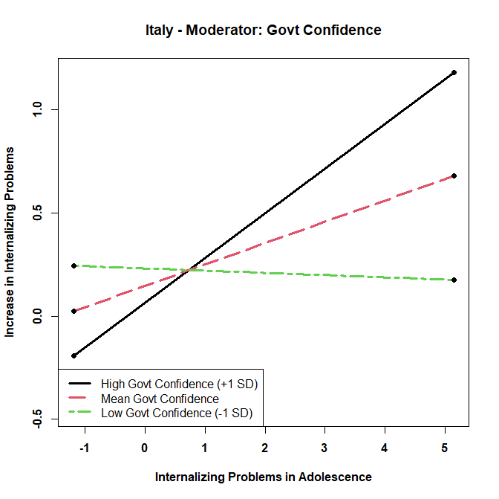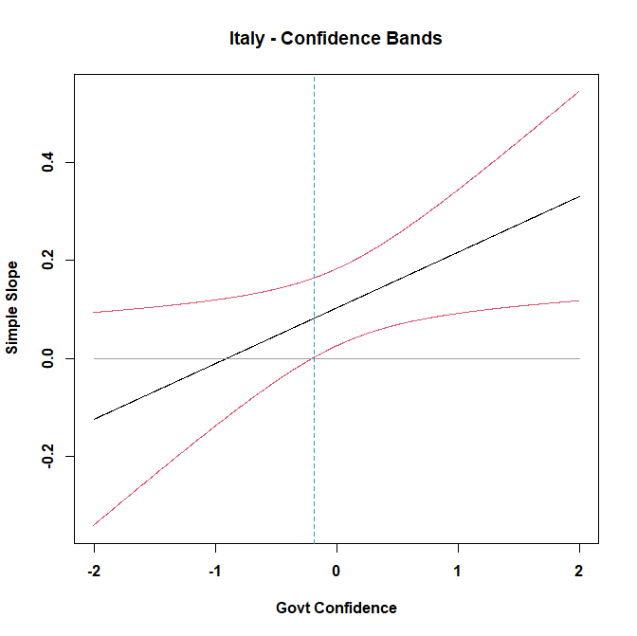

Supplemental Figure 2: Moderation of Relation between Externalizing Problems in Adolescence and Increase in Internalizing Problems during the Pandemic by Parental Education
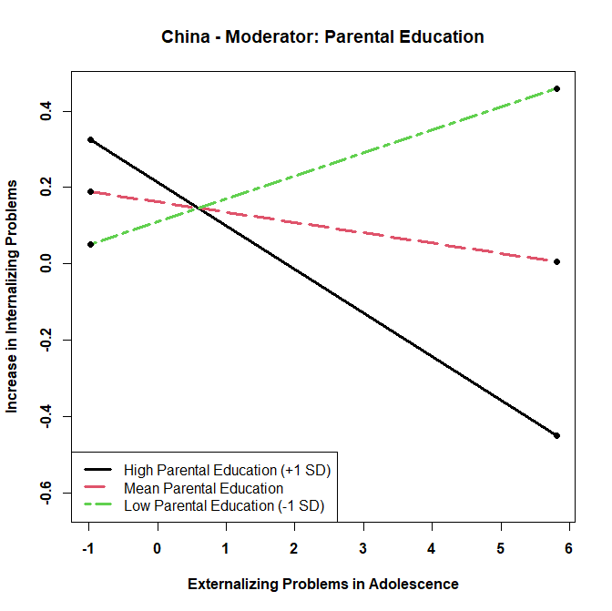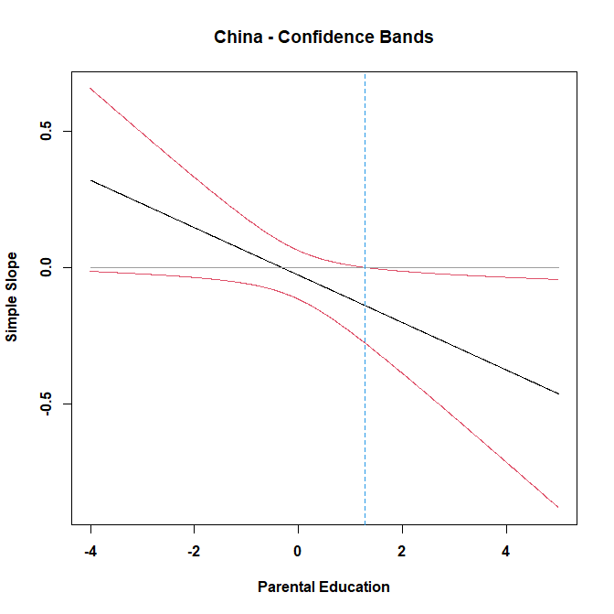
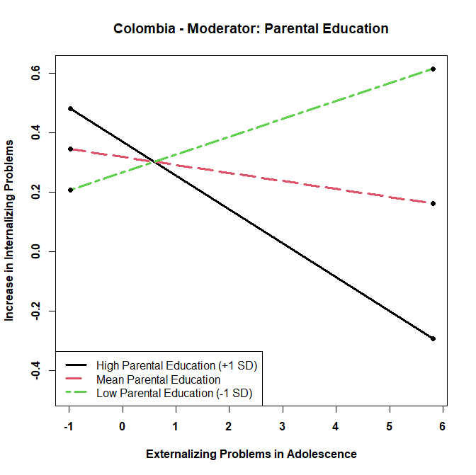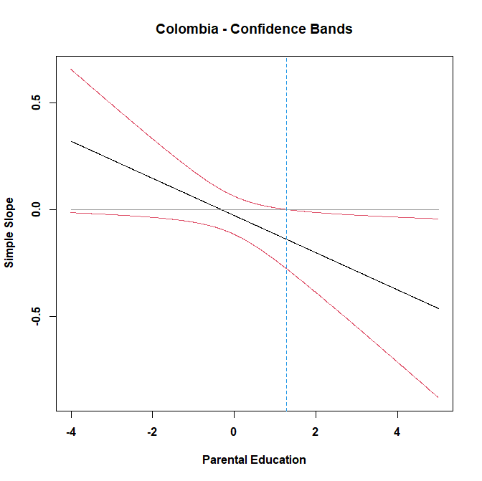
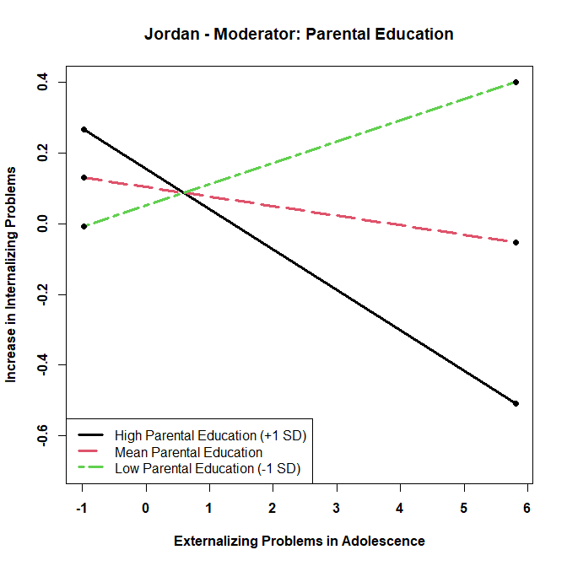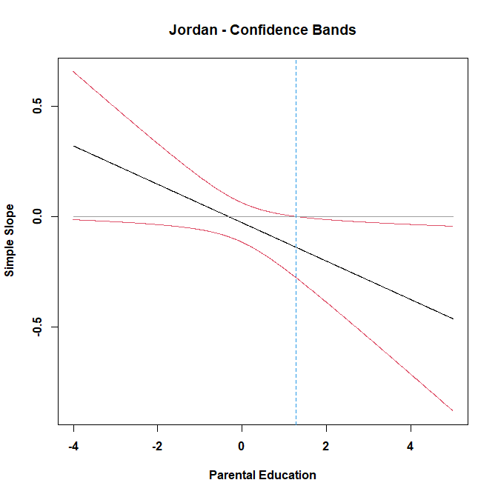

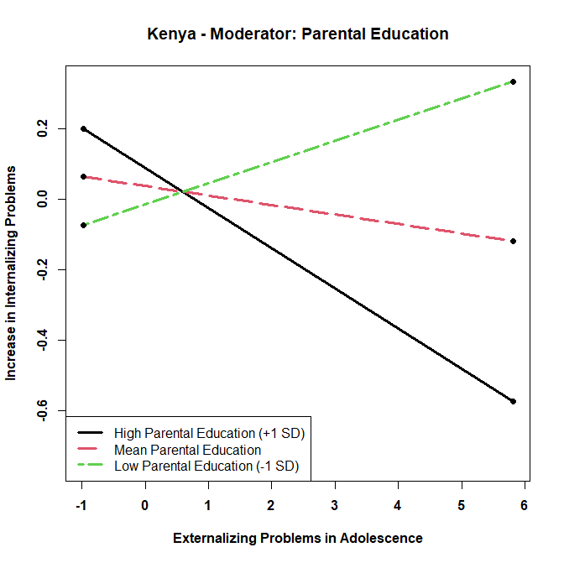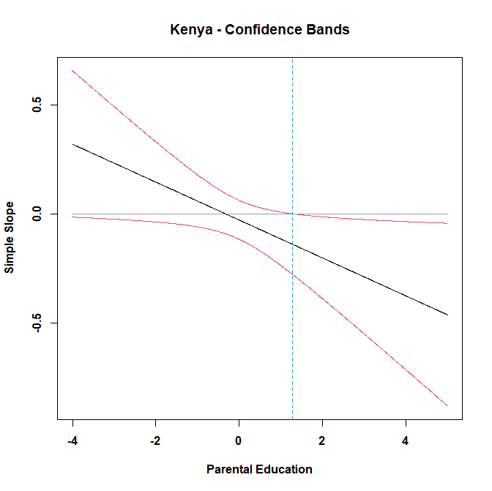
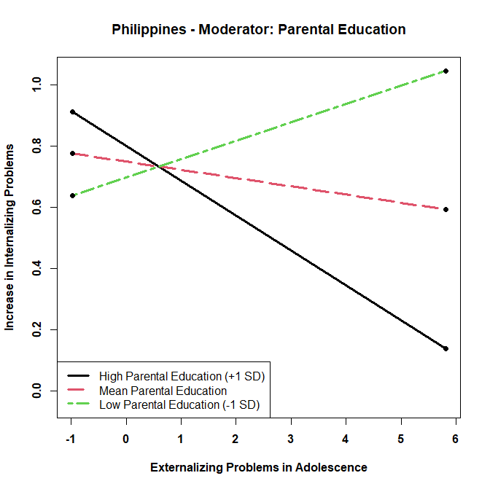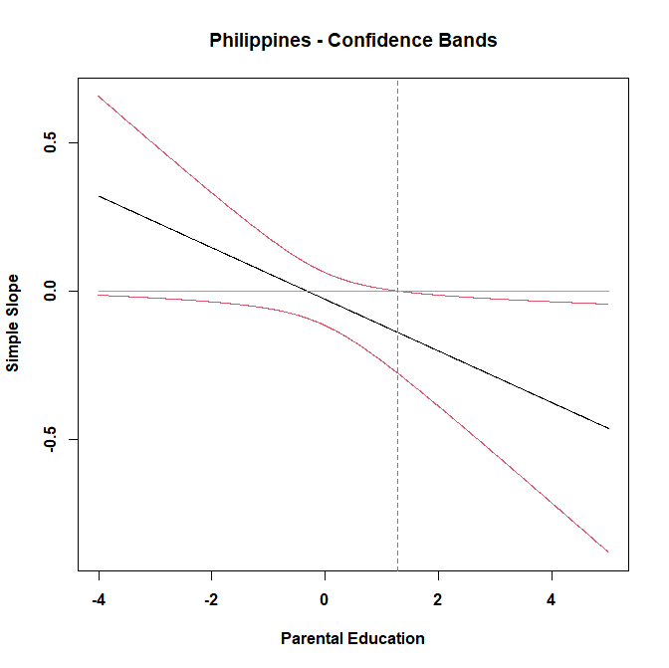
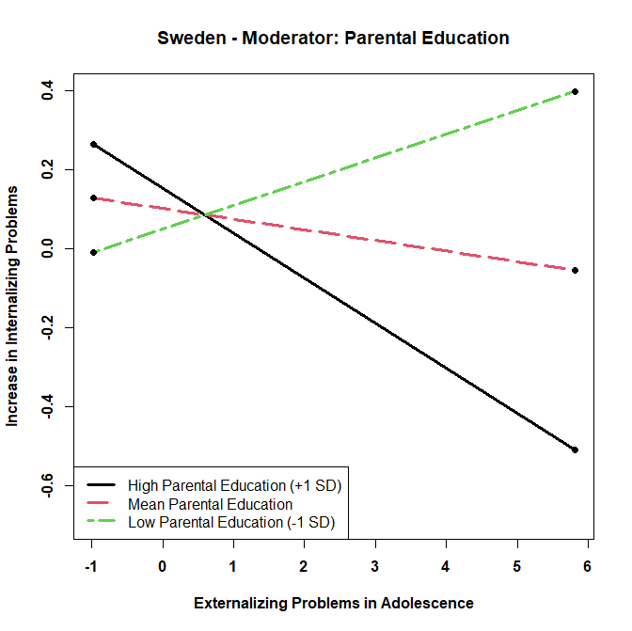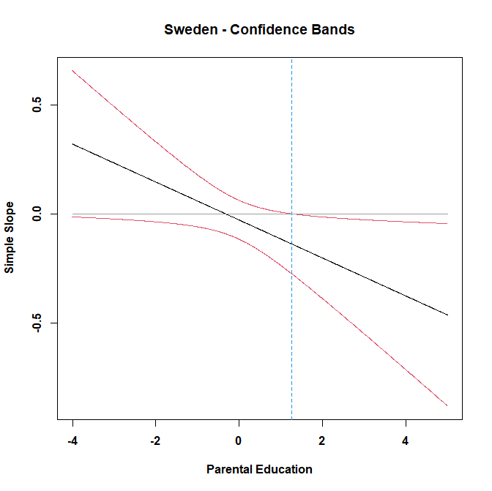

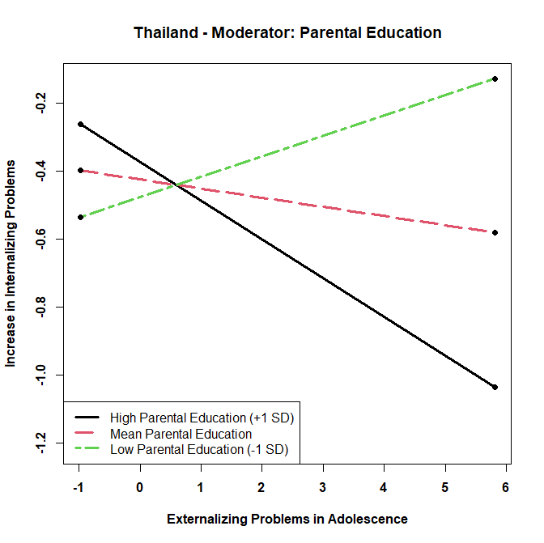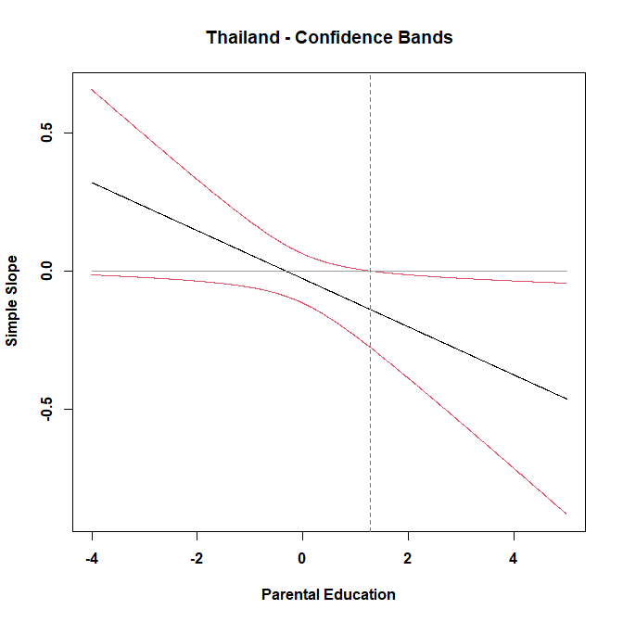
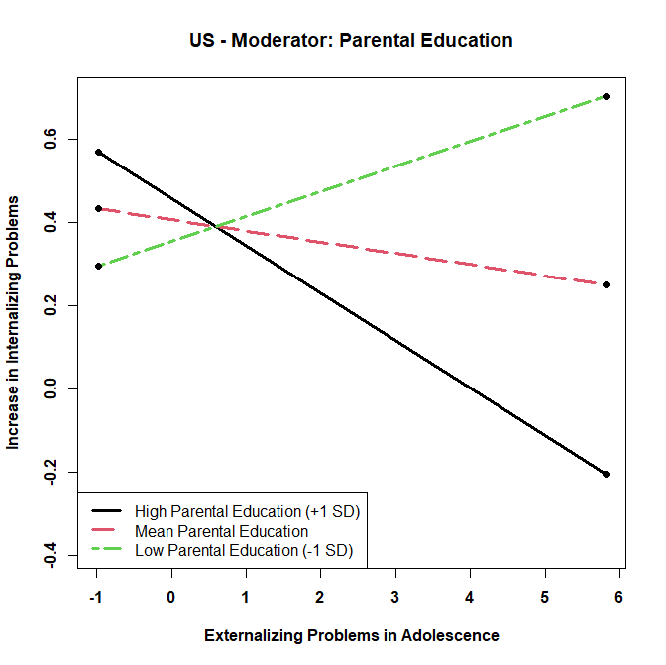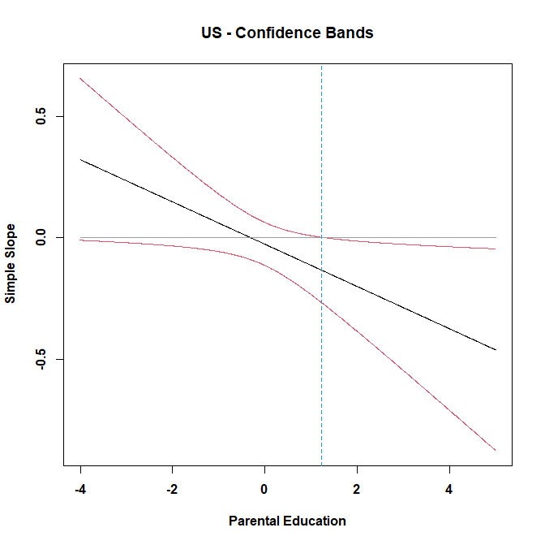

Supplemental Figure 3: Moderation of Relation between Risk-Taking Tendencies in Adolescence and Increase in Internalizing Problems during the Pandemic by Confidence of Government’s Handling of Pandemic
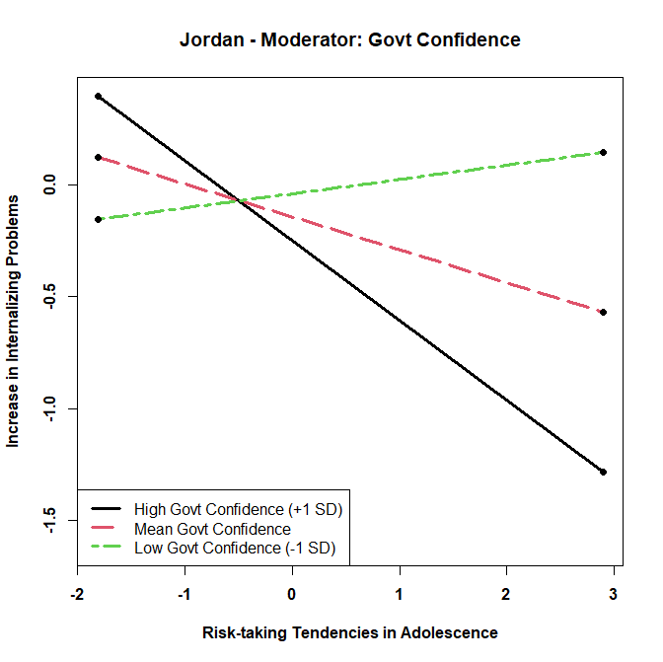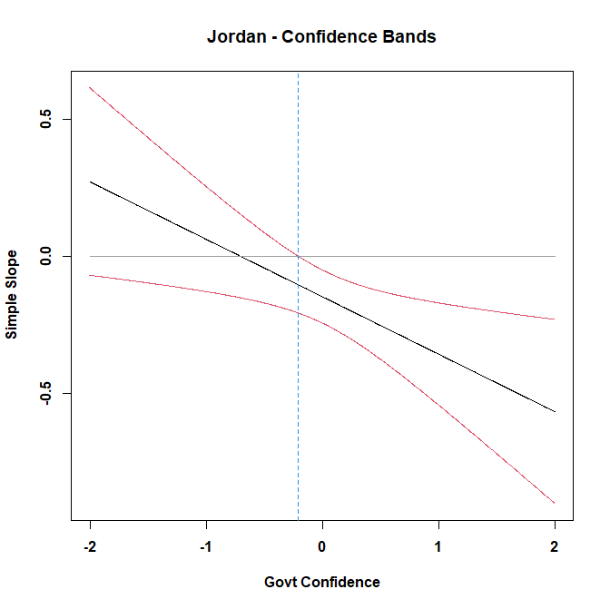
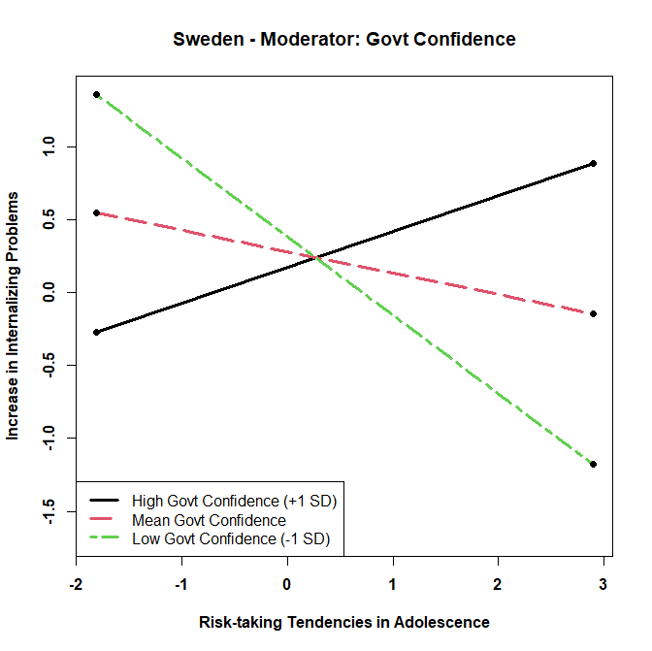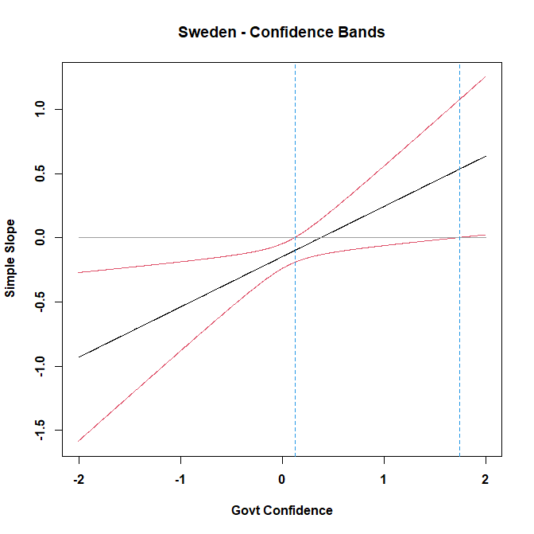

Supplemental Figure 4: Moderation of Relation between Risk-Taking Tendencies in Adolescence and Increase in Internalizing Problems during the Pandemic by Gender
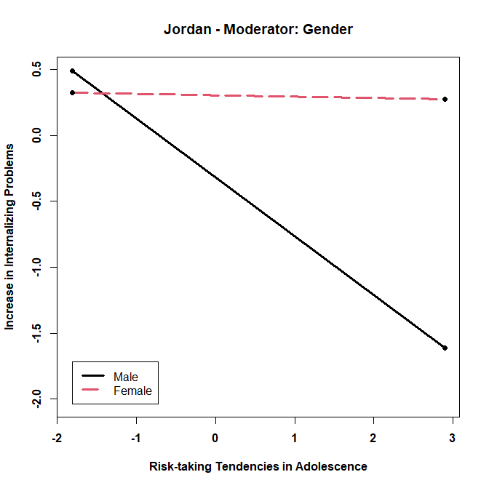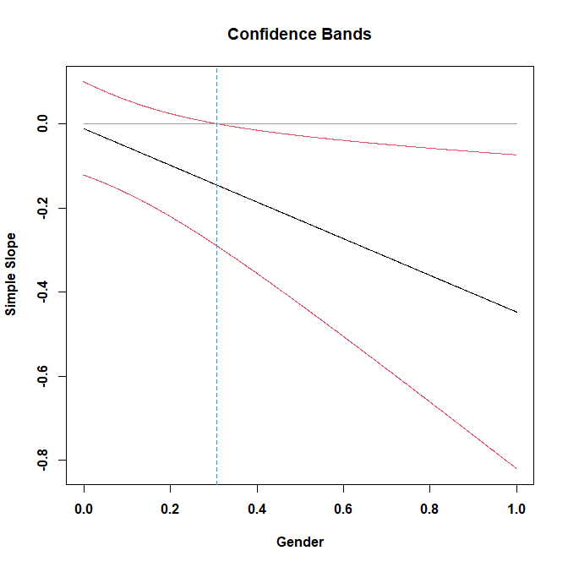
Supplemental Figure 5: Moderation of Relation between Risk-Taking Tendencies in Adolescence and Increase in Internalizing Problems during the Pandemic by Parental Education
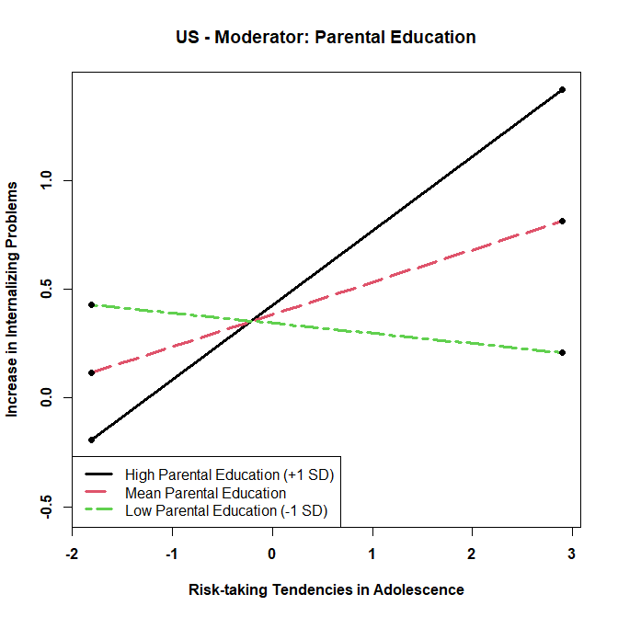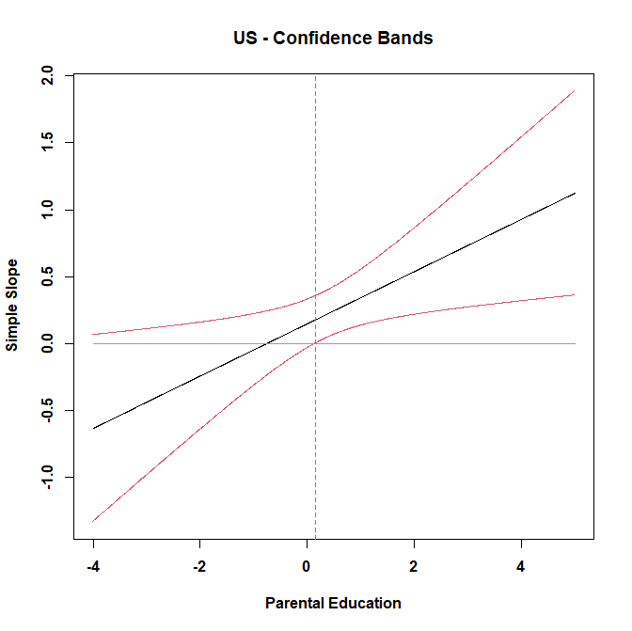

Supplemental Figure 6: Moderation of Relation between Risk-Taking Tendencies in Adolescence and Increase in Externalizing Problems during the Pandemic by Confidence of Government’s Handling of Pandemic
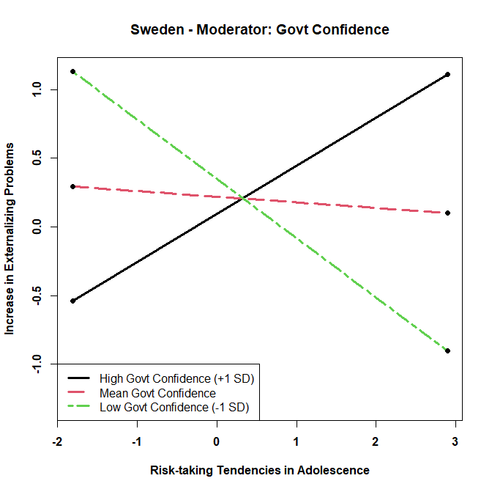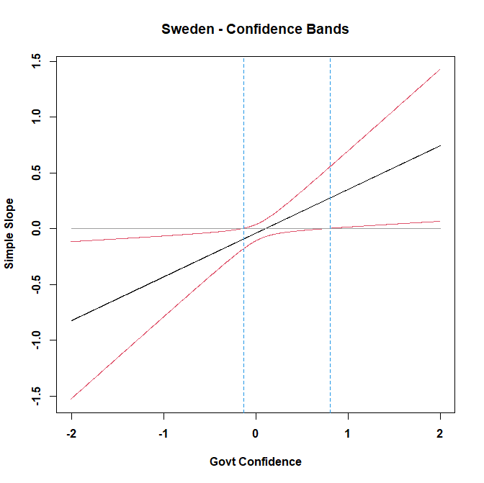

Supplemental Figure 7: Moderation of Relation between Risk-Taking Tendencies in Adolescence and Increase in Externalizing Problems during the Pandemic by Gender
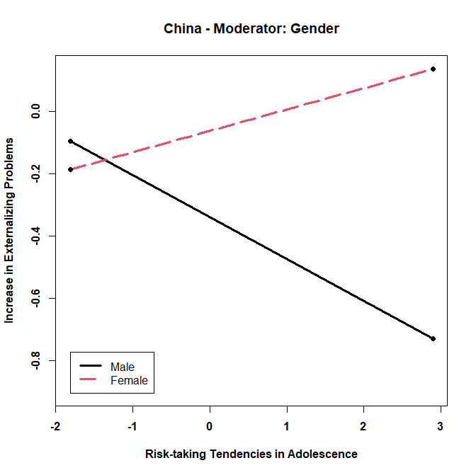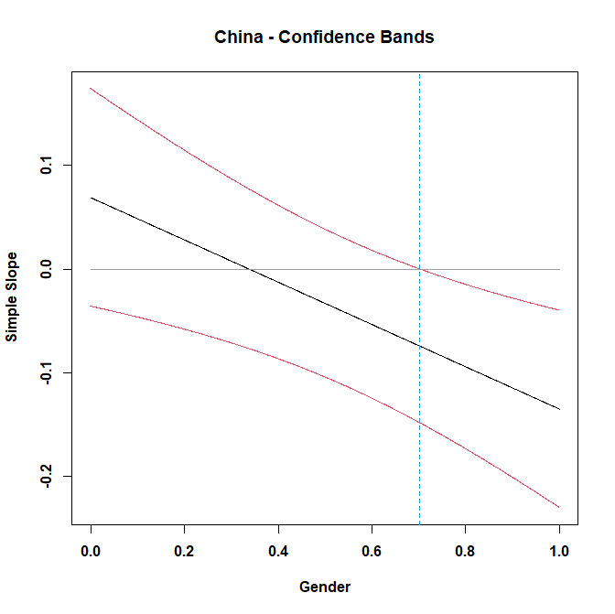
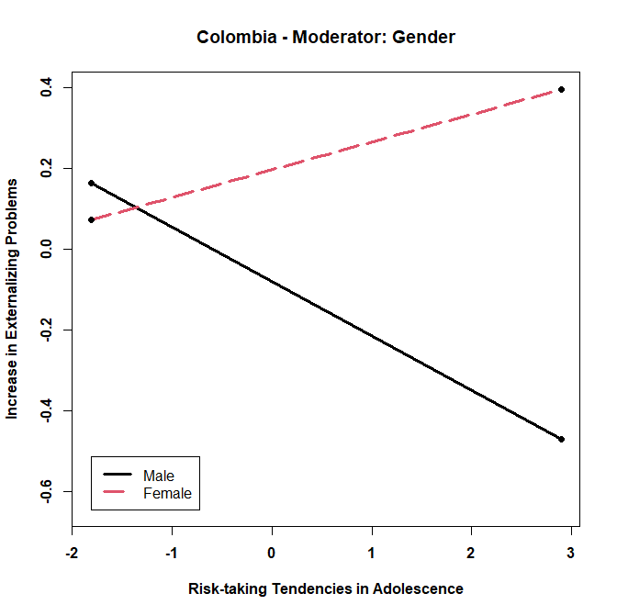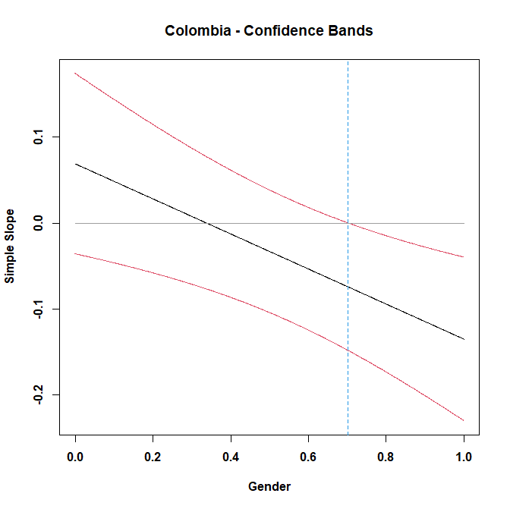
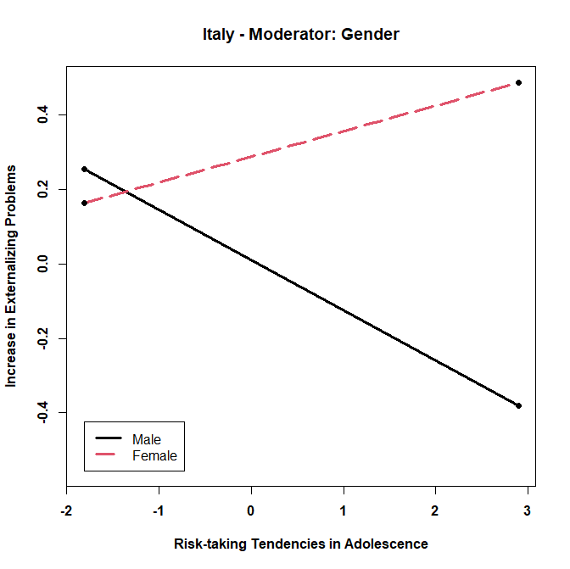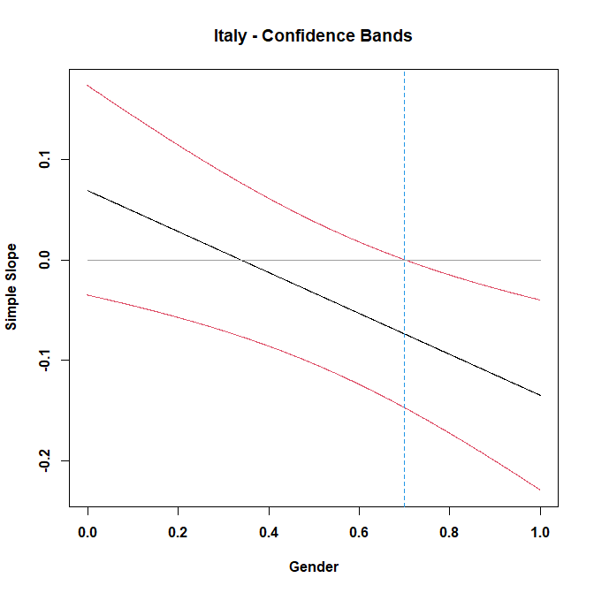
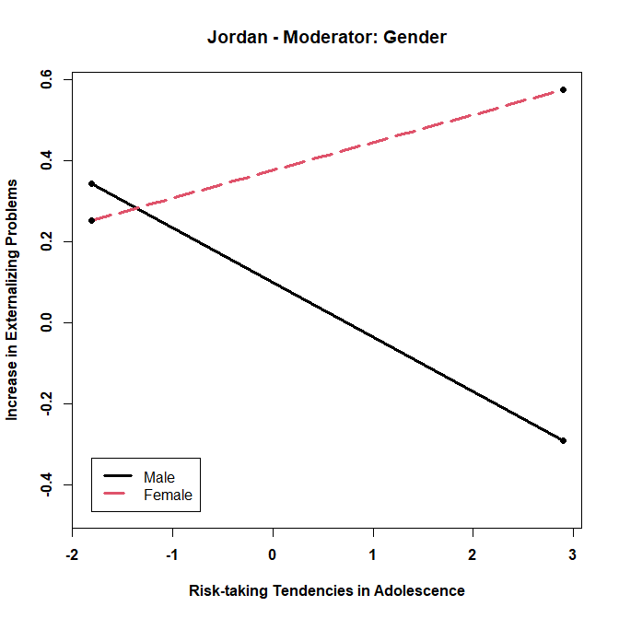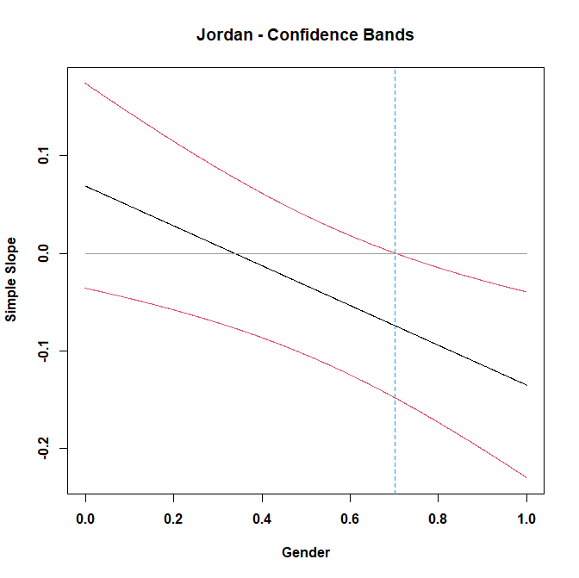
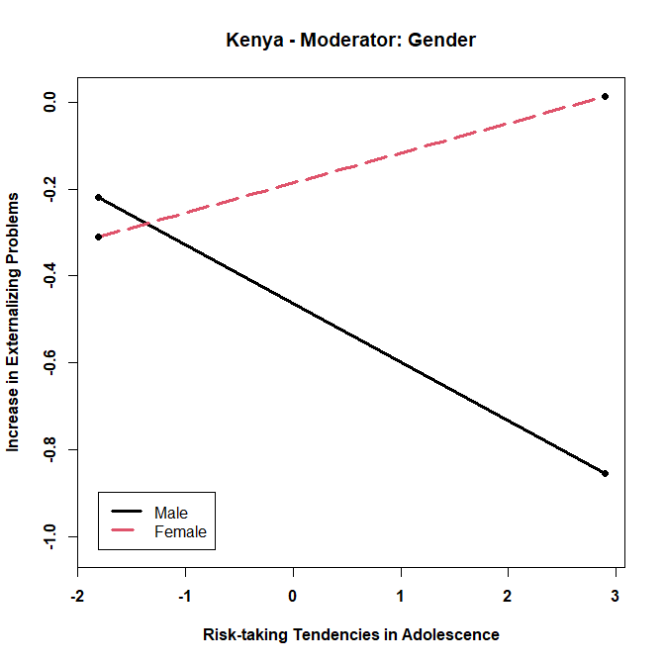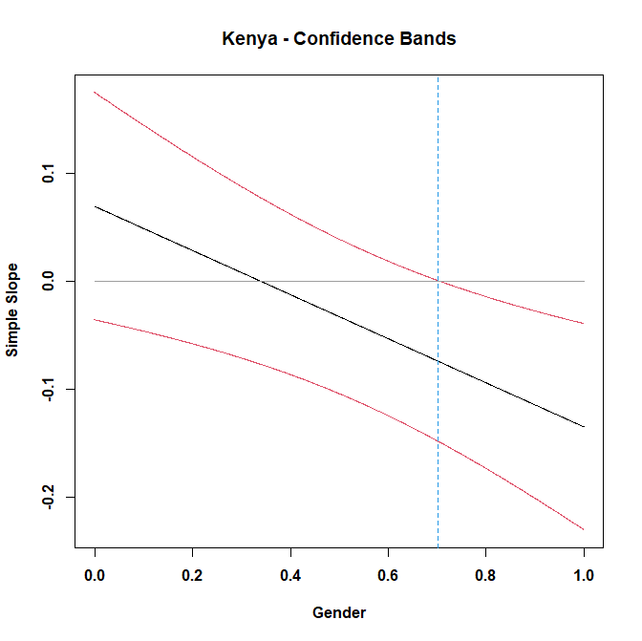
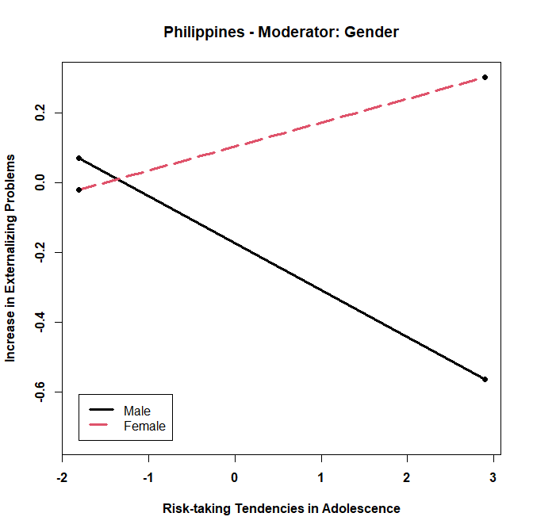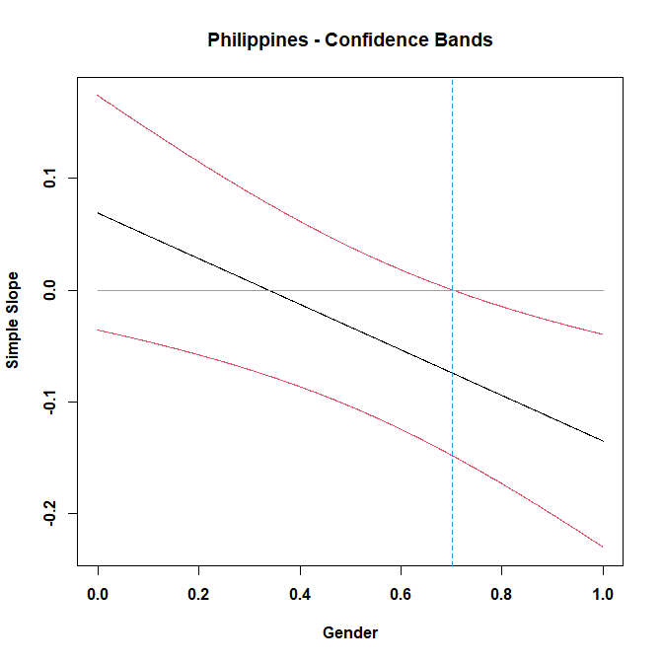

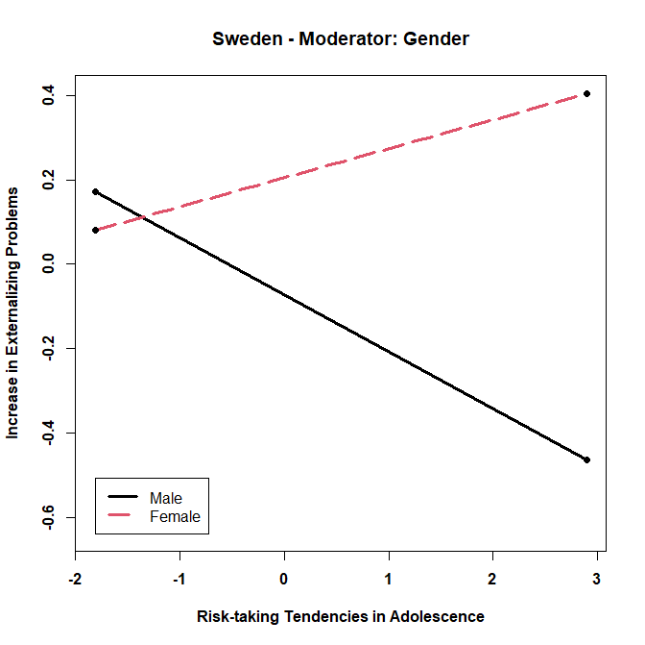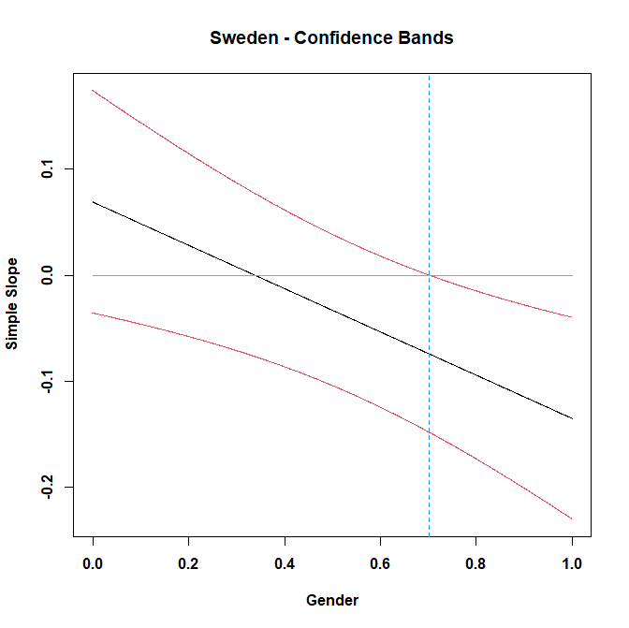
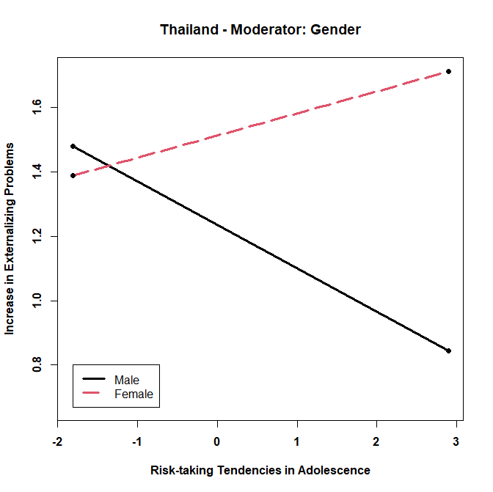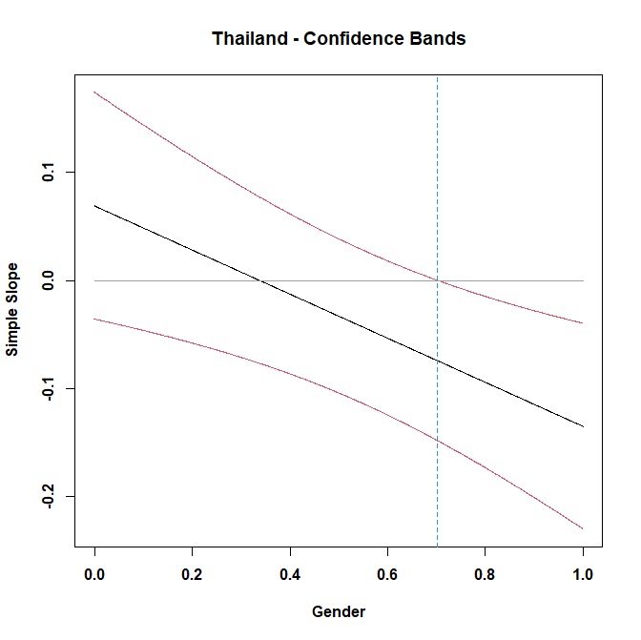
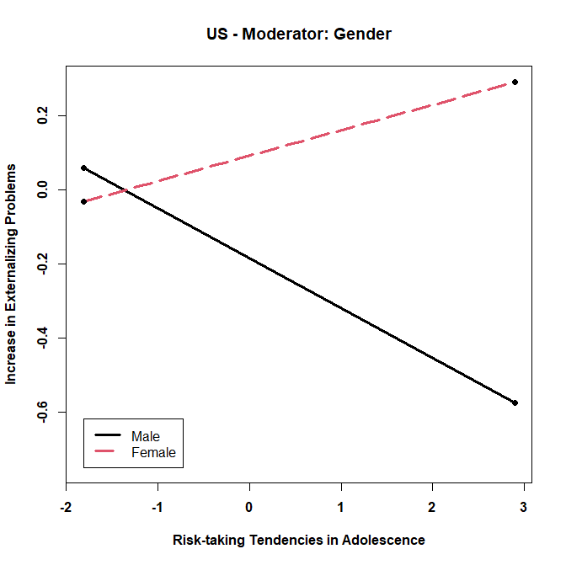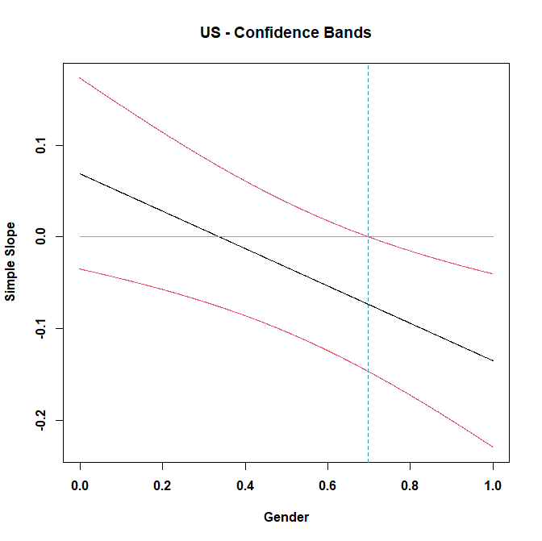

Supplemental Figure 8: Moderation of Relation between Well-being in Adolescence and Increase in Externalizing Problems during the Pandemic by Confidence of Government’s Handling of Pandemic
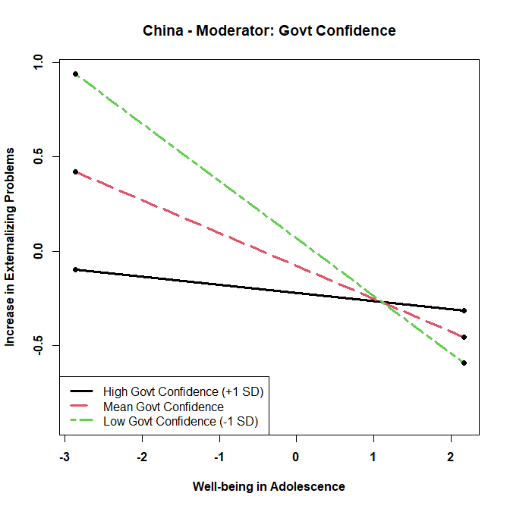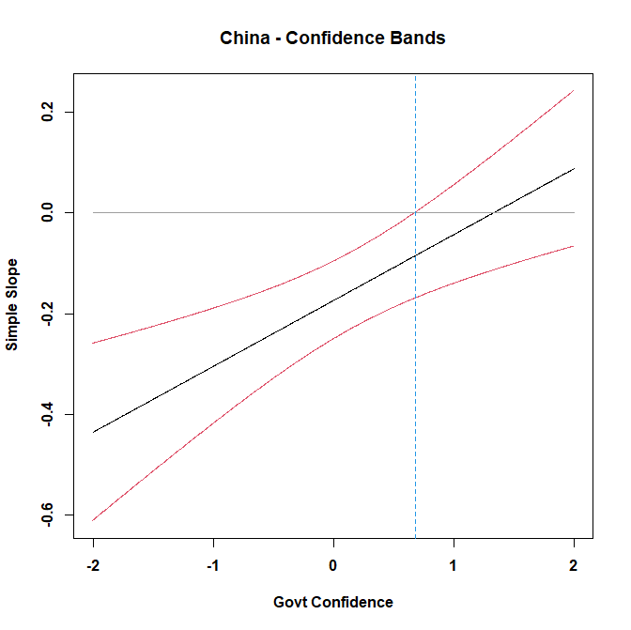
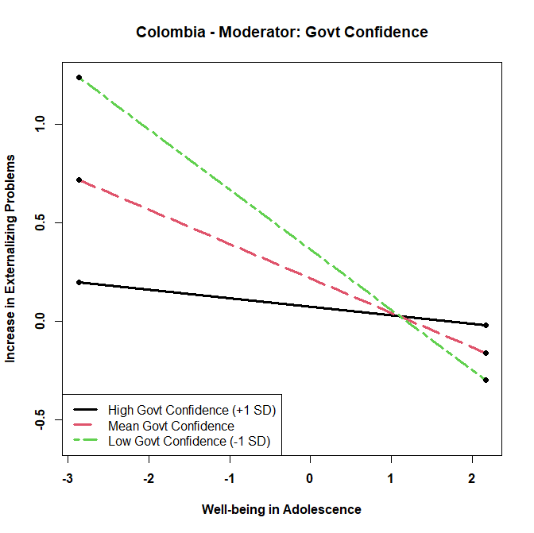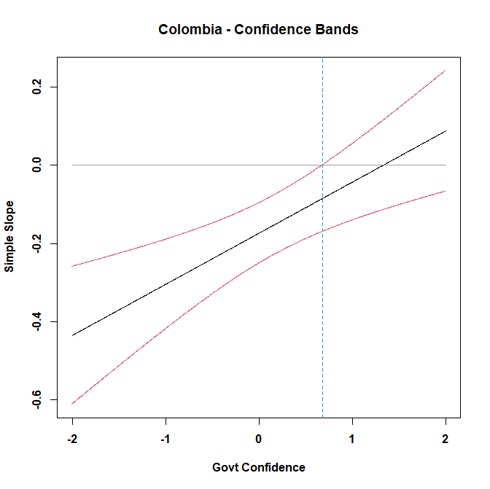
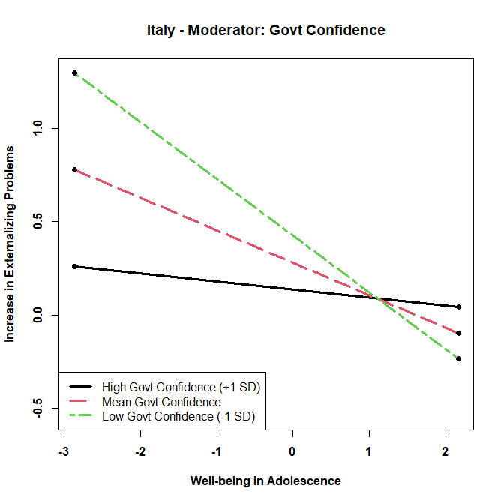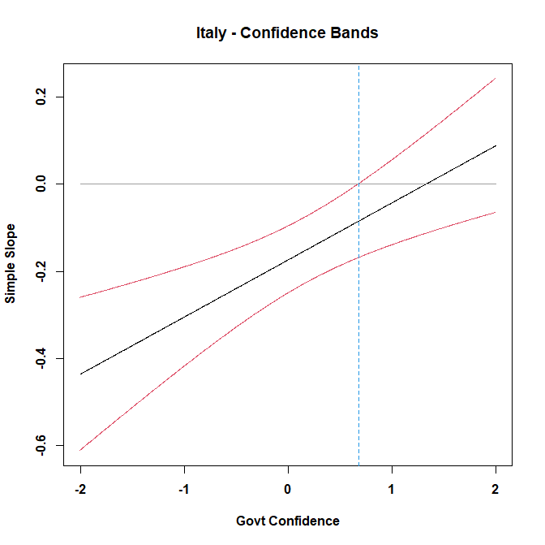

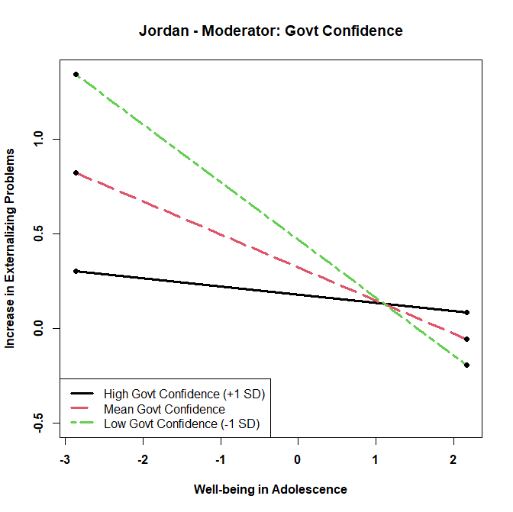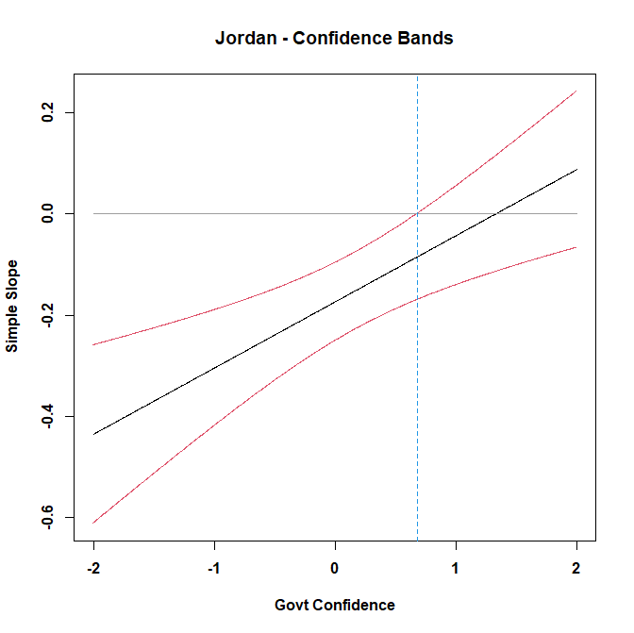
0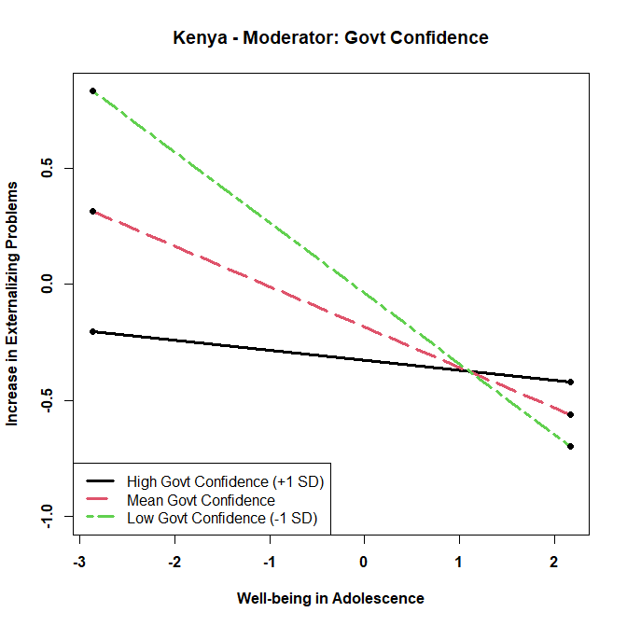 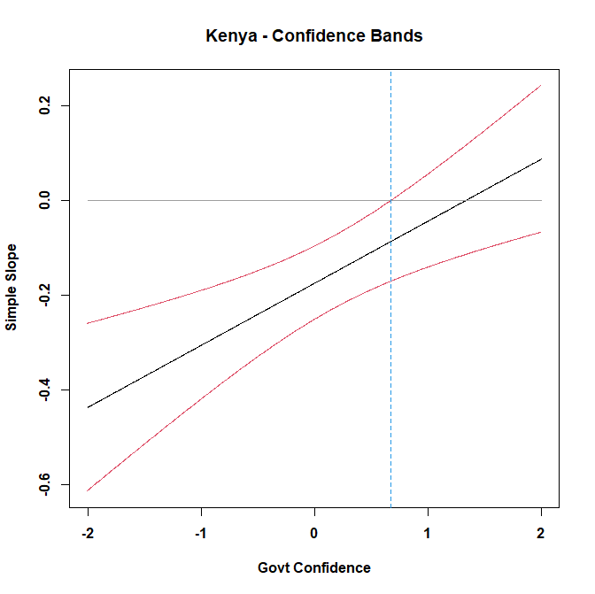
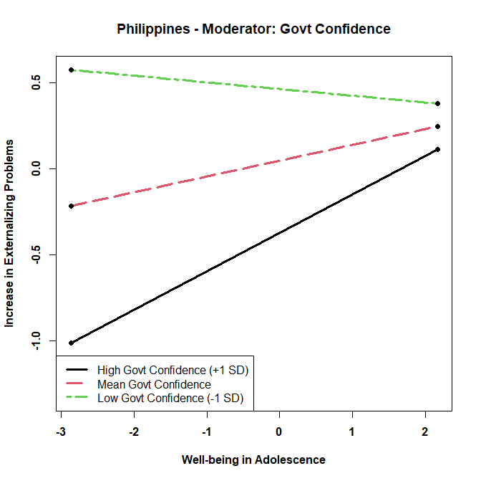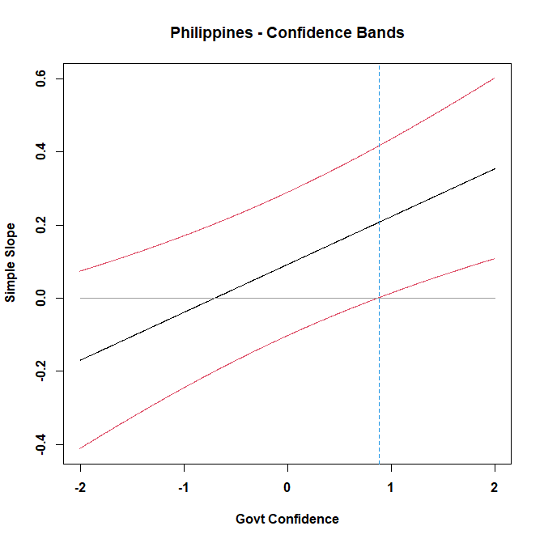
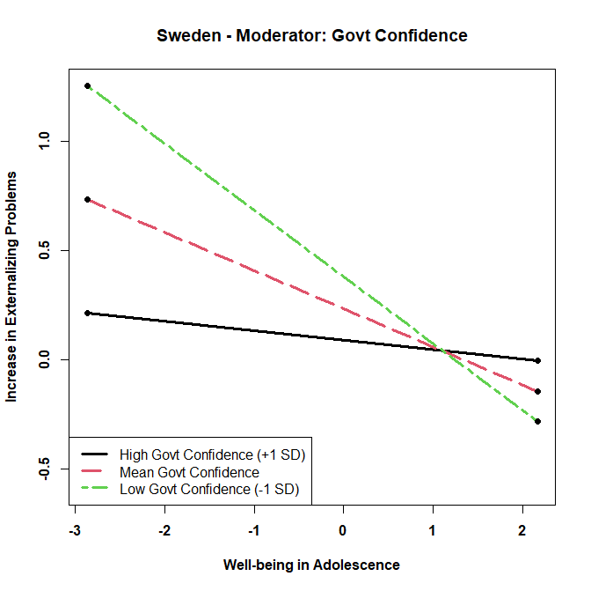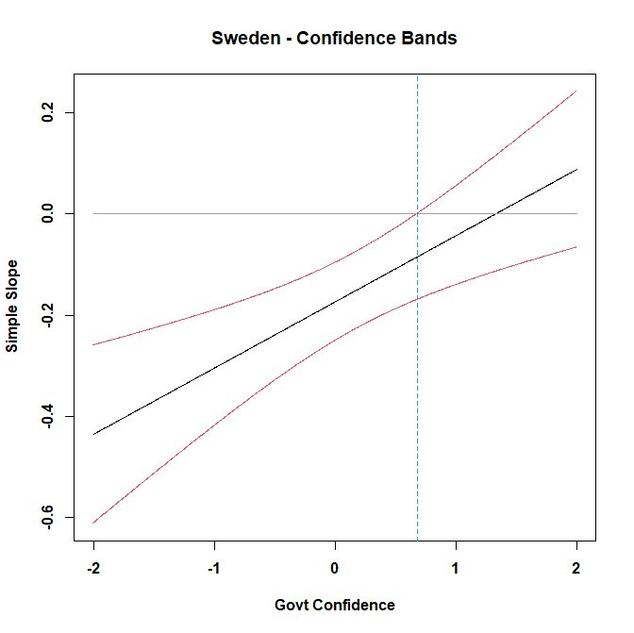
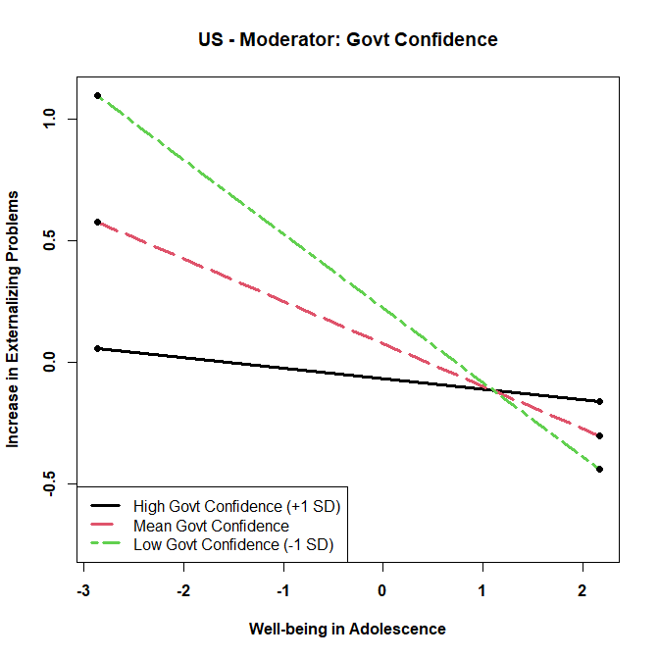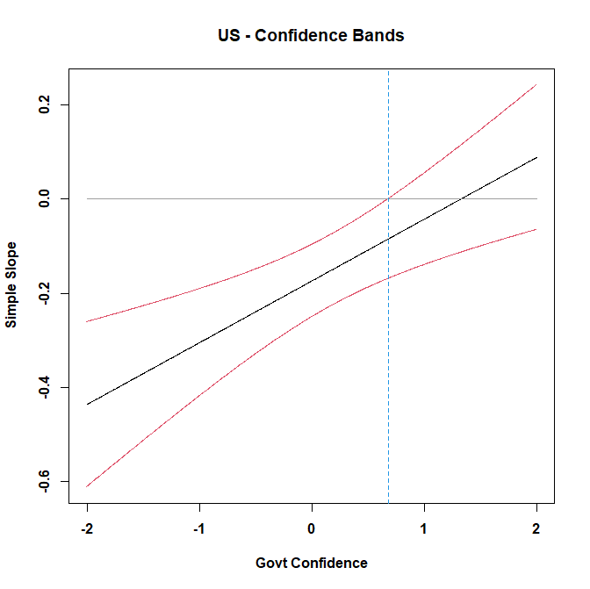

Supplemental Figure 9: Moderation of Relation between Well-being in Adolescence and Increase in Externalizing Problems during the Pandemic by Parental Education
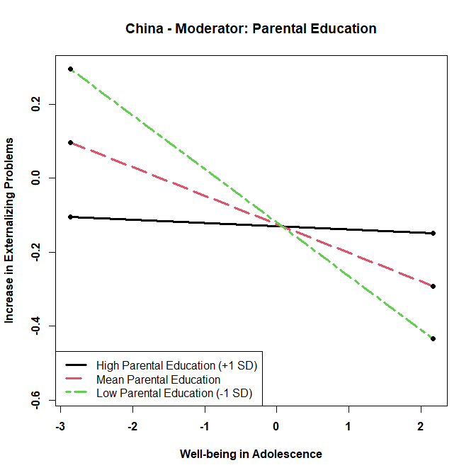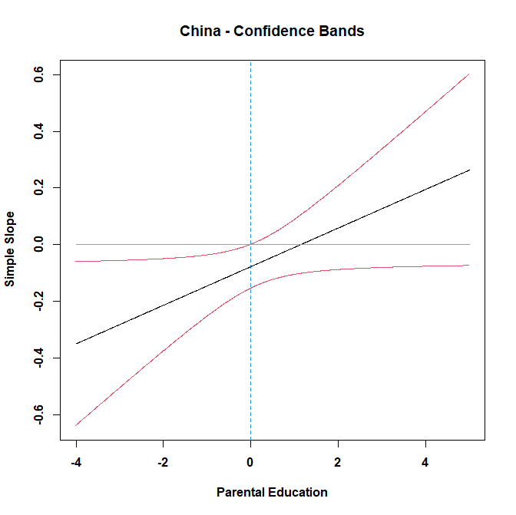
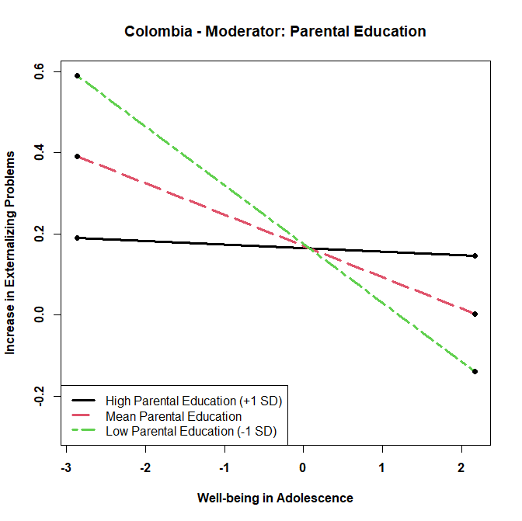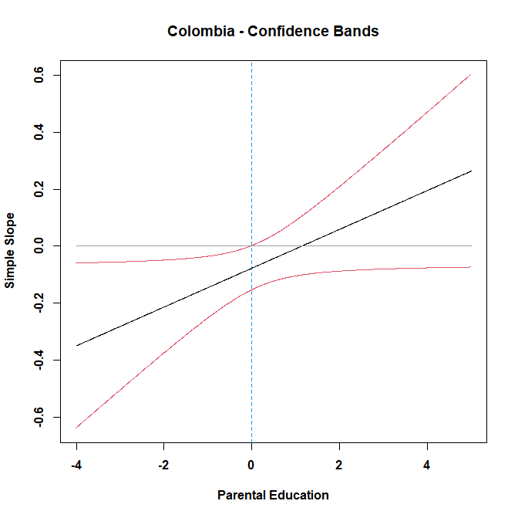
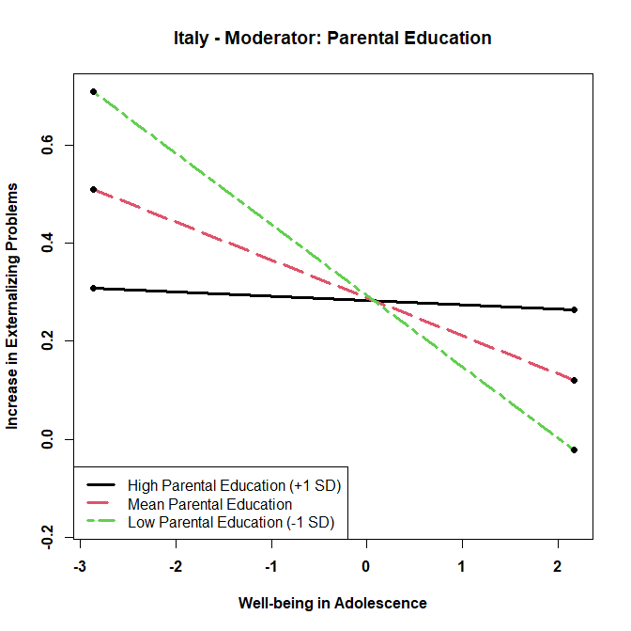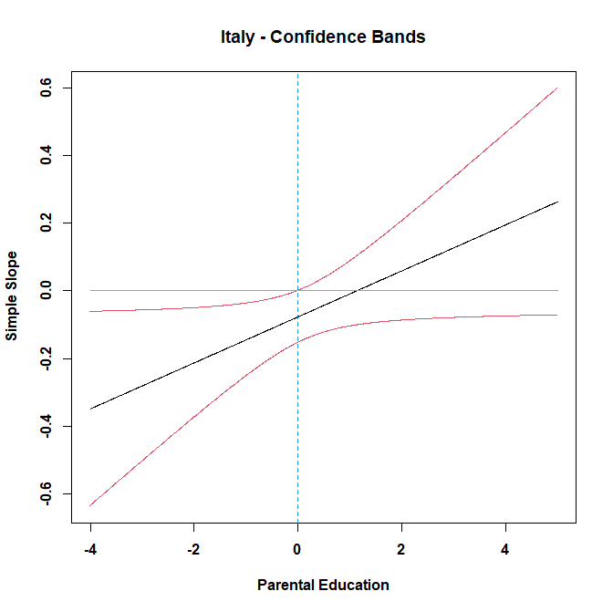
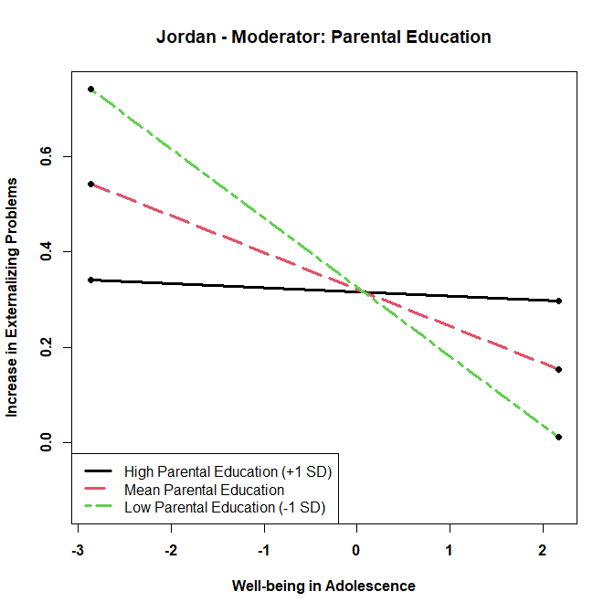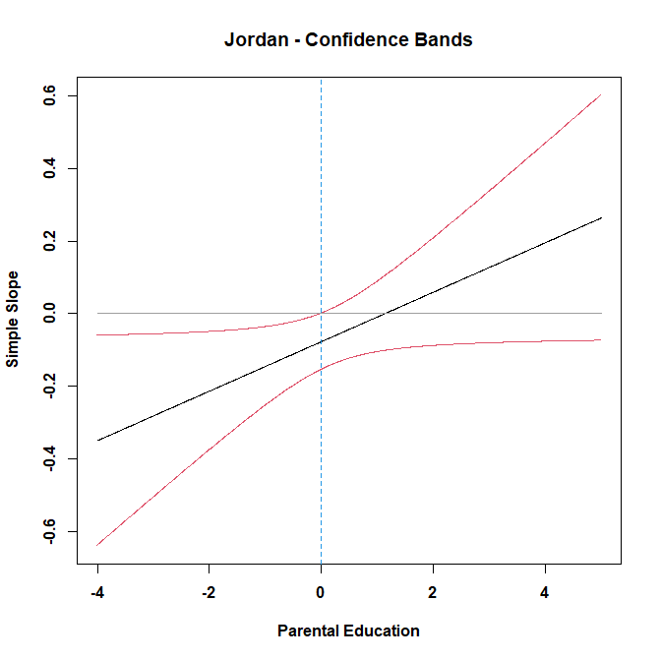
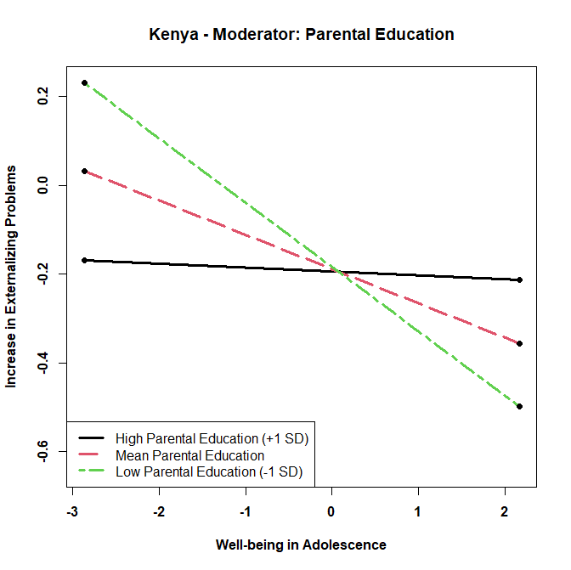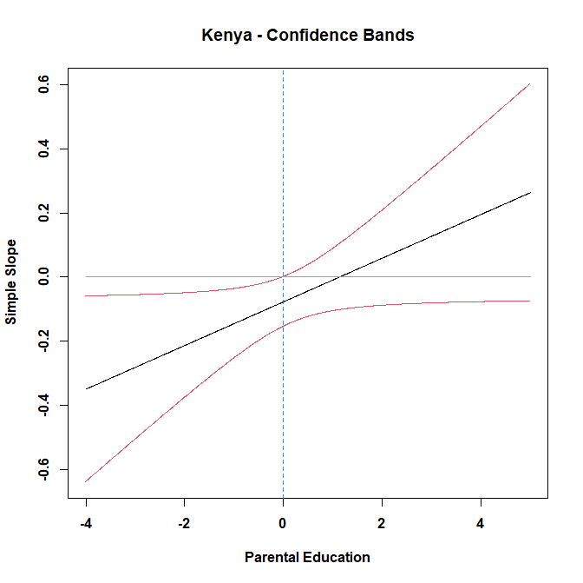
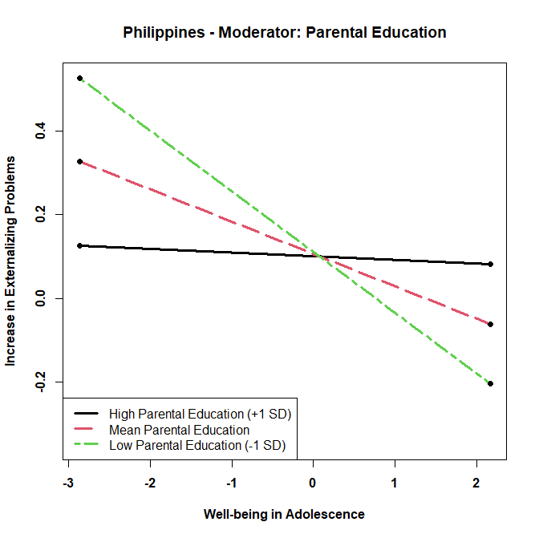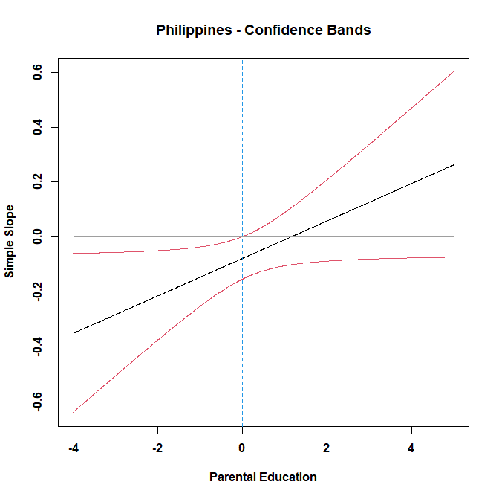

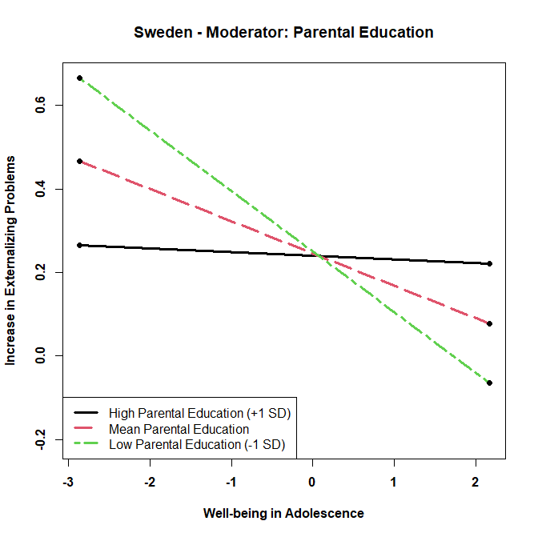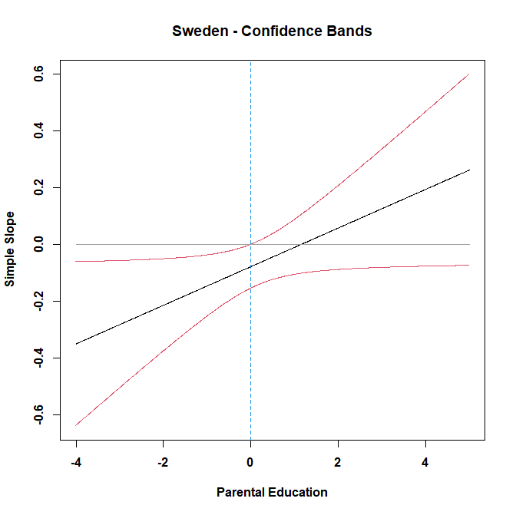
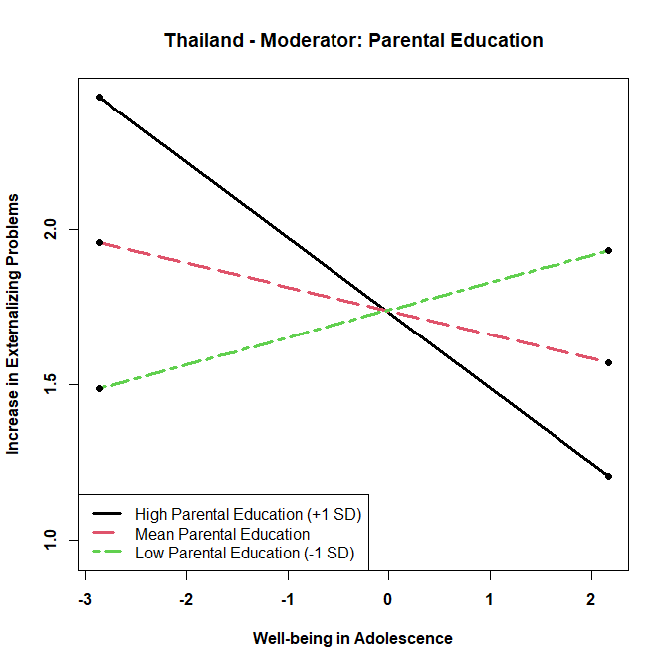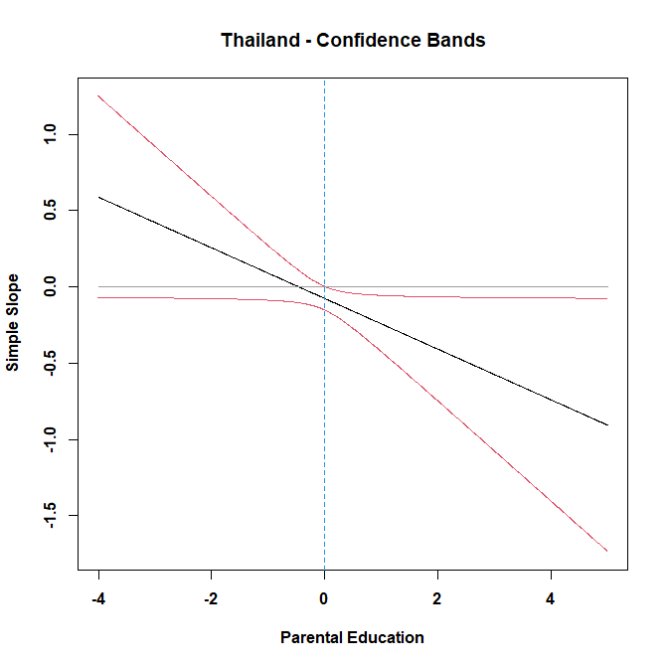
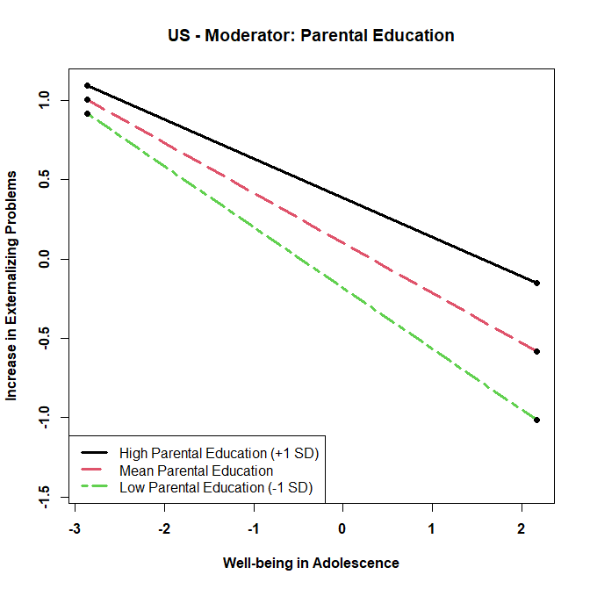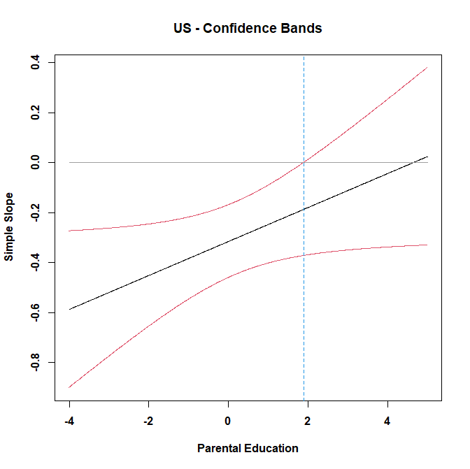

Supplemental Figure 10: Moderation of Relation between Well-being in Adolescence and Change in Substance Use during the Pandemic by Confidence of Government’s Handling of Pandemic
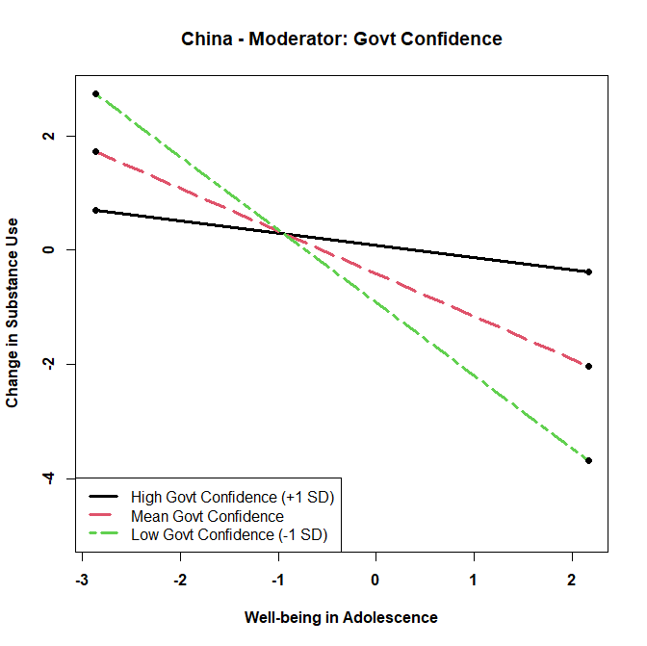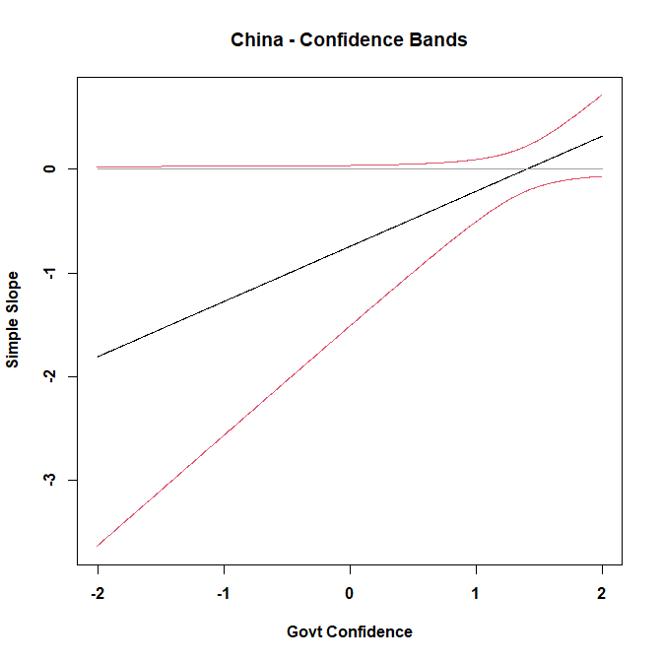

Supplemental Figure 11: Moderation of Relation between Well-being in Adolescence and Change in Substance Use during the Pandemic by Gender
