Supplementary Figure 1. Distribution of family socioeconomic status during childhood

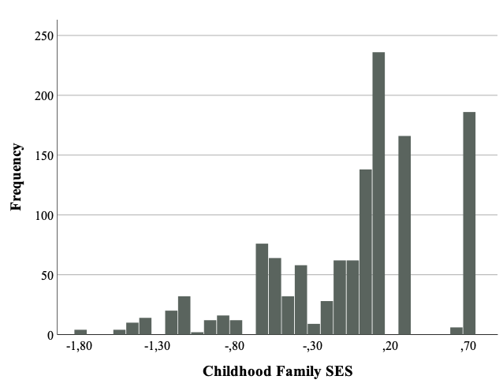

Supplementary Figure 2. Distribution of family socioeconomic status during adolescence

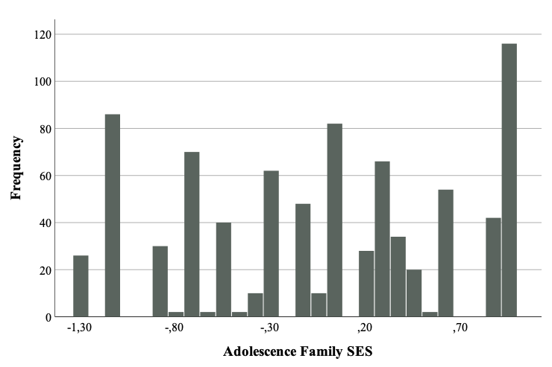

Supplementary Table 1. Univariate models factors for the CAR, awakening cortisol levels and cortisol diurnal change

 | A | C or D | E | A² | C² or D² | E² | RMSEA | AIC | BIC | -2ll(np) | ∆χ² | ∆df | P
CAR
ADE | .48  [.00;1.1] | .86  [.00;1.1] | 1.07  [.94;.82] | 11% | 35% | 54% | 0.10 | 1455.10 | 1469.68 | -723.10(4) | .97 | 2 | .61
AE | .96  [.71;1.2] | ⎯ | 1.09  [.96;1.2] | 44% | ⎯ | 56% | 0.09 | 1454.56 | 1464.82 | -724.28(3) | 1.53 | 3 | .67
DE | ⎯ | .28  [.24;.33] | -.27  [-.30;-.24] | ⎯ | 54% | 46% | 0.09 | 1454.05 | 1464.31 | -724.02(3) | 1.02 | 3 | .79
E | ⎯ | ⎯ | 1  [.90;1.06] | ⎯ | ⎯ | 100% | 0.18 | 1477.59 | 1484.43 | -736.79(2) | 26.56 | 4 | .00
Awakening cortisol
ACE | .55  [.00;.72] | .33  [.00;.64] | .701  [.62;.78] | 34% | 12% | 54% | .07 | 1183.59 | 1197.32 | -587.79(4) | 3 | 2 | .22
AE | .65  [.53;.75] | ⎯ | .69  [.61;.77] | 40% | ⎯ | 60% | .06 | 1181.91 | 1192.21 | -587.95(3) | 3.32 | 3 | .34
CE | ⎯ | .59  [.48;.69] | .74  [.67;.81] | ⎯ | 39% | 61% | .08 | 1183.85 | 1194.15 | -588.92(3) | 5.26 | 3 | .15
E | ⎯ | ⎯ | 1  [.89;1.01] | ⎯ | ⎯ | 100% | 0.21 | 1217.462 | 1224.33 | -606.731(2) | 40.87 | 4 | .00
Diurnal change
ACE | .22  [.00;.31] | .18  [.00;.27] | -.27  [-.30;-.24] | 32% | 20% | 48% | .07 | 403.9 | 417.74 | -197.95(4) | 3.62 | 2 | .16
AE | .29  [.24;.33] | ⎯ | .27  [.24;.30] | 54% | ⎯ | 46% | .07 | 403.21 | 413.59 | -198.61(3) | 4.94 | 3 | .18
CE | ⎯ | .83  [.58;1.03] | 1.19  [1.07;1.32] | ⎯ | 32.5% | 67.5% | .08 | 404.51 | 414.89 | -199.256(2) | 6.24 | 3 | .10
E | ⎯ | ⎯ | 1  [.36;.42] | ⎯ | ⎯ | 100% | .24 | 452.46 | 459.38 | -224.23(2) | 56.18 | 4 | .00

Note. The selected models are in bold.

Supplementary Table 2. Description of the range of SES deprivation captured in the sample according to the low-income cut-offs provided by Statistics Canada.
Income assessments
5 months (1st wave) | 1995 | 1996 | 1997 | 1998
Low-income cut-offs for 4 persons (size of family unit) and Urban areas of 500, 000 and over (Statistics Canada, 2001) before tax | $31,753 | $32,238 | $32,759 | $33,063
28.3% reported income levels below $30,000 and 44.7% reported income levels below $40,000.
18 months (2nd wave) | 1996 | 1997 | 1998 | 1999
Low-income cut-offs for 4 persons (size of family unit) and Urban areas of 500, 000 and over (Statistics Canada, 2001) before tax |  |  |  | $33,659
21.1% reported income levels below $30,000 and 34.8% reported income levels below $40,000.
2.5 years (3rd wave) | 1997 | 1998 | 1999 | 2000
Low-income cut-offs for 4 persons (size of family unit) and Urban areas of 500, 000 and over (Statistics Canada, 2001) before tax |  |  |  | $34,446
22.2% reported income levels below $30,000 and 35.2% reported income levels below $40,000.
4 years (4th wave) | 1999 | 2000 | 2001 | 2002
Low-income cut-offs for 4 persons (size of family unit) and Urban areas of 500, 000 and over (Statistics Canada, 2001) before tax |  |  | $35,313 | $36,107
16.3% reported income levels below $30,000 and 27.2% reported income levels below $40,000.
14 years (13th wave) | 2009 | 2010 | 2011 | 2012
Low-income cut-offs for 4 persons (size of family unit) and Urban areas of 500, 000 and over (Statistics Canada, 2001) before tax | $41,307 | $42,065 | $43,292 | $43,942
20.1% reported income levels below or equal to $40,000 and 29.9% reported income levels below or equal to $50,000.

Supplementary Table 3. Intra-pair correlations for adolescence diurnal cortisol indicators according to zygosity

 | Monozygotic twins | Dizygotic twins | Mixed-sex twins
Awakening cortisol | .47*** | .27** | .43***
CAR | .43*** | .15$†$ | -.17
Diurnal change | .49*** | .38*** | .36**

