**Supplemental Information Table of Contents**

**Cognitive Task Descriptions** p. 2

**Tables**  pp. 7-8

**Table S1.** Detailed information on cohort retention

**Table S2.** Correlations matrices with all incoming and outgoing edge weights

(parent-reported ADHD symptom networks)

**Table S2.** Correlations matrices with all incoming and outgoing edge weights

(teacher-reported ADHD symptom networks)

**Figures** pp. 9-10

**Figure S1.** Network using teacher-reported ADHD symptoms

**Figure S2.** Centrality for networks using teacher-reported ADHD symptoms

**References** pp. 11-13

**Cognitive task descriptions**

Cognitive measures were administered in a fixed order after a medication washout of stimulant medications of at least 7 half-lives. Other psychiatric medications were exclusionary.

**Stop task.** Simulation data indicate that stop signal reaction time is most reliably assessed using a tracking version of the task (Band, Van Der Molen, & Logan, 2003) in which timing of the stop signal is varied stochastically with success at stopping on the prior stop trial. Children completed the stop task in a single session lasting about 15-20 minutes. They sat facing a computer screen accompanied by a trained examiner who provided verbal instructions from a practiced script. The examiners were blind to child diagnosis and study hypotheses. The procedures were identical to (Logan, Schachar, & Tannock, 1997) and (Logan, 1994; Logan & Cowan, 1984; Nigg, 1999), as follows. The computer screen displays an X or an O on a black and white 14" computer monitor in random sequence. Children first complete two sets of 32 practice trials during which they practice pressing the designated key on the keyboard for the X or the O as quickly as possible, using two fingers on their dominant hand. They then complete a second set of 32 practice trials during which they again press the appropriate key, but this time trying not to hit any key when they heard the tone. Children are instructed to respond as quickly as possible without making errors on the X/O discrimination, that they will not be able in every instance to stop, and that they should not wait for the beep. The experimenter remains with each child throughout the task. In the experimental procedure, a fixation point appears at the center of the screen for 500 ms at the beginning of each trial. It is replaced by an X or O for 1000 ms. The child responds with a key press, and the screen then is blank for 1000 ms. Four blocks of 64 trials are administered, with a rest in between each block, for a total of 256 trials. On 25% of the trials, the stop tone sounds for 100 ms. Thus, a total of 64 trials (16 per block) include the stop signal tone. The timing of the stop tone is varied to implement the tracking procedure as follows. The stop signal delay is initially set at 250 ms. If the child fails to inhibit their response when the tone sounds, on the subsequent trial the stop signal delay is decreased by 50 ms (making it easier to stop next time); if they inhibit successfully, stop signal delay is increased by 50 ms on the next trial (making it harder to stop next time). Probability of stopping successfully is thus maintained at approximately 50%. In this procedure, stop signal reaction time is estimated simply by subtracting mean stop signal latency from mean go response time (Logan, 1994) provides details justifying the validity of this procedure and (Band et al., 2003) demonstrate its robustness to various violations of task assumptions.

Prior to creating the total score across blocks, the following validity criteria were applied to each block: a) stop accuracy between 30-70%, b) hit accuracy greater than 75%, and c) mean RT for the block between 100-1500ms (to avoid anticipations on current or next trial). Stop signal RT (SSRT), the primary measure of response inhibition, was calculated for each valid block by subtracting the average stop signal delay from average RT (Logan, 1994); SSRTs less than 50ms were considered invalid. The practice trials and the first block of data were not excluded from the final average to exclude warm-up effects. Valid block SSRT scores were averaged to create the final outcome variable. Executive behavioral inhibition requires the suppression of a prepotent motor response (Logan, 1994). Imaging and lesion data indicate that interrupting a response on this task activates regions of inferior right prefrontal cortex and basal ganglia, perhaps in particular the caudate. As a multi-trial RT-based measure, it is highly reliable. Internal alpha reliability is > .85.

For the go-trials on the stop task, rather than simply report the multi-componential within-child standard deviation, we used a diffusion model decomposition to isolate drift rate as an index of arousal/vigilance (Aston‐Jones & Cohen, 2005; Ratcliff & McKoon, 2008).

**Spatial Span Task.** Working memory was assessed using a computerized spatial span backwards task identical to the Spatial Span subtest from the CANTAB test battery (De Luca et al., 2003). On this task, children were presented with a screen containing 10 squares arranged in a fixed position oriented in the WISC-III-PI orientation, which changes colors one by one. Individual squares changed color (from gray to yellow) in a fixed sequence. A tone sounded at the end of the sequence to note when the sequence was finished. Children were instructed to click on the squares in the *reverse* order in which they changed color. The number of squares in the sequence began at three and increased to nine, with two trials for each sequence length. The child is to click on the squares in the same order in which they changed color; in the backward condition, they do so in reverse order. A practice trial (3 boxes) preceded each 14 trial session (forward and backward conditions), each with 2 trials each of 3, 4, 5, 6, 7, 8, and 9 items. Trials are presented in a sequential order that is consistent in both forwards and backwards order. Each box flashes for 500 ms on a trial, with 1200 ms in between each trial, followed by the tone at the end of the sequence indicating it is time to respond. Each trial ends when the child has clicked on the number of boxes required, regardless of the order. The task discontinued when a child failed all trials at a specific sequence length. The primary outcome variable used total correct.

**WISC-IV Digit Span.** Digit span was administered exactly as in the WISC-IV manual by a trained examiner.

**N-back.** An N-back task was administered via computer with 3 conditions: 0-back, 1-back, and 2-back, presented in that fixed order to all children. In each condition, children saw a picture of an apple with 4 holes. Every 2000ms, a worm appeared in one of the holes. The worm stayed on the screen for 1000ms. Immediately after the worm disappeared from the screen, a tone prompted the child to respond with a button press to indicate either a) which hole the work was just in (0-back), b) which hole the worm was in one trial ago (1-back), or c) which trial the worm had appeared in two trials ago (2-back). A cutout of the apple shape was placed on the number pad of a standard keyboard with holes over each of the corresponding response keys. Responses were made by pressing the key on the number pad corresponding to the correct hole. A practice block of 10 trials was presented before each condition to ensure understanding. Practice was followed by a single block of 45 scored trials for each condition. Responses were scored as either correct or incorrect. The primary outcome variable was % accuracy for each condition.

**Continuous Performance Task (CPT).** To assess vigilance, we administered a computerized an Identical Pairs CPT (CPT-IP) similar to the A-X CPT design used by Nigg et al. (1996). However, an IP-CPT was used because (a) it shows more promise than other versions of being familial both in schizophrenia (Cornblatt & Malhotra, 2001) and in ADHD (Kera, Marks, Berwid, Santra, & Halperin, 2004) and (b) is less vulnerable to the ceiling effects that interfere with calculation of signal detection parameters in a less difficult CPT. The CPT-IP version used here was modeled on the task used successfully by Curko-Kera et al (Kera et al., 2004) to show an endophenotype (family) effect in parents of children with ADHD. That task is turn is modeled on the successful designs used by Cornblatt and colleagues(Cornblatt & Malhotra, 2001) in their research on children at risk for schizophrenia, including satisfactory test-retest stability and task heritability.

In the task, children viewed a series of four-digit numbers are displayed one at a time in pseudo-random order to ensure unpredictability while achieving the required ratio of trial types. A total of 11 different 4-digit were used. When two identical numbers appear back-to-back, the child pushes the response button. Like Curko-Kera et al,(Kera et al., 2004) we used a 200 ms display followed by a 1500 ms dark screen, for a total time per trial of 1700 ms. Target frequency was 20%, with an additional 20% “catch” trials (only one digit off), and 60% “stim” or “non-targets.” With a total of 300 stimuli, the task required about 10 minutes to complete.

After instructions were given to the child, the trained research assistant sat quietly out of view of the child for the duration of the task and did not interact with the child as long as they were in their chair and making an attempt to do the task.

Measures of perceptual sensitivity or signal detection accuracy (d’) were calculated. D-prime (d’) was computed for both the catch and non-target trials, labeled in the text as d’-A and d’-B. It is a standardized measure of how distinctly a target is perceived from a non-target. Thus, the smaller the value of d’, the harder it is for a perceiver to distinguish between noise and targets and thus the weaker the participants’ presumed alertness or vigilance (Sergeant, Oosterlaan, & van der Meere, 1999). When d’ = 0, the hit rate and false alarm rate are equal (chance performance). To ensure data quality we required the following filters. First, each block was considered valid if children had no more than 50% false alarms on the “easy” non-target trials in that block. Next average scores were computed for hit rate, omissions, false alarms on “easy” non-target trials, and false alarms on “difficult” or “catch” trials using all of the valid blocks. To be included in final analyses, children were required to have an average of >10% correct hits *and* <90% false alarms on “easy” non-target trials.

**Retention Information**

**Table S1.** Information on sample retention for the Oregon ADHD Study cohort overall.

|  |  |  |  |  |  |  |  |  |  |
| --- | --- | --- | --- | --- | --- | --- | --- | --- | --- |
| *Cohort Retention* | | |  |  |  |  |  |  |  |
|  | Ages | Status | Years collected | Original Target N | Planned Missing N for wavea | Annual N LTFUb | Cum LTFU N | Target N | Actual N as of 2020 |
| Year 1 | 7-13 | FIN | 2009-2015 | 849 | n/a | n/a | 0 | n/a | 849 |
| Year 2 | 8-15 | FIN | 2010-2015 | 610 | 50 | 10 | 10 | 550 | 524 |
| Year 3 | 9-15 | FIN | 2011-2018 | 610 | 50 | 15 | 25 | 535 | 527 |
| Year 4 | 10-16 | FIN | 2012-2018 | 610 | 100 | 34 | 59 | 451 | 383 |
| Year 5 | 11-17 | FIN | 2014-2019 | 610 | 86 | 34 | 93 | 431 | 368 |
| Year 6 | 12-18 | ONGOING | 2014-2020 | 610 | 0 | tbd | tbd | tbd | 413 |

Note: Planned follow up after Wave 1 is how many we attempted to follow. N includes any data collected, does not reflect N per measure. Subsequent grants allowed an additional n = 60 participants to be recruited from the 849 that were not planned for follow-up during waves 3-5. W3 (n = 12), W4 (n=47), W5 (n = 41), and W6 (n = 59). They 'replace' some of those lost to follow up (LTFU) and are included in this total.

a Planned missing was implemented to remain within budget and to cover budget gaps and for later years due to ending of grant project.

b LTFU: Loss to follow up prior to wave starting; shown are N, %, annual, cumulative (cum)

**Table S2.** Correlations matrices with all incoming and outgoing edge weights in network using parent-reported ADHD symptoms



**Table S3.** Correlations matrices with all incoming and outgoing edge weights in network using teacher-reported ADHD symptoms



**Figure S1.** Network using teacher-reported ADHD symptoms

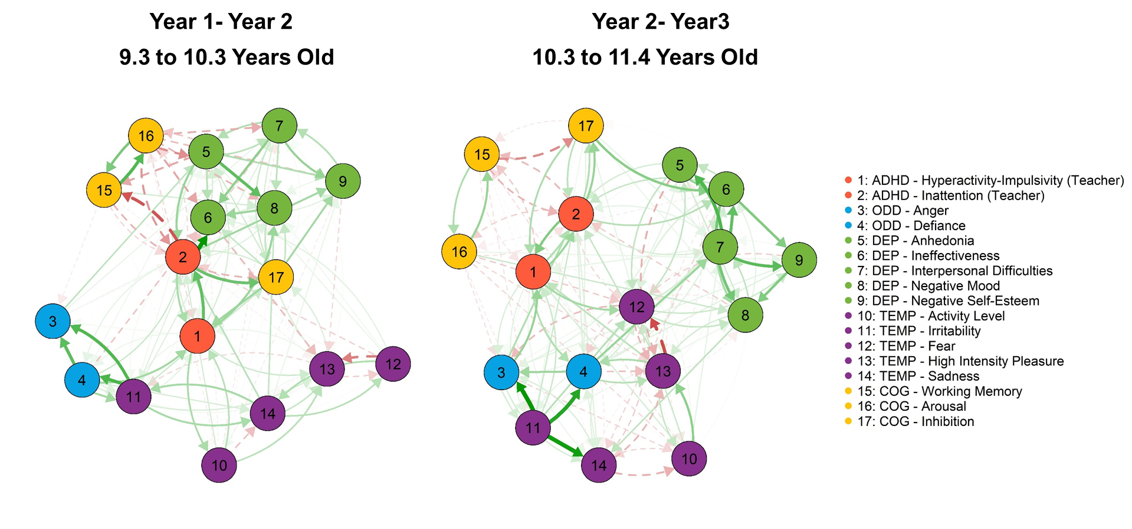

**Figure S2.** Centrality for networks using teacher-reported ADHD symptoms

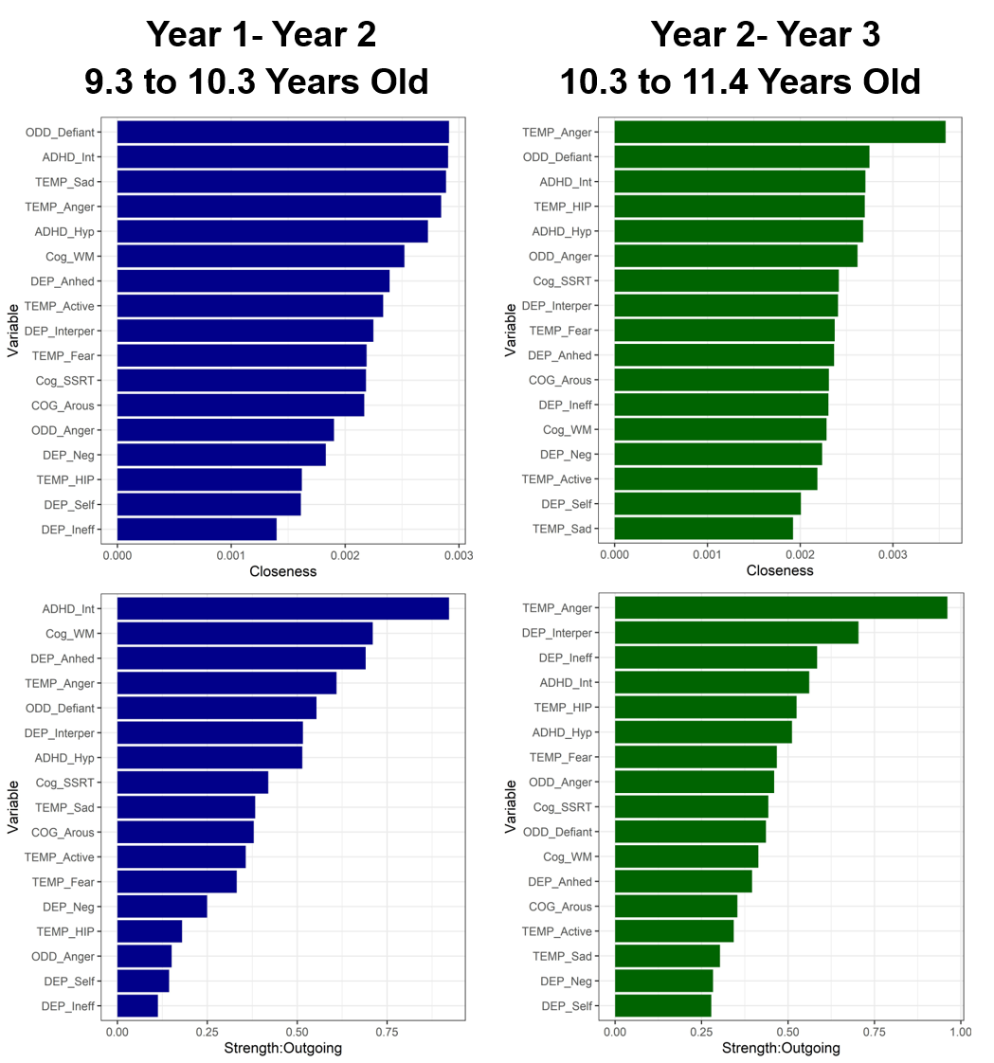

**References**

Aston‐Jones, G., & Cohen, J. D. (2005). Adaptive gain and the role of the locus coeruleus–norepinephrine system in optimal performance. *Journal of Comparative Neurology, 493*(1), 99-110.

Band, G. P., Van Der Molen, M. W., & Logan, G. D. (2003). Horse-race model simulations of the stop-signal procedure. *Acta Psychologica, 112*(2), 105-142.

Cornblatt, B. A., & Malhotra, A. K. (2001). Impaired attention as an endophenotype for molecular genetic studies of schizophrenia. *American Journal of Medical Genetics, 105*(1), 11-15.

De Luca, C. R., Wood, S. J., Anderson, V., Buchanan, J.-A., Proffitt, T. M., Mahony, K., & Pantelis, C. (2003). Normative data from the CANTAB. I: development of executive function over the lifespan. *Journal of Clinical and Experimental Neuropsychology, 25*(2), 242-254.

Kera, E. A. C., Marks, D. J., Berwid, O. G., Santra, A., & Halperin, J. M. (2004). Self-report and objective measures of ADHD-related behaviors in parents of preschool children at risk for ADHD. *CNS spectrums, 9*(09), 639-647.

Logan, G. D. (1994). On the ability to inhibit thought and action: A users' guide to the stop signal paradigm.

Logan, G. D., & Cowan, W. B. (1984). On the ability to inhibit thought and action: A theory of an act of control. *Psychological Review, 91*(3), 295.

Logan, G. D., Schachar, R. J., & Tannock, R. (1997). Impulsivity and inhibitory control. *Psychological Science, 8*(1), 60-64.

Nigg, J. T. (1999). The ADHD response-inhibition deficit as measured by the stop task: Replication with DSM–IV combined type, extension, and qualification. *Journal of Abnormal Child Psychology, 27*(5), 393-402.

Ratcliff, R., & McKoon, G. (2008). The diffusion decision model: Theory and data for two-choice decision tasks. *Neural Computation, 20*(4), 873-922. doi:10.1037/h0027366

Sergeant, J. A., Oosterlaan, J., & van der Meere, J. (1999). Information processing and energetic factors in attention-deficit/hyperactivity disorder. In *Handbook of disruptive behavior disorders* (pp. 75-104): Springer.