S1. ASD, ADHD, RAD/DAD networks
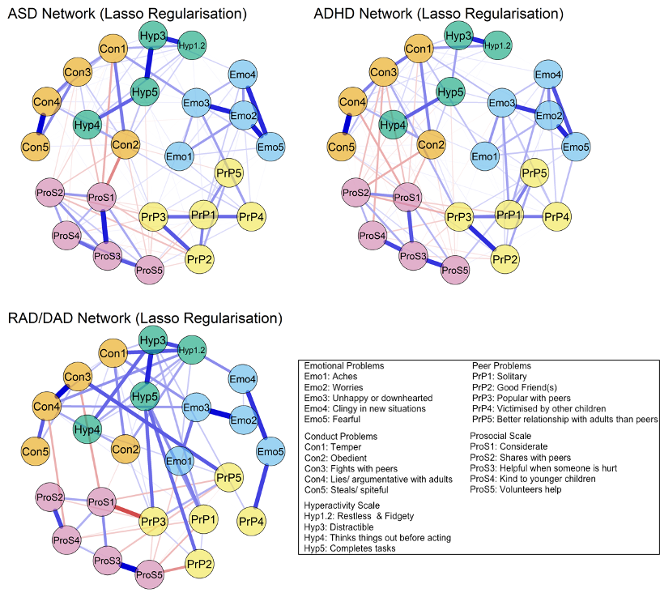

S2. Centrality estimates all networks
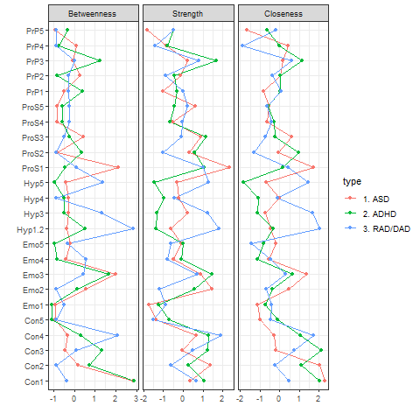

S3. ASD Bootstrapped Edge Weights
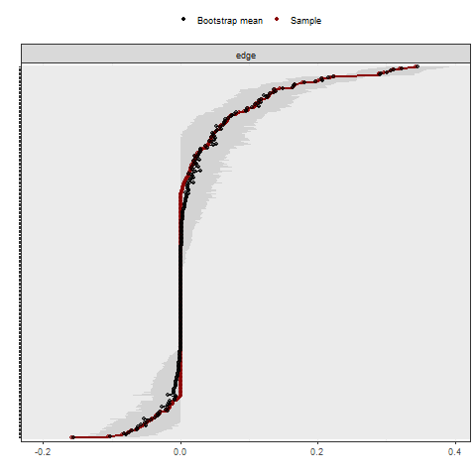

S4. ADHD Bootstrapped Edge weights
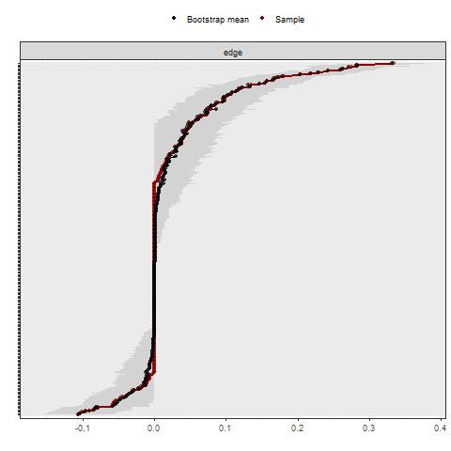

S5. RAD/DAD Bootstrapped Edge weights
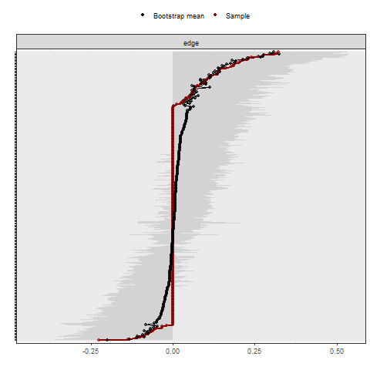

S6. Bootstrapped differences (alpha =0.05) in Strength centrality for RAD/DAD network
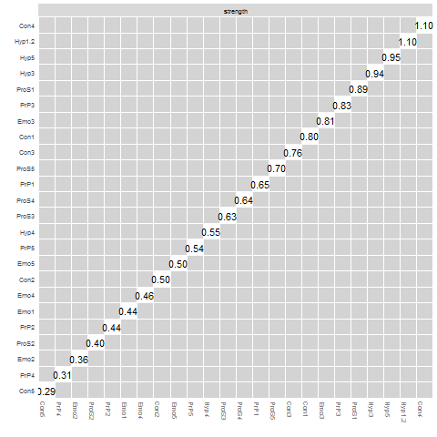
Non-parametric bootstrap (number of bootstraps = 2000). Black boxes represent statistically significant differences (alpha = 0.05), whereas grey boxes denote non-significant differences. Values cutting diagonally across the centre line are strength value
RAD/DAD Networks Strength centrality
As shown in Figure 3, it would appear that “lies/ argumentative with adults” (Con4), “restless & fidgety” (Hyp 1.2), “completes tasks” (Hyp5), “distractible” (“Hyp3”) and “considerate” (pros1). However, in light of the centrality stability analysis and the fairly wide confidence intervals observed during bootstrapping, RAD/DAD networks should be interpreted as especially exploratory. Further, the nonparametric test of differences in Strength yielded no significant items. This indicates that no items were statistically more different in terms of Strength centrality compared to other items.

S7. Descriptive Statistics for the entire cohort (n = 11,443)
Index Diagnosis | N | Age |  |  | Gender | Ever diagnosis
 |  | Mean Age (Y) | Median  (Y) | SD | (%  Male) | ASD/ ADHD | ADHD/  ASD | ASD or ADHD and RAD/ DAD
ASD | 6312 | 10.7 | 11 | 3.7 | 76.1% | 1136 | - | -
ADHD | 4944 | 10.6 | 10 | 3.4 | 81.4% | - | 568 | -
RAD/ DAD | 187 | 8.8 | 8 | 4.1 | 70% | - | - | 37
Y=Years, SD = Standard Deviation

S8. Participant flow chart
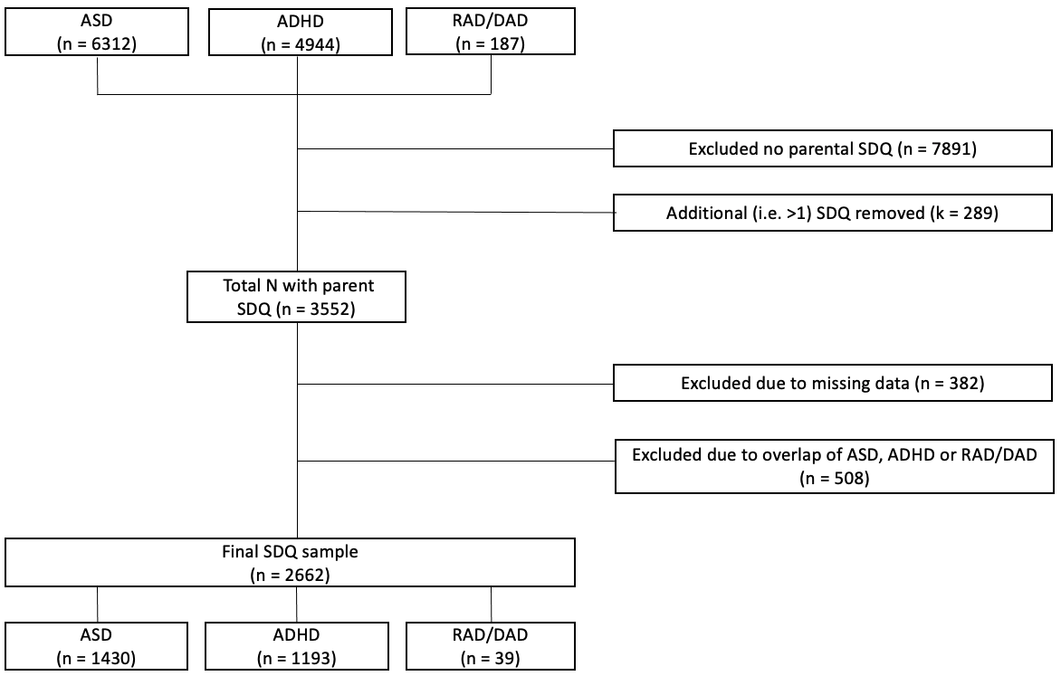

S9. Item level SDQ Descriptive Statistics
Item | ASD |  |  |  | ADHD |  |  |  | RAD/DAD
 | Mean | SD | Skew | Kurtosis | Mean | SD | Skew | Kurtosis | Mean | SD | Skew | Kurtosis
Con1: Temper | 1.42 | 0.74 | -0.86 | -0.68 | 1.53 | 0.67 | -1.11 | -0.02 | 1.41 | 0.68 | -0.67 | -0.73
Con2: Obedient | 1.05 | 0.69 | -0.07 | -0.89 | 1.28 | 0.67 | -0.38 | -0.79 | 1.05 | 0.76 | -0.08 | -1.31
Con3: Fights with peers | 0.51 | 0.71 | 1.04 | -0.29 | 0.87 | 0.79 | 0.24 | -1.36 | 0.69 | 0.69 | 0.46 | -.0.94
Con4: Lies/ argumentative with adults | 0.61 | 0.77 | 0.80 | -0.88 | 1.06 | 0.77 | -0.10 | -1.32 | 1.21 | 0.77 | -0.35 | -1.28
Con5: Steals/ spiteful | 0.28 | 0.59 | 1.97 | 2.64 | 0.53 | 0.75 | 1.02 | -0.48 | 0.69 | 0.80 | 0.58 | -1.24
Emo1: Aches | 0.80 | 0.81 | 0.37 | -1.40 | 0.79 | 0.79 | 0.39 | -1.29 | 0.72 | 0.79 | 0.52 | -1.27
Emo2: Worries | 1.25 | 0.78 | -0.47 | -1.21 | 0.90 | 0.77 | 0.17 | -1.29 | 0.97 | 0.78 | 0.04 | -1.39
Emo3: Unhappy or downhearted | 0.96 | 0.77 | 0.07 | -1.32 | 0.74 | 0.73 | 0.46 | -1.04 | 0.77 | 0.71 | 0.33 | -1.03
Emo4: Clingy in new situations | 1.42 | 0.74 | -0.85 | -0.71 | 1.05 | 0.83 | -0.09 | -1.54 | 1.21 | 0.83 | -0.38 | -1.49
Emo5: Fearful | 1.17 | 0.78 | -0.31 | -1.31 | 0.75 | 0.79 | 0.47 | -1.25 | 0.90 | 0.79 | 0.17 | -1.41
Hyp1.2: Restless & Fidgety | 1.22 | 0.86 | -0.43 | -1.51 | 1.75 | 0.56 | -2.10 | 3.27 | 1.33 | 0.84 | -0.66 | -1.29
Hyp3: Distractible | 1.54 | 0.67 | -1.12 | 0.02 | 1.89 | 0.36 | -3.49 | 12.27 | 1.69 | 0.52 | -1.33 | 0.75
Hyp4: Thinks things out before acting | 1.47 | 0.67 | -0.89 | -0.39 | 1.64 | 0.61 | -1.51 | 1.11 | 1.51 | 0.56 | -0.50 | -0.96
Hyp5: Completes tasks | 1.47 | 0.67 | -0.90 | -0.38 | 1.74 | 0.54 | -1.92 | 2.75 | 1.54 | 0.64 | -1.01 | -0.16
Pros1: Considerate | 0.92 | 0.70 | 0.11 | -0.95 | 1.08 | 0.63 | -0.07 | -0.51 | 1.08 | 0.66 | -0.08 | -0.80
Pros2: Shares with peers | 0.86 | 0.73 | 0.22 | -1.13 | 1.07 | 0.67 | -0.09 | -0.80 | 1.13 | 0.73 | -0.19 | -1.17
Pros3: Helpful when someone is hurt | 1.05 | 0.76 | -0.09 | -1.25 | 1.38 | 0.66 | -0.60 | -0.68 | 1.31 | 0.66 | -0.38 | -0.84
Pros4: Kind to younger children | 1.36 | 0.71 | -0.66 | -0.82 | 1.50 | 0.63 | -0.88 | -0.27 | 1.51 | 0.64 | -0.91 | -0.32
Pros5: Volunteers help | 0.88 | 0.76 | 0.21 | -1.27 | 1.16 | 0.72 | -0.24 | -1.08 | 1.41 | 0.68 | -0.67 | -0.73
Prp1: Solitary | 1.36 | 0.70 | -0.62 | -0.80 | 0.77 | 0.76 | 0.42 | -1.15 | 0.90 | 0.72 | 0.14 | -1.11
Prp2: Good Friend(s) | 0.95 | 0.83 | 0.10 | -1.54 | 0.59 | 0.73 | 0.83 | -0.70 | 0.79 | 0.73 | 0.32 | -1.14
Prp3: Popular with peers | 0.85 | 0.69 | 0.21 | -0.91 | 0.69 | 0.64 | 0.39 | -0.72 | 0.67 | 0.62 | 0.33 | -0.78
Prp4: Victimised by other children | 0.84 | 0.78 | 0.29 | -1.31 | 0.72 | 0.75 | 0.51 | -1.07 | 0.56 | 0.75 | 0.87 | -0.76
Prp5: Better relationship with adults than peers | 1.19 | 0.77 | -0.35 | -1.26 | 0.91 | 0.77 | 0.16 | -1.29 | 0.79 | 0.70 | 0.28 | -0.99
SD = Standard Deviation; Skew = Skewness
S10. Line graph with SDQ scales and Total Difficulties
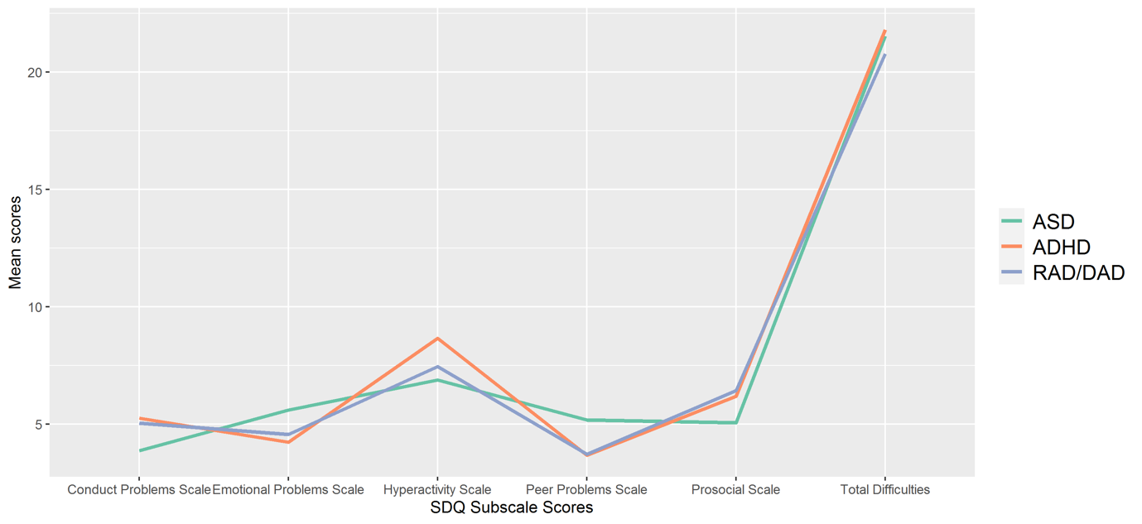

S11. Unadjusted and Adjusted mean values following analysis of variance
Scale | ASD | ADHD
Emotional Problems
Unadjusted | 5.60 | 4.23
Adjusted | 5.57 | 4.27
Conduct problems
Unadjusted | 3.87 | 5.26
Adjusted | 3.89 | 5.24
Hyperactivity
Unadjusted | 6.88 | 8.66
Adjusted | 6.93 | 8.60
Peer Problems
Unadjusted | 5.19 | 3.67
Adjusted | 5.17 | 3.69
Pro Social
Unadjusted | 5.07 | 6.19
Adjusted | 5.07 | 6.19

S12. Edge Strength ASD and ADHD
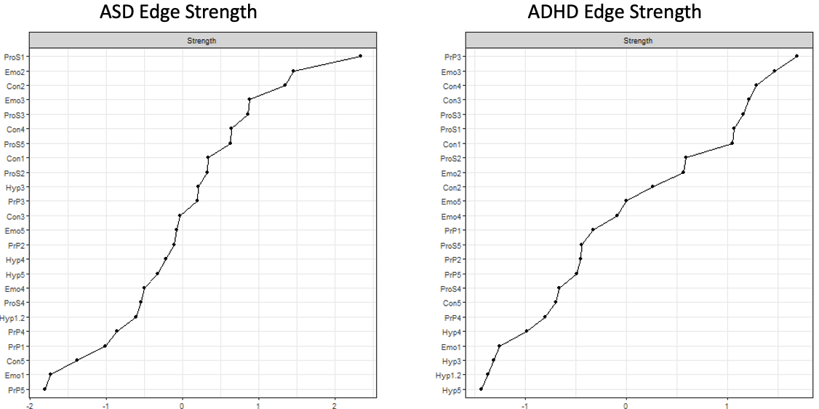
Please note differences in x and y-axis.

S13. Stability of Centrality Estimates for each network

S14. Bootstrapped differences (alpha =0.05) in Strength centrality for ASD network
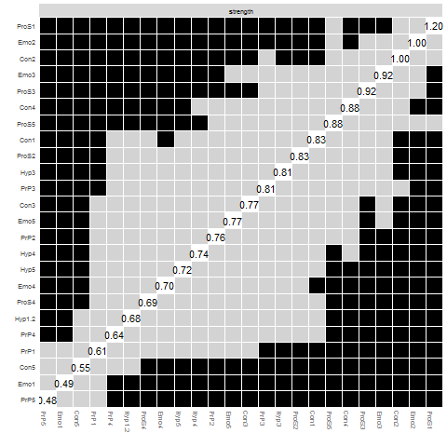
Non-parametric bootstrap (number of bootstraps = 2000). Black boxes represent statistically significant differences (alpha = 0.05), whereas grey boxes denote non-significant differences. Values cutting diagonally across the centre line are strength values.

S15. Bootstrapped differences (alpha =0.05) in Strength centrality for ADHD network
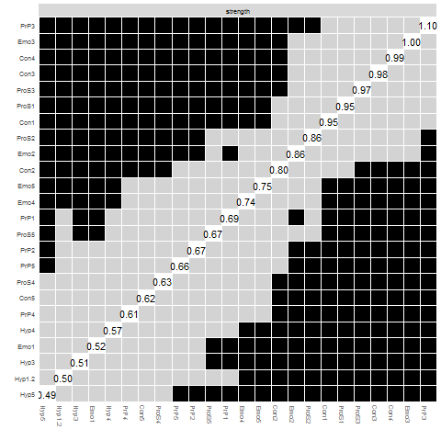
Non-parametric bootstrap (number of bootstraps = 2000). Black boxes represent statistically significant differences (alpha = 0.05), whereas grey boxes denote non-significant differences. Values cutting diagonally across the centre line are strength value.

S16. Community detection using Spin glass
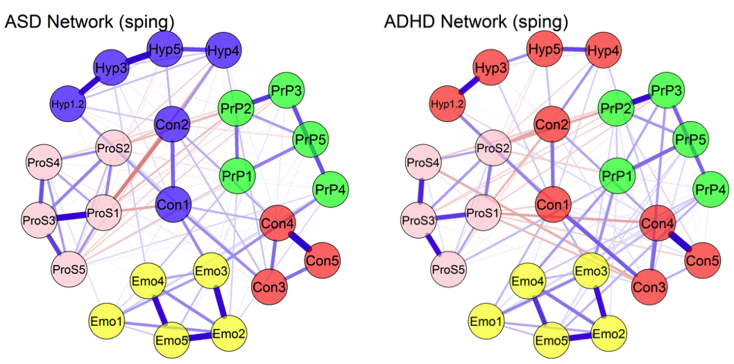
In these networks communities of nodes are identified by their colours.

S17. ASD Gender Networks
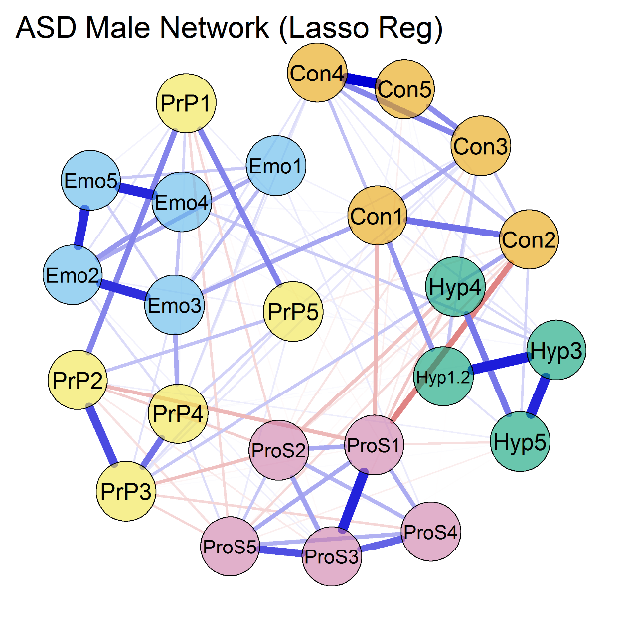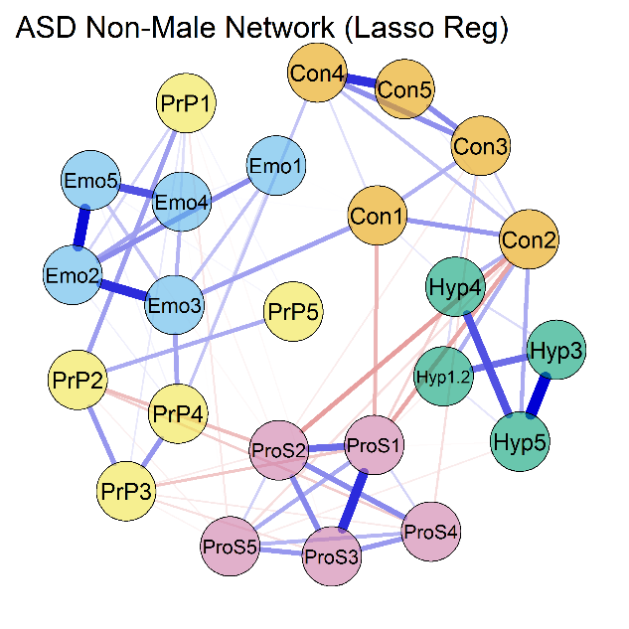

S18. Bootstrapped differences edge strength centrality ASD Male network (alpha = 0.05)
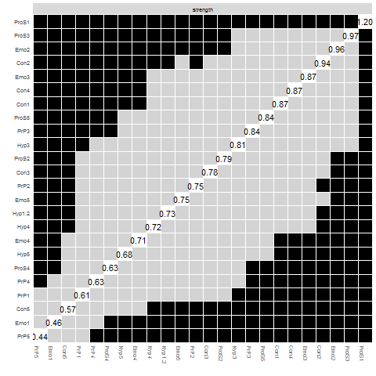
Non-parametric bootstrap (number of bootstraps = 2000). Black boxes represent statistically significant differences (alpha = 0.05), whereas grey boxes denote non-significant differences. Values cutting diagonally across the centre line are strength value

S19. Bootstrapped differences edge strength centrality ASD Non-Male network (alpha = 0.05)
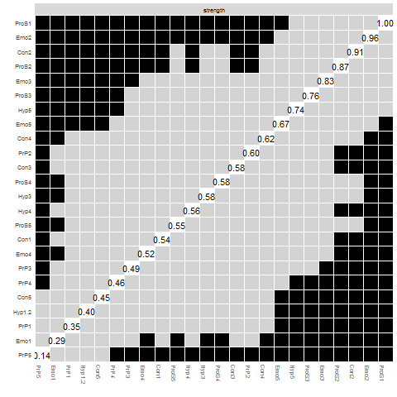
Non-parametric bootstrap (number of bootstraps = 2000). Black boxes represent statistically significant differences (alpha = 0.05), whereas grey boxes denote non-significant differences. Values cutting diagonally across the centre line are strength value

S20. Stability of Centrality Estimates ASD Male Network
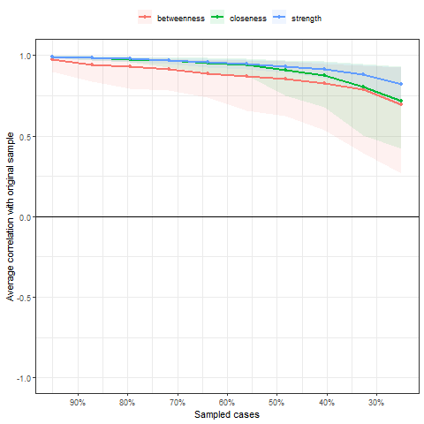

S21. Stability of Centrality Estimates ASD Non-Male Network
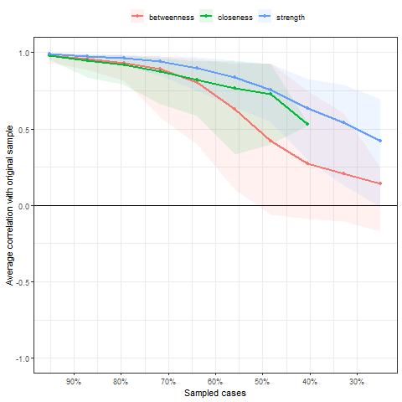

S22. ADHD Gender network
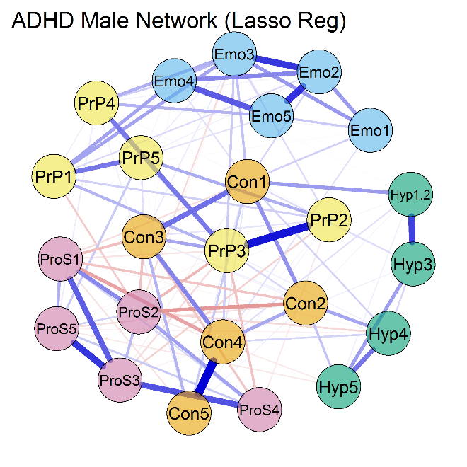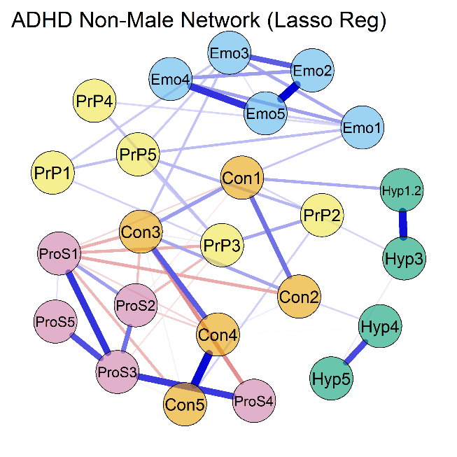

S23. Bootstrapped differences edge strength centrality ADHD Male network (alpha = 0.05)
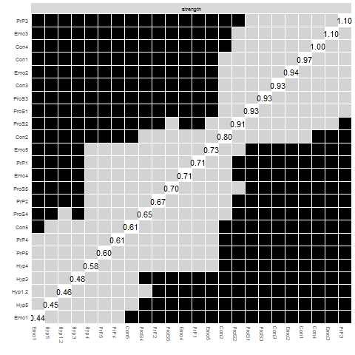
Non-parametric bootstrap (number of bootstraps = 2000). Black boxes represent statistically significant differences (alpha = 0.05), whereas grey boxes denote non-significant differences. Values cutting diagonally across the centre line are strength value

S24. Bootstrapped differences edge strength centrality ADHD Non-Male network (alpha = 0.05)
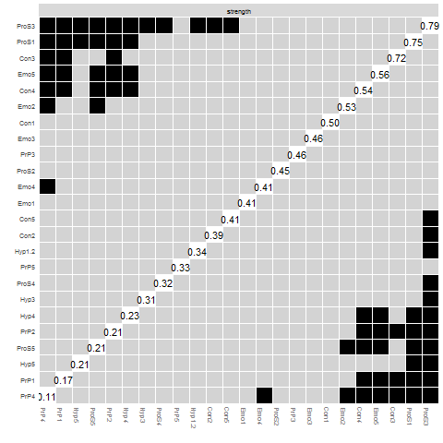
Non-parametric bootstrap (number of bootstraps = 2000). Black boxes represent statistically significant differences (alpha = 0.05), whereas grey boxes denote non-significant differences. Values cutting diagonally across the centre line are strength value

S25. Stability of Centrality Estimates ADHD Male Network
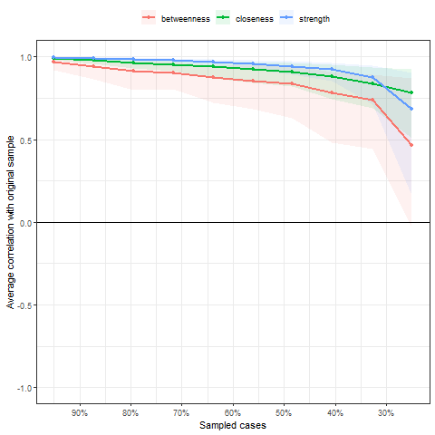

S26. Stability of Centrality Estimates ADHD Non-Male Network
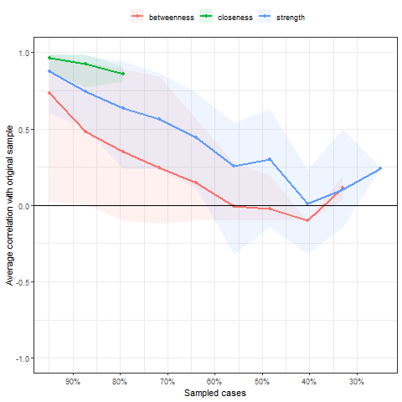

S27. ASD AGE Networks
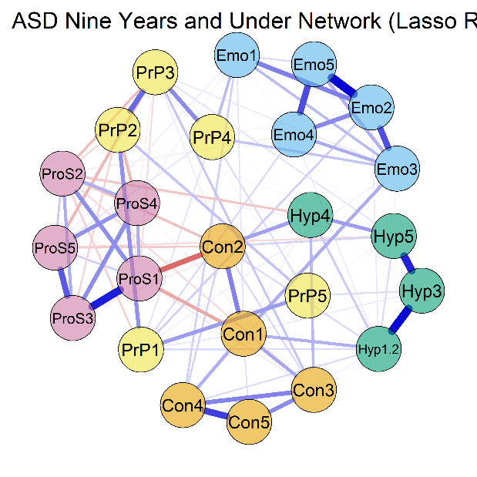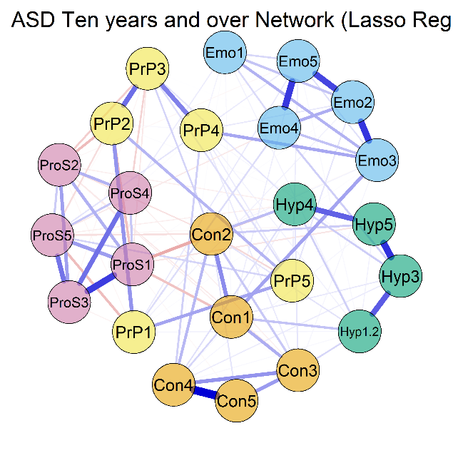

S28. Bootstrapped differences edge strength centrality ASD Nine years and under network (alpha = 0.05)
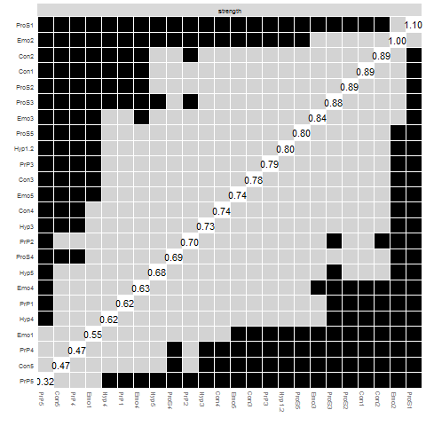
Non-parametric bootstrap (number of bootstraps = 2000). Black boxes represent statistically significant differences (alpha = 0.05), whereas grey boxes denote non-significant differences. Values cutting diagonally across the centre line are strength value

S29. Bootstrapped differences edge strength centrality ASD ten years and over network (alpha = 0.05)
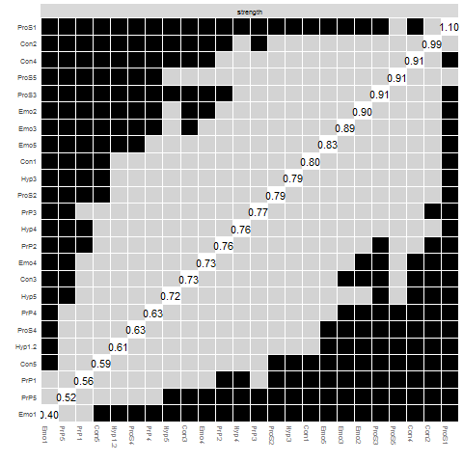
Non-parametric bootstrap (number of bootstraps = 2000). Black boxes represent statistically significant differences (alpha = 0.05), whereas grey boxes denote non-significant differences. Values cutting diagonally across the centre line are strength value

S30. Stability of Centrality Estimates ASD nine years and under Network
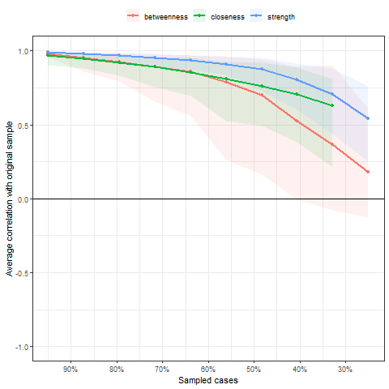

S31. Stability of Centrality Estimates ASD ten years and older Network
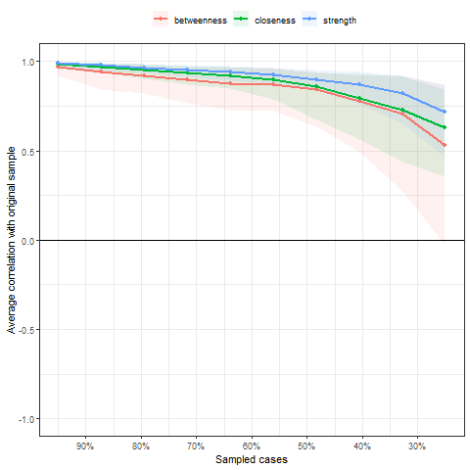

S32. ADHD Age Networks
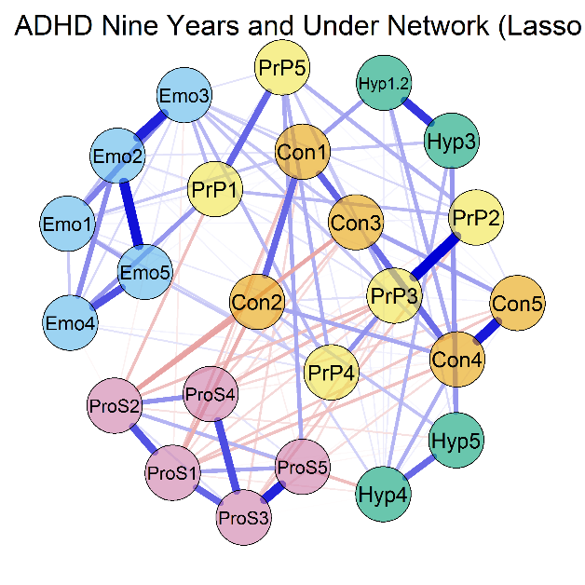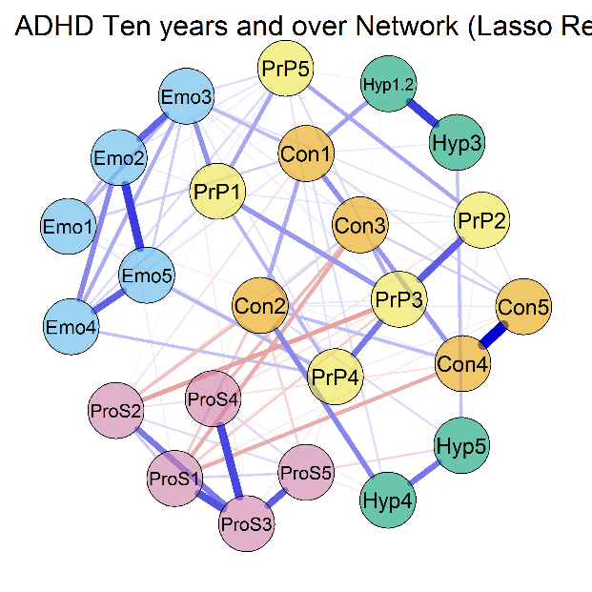

S33. Bootstrapped differences Edge Strength centrality ADHD nine years and under (alpha = 0.05)
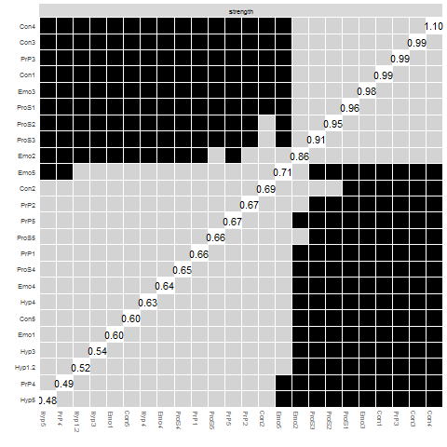
Non-parametric bootstrap (number of bootstraps = 2000). Black boxes represent statistically significant differences (alpha = 0.05), whereas grey boxes denote non-significant differences. Values cutting diagonally across the centre line are strength value

S34. Bootstrapped differences edge strength centrality ADHD ten years and older (alpha = 0.05)
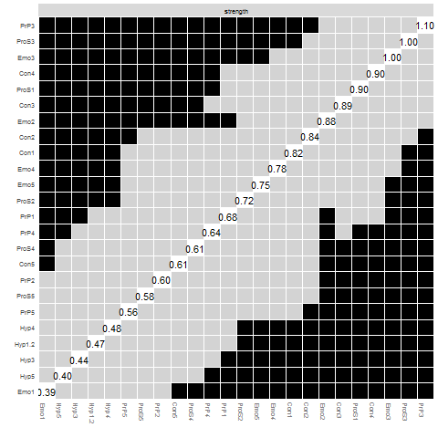
Non-parametric bootstrap (number of bootstraps = 2000). Black boxes represent statistically significant differences (alpha = 0.05), whereas grey boxes denote non-significant differences. Values cutting diagonally across the centre line are strength value

S35. Stability of Centrality Estimates ADHD nine years and under
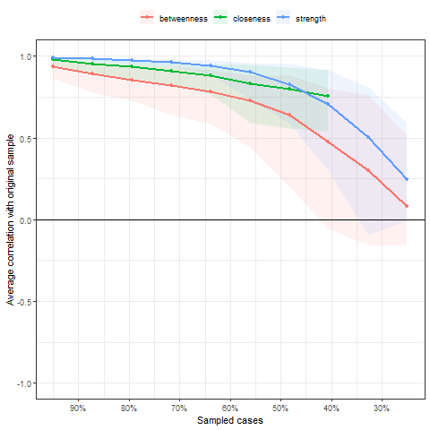

S36. Stability of Centrality Estimates ADHD ten years and older
