Supplementary Information

Results:
We also examined whether parents’ social support and temperament moderated the effect of parent’s history of MDD on their offspring perceived parenting styles. Using a generalized estimating equation framework to account for potential nonindependence resulting from family relatedness, for G1-to-G2 parent-child cycle: no significant interactions between a history of MDD and parental temperament (F=0.771, P=0.38), and social support (F=0.753, P=0.38) in predicting perceived Care. No significant interactions between a history of MDD and parental temperament (F=1.174, P=0.28) and social support (F=3.018, P=0.18) in predicting perceived Overprotection. As for G2(+spouses)-to-G3 parent-child cycle: no significant interactions between a history of MDD and parental temperament (F=1.692, P=0.20), and social support (F=0.199, P=0.65) in predicting perceived parental Care. No significant interactions between a history of MDD and parental temperament (F=2.523, P=0.11) and social support (F=1.935, P=0.16) in predicting perceived Overprotection.

Figure S1-
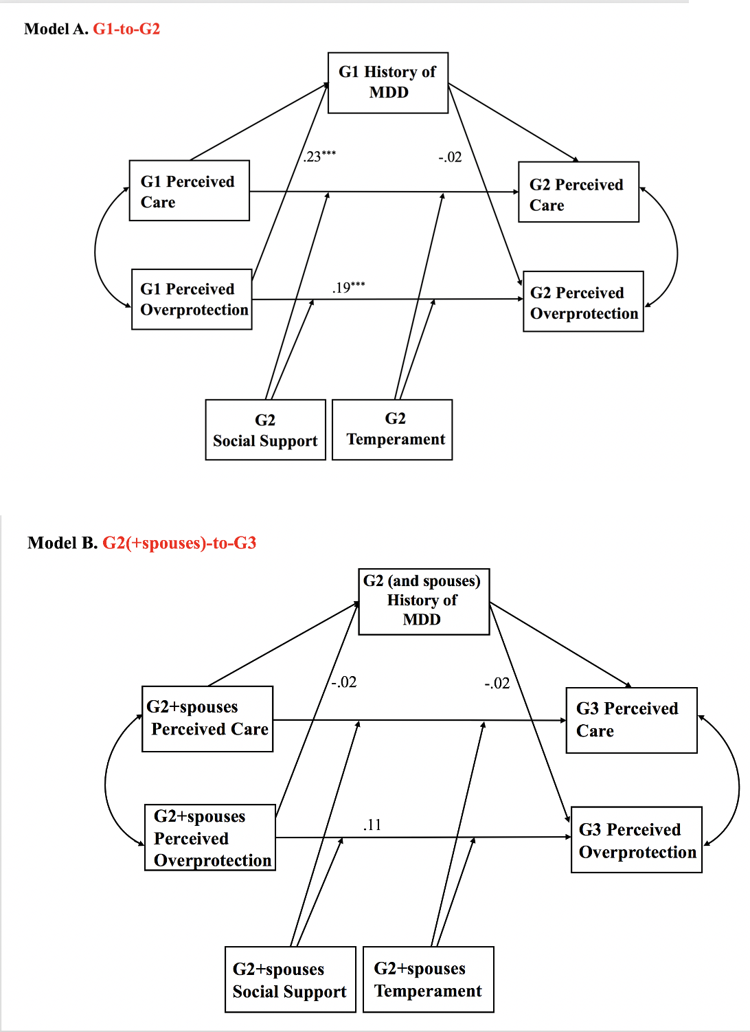
Note: History of MDD as a mediator for the associations between G1 perceived parental overprotection and G2 perceived parental overprotection (Model A: G1-to-G2), and G2(+spouses) perceived parental overprotection and G3 perceived parental overprotection (Model B: G2+spouses-to-G3). ***P<0.001

