Appendix Table 1. Within- and between-dyad model equations for emotion regulation and coregulation processes during mother-infant free play
Within-dyad equations
MP_{ti} = α_{1i} + φ_{1i}MP^{c}_{(t-1)i} + φ_{4i}IP^{c}_{(t-1)i} + φ_{7i}IN^{c}_{(t-1)i} + e_{1ti}
IP_{ti} = α_{2i} + φ₂MP^{c}_{(t-1)} + φ_{5i}IP^{c}_{(t-1)i} + φ_{8i}IN^{c}_{(t-1)i} + e_{2ti}
IN_{ti} = α_{3i} + φ₃MP^{c}_{(t-1)} + φ_{6i}IP^{c}_{(t-1)i} + φ_{9i}IN^{c}_{(t-1)i} + e_{3ti}

Between-dyad equations
α_{1i} = γ₀₀ + γ₀₁MRSA^{c}_{i} + γ₀₂SDRSA^{c}_{i} + u_{0i}
α_{2i} = γ₁₀ + γ₁₁MRSA^{c}_{i} + γ₁₂SDRSA^{c}_{i} + u_{1i}
α_{3i} = γ₂₀ + γ₂₁MRSA^{c}_{i} + γ₂₂SDRSA^{c}_{i} + γ₂₃COG^{c}_{i} + u_{2i}
φ_{1i} = γ₃₀ + γ₃₁MRSA^{c}_{i} + γ₃₂SDRSA^{c}_{i} + u_{3i}
φ_{2i} = γ₄₀ + γ₄₁MRSA^{c}_{i} + γ₄₂SDRSA^{c}_{i} + u_{4i}
φ_{3i} = γ₅₀ + γ₅₁MRSA^{c}_{i} + γ₅₂SDRSA^{c}_{i} + γ₅₃COG^{c}_{i} + u_{5i}
φ_{4i} = γ₆₀ + γ₆₁MRSA^{c}_{i} + γ₆₂SDRSA^{c}_{i} + u_{6i}
φ_{5i} = γ₇₀ + γ₇₁MRSA^{c}_{i} + γ₇₂SDRSA^{c}_{i} + u_{7i}
φ_{6i} = γ₈₀ + γ₈₁MRSA^{c}_{i} + γ₈₂SDRSA^{c}_{i} + γ₈₃COG^{c}_{i} + u_{8i}
φ_{7i} = γ₉₀ + γ₉₁MRSA^{c}_{i} + γ₉₂SDRSA^{c}_{i} + γ₉₃COG^{c}_{i} + u_{9i}
φ_{8i} = γ_{10,0} + γ_{10,1}MRSA^{c}_{i} + γ_{10,2}SDRSA^{c}_{i} + γ_{10,3}COG^{c}_{i} + u_{10i}
φ_{9i} = γ_{11,0} + γ_{11,1}MRSA^{c}_{i} + γ_{11,2}SDRSA^{c}_{i} + γ_{11,3}COG^{c}_{i} + u_{11i}
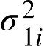 = exp(ω₀₀ + γ_{12,1}MRSA^{c}_{i} + γ_{12,2}SDRSA^{c}_{i} + u_{12i})
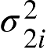= exp(ω₁₀ + γ_{13,1}MRSA^{c}_{i} + γ_{13,2}SDRSA^{c}_{i} + u_{13i})
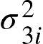 = exp(ω₂₀ + γ_{14,1}MRSA^{c}_{i} + γ_{14,2}SDRSA^{c}_{i} + u_{14i})

Covariances

u_{i} ~ MVN (0₁₅, 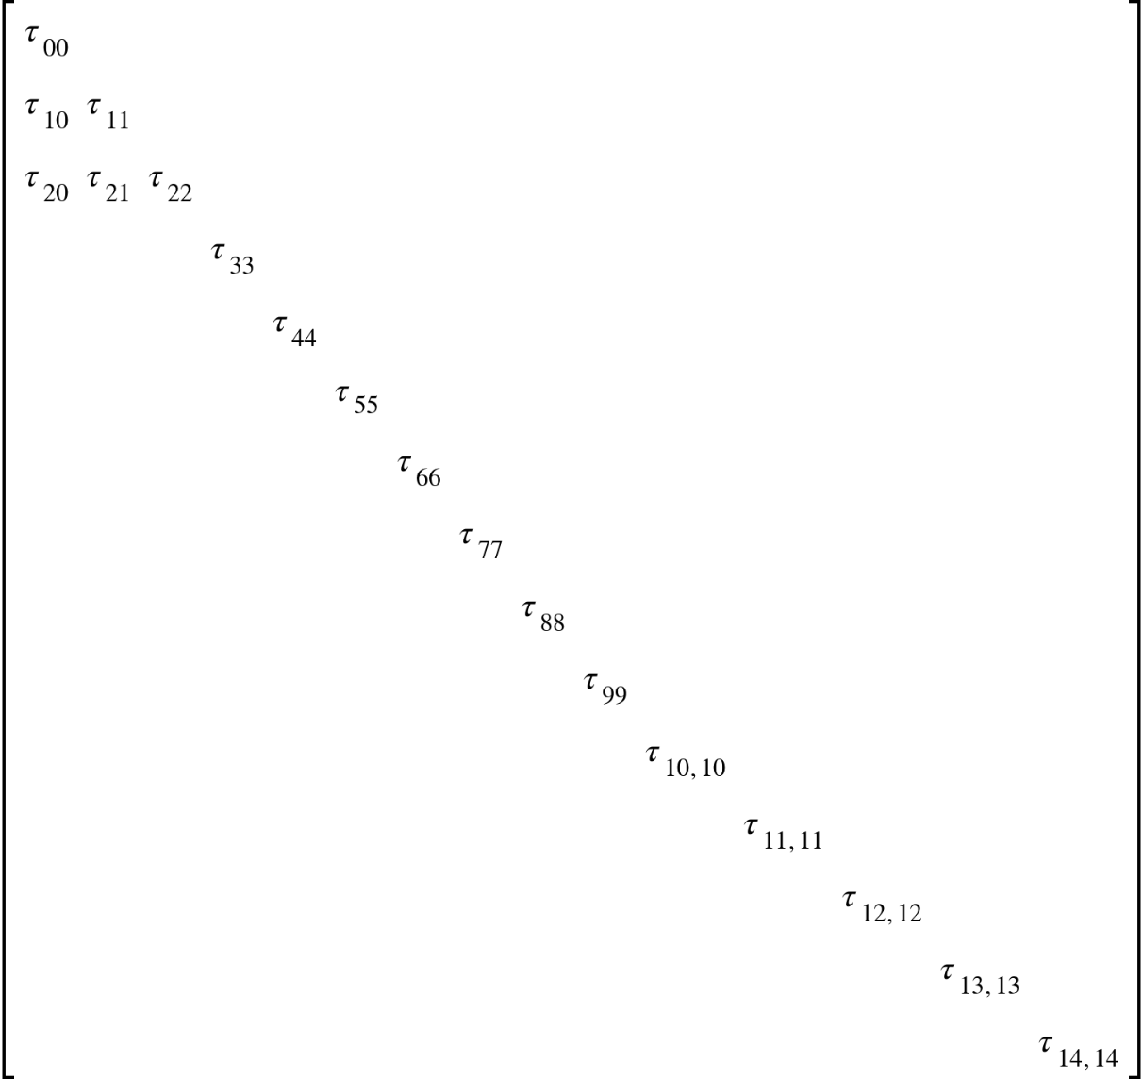 )

Note. MP = Maternal positive affect. IP = Infant positive affect. IN = Infant negative affect. MRSA = Within-infant mean of respiratory sinus arrhythmia (RSA) during free play. SDRSA = Within-infant standard deviation of RSA during free play. COG = Maternal country of origin (0 = Mexico, 1 = United States).
Appendix Figure 1. Individual differences in volatility in negative affect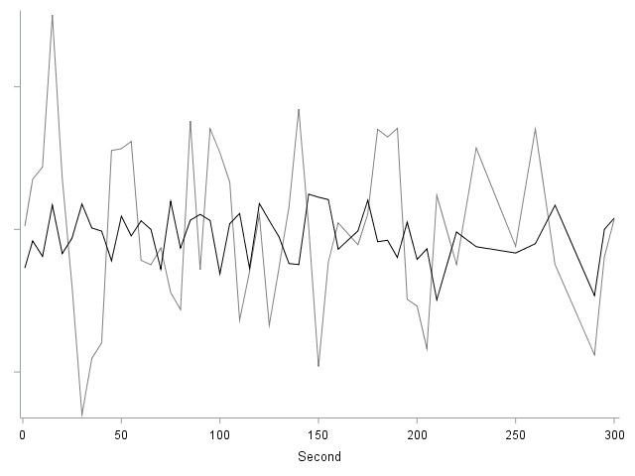
Note. The gray line represents a time series for an infant with more volatility in negative affect. The black line represents a time series for an infant with less volatility in negative affect.
Appendix Figure 2. Differences in carryover in positive affect

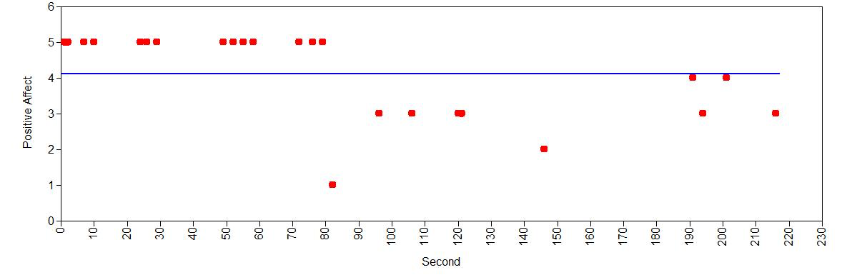

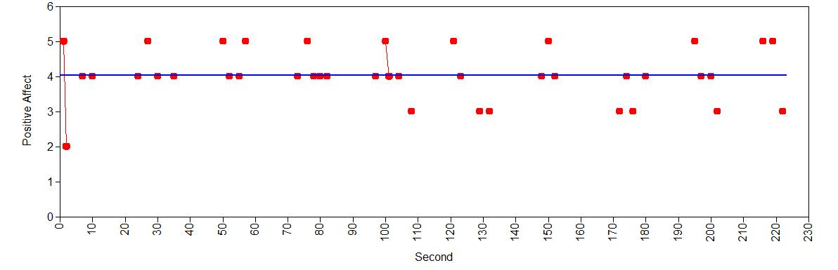
Note. The horizontal lines represent the average value of positive affect for each person. The dots reflect the amount of positive affect, at each second that it was observed. The time series shown in the top panel exhibits a high level of positive carryover in positive affect (estimate = .904). The time series shown in the bottom panel exhibits a null amount of carryover in positive affect (estimate = -.003).

Appendix Table 2. Descriptions of infant and maternal positive and negative affect
 | Infant Positive Affect | Maternal Positive Affect
Value
0 | Showed negative affect | Showed negative affect
1 | Positive facial/vocal affect, disengaged; Neutral or uncodable facial/vocal affect, passive engaged; Uncodable facial/vocal affect, active engaged | Positive facial/vocal, disengaged
2 | Neutral facial/vocal affect, active engaged | Neutral or uncodable facial/vocal affect, passive engaged; Neutral or uncodable facial/vocal affect, comforting or active engaged; Positive facial/vocal affect, comforting engaged
3 | Positive facial/vocal affect, passive engaged | Positive facial/vocal affect, passive engaged
4 | Positive facial/vocal affect, active engaged | Positive facial/vocal affect, active engaged
 | Infant Negative Affect | Maternal Negative Affect
Value
0 | Showed positive affect | Showed positive affect
1 | Neutral facial/vocal affect, disengaged | Neutral facial/vocal affect, disengaged
2 | Negative or uncodable facial/vocal affect, disengaged | Negative or uncodable facial/vocal affect, disengaged
3 | Negative facial/vocal affect, passive engaged | Negative facial/vocal affect, passive engaged
4 | Negative facial/vocal affect, active engaged | Negative facial/vocal affect, active engaged

Note. Affect was treated as missing when engagement was not coded. No mothers expressed negative affect while engaged in comforting behavior.

