Appendix A

**Table 1**

*Simulation Table of Samples and Distribution Parameters for 1,955,000 Simulations*

|  |  |  |  |  |  |  |
| --- | --- | --- | --- | --- | --- | --- |
| *Population Specifications* | | | | | | |
| Sample Size | 300, 500, 800, 1000, 2000 | | | | | |
| Replications | 1000 | | | | | |
| *Distribution Specifications* | | | | | | |
| Skew | 0.0, 1.0, 2.0, 3.0, 4.0 | | | | | |
| Kurtosis | 1.0, 3.0, 6.0, 10.0, 14.0, 18.0, 22.0, 26.0, 30.0 | | | | | |
| Effect Size | 0.30, 0.50, 0.80, 1.20, 2.00 | | | | | |
|  | *Number of Groups* | | | | | |
|  | 1 | 2 | 3 | 4 |  |
| Group Proportions | N/A | .70, .30 | .50, .30, .20 | .50, .30, .10, .10 |  |
|  |  | .85, .15 | .60, .30, .10 | .40, .30, .20, .10 |  |
|  |  | .95, .05 | .70, .20, .10 | .60, .20, .15,.05 |  |
|  |  | .90, .10 |  |  |  |

**Table 2**

*Combinations of Skew and Kurtosis for One Group Simulations*

|  |  |
| --- | --- |
| Skew | Kurtosis |
| 0.00 | 1.00 |
| 0.00 | 3.00 |
| 0.00 | 6.00 |
| 1.00 | 1.00 |
| 1.00 | 3.00 |
| 1.00 | 6.00 |
| 2.00 | 6.00 |
| 2.00 | 14.00 |
| 3.00 | 14.00 |
| 4.00 | 26.00 |

Table 3

*One Group results for Linear Simulations*



Note. **\*** Simulations that correctly identified one group. Akaike information criterion = AIC, Bayesian information criterion = BIC, bootstrap parametric likelihood ratio test = BLRT, Lo-Mendell-Rubin likelihood ratio test = LMR. P-values are presented for BLRT and LMR. The columns with numbers 0-5 are the group identified by each fit index.

Table 4

*One Group results for Quadratic and Exponential Simulations*



Note. **\*** Simulations that correctly identified one group. Akaike information criterion = AIC, Bayesian information criterion = BIC, bootstrap parametric likelihood ratio test = BLRT, Lo-Mendell-Rubin likelihood ratio test = LMR. P-values are presented for BLRT and LMR. The columns with numbers 0-5 are the group identified by each fit index.

Table 5

*One Group results for Linear, Exponential, and Quadratic Models that were successful*



Note. Akaike information criterion = AIC, Bayesian information criterion = BIC, bootstrap parametric likelihood ratio test = BLRT, Lo-Mendell-Rubin likelihood ratio test = LMR, percentage of replications that supported one group = %, group number identified as best fit based on all fit indices = #. P-values are presented for BLRT and LMR.

Table 6

*Two Group results for no growth and linear growth with a small increase*



Note. **\*** Simulations that correctly identified one group. Akaike information criterion = AIC, Bayesian information criterion = BIC, bootstrap parametric likelihood ratio test = BLRT, Lo-Mendell-Rubin likelihood ratio test = LMR. P-values are presented for BLRT and LMR. The columns with numbers 0-5 are the group identified by each fit index.

Table 7

*Two Group results for linear no growth and linear growth with a small increase that were successful*



Note. Sample size = SS, Effect size = ES, Akaike information criterion = AIC, Bayesian information criterion = BIC, bootstrap parametric likelihood ratio test = BLRT, Lo-Mendell-Rubin likelihood ratio test = LMR, percentage of replications that supported one group = %, group number identified as best fit based on all fit indices = #. P-values are presented for BLRT and LMR.

Table 8

*Two Group results for linear growth with a large increase over time*



Note. Akaike information criterion = AIC, Bayesian information criterion = BIC, bootstrap parametric likelihood ratio test = BLRT, Lo-Mendell-Rubin likelihood ratio test = LMR, percentage of replications that supported one group = %, group number identified as best fit based on all fit indices = #. P-values are presented for BLRT and LMR.

Table 9

*Two Group results for linear growth with a large increase and a small increase over time*



Note. Akaike information criterion = AIC, Bayesian information criterion = BIC, bootstrap parametric likelihood ratio test = BLRT, Lo-Mendell-Rubin likelihood ratio test = LMR, percentage of replications that supported one group = %, group number identified as best fit based on all fit indices = #. P-values are presented for BLRT and LMR.

Table 10

*Two group linear growth with a small increase and a large increase, minimum and maximum percentage of correctly identified replications for each fit index and group proportion*



*Note.* Akaike information criterion = AIC, Bayesian information criterion = BIC, bootstrap parametric likelihood ratio test = BLRT, Lo-Mendell-Rubin likelihood ratio test = LMR, Minimum = Min, Maximum = Max.

Table 11

*Two Group results for exponential growth simulations*



Note. Akaike information criterion = AIC, Bayesian information criterion = BIC, bootstrap parametric likelihood ratio test = BLRT, Lo-Mendell-Rubin likelihood ratio test = LMR, percentage of replications that supported one group = %, group number identified as best fit based on all fit indices = #. P-values are presented for BLRT and LMR.

Table 12

*Two Group results for quadratic inverted U-shaped growth simulations*



Note. Akaike information criterion = AIC, Bayesian information criterion = BIC, bootstrap parametric likelihood ratio test = BLRT, Lo-Mendell-Rubin likelihood ratio test = LMR, percentage of replications that supported one group = %, group number identified as best fit based on all fit indices = #. P-values are presented for BLRT and LMR.

Table 13

*Three Group results for no growth and linear growth with a gradual increase for Group 2*





Note. Effect Size = ES, Akaike information criterion = AIC, Bayesian information criterion = BIC, bootstrap parametric likelihood ratio test = BLRT, Lo-Mendell-Rubin likelihood ratio test = LMR, P-values are presented for BLRT and LMR.

Table 14

*Three Group results for linear growth with a steep increase for Group 2 and gradual decrease for Group 3 and linear growth with a gradual decrease for Group 1 and a steep increase for Group 3*





Note. Effect Size = ES, Akaike information criterion = AIC, Bayesian information criterion = BIC, bootstrap parametric likelihood ratio test = BLRT, Lo-Mendell-Rubin likelihood ratio test = LMR, P-values are presented for BLRT and LMR.

Table 15

*Significant three group results for linear growth with steep increase for Group 2 and gradual decrease for Group 3*



Note. Sample size = SS, Effect size = ES, Akaike information criterion = AIC, Bayesian information criterion = BIC, bootstrap parametric likelihood ratio test = BLRT, Lo-Mendell-Rubin likelihood ratio test = LMR, percentage of replications that supported three groups = %, group number identified as best fit based on all fit indices = #. P-values are presented for BLRT and LMR.

Table 16

*Three Group results for quadratic growth with an inverted U-shaped growth and exponential growth with a small increase for Group 2 and large increase for Group 3*





Note. Effect Size = ES, Akaike information criterion = AIC, Bayesian information criterion = BIC, bootstrap parametric likelihood ratio test = BLRT, Lo-Mendell-Rubin likelihood ratio test = LMR, P-values are presented for BLRT and LMR.

Table 17

*Significant three group results for quadratic inverted U-shaped growth*



Note. Akaike information criterion = AIC, Bayesian information criterion = BIC, bootstrap parametric likelihood ratio test = BLRT, Lo-Mendell-Rubin likelihood ratio test = LMR, percentage of replications that supported three groups = %, group number identified as best fit = #. P-values are presented for BLRT and LMR.

Table 18

*Four Group results for no growth and linear steep growth with a crossover*





Note. Effect Size = ES, Akaike information criterion = AIC, Bayesian information criterion = BIC, bootstrap parametric likelihood ratio test = BLRT, Lo-Mendell-Rubin likelihood ratio test = LMR, P-values are presented for BLRT and LMR.

Table 19

*Four group results for linear gradual growth with a crossover and linear fan growth*





Note. Effect Size = ES, Akaike information criterion = AIC, Bayesian information criterion = BIC, bootstrap parametric likelihood ratio test = BLRT, Lo-Mendell-Rubin likelihood ratio test = LMR, P-values are presented for BLRT and LMR.

Table 20

*Four group results for simulations where GMM effectively identified four groups.*



Note. Akaike information criterion = AIC, Bayesian information criterion = BIC, bootstrap parametric likelihood ratio test = BLRT, Lo-Mendell-Rubin likelihood ratio test = LMR, percentage of replications that supported three groups = %, group number identified as best fit = #. P-values are presented for BLRT and LMR.

Table 21

*Four group results for exponential/quadratic growth and quadratic inverted U-shaped growth*





Note. Effect Size = ES, Akaike information criterion = AIC, Bayesian information criterion = BIC, bootstrap parametric likelihood ratio test = BLRT, Lo-Mendell-Rubin likelihood ratio test = LMR, P-values are presented for BLRT and LMR.

**Figure 1.** Examples of the three quadratic growth functions. Graph A represents inverted U-shaped growth with the equation f(x) = -2x2 + 12x +40. Graphs B and C have exponential growth over time. For graph B time 3-5 have a growth of Time 1 value + .25*x where x = 1, 3, 6. For graph C time 3-5 have a growth of Time 1 value + 2*x where x = 1,3,6.

**B. C.**

**Figure 2.** Examples of two-group growth distributions with effect size of 0.5. Graph A represents no growth, graph B no growth and small growth (slope = 0.5), graph C represents no growth and large growth (slope = 2.0), and graph D represents small growth and large growth. Graphs E represent inverted U-shaped growth. Graph E has a no slope group and a group with quadratic growth (f(x) = -2x2 + 12x +45). Graph F has exponential growth over time, and includes one group with small decreasing growth with time 3-5 having a growth of Time 1 value -.25*x where x = 1, 3, 6. and one group has large increasing exponential growth with time 3-5 having a growth of Time 1 value + 2*x where x = 1, 3, 6.

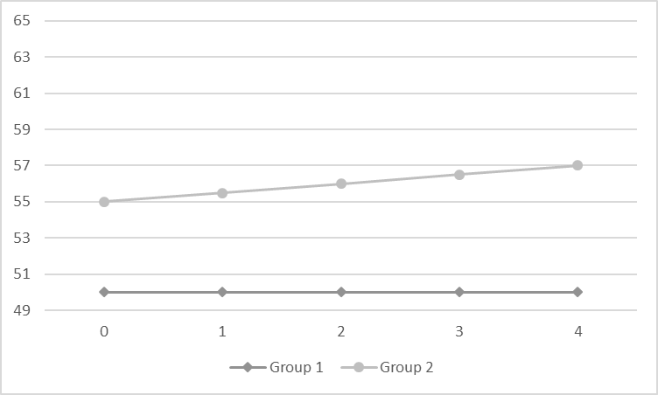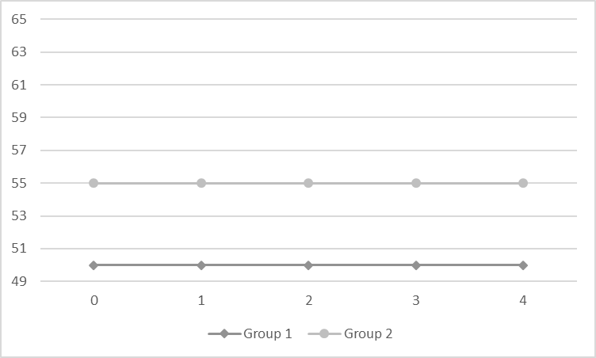**A. B.**

1. 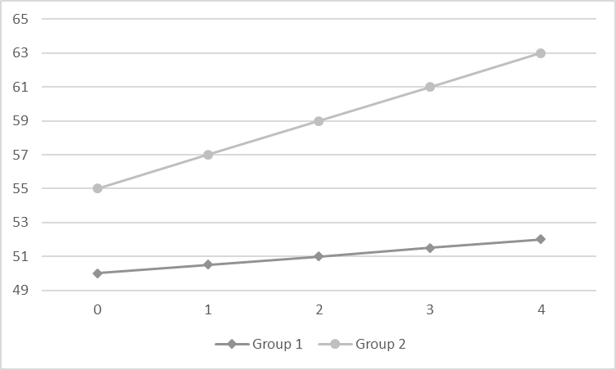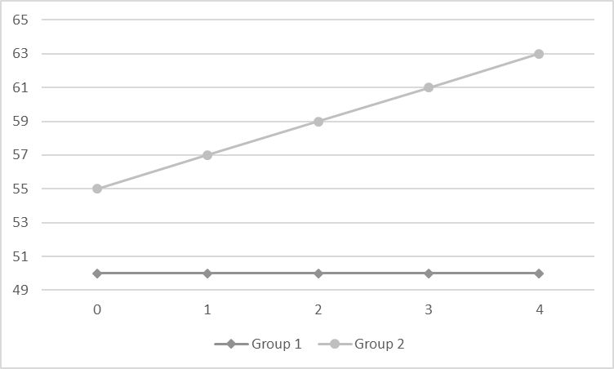 **D.**

**E. F.**

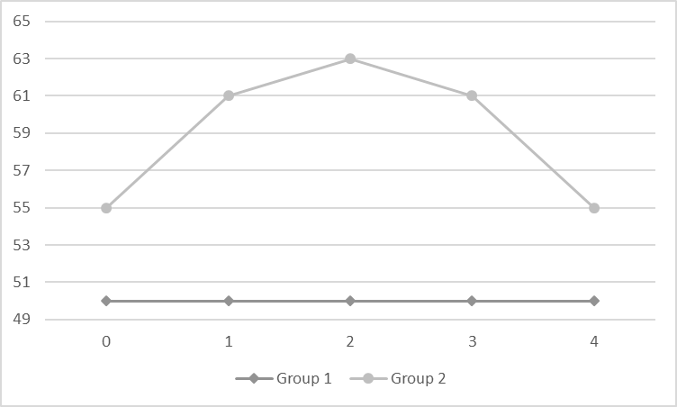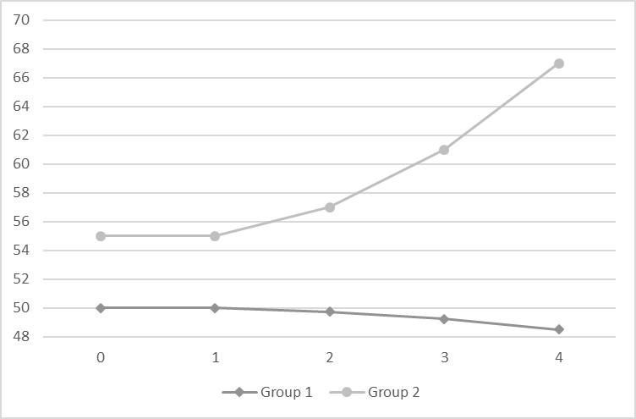

**Figure 3.** Examples of linear three group growth distributions with effect sizes of 0.3/.5 and 0.3/2.0. Graph A represents no growth, graph B group 2 small increase (slope = 0.5), graph C group two large increase (slope = 2.0) and group 3 small decrease (slope = -0.5), graph D group 1 small decrease, group 2 no growth, group 3 large increase.

Effect Size 0.3/2.0

Effect Size 0.3/0.5

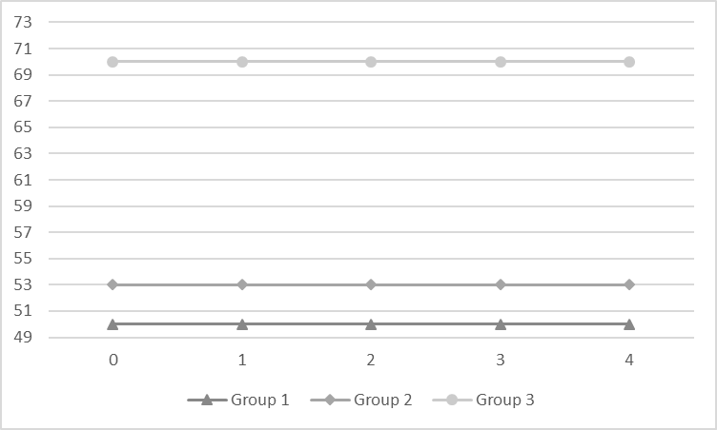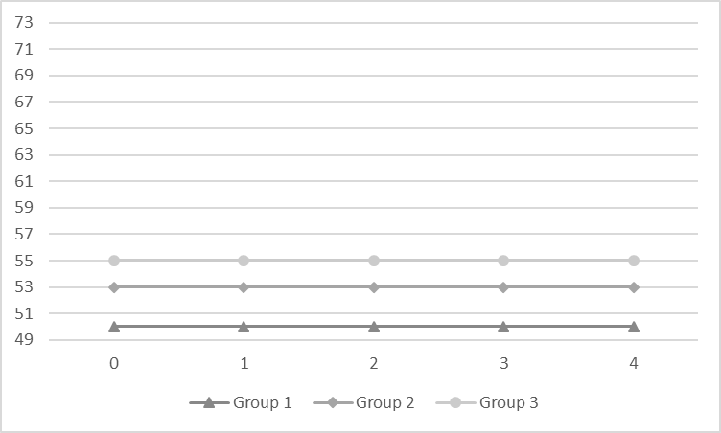A.

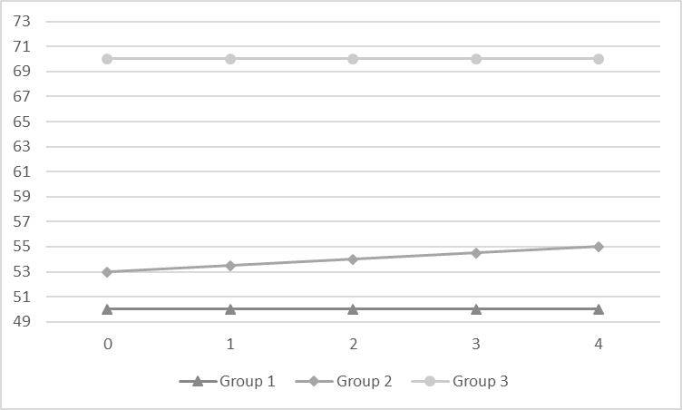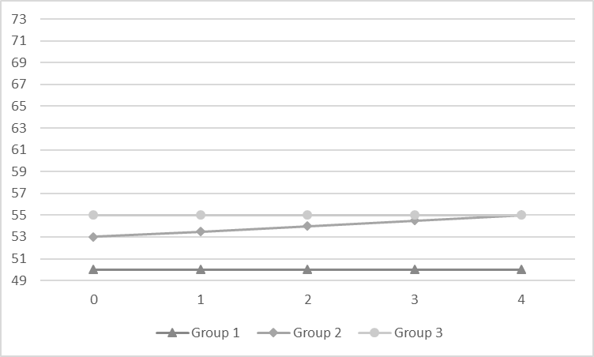B.

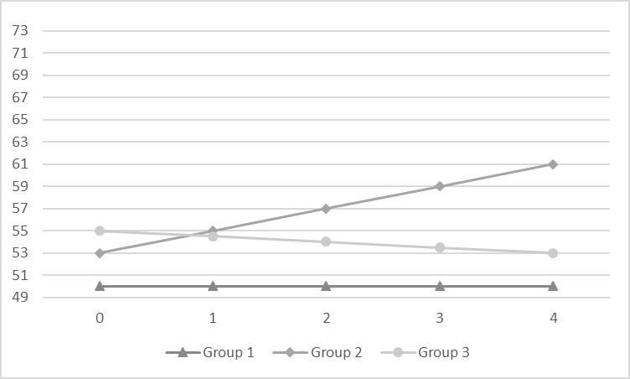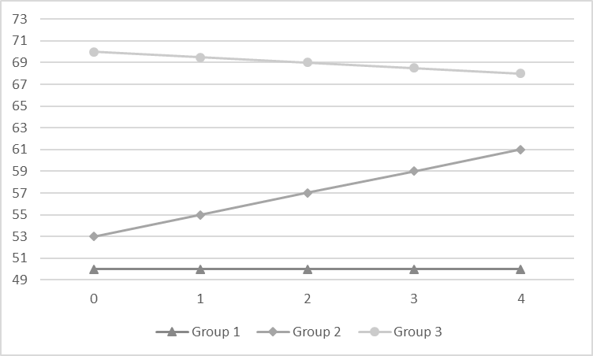C.

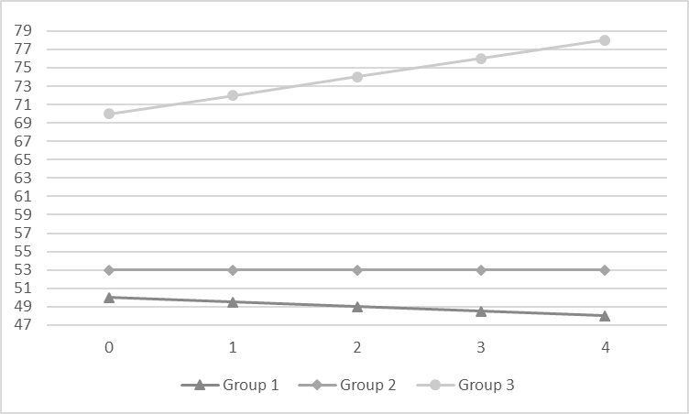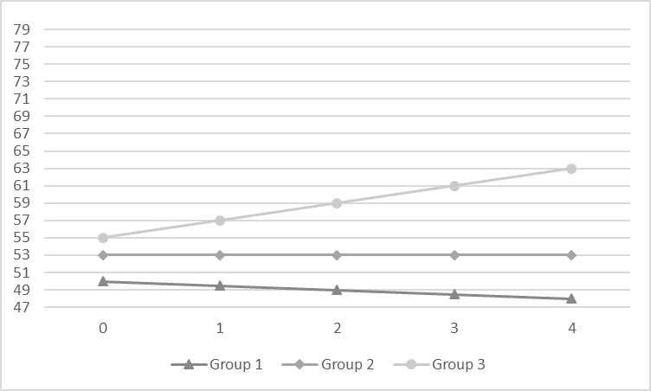D.

**Figure 4**. Examples of three group growth distributions with effect sizes of 0.3/0.5 and 0.3/2.0. Graph A includes inverted U-shaped growth. For these growth patterns, group 2 has large growth whereas group three has small growth. Graph B includes exponential growth. For these growth patterns group 1 has a small decrease, group two a small increase, and group three a large increase.

Effect Size 0.3 & 0.5

Effect Size 0.3 & 2.0 2.00.5==2

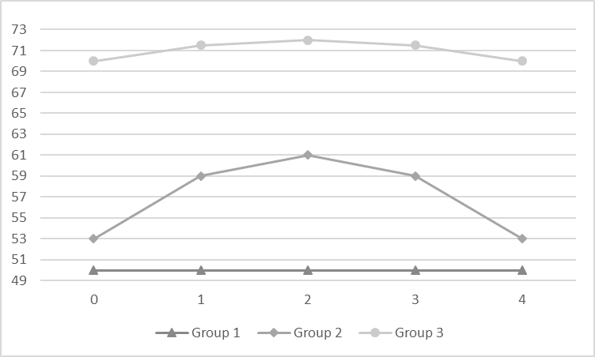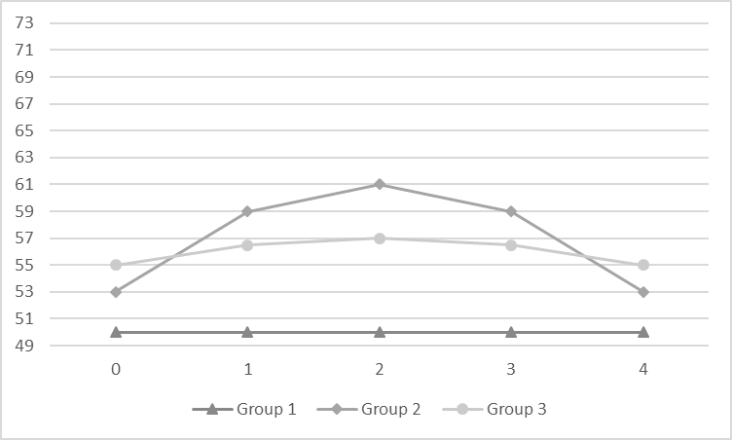**A.**

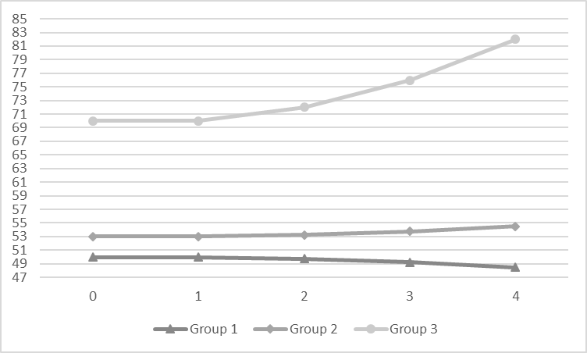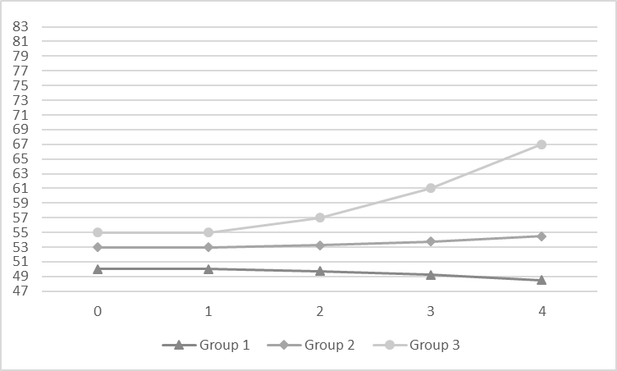**B.**

**Figure 5.** Examples of four group linear growth distributions with effect sizes of 0.3/0.5/0.8 and 0.3/0.8/2.0. Graph A represents no growth, graph B represents Group 2 small increase (slope = 0.5)/Group 3 small decrease, graph C Group 2 large increase (slope = 2.0)/Group 3 large increase, graph D Group 2 small decrease (slope = -0.5)/Group 3 increase (slope =1.0)/Group 4 increase (slope = 2.0).

Effect Size 0.3, 0.8, & 2.0

Effect Size 0.3, 0.5, & 0.8

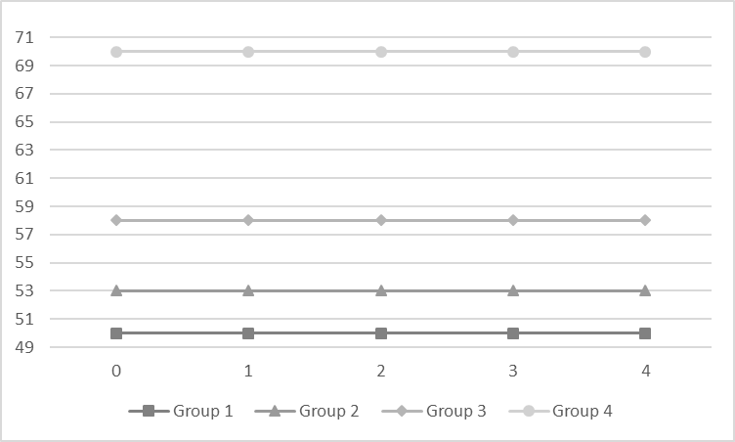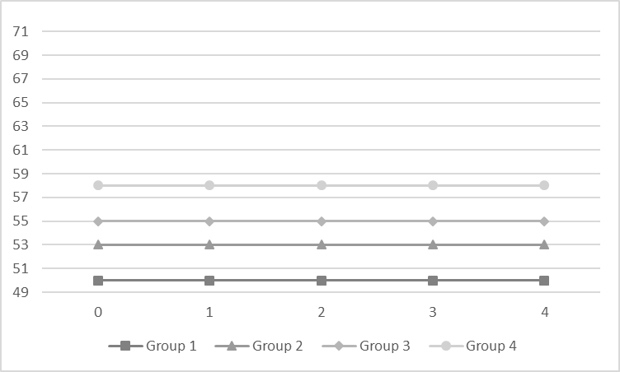**A.**

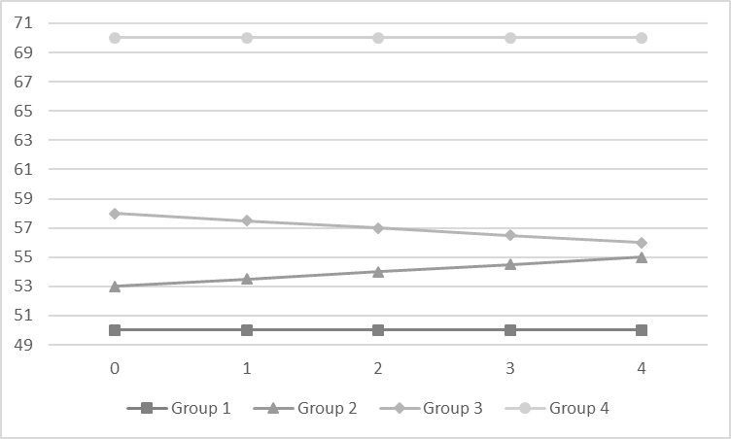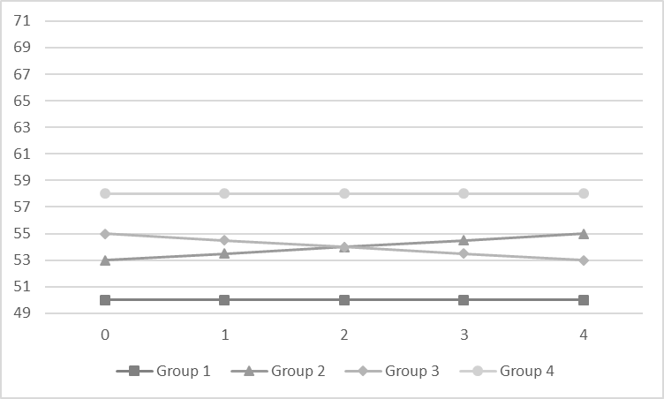**B.**

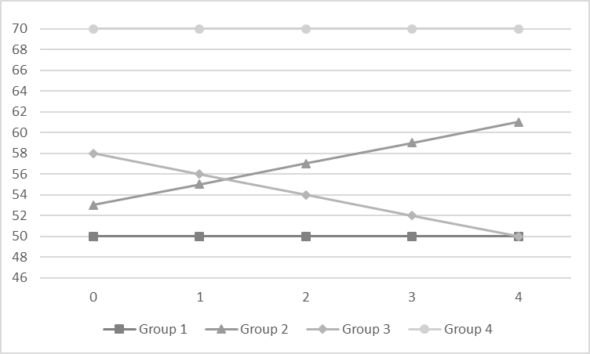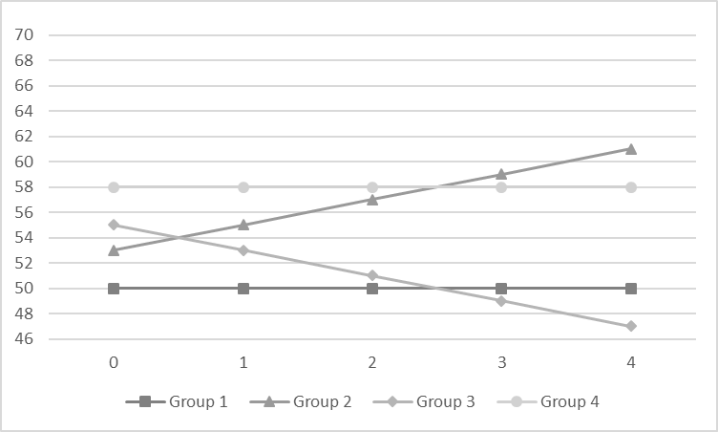**C.**

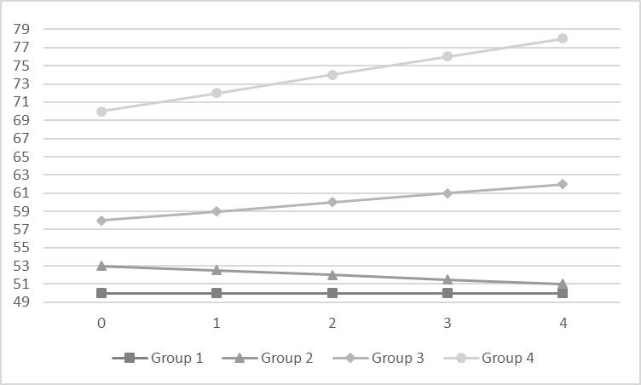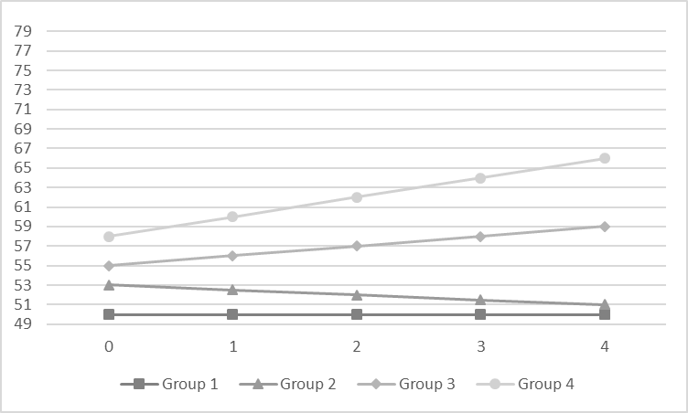**D.**

**Figure 6.** Examples of four group quadratic growth distributions with effect sizes of 0.3/0.5/0.8 and 0.3/0.8/2.0. Graph B represents Group 2 large inverted U-shaped increase/Group 3 small bell-shaped decrease. Graph D represents small inverted U-shaped growth for Groups 1 and 2/exponential decrease for Group 2 and increase for Group 3.

Effect Sizes: 0.3, 0.8, & 2.0

Effect Sizes: 0.3, 0.5, & 0.8

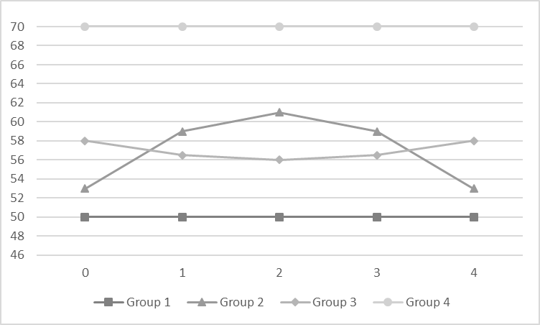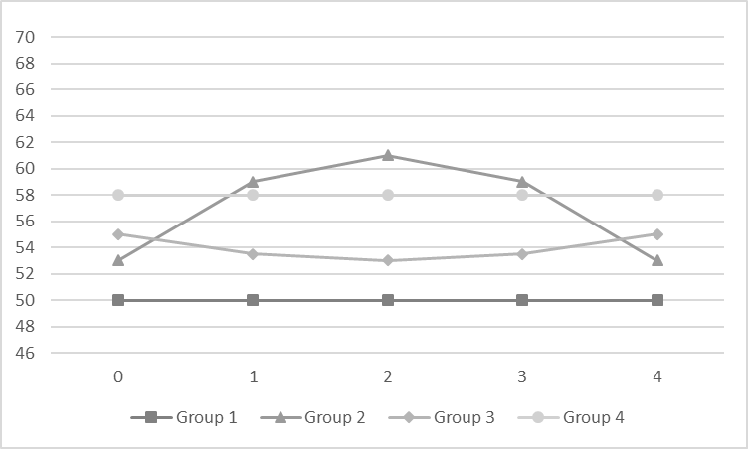**A.**

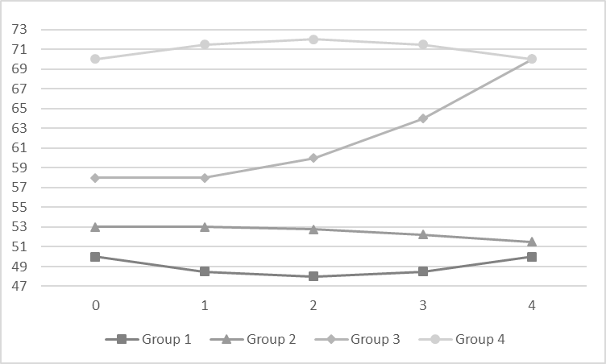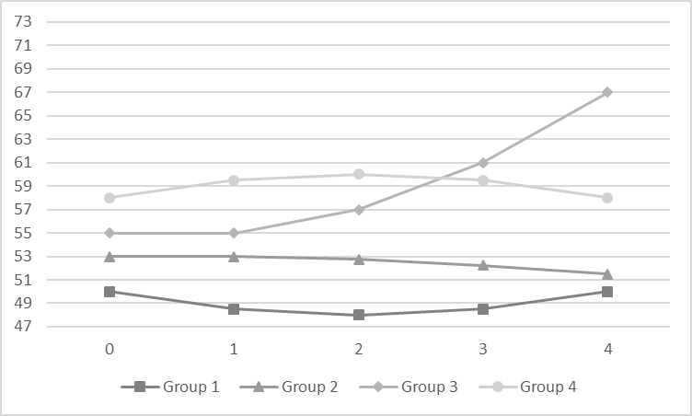**B.**

**Figure 7.** Example graphs of correctly and incorrectly identified groups. Column I consist of graphs where one group was correctly identified. Column II consists of graphs where one group was not identified, and instead 4 or 5 groups were identified.

**I. II.**

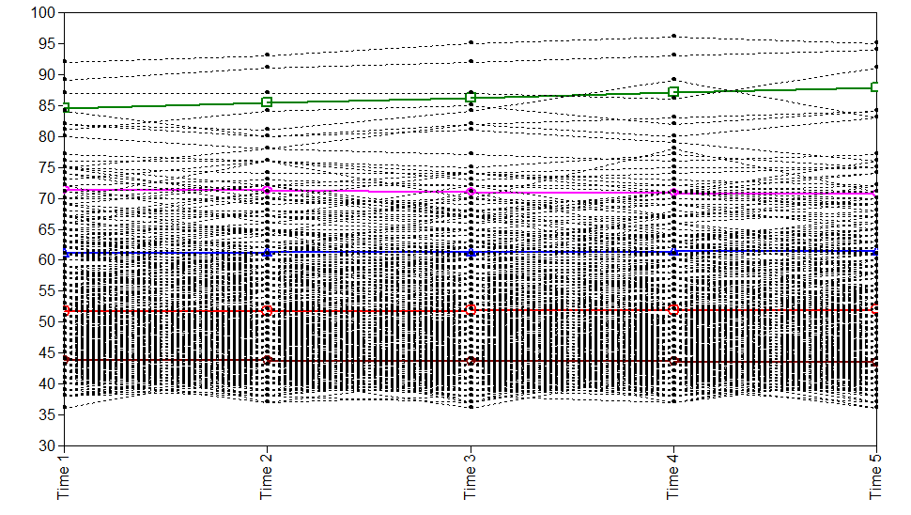a. No Growth, SS=300, Skew=0, Kurtosis =1 a. No Growth, SS=500, Skew=2, Kurtosis=6

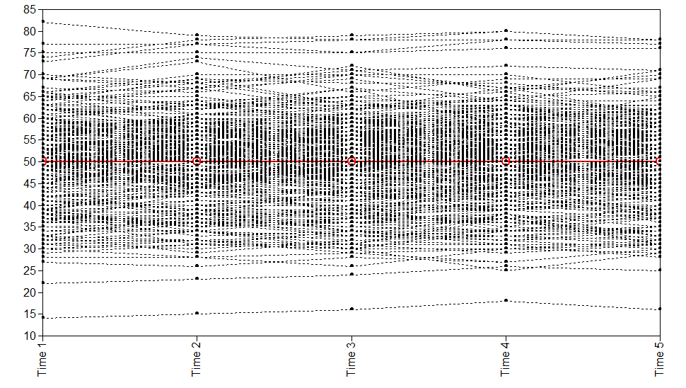

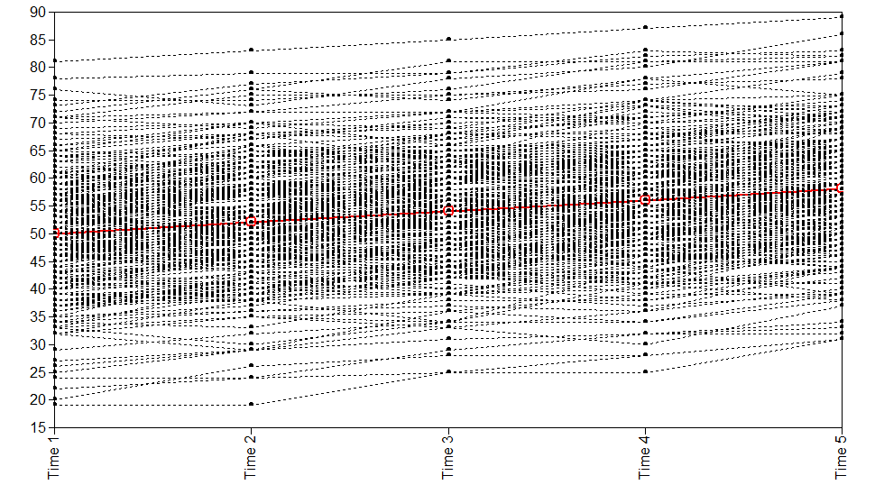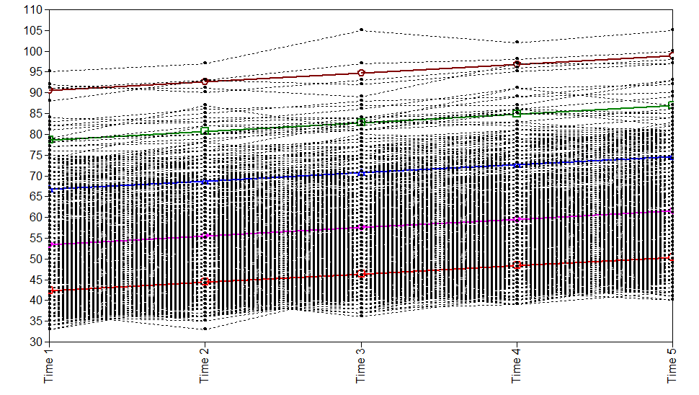b. Linear Large, SS = 300, Skew=0, Kurtosis=1 b. Linear Large, SS=1000, Skew=1, Kurtosis=1

c. Exponential Growth c. Exponential Growth

SS=300, Skew=0, kurtosis=3 SS= 2,000, skew =1, kurtosis =1

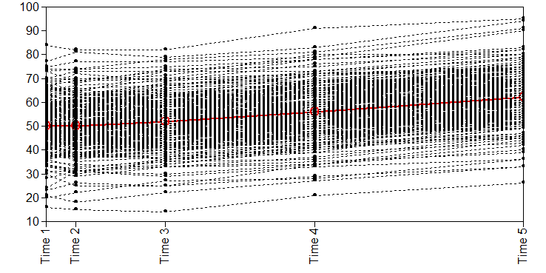 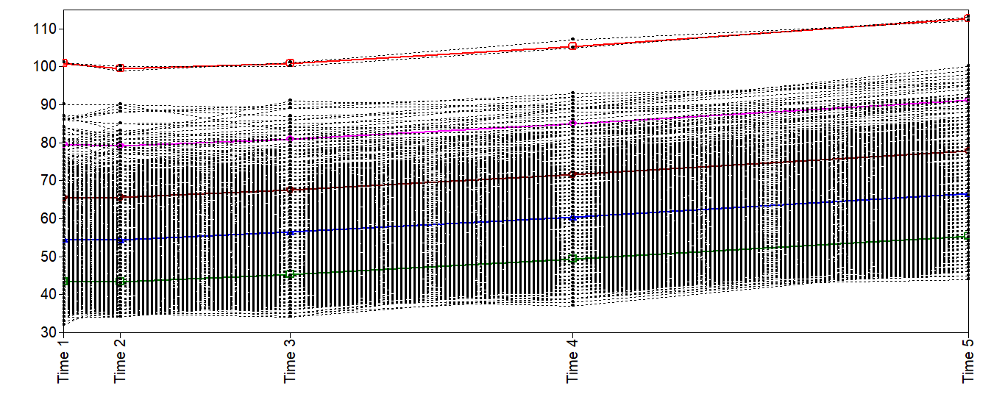

d. Quadratic inverted U-shaped Growth d. Quadratic inverted U-shaped Growth

SS=300, Skew=0, kurtosis=1 SS=2,000, skew =1, kurtosis =1

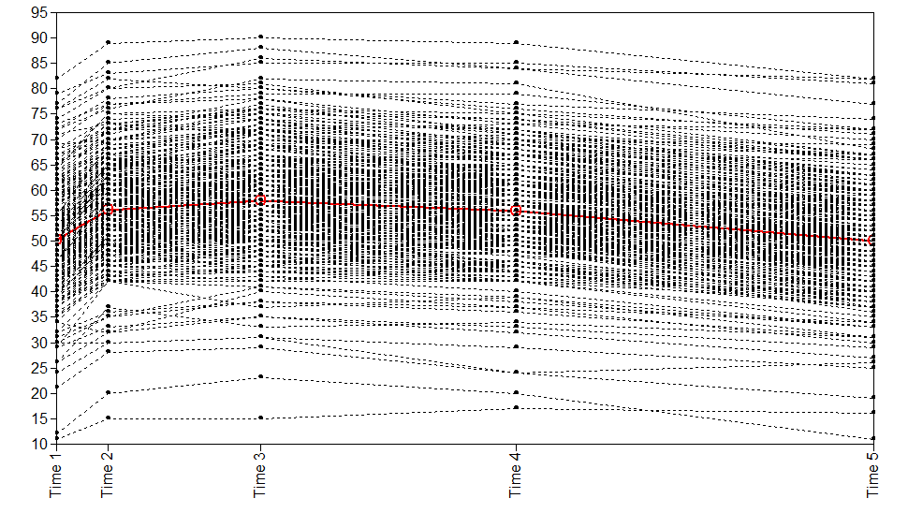 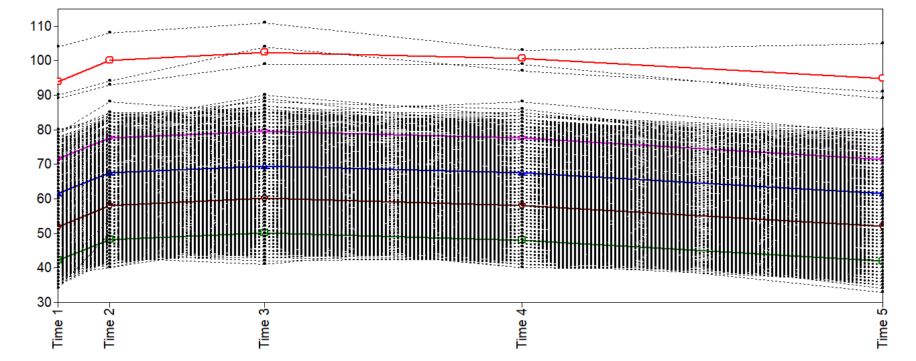

**Figure 8.** Example graphs of correctly and incorrectly identified groups. Column I consist of graphs where two groups were correctly identified. Column II consists of graphs where two groups were not identified, and instead one group was identified.

I. II.

a. No Growth a. No Growth

SS =2,000, ES =2.0, Proportions .95/.05 SS =300, ES =2.0, Proportions .95/.05

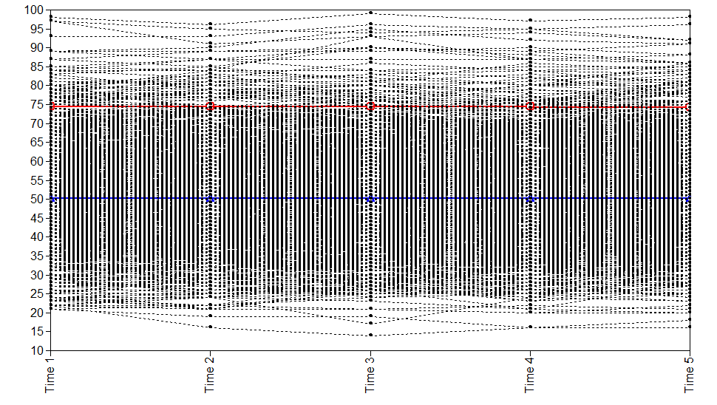 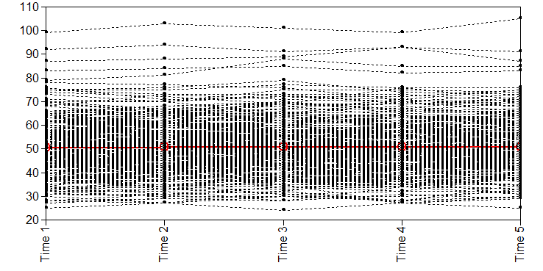

b. Linear Large Growth

SS= 800, ES 2.0, Proportions .95/.05

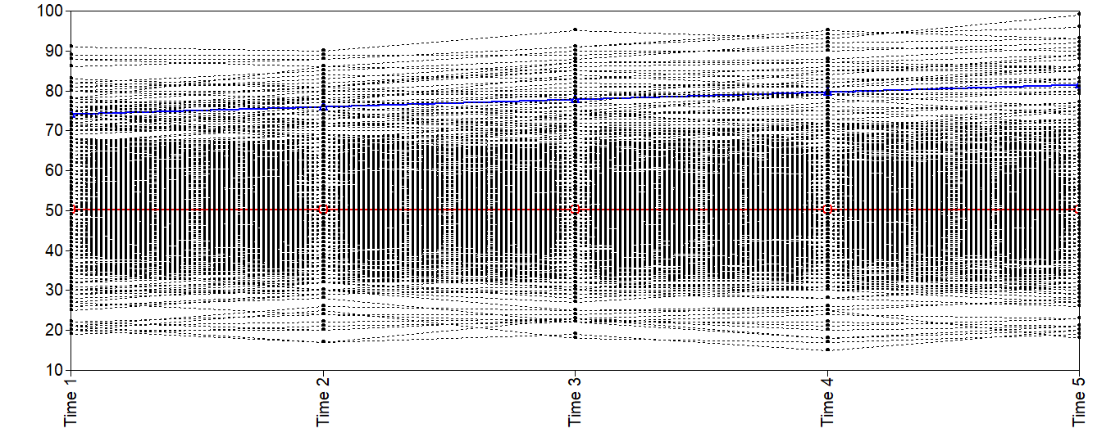

c. Linear Small Growth c. Linear Small Growth

SS= 800, ES 2.0, Proportions .70/.30 SS = 800, ES 1.2, Proportions .70/.30

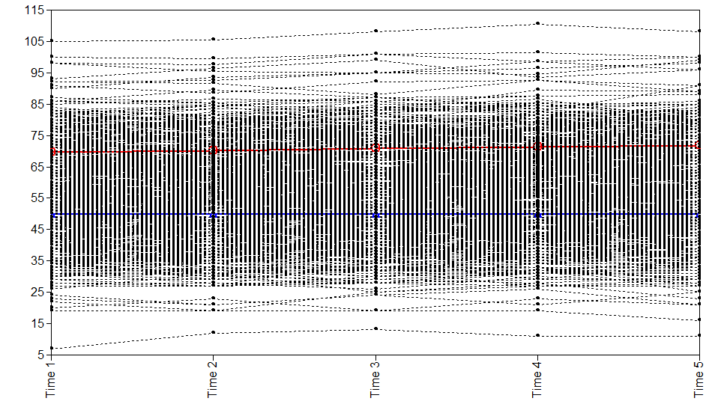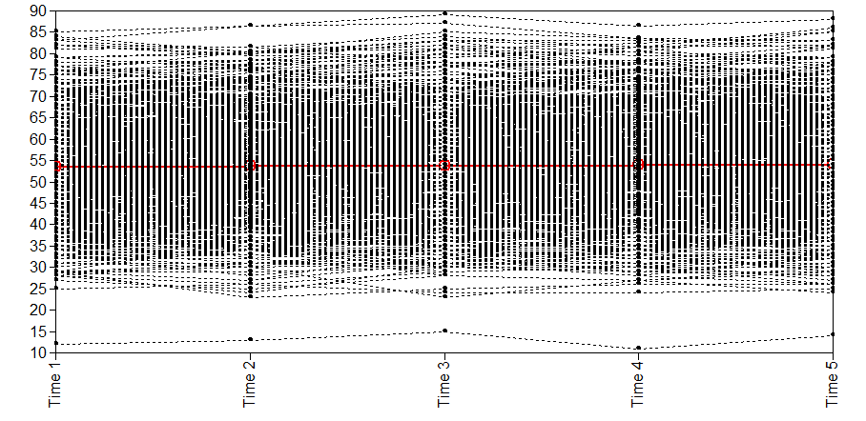

d. Linear Small and Large Growth d. Linear Small and Large Growth

SS= 1,000, ES 0.3, Proportions .95/.05 SS = 300, ES 0.3, Proportions .95/.05

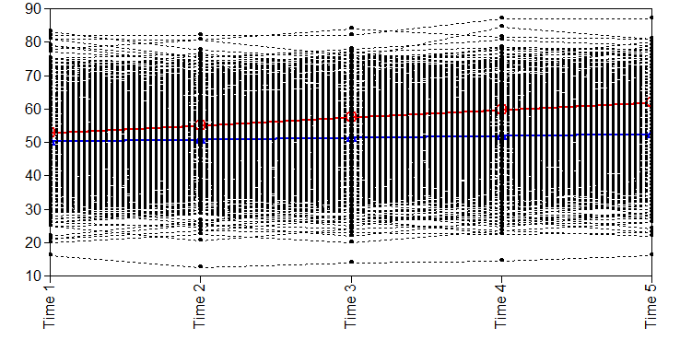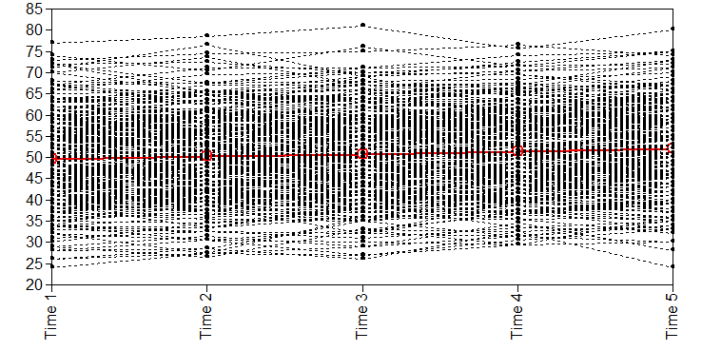

**Figure 9.** Example graphs for quadratic growth simulations where two groups were correctly identified.

I. Quadratic Inverted U-shaped Growth

a. SS=1,000, ES 0.3, Proportions .70/.30 b. SS = 1,000, ES 2.0, Proportions .70/.30

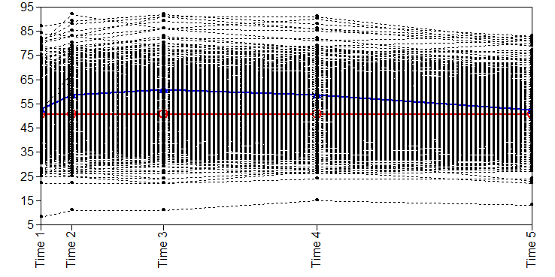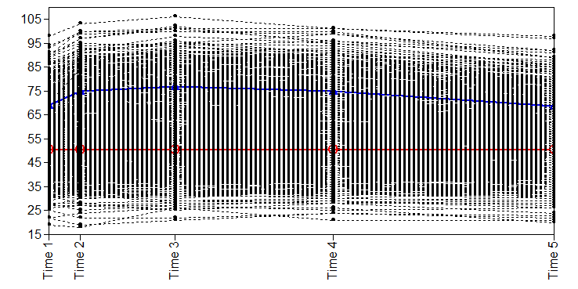

II. Exponential Growth

a. SS=800, ES 0.3, Proportions .70/.30 b. SS=800, ES 2.0, Proportions .70/.30

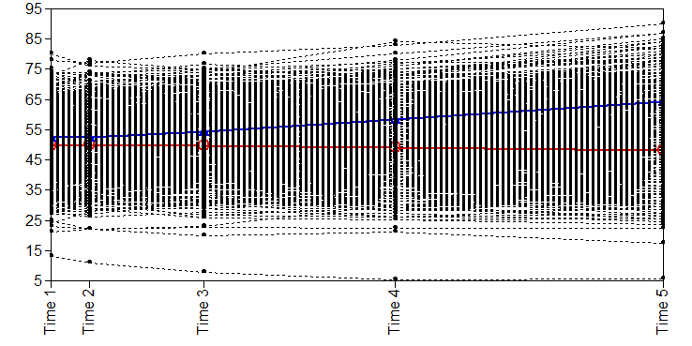 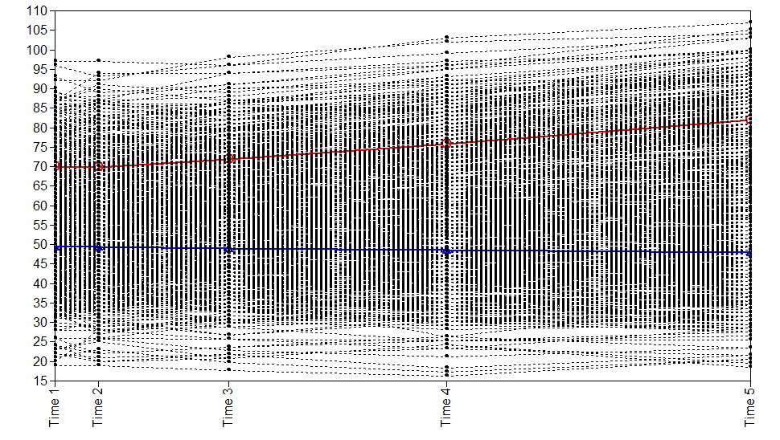

**Figure 10.** Example graphs of correctly and incorrectly identified groups when simulated data had 1 increasing group and 1 decreasing group. Column I consist of graphs where three groups were correctly identified. Column II consists of graphs where three groups were not identified, and instead two groups were identified.

**I. II.**

SS= 300, ES 0.3/2.0 SS = 300, ES 0.3/2.0

Proportions .50/.30/.20 Proportions .60/.30/.10

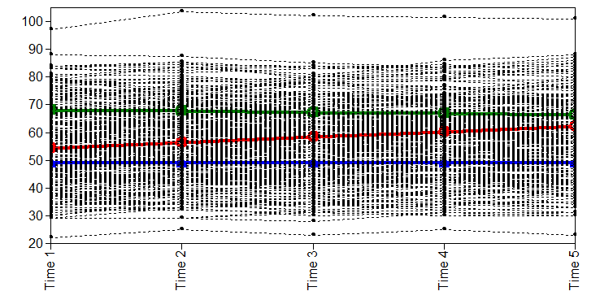 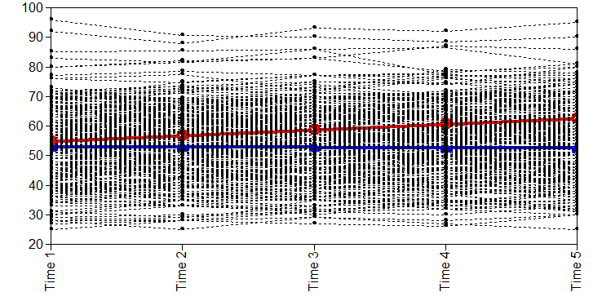

SS= 800, ES 0.5/2.0 SS= 800, ES 0.5/0.8

Proportion .70/.20/.10 Proportion .70/.20/.10

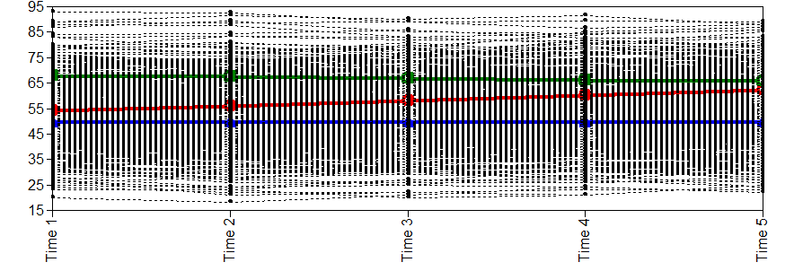 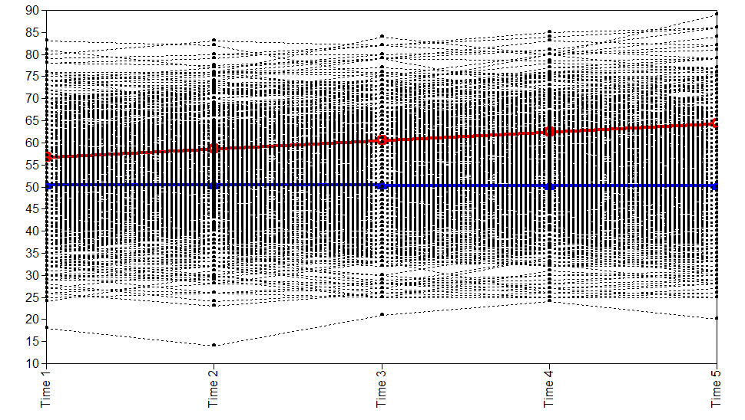

SS= 2,000, ES 0.3/1.2 SS= 2,000, ES 0.3/1.2

Proportions .50/.30/.20 Proportions .60/.30/.10

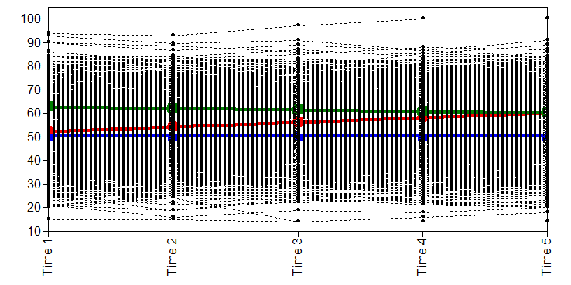 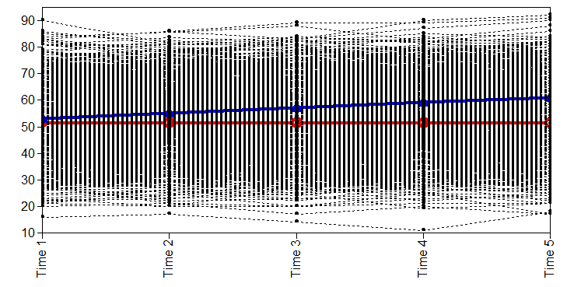

**Figure 11.** Example graphs of correctly and incorrectly identified groups given quadratic growth. Column I consist of graphs where three groups were correctly identified. Column II consists of graphs where three groups were not identified, and instead two groups were identified.

**I. II.**

Quadratic Inverted U-shaped Growth Quadratic Inverted U-shaped Growth

SS=300, ES 0.3/2.0, Proportion .50/.30/.20 SS=300, ES 0.3/2.0, Proportion .70/.20/.10

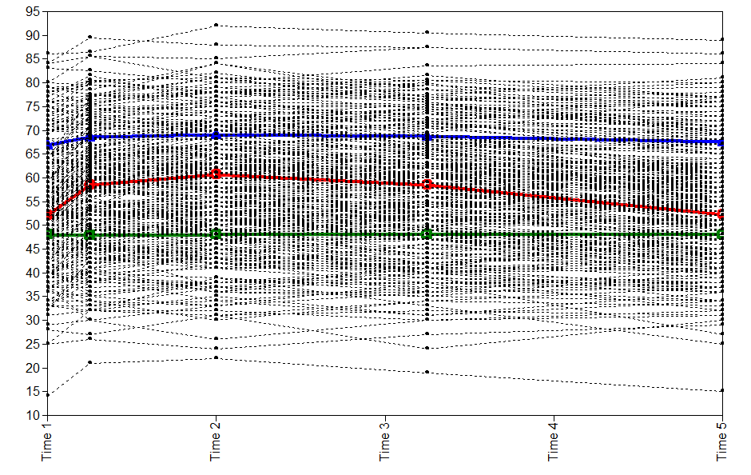 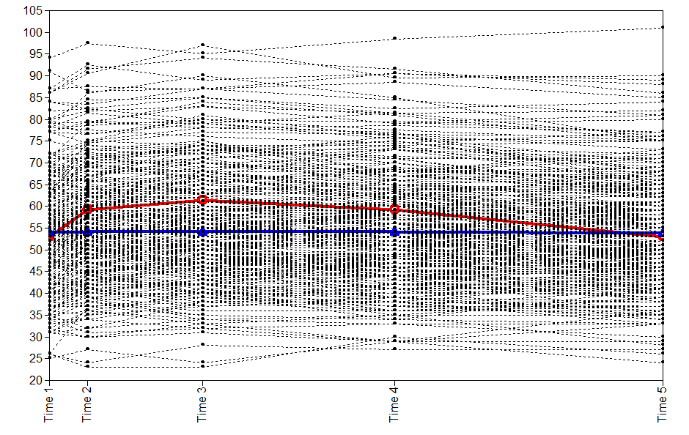

Quadratic Inverted U-shaped Growth Quadratic Inverted U-shaped Growth

SS=2,000, ES 0.5/1.2, Proportion .50/.30/.20 SS=2,000, ES 0.5/1.2, Proportion .60/.30/.10

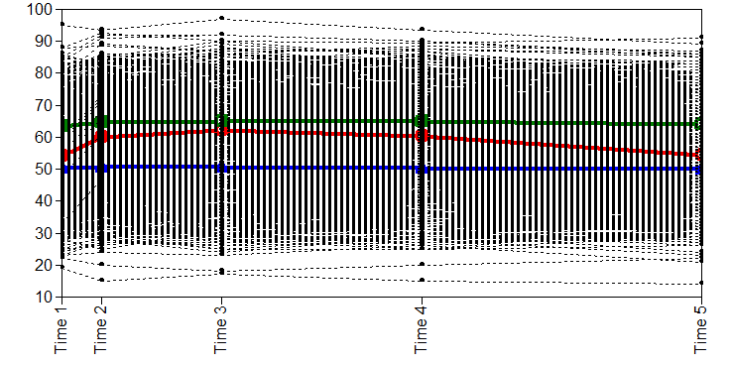 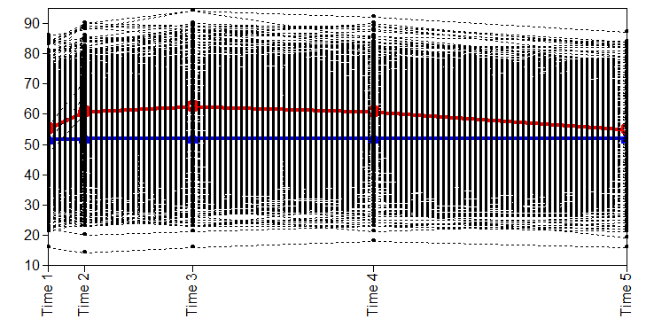

**Figure 12.** Example graphs of correctly and incorrectly identified groups when simulated data had large linear growth with crossover. Column I consist of graphs where four groups were correctly identified. Column II consists of graphs where four groups were not correctly identified, and instead 1 or 3 groups were identified.

**I. II.**

a. SS= 800, ES 0.3/0.8/2.0, a. SS= 300, ES 0.3/0.5/0.8

Proportions .40/.30/.20/.10 Proportions .50/.30/.10/.10

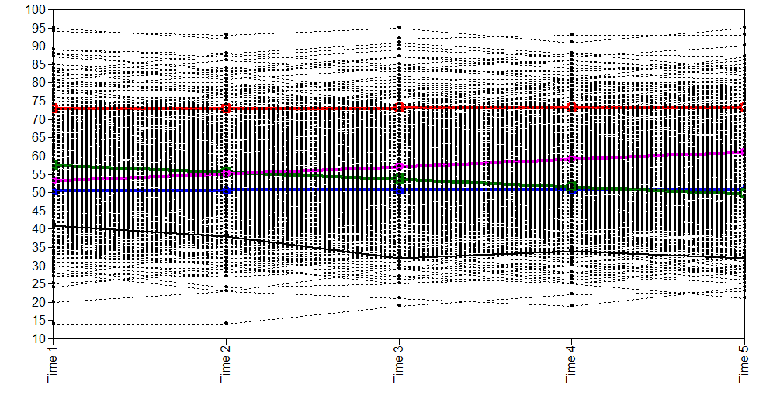 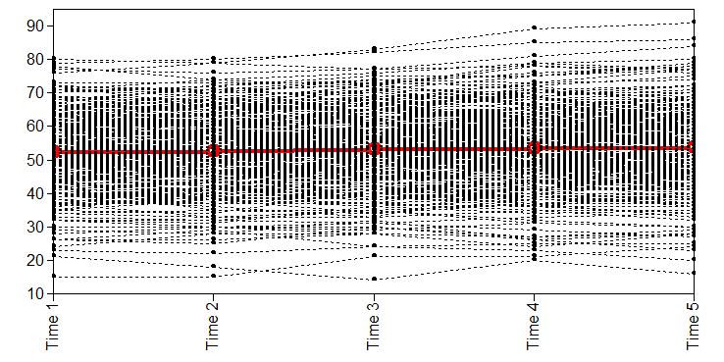

b. SS= 1,000, ES 0.3/0.8/2.0 b. SS= 800, ES 0.3/0.8/1.2

Proportions .50/.30/.10/.10 Proportions .40/.30/.20/.10

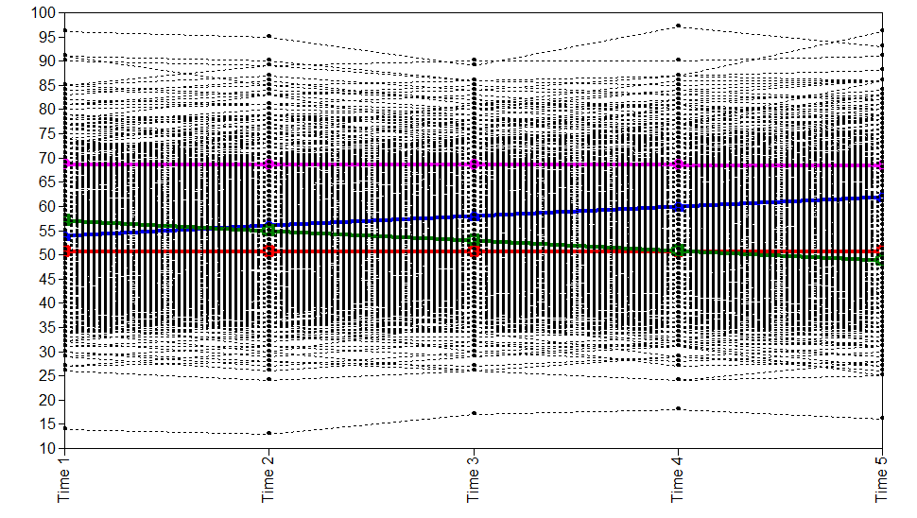 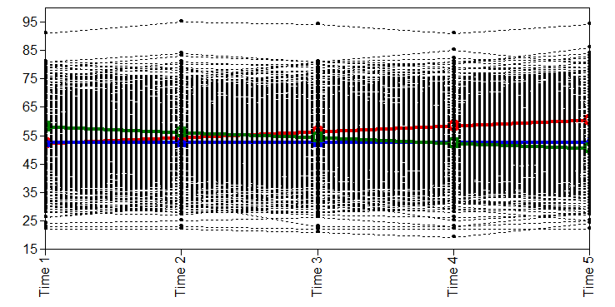

c. SS= 2,000, ES 0.3/0.8/2.0 c. SS= 2,000, ES 0.3/0.5/0.8

Proportions .60/.20/.15/.05 Proportions .60/.20/.15/.05

