Supplementary Materials of Infant Temperament Prospectively Predicts General Psychopathology in Childhood

Santiago Morales^{1,2*}, Alva Tang¹, Maureen E. Bowers², Natalie V. Miller¹, George A. Buzzell^{1,2}, Elizabeth Smith¹, Kaylee Seddio¹, Heather A. Henderson³, & Nathan A. Fox^{1,2}

¹ Department of Human Development and Quantitative Methodology, University of Maryland, College Park, MD, USA
² Neuroscience and Cognitive Science Program, University of Maryland, College Park, MD, USA
³ Department of Psychology, University of Waterloo, Waterloo, Canada

Examining the longitudinal relations between temperament and psychopathology separately for observed measures and parent-reports of temperament

The Impact of Infant Temperament on the Bifactor Model
Observed Temperament. In order to examine the relations between the observed temperament dimensions and psychopathology, we added the three temperament dimensions of motor activity, positive affect, and negative affect as predictors of the three psychopathology factors (general psychopathology, internalizing, and externalizing) within the bifactor model. Moreover, we also included child gender, maternal ethnicity, and maternal education as covariates. As shown in Table S1 and Figure S1A, motor activity significantly predicted the general psychopathology factor (b = 0.268, SE = 0.084, p = 0.001), such that increased motor reactivity in infancy predicted increased general psychopathology in childhood. Importantly, this relation survived multiple comparisons correction. Infant positive affect also significantly predicted the internalizing-specific factor (b = -0.298, SE = 0.151, p = 0.048), such that increased positive affect in infancy predicted lower scores in the internalizing specific factor. However, this relation did not survive multiple comparison correction. No other relations between observed infant temperament and the latent psychopathology factors were statistically significant (Table S1 and Figure S1A).
Parent-reported Temperament. In order to examine the relations between the parent-reported temperament dimensions and psychopathology, we added the six temperament dimensions (activity level, smiling and laughter, fear, distress to limitations, soothability, and duration of orienting) as predictors of the three psychopathology factors within the bifactor model. In addition, we included child gender, maternal ethnicity, and maternal education as covariates. As shown in Table S2 and Figure S1C, motor activity levels significantly predicted the general psychopathology factor (b = 0.524, SE = 0.118, p < 0.001), such that increased motor activity in infancy predicted increased general psychopathology in childhood. This relation remained significant after adjusting for multiple comparisons. No other relations between parent-reported infant temperament and the latent psychopathology factors were statistically significant (Table S2 and Figure S1C).
The Effects of Infant Temperament on the Correlated-Factor Model
Observed Temperament. In order to examine the relations between the observed temperament dimensions and the more traditional factors of psychopathology, we added the three temperament dimensions of motor activity, positive affect, and negative affect as predictors of the psychopathology factors (internalizing, and externalizing) within the correlated-factors model. We also included child gender, maternal ethnicity, and maternal education as covariates. As shown in Table S1, motor activity significantly predicted the externalizing and internalizing factors (b = 0.219, SE = 0.074, p = 0.003 and b = 0.190, SE = 0.092, p = 0.038, respectively), such that increased motor reactivity in infancy predicted increased externalizing and internalizing psychopathology in childhood. Importantly, only the relation with externalizing survived multiple comparison correction. No other relations between observed infant temperament and the latent psychopathology factors were statistically significant (Table S1 and Figure S1B).
Parent-reported Temperament. To examine the relations between the parent-reported temperament dimensions and the more traditional factors of psychopathology, we included the six temperament dimensions (activity level, smiling and laughter, fear, distress to limitations, soothability, and duration of orienting) as predictors of the psychopathology factors (internalizing, and externalizing) within the correlated-factors model – while including child gender, maternal ethnicity, and maternal education as covariates. As shown in Table S2 and Figure S1D, motor activity levels significantly predicted the externalizing and internalizing factors (b = 0.551, SE = 0.122, p < 0.001 and b = 0.271, SE = 0.133, p = 0.041, respectively), such that increased motor activity levels in infancy predicted increased externalizing and internalizing psychopathology in childhood. In addition, lower Soothability (b = -0.253, SE = 0.129, p = 0.049) and lower Fear (b = -0.270, SE = 0.136, p = 0.047) predicted higher levels of internalizing problems. Importantly, only the relation between motor activity and externalizing remained significant after correction for multiple comparisons. No other relations between parent-reported infant temperament and the latent psychopathology factors were statistically significant (Table S2 and Figure S1D).

In summary, the longitudinal relations between temperament and psychopathology are largely similar across methods of assessment (parent-report and observed measures). This is especially true for motor activity, which was consistently (across methods of assessment and psychopathology model) predicted the general psychopathology factor. Importantly, in a closer parallel to the results presented in the main text, we also examined the models with parent-reported temperament without the soothability and duration of orienting IBQ scales. Results were highly similar and as such, to provide more information, we present this more comprehensive examination of infant temperament on later psychopathology that includes all the scales of the IBQ.
Table S1. Regression paths from the path model of observed temperament reactivity scores predicting psychopathology factors.
 | Bifactor Model |  |  |  |  |  | Correlated-Factors Model
Factors/Predictors | b | SE | z | p | LL | UL | b | SE | z | p | LL | UL
p Factor
Negative Affect | -0.11 | 0.09 | -1.3 | 0.193 | -0.11 | 0.09
Positive Affect | -0.01 | 0.10 | -0.09 | 0.931 | -0.01 | 0.10
Motor Activity | 0.27 | 0.08 | 3.20 | 0.001 | 0.27 | 0.08
Maternal Ethnicity | 0.16 | 0.19 | 0.85 | 0.396 | 0.16 | 0.19
Maternal Education | -0.11 | 0.13 | -0.82 | 0.410 | -0.11 | 0.13
Gender | -0.46 | 0.18 | -2.54 | 0.011 | -0.46 | 0.18
Externalizing Factor
Negative Affect | 0.00 | 0.11 | 0.01 | 0.991 | -0.21 | 0.22 | -0.14 | 0.08 | -1.66 | 0.098 | -0.30 | 0.03
Positive Affect | 0.12 | 0.10 | 1.14 | 0.253 | -0.09 | 0.32 | 0.02 | 0.09 | 0.27 | 0.791 | -0.15 | 0.20
Motor Activity | -0.13 | 0.14 | -0.96 | 0.339 | -0.4 | 0.14 | 0.22 | 0.07 | 2.97 | 0.003 | 0.07 | 0.36
Maternal Ethnicity | -0.14 | 0.25 | -0.57 | 0.569 | -0.63 | 0.35 | 0.12 | 0.19 | 0.64 | 0.523 | -0.25 | 0.50
Maternal Education | -0.26 | 0.16 | -1.57 | 0.115 | -0.57 | 0.06 | -0.19 | 0.12 | -1.51 | 0.131 | -0.43 | 0.06
Gender | -0.20 | 0.23 | -0.85 | 0.394 | -0.65 | 0.25 | -0.50 | 0.16 | -3.02 | 0.003 | -0.82 | -0.17
Internalizing Factor
Negative Affect | -0.24 | 0.14 | -1.74 | 0.082 | -0.52 | 0.03 | -0.19 | 0.10 | -1.79 | 0.073 | -0.39 | 0.02
Positive Affect | -0.30 | 0.15 | -1.98 | 0.048 | -0.59 | 0.00 | -0.19 | 0.11 | -1.67 | 0.096 | -0.41 | 0.03
Motor Activity | -0.04 | 0.15 | -0.25 | 0.800 | -0.34 | 0.26 | 0.19 | 0.09 | 2.07 | 0.038 | 0.01 | 0.37
Maternal Ethnicity | 0.06 | 0.33 | 0.17 | 0.862 | -0.59 | 0.70 | 0.15 | 0.21 | 0.71 | 0.478 | -0.27 | 0.57
Maternal Education | -0.42 | 0.19 | -2.22 | 0.027 | -0.78 | -0.05 | -0.32 | 0.14 | -2.25 | 0.024 | -0.59 | -0.04
Gender | 0.65 | 0.30 | 2.16 | 0.031 | 0.06 | 1.24 | 0.16 | 0.19 | 0.84 | 0.401 | -0.21 | 0.53
Note: p Factor = General Psychopathology Factor. b = unstandardized estimates. LL = lower limit of 95% confidence interval. UL = upper limit of 95% confidence interval. Bolded estimates and p values meet statistical significance with adjustment for multiple comparisons (q < .05; FDR). Albeit the analysis with the bifactor model was performed following the recommended methods from Koch et al. (2018), the table is presented as traditional regression analyses to simplify its presentation.

Table S2. Regression paths from the path model of parent-reported temperament scores predicting psychopathology factors.
 | Bifactor Model |  |  |  |  |  | Correlated-Factors Model
Factors/Predictors | b | SE | z | p | LL | UL | b | SE | z | p | LL | UL
p Factor
Distress to Limitations | -0.06 | 0.13 | -0.46 | 0.643 | -0.31 | 0.19
Smiling and Laughter | -0.12 | 0.11 | -1.16 | 0.244 | -0.33 | 0.08
Activity Levels | 0.52 | 0.12 | 4.43 | 0.000 | 0.29 | 0.76
Fear | -0.02 | 0.14 | -0.13 | 0.896 | -0.29 | 0.26
Orienting Duration | 0.02 | 0.09 | 0.21 | 0.836 | -0.16 | 0.20
Soothability | -0.01 | 0.12 | -0.04 | 0.965 | -0.25 | 0.24
Maternal Ethnicity | 0.13 | 0.20 | 0.67 | 0.502 | -0.26 | 0.52
Maternal Education | -0.11 | 0.14 | -0.83 | 0.409 | -0.38 | 0.15
Gender | -0.44 | 0.18 | -2.41 | 0.016 | -0.79 | -0.08
Externalizing Factor
Distress to Limitations | 0.06 | 0.16 | 0.39 | 0.695 | -0.25 | 0.38 | -0.03 | 0.13 | -0.25 | 0.804 | -0.28 | 0.22
Smiling and Laughter | -0.21 | 0.13 | -1.57 | 0.118 | -0.47 | 0.05 | -0.17 | 0.1 | -1.63 | 0.103 | -0.37 | 0.03
Activity Levels | 0.26 | 0.15 | 1.79 | 0.073 | -0.02 | 0.55 | 0.55 | 0.12 | 4.53 | 0.000 | 0.31 | 0.79
Fear | -0.27 | 0.18 | -1.50 | 0.133 | -0.62 | 0.08 | -0.09 | 0.13 | -0.68 | 0.494 | -0.35 | 0.17
Orienting Duration | -0.19 | 0.13 | -1.46 | 0.144 | -0.45 | 0.07 | -0.02 | 0.08 | -0.24 | 0.813 | -0.17 | 0.14
Soothability | 0.22 | 0.13 | 1.68 | 0.093 | -0.04 | 0.49 | 0.02 | 0.11 | 0.14 | 0.888 | -0.20 | 0.23
Maternal Ethnicity | -0.12 | 0.25 | -0.46 | 0.648 | -0.61 | 0.38 | 0.11 | 0.2 | 0.55 | 0.582 | -0.28 | 0.51
Maternal Education | -0.24 | 0.19 | -1.29 | 0.199 | -0.61 | 0.13 | -0.20 | 0.12 | -1.61 | 0.107 | -0.43 | 0.04
Gender | -0.16 | 0.25 | -0.63 | 0.529 | -0.65 | 0.34 | -0.45 | 0.17 | -2.66 | 0.008 | -0.78 | -0.12
Internalizing Factor
Distress to Limitations | 0.26 | 0.23 | 1.14 | 0.255 | -0.19 | 0.72 | 0.15 | 0.15 | 0.99 | 0.321 | -0.15 | 0.45
Smiling and Laughter | -0.16 | 0.22 | -0.72 | 0.473 | -0.59 | 0.27 | -0.16 | 0.13 | -1.27 | 0.204 | -0.42 | 0.09
Activity Levels | -0.22 | 0.20 | -1.13 | 0.259 | -0.61 | 0.17 | 0.27 | 0.13 | 2.04 | 0.041 | 0.01 | 0.53
Fear | -0.34 | 0.20 | -1.69 | 0.091 | -0.74 | 0.05 | -0.27 | 0.14 | -1.98 | 0.047 | -0.54 | 0.00
Orienting Duration | 0.10 | 0.17 | 0.60 | 0.545 | -0.22 | 0.42 | 0.14 | 0.09 | 1.50 | 0.134 | -0.04 | 0.32
Soothability | -0.31 | 0.20 | -1.54 | 0.123 | -0.71 | 0.08 | -0.25 | 0.13 | -1.97 | 0.049 | -0.51 | 0.00
Maternal Ethnicity | -0.09 | 0.36 | -0.25 | 0.804 | -0.79 | 0.61 | 0.02 | 0.21 | 0.08 | 0.935 | -0.40 | 0.44
Maternal Education | -0.54 | 0.22 | -2.43 | 0.015 | -0.98 | -0.10 | -0.41 | 0.15 | -2.73 | 0.006 | -0.70 | -0.12
Gender | 0.73 | 0.33 | 2.25 | 0.024 | 0.09 | 1.37 | 0.26 | 0.19 | 1.38 | 0.169 | -0.11 | 0.64
Note: p Factor = General Psychopathology Factor. b = unstandardized estimates. LL = lower limit of 95% confidence interval. UL = upper limit of 95% confidence interval. Bolded estimates and p values meet statistical significance with adjustment for multiple comparisons (q < .05; FDR). Albeit the analysis with the bifactor model was performed following the recommended methods from Koch et al. (2018), the table is presented as traditional regression analyses to simplify its presentation.
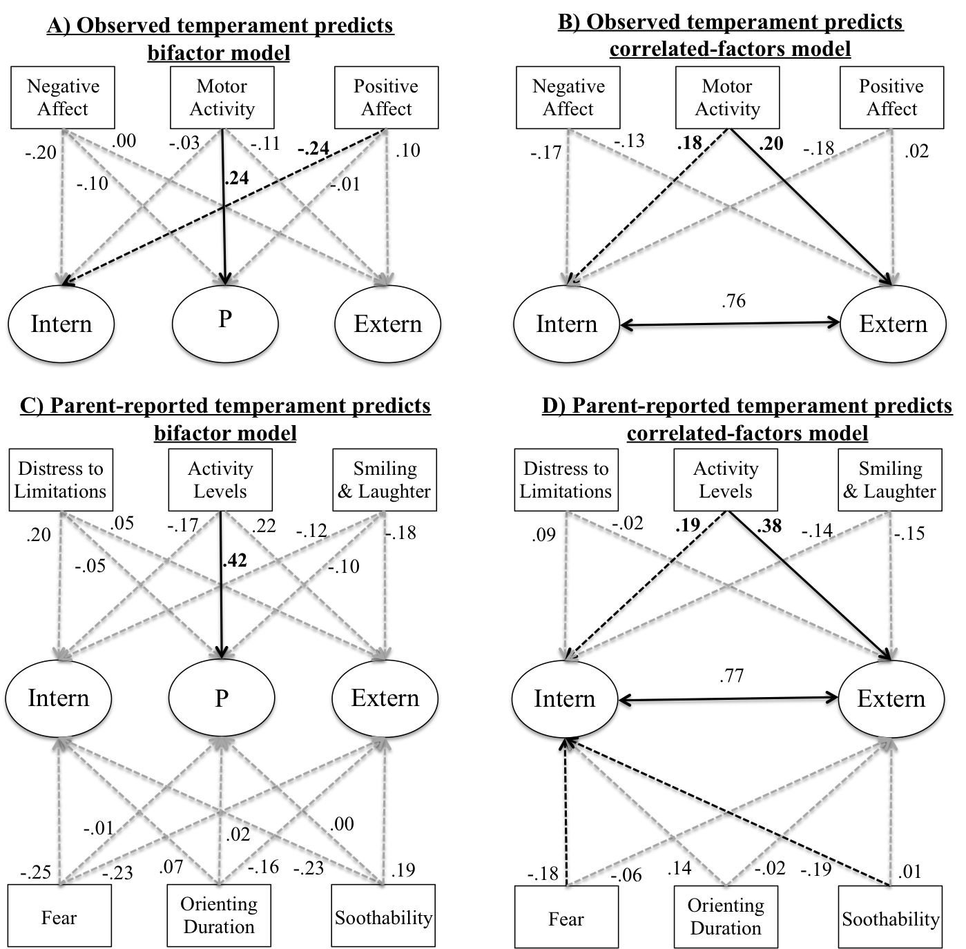
Figure S1. Standardized regression coefficients for the regression models for observed temperament predicting latent psychopathology factor scores in the bifactor model (A) and the correlated-factors model (B) as well as parent-reported predicting latent psychopathology factor scores in the bifactor model (C) and the correlated-factors model (D). Black solid arrows indicate statistically significant relations after correction for multiple comparisons (FDR). Black dotted arrows represent significant relations that do not survive multiple comparisons correction. Grey dotted arrows represent non-significant regression paths. Albeit the analysis with the bifactor model was performed following the recommended methods from Koch et al. (2018), the figure is presented as traditional regression analyses to simplify its presentation. The effects of the covariates are not displayed in the figure, but are shown on Table S1 and Table S2.
Table S3. Factor loadings and fit information for the Correlated Factors Model and the Bifactor Model including age-related factors as in Caspi et al., 2014.

 | Correlated Factors Model |  |  |  | Bifactor Model
Factor/Scale | Estimate | Std. Err. | z | p | Estimate | Std. Err. | z | p
p factor
anxdep7 |  |  |  |  | 0.49 | 0.08 | 6.42 | 0.000
withdep7 |  |  |  |  | 0.19 | 0.07 | 2.72 | 0.007
soma7 |  |  |  |  | 0.24 | 0.07 | 3.54 | 0.000
atten7 |  |  |  |  | 0.55 | 0.09 | 6.29 | 0.000
rulebre7 |  |  |  |  | 0.46 | 0.07 | 6.30 | 0.000
aggr7 |  |  |  |  | 0.98 | 0.09 | 11.1 | 0.000
anxdep9 |  |  |  |  | 0.50 | 0.10 | 5.22 | 0.000
withdep9 |  |  |  |  | 0.29 | 0.09 | 3.35 | 0.001
soma9 |  |  |  |  | 0.21 | 0.06 | 3.35 | 0.001
atten9 |  |  |  |  | 0.55 | 0.09 | 5.83 | 0.000
rulebre9 |  |  |  |  | 0.45 | 0.10 | 4.42 | 0.000
aggr9 |  |  |  |  | 0.94 | 0.08 | 11.34 | 0.000
anxdep12 |  |  |  |  | 0.33 | 0.09 | 3.84 | 0.000
withdep12 |  |  |  |  | 0.14 | 0.07 | 1.96 | 0.050
soma12 |  |  |  |  | 0.24 | 0.07 | 3.42 | 0.001
atten12 |  |  |  |  | 0.51 | 0.10 | 5.02 | 0.000
rulebre12 |  |  |  |  | 0.28 | 0.12 | 2.24 | 0.025
aggr12 |  |  |  |  | 0.71 | 0.08 | 8.65 | 0.000
Externalizing factor
atten7 | 0.61 | 0.08 | 7.52 | 0.000 | 0.24 | 0.11 | 2.15 | 0.032
rulebre7 | 0.52 | 0.05 | 9.64 | 0.000 | 0.31 | 0.10 | 3.04 | 0.002
aggr7 | 0.86 | 0.11 | 7.64 | 0.000 | 0.11 | 0.15 | 0.73 | 0.463
atten9 | 0.69 | 0.10 | 6.62 | 0.000 | 0.31 | 0.10 | 3.08 | 0.002
rulebre9 | 0.59 | 0.07 | 8.18 | 0.000 | 0.43 | 0.10 | 4.31 | 0.000
aggr9 | 0.92 | 0.09 | 10.5 | 0.000 | 0.22 | 0.15 | 1.51 | 0.130
atten12 | 0.65 | 0.09 | 7.52 | 0.000 | 0.30 | 0.10 | 3.00 | 0.003
rulebre12 | 0.49 | 0.06 | 7.89 | 0.000 | 0.69 | 0.12 | 5.79 | 0.000
aggr12 | 0.76 | 0.09 | 8.47 | 0.000 | 0.29 | 0.13 | 2.16 | 0.031
Internalizing factor
anxdep7 | 0.54 | 0.09 | 5.86 | 0.000 | 0.26 | 0.10 | 2.62 | 0.009
withdep7 | 0.24 | 0.07 | 3.37 | 0.001 | 0.23 | 0.09 | 2.55 | 0.011
soma7 | 0.33 | 0.06 | 5.09 | 0.000 | 0.26 | 0.09 | 2.81 | 0.005
anxdep9 | 0.75 | 0.09 | 8.76 | 0.000 | 0.46 | 0.11 | 4.13 | 0.000
withdep9 | 0.57 | 0.11 | 5.00 | 0.000 | 0.51 | 0.16 | 3.18 | 0.001
soma9 | 0.30 | 0.08 | 3.76 | 0.000 | 0.18 | 0.10 | 1.83 | 0.067
anxdep12 | 0.47 | 0.11 | 4.24 | 0.000 | 0.32 | 0.17 | 1.94 | 0.053
withdep12 | 0.37 | 0.08 | 4.45 | 0.000 | 0.42 | 0.12 | 3.35 | 0.001
soma12 | 0.32 | 0.08 | 4.21 | 0.000 | 0.20 | 0.11 | 1.86 | 0.062
Age7 factor
anxdep7 | 0.42 | 0.09 | 4.93 | 0.000 | 0.36 | 0.14 | 2.49 | 0.013
withdep7 | 0.39 | 0.08 | 4.69 | 0.000 | 0.38 | 0.13 | 2.91 | 0.004
soma7 | 0.24 | 0.08 | 3.07 | 0.002 | 0.22 | 0.11 | 2.02 | 0.043
atten7 | 0.15 | 0.14 | 1.08 | 0.281 | 0.07 | 0.12 | 0.59 | 0.553
rulebre7 | 0.17 | 0.10 | 1.74 | 0.082 | 0.12 | 0.14 | 0.85 | 0.394
aggr7 | 0.38 | 0.15 | 2.45 | 0.014 | 0.23 | 0.20 | 1.19 | 0.233
Age9 factor
anxdep9 | 0.22 | 0.22 | 0.99 | 0.322 | 0.35 | 0.24 | 1.46 | 0.144
withdep9 | -0.03 | 0.32 | -0.11 | 0.913 | 0.12 | 0.24 | 0.52 | 0.600
soma9 | 0.20 | 0.15 | 1.37 | 0.172 | 0.22 | 0.08 | 2.69 | 0.007
atten9 | 0.27 | 0.27 | 0.99 | 0.323 | 0.36 | 0.11 | 3.24 | 0.001
rulebre9 | 0.13 | 0.16 | 0.83 | 0.404 | 0.18 | 0.08 | 2.41 | 0.016
aggr9 | 0.46 | 0.14 | 3.26 | 0.001 | 0.43 | 0.10 | 4.23 | 0.000
Age12 factor
anxdep12 | 0.40 | 0.08 | 4.81 | 0.000 | 0.38 | 0.11 | 3.42 | 0.001
withdep12 | 0.54 | 0.07 | 7.80 | 0.000 | 0.53 | 0.09 | 5.65 | 0.000
soma12 | 0.28 | 0.07 | 3.85 | 0.000 | 0.28 | 0.09 | 3.13 | 0.002
atten12 | 0.47 | 0.07 | 6.32 | 0.000 | 0.46 | 0.07 | 6.20 | 0.000
rulebre12 | 0.29 | 0.06 | 4.93 | 0.000 | 0.27 | 0.07 | 3.77 | 0.000
aggr12 | 0.51 | 0.09 | 5.74 | 0.000 | 0.50 | 0.08 | 6.18 | 0.000
Fit Indices
χ² | 130.43(df=98) |  |  | 0.016 | 105.89(df=87) |  |  | 0.082
CFI | 0.98 |  |  |  | 0.99
TLI | 0.97 |  |  |  | 0.98
RMSEA | 0.04 |  |  |  | 0.03
SRMR | 0.05 |  |  |  | 0.04
Note: Numbers in the Factor/Scale column represent age of assessment; Estimate = unstandardized estimates; anxdep = Anxious/Depressed; withdep = Withdrawn/Depressed; soma = Somatic Complaints; atten = Attention Problems; rulebre = Rule-Breaking Behavior; aggr = Aggressive Behavior; For the bifactor model, the residual covariances between ages 7, 9, and 12 for Rule Breaking and Aggression scales were not significant and set to zero (not estimated) following modification indices to aid convergence and model fit.

Table S4. Means, standard deviations, and correlations of study variables.
Variable | M | SD | 1 | 2 | 3 | 4 | 5 | 6 | 7 | 8 | 9 | 10 | 11 | 12 | 13 | 14 | 15 | 16 | 17 | 18 | 19 | 20 | 21 | 22 | 23 | 24 | 25 | 26 | 27 | 28 | 29
1. Gender | *** | ***
2. Maternal Ethnicity | ** | ** | .05
3. Maternal Education | 1.21 | 0.72 | -.01 | .19
4. Positive Affect | 0.00 | 1.00 | -.13 | -.03 | .09
5. Negative Affect | 0.00 | 1.00 | .10 | -.07 | .02 | -.31
6. Motor Activity | 0.00 | 1.00 | -.03 | .02 | .06 | .07 | .15
7. Activity Level | 3.85 | 0.77 | -.12 | -.04 | -.03 | .05 | .12 | .19
8. Distress to Limitations | 3.36 | 0.68 | -.16 | -.06 | .04 | -.02 | .19 | .16 | .23
9. Fear | 2.17 | 0.73 | .11 | -.27 | -.13 | -.09 | .11 | -.05 | .11 | .28
10. Duration of Orienting | 4.20 | 1.11 | .10 | -.01 | -.15 | .09 | -.01 | .08 | .05 | -.20 | .06
11. Smiling & Laughter | 4.68 | 0.91 | -.09 | -.05 | -.16 | .05 | .02 | .04 | .28 | -.11 | -.01 | .34
12. Soothability | 5.14 | 0.85 | .05 | -.18 | -.12 | .07 | -.03 | -.08 | .04 | .00 | .24 | .36 | .35
13. anxdep7 | 1.51 | 0.90 | -.02 | .08 | -.10 | -.04 | -.02 | .10 | .18 | .04 | -.09 | .06 | .00 | -.12
14. withdep7 | 0.68 | 0.73 | -.03 | -.06 | -.04 | -.01 | -.09 | -.09 | .00 | -.10 | -.06 | .12 | -.02 | -.10 | .42
15. soma7 | 0.69 | 0.75 | .06 | .03 | -.10 | .06 | -.06 | .02 | .07 | .03 | -.04 | .08 | .00 | -.05 | .39 | .34
16. atten7 | 1.61 | 0.99 | -.16 | .00 | -.10 | .13 | -.18 | .08 | .23 | .05 | -.13 | .05 | .07 | -.07 | .29 | .21 | .25
17. rulebre7 | 0.97 | 0.78 | -.18 | .02 | -.14 | .12 | -.10 | .03 | .21 | .08 | -.05 | -.07 | -.04 | .01 | .35 | .19 | .31 | .40
18. aggr7 | 1.70 | 1.14 | -.24 | .08 | -.02 | .07 | -.08 | .17 | .26 | .05 | -.07 | -.03 | -.02 | -.09 | .53 | .32 | .30 | .52 | .58
19. anxdep9 | 1.62 | 1.04 | .01 | .02 | -.09 | -.07 | -.02 | .04 | .17 | .07 | -.14 | .05 | -.03 | -.10 | .62 | .23 | .30 | .35 | .23 | .37
20. withdep9 | 0.72 | 0.77 | .04 | -.07 | -.16 | -.07 | -.07 | .04 | .03 | -.02 | -.10 | .02 | -.09 | -.11 | .39 | .40 | .33 | .34 | .33 | .31 | .57
21. soma9 | 0.81 | 0.75 | .06 | .04 | .00 | -.19 | .02 | .02 | .10 | .07 | -.01 | .05 | -.14 | -.09 | .28 | .12 | .39 | .14 | .15 | .27 | .37 | .29
22. atten9 | 1.58 | 1.08 | -.22 | .01 | .04 | .07 | -.11 | .08 | .26 | .06 | -.11 | -.10 | -.12 | -.13 | .24 | .13 | .24 | .71 | .47 | .51 | .38 | .40 | .31
23. rulebre9 | 0.92 | 0.80 | -.19 | -.04 | -.07 | -.01 | -.04 | .02 | .23 | .07 | -.03 | -.09 | -.11 | -.08 | .33 | .14 | .25 | .50 | .57 | .52 | .35 | .37 | .24 | .56
24. aggr9 | 1.66 | 1.15 | -.19 | .02 | .03 | .03 | -.08 | .18 | .29 | .12 | -.11 | -.05 | -.10 | -.09 | .48 | .21 | .32 | .50 | .55 | .71 | .54 | .39 | .35 | .59 | .66
25. anxdep12 | 1.45 | 0.96 | .15 | .14 | -.12 | -.12 | -.10 | .03 | -.04 | -.01 | -.07 | .04 | .07 | -.12 | .49 | .21 | .27 | .24 | .13 | .27 | .52 | .33 | .26 | .12 | .09 | .24
26. withdep12 | 1.00 | 0.86 | .10 | .00 | -.26 | -.15 | -.17 | -.02 | -.07 | .00 | .02 | .09 | -.03 | .03 | .23 | .27 | .19 | .10 | .05 | .07 | .30 | .55 | .23 | .18 | .11 | .18 | .47
27. soma12 | 0.72 | 0.80 | .02 | .05 | -.13 | -.15 | -.01 | .01 | .04 | .08 | -.06 | -.02 | -.05 | -.15 | .22 | .23 | .36 | .17 | .14 | .28 | .24 | .30 | .35 | .28 | .12 | .25 | .40 | .41
28. atten12 | 1.46 | 1.10 | -.14 | -.03 | -.09 | .12 | -.18 | .01 | .20 | -.02 | .03 | .14 | .03 | -.02 | .25 | .14 | .14 | .60 | .31 | .41 | .29 | .30 | .20 | .66 | .35 | .40 | .30 | .36 | .36
29. rulebre12 | 0.86 | 0.82 | -.12 | -.07 | -.08 | .12 | -.09 | .04 | .22 | .03 | -.04 | -.02 | -.01 | .06 | .16 | .10 | .10 | .38 | .48 | .34 | .16 | .25 | .16 | .44 | .64 | .48 | .12 | .28 | .17 | .49
30. aggr12 | 1.72 | 1.05 | -.08 | .01 | -.11 | -.01 | -.09 | .08 | .24 | -.06 | .08 | .12 | .15 | .12 | .35 | .19 | .15 | .42 | .42 | .57 | .33 | .28 | .16 | .40 | .50 | .64 | .38 | .41 | .31 | .56 | .58
Note: Numbers at the end of the Variable name represent age of assessment; anxdep = Anxious/Depressed; withdep = Withdrawn/Depressed; soma = Somatic Complaints; atten = Attention Problems; rulebre = Rule-Breaking Behavior; aggr = Aggressive Behavior; M = mean; SD = standard deviation; *** Gender coded as 1 = female and 0 = male; ** Maternal ethnicity coded as 1 = non-Hispanic Caucasian and 0 = other. Maternal education was coded as High school graduate = 0, College Graduate = 1, Graduate school graduate = 2, and Other = missing.

Table S5. Factor loadings and fit information for the Correlated Factors Model and the Bifactor Model.
 | Correlated Factors Model |  |  |  | Bifactor Model
Factor/Scale | Estimate | Std. Err. | z | p | Estimate |  | Std. Err. |  | z |  | p
p factor
anxdep7 |  |  |  |  | 0.51 |  | 0.07 |  | 7.41 |  | 0.000
withdep7 |  |  |  |  | 0.19 |  | 0.06 |  | 3.17 |  | 0.002
soma7 |  |  |  |  | 0.24 |  | 0.06 |  | 3.93 |  | 0.000
atten7 |  |  |  |  | 0.55 |  | 0.08 |  | 6.91 |  | 0.000
rulebre7 |  |  |  |  | 0.44 |  | 0.07 |  | 6.78 |  | 0.000
aggr7 |  |  |  |  | 0.95 |  | 0.08 |  | 12.27 |  | 0.000
anxdep9 |  |  |  |  | 0.49 |  | 0.08 |  | 6.38 |  | 0.000
withdep9 |  |  |  |  | 0.31 |  | 0.06 |  | 4.82 |  | 0.000
soma9 |  |  |  |  | 0.22 |  | 0.06 |  | 3.61 |  | 0.000
atten9 |  |  |  |  | 0.54 |  | 0.09 |  | 6.10 |  | 0.000
rulebre9 |  |  |  |  | 0.47 |  | 0.08 |  | 5.76 |  | 0.000
aggr9 |  |  |  |  | 0.96 |  | 0.07 |  | 13.93 |  | 0.000
anxdep12 |  |  |  |  | 0.32 |  | 0.08 |  | 4.23 |  | 0.000
withdep12 |  |  |  |  | 0.14 |  | 0.07 |  | 2.04 |  | 0.041
soma12 |  |  |  |  | 0.24 |  | 0.07 |  | 3.62 |  | 0.000
atten12 |  |  |  |  | 0.55 |  | 0.10 |  | 5.65 |  | 0.000
rulebre12 |  |  |  |  | 0.32 |  | 0.10 |  | 3.27 |  | 0.001
aggr12 |  |  |  |  | 0.75 |  | 0.07 |  | 10.89 |  | 0.000
Externalizing factor
atten7 | 0.62 | 0.08 | 7.66 | 0.000 | 0.22 |  | 0.10 |  | 2.23 |  | 0.026
rulebre7 | 0.51 | 0.05 | 9.44 | 0.000 | 0.33 |  | 0.07 |  | 4.46 |  | 0.000
aggr7 | 0.89 | 0.09 | 9.61 | 0.000 | 0.09 |  | 0.14 |  | 0.66 |  | 0.506
atten9 | 0.63 | 0.08 | 7.51 | 0.000 | 0.33 |  | 0.11 |  | 3.11 |  | 0.002
rulebre9 | 0.56 | 0.06 | 9.27 | 0.000 | 0.44 |  | 0.08 |  | 5.32 |  | 0.000
aggr9 | 0.95 | 0.08 | 12.63 | 0.000 | 0.23 |  | 0.13 |  | 1.74 |  | 0.082
atten12 | 0.62 | 0.09 | 7.00 | 0.000 | 0.14 |  | 0.11 |  | 1.29 |  | 0.199
rulebre12 | 0.46 | 0.06 | 7.38 | 0.000 | 0.59 |  | 0.09 |  | 6.38 |  | 0.000
aggr12 | 0.78 | 0.07 | 11.13 | 0.000 | 0.17 |  | 0.13 |  | 1.32 |  | 0.186
Internalizing factor
anxdep7 | 0.62 | 0.09 | 6.99 | 0.000 | 0.29 |  | 0.09 |  | 3.12 |  | 0.002
withdep7 | 0.26 | 0.07 | 3.9 | 0.000 | 0.23 |  | 0.12 |  | 2.02 |  | 0.043
soma7 | 0.35 | 0.07 | 4.89 | 0.000 | 0.27 |  | 0.08 |  | 3.46 |  | 0.001
anxdep9 | 0.66 | 0.10 | 6.89 | 0.000 | 0.34 |  | 0.11 |  | 3.23 |  | 0.001
withdep9 | 0.49 | 0.08 | 6.40 | 0.000 | 0.40 |  | 0.12 |  | 3.41 |  | 0.001
soma9 | 0.31 | 0.07 | 4.34 | 0.000 | 0.23 |  | 0.10 |  | 2.29 |  | 0.022
anxdep12 | 0.49 | 0.09 | 5.20 | 0.000 | 0.38 |  | 0.14 |  | 2.75 |  | 0.006
withdep12 | 0.35 | 0.08 | 4.15 | 0.000 | 0.49 |  | 0.14 |  | 3.55 |  | 0.000
soma12 | 0.31 | 0.08 | 3.81 | 0.000 | 0.22 |  | 0.11 |  | 2.10 |  | 0.035
Fit Indices
χ² | 89.13(df=71) |  | 0.072 | 64.03 (df=60) |  |  |  | 0.337
CFI | 0.99 |  |  |  | 1.00
TLI | 0.98 |  |  |  | 0.99
RMSEA | 0.03 |  |  |  | 0.02
SRMR | 0.04 |  |  |  | 0.04
Note: Numbers in the Factor/Scale column represent age of assessment; Estimate = unstandardized estimates; anxdep = Anxious/Depressed; withdep = Withdrawn/Depressed; soma = Somatic Complaints; atten = Attention Problems; rulebre = Rule-Breaking Behavior; aggr = Aggressive Behavior; For the bifactor model, the residual covariances between ages 7, 9, and 12 for Rule Breaking and Aggression scales were not significant and set to zero (not estimated) following modification indices to aid convergence and model fit.

Examining the longitudinal relations general psychopathology factors

Previous developmental studies suggest a high degree of stability in psychopathology factors across age, including the age range of the current study (Greene & Eaton, 2017; McElroy et al., 2018; Murray et al., 2016; Olino et al., 2018; Snyder, Young, et al., 2017). Thus, as in previous studies examining general psychopathology (Caspi et al., 2014; Lahey et al., 2015), we evaluated the structure of psychopathology across age (i.e., the 7, 9, and 12-year assessments). In order to provide additional support for our decision to examine the structure of psychopathology across age, we examined the stability of the general psychopathology factor across age. In order to examine the relative stability of the general psychopathology factor, we longitudinally modeled the structure of psychopathology for each age separately in a longitudinal bifactor model. We encountered convergence problems and had to simplify the models to obtain unique and interpretable solutions. We constrained all covariances across the 7- to 12-year assessments to zero. Results showed that the stability of the general psychopathology factor across ages 7-12 was comparable to previous studies (e.g., McElroy et al., 2018). Specifically, we observed high stability from the 7- to 9-year assessments, β = .85, from 9- to 12-year assessments, β = .71, and from 7- to 12-year assessments, β = .73. This relatively high stability further supports our decision to examine psychopathology across childhood (7-12 years), rather than developmental changes between across age.
Moreover, as a further examination of our analytic decision, we decided to examine the relations between temperament and psychopathology for each age separately. Although it is not ideal to model each age independently in separate models, this allowed us to simplify the models to examine age differences by comparing the estimates across models. As shown in the Figure S2, all the relations between temperament and the psychopathology factors were similar across ages. Importantly, the 95% confidence intervals of the estimates overlapped across ages, suggesting that there were no significant differences. This provided further support to examine psychopathology across childhood (7-12 years), rather than developmental changes across age.

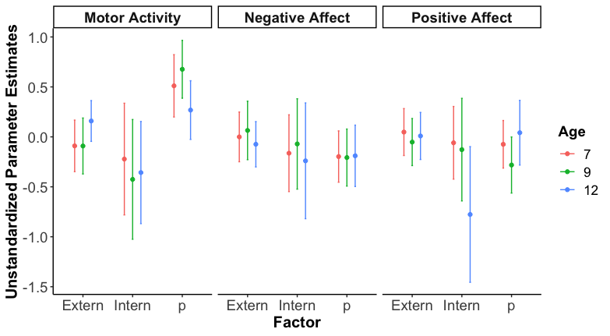
Figure S2. Unstandardized estimates for each temperament dimension (columns) and the psychopathology factors separately for each age. Points represent the unstandardized estimates and error bars indicate the 95% confidence intervals.

