Supplemental Materials for “Gonadal and Adrenal Hormones Interact with Pubertal Maturation to Predict Depressive Symptoms in a Group of High School Females”

Below please find all tables and figures referenced in the manuscript entitled, “Gonadal and Adrenal Hormones Interact with Pubertal Maturation to Predict Depressive Symptoms in a Group of High School Females.”

Table 4 provides results of non-significant (after controlling for multiple analyses) findings relating main effects, two-, and three-way interactions of cortisol, estradiol, pubertal stage, and perceived pubertal onset predicting change in depressive scores from fall to spring of 9th grade and fall of 9th grade to spring of 10th grade. See table notes to interpret abbreviations and for further details.
Table 4
Main effect, two-, and three-way interactions between hormones and puberty predicting change in CDI scores
Variable | DV | b | SE | R2 | F | P
E | Spring 9 CDI - Fall 9 CDI | -0.013 | 0.025 | 0.080 | 1.089 on 4 and 50 DF | 0.604
E | Spring 10 CDI - Fall 9 CDI | 0.019 | 0.033 | 0.222 | 3.062 on 4 and 43 DF | 0.565
C | Spring 9 CDI - Fall 9 CDI | 0.058 | 0.023 | 0.181 | 2.764 on 4 and 50 DF | 0.014
C | Spring 10 CDI - Fall 9 CDI | 0.010 | 0.028 | 0.220 | 3 on 4 and 43 DF | 0.709
PDS | Spring 9 CDI - Fall 9 CDI | 0.041 | 0.030 | 0.108 | 1.517 on 4 and 50 DF | 0.179
PDS | Spring 10 CDI - Fall 9 CDI | 0.025 | 0.038 | 0.223 | 3.094 on 4 and 43 DF | 0.513
Onset | Spring 9 CDI - Fall 9 CDI | -0.011 | 0.022 | 0.079 | 1.077 on 4 and 50 DF | 0.634
Onset | Spring 10 CDI - Fall 9 CDI | -0.005 | 0.027 | 0.216 | 2.964 on 4 and 43 DF | 0.866
E x PDS | Spring 9 CDI - Fall 9 CDI | 0.009 | 0.022 | 0.123 | 1.119 on 6 and 48 DF | 0.683
E x PDS | Spring 10 CDI - Fall 9 CDI | -0.02 | 0.026 | 0.243 | 2.193 on 6 and 41 DF | 0.357
E x onset | Spring 9 CDI - Fall 9 CDI | 0.004 | 0.018 | 0.088 | 0.7678 on 6 and 48 DF | 0.831
E x onset | Spring 10 CDI - Fall 9 CDI | -0.008 | 0.025 | 0.224 | 1.97 on 6 and 41 DF | 0.743
E x C x PDS | Spring 9 CDI - Fall 9 CDI | 0.034 | 0.038 | 0.252 | 1.482 on 10 and 44 DF | 0.377
E x C x PDS | Spring 10 CDI - Fall 9 CDI | 0.015 | 0.060 | 0.246 | 1.209 on 10 and 37 DF | 0.801
E x C x onset | Spring 9 CDI - Fall 9 CDI | -0.011 | 0.020 | 0.225 | 1.275 on 10 and 44 DF | 0.576
E x C x onset | Spring 10 CDI - Fall 9 CDI | 0.01 | 0.036 | 0.32 | 1.743 on 10 and 37 DF | 0.794
Note: No significant relationships observed. Regression table including main effects, two-, and three-way interactions between log transformed hormones Cortisol (C) and Estradiol (E), Pubertal Development Stage (PDS), and perceived pubertal onset (Onset) predicting change in depression (CDI) from Fall to Spring of 9th grade (Spring 9 CDI - Fall 9 CDI), and Fall of 9th grade to Spring of 10th grade (Spring 10 CDI - Fall 9 CDI). All analyses included in table control for menstrual cycle phase and ethnicity. DV = dependent variable. Results include covariates of menstrual cycle stage and ethnicity.

Table 5 provides results of main effects, two-, and three-way interactions of cortisol, estradiol, pubertal stage, and perceived pubertal onset predicting change in depressive scores from fall to spring of 9th grade and fall of 9th grade to spring of 10th grade without inclusion of covariates in models. See table notes to interpret abbreviations and for further details.

Table 5
Main effect, two-, and three-way interactions between hormones and puberty predicting change in CDI scores *without covariates*
Variable | DV | b | SE | R2 | F | P
E | Spring 9 CDI - Fall 9 CDI | -0.028 | 0.022 | 0.022 | 1.658 on 1 and 74 DF | 0.202
E | Spring 10 CDI - Fall 9 CDI | 0.041 | 0.033 | 0.023 | 1.553 on 1 and 65 DF | 0.217
C | Spring 9 CDI - Fall 9 CDI | 0.030 | 0.021 | 0.027 | 2.028 on 1 and 74 DF | 0.159
C | Spring 10 CDI - Fall 9 CDI | -0.012 | 0.030 | 0.002 | 0.1611 on 1 and 65 DF | 0.689
PDS | Spring 9 CDI - Fall 9 CDI | 0.008 | 0.022 | 0.002 | 0.1466 on 1 and 74 DF | 0.703
PDS | Spring 10 CDI - Fall 9 CDI | -0.071 | 0.030 | 0.081 | 5.683 on 1 and 65 DF | 0.02*
Onset | Spring 9 CDI - Fall 9 CDI | -0.005 | 0.020 | 0.001 | 0.05584 on 1 and 74 DF | 0.814
Onset | Spring 10 CDI - Fall 9 CDI | 0.006 | 0.029 | 0.001 | 0.04723 on 1 and 65 DF | 0.829
E x PDS | Spring 9 CDI - Fall 9 CDI | 0.005 | 0.019 | 0.026 | 0.642 on 3 and 72 DF | 0.797
E x PDS | Spring 10 CDI - Fall 9 CDI | 0.003 | 0.026 | 0.116 | 2.745 on 3 and 63 DF | 0.893
E x onset | Spring 9 CDI - Fall 9 CDI | 0.007 | 0.017 | 0.027 | 0.6643 on 3 and 72 DF | 0.675
E x onset | Spring 10 CDI - Fall 9 CDI | -0.012 | 0.027 | 0.031 | 0.6772 on 3 and 63 DF | 0.668
E x C x PDS | Spring 9 CDI - Fall 9 CDI | 0.019 | 0.033 | 0.074 | 0.7805 on 7 and 68 DF | 0.556
E x C x PDS | Spring 10 CDI - Fall 9 CDI | 0.005 | 0.050 | 0.129 | 1.25 on 7 and 59 DF | 0.921
E x C x onset | Spring 9 CDI - Fall 9 CDI | -0.010 | 0.018 | 0.075 | 0.7856 on 7 and 68 DF | 0.574
E x C x onset | Spring 10 CDI - Fall 9 CDI | 0.035 | 0.034 | 0.087 | 0.8102 on 7 and 59 DF | 0.322
Note: Results do not include covariates of menstrual cycle stage and ethnicity--check to ensure no bias introduced by inclusion of covariates in models. No significant relationships observed. Regression table including main effects, two-, and three-way interactions between log transformed hormones Cortisol (C) and Estradiol (E), Pubertal Development Stage (PDS), and perceived pubertal onset (Onset) predicting change in depression from Fall to Spring of 9th grade (Spring 9 CDI - Fall 9 CDI), and Fall of 9th grade to Spring of 10th grade (Spring 10 CDI - Fall 9 CDI). DV = dependent variable.
* p<0.05

Table 6 provides results of main effects, two-, and three-way interactions of cortisol, estradiol, pubertal stage, and perceived pubertal onset predicting change in depressive scores from fall to spring of 9th grade and fall of 9th grade to spring of 10th grade without log transformation of hormone levels in models. See table notes to interpret abbreviations and for further details.
Table 6
Main effect, two-, and three-way interactions between hormones and puberty predicting change in CDI *without log transformation*
Variable | DV | b | SE | R2 | F | P
E | Spring 9 CDI - Fall 9 CDI | -0.018 | 0.027 | 0.083 | 1.131 on 4 and 50 DF | 0.515
E | Spring 10 CDI - Fall 9 CDI | -0.019 | 0.035 | 0.221 | 3.043 on 4 and 43 DF | 0.602
C | Spring 9 CDI - Fall 9 CDI | 0.062 | 0.023 | 0.189 | 2.917 on 4 and 50 DF | 0.0107*
C | Spring 10 CDI - Fall 9 CDI | -0.09 | 0.027 | 0.222 | 3.063 on 4 and 43 DF | 0.563
E x PDS | Spring 9 CDI - Fall 9 CDI | 0.010 | 0.026 | 0.125 | 1.147 on 6 and 48 DF | 0.702
E x PDS | Spring 10 CDI - Fall 9 CDI | -0.031 | 0.032 | 0.244 | 2.199 on 6 and 41 DF | 0.339
E x onset | Spring 9 CDI - Fall 9 CDI | 0.006 | 0.018 | 0.092 | 0.8109 on 6 and 48 DF | 0.732
E x onset | Spring 10 CDI - Fall 9 CDI | -0.012 | 0.028 | 0.224 | 1.976 on 6 and 41 DF | 0.663
E x C x PDS | Spring 9 CDI - Fall 9 CDI | 0.038 | 0.050 | 0.263 | 1.571 on 10 and 44 DF | 0.450
E x C x PDS | Spring 10 CDI - Fall 9 CDI | 0.006 | 0.080 | 0.250 | 1.216 on 10 and 37 DF | 0.936
E x C x onset | Spring 9 CDI - Fall 9 CDI | -0.020 | 0.022 | 0.245 | 1.426 on 10 and 44 DF | 0.364
E x C x onset | Spring 10 CDI - Fall 9 CDI | 0.022 | 0.044 | 0.335 | 1.861 on 10 and 37 DF | 0.623
Note: Results include untransformed hormone values--check to ensure no bias introduced by inclusion of log transformation in models. Regression table including main effects, two-, and three-way interactions between hormones Cortisol (C) and Estradiol (E), Pubertal Development Stage (PDS), and perceived pubertal onset (Onset) predicting change in depression from Fall to Spring of 9th grade (Spring 9 CDI - Fall 9 CDI), and Fall of 9th grade to Spring of 10th grade (Spring 10 CDI - Fall 9 CDI). All analyses included in table control for menstrual cycle phase and ethnicity. DV = dependent variable.
* p<0.05

Table 7 provides results of main effects, two-, and three-way interactions of cortisol, estradiol, pubertal stage, and perceived pubertal onset predicting depressive scores in fall of 9th grade, spring of 9th grade, and spring of 10th grade without log transformation of hormone levels in models. See table notes to interpret abbreviations and for further details.
Table 7
Main effect, two-, and three-way interactions between hormones and puberty predicting CDI scores *without log transformation*
Variable | DV | b | SE | R2 | F | P
E | Fall 9 CDI | 0.129 | 0.050 | 0.149 | 2.194 on 4 and 50 DF | 0.014*
E | Spring 9 CDI | -0.022 | 0.042 | 0.13 | 1.877 on 4 and 50 DF | 0.027*
E | Spring 10 CDI | -0.100 | 0.043 | 0.154 | 1.955 on 4 and 43 DF | 0.123
C | Fall 9 CDI | 0.026 | 0.045 | 0.044 | 0.569 on 4 and 50 DF | 0.601
C | Spring 9 CDI | 0.088 | 0.045 | 0.108 | 1.512 on 4 and 50 DF | 0.058
C | Spring 10 CDI | -0.004 | 0.046 | 0.105 | 1.267 on 4 and 43 DF | 0.934
E x PDS | Fall 9 CDI | -0.050 | 0.049 | 0.174 | 1.687 on 6 and 48 DF | 0.314
E x PDS | Spring 9 CDI | -0.040 | 0.047 | 0.181 | 1.771 on 6 and 48 DF | 0.399
E x PDS | Spring 10 CDI | -0.036 | 0.049 | 0.223 | 1.956 on 6 and 41 DF | 0.469
E x onset | Fall 9 CDI | 0.096 | 0.031 | 0.307 | 3.548 on 6 and 48 DF | 0.0032**
E x onset | Spring 9 CDI | 0.102 | 0.029 | 0.338 | 4.086 on 6 and 48 DF | 0.0009***
E x onset | Spring 10 CDI | 0.011 | 0.041 | 0.278 | 2.635 on 6 and 41 DF | 0.786
E x C x PDS | Fall 9 CDI | -0.332 | 0.083 | 0.452 | 3.635 on 10 and 44 DF | 2.4e-04***
E x C x PDS | Spring 9 CDI | -0.293 | 0.080 | 0.447 | 3.558 on 10 and 44 DF | 6.4e-04***
E x C x PDS | Spring 10 CDI | -0.217 | 0.115 | 0.312 | 1.676 on 10 and 37 DF | 0.0675
E x C x onset | Fall 9 CDI | 0.163 | 0.031 | 0.580 | 6.074 on 10 and 44 DF | 4.45e-06***
E x C x onset | Spring 9 CDI | 0.144 | 0.030 | 0.581 | 6.101 on 10 and 44 DF | 1.86e-05***
E x C x onset | Spring 10 CDI | 0.188 | 0.060 | 0.462 | 3.178 on 10 and 37 DF | 0.0033**
Note: Results include untransformed hormone values--check to ensure no bias introduced by inclusion of log transformation in models. Regression table including main effects, two-, and three-way interactions between Cortisol (C), Estradiol (E), Pubertal Development Stage (PDS), and perceived pubertal onset (Onset) predicting depression scores (CDI) in Fall of 9th grade (Fall 9 CDI), Spring of 9th grade (Spring 9 CDI), and Spring of 10th grade (Spring 10 CDI). All analyses included in table control for menstrual cycle phase and ethnicity. DV = dependent variable.
* p<0.05
** p<0.01
*** p< 0.001

Table 8 provides results of main effects, two-, and three-way interactions of cortisol, estradiol, pubertal stage, and perceived pubertal onset predicting depressive scores in fall of 9th grade, spring of 9th grade, and spring of 10th grade without inclusion of covariates in models. See table notes to interpret abbreviations and for further details.
Table 8
Main effect, two-, and three-way interactions between hormones and puberty predicting CDI scores *without covariates*
Variable | DV | b | SE | R2 | F | P
E | Fall 9 CDI | 0.072 | 0.038 | 0.044 | 3.524 on 1 and 77 DF | 0.06
E | Spring 9 CDI | 0.044 | 0.040 | 0.016 | 1.211 on 1 and 74 DF | 0.275
E | Spring 10 CDI | 0.061 | 0.043 | 0.030 | 1.993 on 1 and 65 DF | 0.163
C | Fall 9 CDI | 0.035 | 0.038 | 0.011 | 0.8549 on 1 and 77 DF | 0.358
C | Spring 9 CDI | 0.068 | 0.038 | 0.041 | 3.129 on 1 and 74 DF | 0.081
C | Spring 10 CDI | -0.014 | 0.039 | 0.002 | 0.1356 on 1 and 65 DF | 0.714
PDS | Fall 9 CDI | 0.081 | 0.038 | 0.060 | 4.609 on 1 and 77 DF | 0.035*
PDS | Spring 9 CDI | 0.092 | 0.038 | 0.073 | 5.802 on 1 and 74 DF | 0.019*
PDS | Spring 10 CDI | 0.018 | 0.041 | 0.003 | 0.2028 on 1 and 65 DF | 0.654
Onset | Fall 9 CDI | -0.060 | 0.034 | 0.039 | 3.151 on 1 and 77 DF | 0.0798
Onset | Spring 9 CDI | -0.068 | 0.035 | 0.048 | 3.744 on 1 and 74 DF | 0.0568
Onset | Spring 10 CDI | -0.106 | 0.036 | 0.117 | 8.643 on 1 and 65 DF | 0.005**
E x PDS | Fall 9 CDI | -0.021 | 0.033 | 0.098 | 2.709 on 3 and 75 DF | 0.531
E x PDS | Spring 9 CDI | -0.016 | 0.034 | 0.087 | 2.273 on 3 and 72 DF | 0.640
E x PDS | Spring 10 CDI | -0.011 | 0.035 | 0.032 | 0.7045 on 3 and 63 DF | 0.762
E x onset | Fall 9 CDI | 0.073 | 0.028 | 0.154 | 4.553 on 3 and 75 DF | 0.008**
E x onset | Spring 9 CDI | 0.086 | 0.028 | 0.166 | 4.768 on 3 and 72 DF | 0.003**
E x onset | Spring 10 CDI | 0.015 | 0.034 | 0.127 | 3.056 on 3 and 63 DF | 0.654
E x C x PDS | Fall 9 CDI | -0.203 | 0.050 | 0.321 | 4.793 on 7 and 71 DF | 0.000123***
E x C x PDS | Spring 9 CDI | -0.185 | 0.052 | 0.283 | 3.825 on 7 and 68 DF | 0.000714**
E x C x PDS | Spring 10 CDI | -0.160 | 0.064 | 0.162 | 1.628 on 7 and 59 DF | 0.0153**
E x C x onset | Fall 9 CDI | 0.143 | 0.026 | 0.423 | 7.438 on 7 and 71 DF | 5.91e-07***
E x C x onset | Spring 9 CDI | 0.132 | 0.027 | 0.411 | 6.788 on 7 and 68 DF | 5.41e-06***
E x C x onset | Spring 10 CDI | 0.139 | 0.040 | 0.297 | 3.556 on 7 and 59 DF | 0.000898***
Note: Results do not include covariates of menstrual cycle stage and ethnicity--check to ensure no bias introduced by inclusion of covariates in models. Regression table including main effects, two-, and three-way interactions between Cortisol (C), Estradiol (E), Pubertal Development Stage (PDS), and perceived pubertal onset (Onset) predicting depression scores (CDI) in Fall of 9th grade (Fall 9 CDI), Spring of 9th grade (Spring 9 CDI), and Spring of 10th grade (Spring 10 CDI). All analyses included in table do not control for menstrual cycle phase and ethnicity. DV = dependent variable.
* p<0.05
** p<0.01
*** p< 0.001

Table 9 provides results of Menstrual Cycle Stage predicting change in depressive scores from the fall to the spring of 9th grade and from the fall of 9th grade to the spring of 10th grade, and depressive scores in fall of 9th grade, spring of 9th grade, and spring of 10th grade. See table notes to interpret abbreviations and for further details.

Table 9
Menstrual Cycle Stage Predicting CDI change and CDI at Individual Time Points
Variable | DV | b | SE | R2 | F | P
MCS | Spring 9 CDI - Fall 9 CDI | -0.0434 | 0.02213 | 0.06765 | 3.846 on 1 and 53 DF | 0.0551
MCS | Spring 10 CDI - Fall 9 CDI | -0.08564 | 0.02608 | 0.19 | 10.79 on 1 and 46 DF | 0.001959**
MCS | Fall 9 CDI | 0.03622 | 0.0438 | 0.01274 | 0.6841 on 1 and 53 DF | 0.411888
MCS | Spring 9 CDI | -0.007179 | 0.042226 | 0.0005451 | 0.02891 on 1 and 53 DF | 0.866
MCS | Spring 10 CDI | -0.08427 | 0.04186 | 0.08098 | 4.053 on 1 and 46 DF | 0.05*
Note: Results of menstrual cycle stage (MCS) predicting CDI. Regression table includes results of linear regression examining correlation between Menstrual Cycle Stage (MCS) and depression scores (CDI). Dependent Variables include change in depression from Fall to Spring of 9th grade (Spring 9 CDI - Fall 9 CDI), and Fall of 9th grade to Spring of 10th grade (Spring 10 CDI - Fall 9 CDI), and Depression scores in Fall of 9th grade (Fall 9 CDI), Spring of 9th grade (Spring 9 CDI), and Spring of 10th grade (Spring 10 CDI). Results should be considered in light of the small sample of females who provided self-reported menstrual cycle stage. DV = dependent variable
* p<0.05
** p<0.01

Below are the figures mentioned in the text of the manuscript for models whose p values were significant at p<0.05, but did not remain significant after Bonferroni corrections for multiple comparisons.

Figure 6 displays the results of a linear regression correlating estradiol (log(E)) with spring 9th grade depression (CDI) scores. Covariates are ethnicity and menstrual cycle stage. Summary values can be found in the main text of the manuscript (p = 0.05, R²=0.113).

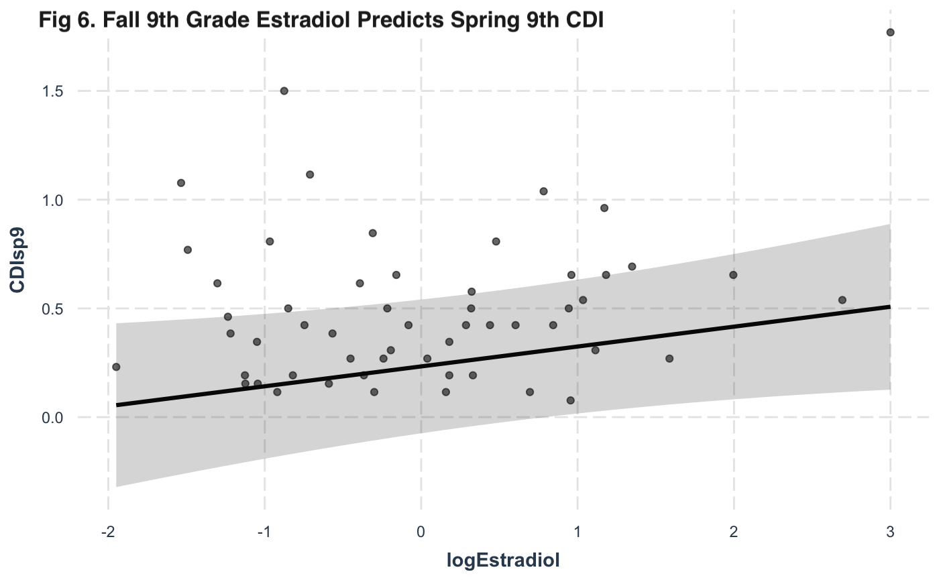

Figure 7 displays the results of a linear regression correlating Pubertal Development Stage (PDS) with spring 10th grade depression (CDI) scores. Covariates are ethnicity and menstrual cycle stage. Summary values can be found in the main text of the manuscript (p = 0.045, R²=0.186).

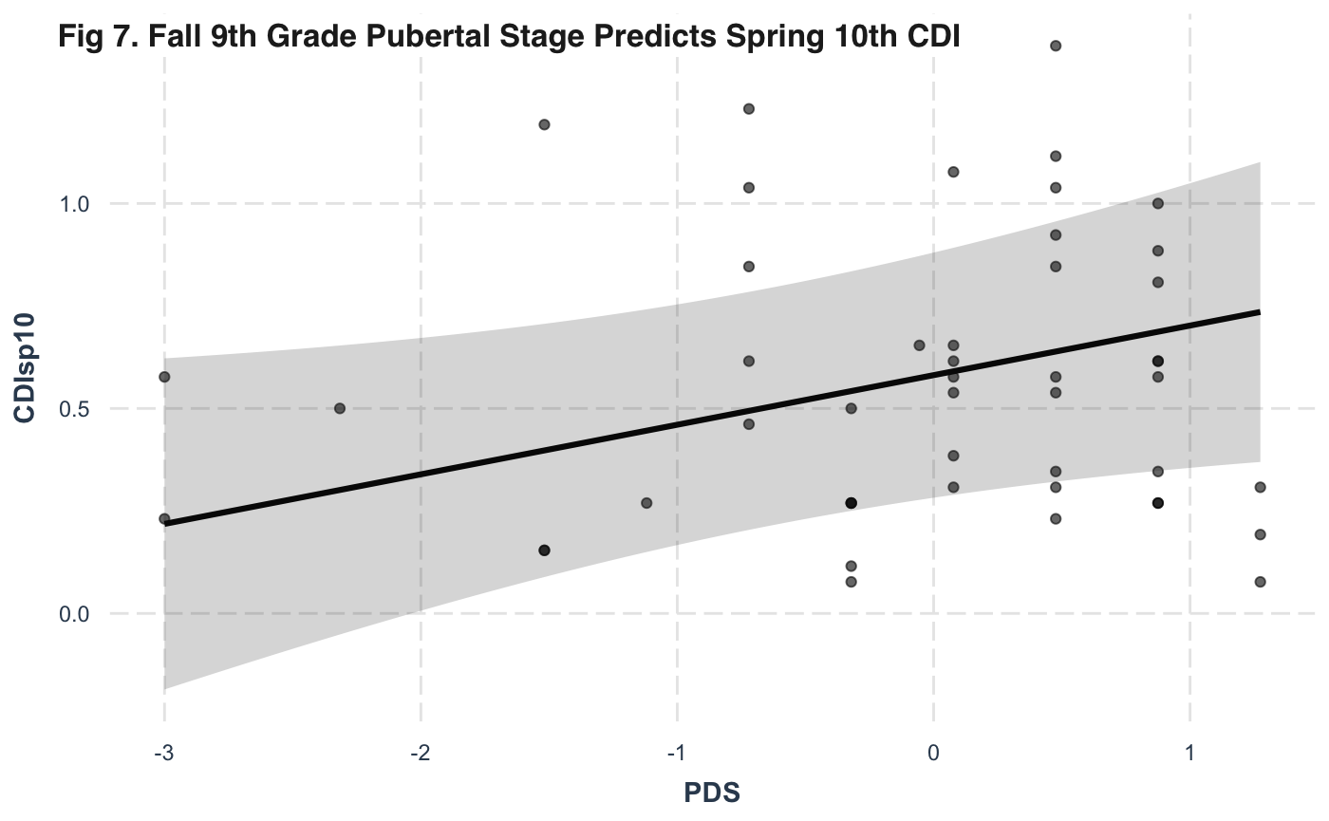

Figure 8 displays the results of a correlation between the interaction of estradiol (log(E)) and Perceived Pubertal Onset (Onset) with Fall 9th grade depression (CDI) scores. Covariates are ethnicity and menstrual cycle stage. Summary values can be found in the main text of the manuscript (p = 0.005, R²=0.275).

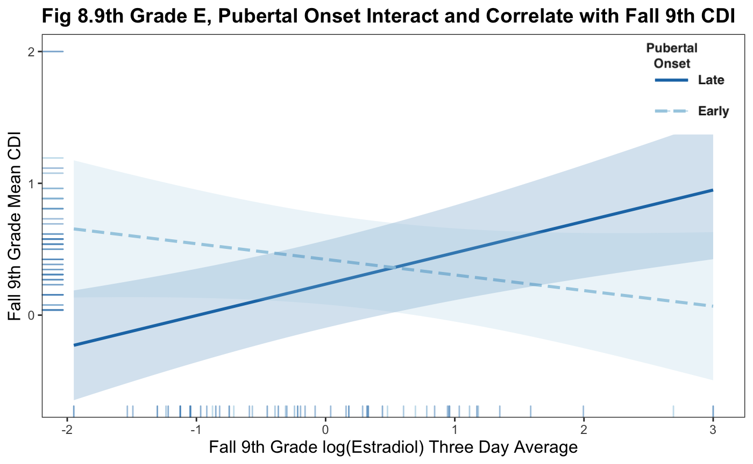

Figure 9 displays the results of a correlation between the interaction of estradiol (log(E)), cortisol (log(C)), and Perceived Pubertal Onset (Onset) with Spring 10th grade depression (CDI) scores. Covariates are ethnicity and menstrual cycle stage. Summary values can be found in the main text of the manuscript (p = 0.016, R²=0.432).

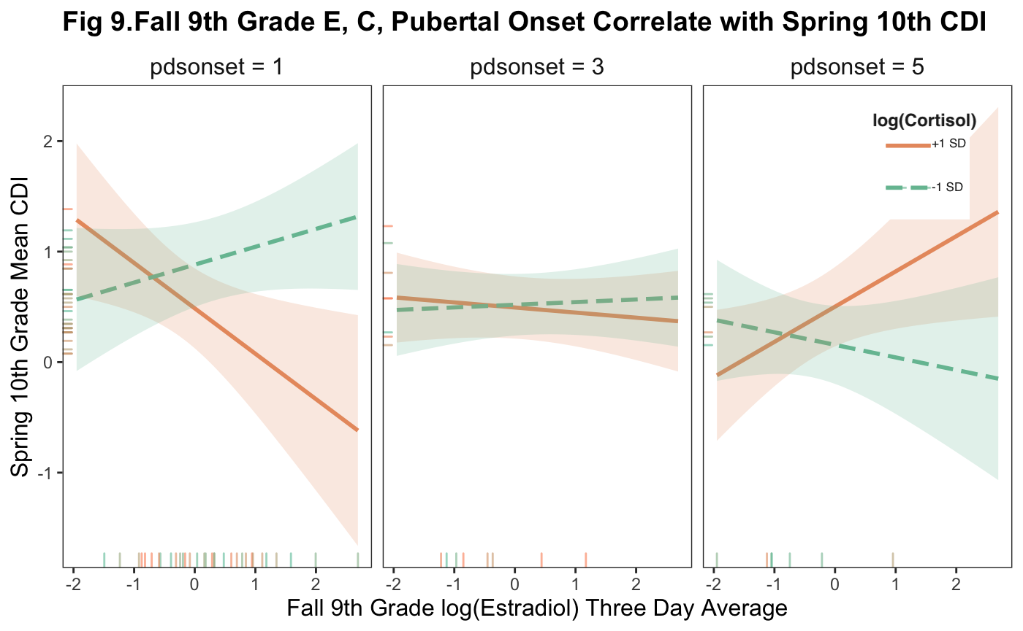

For further supplemental materials and to view our analytical output for all analyses, please visit our OSF page.

