SUPPLEMENT
METHODS
Behavioral Emotion Recognition Task
During the task, youth would first see a fixation cross for 4±1 seconds and then they would see the face for 3 seconds. The nose of each face fell on the same point on the screen for every trial. Following face presentation, participants were asked to choose which emotion they thought best described the preceding face from a list of the six emotion options. Faces continued to remain on screen during the emotion identification portion so as to avoid confounding working memory demands. While there was no time limitation for the emotion identification portion of the task, reaction time was recorded. Half of the participants in each group completed the emotion recognition task first, while the other half completed the sex recognition task first.
Both tasks were completed with an ASL D6 desk-mounted eye tracker with a 60 Hz monitoring frequency (Applied Science Laboratories, Bedford, MA). Youth sat approximately 60 cm away from the monitor and underwent a nine-point eye calibration prior to the task, and any further calibration adjustment was made during the task when needed. Further, real-time head tracking was used in order to account for head movements during the task.
Areas of interest for eye-tracking analyses were defined as the following: the “eye” region was bound vertically by the superior edge of the corrugator muscle and inferior orbit, and horizontally by the lateral corner of each eye. The “mouth” region was bound vertically by the middle of the philtrum and inferior to the lower lip and horizontally bound by both corners of the lips. The “face” region was a rectangle bound by the greatest height and width of each face. Finally, the “outside” region was outside the bounds of the “face” region.
Functional MRI Acquisition and Preprocessing
Acquisition. Whole-brain fMRI data were acquired at the University of Wisconsin Department of Psychiatry in a 3.0T GE Discovery MR750 scanner (General Electric, Milwaukee, WI) using an eight-channel radiofrequency head coil. Structural T1-weighted images were acquired with the following parameters: TE = 3.18ms, TR = 8.16ms, TI = 450 ms; flip angle = 12°, FOV = 25.6 cm, slice thickness = 1.0 mm, 156 slices, image acquisition matrix = 256 x 256, isotropic voxel size =2 x 2 x 2 mm³. Functional scans were acquired with a gradient echo EPI sequence with the following parameters: TE: 22 ms, TR: 2150 ms, flip angle: 79°, slice thickness: 3 mm, gap: 0.5 mm, 41 sagittal slices, FOV: 224 mm, and matrix size: 64 by 64.
Preprocessing. All image preprocessing was completed using AFNI (Cox, 1996) and FSL (Woolrich et al., 2009). The T1-weighted images were registered to the 2mm³ MNI-152 template. Functional data was first slice-time and motion corrected before being aligned to their respective T1-weighted structural image. In order to control for T1-equilibirum effects, we removed the first three volumes of each EPI time series, and the transformation matrix used to register the T1-weighted image to the MNI-152 template was applied to the functional data. Subsequent analyses were all preformed in MNI space. Volume-to-volume displacement (SSD) was estimated from the six rigid body motion registration parameters. Any functional volume with SSD >1 mm and its preceding volume were censored. All included subjects had ≤ 20% of volumes censored. Functional data was smoothed using a 6mm Gaussian kernel.

RESULTS
Gender Recognition Performance
Importantly, when youth were instructed only to attend to the gender rather than the emotion of the face presented, the groups performed equally well (Supplemental Figure 1; F_{(5, 40)}=1.49, p_{FDR} = 0.69). Average accuracy was 0.90 ± SD 0.30 i.e., 90% correct identification for PTSD youth and 0.91 ± SD 0.29, i.e., 91% correct identification for TD youth. Linear mixed-effects modeling revealed significant main effects of emotion across four behavioral and physiological domains when presented with disgust as compared to all other emotions unrelated to psychopathology status. Specifically, when viewing disgust, recognition of the correct gender was lowest (Supplemental Figure 1; χ² = 418.27, p_{FDR} < 0.001), reaction times were highest (F_{(5, 7083)} = 9.81, p_{FDR} < 0.001), number of fixations made to the eyes was lowest (F_{(15, 7056)} = 3.57, p_{FDR} < 0.001), and duration of time spent looking at the eyes was lower than all other regions (Supplemental Figure 2; F_{(15,7056)}=5.14, p_{FDR} < 0.001). Additionally, an emotion by age effect revealed that reaction times to disgust steadily decreased with age across all youth until there were no significant between-emotion differences observed by the age of 16 (Supplemental Figure 3; F_{(5, 7082)}=6.64, p_{FDR} < 0.001).

Emotion Recognition Deficits and PTSD Symptom Severity
Symptom severity was positively associated with neutral identification accuracy (PTSD: PTSD-RI Total, t = 2.74, p_{FDR} = 0.02; Hyperarousal: PTSD-RI D, t = 3.18, p_{FDR} = 0.005; Anxiety: SCARED, t = 2.49, p_{FDR} = 0.03), disgust identification accuracy (PTSD: PTSD-RI Total, t = 8.53 , p_{FDR} < 0.005; Re-experiencing, PTSD-RI B, t = 4.71, p_{FDR} < 0.005; Hyperarousal, PTSD-RI D, t = 4.81, p_{FDR} < 0.005; Depression, MFQ, t = 6.34, p_{FDR} < 0.005 ; Anxiety, SCARED, t = 5.23, p_{FDR} < 0.005), and anger identification accuracy (PTSD: PTSD-RI Total, t = 3.44, p_{FDR}=0.002; Re-experiencing, PTSD-RI B, t = 2.50, p_{FDR} = 0.03; Avoidance, PTSD-RI C, t = 3.33, p_{FDR} = 0.003; Hyperarousal, PTSD-RI D, t = 4.03, p_{FDR} < 0.005; Anxiety, SCARED, t = 3.18, p_{FDR} = 0.004).

TABLES

Group | Emotion | Average Accuracy | Standard Deviation
TD | Anger | 0.881 | 0.324
TD | Happiness | 0.956 | 0.205
TD | Fear | 0.77 | 0.421
TD | Neutral | 0.957 | 0.204
TD | Disgust | 0.831 | 0.375
TD | Sadness | 0.881 | 0.323
PTSD | Anger | 0.788 | 0.409
PTSD | Happiness | 0.952 | 0.214
PTSD | Fear | 0.774 | 0.419
PTSD | Neutral | 0.905 | 0.294
PTSD | Disgust | 0.773 | 0.418
PTSD | Sadness | 0.884 | 0.32
Supplemental Table 1 Average accuracy for each emotion in the TD and
PTSD groups.
Abbreviations: TD, typically developing; PTSD, posttraumatic stress disorder.

MODEL | MODEL PARAMETER | ESTIMATE | STD ERROR | TEST STATISTIC | P-VALUE
Behavioral Analyses Emotion Recognition Accuracy | Intercept | -2.9784026 | 0.60913148 | -4.889589032 | 1.01E-06
 | Group (PTSD) | -1.1108606 | 0.28912127 | -3.842195955 | 0.000121938
 | Emotion (Happiness) | 1.08770098 | 0.23121359 | 4.704312585 | 2.55E-06
 | Emotion (Fear) | -0.8436538 | 0.1576036 | -5.353011034 | 8.65E-08
 | Emotion (Neutral) | 1.1035405 | 0.26174811 | 4.216040045 | 2.49E-05
 | Emotion (Disgust) | -0.4409701 | 0.16489036 | -2.67432322 | 0.007488024
 | Emotion (Sadness) | -0.0133096 | 0.17605317 | -0.075600087 | 0.939737267
 | Age | 0.17371305 | 0.02802061 | 6.199474173 | 5.67E-10
 | Sex (Female) | 0.78501597 | 0.08808293 | 8.912237398 | 5.00E-19
 | Trial Number | 0.00532061 | 0.00319713 | 1.664180362 | 0.096076391
 | IQ | 0.01813186 | 0.0040806 | 4.443429643 | 8.85E-06
 | Tanner | -0.1164013 | 0.05784241 | -2.012387322 | 0.044179124
 | Age at Index Trauma | 0.04094536 | 0.0196413 | 2.084656795 | 0.037100465
 | SLES | 0.00510024 | 0.00152415 | 3.346280996 | 0.000819033
 | Trauma Load | -0.0050566 | 0.02637351 | -0.191731142 | 0.847952811
 | Abuse Severity | 0.01024774 | 0.00688597 | 1.488205761 | 0.136696638
 | Past or Current Comorbid Disorders | 0.48444868 | 0.06791843 | 7.13280187 | 9.83E-13
 | Medication History | -0.206517 | 0.14585919 | -1.415865468 | 0.156814897
 | Therapy History | -1.0172373 | 0.1529865 | -6.649196879 | 2.95E-11
 | Group (PTSD) x Emotion (Happiness) Interaction | 0.75847788 | 0.32468407 | 2.336048942 | 0.019488691
 | Group (PTSD) x Emotion (Fear) Interaction | 0.73347305 | 0.21863954 | 3.354713609 | 0.000794472
 | Group (PTSD) x Emotion (Neutral) Interaction | -0.0615606 | 0.33277591 | -0.184991248 | 0.8532359
 | Group (PTS) x Emotion (Disgust) | 0.33307176 | 0.22389154 | 1.487647825 | 0.136843794
 | Group (PTSD) x Emotion (Sadness) Interaction | 0.8288943 | 0.24793509 | 3.343190736 | 0.00082821
Functional Connectivity Analyses Amygdala and Hippocampus | Intercept | -3.0138522 | 1.2593777 | -2.393128151 | 0.023652604
 | Group (PTSD) | 2.02033792 | 0.890995 | 2.26750759 | 0.03127102
 | Anger Accuracy | 1.61870594 | 0.6209624 | 2.606769644 | 0.014485011
 | Age | 0.01517453 | 0.04204902 | 0.360877045 | 0.720899902
 | Sex (Female) | -0.2007408 | 0.14607636 | -1.374217988 | 0.180274933
 | IQ | 0.00913766 | 0.0066271 | 1.378832174 | 0.178863018
 | Tanner | 0.05874281 | 0.08695317 | 0.675568415 | 0.504856307
 | Age at Index Trauma | -0.0496891 | 0.02746359 | -1.809271719 | 0.081157859
 | SLES | 0.00081751 | 0.00225648 | 0.362296204 | 0.719850944
 | Trauma Load | 0.09440503 | 0.05457583 | 1.729795658 | 0.094677541
 | Abuse Severity | 0.00363573 | 0.01171165 | 0.310436987 | 0.758527743
 | Past or Current Comorbid Disorders | -0.0772409 | 0.14147452 | -0.545970397 | 0.589410292
 | Medication History | 0.70264245 | 0.29596615 | 2.374063572 | 0.024687566
 | Therapy History | -0.2450682 | 0.26648229 | -0.919641443 | 0.365615517
 | Group (PTSD) x Anger Accuracy Interaction | -1.7766449 | 0.86119085 | -2.063009438 | 0.048495798
Supplemental Table 2 Results of confound analyses for the emotion recognition and functional connectivity models. Models were run controlling for IQ, Tanner stage, age at index trauma, SLES, trauma load, abuse severity (as measured by the CTQ abuse subscale), past/current comorbid anxiety or depressive disorders, history of psychotropic medication, and history of psychotherapy (in addition to covariates in the main model, as described in the Methods section). The test statistic for the behavioral analyses are the reported z value, while the test statistic for the functional connectivity analyses are the reported t value. The level of a factor parameter that is parenthetically listed is in reference the other/one other factor level. For example, all emotion parameters listed are in reference to anger, thus why anger is not listed parenthetically.
Abbreviations: PTSD, posttraumatic stress disorder; IQ, intelligence quotient; SLES, Stressful Life Events Schedule.

FIGURES

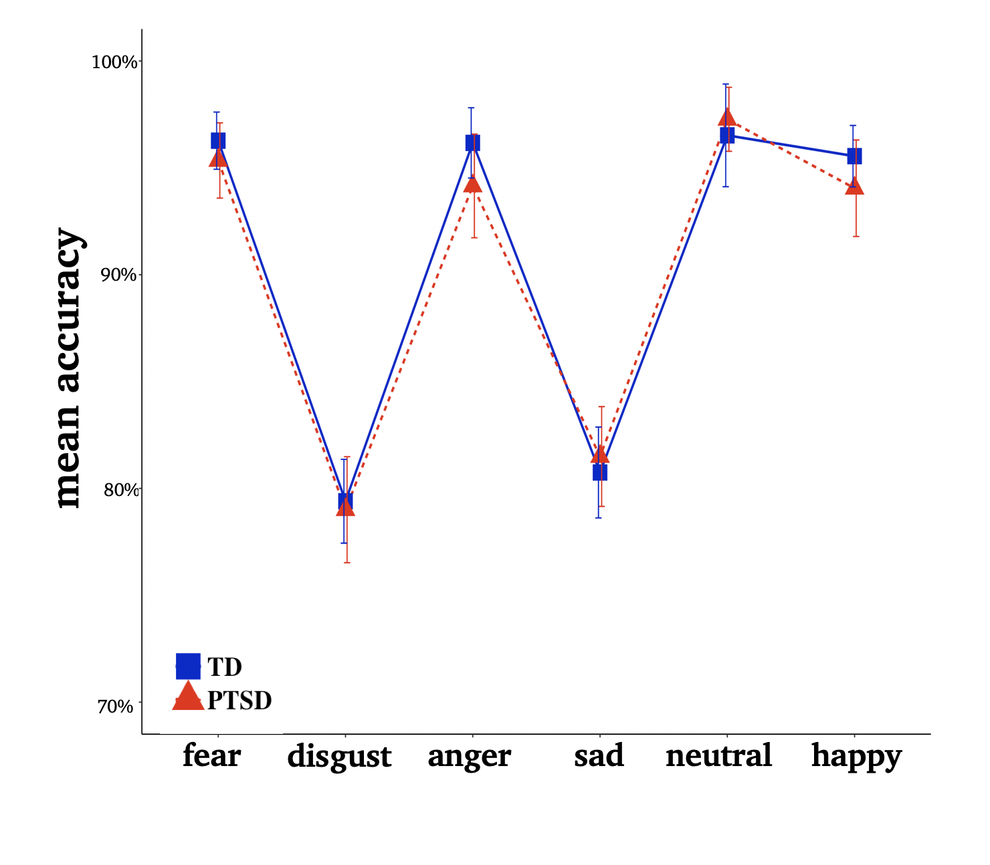
Figure 1 Lack of gender recognition deficits in youth with PTSD. Line chart representing mean accuracy across all trials per participant per group, based upon emotion of the face presented. Error bars represent the standard error.
Abbreviations: TD, typically developing; PTSD, posttraumatic stress disorder.

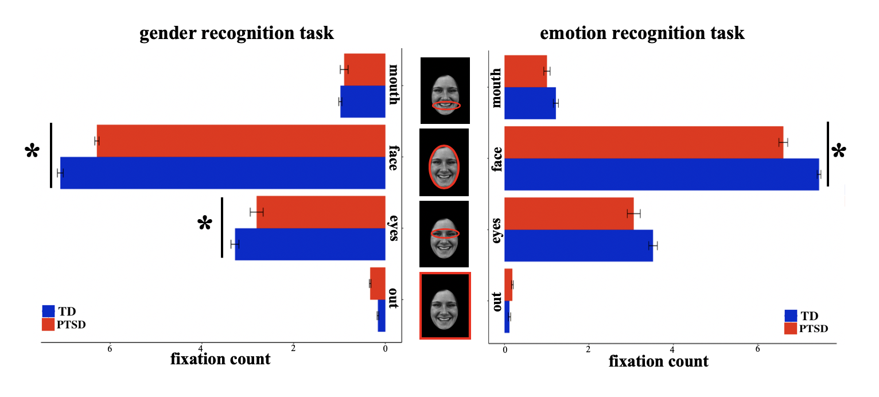
Figure 2 Aberrant fixation during emotion and gender recognition tasks unrelated to emotion. Bar charts represent the average number of unique fixations to each region of interest (mouth, face, eyes, and outside) during the gender (left) and emotion (right) recognition tasks, collapsed across all emotions. Error bars represent the standard error. Asterisk represents significant group differences (TD, blue; PTSD, red) in the number of fixations (p_{FDR} < 0.05).
Abbreviations: TD, typically developing; PTSD, posttraumatic stress disorder.

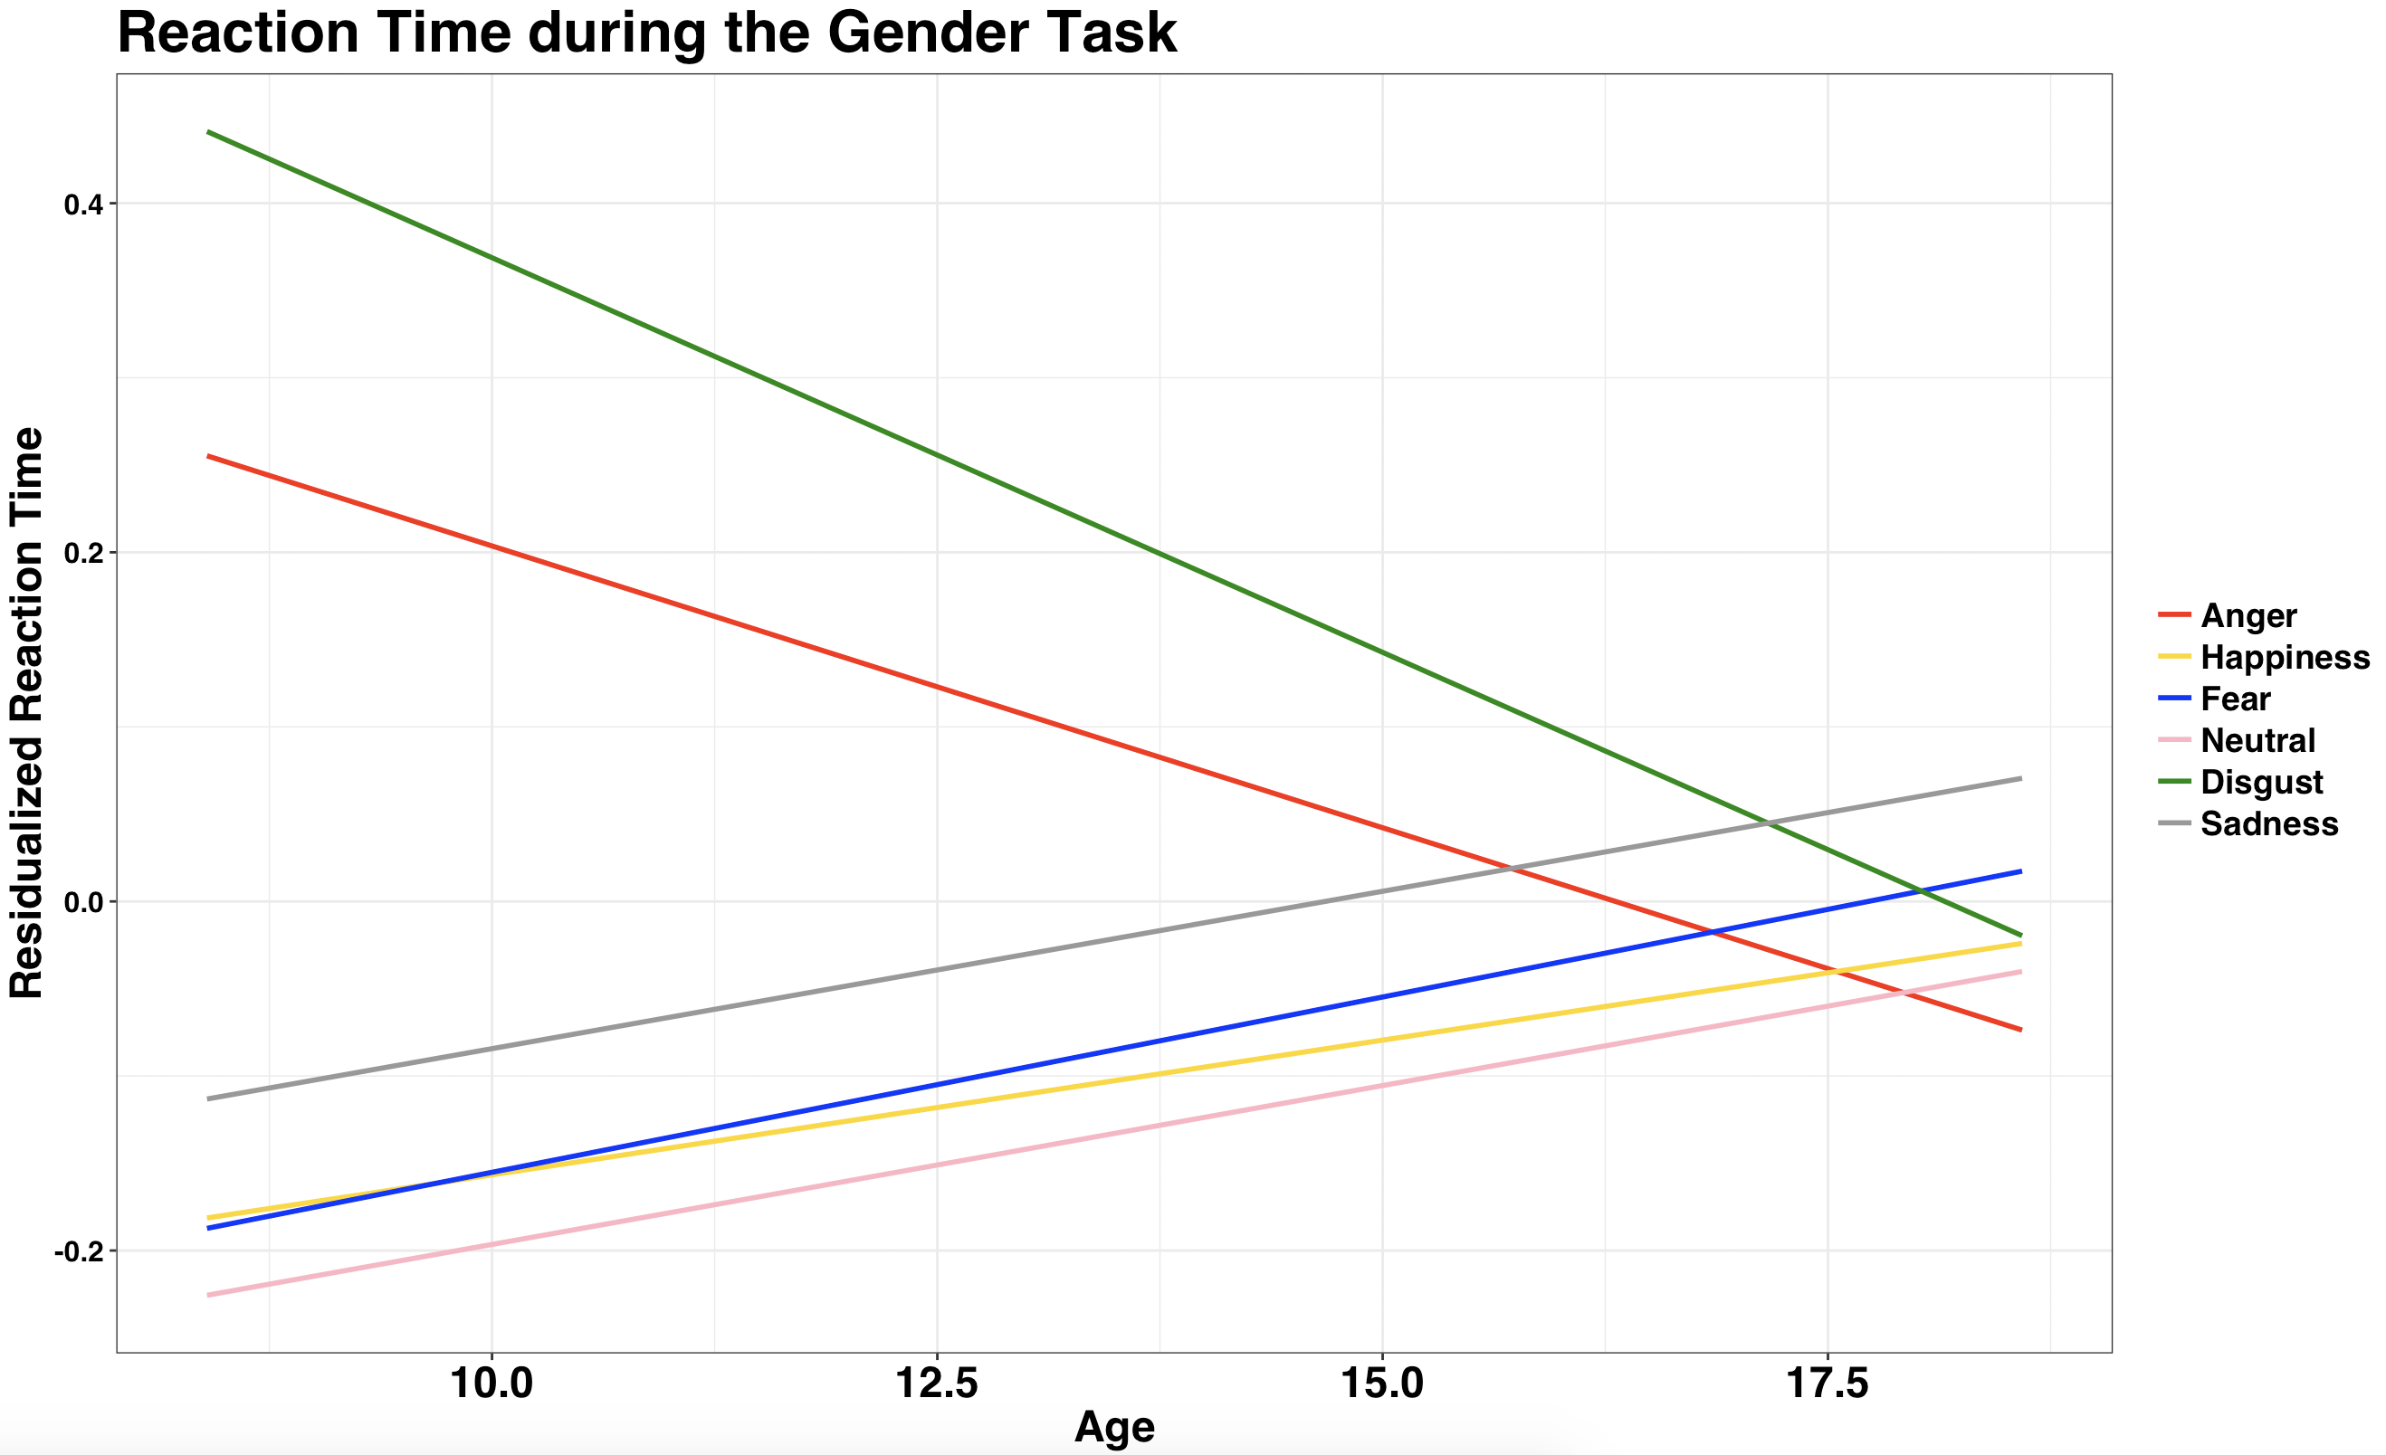
Figure 3. Age and reaction time during emotion recognition tasks across the entire cohort. Line chart representing the average reaction time during the emotion recognition task across all trials per participant, based upon emotion presented. Reaction time is residualized for sex and subject as a random effect.

