Individual Differences in Sensitivity to the Early Environment as a Function of Amygdala and Hippocampus Volumes: An Exploratory Analysis in 12-Year Old Boys
Michael Pluess¹
Stephane A. De Brito²
Alice Jones Bartoli³
Eamon McCrory⁴
Essi Viding⁴

¹ Department of Biological and Experimental Psychology, Queen Mary University of
London, Mile End Road, London E1 4NS, United Kingdom
² School of Psychology, University of Birmingham, Edgbaston, Birmingham B15 2TT, United Kingdom
³ Department of Psychology, Goldsmiths University of London, Whitehead Building
New Cross, London SE14 6NW, United Kingdom
⁴ Psychology and Language Sciences, University College London, 26 Bedford Way
London WC1E 7HB, United Kingdom

Correspondence to:
Michael Pluess, Department of Biological and Experimental Psychology, Queen Mary University of London, Mile End Road, London E1 4NS, United Kingdom
Email: m.pluess@qmul.ac.uk, Phone: +44 (0)207-882-8004

Supplementary Information
Methods

Measures

Environmental Quality. The following variables were included in the Environmental Quality score:

Social Environment: Parental Discipline. The way parents discipline their children was measured with a scale (Deater–Deckard, Dodge, Bates, & Pettit, 1998) consisting of the following 6 items: “give a smack or slap”, “telling off or shouting”, “explain to child or reason with child”, “be firm and calm with child”, “make a joke out of it”, and “ask someone else to deal with the situation”. At 3 years these items were rated by parents on scale ranging from “1 = never” to “5 = usually” and at 9 years on a scale ranging with “1 = often”, “2 = sometimes”, “3 = rarely or never”. Items were reverse coded (if necessary) and summed up into a scale with higher scores reflecting a more positive approach to disciplining children. For the cumulative score the continuous scale (not the individual items) was divided into tertiles with “tertile 1 = negative parenting”, “tertile 2 = average parenting”, and “tertile 3 = positive parenting”.

Social Environment: Parental Feelings. Feelings of parents towards their children were measured with 7 items (Deater‐Deckard, 2000): “Sometimes I feel very impatient with him/her”, “I usually feel quite happy about my relationship with him/her”, “Sometimes I am amused by him/her”, “Sometimes I wish s/he would go away for a few minutes”, “Sometimes s/he makes me angry”, “I usually feel close to him/her”, and “Sometimes I am frustrated by him/her“. At 3 years these items were rated by parents on a scale ranging from “1 = untrue” to “5 = true” and at 9 years on a scale with “1 = often”, “2 = sometimes”, and “3 = rarely or never”. Items were reverse coded (if necessary) and summed up with higher scores reflecting more positive feelings towards the child. For the cumulative score the continuous scale (not the individual items) was divided into tertiles with “tertile 1 = negative feelings”, “tertile 2 = average feelings”, and “tertile 3 = positive feelings”.

Social Environment: Family Chaos and Order. The Confusion, Hubbub and Order Scale (CHAOS) was used to measure “environmental confusion” within the family home (Matheny, Wachs, Ludwig, & Phillips, 1995) with the following 6 items: “The twins have a regular bedtime routine”, “You can’t hear yourself think in our home”, “It’s a real zoo in our home”, “We are usually able to stay on top of things”, “There is usually a television turned on somewhere in our home”, and “The atmosphere in our house is calm”. Items were rated by parents on a scale ranging from “1 = untrue” to “5 = true” at 3 years and on a scale with “1 = often”, “2 = sometimes”, “3 = rarely or never” at 9 years. Items were summed up and reverse coded (if necessary) with higher scores reflecting more order and less chaos. For the cumulative score the continuous scale (not the individual items) was divided into tertiles with “tertile 1 = high chaos”, “tertile 2 = medium chaos”, and “tertile 3 = low chaos”.

Social Environment: Reading to Child. At 3 years parents were asked to respond to the question “Does your child read books or look at books with you?” on a scale with “1 = less than once a month”, “2 = 1-2 times a month”, “3 = 1-2- times a week”, “4 = several times a week”, and “5 = almost daily”. For the cumulative score this item was recoded into “1 = twice a week or less”, “2 = several times a week”, and “3 = daily”. At 9 years parents responded to the question “I often read to my child” with either “0 = not true”, “1 = somewhat true”, “2 = certainly true” (coded “1 = not true”, “2 = somewhat true”, and “3 = certainly true” for the cumulative score).

Social Environment: Outings with Child. At 3 years parent responded to the question “Has your child been taken to a theme centre (for example, zoo museum, castle) in the past year (do not include parks, playgrounds or amusement parks)” on a scale with “1 = no”, “2 = once”, “3 = 2 or 3 times”, “4 = 4 or 5 times”, “5 = 6 or more times”. At 9 years they responded to a similar question “Someone in our family has taken my child to a museum (children’s, scientific, art, historical etc.) in the last year” with “0 = not true”, “1 = somewhat true”, or “2 = certainly true”. For the cumulative environmental scores visits to theme centres at 3 years was recoded into “1 = no visits”, “2 = 1-3 visits”, and “3 = more than 4 visits” and visits to museums at 9 years into “1 = not true”, “2 = somewhat”, and “3 = true”.

Social Environment: Partner Presence. The responding parent was asked to indicate the presence of a partner in the family home both at 3 and 9 years. For the cumulative score partner presence was coded as “1 = no partner” and “3 = partner present”.

Material Environment: Socio-Economic Status Composite. Socio-economic status of the family across childhood was measured with two composite scores with the one at first contact based on five different variables (i.e., mother and father highest qualification level (1-7), mother and father Standard Occupational Classification (1-9, reversed), and mother's age at birth of first child) and the one at 7 years based on four variables (i.e., mother and father highest qualification level (1-7) and mother and father Standard Occupational Classification (1-9, reversed)). Individual variables were standardized and reverse coded (if necessary) with higher scores on the mean across the variables reflecting higher SES. For the cumulative score each of the two composite scores were divided into tertiles with “tertile 1 = low SES”, “tertile 2 = medium SES”, and “tertile 3 = high SES”.

Material Environment: Number of Books. At 3 years parents were asked to answer the question “Does your child have any children’s books” with either “1 = none”, “2 = 1-10”, “3 = 11-50”, “4 = 51-100”, or “5 = 101 or more”. For the cumulative score number of books was recoded into “1 = 0-10 books”, “2 = 11-49 books”, and “3 = more than 50 books”.

Material Environment: Unemployment. Whether one of the parents experienced unemployment was assessed at 9 years with the following question: “Thinking back over the last TWO years, could you tell us if any of the following major changes or particular events have occurred? - Redundancy/unemployment of parent” rated as either “1 = yes”, or “2 = no”. For the cumulative score this item was recoded “1 = yes”, “3 = no”.

Material Environment: Financial Difficulties. At 9 years parents were asked to respond to the question “Have there been any major changes or difficulties in your financial circumstances over the last two years?” with either “1 = yes” or “2 = no”. This item was recoded as “1 = yes” and “3 = no” for use in the cumulative score.

Material Environment: Household Income. At 9 years parents provided information on their income “On average, what is your household’s income (per year, before tax)” using the following scale “1 = under £4,500”, “2 = £4,500 - £9,499”, “3 = £9,500 - £15,499”, “4 = £15,500 - £17,499”, “5 = £17,500 - £24,999”, “6 = £25,000 - £29,999”, “7 = £30,000 - £39,999”, “8 = £40,000 - £49,999”, “9 = £50,000 - £74,999”, “10 = £75,000 - £99,999”, and “11 = more than £100,000”. For the cumulative score this item was recoded into low income with “1 = 1-4”, medium income with “2 = 5-8”, and high income with “3 = 9-11”.
Results

Bivariate Correlations. According to bivariate correlations all four brain volumes were significantly associated with each other (see Table S2 for all bivariate correlations). Importantly, brain volumes were not associated with the environmental quality score or the outcome variable, except for left amygdala volume which was significantly and negatively correlated with the SDQ subscales of peer problems (r = -.34, p < .01) and emotional symptoms (r = -.28, p < .05)..

Hierarchical Linear Models. Interactions between brain volumes and the environmental quality subscales were tested through separate multi-level models with biologically related boys nested in families. Six additional significant interactions emerged, all involving the left amygdala volume which was found to moderate the effects of the cumulative environmental quality score on total problems (B = -16.10, p = .01), peer (B = -6.05, p = .01) and conduct problems (B = -3.73, p = .02), the effects of the social environment subscale on emotional symptoms (B = -3.65, p = .03) and peer problems (B = -4.41, p = .02), the effects of the material environment subscale on prosocial behavior (B = 3.18, p = .05) and conduct problems (B = -2.43, p = .02).The multi-level model results of the significant interaction models are displayed in Table S3.

Follow-up Analyses. All significant interactions were followed-up by dividing the sample by median split into two groups, low and high left amygdala volume, in order to investigate simple slopes. In addition to testing simple slopes between environmental scores and outcomes for the low and high left amygdala volume groups we also conducted regions of significance analyses in order to identify the specific pattern of each interaction (Preacher, Curran, & Bauer, 2006; Roisman et al., 2012). Three out of the six significant interactions yielded clearly interpretable simple slope results with larger left amygdala volume reflecting higher sensitivity to higher quality of the early environment (see Figure S2). The follow-up analyses of the three remaining interactions reflected the same pattern but simple slopes did not reach significance or detected regions of significance were outside of the observed range. Hence, these results are not discussed in more detail.

According to simple slopes and regions of significance analysis larger left amygdala volume was consistently associated with higher sensitivity to higher quality of the environment: Environmental quality predicted peer problems in boys with a large amygdala (β = -.45, p = .01), when total environment was >13.23, but not in those with a small amygdala (β = .21, p = .26) (see Figure S2.A). Regarding the social environment subscale and emotional problems, the association was not significant for those with a small amygdala (β = .20, p = .28), but significant for those with a large amygdala (β = -.40, p = .03), with differences being significant when social environment was >12.73 (see Figure S2.B). Finally, the material environment subscale did predict prosocial behavior in boys with a large amygdala (β = .41, p = .02), with differences being significant if material environment was >16.00, but this association was not significant in those with a small amygdala (β = -.26, p = .16; see Figure S2.C).

Table S1
Demographic Characteristics of the Sample (N = 62)
Variables | Mean, Standard Deviation
Environmental Quality Scores¹
Social Environment Subscale | M = 13.75, SD = 1.95
Material Environment Subscale | M = 13.87, SD = 2.80
Environment Quality | M = 13.81, SD = 1.72
Strengths and Difficulties Questionnaire (SDQ)
SDQ Prosocial Behavior | M = 7.23, SD = 2.11
SDQ Hyperactivity/Inattention | M = 2.79, SD = 2.39
SDQ Conduct Problems | M = .81, SD = 1.36
SDQ Peer Relationship Problems | M = 1.61, SD = 2.07
SDQ Emotional Symptoms | M = 1.30, SD = 1.83
SDQ Total Problems | M = 6.50, SD = 5.57
Note. ¹ Higher scores reflect higher quality of the environment. The Environmental Quality score ranges from 8 = lowest quality to 18 = highest quality.

References
Deater‐Deckard, K. (2000). Parenting and child behavioral adjustment in early childhood: A quantitative genetic approach to studying family processes. Child Development, 71(2), 468-484.
Deater–Deckard, K., Dodge, K. A., Bates, J. E., & Pettit, G. S. (1998). Multiple risk factors in the development of externalizing behavior problems: Group and individual differences. Development and Psychopathology, 10(03), 469-493.
Matheny, A. P., Wachs, T. D., Ludwig, J. L., & Phillips, K. (1995). Bringing order out of chaos: Psychometric characteristics of the confusion, hubbub, and order scale. Journal of Applied Developmental Psychology, 16(3), 429-444.
Preacher, K. J., Curran, P. J., & Bauer, D. J. (2006). Computational Tools for Probing Interactions in Multiple Linear Regressions, Multilevel Modeling, and Latent Curve Analysis. Journal of Educational and Behavioral Statistics, 31(4), 437-448.
Roisman, G. I., Newman, D. A., Fraley, R. C., Haltigan, J. D., Groh, A. M., & Haydon, K. C. (2012). Distinguishing differential susceptibility from diathesis-stress: Recommendations for evaluating interaction effects. Development and Psychopathology, 24(2), 389-409. doi:10.1017/S0954579412000065

Table S2

Unadjusted Associations between Variables (N = 62)

 | Variables | 1 | 2 | 3 | 4 | 5 | 6 | 7 | 8 | 9 | 10 | 11 | 12
1 | Amygdala Left Volume | —
2 | Amygdala Right Volume | .66** | —
3 | Hippocampus Left Volume | .52** | .46** | —
4 | Hippocampus Right Volume | .46** | .58** | .77** | —
5 | Social Environment Subscale¹ | -.12 | -.26* | .06 | -.02 | —
6 | Material Environment Subscale¹ | -.03 | -02 | .10 | .12 | .02 | —
7 | Environment Quality¹ | -.10 | -.13 | .12 | .08 | .58** | .82** | —
8 | Prosocial Behavior | .14 | .18 | .03 | -.01 | .01 | .10 | .09 | —
9 | Hyperactivity/Inattention | -.05 | -.02 | .09 | .14 | .01 | -.19 | -.15 | -.61** | —
10 | Conduct Problems | .14 | .08 | .24 | .16 | -.02 | -.04 | -.05 | -.56** | .63** | —
11 | Peer Problems | -.34** | -.21 | -.04 | >.01 | .05 | -.07 | -.03 | -.54** | .24 | .26* | —
12 | Emotional Symptoms | -.28* | .01 | -.06 | .07 | -.02 | -.16 | -.15 | -.41** | .22 | .17 | .62** | —
13 | Total Problems | -.21 | -.07 | .06 | .12 | .01 | -.18 | -.14 | -.74** | .75** | .67** | .75** | .70**

Note. ¹ Higher scores reflect higher quality of the environment. * p < .05. ** p < .01.
Table S3
Summary of Hierarchical Linear Models
Predictor Variables |  | Conduct Problems | Conduct Problems | Emotional Symptoms | Peer Problems | Peer Problems | Prosocial Behavior
Step 1
 | Amygdala Left Volume | 3.81 | 3.84 | -7.01* | -9.44** | -9.25** | 3.75
 | Social Environment Subscale | — | — | -.05 | — | .01 | —
 | Material Environment Subscale | — | .001 | — | — | — | .06
 | Environmental Quality | -.01 | — | — | -.07 | — | —
Step 2
 | Amygdala Left X Social Environment | — | — | -3.65* | — | -4.41* | —
 | Amygdala Left X Material Environment | — | -2.43* | — | — | — | 3.18*
 | Amygdala Left X Environmental Quality | -3.73* | — | — | -6.05* | — | —

Note. The displayed coefficients of variables at step 1 represent the values before inclusion of interaction term at step 2;
* p < .05. ** p < .01.

Figure S2.
Simple slopes of significant interactions. The sample was divided into small and large amygdala by medium split. Shaded areas reflect regions of significance. In these regions the association between amygdala left volume and outcome is significant.
Figure S2
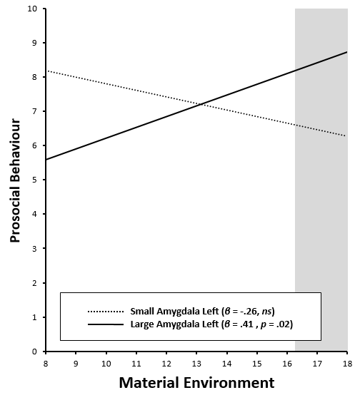
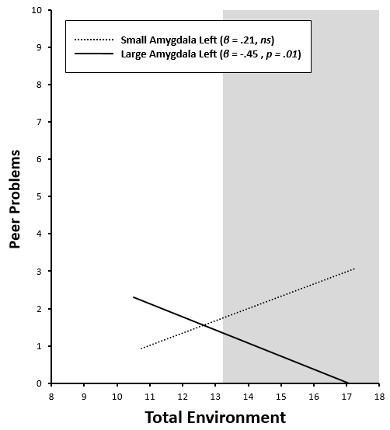
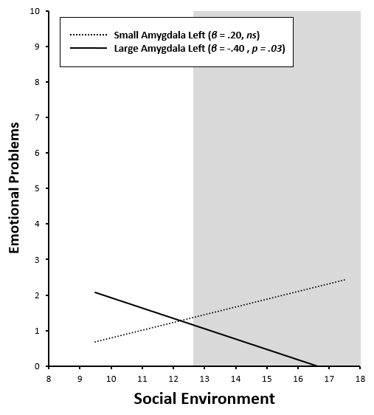
C
A
B

