Supplementary Materials
Do You See What I Mean?: Using Mobile Eye-Tracking to Capture Parent-Child Dynamics in the Context of Anxiety Risk

Method

Mobile Eye-Tracking Calibration and Validation Procedures
The eye-tracker set-up and calibration procedure were carried out in a testing room using an overhead projector to capture the scope of a room. Calibration and validation procedures are essential for documenting accurate and reliable data (Franchak, 2017). First, the experimenter asked the child to stand on a three-level staircase in the center of the room facing the projector screen. The experimenter then adjusted the world and eye cameras to ensure they were in focus and could capture the child’s field of view and pupils, respectively. Next, before calibration and once the eye-tracker was placed, the experimenter instructed the child to follow where they were pointing on different parts of the screen. This procedure was to ensure that the eye cameras could consistently find the child’s pupils as they moved their eyes. The child was instructed to fixate their gaze on the center of a target that appeared at five different points across the screen while keeping their head still. The experimenter then asked the child to follow their hand as they walked from one side of the projector to the other, using the projected image to verify that the child’s gaze was in the expected directions. Calibration was repeated if a second experimenter determined that the fixation point could not reliably indicate where the child was looking.
Before the dyadic interaction task, the experimenter performed a validation procedure by asking the child to fixate gaze on five points located on the puzzle board. The validation procedure was used for off-line calibration accuracy inspection and gaze correction, in order to ensure satisfactory accuracy and minimize parallax errors.
Mobile Eye-tracking Recording Processing
Eye-tracking recordings were processed using Pupil Player v.0.9.12 (Pupil Labs). First, the eye camera recordings were overlaid on the world camera recording. Then, three concentric circles were added to indicate point of gaze. The radius of each circle was proportional to the screen resolution (red: 2%; yellow: 5%; green: 8%).
Manual gaze correction procedures in Pupil Player v.0.9.12 (Pupil Labs) were implemented to ensure that the observed eye-tracking data matched where the child was looking during the episode. Two trained research assistants independently watched each participant’s video and determined whether the red circle aligned with where the child was asked to look during the validation procedure that occurred prior to the episode. Any corrections on the x and y coordinates were made using the manual gaze correction plug-in in Pupil Player until the red circle became a reliable indication of the child’s actual gaze location. Corrections were made only if the participant had good calibration, as indicated by the visit notes and whether fixation patterns were consistent across the validation procedure (e.g., consistently above or below the intended coordinate). Each coder selected a frame for gaze correction based on the following criteria: 1) the child’s gaze matched where the experimenter was pointing, 2) both pupils were detected by the eye cameras, 3) three frames before and after the selected frame showed that the child’s pupils were detected by the eye cameras. The master coder compared the manual gaze corrections from the two coders. If they were within 0.03 of each other, the master coder’s coordinates were chosen. For discrepancies greater than 0.03, coders met to decide which of the coordinates best fit the child’s gaze. The eye-tracking video was exported with the appropriate manual gaze correction and synced with the room recording using Final Cut Pro. The integrated recordings were inspected to ensure that the two recordings were not out of sync for more than three frames. These integrated videos were then exported for coding with a resolution of 1920x1080 pixels at 30 frames per second.
Results
The generalized linear model (see Main text) was used to account for the non-normally distributed, positively skewed outcome variable of attractor strength in parent-focused/controlling parenting states. To provide a test of sensitivity and to determine the robustness of the results, we used a linear regression model predicting attractor strength in parent-focused/controlling parenting states. This moderation model examining the effects of child age, child BI, parent anxiety, and their interactions to predict parent-focused/controlling parenting attractor strength was significant, F(7,32) = 6.24, p < .001, R² = 0.58 (Table S1). Similar to the generalized linear model (see Main text), child age was negatively related to parent-focused/controlling parenting attractor strength, suggesting that younger children spent more time at each visit in the parent-focused/controlling parenting states. Parent anxiety was positively related to parent-focused/controlling parenting attractor strength, suggesting that parents with higher levels of anxiety spent more time in parent-focused/controlling parenting states at each visit with their child.
The interaction between parent anxiety and child age significantly predicted parent-focused/controlling parenting attractor strength. The regions of significance test, demonstrated by Figure S4A, indicated that parent anxiety was positively related to parent-focused/controlling parenting attractor strength for children ages 0.02 above the mean (6.07 years) and younger, and parent anxiety was negatively related to parent-focused/controlling parenting attractor strength for children ages 0.87 above the mean (6.92 years) and older. It is important to note that only three children in the current sample were at or above 6.92 years. The interaction between child BI and parent anxiety predicted parent-focused/controlling parenting attractor strength. Regions of significance, demonstrated by Figure S4B, indicated that child BI was positively related to parent-focused/controlling parenting attractor strength when parent anxiety was 0.67 (mean centered) and greater. The main effect of BI and the interaction between BI and child age were not significant.
To rule out the possibility that child BI, parent anxiety, and their interaction were associated with parenting behavior or gaze alone, two additional moderation models were examined predicting a) proportion of time spent in controlling behaviors (directives and intrusion; Table S2), and b) proportion of time spent looking to parent (face, body, and reference; Table S3). Neither BI, anxiety, nor their interaction were significant predictors in either model.
Given the low base rate of attention to parent face and body, an additional moderation model was examined predicting attractor strength in parent-focused/controlling parenting states where parent-focused was defined only by parent references (no looking behavior to parent face or body; Table S4). The results from the model in the main text (where parent-focused was defined by looking behavior to parent face, body, and reference) were maintained in this model.

SM Table S1.
Liner regression model predicting attractor strength in parent-focused/controlling parenting states
Variable | Estimate | SE | t | F | df | R² | p
Overall Model |  |  |  | 6.24 | 7, 32 | .58 | < .001
Intercept | 712.72*** | 95.42 | 7.47
Proportion Coded | 927.31 | 571.65 | 1.62
Age | -468.34 | 161.76 | -2.90
BI | 6.23 | 3.76 | 1.66
Anxiety | 57.85* | 26.75 | 2.16
BI x Age | -1.80 | 7.02 | -0.26
Anxiety x Age | -169.30*** | 41.09 | -4.12
BI x Anxiety | 2.13* | 0.92 | 2.33
Note. Estimates are unstandardized regression coefficients. SE = Standard Error. BI = Behavioral Inhibition. † p < .10; * p < .05; ** p < .01; *** p < .001.
SM Table S2.
Linear regression model predicting proportion of time spent in controlling parenting (proportion directives plus proportion intrusion)
Variable | Estimate | SE | t | F | df | R² | p
Overall Model |  |  |  | 1.53 | 3, 36 | .11 | 0.22
Intercept | 0.26*** | 0.02 | 12.23
BI | < 0.01 | < 0.01 | -0.14
Anxiety | -0.01 | 0.01 | -1.59
BI x Anxiety | < 0.01 | < 0.01 | -0.30
Note. Estimates are unstandardized regression coefficients. Child age and sex were not significantly related to the outcome, so these covariates were removed from the model. SE = Standard error. BI = Behavioral Inhibition. † p < .10; * p < .05; ** p < .01; *** p < .001.

SM Table S3.
Linear regression model predicting proportion of time spent looking to parent (face, body, reference)
Variable | Estimate | SE | t | F | df | R² | p
Overall Model |  |  |  | 0.33 | 3, 36 | .03 | 0.80
Intercept | 0.17*** | 0.02 | 9.79
BI | < 0.01 | < 0.01 | -0.85
Anxiety | < 0.01 | < 0.01 | 0.94
BI x Anxiety | < 0.01 | < 0.01 | 0.53
Note. Estimates are unstandardized regression coefficients. Child age and sex were not significantly related to the outcome, so these covariates were removed from the model. SE = Standard error. BI = Behavioral Inhibition. † p < .10; * p < .05; ** p < .01; *** p < .001.
SM Table S4.
Generalized linear model assuming a Gamma distribution predicting attractor strength in parent-reference/controlling parenting states (parent reference AOI only; no parent face or body AOIs)
Variable | Estimate | SE | t | df | Pseudo R²
Overall Model |  |  |  | 7, 32 | .21
Intercept | 6.53*** | 0.10 | 67.80
Proportion Coded | 1.95** | 0.58 | 3.38
Age | -0.44* | 0.16 | -2.72
BI | < 0.01 | < 0.01 | 1.15
Anxiety | 0.07* | 0.03 | 2.54
BI x Age | < 0.01 | 0.01 | -0.43
Anxiety x Age | -0.09* | 0.04 | -2.27
BI x Anxiety | < 0.01 | < 0.01 | 0.18
Note. Estimates results are estimated coefficients from the generalized linear model. SE = Standard Error. BI = Behavioral Inhibition. † p < .10; * p < .05; ** p < .01; *** p < .001.

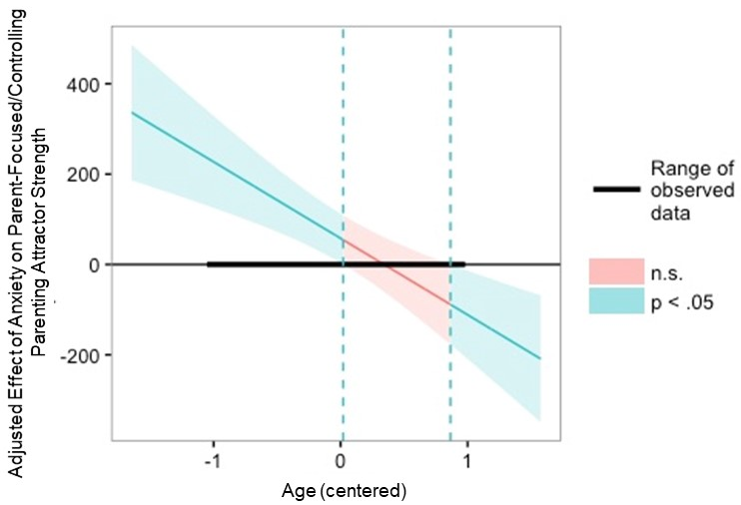
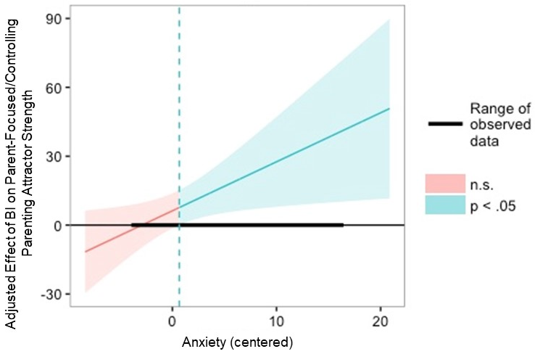
B.
A.

Figure S4. Panel A portrays the interaction between parent level of anxiety and child age predicting parent-focused/controlling parenting attractor strength. Panel B portrays the interaction between child BI and parent level of anxiety predicting parent-focused/controlling parenting attractor strength. Y-axis portrays the continuous range of values for the adjusted effect of the predictor on the outcome. Diagonal line represents values of the adjusted effect that correspond to moderator values. Curved area represents 95% confidence bands around the adjusted effect. Regions of significance analyses indicated that parent level of anxiety was positively related to parent-focused/controlling parenting attractor strength for children ages 0.02 (mean centered) and younger, and parent level of anxiety was negatively related to parent-focused/controlling parenting attractor strength for children ages 0.87 (mean centered) and older. Regions of significance analyses also indicated that child BI was positively related to parent-focused/controlling parenting attractor strength when parent anxiety was 0.67 (mean centered) or greater.

