Supplementary Figures

Figure 3
RMSSD reactivity change scores of adolescents classified as organized and disorganized during the FIT with mothers
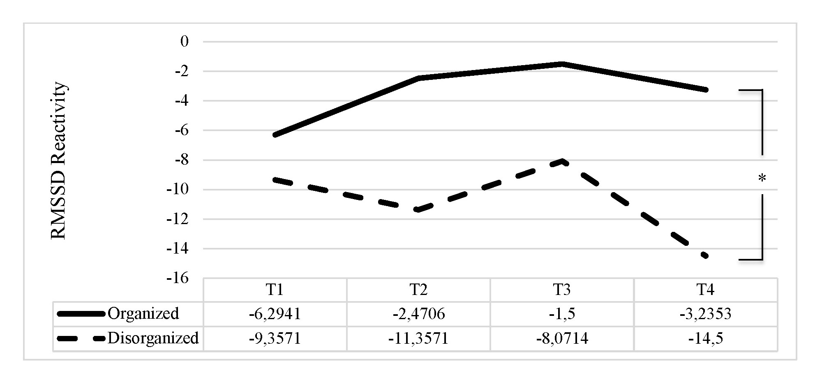
Note. *p < .05.

Figure 4
RMSSD reactivity change scores of adolescents classified as organized and disorganized during the FIT with fathers
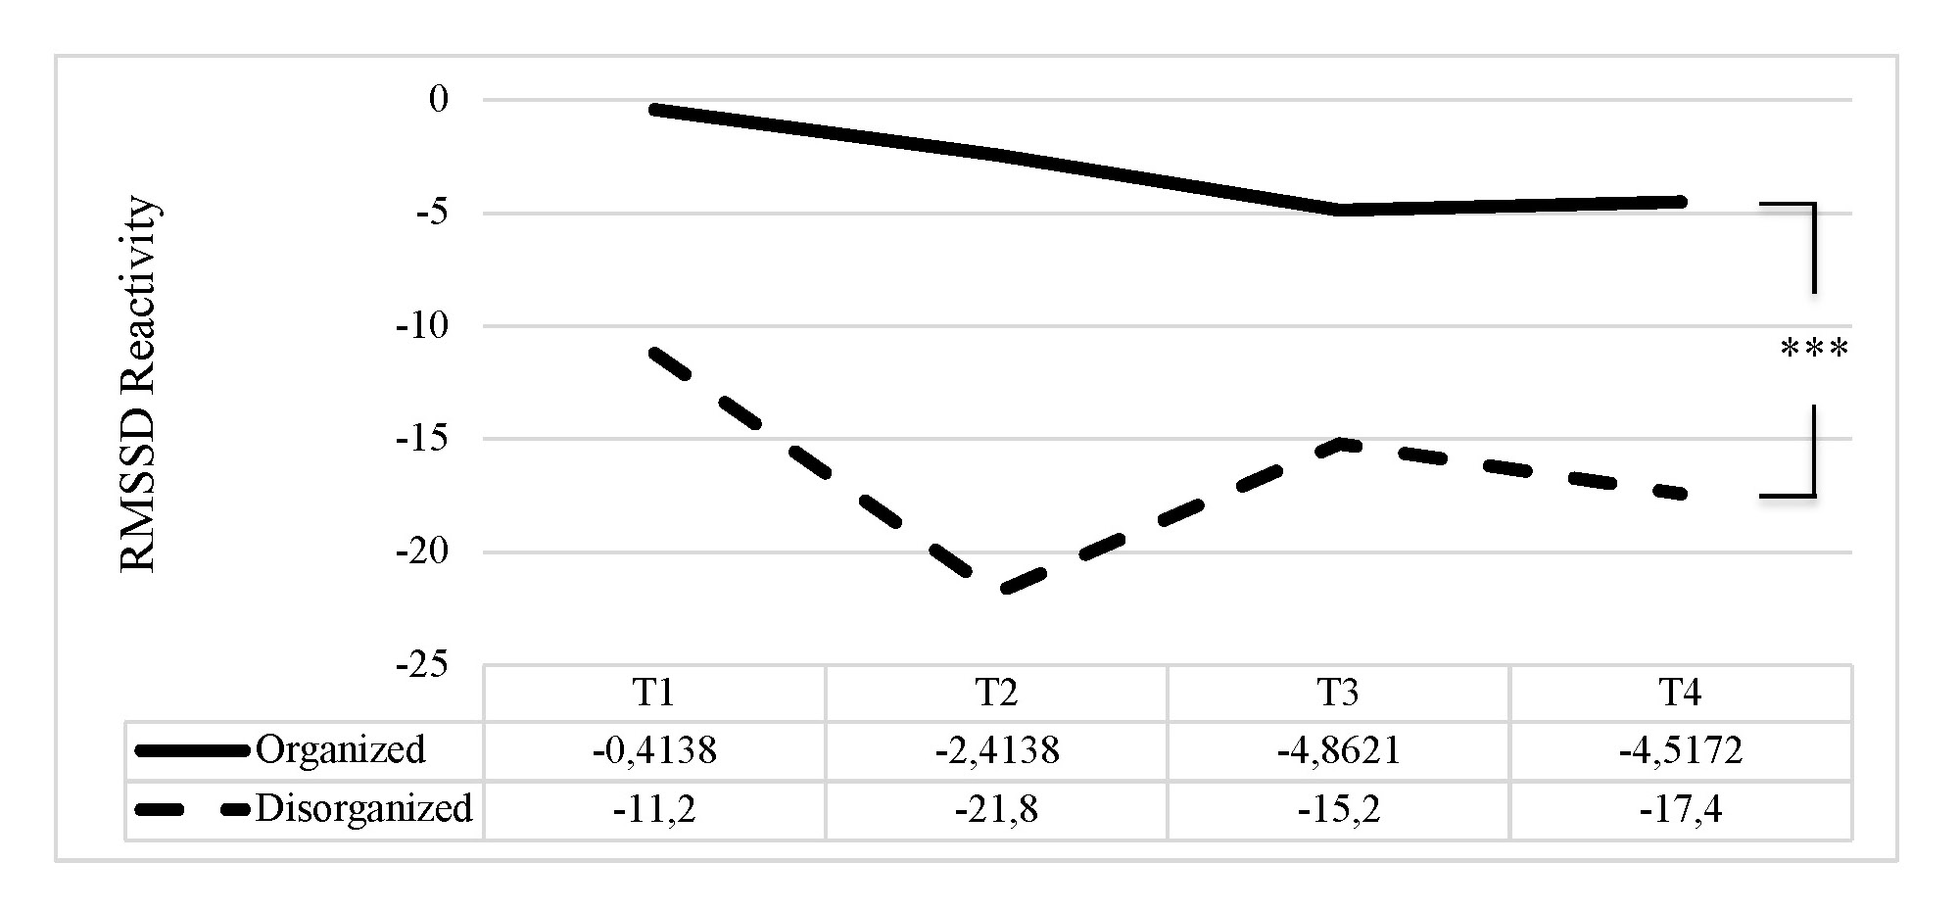
Note. ***p < .001.

