Table S1. Demographic Characteristics of the Michigan State University Twin Registry Sample

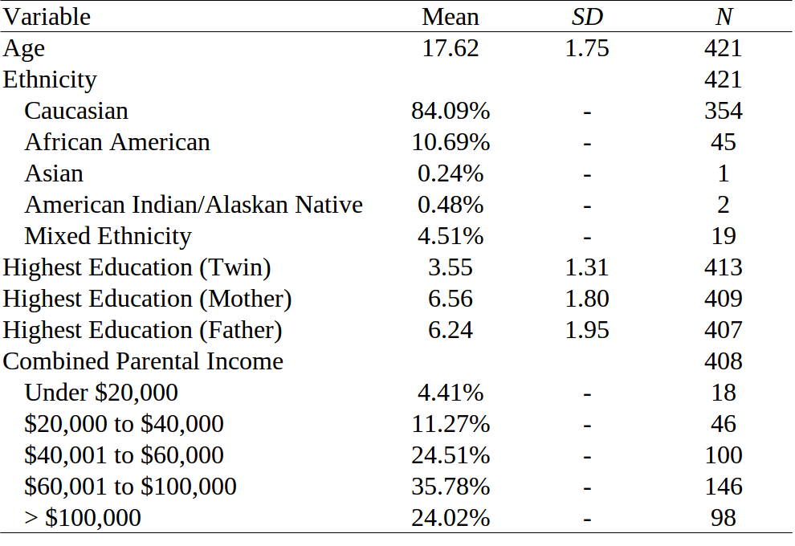

Note. Education variables are coded as follows: 1 = less than 7th grade; 2 = junior high school (9th grade); 3 = partial high school (10th or 11th grade); 4 = high school graduate; 5 = trade school (after graduating high school); 6 = some college (at least 1 year); 7 = associates degree; 8 = bachelors degree;
9 = masters degree; 10=advanced degree (more than 2 years of grad school). Sample sizes are lower than the N = 441 twins in the analytic sample, as 20 pairs were from the pilot study sample, which did not collect the same demographic data.

