Supplemental Tables and Figures
Supplemental Table 1. Bivariate correlations between study variables.
 | PAS T1 | PAS T2 | PAS T3 | NE T1 | NE T2 | NE T3 | RCO T1 | RCO T2 | RCO T3 | Internalizing | Externalizing
PAS T1 | –
PAS T2 | .504** | –
PAS T3 | .379** | .534** | –
NE T1 | .084** | .056* | .082** | –
NE T2 | .039 | .151** | .109** | .465** | –
NE T3 | .035 | .087** | .185** | .374** | .497** | –
RCO T1 | .350** | .279** | .241** | -.128** | -.152** | -.079** | –
RCO T2 | .232** | .311** | .263** | -.100** | -.217** | -.125** | .449** | –
RCO T3 | .220** | .242** | .327** | -.116** | -.140** | -.153** | .366** | .527** | –
Internalizing | -.057 | -.070* | -.127** | .148** | .234** | .201** | -.125** | -.182** | -.191** | –
Externalizing | -.060 | -.053 | -.067* | .239** | .256** | .243** | -.128** | -.247** | -.321** | .606** | –
Note: T1 = 3-months, T2=6-months, T3=12-months. NE = Negative Emotionality; RCO = Regulatory Capacity/Orienting; PAS = Positive Affectivity/Surgency. *p ≤ .05, **p ≤ .01.

Supplemental Table 2. Chi-square values for pairwise comparisons of intercepts (above diagonal) and slopes (below diagonal) for latent trajectories within each dimension of temperament.
Negative Emotionality (NE)
Trajectory Class | 1. | 2. | 3. | 4. | 5.
1. | - | 244.10*** | 33.20*** | 33.01*** | 513.34***
2. | 4.26 | - | 12.30*** | 1.56 | 232.98***
3. | 15.99*** | 22.17*** | - | 5.11* | 0.33
4. | 21.32*** | 24.64*** | 28.98*** | - | 59.79***
5. | 13.31** | 22.77*** | 10.11** | 50.08*** | -
Regulatory Capacity/Orienting (RCO)
Trajectory Class | 1. | 2. | 3. | 4. | 5.
1. | - | 155.41*** | 19.43*** | 358.64*** | 537.53***
2. | ª | - | 8.07** | 135.60*** | 306.25***
3. | ª | 41.94*** | - | 80.76*** | 143.78***
4. | ª | 3.69* | 75.90*** | - | 112.38***
5. | ª | 19.05*** | 39.41*** | 19.88*** | -
Positive Affect/ Surgency (PAS)
Trajectory Class | 1. | 2. | 3. | 4.
1. | - | 21.36*** | 158.52*** | 581.89***
2. | 18.73*** | - | 263.20*** | 738.23***
3. | 22.62*** | 36.36*** | - | 293.29***
4. | 74.02*** | 229.332*** | 75.92*** | -

Note: ª Class 1 for the RCO model was estimated with only an intercept (see Table 5).

Supplemental Table 3. Overall associations between temperament trajectory groups and internalizing and externalizing behaviors.
Temperament Dimension | Internalizing |  |  | Externalizing
 | F(10,1130) | p |  | F(10,1130) | p
NE | 6.91 | <.001 |  | 11.11 | <.001
RCO | 5.15 | <.001 |  | 9.82 | <.001
PAS | 1.63 | .11 |  | 1.10 | .36
Note: NE = Results are for main effects of trajectory groups in two-way ANCOVAs with trajectory group and sex as fixed factors and child age at T4 (24-months) as a covariate. NE = Negative Emotionality; RCO = Regulatory Capacity/Orienting; PAS = Positive Affectivity/Surgency.

Supplemental Table 4. Estimated marginal means for associations between trajectory groups and internalizing and externalizing behaviors.
Temperament Dimension | Internalizing |  |  | Externalizing
 | Estimate | 95% CI |  | Estimate | 95% CI
NE Trajectory Group
1. Low | -.308 | -.419, -.198 |  | -.379 | -.488, -.271
2. Moderate | .049 | -.027, .124 |  | .037 | -.038, .111
3. Decreasing | -.595 | -1.200, .010 |  | -.535 | -1.129, .059
4. Increasing | .602 | .320, .884 |  | .555 | .278, .832
5. High | .317 | .143, .488 |  | .564 | .396, .732
RCO Trajectory Group
1. Low | .542 | .410, .944 |  | .839 | .444, 1.233
2. Moderate | .250 | .126, .375 |  | .321 | .200, .443
3. Increasing | -.267 | -.589, .055 |  | -.245 | -.560, .070
4. High decreasing | .009 | -.068, .086 |  | .011 | -.064, .087
5. High stable | -.431 | -.478, -.205 |  | -.460 | -.594, -.326
PAS Trajectory Group
1. Low | .122 | -.085, .329 |  | .113 | -.094, .320
2. Low-moderate | .057 | -.030, .145 |  | .031 | -.057, .119
3. High-moderate | -.025 | -.120, .069 |  | -.005 | -.100, .090
4. High | -.244 | -.435, -.052 |  | -.199 | -.391, -.007
Note: Estimates are based on z-scores. Covariate is infant age at assessment of internalizing and externalizing symptoms. NE = Negative Emotionality; RCO = Regulatory Capacity/Orienting; PAS = Positive Affectivity/Surgency. The estimates reported here are the basis of Figures 4.
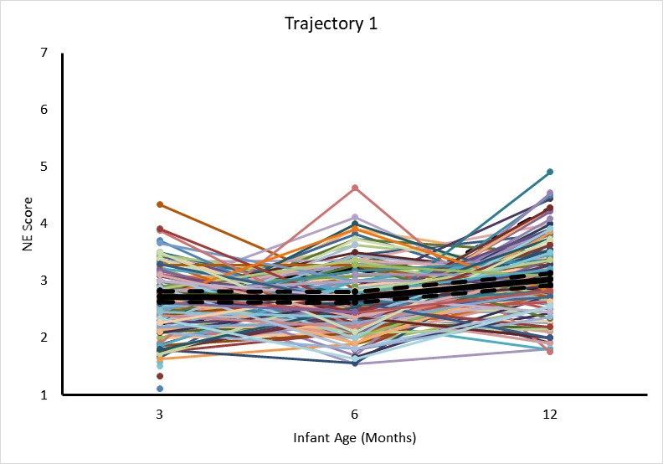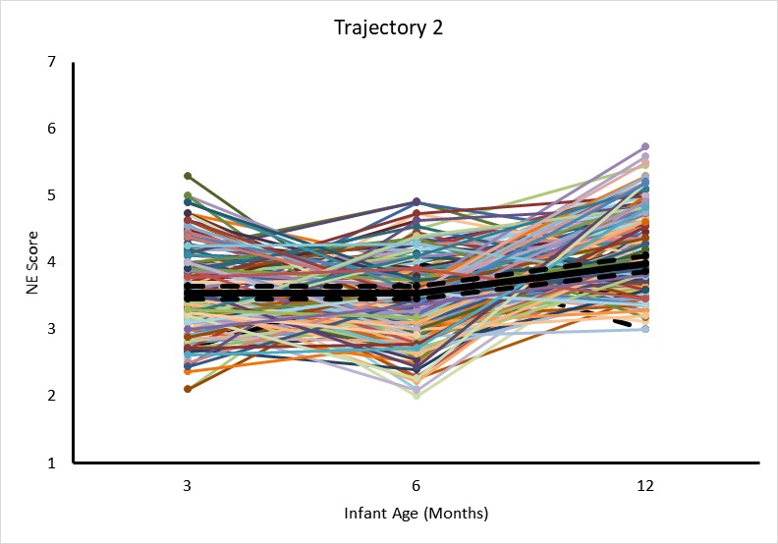
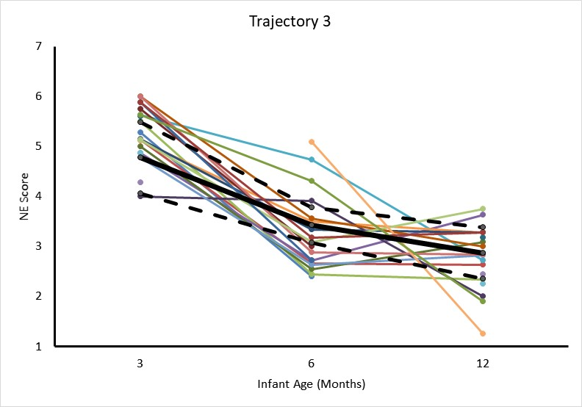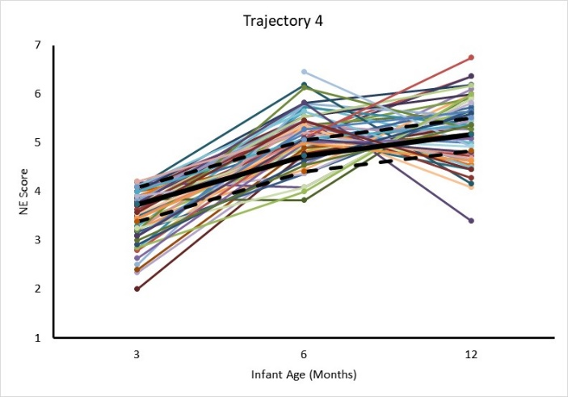
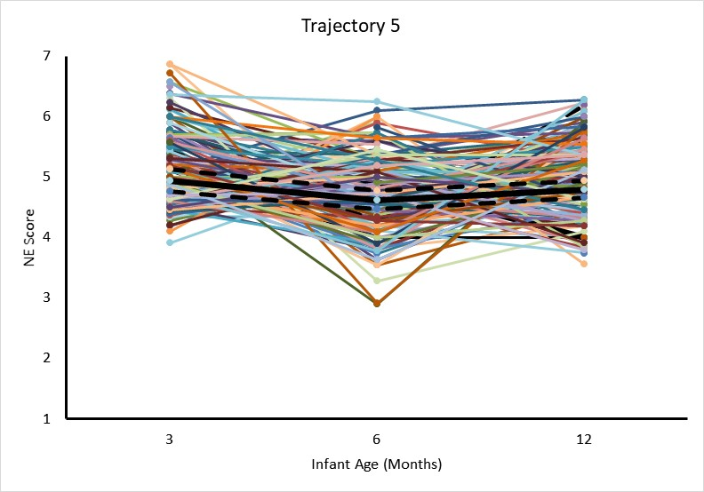
Supplemental Figure 1. Individual NE trajectories and associated predicted trajectory for each latent NE trajectory class. Solid black lines indicate the mean predicted trajectory. Dashed black lines indicate the upper and lower 95% CI for the mean predicted trajectory.

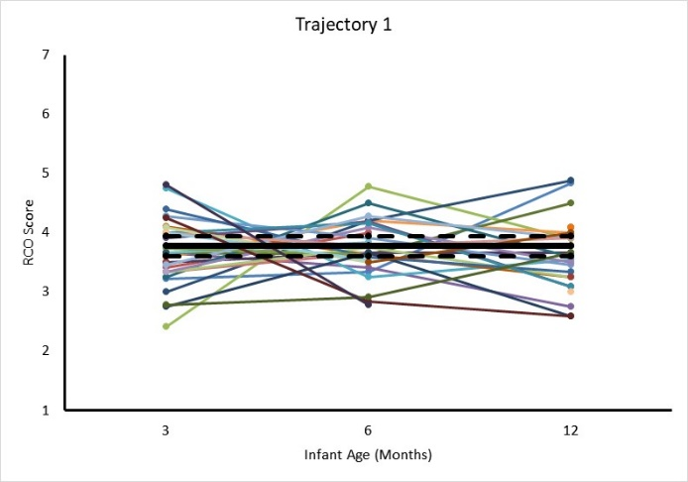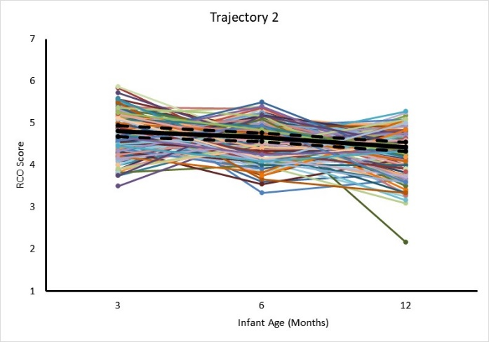
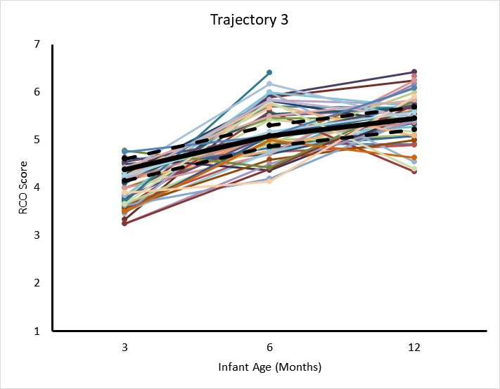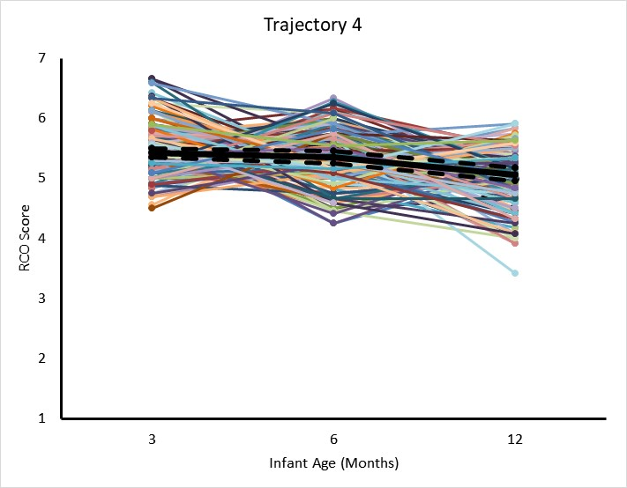
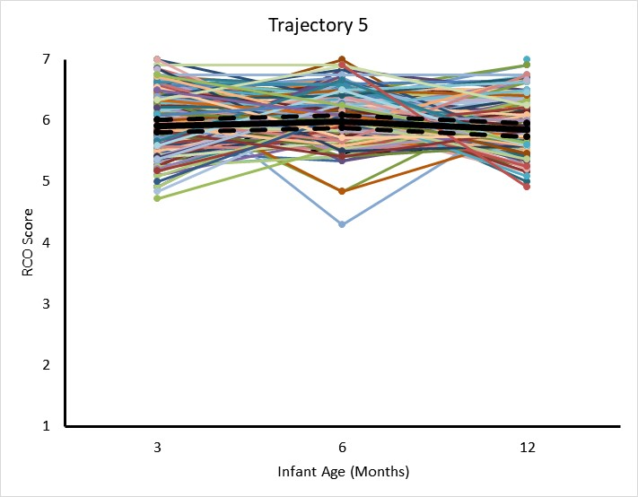
Supplemental Figure 2. Individual RCO trajectories and associated predicted trajectory for each latent RCO trajectory class. Solid black lines indicate the mean predicted trajectory. Dashed black lines indicate the upper and lower 95% CI for the mean predicted trajectory.

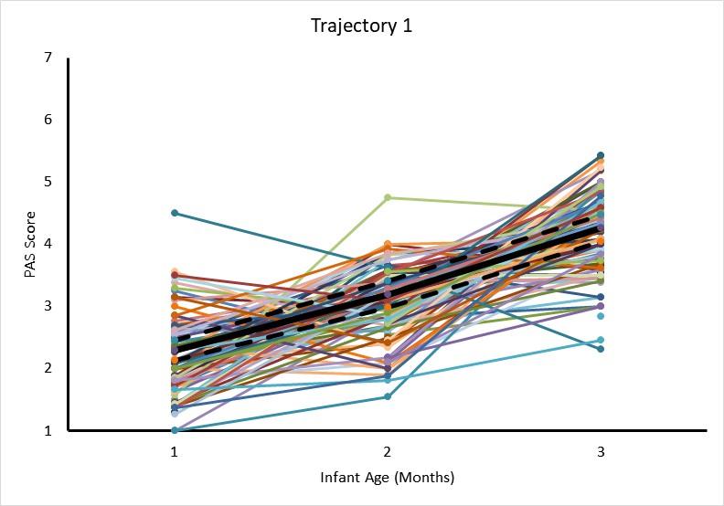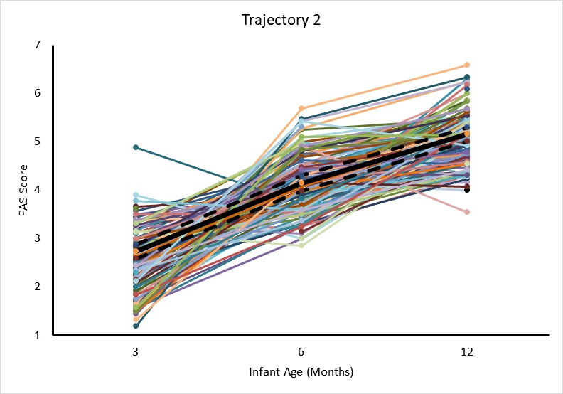
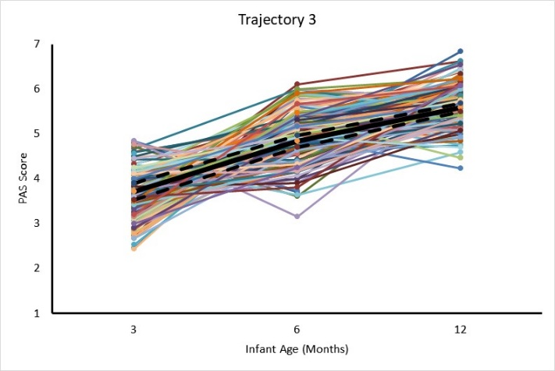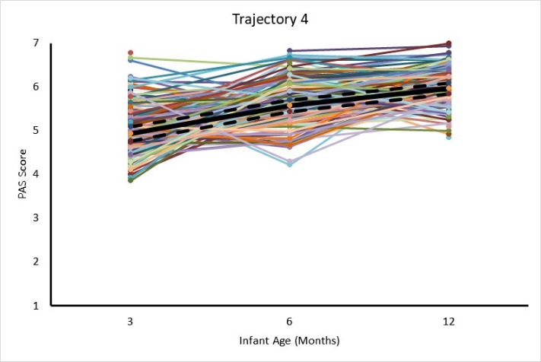
Supplemental Figure 3. Individual PAS trajectories and associated predicted trajectory for each latent PAS trajectory class. Solid black lines indicate the mean predicted trajectory. Dashed black lines indicate the upper and lower 95% CI for the mean predicted trajectory.

