Supplemental Materials

Table S1.

Fit Indices from Different Models Estimated

 |  | (df) ² | p | CFI | RMSEA and 90% CI | SRMR | BIC | ² difference test | Preferred
Internalizing  Measurement  Model | Internalizing:  AR Paths Free | (2) 16.64 | .00 | .994 | .082 [.049, .120] | .050 | 27932 | (2) 2.29, p = .32 | No
 | Internalizing:  AR Paths Constrained | (4) 18.93 | .00 | .994 | .059 [.034, .086] | .054 | 27921 |  | Yes
Conflict  Measurement Model | Conflict:  AR Paths Free | (2) 15.00 | .00 | .995 | .077 [.044, .116] | .032 | 23799 | (2) 7.73, p = .02 | Yes
 | Conflict:  AR Paths Constrained | (4) 22.73 | .00 | .993 | .066 [.041, .093] | .043 | 23792 |  | No
RI CLPM  RI CLPM | Primary Model  with no Covariates | (11) 35.85 | .00 | .995 | .046 [.029, .063] | .034 | 51352 | (48) 45.82, p = .56 | N/A
 | Primary Model with  Covariates | (59) 81.67 | .03 | .995 | .017 [.006, .025] | .022 | 80688 |  | N/A
RI CLPM  Group Analysis | Estimates freely estimated | (112) 133.50 | .08 | .996 | .017 [.000, .027] | .028 | 79090 | (64) 40.44, p = .99 | No
 | Estimates constrained | (176) 173.94 | .53 | 1.000 | .000 [.000, .017] | .038 | 78698 |  | Yes
CLPM | One lagged AR paths | (12) 264.65 | .00 | .942 | .124 [.111, .137] | .032 | 81285 | (4) 214.27, p < .001 | No
 | One and Two lagged AR paths | (8) 50.38 | .00 | .990 | .062 [.047, .079] | .008 | 81022 |  | Yes

Note. For nested models, a significant (p < .05) change in chi-square indicates a decrement in model fit. When non-significant differences emerged, we selected the more parsimonious model. When statistically significant differences emerged, we selected the improved model over the parsimonious one. Comparisons across non-nested models were based on CFI (higher values indicate better fit), RMSEA and BIC (lower values indicate better fit).
Table S2.

Unstandardized Estimates from RI CLPM for Internalizing and Conflict

 | Internalizing RI |  |  |  | Conflict RI
 | B | SE | P |  | B | SE | P
Male | 0.13 | 0.57 | .823 |  | -0.36 | 0.30 | .230
Black | -1.33 | 0.58 | .023 |  | -1.23 | 0.20 | .000
Hispanic | -1.10 | 1.23 | .369 |  | 0.77 | 0.39 | .049
Other | 1.70 | 2.02 | .402 |  | -3.10 | 1.25 | .013
Mom Education | -0.05 | 0.13 | .671 |  | -0.01 | 0.09 | .916
Mom Vocabulary | 0.03 | 0.01 | .005 |  | -0.01 | 0.01 | .684
Mom Depression | 0.30 | 0.03 | .000 |  | 0.16 | 0.02 | .000
Family Income | -0.21 | 0.08 | .010 |  | -0.07 | 0.07 | .271
 | Internalizing (T+1) |  |  |  | Conflict (T+1)
Internalizing G3 | 0.13 | 0.04 | .000 |  | 0.01 | 0.02 | .498
Conflict G3 | -0.01 | 0.04 | .764 |  | 0.13 | 0.03 | .000
Internalizing G4 | 0.13 | 0.04 | .000 |  | -0.01 | 0.02 | .554
Conflict G4 | -0.04 | 0.06 | .572 |  | 0.08 | 0.03 | .016
Internalizing G5 | 0.13 | 0.04 | .000 |  | 0.03 | 0.02 | .187
Conflict G5 | -0.06 | 0.04 | .157 |  | 0.08 | 0.04 | .043

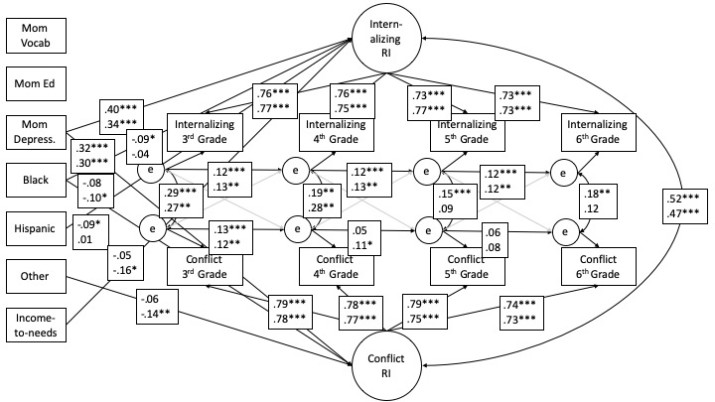Figure S1. Random Intercept Cross-Lagged Panel Model for Internalizing and Conflict by Gender. Female estimates are on the top; male estimates are on the bottom.
* p < .05.
** p < .01.
*** p < .001.

Figure S2. Cross-Lagged Panel Model for Internalizing and Conflict (Single Lagged Path). All covariates included as predictors of each outcome but not shown to reduce clutter.
* p < .05.
** p < .01.
*** p < .001.

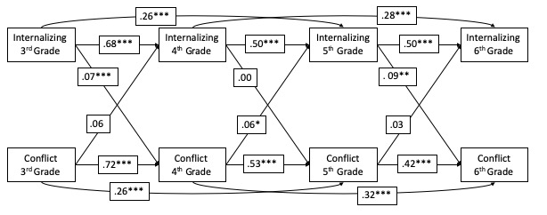
Figure S3. Cross-Lagged Panel Model for Internalizing and Conflict (Two Lagged Paths). All covariates included as predictors of each outcome but not shown to reduce clutter.
* p < .05.
** p < .01.
*** p < .001.

