Online supplement. Unidirectional model with covariances allowed.
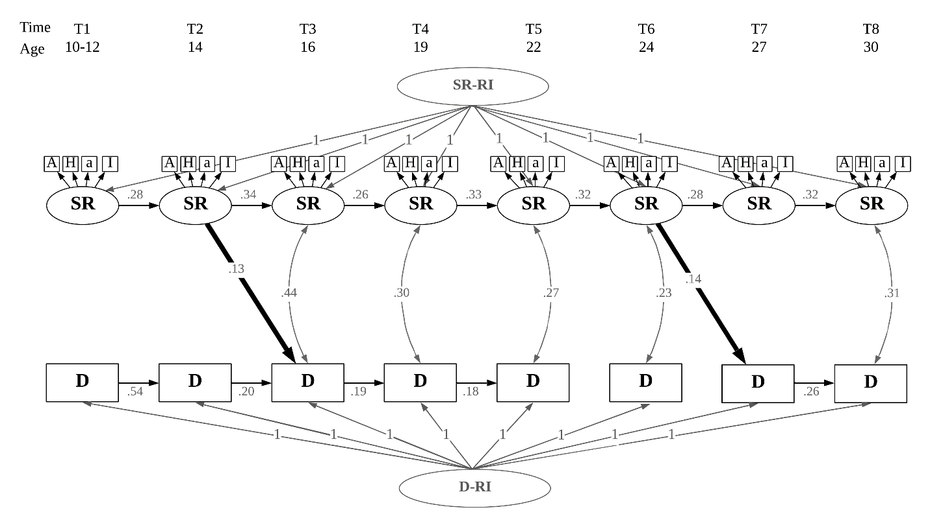
Figure. Outcome model for the unidirectional RI-CLMP, single-headed arrows represent regressions (connoted with standard estimates similar to β-coefficients), double-headed arrows represent covariances (connoted with estimated correlation coefficient). All arrows shown represent associations significant at the .05 level. Non-significant associations and covariance between latent indicators are not represented in this figure for clarity. SR = self-regulation, D = deviance, RI = Random Intercept, A = Affective, H = Hyperactive, a = Lack of Attention, I = Impulsivity.

