Supplementary materials

Additional analysis for cross-sectional results
Table 1S
Pearson correlations of regions of interest (N = 102).
ROIs | Atlas parcellation components
Left Hemisphere |  | 1 | 2 | 3 | 4 | 5 | 6 | 7 | 8
1. Insula | Insula | —- | .55** | .60** | 0.15 | .38** | .25* | .37** | .40**
2. Anterior insula | G_insular _short | —- | —- | .46** | .29** | .39** | .28** | .27** | .27**
3. Posterior insula | G_Ins_lg&S_cent_ins and S_circular _ins_inf | —- | —- | —- | 0.03 | .33** | 0.18 | 0.18 | 0.18
4. ACC | Caudal and rostral anterior cingulate | —- | —- | —- | —- | .38** | .33** | .34** | .27**
5. Inf frontal | pars opercularis and pars triangularis | —- | —- | —- | —- | —- | .65** | .76** | .51**
6. Sup frontal | Superior frontal gyrus | —- | —- | —- | —- | —- | —- | .77** | .49**
7. Mid frontal | Rostral and caudal middle frontal gyrus | —- | —- | —- | —- | —- | —- | —- | .57**
8. OFC | Lateral and medial orbitofrontal cortex | —- | —- | —- | —- | —- | —- | —- | —-
Right Hemisphere
1. Insula |  | —- | 0.11 | .24* | .27** | .38** | .31** | .34** | .21*
2. Anterior insula |  | —- | —- | .21* | .38* | .26** | .34** | .31** | .40**
3. Posterior insula |  | —- | —- | —- | .22* | .53** | .54** | .50** | .54**
4. ACC |  | —- | —- | —- | —- | .33** | .45** | .37** | .27**
5. Inf frontal |  | —- | —- | —- | —- | —- | .34** | .63** | .51**
6. Sup frontal |  | —- | —- | —- | —- | —- | —- | .79** | .49**
7. Mid frontal |  | —- | —- | —- | —- | —- | —- | —- | .49**
8. OFC |  | —- | —- | —- | —- | —- | —- | —- | —-
Note. ROIs = Regions of interest, ACC = anterior cingulate cortex, Inf = inferior, Sup = superior, Mid = middle, OFC = orbitofrontal cortex.
* p < .05
** p < .01
Table 2S.
Effects of cortical thickness of left and right regions of interest at time 1 on externalizing behavior with controlling for cortical thickness mean hemisphere.
Control and Independent Variables
 | b | SE | β | t | p
Age | 0.00 | 0.34 | –0.00 | –0.00 | 1
Sex | –0.36 | 1.96 | 0.11 | 0.19 | .98
Cognitive functioning | –0.05 | 0.34 | –0.01 | –0.14 | .98
MRI scanner | 1.01 | 1.78 | 0.11 | 0.57 | .97
Internalizing | 0.33 | 0.09 | 0.36 | 3.88 | .002**
Left Hemisphere CT | 7.52 | 26.45 | 0.07 | 0.28 | 0.98
Insula | –18.63 | 6.87 | –.31 | –2.71 | .05*
ACC | –12.39 | 6.64 | –.19 | –1.87 | .28
Inf frontal | 3.90 | 13.53 | 0.05 | 0.29 | .98
Sup frontal | 6.83 | 14.36 | 0.08 | 0.48 | .98
Mid frontal | –1.83 | 14.64 | –.02 | –.12 | .98
OFC | 2.71 | 10.37 | .03 | .26 | .98
Right Hemisphere | 9.45 | 26.83 | 0.08 | 0.24 | 0.95
Insula | 0.38 | 6.68 | 0.01 | 0.06 | 0.95
ACC | –6.16 | 6.61 | –0.10 | –0.93 | 0.95
Inf frontal | –6.29 | 11.73 | –0.08 | –0.54 | 0.95
Sup frontal | 11.40 | 15.34 | 0.14 | 0.74 | 0.95
Mid frontal | 4.68 | 15.06 | 0.05 | 0.31 | 0.95
OFC | –33.79 | 12.15 | –0.35 | –2.78 | 0.04*

Note. ACC = anterior cingulate cortex, CT = cortical thickness, Inf = inferior, Sup = superior, Mid = middle, OFC = orbitofrontal cortex.
* p FDR corrected < .05
** p FDR corrected < .01

Interactions of ROIs cortical thickness main findings with age or sex. Interaction effects for age or sex by left insula cortical thickness on externalizing score were not significant (Age p = .97, Figure 1S; Sex p = .63). Interaction effects for age or sex by right OFC cortical thickness on externalizing score were not significant (Age p = .97, Figure 1S; Sex p = .29). Plotting the interactions with age among the three age groups (±SD and mean age) showed that all three groups had a similar negative associations (Figure 1S).

Figure 1S. Interactions of (a) left insula and (b) right OFC cortical thickness with age.
- (b)
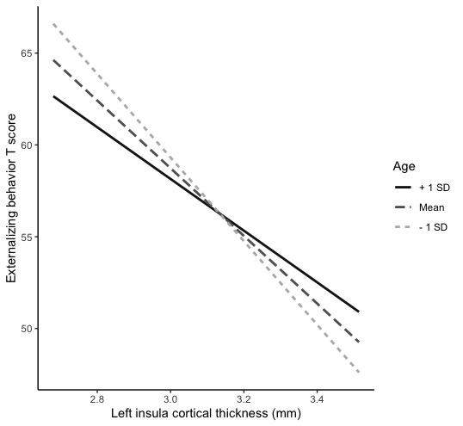
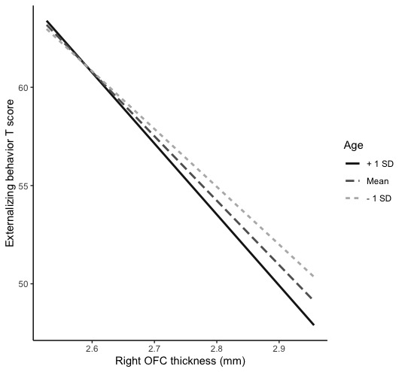

Table 3S.
Effects of surface area of left and right regions of interest at time 1 on externalizing behavior.
Control and Independent Variables
 | b | SE | β | t | p
Age | –0.11 | 0.52 | –0.02 | –0.22 | 0.97
Sex | –1.61 | 2.38 | –0.17 | –0.68 | 0.85
Cognitive functioning | –0.20 | 0.35 | –0.05 | –0.57 | 0.85
MRI scanner | 0.87 | 1.87 | 0.09 | 0.47 | 0.87
Internalizing | 0.35 | 0.08 | 0.39 | 3.97 | 0.002
Left Hemisphere
Amygdala | 0.00 | 0.01 | 0.00 | 0.05 | 0.98
Insula | 0.01 | 0.00 | 0.20 | 1.59 | 0.45
ACC | –0.01 | 0.01 | –0.18 | –1.36 | 0.48
Inf frontal | 0.00 | 0.01 | –0.11 | –0.88 | 0.78
Sup frontal | 0.00 | 0.00 | –0.17 | –1.25 | 0.52
Mid frontal | 0.00 | 0.00 | 0.03 | 0.20 | 0.98
OFC | 0.00 | 0.00 | 0.06 | 0.36 | 0.85
Right Hemisphere
Amygdala | 0.01 | 0.00 | 0.29 | 2.04 | 0.18
Insula | 0.00 | 0.00 | –0.11 | –0.91 | 0.63
ACC | –0.01 | 0.01 | –0.18 | –1.51 | 0.43
Inf frontal | 0.00 | 0.01 | –0.04 | –0.39 | 0.78
Sup frontal | –0.01 | 0.01 | –0.17 | –1.08 | 0.60
Mid frontal | 0.00 | 0.00 | –0.07 | –0.45 | 0.78
OFC | 0.01 | 0.01 | 0.16 | 1.09 | 0.60

Note. ACC = anterior cingulate cortex, CT = cortical thickness, Inf = inferior, Sup = superior, Mid = middle, OFC = orbitofrontal cortex.
* p FDR corrected < .05
** p FDR corrected < .01

Additional analysis for longitudinal results
Figure 2S. Visualizing the individual’s score of change in EB following one year. While overall there was no change in EB score, different participants showed different trajectories, which supports our endeavor to examine factors contributing to individual expression of EB during adolescence.

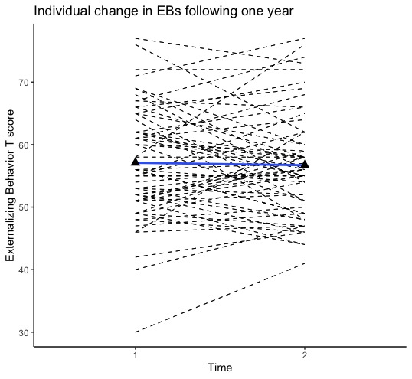

Table 4S.
Effects of cortical thickness of left/right regions of interest at time 1 on the score of change in externalizing behavior after 1 year, controlling for mean cortical thickness.
Control and Independent Variables
 | b | SE | β | t | p*
Age | 0.81 | 0.53 | –0.20 | –1.46 | 0.36
Sex | 0.80 | 1.9 | 0.11 | 0.42 | 0.86
Cognitive functioning | –0.30 | 0.36 | –0.10 | –0.83 | 0.71
MRI scanner | –2.768 | 1.68 | –0.39 | –1.65 | 0.36
Externalizing time 1 | –0.40 | 0.10 | –0.50 | –4.00 | 0.003**
Internalizing time 1 | –0.11 | 0.08 | –0.18 | –1.45 | 0.28
Left Hemisphere CT | 6.03 | 37.14 | 0.07 | 0.22 | 0.96
Insula | –3.88 | 6.98 | –0.09 | –0.56 | 0.81
ACC | –19.95 | 6.76 | –0.40 | –2.95 | 0.03*
Inf frontal | 24.36 | 11.89 | 0.44 | 2.05 | 0.21
Sup frontal | 0.59 | 13.79 | 0.01 | 0.04 | 0.98
Mid frontal | –17.72 | 13.22 | –0.31 | –1.34 | 0.37
OFC | –0.14 | 10.15 | 0.00 | –0.01 | 0.99
Right Hemisphere CT | 64.69 | 30.02 | 0.18 | 2.16 | 0.25
Insula | –4.07 | 6.20 | –0.10 | –0.66 | 0.69
ACC | –6.00 | 7.17 | –0.12 | –0.84 | 0.69
Inf frontal | –11.24 | 10.28 | –0.20 | –1.09 | 0.69
Sup frontal | –10.88 | 14.14 | 0.19 | –0.77 | 0.69
Mid frontal | –17.20 | 14.73 | –0.27 | –1.17 | 0.69
OFC | –6.98 | 11.76 | –0.10 | –0.59 | 0.69

Note. CT = cortical thickness, ACC = anterior cingulate cortex, Inf = inferior, Sup = superior, Mid = middle, OFC = orbitofrontal cortex.
- p FDR corrected < .05

Interactions of ACC cortical thickness with age or sex. Interaction effects for age or sex by left ACC cortical thickness at time 1 on the score of change in externalizing behavior after 1 year were not significant (Age p = .86, Figure 2S; Sex - p = .99; FDR corrected). Plotting the interaction with age among the three age groups (±SD and mean age), showed that all three groups had a similar negative associations (Figure 3S).

Figure 3S. Interactions of ACC cortical thickness with age.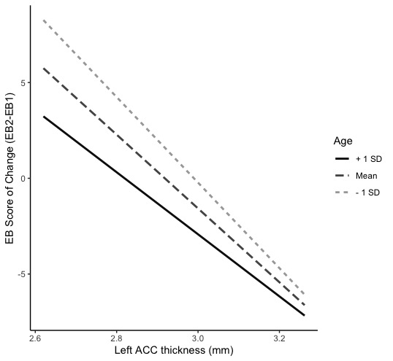

Table 5S.
Effects of surface area of left/right regions of interest at time 1 on the score of change in externalizing behavior after 1 year.
Control and Independent Variables
 | b | SE | β | t | p
Age | –0.25 | 0.09 | –0.06 | –0.50 | 0.73
Sex | –0.60 | 0.49 | –0.08 | 0.30 | 0.84
Cognitive functioning | –0.05 | 0.36 | –0.01 | –0.14 | 0.88
MRI scanner | –2.77 | 1.65 | –0.39 | –1.67 | 0.23
Externalizing time 1 | –0.26 | 0.09 | –0.32 | –2.65 | 0.11
Internalizing time 1 | –0.14 | 0.08 | –0.21 | –1.73 | 0.23
Left Hemisphere
Amygdala | –0.01 | 0.01 | –0.16 | –1.06 | 0.58
Insula | 0.01 | 0.00 | 0.35 | 2.48 | 0.11
ACC | 0.01 | 0.01 | 0.10 | 0.62 | 0.73
Inf frontal | 0.00 | 0.01 | –0.07 | –0.51 | 0.73
Sup frontal | 0.00 | 0.00 | –0.09 | –0.48 | 0.73
Mid frontal | 0.00 | 0.00 | 0.10 | 0.53 | 0.73
OFC | –0.01 | 0.01 | –0.41 | –2.21 | 0.11
Right Hemisphere
Amygdala | –0.01 | 0.01 | –0.28 | –1.44 | 0.86
Insula | 0.00 | 0.00 | 0.01 | 0.09 | 0.97
ACC | 0.01 | 0.01 | 0.17 | 0.54 | 0.86
Inf frontal | 0.00 | 0.01 | 0.08 | 0.51 | 0.86
Sup frontal | 0.00 | 0.01 | 0.14 | 0.63 | 0.86
Mid frontal | 0.00 | 0.00 | –0.13 | –0.58 | 0.86
OFC | 0.00 | 0.01 | –0.02 | –0.09 | 0.97

Note. ACC = anterior cingulate cortex, CT = cortical thickness, Inf = inferior, Sup = superior, Mid = middle, OFC = orbitofrontal cortex.
* p FDR corrected < .05
** p FDR corrected < .01

