Supplementary Materials for Perra, Paine, & Hay (DPP-2018-00125.R2)
Figure 1A.
Frequencies of responses by item and by measurement occasion. Responses categories were derived by averaging scores across informants. Higher scores indicate more frequent display of behaviour
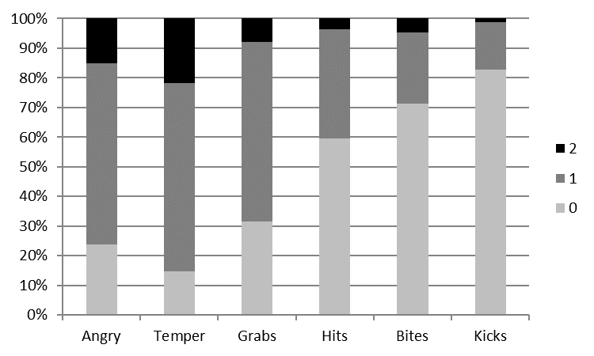
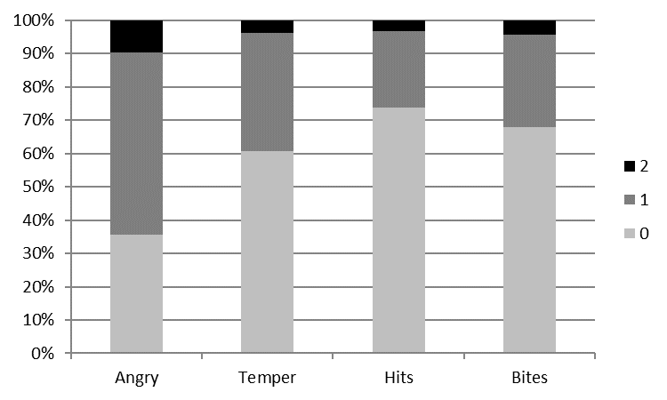

Toddlerhood
Infancy

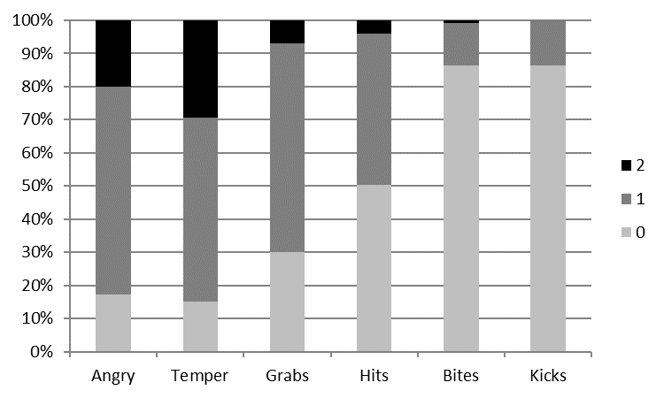

Early Childhood

Table 1A.
Log-Likelihood (LL) and LL correction factor, Information Criteria, and Entropy of latent class models of angry-aggressiveness by age, displayed in order of increasing latent number of latent classes.

Age and number and type of classes | LL | LL  Correction  Factor | Parameters | BIC | aBIC | Entropy
Infancy: 2 classes | -3083.12 | 1.01 | 40 | 6394.93 | 6268.07 | 0.85
Infancy: 3 classes | -3053.05 | 1.06 | 49 | 6386.23 | 6230.83 | 0.84
Infancy: 3-ordered classes | -3060.03 | 1.00 | 41 | 6354.46 | 6224.43 | 0.79
Infancy: 4 classes | -3046.37 | 1.00 | 58 | 6424.32 | 6240.37 | 0.86
Infancy: 4-ordered classes | -3058.6 | 1.06 | 42 | 6357.32 | 6224.12 | 0.83
Toddlerhood: 2 classes | -3061.72 | 1.04 | 44 | 6374.99 | 6235.44 | 0.73
Toddlerhood: 3 classes | -3008.82 | 1.02 | 57 | 6343.52 | 6162.74 | 0.72
Toddlerhood: 3-ordered classes | -3015.77 | 1.02 | 45 | 6288.8 | 6146.08 | 0.72
Toddlerhood: 4 classes | -2993.86 | 1.02 | 70 | 6387.9 | 6165.9 | 0.77
Toddlerhood: 4-ordered classes | -3010.42 | 1.10 | 46 | 6283.82 | 6137.93 | 0.76
Early Childhood: 2 classes | -3094.26 | 1.02 | 43 | 6434.35 | 6297.97 | 0.66
Early Childhood: 3 classes | -3055.74 | 1.03 | 55 | 6425.92 | 6251.49 | 0.66
Early Childhood: 3-ordered classes | -3066.4 | 1.05 | 44 | 6384.35 | 6244.80 | 0.66
Early Childhood: 4 classes | -3036.92 | 1.03 | 67 | 6456.89 | 6244.39 | 0.72
Early Childhood: 4-ordered classes | -3065.13 | 1.02 | 45 | 6387.53 | 6244.81 | 0.61

Table 2A.
Adjusted Odds Ratios (OR) and Standard Errors (SE) of being in the High or Moderate angry-aggressive class compared to the Low angry-aggressive class, by parental Endorsement of Physical Punishment and by age, N=304.
 | High |  |  |  | Moderate |  |  | Low (Reference category)
Infancy | OR | SE | p |  | OR | SE | p
Endorsement of Punishment | 0.91 | 0.35 | .79 |  | 1.10 | 0.17 | .56 | ---
 | High |  |  |  | Moderate |  |  | Low (Reference category)
Toddlerhood | OR | SE | p |  | OR | SE | p
Endorsement of Punishment | 1.18 | 0.31 | .60 |  | 1.04 | 0.24 | .87 | ---
 | High |  |  |  | Moderate |  |  | Low (Reference category)
Early Childhood | OR | SE | p |  | OR | SE | p
Endorsement of Punishment | 0.80 | 0.43 | .61 |  | 1.64 | 0.30 | .10 | ---
Note: Parameters are estimated across 50 completed datasets created using multiple imputation. When estimating parameters based on multiple imputations, Mplus does not estimate 95% Confidence Intervals. Here we report the SE of the ORs. The models controlled for associations between latent classes and other covariates (child sex; family adversity; maternal antenatal depression; maternal history of conduct problems). In these latent class models, the latent class affiliation at 21 and 33 months was estimated controlling for latent class affiliation at the previous age.

