Supplemental Table S1. Comparisons of participants who provided blood with and without missing data to assess potential differential loss of participants in the analytic sample
 | With Complete Data  (n = 412) |  | With Missing Data  (n = 58)
 | Mean  (SD) |  | Mean  (SD) |  | t-value | p-value
Childhood Adversity | 3.461  (3.109) |  | 3.155  (3.707) |  | .684 | .494
Depression | 1.845  (2.328) |  | 2.075  (2.730) |  | -.635 | .526
Gender | .388  (.487) |  | .379  (.489) |  | .132 | .895
Education | 13.104  (1.756) |  | 12.913  (1.581) |  | .783 | .434
Childhood Socioeconomic Status | 1.842  (1.540) |  | 1.569  (1.171) |  | 1.593 | .115
Substance Use | .018  (.711) |  | -.114  (.673) |  | 1.340 | .181
Healthy Diet | 6.679  (2.431) |  | 6.137  (2.387) |  | 1.592 | .112
Exercise | 4.973  (2.290) |  | 5.534  (2.414) |  | -1.735 | .083
Income | 442.46  (337.073) |  | 403.57  (376.448) |  | .811 | .418
Note: * ≤ .05; All variables measured during wave at which the blood draw occurred, except childhood socioeconomic status which was measured at the first wave.

Supplemental table S2: List of all items on the Childhood Adversity Scale along with item-total correlations
Items included on the Childhood Adversity Scale | Item-total Correlation
When you were growing up (before age 10) how often did the following happen? Someone said something insulting to you just because of your race or ethnic background? | .424
When you were growing up (before age 10) how often did the following happen? Members of your family or close friends were treated unfairly just because of their race or ethnic background? | .441
This next group of questions asks about when you were growing up, prior to age 10. Prior to age 10, would you say I didn't have enough to eat at home. | .056
Prior to age 10, would you say...My parents were too drunk or high to take care of the family. | .168
Prior to age 10, would you say...I had to wear old or dirty clothes or clothes that did not fit. | .194
Prior to age 10, would you say...People in my family hit me so hard that it left me with bruises or marks. | .198
Prior to age 10, would you say...I was punished with a belt, a board, a cord, or some other hard object. | .279
Prior to age 10, would you say...I got hit or beaten so badly that it was noticed by someone like a teacher, neighbor, or doctor. | .161
Prior to age 10, would you say...Someone in my family tried to touch me in a sexual way, or tried to make me touch them. | .266
Prior to age 10, would you say...Someone in my family threatened to hurt me or tell lies about me unless I did something sexual with them. | .261
Prior to age 10, would you say...Someone in my family tried to make me do sexual things or watch sexual things. | .261
Prior to age 10, would you say...There was no one to take me to the doctor when I needed it. | .054
Prior to age 10, would you say...There was a lot of violence in my neighborhood. | .233
Prior to age 10, would you say...A family member or friend was the victim of a crime. | .283
Prior to age 10, would you say...There was a lot of graffiti and run-down buildings in my neighborhood. | .252
Prior to age 10, would you say...There were a lot of fights at my school. | .247
Prior to age 10, would you say...I was sometimes afraid to go to school. | .117
Prior to age 10, would you say...I was sometimes bullied at school. | .237
Prior to age of ten...Did one or both of your parents die? | .023
Prior to age of ten did...Your parents separate or divorce? | .177
Prior to age of ten did...You move more than once? | .329
Prior to age 10, when you were growing up, would you say the number of adults in your home shifted? | .216
Prior to age 10…Did you attend more than one elementary school? | .260

Supplemental Table S3. Weights, Frequency of homozygosity and heterozygosity, and Correlations with Change in Body Mass Index for each SNP in the Genetic Risk Score for Obesity (GRSO) *
 |  |  |  | Frequency* |  |  |  | Correlation
Gene | rs number | Weighted |  | Homozygous for the non-risk allele | Heterozygous | Homozygous for the risk allele |  | ΔBMI
SEC16B | rs543874 | 0.060 |  | 221 | 164 | 27 |  | .053
ADCY3 | rs6545800 | 0.047 |  | 13 | 151 | 248 |  | .036
GNPDA2 | rs348495 | 0.051 |  | 169 | 193 | 49 |  | .042
GALNT10 | rs7708584 | 0.040 |  | 201 | 171 | 39 |  | .058
KLHL32 | rs974417 | 0.031 |  | 45 | 176 | 191 |  | .027
MIR148A-NFE2L3 | rs10261878 | 0.032 |  | 125 | 199 | 85 |  | .059
FTO | rs17817964 | 0.073 |  | 317 | 88 | 7 |  | .099*
MC4R | rs6567160 | 0.059 |  | 273 | 123 | 16 |  | .039
Note: *p ≤.05 (two-tailed tests)

*All genotype frequencies were in Hardy-Weinberg Equilibrium. SEC16B: χ² = 0.2164, p =.6417; ADCY3: χ² =3.0821, p =.0791; GNPDA2: χ² =0.2929, p =.5883; GALNT10: χ² =0.0903, p =.7637; KLHL32: χ² =0.2167, p =.6415; MIR148A-NFE2L3: χ² =0.1252,
p = .7234; FTO: χ² = 0.0973, p = .7550; MC4R: χ² = 0.2103, p = .6465;
All Analyses based on N = 412, except for missing data for one individual on rs348495 and rs7708584, and missing data for three individuals on rs10261878.

Supplemental Table S4. Conditional Indirect Effects of Moderated Mediation Model portrayed in Figure S2, excluding control variables.

Paths | Effect | 95% CI

Low GRSO (-1sd)
CA → ΔBMI → Chronic Illness at Low GRSO | .001 | [-.001,.005]
CA → ΔBMI → CMR at Low GRSO | .016 | [-.020, .051]
CA → ΔBMI → DNAm PhenoAge at Low GRSO | .012 | [-.011, .052]

Low CA (-1sd)
GRSO → ΔBMI → Chronic Illness at Low CA | .002 | [-.010,.018]
GRSO → ΔBMI → CMR at Low CA | .022 | [-.117,.186]
GRSO → ΔBMI → DNAm PhenoAge at Low CA | .017 | [-.090,.165]

High GRSO (+1sd)
CA → ΔBMI → Chronic Illness at High GRSO | .008** | [.003,.016]
CA → ΔBMI → CMR at High GRSO | .095** | [.047,.145]
CA → ΔBMI → DNAm PhenoAge at High GRSO | .073* | [.028,.161]

High CA (+1sd)
GRSO → ΔBMI → Chronic Illness at High CA | .023** | [.009,.044]
GRSO → ΔBMI → CMR at High CA | .267** | [.147,.382]
GRSO → ΔBMI → DNAm PhenoAge at High CA | .204** | [.081,.389]
Note: *p ≤.05 (two-tailed tests); ** p ≤.01

Supplemental Table S5. Conditional Indirect Effects of Moderated Mediation Model portrayed in Figure S3, with all control variables included in the model, but excluding controls for effects of cell-type variation on DNAm PhenoAge.

Paths | Effect | 95% CI

3c. Without controlling cell-types

Low GRSO (-1sd)
CA → ΔBMI → Chronic Illness at Low GRSO | .001 | [-.002, .005]
CA → ΔBMI → CMR at Low GRSO | .016 | [-.022, .051]
CA → ΔBMI → DNAm PhenoAge at Low GRSO | .011 | [-.011, .046]

Low CA (-1sd)
GRSO → ΔBMI → Chronic Illness at Low CA | .002 | [-.009,.018]
GRSO → ΔBMI → CMR at Low CA | .029 | [-.105,.187]
GRSO → ΔBMI → DNAm PhenoAge at Low CA | .020 | [-.066,.166]

High GRSO (+1sd)
CA → ΔBMI → Chronic Illness at High GRSO | .008** | [.003,.016]
CA → ΔBMI → CMR at High GRSO | .093** | [.042,.142]
CA → ΔBMI → DNAm PhenoAge at High GRSO | .063* | [.020,.139]

High CA (+1sd)
GRSO → ΔBMI → Chronic Illness at High CA | .023** | [.009,.045]
GRSO → ΔBMI → CMR at High CA | .267** | [.145,.387]
GRSO → ΔBMI → DNAm PhenoAge at High CA | .182* | [.058,.367]
Note: *p ≤.05 (two-tailed tests); ** p ≤.01

Supplemental Table S6: Conditional Indirect Effects of Moderated Mediation Model portrayed in Supplemental Figure S4.
Paths | Effect | 95% CI

Low GRSO (-1sd)
CA → ΔBMI → DNAm PhenoAge at Low GRSO | .012 | [-.011, .049]
CA → ΔBMI → Hannum at Low GRSO | .005 | [-.004, .020]
CA → ΔBMI → Horvath at Low GRSO | .006 | [-.005, .029]
CA → ΔBMI → Grim at Low GRSO | -.001 | [-.019, .004]

Low CA (-1sd)
GRSO → ΔBMI → Chronic Illness at Low CA | .021 | [-.076,.164]
GRSO → ΔBMI → Hannum at Low CA | .008 | [-.023,.078]
GRSO → ΔBMI → Horvath at Low CA | .010 | [-.032,.084]
GRSO → ΔBMI → Grim at Low CA | -.002 | [-.048, .016]

High GRSO (+1sd)
CA → ΔBMI → Chronic Illness at High GRSO | .067* | [.026,.157]
CA → ΔBMI → Hannum at High GRSO | .026* | [.006,.058]
CA → ΔBMI → Horvath at High GRSO | .032* | [.004,.081]
CA → ΔBMI → Grim at High GRSO | -.007 | [-.049, .021]

High CA (+1sd)
GRSO → ΔBMI → Chronic Illness at High CA | .192** | [.074,.376]
GRSO → ΔBMI → Hannum at High CA | .074* | [.014,.162]
GRSO → ΔBMI → Horvath at High CA | .093* | [.013,.222]
GRSO → ΔBMI → Grim at High CA | -.020 | [-.125, .059]
Note: *p ≤.05 (two-tailed tests); ** p ≤.01

Supplemental Table S7. Correlations, Means, and Standard Deviations for Primary Outcomes (DNAm PhenoAge, Hannum Age, Horvath Age, and Grim Age), and cell-type indicators for CD8T, CD4T, NK cells, B cells, and Monocytes (N = 412)
 | 1 | 2 | 3 | 4 | 5 | 6 | 7 | 8 | 9
1. DNAm PhenoAge | —
2. Hannum Age | .52** | —
3. Horvath Age | .36** | .35** | —
4. Grim Age | .28** | .22** | .01 | —
5. CD8T | -.26** | -.31** | .06 | -.16** | —
6. CD4T | -.40** | -.44** | -.09† | -.17** | .18** | —
7. NK | -.01 | .17** | .09† | -.07 | .18** | -.08† | —
8. Bcell | -.25** | -.23** | -.10* | -.14** | .17** | .36** | -.03 | —
9. Mono | .29** | .35** | .11* | .17** | -.18** | -.50** | .03 | -.30** | —
Mean | -.05 | .00 | -.022 | -.048 | .10 | .14 | .00 | .04 | .05
SD | 5.33 | 3.41 | 3.97 | 4.15 | .04 | .05 | .02 | .03 | .02
Note: †p ≤ 0.10; *p ≤ .05; **p ≤ .01 (two-tailed tests).

Supplemental Figure S1: Full conditional indirect effects model, not including BMI age 29 as part of the cardiometabolic risk score. Results show the significant indirect pathways from Childhood Adversity, Genetic Risk, and their interaction, to Chronic Illness at age 29, Cardiometabolic Risk at age 29, and DNAm PhenoAge at age 29, through ΔBMI, moderated by a weighted genetic risk score for obesity.

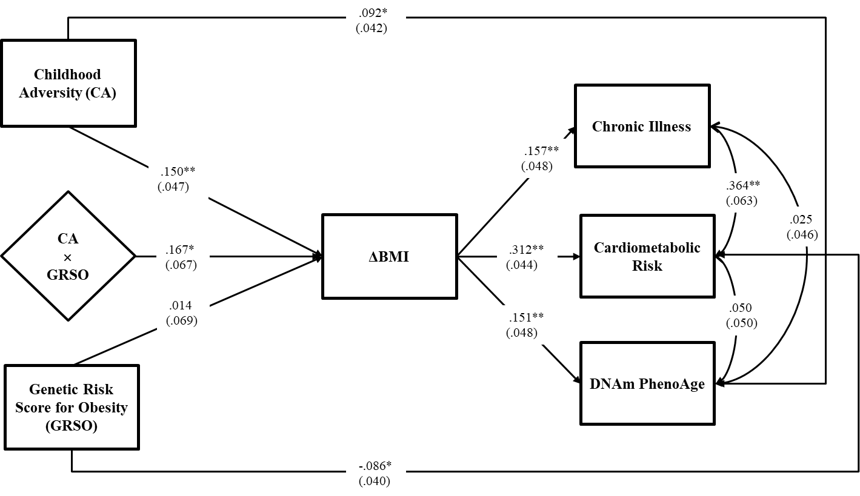

Note: Cardiometabolic Risk in this figure does not include BMI at age 29 (i.e., it includes only the log transformation of MAP and HbA1C). The resulting model fit is χ² = 87.534, df=38, p = .0000; CFI = .877; SRMR = .029; Values are standardized parameter estimates, and standard errors are in parentheses. Depression age 29 is controlled for CA and Age 29 outcomes, controlling potential recall bias; gender and childhood socioeconomic status age 10 are controlled for ΔBMI and outcomes isolating CA effects; education age 29, substance use age 29, healthy diet age 29, exercise age 29, income age 29 are controlled for all outcomes to control alternative influences on health; and cell types are controlled for DNAm PhenoAge to yield intrinsic PhenoAge. Control variable effects are not shown in the figure. DNAm PhenoAge is residualized on chronological age and so represents age acceleration.
**p ≤ .01; *p ≤ .05 (two-tailed tests), n = 412.

Supplemental Figure S2. Full conditional indirect effects model, not including control variables. Results show the significant indirect pathways from Childhood Adversity, Genetic Risk, and their interaction, to Chronic Illness at age 29, Cardiometabolic Risk at age 29, and DNAm PhenoAge at age 29, through ΔBMI, moderated by a weighted genetic risk score for obesity.

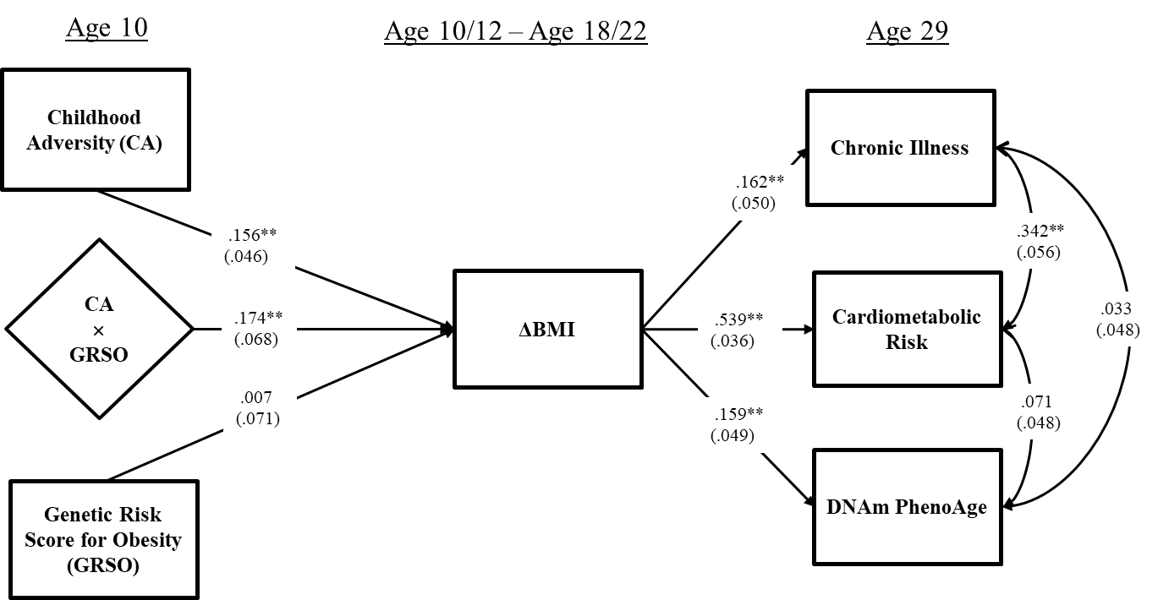
Chi-square = 27.219, df = 18, p = .0750; RMSEA = .035; CFI = 0. 974; SRMR= 0. 025. Values are standardized parameter estimates, and standard errors are in parentheses. Cell type is controlled in these analyses for DNAm PhenoAge but not shown in the figure. DNAm PhenoAge is residualized on chronological age and so represents age acceleration.

**p ≤ .01; *p ≤ .05 (two-tailed tests), n = 412.

Supplemental Figure S3. Full conditional indirect effects model, including all control variables except for cell-type variation effects on DNAm PhenoAge. Results show the significant indirect pathways from Childhood Adversity, Genetic Risk, and their interaction to Chronic Illness at age 29, Cardiometabolic Risk at age 29, and DNAm PhenoAge at age 29, through ΔBMI, moderated by a weighted genetic risk score for obesity.

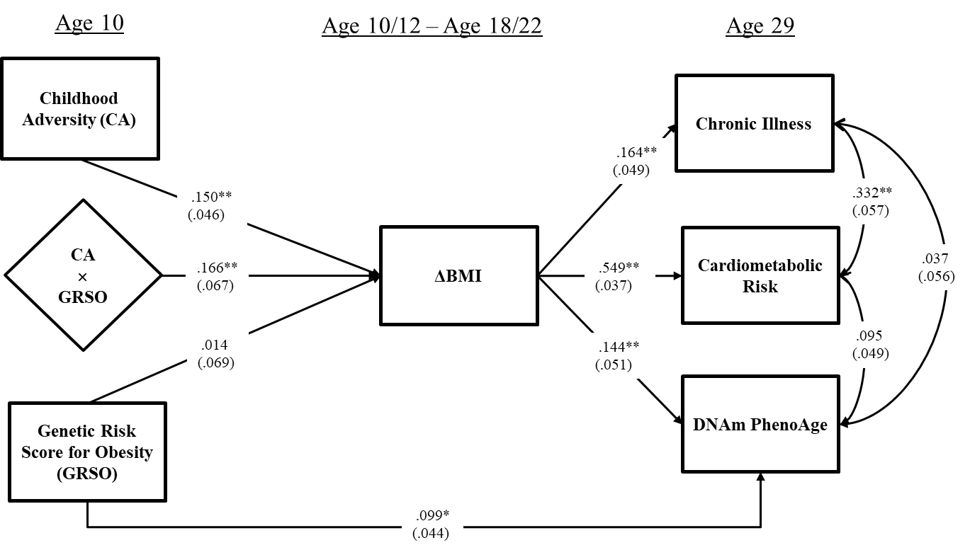

Note: Model fit indices are Chi-square = 2.216, df = 8, p = .9736; RMSEA=. 000; CFI = 1. 000; SRMR= 0. 006.; Values are standardized parameter estimates, and standard errors are in parentheses. Depression age 29 is controlled for CA and Age 29 outcomes, controlling potential recall bias; gender and childhood socioeconomic status age 10 are controlled for ΔBMI and outcomes isolating CA effects; education age 29, substance use age 29, healthy diet age 29, exercise age 29, income age 29 are controlled for all outcomes to control alternative influences on health; and cell types are controlled for DNAm PhenoAge to yield intrinsic PhenoAge. Control variable effects are not shown in the figure. Celltype is not controlled in DNAm PhenoAge and so the index is not an “intrinsic” aging measure in this analysis. DNAm PhenoAge is, however, residualized on chronological age and so represents age acceleration.
**p ≤ .01; *p ≤ .05 (two-tailed tests), n = 412.

Supplemental Figure S4. Moderated Mediation comparing effects on DNAm Pheno Age to those for Hannum Methylomic Age, Horvath Methylomic Age, and Grim Age, controlling for cell-type variation in all methylomic measures. Descriptions of each alternative measure provided below.
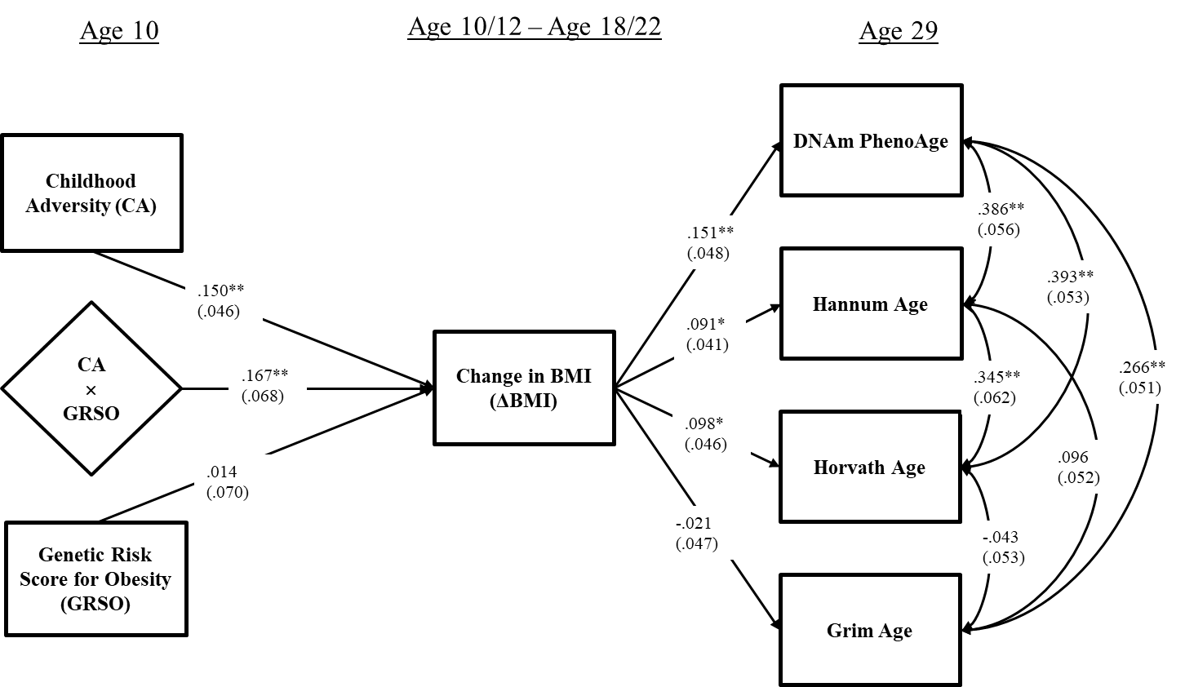
Note: Chi-square = 77.778, df = 33, p = .0000; RMSEA = .057; CFI = 0. 936; SRMR= 0. 027. Values are standardized parameter estimates, and standard errors are in parentheses. Depression age 29 is controlled for CA and age 29 methylomic outcomes, controlling potential recall bias; gender and childhood socioeconomic status age 10 are controlled for ΔBMI and outcomes isolating CA effects; education age 29, substance use age 29, healthy diet age 29, exercise age 29, income age 29 are controlled for age 29 methylomic outcomes to control alternative influences. Cell type effects are controlled for all age 29 methylomic outcomes. Control variable effects are not shown in the figure. All methylomic measures are residualized on chronological age and so represent age acceleration.
**p ≤ .01; *p ≤ .05 (two-tailed tests), n = 412.

Brief Descriptions of Alternative Methylomic Aging measures

DNAm PhenoAge
The Levine et al. (2018) DNAm PhenoAge methylomic index has been shown to be related to all cause and specific patterns of mortality as well as patterns of increased morbidity for both Black and White samples (Levine et al., 2018). A positive value on DNAm PhenoAge indicates accelerated epigenetic aging, while a negative value indicates decelerated aging.
We regressed epigenetic age for each of the methylomic measures on chronological age to transform epigenetic age into accelerated aging scores. Because cell type distribution is correlated with age, we also corrected this measure for cell type using a procedure described by Horvath (2013), providing a measure of intrinsic PhenoAge acceleration.

Horvath Age
Horvath (2013) identified a set of 353 methylation markers highly associated with age. The Horvath index has been shown to have cross tissue reliability, allowing cross-tissue generalization of findings regarding cellular level aging, and so strengthening conclusions about organism-wide effects. For Horvath, the correlation between age and the weighted sum of the methylation scores at the 353 sites utilized was roughly .97 in the samples used to develop the measure. To transform this epigenetic age into an accelerated aging score, we regressed epigenetic age on chronological age. In addition, we corrected this measure for cell type using a procedure described by Horvath (2013), providing a measure of intrinsic cellular-level age acceleration.

Hannum Age
Hannum and colleagues (2013) devised a “biological clock” optimized for use with blood samples, comprising weighted methylation values at 71 cytosine-phospho-guanine dinucleotide (CpGs) pairs in DNA prepared from peripheral blood. The index has been shown to accurately predict chronological age. Like the Horvath clock, this measure appears to have a relatively constant rate of change across adulthood after age 20 and has a high correlation with chronological age (r = 0.96). To transform this epigenetic age into an accelerated aging score, we regressed epigenetic age on chronological age. In addition, we corrected this measure for cell type using a procedure described by Horvath (2013), providing a measure of intrinsic cellular-level age acceleration.

Grim Age
Recently, Horvath and associates developed a DNAm-based measure of predicted lifespan, focusing on time to death due to all-cause mortality (see Lu et al., 2019). They developed the measure by first identifying a set of plasma protein predictors of mortality and then used these to identify DNAm-based biomarkers that could predict mortality. The resulting index allows accurate prediction of time-to-death, providing a mortality risk estimate called “DNAm GrimAge.” The index has demonstrated good predictive ability for time-to-death, time-to-coronary heart disease, time-to-cancer, and has also shown an association with computed tomography data for fatty lever/excess visceral fat, and age at menopause. Age adjusted GRIM, used in the current supplemental analyses, is derived by regressing values on chronological age, providing an index of age accelerated GRIM. In addition, we corrected this measure for cell type using a procedure described by Horvath (2013), providing a measure of intrinsic cellular-level GRIM acceleration..

References

Hannum, G., Guinney, J., Zhao, L., Zhang, L, Hughes, G., Sadda, S.,…. & Zhang, K. (2013). Genome-Wide methylation profiles reveal quantitative views of human aging rates. Molecular Cell, 49(2), 359-367. doi: 10.1016/j.molcel.2012.10.016.
Horvath S. (2013). DNA methylation age of human tissues and cell types. Genome Biology, 14(10), R115. doi:10.1186/gb-2013-14-10-r115.
Levine, M. E., Lu, A. T., Quach, A., Chen, B. H., Assimes, T. L., Bandinelli, S., … & Horvath, S. (2018). An epigenetic biomarker of aging for lifespan and healthspan. Aging, 10(4), 573–591. doi: 10.18632/aging.101414
Lu, A. T., Quach, A., Wilson, J. G., Reiner, A. P., Aviv, A., Raj, K., … Horvath, S. (2019). DNA methylation GrimAge strongly predicts lifespan and healthspan. Aging, 11(2), 303–327. doi:10.18632/aging.101684

