Supplementary file A

In this supplementary file we present additional analyses in which all predictors and interactions were included simultaneously. Table 1 presents the models in which all main effects of the predictors are included simultaneously. Table 2 presents the models in which all main effects of the predictors and their interactions are included. The significant interactions are presented in Figures 1–4.

Table 1. Daily parenting as a function of daily child behavior, parents’ psychological needs, and mindful parenting
 | Autonomy support | Psychological control | Responsiveness
 | B (SE) | B (SE) | B (SE)
Fixed effects
Overall Intercept | 3.36 (.09)*** | 1.54 (.04)*** | 3.90 (.08)***
Day level predictors
Externalizing child behavior | -.23 (.08)** | .31 (.05)*** | -.17 (.06)**
Internalizing child behavior | -.07 (.08) | .09 (.05) | .10 (.06)
Prosocial child behavior | -.00 (.06) | -.01 (.04) | .14 (.05)**
Parents’ need satisfaction | .18 (.08)* | -.08 (.05) | .15 (.06)*
Parents’ need frustration | .01 (.08) | .06 (.05) | .03 (.07)
Person level predictors
Mindful parenting | .39 (.21) † | -.29 (.10)** | .47 (.16)**
Control variable
GMFCS | -.06 (.07) | -.04 (.03)* | .07 (.05)
Random effects
u₀ (intercept) | .43 (.09)*** | .08 (.02) | .27 (.06)***
e₀ | .25 (.02)*** | .12 (.01) | .16 (.01)***
-2 × loglikelihood | 612.42 | 329.51 | 469.55
*p < .05 **p < .01 *** p < .001.

Table 2. Daily Parenting as a Function of Daily Child Behavior, Parents’ Psychological Needs, the Interactions between Child Behavior and Parents’ Needs, and Mindful Parenting
 | Autonomy support | Psychological control | Responsiveness
 | B (SE) | B (SE) | B (SE)
Fixed effects
Overall Intercept | 3.32 (.09)*** | 1.55 (.05)*** | 3.88 (.08)***
Day level predictors
Externalizing child behavior | -.17 (.08)* | .25 (.06)*** | -.12 (.07)
Internalizing child behavior | -.11 (.08) | .12 (.06)* | .07 (.07)
Prosocial child behavior | -.01 (.06) | -.01 (.04) | .14 (.05)**
Need satisfaction | .26 (.08)*** | -.12 (.06)* | .20 (.07)**
Need frustration | .06 (.08) | .05 (.05) | .06 (.07)
Interactions at day level
EXT × INT | -.15 (.20) | -.11 (.14) | .11 (.17)
EXT PRO | .17 (.16) | .03 (.11) | .01 (.13)
EXT × NS | .15 (.22) | -.03 (.15) | .09 (.18)
EXT × NF | .02 (.18) | .27 (.13)* | -.07 (.15)
INT × PRO | -.50 (.19)** | .09 (.13) | -.20 (.15)
INT × NS | .11 (.16) | -.08 (.11) | .13 (.14)
INT × NF | .04 (.17) | -.09 (.12) | .05 (.14)
PRO × NS | -.15 (.17) | .22 (.11) | -.11 (.14)
PRO × NF | -.27 (.15) | -.00 (.10) | -.15 (.12)
NS × NF | -.31 (.12)* | .19 (.08)* | -.11 (.10)
Person level predictors
Mindful parenting | .38 (.21) | -.30 (.10)** | .47 (.17)**
Control variable
GMFCS | -.06 (.07) | -.03 (.03) | .07 (.06)
Random effects
u₀ (intercept) | .44 (.09)*** | .11 (.02)*** | .28 (.06)***
e₀ | .25 (.02)*** | .13 (.01) | .16 (.01)***
-2 × loglikelihood | 591.32 | 310.51 | 461.25
Note: EXT = Externalizing child behavior, INT = Internalizing child behavior, PRO = Prosocial child behavior, NS = parents’ need satisfaction, NF = parents’ need frustration;*p < .05 **p < .01 *** p < .001.

Figure 2 Interaction between daily need satisfaction and daily need frustration behavior in the prediction of daily autonomy support
Figure 1 Interaction between daily internalizing child behavior and daily prosocial child behavior in the prediction of daily autonomy support
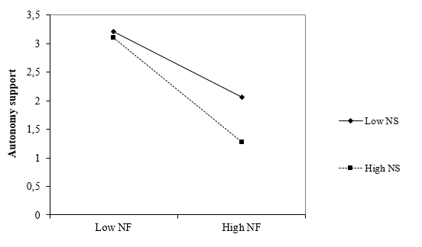
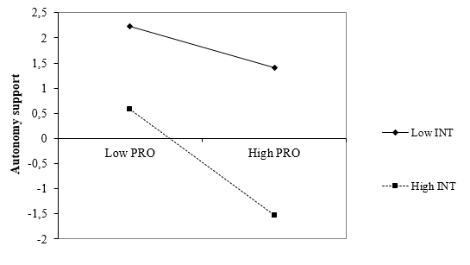

Figure 4 Interaction between daily need satisfaction and need frustration in the prediction of daily psychological control
Figure 3 Interaction between daily need frustration and daily externalizing child behavior in the prediction of daily psychological control
