eTable 1. Descriptive statistics of Alcohol Use Disorder (AUD) symptoms before and after log-transformation.
Variable | M | SD | Skewness | Kurtosis
AUD symptoms age 17 (raw) | .62 | 1.54 | 3.09 | 10.01
AUD symptoms age 17 (log-transformed) | .26 | .55 | 2.04 | 2.99
AUD symptoms age 24 (raw) | 1.06 | 1.79 | 2.05 | 4.07
AUD symptoms age 24 (log-transformed) | .47 | .65 | 1.08 | -.15
AUD symptoms age 29 (raw) | .67 | 1.51 | 2.99 | 9.85
AUD symptoms age 29 (log-transformed) | .30 | .56 | 1.78 | 2.10
Notes. After log-transformation AUD symptoms had skewness statistics of ≤ 2.04 and kurtosis statistics ≤ 3.00, which are adequate for normality assumptions (Kline, 2005).
eTable 2. Unstandardized coefficients (standard errors) from cross-lagged panel models for those in a romantic relationship by age 29
Path | Whole-Group Model  (Males + Females)¹  (N = 1,854) |  | Multiple-Group Model  (Males vs. Females)²
 |  |  | Males  (n = 830) | Females  (n = 1,024) | ΔSB χ²  (1 df)
 | B (S.E.) |  | B (S.E.) | B (S.E.)
Covariates
- SES -> CN age 17 | -.94 (.65) |  | -1.38 (.87) | -1.05 (.86) | .07
- SES -> NE age 17 | -2.08 (.55)*** |  | -1.69 (.81)* | -2.32 (.74)** | .27
- SES -> AUD Sx age 17 | -.09 (.02)** |  | -.16 (.03)*** | -.02 (.03) | 11.90***
- Rural status -> CN age 17 | 2.61 (.91)** |  | 2.89 (1.23)* | 1.80 (1.22) | .41
- Rural status -> NE age 17 | .79 (.80) |  | .20 (1.16) | 1.45 (1.10) | .67
- Rural status -> AUD Sx age 17 | .01 (.03) |  | -.04 (.05) | .06 (.03) | 2.60
Stability paths
- CN age 17 -> CN age 24 | .64 (.02)*** |  | .69 (.04)*** | .54 (.03)*** | 10.71**
- CN age 24 -> CN age 29 | .76 (.02)*** |  | .70 (.03)*** | .79 (.02)*** | 7.98**
- NE age 17 -> NE age 24 | .52 (.02)*** |  | .52 (.03)*** | .52 (.03)*** | .04
- NE age 24 -> NE age 29 | .71 (.02)*** |  | .67 (.03)*** | .74 (.02)*** | 3.90*
- Rom RQ age 24 -> Rom RQ age 29 | .36 (.06)*** |  | .40 (.09)*** | .31 (.09)*** | .51
- Rom part alc use age 24 -> Rom part alc use age 29 | .69 (.03)*** |  | .60 (.06)*** | .69 (.04)*** | 1.52
- AUD Sx age 17 -> AUD Sx age 24 | .33 (.03)*** |  | .37 (.05)*** | .24 (.05)*** | 4.03*
- AUD Sx age 24 -> AUD Sx age 29 | .30 (.02)*** |  | .34 (.03)*** | .19 (.04)*** | 11.19***
Cross-paths
- CN age 17 -> Rom RQ age 24 | .005 (.002)** |  | .006 (.003)* | .004 (.003) | .16
- CN age 17 -> Rom part alc use age 24 | -.01 (.004)** |  | -.02 (.006)*** | -.02 (.005)** | .54
- CN age 17 -> NE age 24 | -.07 (.02)** |  | -.08 (.03)* | -.05 (.03) | .48
- CN age 17 -> AUD Sx age 24 | .001 (.001) |  | .002 (.002) | .000 (.001) | .41
- NE age 17 -> Rom RQ age 24 | -.01 (.002)*** |  | -.01 (.003)*** | -.01 (.004)*** | .01
- NE age 17 -> Rom part alc use age 24 | -.006 (.004) |  | -.01 (.006) | -.001 (.005) | 1.24
- NE age 17 -> CN age 24 | .04 (.02) |  | .09 (.04)* | .03 (.03) | 1.89
- NE age 17 -> AUD Sx age 24 | .001 (.001) |  | .004 (.002) | -.001 (.001) | 3.96
- AUD Sx age 17 -> Rom RQ age 24 | -.05 (.07) |  | -.10 (.08) | .05 (.12) | 1.11
- AUD Sx age 17 -> Rom part alc use age 24 | -.01 (.12) |  | -.13 (.13) | .29 (.18) | 3.44
- AUD Sx age 17 -> CN age 24 | -.12 (.61) |  | .51 (.74) | -.10 (1.00) | .27
- AUD Sx age 17 -> NE age 24 | 1.00 (.64) |  | 1.77 (.78)* | -.42 (1.04) | 2.88
- CN age 24 -> Rom RQ age 29 | .002 (.001)* |  | .003 (.002) | .002 (.002) | .29
- CN age 24 -> Rom part alc use age 29 | .000 (.003) |  | -.004 (.004) | -.006 (.004) | .10
- CN age 24 -> NE age 29 | -.02 (.02) |  | -.02 (.03) | -.004 (.02) | .26
- CN age 24 -> AUD Sx age 29 | -.002 (.001) |  | -.004 (.002) | .000 (.001) | 3.04
- NE age 24 -> Rom RQ age 29 | -.007 (.002)*** |  | -.006 (.002)* | -.008 (.002)*** | .43
- NE age 24 -> Rom part alc use age 29 | -.003 (.003) |  | -.004 (.005) | .002 (.004) | .97
- NE age 24 -> CN age 29 | .005 (.02) |  | -.02 (.03) | .03 (.02) | 1.70
- NE age 24 -> AUD Sx age 29 | .001 (.001) |  | -.001 (.002) | .001 (.001) | .05
- Rom RQ age 24 -> CN age 29 | 1.05 (.52)* |  | 1.72 (.74)* | .81 (.78) | .61
- Rom RQ age 24 -> NE age 29 | -2.67 (.54)*** |  | -4.05 (.80)*** | -1.64 (.70)* | 5.29*
- Rom RQ age 24 -> Rom part alc use age 29 | -.21 (.09)* |  | -.37 (.12)** | -.08 (.11)* | 3.18
- Rom RQ age 24 -> AUD Sx age 29 | -.06 (.04) |  | -.13 (.06)* | -.02 (.02) | 2.69
- Rom part alc use age 24 -> CN age 29 | -.11 (.20) |  | -.62 (.37) | -.14 (.26) | 1.32
- Rom part alc use age 24 -> NE age 29 | -.28 (.22) |  | -.76 (.40) | -.03 (.27) | 2.43
- Rom part alc use age 24 -> Rom RQ age 29 | .01 (.02) |  | .02 (.03) | .01 (.02) | .06
- Rom part alc use age 24 -> AUD Sx age 29 | .01 (.02) |  | -.01 (.03) | .02 (.02) | .20
- AUD Sx age 24 -> CN age 29 | -.59 (.39) |  | .18 (.56) | -.82 (.56) | 1.60
- AUD Sx age 24 -> NE age 29 | .31 (.41) |  | .49 (.62) | -1.37 (.67)* | 4.84*
- AUD Sx age 24 -> Rom RQ age 29 | -.04 (.03) |  | -.10 (.05)* | .000 (.05) | 2.04
- AUD Sx age 24 -> Rom part alc use age 29 | -.15 (.07)* |  | .07 (.10) | -.26 (.11)* | 5.96*
Indirect effects
- CN age 17 -> Rom RQ age 24 -> AUD Sx age 29 | .000 (.000) |  | -.001 (.001) | .000 (.000) | 1.67
- CN age 17 -> Rom part alc use age 24 -> AUD Sx age 29 | .000 (.000) |  | .000 (.000) | .000 (.000) | .25
- NE age 17 -> Rom RQ age 24 -> AUD Sx age 29 | .001 (.000) |  | .001 (.001) | .000 (.000) | 1.86
- NE age 17 -> Rom part alc use age 24 -> AUD Sx age 29 | .000 (.000) |  | .000 (.000) | .000 (.000) | .04
- AUD Sx age 17 -> Rom RQ age 24 -> CN age 29 | -.05 (.08) |  | -.17 (.15) | .04 (.10) | 1.25
- AUD Sx age 17 -> Rom part alc use age 24 -> CN age 29 | .001 (.01) |  | .08 (.10) | -.04 (.08) | .96
- AUD Sx age 17 -> Rom RQ age 24 -> NA age 29 | .14 (.19) |  | .40 (.31) | -.08 (.19) | 1.39
- AUD Sx age 17 -> Rom part alc use age 24 -> NA age 29 | .003 (.93) |  | .10 (.12) | -.01 (.08) | .50
Concurrent Interactions
(controlling for main effects, shown in letters)
a. CN age 24 -> AUD Sx age 24 | -.01 (.001)*** |  | -.008 (.002)*** | -.005 (.002)** | 1.42
b. NE age 24 -> AUD Sx age 24 | .007 (.001)*** |  | .005 (.002)* | .007 (.002)*** | .71
c. Rom RQ age 24 -> AUD Sx age 24 | -.05 (.03) |  | -.04 (.06) | -.04 (.03) | .001
d. Rom part alc use age 24 -> AUD Sx  age 24 | .05 (.02)** |  | .09 (.03)** | .08 (.02)*** | .11
1. CN age 24 x Rom RQ age 24 -> AUD  Sx age 24 | .003 (.002) |  | .000 (.003) | .001 (.002) | .04
2. CN age 24 x Rom part alc use age 24 ->  AUD Sx age 24 | .000 (.001) |  | .003 (.002)* | -.002 (.001)* | 9.83**
3. NE age 24 x Rom RQ age 24 -> AUD  Sx age 24 | -.002 (.002) |  | -.003 (.004) | -.002 (.002) | .07
4. NE age 24 x Rom part alc use age 24 ->  AUD Sx age 24 | .000 (.001) |  | -.001 (.001) | .001 (.001) | 1.18
e. CN age 29 -> AUD Sx age 29 | -.003 (.001)** |  | -.001 (.002) | -.004 (.001)** | 2.52
f. NE age 29 -> AUD Sx age 29 | .002 (.001) |  | .000 (.003) | .002 (.002) | .46
g. Rom RQ age 29 -> AUD Sx age 29 | -.03 (.02) |  | -.003 (.04) | -.06 (.03)* | 1.98
h. Rom part alc use age 29 -> AUD Sx  age 29 | .01 (.01) |  | .03 (.02) | .02 (.01) | .17
5. CN age 29 x Rom RQ age 29 -> AUD  Sx age 29 | .000 (.001) |  | .000 (.002) | .002 (.002) | .45
6. CN age 29 x Rom part alc use age 29 ->  AUD Sx age 29 | .000 (.001) |  | .001 (.001) | -.001 (.001) | 3.63
7. NE age 29 x Rom RQ age 29 -> AUD  Sx age 29 | .000 (.002) |  | .002 (.002) | -.002 (.002) | 1.12
8. NE age 29 x Rom part alc use age 29 ->  AUD Sx age 29 | -.001 (.001) |  | -.002 (.001) | -.001 (.001) | .39
Longitudinal interactions
(controlling for main effects, displayed in rows above)
17. CN age 24 x Rom RQ age 24 -> AUD  Sx age 29 | .001 (.002) |  | -.001 (.004) | .000 (.003) | .13
18. CN age 24 x Rom part alc use age 24  -> AUD Sx age 29 | -.003 (.001)** |  | -.005 (.002)** | -.002 (.001) | 1.91
19. NA age 24 x Rom RQ age 24 -> AUD  Sx age 29 | -.004 (.003) |  | -.006 (.01) | -.001 (.003) | 1.11
20. NA age 24 x Rom part alc use age 24  –> AUD Sx age 29 | .001 (.001) |  | .003 (.002) | .001 (.001) | .74
Residual correlations
- CN age 17 <-> NE age 17 | -22.76 (6.01)*** |  | -18.68 (8.82)* | -16.70 (7.83)* | .04
- CN age 17 <-> AUD Sx age 17 | -2.04 (.23)*** |  | -1.56 (.34) *** | -1.87 (.31)*** | .53
- NE age 17 <-> AUD Sx age 17 | .99 (.20)*** |  | .88 (.33)** | .89 (.25)*** | .06
- CN age 24 <-> NE age 24 | -3.43 (3.61) |  | .86 (5.34) | -2.52 (4.54) | .31
- CN age 29 <-> NE age 29 | 1.54 (2.27) |  | .08 (3.82) | 2.57 (2.63) | .30
R² |  |  | R² (males) | R² (females)
- CN17 | .01 |  | .02 | .01 | --
- CN24 | .41*** |  | .41*** | .35*** | --
- CN29 | .64*** |  | .59*** | .62*** | --
- NA17 | .01* |  | .01 | .02 | --
- NA24 | .32*** |  | .30*** | .33*** | --
- NA29 | .57*** |  | .56*** | .59*** | --
- ALC17 | .01* |  | .03** | .01 | --
- ALC24 | .23*** |  | .22*** | .19*** | --
- ALC29 | .29*** |  | .31*** | .24*** | --
- RomRQ24 | .06** |  | .06* | .05* | --
- RomRQ29 | .17*** |  | .22** | .13** | --
- Rom part alc use 24 | .02 |  | .05 | .04* | --
- Rom part alc use 29 | .39*** |  | .32*** | .40*** | --
Notes. SES = baseline socioeconomic status, CN = constraint, NE = negative emotionality, AUD Sx = alcohol use disorder symptoms, Rom RQ = Romantic relationship quality, Rom part alc use = Romantic partner’s past year frequency of alcohol use. This table shows results from the full cross-lagged models in terms of unstandardized coefficients (standard errors). Results for the entire sample (for those who had ever been in a romantic relationship) are provided in addition to group differences by gender as there were limited gender differences in cross-effects. All interaction terms were also correlated in this model but are not shown for clarity of presentation. For coefficients that were < .01, results are presented in three decimal points, otherwise they are presented in two decimal points. Significant differences in the unstandardized estimates by gender were tested using the Satorra Bentler chi-square difference test (ΔSB χ²) for all estimates except for the indirect effects; for these the Wald test of parameter constraints was used. Coefficients shown in gray for the multi-group model (males vs. females) are not significantly different across gender. Coefficients shown in gray for the whole sample (males + females) are significantly different across gender. Statistical significance is denoted by ***p < .001, **p < .01, *p <.05
¹ Fit statistics: χ² (153) = 491. 51, p < .001; RMSEA = .04 (95% CI: .03, .04); CFI = .93; RMSEA = .05
² Fit statistics: χ² (314) = 1,159.23, p < .001; RMSEA = .05 (95% CI: .05, .06); CFI = .83; RMSEA = .08
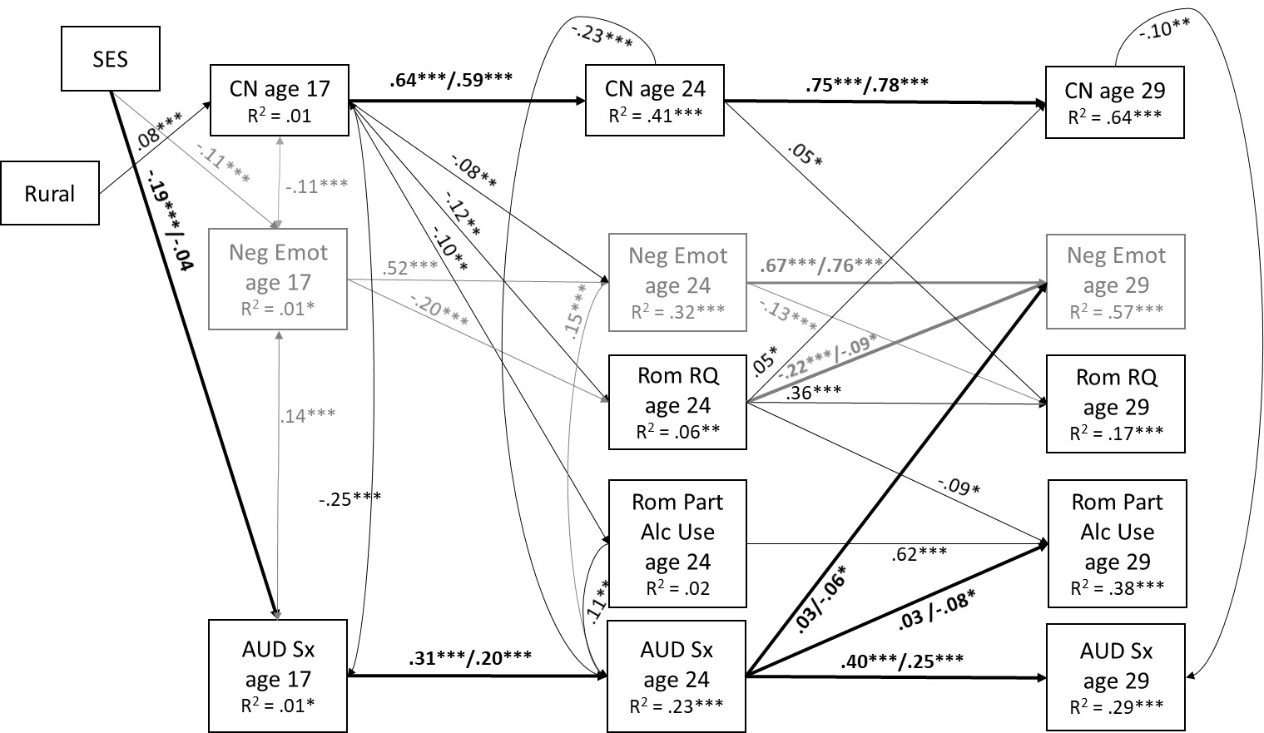
eFigure 1. Cross-lagged panel results for those in a romantic relationship by age 29 (N = 1,854). SES = socioeconomic status, CN = constraint, Neg Emot = negative emotionality, AUD Sx = alcohol use disorder symptoms, Rom RQ = romantic relationship quality, Rom Part Alc Use = romantic partner alcohol use. Results are shown in terms of standardized coefficients. All paths corresponding to a significant difference in gender from the multi-group model are shown in bold with results for males (n = 830) presented before the slash and females (n = 1,024) after the slash. For those results that were not significantly different by gender, standardized coefficients from the model that combined males and females are provided. R²s are also provided from the model that combined males and females. Paths and coefficients involving negative emotionality are shown in gray for clarity of presentation. Paths representing correlations between within assessment constructs (e.g., personality at age 17 and AUD symptoms at age 29) refer to residual correlations. Paths representing correlations between within assessment constructs (e.g., personality at age 17 and AUD symptoms at age 29) refer to residual correlations. All paths that were not significantly different than zero are not shown for clarity of presentation; see eTable 2 for detailed results in terms of unstandardized coefficients, including those from all interaction terms (none met the conservative threshold of p < .002).

Statistical significance is denoted by ***p < .001, **p < .01, *p <.05
eTable 3. Unstandardized coefficients (standard errors) from cross-lagged panel models for the younger cohort only (N = 1,517)
Path | Whole-Group Model  (Males + Females)¹  (N = 1,448) |  | Multiple-Group Model  (Males vs. Females)²
 |  |  | Males  (n = 724) | Females  (n = 724) | ΔSB χ²  (1 df)
 | B (S.E.) |  | B (S.E.) | B (S.E.)
Covariates
- SES -> CN age 17 | .23 (.73) |  | .12 (.94) | -.51 (1.03) | .18
- SES -> NE age 17 | -2.57 (.63)*** |  | -3.36 (.88)*** | -1.59 (.90) | 2.01
- SES -> AUD Sx age 17 | -.09 (.03)*** |  | -.16 (.04)*** | -.004 (.02) | 11.28***
- Rural status -> CN age 17 | 3.21 (1.08)** |  | 3.66 (1.42)* | 1.89 (1.49) | .76
- Rural status -> NE age 17 | 1.02 (.94) |  | -.64 (1.26) | 2.88 (1.37)* | 3.66
- Rural status -> AUD Sx age 17 | -.01 (.04) |  | -.04 (.07) | .04 (.04) | 1.42
Stability paths
- CN age 17 -> CN age 24 | .65 (.03)*** |  | .65 (.04)*** | .60 (.03)*** | .89
- CN age 24 -> CN age 29 | .79 (.02)*** |  | .72 (.03)*** | .81 (.03)*** | 5.53*
- NE age 17 -> NE age 24 | .54 (.02)*** |  | .52 (.03)*** | .56 (.03)*** | .96
- NE age 24 -> NE age 29 | .71 (.03)*** |  | .67 (.04)*** | .75 (.03)*** | 2.60
- Rom RQ age 24 -> Rom RQ age 29 | .32 (.07)*** |  | .38 (.12)** | .28 (.08)** | .49
- Rom part alc use age 24 -> Rom part alc use age 29 | .70 (.03)*** |  | .61 (.06)*** | .70 (.04)*** | 1.48
- AUD Sx age 17 -> AUD Sx age 24 | .37 (.04)*** |  | .41 (.05)*** | .17 (.07)* | 12.03***
- AUD Sx age 24 -> AUD Sx age 29 | .35 (.03)*** |  | .39 (.04)*** | .25 (.04)*** | 4.81*
Cross-paths
- CN age 17 -> Rom RQ age 24 | .004 (.002)* |  | .006 (.003)* | .002 (.002) | .94
- CN age 17 -> Rom part alc use age 24 | -.02 (.004)*** |  | -.03 (.006)*** | -.02 (.005)*** | .75
- CN age 17 -> NE age 24 | -.07 (.02)** |  | -.06 (.04) | -.07 (.03)* | .06
- CN age 17 -> AUD Sx age 24 | .000 (.002) |  | .002 (.003) | .001 (.002) | .14
- NE age 17 -> Rom RQ age 24 | -.01 (.002)*** |  | -.01 (.003)*** | -.01 (.002)*** | .10
- NE age 17 -> Rom part alc use age 24 | -.01 (.004)** |  | -.02 (.006)* | -.008 (.005) | .82
- NE age 17 -> CN age 24 | .02 (.03) |  | .05 (.04) | .000 (.03) | .99
- NE age 17 -> AUD Sx age 24 | .002 (.002) |  | .005 (.002) | .001 (.002) | 2.06
- AUD Sx age 17 -> Rom RQ age 24 | .01 (.06) |  | -.02 (.07) | .15 (.08) | 2.50
- AUD Sx age 17 -> Rom part alc use age 24 | -.16 (.12) |  | -.13 (.13) | .11 (.21) | .89
- AUD Sx age 17 -> CN age 24 | -.82 (.65) |  | -.18 (.77) | -.47 (1.31) | .03
- AUD Sx age 17 -> NE age 24 | .21 (.63) |  | .81 (.79) | -1.85 (.99) | 4.60*
- CN age 24 -> Rom RQ age 29 | .004 (.002)* |  | .005 (.002)* | .002 (.003) | .52
- CN age 24 -> Rom part alc use age 29 | -.002 (.003) |  | -.005 (.005) | -.006 (.006) | .02
- CN age 24 -> NE age 29 | -.04 (.02) |  | -.04 (.03) | -.03 (.03) | .04
- CN age 24 -> AUD Sx age 29 | -.001 (.002) |  | .000 (.003) | -.002 (.002) | .10
- NE age 24 -> Rom RQ age 29 | -.007 (.002)** |  | -.008 (.003)* | -.006 (.003)* | .02
- NE age 24 -> Rom part alc use age 29 | -.003 (.004) |  | -.001 (.006) | -.003 (.006) | .06
- NE age 24 -> CN age 29 | -.03 (.02) |  | -.02 (.43) | -.02 (.03) | .02
- NE age 24 -> AUD Sx age 29 | .001 (.002) |  | -.001 (.003) | .002 (.002) | 1.59
- Rom RQ age 24 -> CN age 29 | .33 (.56) |  | 1.19 (.91) | .01 (.69) | 1.06
- Rom RQ age 24 -> NE age 29 | -1.58 (.54)** |  | -2.16 (.86)* | -1.04 (.68) | .98
- Rom RQ age 24 -> Rom part alc use age 29 | -.12 (.09) |  | -.21 (.13) | -.06 (.12) | .78
- Rom RQ age 24 -> AUD Sx age 29 | -.02 (.04) |  | -.05 (.06) | .02 (.04) | 1.13
- Rom part alc use age 24 -> CN age 29 | .14 (.21) |  | -.52 (.38) | .13 (.25) | 2.09
- Rom part alc use age 24 -> NE age 29 | -.40 (.22) |  | -.76 (.35)* | -.23 (.29) | 1.28
- Rom part alc use age 24 -> Rom RQ age 29 | .03 (.02) |  | .03 (.03) | .03 (.02) | .03
- Rom part alc use age 24 -> AUD Sx age 29 | .01 (.02) |  | .05 (.03) | -.01 (.02) | 4.66*
- AUD Sx age 24 -> CN age 29 | -.32 (.44) |  | .28 (.62) | -.25 (.64) | .36
- AUD Sx age 24 -> NE age 29 | .16 (.47) |  | 1.79 (.65)** | -1.66 (.74)* | 17.35***
- AUD Sx age 24 -> Rom RQ age 29 | -.07 (.04) |  | -.14 (.06)* | .02 (.06) | 5.10*
- AUD Sx age 24 -> Rom part alc use age 29 | -.15 (.08) |  | .06 (.11) | -.25 (.12)* | 3.67
Indirect effects
- CN age 17 -> Rom RQ age 24 -> AUD Sx age 29 | .000 (.000) |  | .001 (.000) | .000 (.000) | .75
- CN age 17 -> Rom part alc use age 24 -> AUD Sx age 29 | .000 (.000) |  | -.001 (.001) | .000 (.000) | 2.64
- NE age 17 -> Rom RQ age 24 -> AUD Sx age 29 | .000 (.000) |  | .001 (.001) | .000 (.000) | .99
- NE age 17 -> Rom part alc use age 24 -> AUD Sx age 29 | .000 (.000) |  | -.001 (.001) | .000 (.000) | 2.15
- AUD Sx age 17 -> Rom RQ age 24 -> CN age 29 | .01 (.02) |  | -.03 (.09) | .002 (.10) | .03
- AUD Sx age 17 -> Rom part alc use age 24 -> CN age 29 | -.02 (.04) |  | .07 (.09) | .01 (.04) | .41
- AUD Sx age 17 -> Rom RQ age 24 -> NA age 29 | -.02 (.09) |  | .05 (.15) | -.15 (.12) | 1.21
- AUD Sx age 17 -> Rom part alc use age 24 -> NA age 29 | .06 (.06) |  | .10 (.11) | -.03 (.05) | 1.05
Concurrent Interactions
(controlling for main effects, shown in letters)
a. CN age 24 -> AUD Sx age 24 | -.01 (.002)*** |  | -.008 (.002)** | -.006 (.003)* | .61
b. NE age 24 -> AUD Sx age 24 | .007 (.002)*** |  | .008 (.002)** | .006 (.002)** | .23
c. Rom RQ age 24 -> AUD Sx age 24 | -.05 (.04) |  | -.01 (.06) | -.03 (.05) | .01
d. Rom part alc use age 24 -> AUD Sx  age 24 | .05 (.02)** |  | .09 (.02)*** | .06 (.02)** | .83
1. CN age 24 x Rom RQ age 24 -> AUD  Sx age 24 | .001 (.002) |  | .000 (.003) | -.003 (.003) | .84
2. CN age 24 x Rom part alc use age 24 ->  AUD Sx age 24 | .000 (.001) |  | .002 (.001) | -.001 (.001) | 2.28
3. NE age 24 x Rom RQ age 24 -> AUD  Sx age 24 | -.004 (.003) |  | -.002 (.004) | -.005 (.003) | .43
4. NE age 24 x Rom part alc use age 24 ->  AUD Sx age 24 | .001 (.001) |  | -.001 (.001) | .002 (.001) | 2.20
e. CN age 29 -> AUD Sx age 29 | -.004 (.002)* |  | -.003 (.002) | -.001 (.002) | .30
f. NE age 29 -> AUD Sx age 29 | .001 (.002) |  | .000 (.003) | .001 (.002) | .04
g. Rom RQ age 29 -> AUD Sx age 29 | -.05 (.03) |  | -.07 (.06) | -.03 (.03) | .59
h. Rom part alc use age 29 -> AUD Sx  age 29 | .01 (.01) |  | .009 (.003) | .03 (.02)* | .78
5. CN age 29 x Rom RQ age 29 -> AUD  Sx age 29 | .000 (.002) |  | -.001 (.003) | -.001 (.002) | .03
6. CN age 29 x Rom part alc use age 29 ->  AUD Sx age 29 | .001 (.001) |  | .002 (.001) | -.001 (.001) | 5.04*
7. NE age 29 x Rom RQ age 29 -> AUD  Sx age 29 | .001 (.002) |  | .004 (.003) | -.001 (.002) | 1.98
8. NE age 29 x Rom part alc use age 29 ->  AUD Sx age 29 | -.002 (.001) |  | -.002 (.002) | -.002 (.001)** | .09
Longitudinal interactions
(controlling for main effects, displayed in rows above)
1. CN age 24 x Rom RQ age 24 -> AUD  Sx age 29 | .001 (.002) |  | .002 (.004) | -.003 (.002) | 1.10
2. CN age 24 x Rom part alc use age 24  -> AUD Sx age 29 | -.003 (.001)** |  | -.005 (.002)* | -.001 (.001) | 2.67
3. NA age 24 x Rom RQ age 24 -> AUD  Sx age 29 | -.005 (.003) |  | -.007 (.004) | -.004 (.003) | .36
4. NA age 24 x Rom part alc use age 24  –> AUD Sx age 29 | .001 (.001) |  | .002 (.002) | .001 (.001) | .04
Residual correlations
- CN age 17 <-> NE age 17 | -20.35 (6.90)** |  | -13.07 (9.65) | -15.72 (9.07) | .06
- CN age 17 <-> AUD Sx age 17 | -2.86 (.29)*** |  | -2.74 (.43) *** | -1.80 (.31)*** | 3.02
- NE age 17 <-> AUD Sx age 17 | 1.24 (.27)*** |  | 1.32 (.44)** | .77 (.26)** | 1.16
- CN age 24 <-> NE age 24 | 3.86 (3.83) |  | 8.85 (5.65) | 1.38 (4.97) | .97
- CN age 29 <-> NE age 29 | 2.54 (2.76) |  | -.89 (4.30) | 4.69 (3.30) | 1.03
R² |  |  | R² (males) | R² (females)
- CN17 | .01 |  | .01 | .01 | --
- CN24 | .44*** |  | .40*** | .40*** | --
- CN29 | .64*** |  | .55*** | .66*** | --
- NA17 | .02* |  | .03 | .02 | --
- NA24 | .34*** |  | .30*** | .37*** | --
- NA29 | .54*** |  | .54*** | .56*** | --
- ALC17 | .01 |  | .03* | .00 | --
- ALC24 | .25*** |  | .30*** | .12*** | --
- ALC29 | .31*** |  | .32*** | .24*** | --
- RomRQ24 | .04** |  | .06* | .03* | --
- RomRQ29 | .16*** |  | .21** | .11** | --
- Rom part alc use 24 | .03* |  | .08* | .04* | --
- Rom part alc use 29 | .40*** |  | .33*** | .41*** | --
Notes. SES = baseline socioeconomic status, CN = constraint, NE = negative emotionality, AUD Sx = alcohol use disorder symptoms, Rom RQ = Romantic relationship quality, Rom part alc use = Romantic partner’s past year frequency of alcohol use. This table shows results from the full cross-lagged models in terms of unstandardized coefficients (standard errors). Results for the younger cohort are provided in addition to group differences by gender as there were limited gender differences in cross-effects. All interaction terms were also correlated in this model but are not shown for clarity of presentation. For coefficients that were < .01, results are presented in three decimal points, otherwise they are presented in two decimal points. Significant differences in the unstandardized estimates by gender were tested using the Satorra Bentler chi-square difference test (ΔSB χ²) for all estimates except for the indirect effects; for these the Wald test of parameter constraints was used. Coefficients shown in gray for the multi-group model (males vs. females) are not significantly different across gender. Coefficients shown in gray for the whole sample (males + females) are significantly different across gender. Statistical significance is denoted by ***p < .001, **p < .01, *p <.05
¹ Fit statistics: χ² (153) = 412.01, p < .001; RMSEA = .03 (95% CI: .03, .04); CFI = .93; RMSEA = .05
² Fit statistics: χ² (314) = 962.34, p < .001; RMSEA = .05 (95% CI: .05, .06); CFI = .83; RMSEA = .08

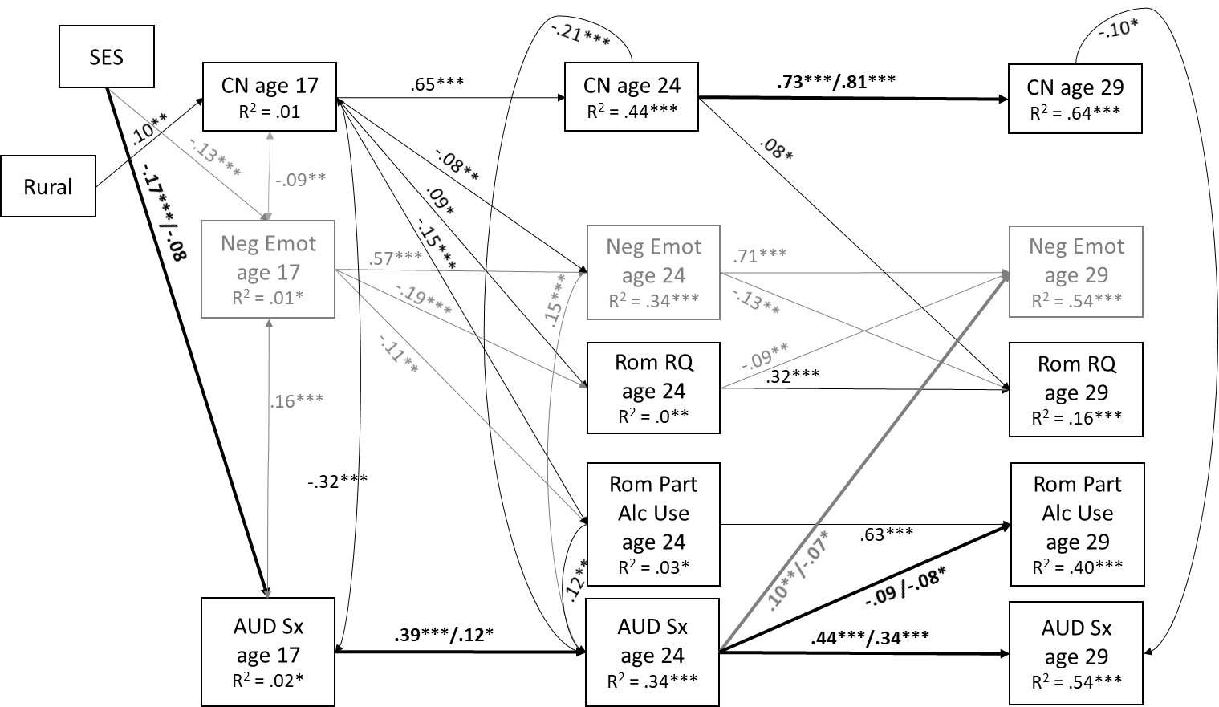
eFigure 2. Cross-lagged panel results for those in the younger cohort (N = 1,448). SES = socioeconomic status, CN = constraint, Neg Emot = negative emotionality, AUD Sx = alcohol use disorder symptoms, Rom RQ = romantic relationship quality, Rom Part Alc Use = romantic partner alcohol use. Results are shown in terms of standardized coefficients. All paths corresponding to a significant difference in gender from the multi-group model are shown in bold with results for males (n = 724) presented before the slash and females (n = 724) after the slash. For those results that were not significantly different by gender, standardized coefficients from the model that combined males and females are provided. R²s are also provided from the model that combined males and females. Paths and coefficients involving negative emotionality are shown in gray for clarity of presentation. Paths representing correlations between within assessment constructs (e.g., personality at age 17 and AUD symptoms at age 29) refer to residual correlations. All paths that were not significantly different than zero are not shown for clarity of presentation; see eTable 3 for detailed results in terms of unstandardized coefficients, including those from all interaction terms (none met the conservative threshold of p < .002).

Statistical significance is denoted by ***p < .001, **p < .01, *p <.05
eTable 4. Unstandardized coefficients (standard errors) from cross-lagged panel models for the older cohort only (N = 1,252)ª
Path | Whole-Group Model  (Males + Females)¹  (N = 1,206) |  | Multiple-Group Model  (Males vs. Females)²
 |  |  | Males  (n = 561) | Females  (n = 645) | ΔSB χ²  (1 df)
 | B (S.E.) |  | B (S.E.) | B (S.E.)
Covariates
- SES -> CN age 17 | -1.18 (.91) |  | -2.10 (.87) | -.63 (1.28) | .72
- SES -> NE age 17 | -1.81 (.55)** |  | -.46 (.96) | -2.75 (.92)** | 3.05
- SES -> AUD Sx age 17 | -.09 (.03)** |  | -.16 (.04)*** | -.03 (.04) | 7.39**
- Rural status -> CN age 17 | 2.69 (1.20)* |  | 3.21 (1.61)* | 1.86 (1.66) | .32
- Rural status -> NE age 17 | -1.10 (.94) |  | -1.67 (1.34) | -.74 (1.30) | .20
- Rural status -> AUD Sx age 17 | .01 (.04) |  | -.05 (.06) | .08 (.05) | 2.87
Stability paths
- CN age 17 -> CN age 24 | .63 (.03)*** |  | .68 (.05)*** | .52 (.04)*** | 7.27**
- CN age 24 -> CN age 29 | .77 (.02)*** |  | .73 (.03)*** | .79 (.03)*** | 1.33
- NE age 17 -> NE age 24 | .55 (.03)*** |  | .52 (.05)*** | .57 (.04)*** | .48
- NE age 24 -> NE age 29 | .74 (.02)*** |  | .71 (.04)*** | .75 (.031)*** | .59
- AUD Sx age 17 -> AUD Sx age 24 | .35 (.04)*** |  | .39 (.05)*** | .29 (.06)*** | 1.50
- AUD Sx age 24 -> AUD Sx age 29 | .35 (.03)*** |  | .34 (.04)*** | .23 (.04)*** | 2.85
Cross-paths
- CN age 17 -> Rom RQ age 29 | .004 (.002) |  | .005 (.004) | .003 (.003) | .18
- CN age 17 -> Rom part alc use age 29 | -.004 (.005) |  | -.009 (.009) | -.002 (.006) | .39
- CN age 17 -> NE age 24 | -.04 (.03) |  | -.04 (.04) | -.02 (.04) | .06
- CN age 17 -> AUD Sx age 24 | .001 (.002) |  | .002 (.003) | .000 (.002) | .24
- NA age 17 -> Rom RQ age 29 | .000 (.002) |  | .004 (.004) | -.003 (.003) | 2.15
- NA age 17 -> Rom part alc use age 29 | .01 (.01) |  | .01 (.01) | .009 (.008) | .13
- NE age 17 -> CN age 24 | .02 (.04) |  | .05 (.05) | .02 (.04) | .18
- NE age 17 -> AUD Sx age 24 | .000 (.002) |  | -.001 (.003) | .001 (.002) | .27
- AUD Sx age 17 -> Rom RQ age 29 | -.09 (.07) |  | -.009 (.07) | -.17 (.11) | 1.79
- AUD Sx age 17 -> Rom part alc use age 29 | .17 (.13) |  | .18 (.19) | .09 (.16) | .14
- AUD Sx age 17 -> CN age 24 | .82 (.87) |  | .28 (1.01) | 1.44 (1.24) | .52
- AUD Sx age 17 -> NE age 24 | 1.40 (.87) |  | 2.48 (1.04)* | .25 (1.36) | 1.66
- CN age 24 -> Rom RQ age 29 | .000 (.002) |  | .001 (.004) | .001 (.003) | .02
- CN age 24 -> Rom part alc use age 29 | .002 (.006) |  | -.008 (.009) | -.007 (.008) | .06
- CN age 24 -> NE age 29 | -.01 (.02) |  | -.02 (.03) | .02 (.03) | .48
- CN age 24 -> AUD Sx age 29 | -.002 (.002) |  | -.002 (.003) | .001 (.002) | .96
- NE age 24 -> Rom RQ age 29 | -.009 (.002)*** |  | -.009 (.004)* | -.01 (.003)** | .003
- NE age 24 -> Rom part alc use age 29 | -.007 (.006) |  | -.02 (.01) | .003 (.008) | 2.59
- NE age 24 -> CN age 29 | .02 (.02) |  | .002 (.04) | .03 (.03) | .32
- NE age 24 -> AUD Sx age 29 | -.001 (.002) |  | -.003 (.003) | .000 (.002) | .37
- AUD Sx age 24 -> CN age 29 | -1.43 (.53)** |  | -.90 (.70) | -2.00 (.77)** | 1.15
- AUD Sx age 24 -> NE age 29 | .39 (.49) |  | .10 (.63) | .51 (.89) | .12
- AUD Sx age 24 -> Rom RQ age 29 | -.04 (.04) |  | -.08 (.06) | -.02 (.08) | .46
- AUD Sx age 24 -> Rom part alc use age 29 | .08 (.11) |  | .31 (.15)* | .34 (.16)* | .05
Concurrent Interactions
(controlling for main effects, shown in letters)
a. CN age 29 -> AUD Sx age 29 | -.005 (.002)** |  | -.003 (.003) | -.005 (.002)** | .20
b. NE age 29 -> AUD Sx age 29 | .006 (.002)*** |  | .008 (.003)* | .005 (.002)* | .71
c. Rom RQ age 29 -> AUD Sx age 29 | -.06 (.03)* |  | -.02 (.05) | -.10 (.03)** | 2.30
d. Rom part alc use age 29 -> AUD Sx  age 29 | .03 (.01)* |  | .06 (.02)** | .04 (.01)** | .45
1. CN age 29 x Rom RQ age 29 -> AUD  Sx age 29 | .001 (.001) |  | -.003 (.003) | .004 (.002)* | 10.11**
2. CN age 29 x Rom part alc use age 29 ->  AUD Sx age 29 | -.002 (.001)** |  | .000 (.001) | -.002 (.001)*** | 4.71*
3. NE age 29 x Rom RQ age 29 -> AUD  Sx age 29 | -.004 (.002) |  | -.006 (.003)* | -.002 (.002) | 1.13
4. NE age 29 x Rom part alc use age 29 ->  AUD Sx age 29 | .000 (.001) |  | .000 (.002) | .001 (.001) | .05
Residual correlations
- CN age 17 <-> NE age 17 | -21.13 (7.02)** |  | -11.74 (9.16) | -20.59 (9.93)* | .44
- CN age 17 <-> AUD Sx age 17 | -2.28 (.34)*** |  | -1.81 (.46)*** | -2.35 (.51)*** | .68
- NE age 17 <-> AUD Sx age 17 | 1.22 (.28)*** |  | 1.09 (.40)* | 1.35 (.39)** | .37
- CN age 24 <-> NE age 24 | -12.50 (5.07)* |  | -20.34 (6.67)** | -.31 (7.08) | 4.65*
- CN age 29 <-> NE age 29 | 1.38 (3.26) |  | -6.11 (5.49) | 2.74 (3.95) | 1.65
R² |  |  | R² (males) | R² (females)
- CN17 | .01 |  | .02 | .01 | --
- CN24 | .40*** |  | .43*** | .32*** | --
- CN29 | .63*** |  | .61*** | .59*** | --
- NA17 | .01 |  | .00 | .02 | --
- NA24 | .30*** |  | .27*** | .31*** | --
- NA29 | .57*** |  | .51*** | .60*** | --
- ALC17 | .02 |  | .04* | .01 | --
- ALC24 | .22*** |  | .18*** | .18*** | --
- ALC29 | .31*** |  | .28*** | .29*** | --
- RomRQ29 | .06** |  | .06* | .08* | --
- Rom part alc use 29 | .01 |  | .06* | .04* | --
Notes. SES = baseline socioeconomic status, CN = constraint, NE = negative emotionality, AUD Sx = alcohol use disorder symptoms, Rom RQ = Romantic relationship quality, Rom part alc use = Romantic partner’s past year frequency of alcohol use. This table shows results from the full cross-lagged models in terms of unstandardized coefficients (standard errors). Results for the older cohort are provided in addition to group differences by gender as there were limited gender differences in cross-effects. All interaction terms were also correlated in this model but are not shown for clarity of presentation. For coefficients that were < .01, results are presented in three decimal points, otherwise they are presented in two decimal points. Significant differences in the unstandardized estimates by gender were tested using the Satorra Bentler chi-square difference test (ΔSB χ²) for all estimates except for the indirect effects; for these the Wald test of parameter constraints was used. Coefficients shown in gray for the multi-group model (males vs. females) are not significantly different across gender. Coefficients shown in gray for the whole sample (males + females) are significantly different across gender. Statistical significance is denoted by ***p < .001, **p < .01, *p <.05
ª Note, the older cohort did not assess romantic relationship quality or romantic partner alcohol use at age 24, therefore these are excluded from the model.
¹ Fit statistics: χ² (78) = 212.81, p < .001; RMSEA = .04 (95% CI: .03, .04); CFI = .95; RMSEA = .05
² Fit statistics: χ² (160) = 492.871, p < .001; RMSEA = .06 (95% CI: .05, .07); CFI = .87; RMSEA = .07
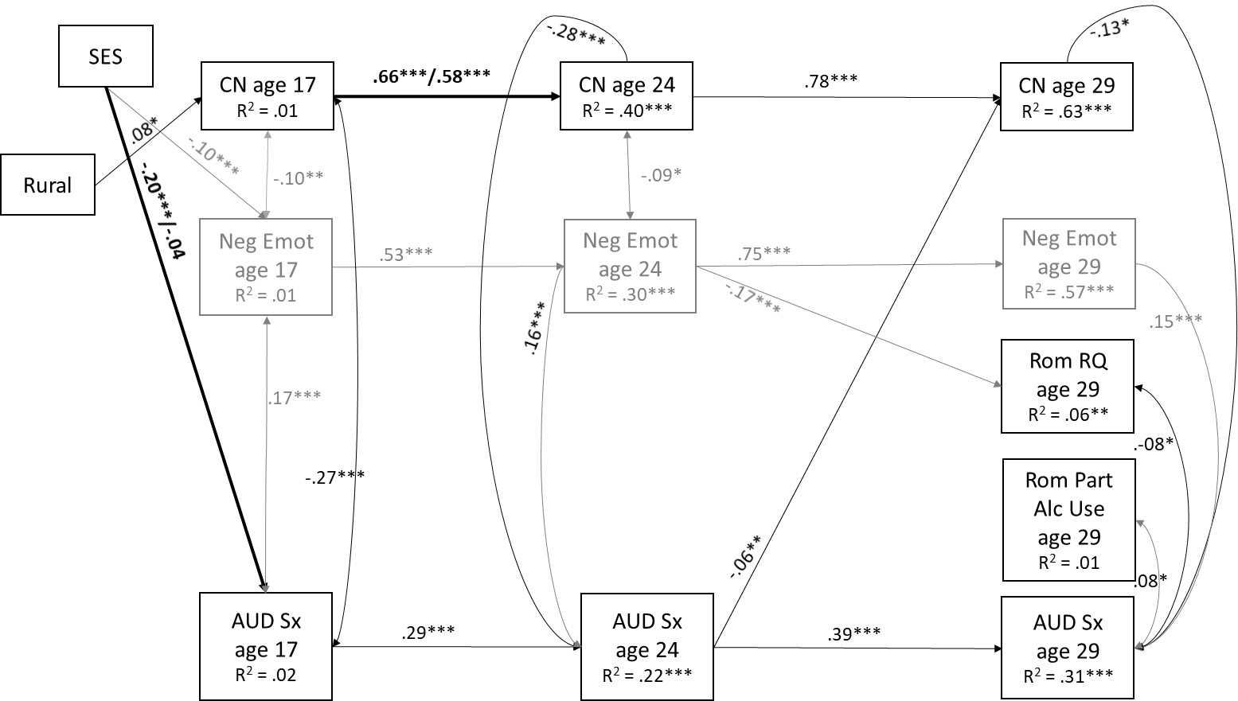

eFigure 3. Cross-lagged panel results for those in the older cohort (N = 1,206). SES = socioeconomic status, CN = constraint, Neg Emot = negative emotionality, AUD Sx = alcohol use disorder symptoms, Rom RQ = romantic relationship quality, Rom Part Alc Use = romantic partner alcohol use. Results are shown in terms of standardized coefficients. All paths corresponding to a significant difference in gender from the multi-group model are shown in bold with results for males (n = 561) presented before the slash and females (n = 645) after the slash. For those results that were not significantly different by gender, standardized coefficients from the model that combined males and females are provided. R²s are also provided from the model that combined males and females. Paths and coefficients involving negative emotionality are shown in gray for clarity of presentation. Paths representing correlations between within assessment constructs (e.g., personality at age 17 and AUD symptoms at age 29) refer to residual correlations. All paths that were not significantly different than zero are not shown for clarity of presentation; see eTable 4 for detailed results in terms of unstandardized coefficients, including those from all interaction terms (none met the conservative threshold of p < .002).
ª Note, the older cohort did not assess romantic relationship quality or romantic partner alcohol use at age 24, therefore these are excluded from the model.
Statistical significance is denoted by ***p < .001, **p < .01, *p <.05

