Supplemental Materials
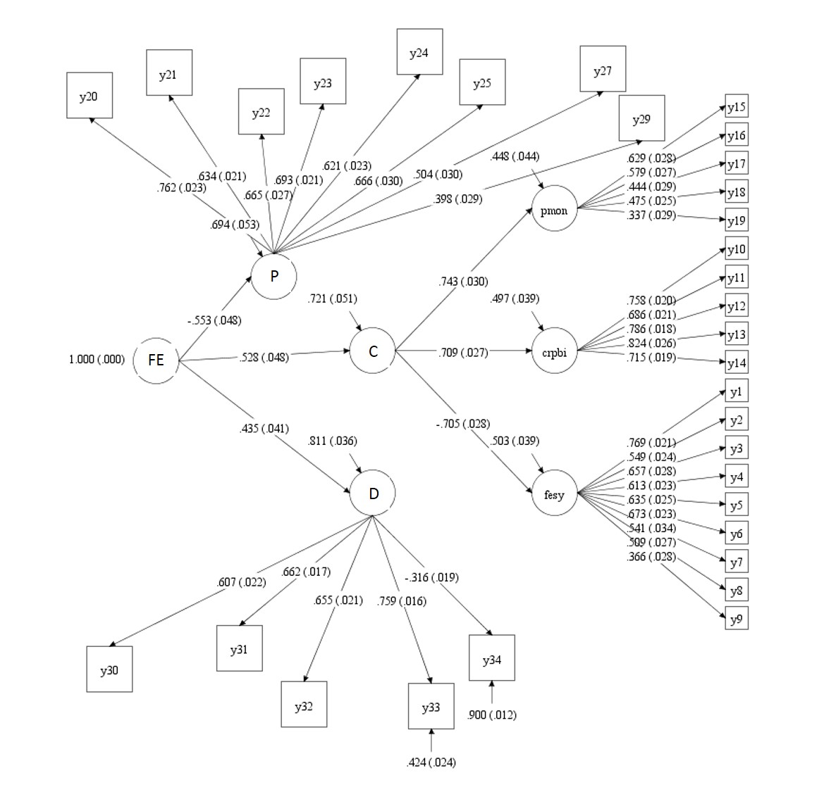
Figure S1. Structural Equation Model Family Environment. FE = Family Environment; P = Parent-reported latent variable; C = Child-report latent variable; D = Demographic and parental latent variable; pmon = Parental monitoring latent variable; crpbi = Child report of parent behavior inventory latent variable; fesy = Family Environment Scale youth report latent variable; y1-y9 = items of Conflict Scale of FESY; y10-y14 = Items of Parental acceptance scale of CRPBI; y15-y19 = items of Parental Monitory Scale; y20-y25, y27 = Items of Conflict scale of FES parent report; y29 = KSADS item on parent-child conflict; y30 = planned pregnancy; y31 = parental education; y32 = parental separation; y33 = family income; y34 = parental psychopathology

Table S1. Correlations among brain measures of motor processing
 | Precentral CA | Precentral FA | SOMM-L Amygdala FC | SOMM- R Amygdala FC
Precentral CT | -0.423 | .204 | .067 | -.034
Precentral CA |  | -.114 | -.040 | -.008
Precentral FA |  |  | -.034 | .040
SOMM-L Amygdala FC |  |  |  | -.197
Note. SOMM = somatomotor-mouth network; FC = functional connectivity; CT = cortical thickness; CA = cortical area; FA = fractional anisotropy.

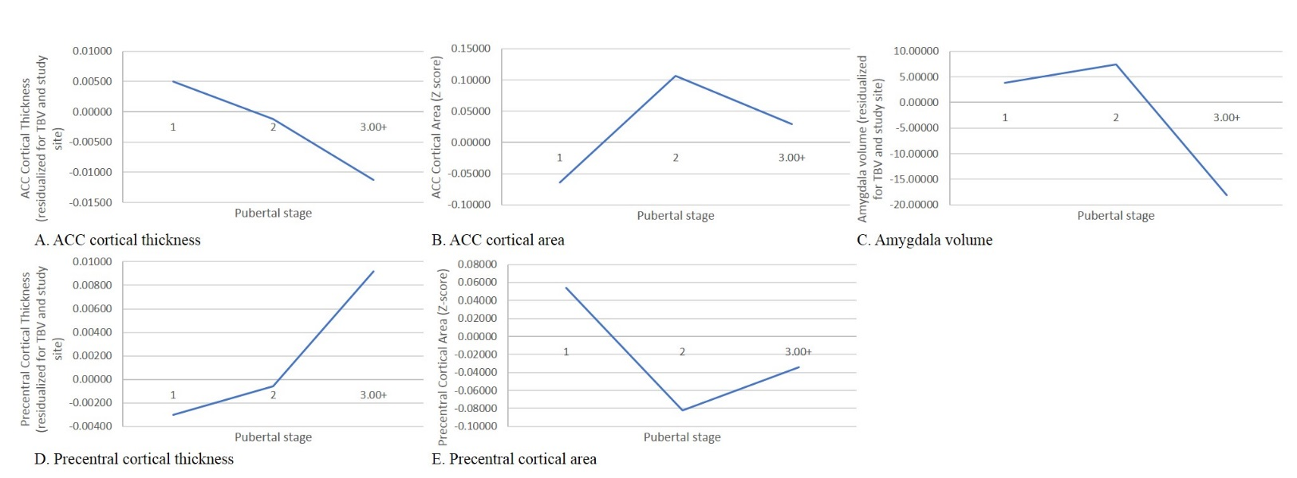
Figure S2. Gray matter by pubertal stage: A. anterior cingulate cortical thickness, B. anterior cingulate cortical area, C. amygdala volume, D. precentral cortical thickness, E. precentral cortical area. Note: ACC = anterior cingulate cortex; TBV = total brain volume

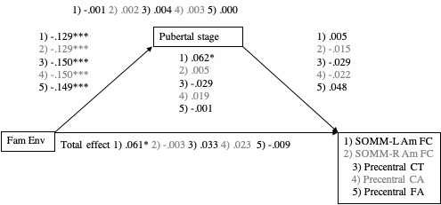
Figure S3. Mediation model of the association between Family Environment and motor processing measures. Values are standardized coefficients. * p < .01, ** p < .01, *** p < .001. Fam Env = Family environment; SOMM-Am FC = somatomotor-mouth network-amygdala functional connectivity; CT = cortical thickness; CA = cortical area; FA = fractional anisotropy.

Table S2. Quadratic mediation model of ACC CA and amygdala volume
 | Model of ACC CA |  |  |  |  |  |  | Amygdala volume
 | R | R² | F | p |  | Df1 | Df2 | R | R² | F | p | Df1 | Df2
 | .113 | .013 | 3.998 | <.001 |  | 8 | 2474 | 0.146 | 0.021 | 6.733 | <.001 | 8 | 2474
 | b | SE | t | p |  |  |  | b | SE | t | p
Constant | -0.850 | 0.354 | -2.400 | 0.017 |  |  |  | -0.662 | 0.352 | -1.878 | .061
Fam Env ∞ | -0.006 | 0.037 | -0.151 | .880 |  |  |  | 0.044 | 0.037 | 1.209 | .227
Pubertal stage | 0.384 | 0.144 | 2.663 | .008 |  |  |  | 0.173 | 0.143 | 1.205 | .229
Pubertal stage² ⁺ | -0.098 | 0.035 | -2.773 | .006 |  |  |  | -0.039 | 0.035 | -1.109 | .268
Age | 0.005 | 0.003 | 1.892 | .059 |  |  |  | 0.003 | 0.003 | 1.087 | .277
Sex | -0.191 | 0.046 | -4.148 | <.001 |  |  |  | 0.266 | 0.046 | 5.785 | <.001
Black | 0.096 | 0.080 | 1.201 | .230 |  |  |  | -0.166 | 0.079 | -2.089 | .037
Hispanic | -0.003 | 0.051 | -0.052 | .959 |  |  |  | -0.074 | 0.050 | 1.471 | .141
Other | 0.008 | 0.065 | 0.121 | .904 |  |  |  | -0.025 | 0.065 | -0.381 | .704
Model of pubertal stage | R | Rsq | F | p |  | Df1 | Df2 | R | Rsq | F | p | Df1 | Df2
 | 0.559 | 0.312 | 187.530 | <.001 |  | 6 | 2476 | 0.559 | 0.312 | 187.530 | <.001 | 6 | 2476
 | b | SE | t | p |  |  |  | b | SE | t | p
Constant | -0.748 | 0.234 | -3.201 | 0.017 |  |  |  | -0.748 | 0.234 | -3.201 | 0.014
Fam Env^{ƒ} | -0.144 | 0.026 | -5.568 | <.001 |  |  |  | -0.144 | 0.026 | -5.568 | <.001
Age | 0.023 | 0.002 | 11.775 | <.001 |  |  |  | 0.023 | 0.002 | 11.775 | <.001
Sex | -0.798 | 0.028 | -28.149 | <.001 |  |  |  | -0.799 | 0.028 | -28.149 | <.001
Black | 0.633 | 0.055 | 11.541 | <.001 |  |  |  | 0.633 | 0.055 | 11.541 | <.001
Hispanic | 0.259 | 0.035 | 7.308 | <.001 |  |  |  | 0.259 | 0.035 | 7.308 | <.001
Other | 0.167 | 0.046 | 3.642 | <.001 |  |  |  | 0.168 | 0.046 | 3.642 | <.001
Note. ∞ = direct effect; ⁺ = indirect effect step 2; ^{ƒ} = indirect effect step 1.

Text S1. Mediation models of motor processing areas
Gray matter
There were no significant total, direct or indirect effects of Family Environment on motor processing gray matter measures (CT: β = 0.033, p = 107, β = 0.029, p = .169, β = 0.004, p = 0.361. for total, direct and indirect effects, respectively; CA: β = 0.023, p = .289, β = ,0.019 p = .378, β = 0.003, p = .455 for total, direct and indirect effects, respectively), nor did we find evidence for surface area quadratic mediation.
None of the stratified precentral CT analyses provided significant results (precentral CT: girls: β = 0.011, p = .719, β = 0.007, p = .816, β = 0.004, p = .637 for total, direct and indirect effects, respectively; boys β = 0.036, p = .209, β = 0.033, p = .258, β = .003, p = .576 for total, direct and indirect effects, respectively.
For precentral CA, no significant associations were found for girls (girls: β = 0.018, p = .559, β = 0.015, p = .632, β = 0.003, p = .694 for total, direct and indirect linear effects, respectively). Nor did we find evidence for non-linear mediation. We found no evidence for linear or non-linear mediation in boys (β = 0.036, p = .235, β = 0.031, p = .318, β = 0.006, p = .347 for total, direct and indirect effects, respectively).
White matter
Neither in the total sample, nor in the stratified analyses did we find significant total, direct or indirect associations between Family Environment and precentral FA (total: β = -0.009, p = .703, β = -0.001, p = .950, β = -0.007, p = .155 for total, direct and indirect effects, respectively; girls: β = 0.003 p = .935, β = 0.007, p = .854, β = -0.004, p = .573 for total, direct and indirect effects, respectively; boys β = -0.018, p = .536, β = -0.005, p = .865, β = -0.013, p = .113 for total, direct and indirect effects, respectively).
Resting-state fMRI
For the resting-state model with motor processing measures only the total and direct effects of Family Environment on SOMM-left amygdala FC were significant (β = .061, p = .003, β = .062, p = .003, respectively), but not the indirect effect (β = -0.001, p = .894). No associations between Family Environment and SOMM-right amygdala were found (β = -0.003, p = .878, β = -0.005, p = .817, β = 0.002, p = .663, for total, direct, and indirect effects, respectively).
For the resting-state model with motor processing measures, in girls the total, and direct effects, and in boys only the total effect of Family Environment on SOMM- left amygdala FC were significant (girls: β = 0.093, p = .002, β = 0.083, p = .007, β = 0.010, p = .107 for total, direct and indirect effects, respectively; boys β = 0.056, p = .073, β = 0.050, p = .115, β = 0.006, p = .360. for total, direct and indirect effects, respectively). No significant associations were found between Family Environment and SOMM-right amygdala (girls: β = 0.060, p = .070, β = 0.055, p = .107, β = 0.005, p = .378 for total, direct and indirect effects, respectively; boys β = -0.026, p = .390, β = -0.032, p = .316, β = 0.005, p = .351 for total, direct and indirect effects, respectively).

Table S3. Mediation model parameters – precentral cortex cortical thickness and area
 | Precental cortical thickness |  |  |  | Precentral cortical area
 | β | S.E. | β/S.E. | p | β | S.E. | β /S.E. | p
Family Environment∞ | 0.029 | 0.021 | 1.376 | .169 | 0.019 | 0.022 | 0.882 | .378
Pubertal stage⁺ | -0.029 | 0.031 | -0.929 | .353 | -0.022 | 0.029 | -0.766 | .443
Age | -0.007 | 0.020 | -0.332 | .740 | 0.019 | 0.021 | 0.884 | .377
Sex | -0.144 | 0.025 | -5.814 | .000 | 0.065 | 0.024 | 2.694 | .007
Race | -0.025 | 0.021 | -1.184 | .236 | -0.001 | 0.021 | -0.060 | .952
 | Outcome: pubertal stage |  |  |  | Outcome: pubertal stage
Family Environment^{ƒ} | -0.150 | 0.020 | -7.442 | <.001 | -0.150 | 0.020 | -7.442 | <.001
Age | 0.218 | 0.019 | 11.392 | <.001 | 0.218 | 0.019 | 11.392 | <.001
Sex | -0.511 | 0.015 | -33.433 | <.001 | -0.511 | 0.015 | -33.433 | <.001
Race | 0.136 | 0.020 | 6.807 | <.001 | 0.136 | 0.020 | 6.806 | <.001
Note. ∞ = direct effect; ⁺ = indirect effect step 2; ^{ƒ} = indirect effect step 1.

Table S4. Quadratic mediation of precentral cortical area by pubertal stage

 | R | R² | F | p | Df1 | Df2
 | .093 | .009 | 2.701 | .006 | 8 | 2474
 | b | SE | t | p
Constant | -0.049 | 0.356 | -0.139 | .890
Fam Env ∞ | 0.030 | 0.037 | 0.789 | .430
Pubertal stage | -0.283 | 0.145 | -1.957 | .050
Pubertal stage² ⁺ | 0.069 | 0.035 | 1.960 | .050
Age | 0.002 | 0.003 | 0.629 | .529
Sex | 0.150 | 0.046 | 3.244 | .001
Black | -0.116 | 0.080 | -1.442 | .149
Hispanic | -0.001 | 0.051 | -0.010 | .992
Other | -0.007 | 0.046 | -0.103 | .918
Model of pubertal stage | R | R² | F | p | Df1 | Df2
 | 0.559 | 0.312 | 187.530 | <.001 | 6 | 2476
 | b | SE | t | p
Constant | -0.748 | 0.233 | -3.201 | 0.014
Fam Env^{ƒ} | -0.144 | 0.026 | -5.568 | <.001
Age | 0.023 | 0.002 | 11.775 | <.001
Sex | -0.799 | 0.028 | -28.149 | <.001
Black | 0.633 | 0.055 | 11.541 | <.001
Hispanic | 0.259 | 0.035 | 7.308 | <.001
Other | 0.168 | 0.046 | 3.642 | <.001
Note. ∞ = direct effect; ⁺ = indirect effect step 2; ^{ƒ} = indirect effect step 1.

Table S5. Mediation model parameters – precentral cortex white matter fractional anisotropy
 | β | S.E. | β/S.E. | p
Family Environment∞ | -0.001 | 0.023 | -0.063 | .950
Pubertal stage⁺ | 0.048 | 0.033 | 1.482 | .138
Age | 0.081 | 0.022 | 3.721 | .000
Sex | -0.053 | 0.026 | -2.035 | .042
Race | 0.039 | 0.023 | 1.714 | .086
 | Outcome: pubertal stage
Family Environment^{ƒ} | -0.149 | 0.022 | -6.894 | <.001
Age | 0.213 | 0.022 | 9.609 | <.001
Sex | -0.507 | 0.017 | -29.495 | <.001
Race | 0.141 | 0.021 | 6.695 | <.001
Note. ∞ = direct effect; ⁺ = indirect effect step 2; ^{ƒ} = indirect effect step 1.

Table S6. Mediation model parameters – somatomotor-mouth network-amygdala connectivity
 | SOMM-left amygdala |  |  |  | SOMM-right amygdala
 | β | S.E. | β/S.E. | p | β | S.E. | β /S.E. | p
Family Environment∞ | 0.062 | 0.021 | 2.946 | .003 | -0.005 | 0.023 | -0.232 | .817
Pubertal stage⁺ | 0.005 | 0.033 | 0.135 | .892 | -0.015 | 0.033 | -0.444 | .657
Age | -0.018 | 0.020 | -0.842 | .400 | -0.012 | 0.024 | -0.494 | .622
Sex | 0.002 | 0.026 | 0.079 | .937 | 0.008 | 0.027 | 0.312 | .755
Race | -0.015 | 0.021 | -0.708 | .479 | -0.016 | 0.021 | -0.759 | .448
 | Outcome: pubertal stage |  |  |  | Outcome: pubertal stage
Family Environment^{ƒ} | -0.129 | 0.020 | -6.530 | <.001 | -0.129 | 0.020 | -6.530 | <.001
Age | 0.231 | 0.020 | 11.483 | <.001 | 0.231 | 0.020 | 11.483 | <.001
Sex | -0.508 | 0.015 | -32.913 | <.001 | -0.508 | 0.015 | -32.913 | <.001
Race | 0.140 | 0.020 | 7.131 | <.001 | 0.140 | 0.020 | 7.131 | <.001
Note. ∞ = direct effect; ⁺ = indirect effect step 2; ^{ƒ} = indirect effect step 1; SOMM = somato-motor mouth network.

Table S7. Mediation model parameters – anterior cingulate cortical thickness and area and amygdala volume in girls
 | ACC cortical thickness |  |  |  | ACC cortical area |  |  |  | Amygdala volume
 | β | S.E. | β/S.E. | p | β | S.E. | β /S.E. | p | β | S.E. | β /S.E. | p
Fam Env∞ | -0.026 | 0.031 | -0.838 | 0.402 | -0.028 | 0.030 | -0.919 | 0.358 | -0.034 | 0.056 | -0.603 | 0.546
Pubertal stage⁺ | -0.100 | 0.037 | -2.714 | 0.007 | 0.000 | 0.039 | -0.003 | 0.998 | 0.048 | 0.089 | 0.536 | 0.592
Age | -0.112 | 0.029 | -3.800 | 0.000 | 0.024 | 0.031 | 0.761 | 0.447 | -0.011 | 0.028 | -0.374 | 0.709
Race | 0.004 | 0.031 | 0.125 | 0.901 | -0.002 | 0.029 | -0.068 | 0.945 | -0.018 | 0.062 | -0.297 | 0.767
 | Outcome: pubertal stage |  |  |  | Outcome: pubertal stage |  |  |  | Outcome: pubertal stage
Fam Env^{ƒ} | -0.198 | 0.031 | -6.492 | 0.000 | -0.198 | 0.031 | -6.492 | 0.000 | -0.211 | 0.033 | -6.357 | 0.000
Age | 0.304 | 0.029 | 10.389 | 0.000 | 0.304 | 0.029 | 10.389 | 0.000 | 0.303 | 0.032 | 9.607 | 0.000
Race | 0.118 | 0.032 | 3.743 | 0.000 | 0.118 | 0.032 | 3.743 | 0.000 | 0.19 | 0.035 | 3.448 | 0.001
Note. ∞ = direct effect; ⁺ = indirect effect step 2; ^{ƒ} = indirect effect step 1; ACC = anterior cingulate cortex

Table S8. Mediation model parameters – anterior cingulate white matter fractional anisotropy in girls
 | β | S.E. | β/S.E. | p
Family Environment∞ | -0.038 | 0.037 | -1.042 | 0.298
Pubertal stage⁺ | 0.129 | 0.039 | 3.331 | 0.001
Age | 0.019 | 0.034 | 0.573 | 0.567
Race | 0.026 | 0.034 | 0.761 | 0.447
 | Outcome: pubertal stage
Family Environment^{ƒ} | -0.156 | 0.033 | -4.721 | 0.000
Age | 0.292 | 0.033 | 8.893 | 0.000
Race | 0.126 | 0.034 | 3.738 | 0.000
Note. ∞ = direct effect; ⁺ = indirect effect step 2; ^{ƒ} = indirect effect step 1.

Table S9. Mediation model parameters – cinculo-opercular network-amygdala connectivity in girls
 | CON-left amygdala |  |  |  | CON-right amygdala
 | β | S.E. | β/S.E. | p | β | S.E. | β /S.E. | p
Family Environment∞ | 0.090 | 0.031 | 2.904 | .004 | 0.053 | 0.034 | 1.551 | .121
Pubertal stage⁺ | -0.070 | 0.035 | -2.004 | .045 | -0.039 | 0.036 | -1.068 | .286
Age | -0.014 | 0.032 | -0.0440 | .660 | 0.020 | 0.030 | 0.645 | 0.519
Race | -0.051 | 0.032 | -1.607 | .108 | -0.057 | 0.031 | -1.866 | .062
 | Outcome: pubertal stage |  |  |  | Outcome: pubertal stage
Family Environment^{ƒ} | -0.158 | 0.032 | -4.985 | 0.000 | -0.158 | 0.032 | -4.985 | 0.000
Age | 0.305 | 0.029 | 10.392 | 0.000 | 0.305 | 0.029 | 10.392 | 0.000
Race | 0.115 | 0.032 | 3.573 | 0.000 | 0.115 | 0.032 | 3.573 | 0.000
Note. ∞ = direct effect; ⁺ = indirect effect step 2; ^{ƒ} = indirect effect step 1; CON = cingulo-opercular network

Table S10. Mediation model parameters – anterior cingulate cortical thickness and area and amygdala volume in boys
 | ACC cortical thickness |  |  |  | ACC cortical area |  |  |  | Amygdala volume
 | β | S.E. | β/S.E. | p | β | S.E. | β /S.E. | p | β | S.E. | β /S.E. | p
Fam Env∞ | 0.018 | 0.029 | 0.623 | 0.533 | 0.001 | 0.031 | 0.037 | 0.970 | 0.077 | 0.046 | 1.661 | 0.097
Pubertal stage⁺ | -0.054 | 0.037 | -1.433 | 0.152 | 0.012 | 0.036 | 0.327 | 0.744 | -0.042 | 0.090 | -0.470 | 0.638
Age | -0.101 | 0.029 | -3.538 | 0.262 | 0.043 | 0.029 | 1.456 | 0.143 | 0.014 | 0.018 | 0.754 | 0.451
Race | -0.034 | 0.031 | -1.121 | 0.000 | 0.009 | 0.07 | 0.328 | 0.743 | 0.033 | 0.047 | 0.690 | 0.490
 | Outcome: pubertal stage |  |  |  | Outcome: pubertal stage |  |  |  | Outcome: pubertal stage
Fam Env^{ƒ} | -0.141 | 0.034 | -4.102 | 0.000 | -0.141 | 0.034 | -4.102 | 0.000 | -0.108 | 0.035 | -3.108 | 0.002
Age | 0.182 | 0.034 | 5.354 | 0.000 | 0.182 | 0.034 | 5.354 | 0.000 | 0.193 | 0.037 | 5.200 | 0.000
Race | 0.202 | 0.031 | 6.487 | 0.000 | 0.202 | 0.031 | 6.487 | 0.000 | 0.214 | 0.032 | 6.687 | 0.000
Note. ∞ = direct effect; ⁺ = indirect effect step 2; ^{ƒ} = indirect effect step 1; ACC = anterior cingulate cortex

Table S11. Mediation model parameters – anterior cingulate white matter fractional anisotropy in boys
 | β | S.E. | β/S.E. | p
Family Environment∞ | -0.077 | 0.028 | -2.721 | 0.007
Pubertal stage⁺ | -0.007 | 0.042 | -0.167 | 0.867
Age | 0.030 | 0.031 | 0.963 | 0.085
Race | 0.057 | 0.033 | 1.724 | 0.336
 | Outcome: pubertal stage
Family Environment^{ƒ} | -0.185 | 0.035 | -5.352 | 0.000
Age | 0.208 | 0.036 | 6.058 | 0.000
Race | 0.183 | 0.034 | 5.044 | 0.000
Note. ∞ = direct effect; ⁺ = indirect effect step 2; ^{ƒ} = indirect effect step 1.

Table S12. Mediation model parameters – cinculo-opercular network-amygdala connectivity in boys
 | CON-left amygdala |  |  |  | CON-right amygdala
 | β | S.E. | β/S.E. | p | β | S.E. | β /S.E. | p
Family Environment∞ | 0.039 | 0.030 | 1.286 | 0.198 | 0.011 | 0.032 | 0.334 | 0.738
Pubertal stage⁺ | -0.038 | 0.041 | -0.940 | 0.347 | -0.064 | 0.040 | -1.596 | 0.111
Age | 0.042 | 0.031 | 1.375 | 0.169 | 0.041 | 0.029 | -0.410 | 0.682
Race | -0.029 | 0.029 | -1.017 | 0.309 | -0.012 | 0.030 | 1.363 | 0.173
 | Outcome: pubertal stage |  |  |  | Outcome: pubertal stage
Family Environment^{ƒ} | -0.140 | 0.033 | -4.202 | 0.000 | -0.140 | 0.033 | -4.202 | 0.000
Age | 0.217 | 0.035 | 6.246 | 0.000 | 0.217 | 0.035 | 6.246 | 0.000
Race | 0.218 | 0.030 | 7.246 | 0.000 | 0.218 | 0.030 | 7.246 | 0.000
Note. ∞ = direct effect; ⁺ = indirect effect step 2; ^{ƒ} = indirect effect step 1; CON = cingulo-opercular network

Table S13. Quadratic mediation of ACC CA in boys and girls separately
ACC CA | Girls |  |  |  |  |  | Boys
 | R | R² | F | p | Df1 | Df2 | R | R² | F | p | Df1 | Df2
 | .093 | .009 | 1.433 | .188 | 7 | 1160 | .067 | .005 | 0.852 | .544 | 7 | 1307
 | b | SE | t | p |  |  | b | SE | t | p
Constant | -0.865 | 0.521 | -1.660 | .097 |  |  | -0.940 | 0.493 | -1.908 | .057
Fam Env∞ | -0.036 | 0.054 | -0.678 | .498 |  |  | 0.017 | 0.051 | 0.331 | .741
Pubertal stage | 0.525 | 0.193 | 2.717 | .007 |  |  | 0.123 | 0.242 | 0.509 | .611
Pubertal stage² ⁺ | -0.131 | 0.045 | -2.869 | .004 |  |  | -0.027 | 0.065 | -0.418 | .676
Age | 0.005 | 0.004 | 1.116 | .265 |  |  | 0.006 | 0.004 | 1.554 | .120
Black | 0.022 | 0.116 | 0.190 | .849 |  |  | 0.157 | 0.111 | 1.416 | .157
Hispanic | -0.061 | 0.073 | -.844 | .399 |  |  | 0.044 | 0.071 | 0.625 | .532
Other | -0.046 | 0.090 | -0.509 | .611 |  |  | 0.060 | 0.095 | 0.629 | .530
Model of pubertal stage | R | R² | F | P | Df1 | Df2 | R | R² | F | p | Df1 | Df2
 | .409 | .167 | 46.601 | <.001 | 5 | 1162 | .328 | .108 | 31.655 | <.001 | 5 | 1309
 | b | SE | t | P |  |  | b | SE | t | p
Constant | -2.359 | 0.403 | -5.855 | <.001 |  |  | -0.128 | 0.254 | -0.507 | .613
Fam Env^{ƒ} | -0.214 | 0.045 | -4.771 | <.001 |  |  | -0.073 | 0.028 | -2.627 | .009
Age | 0.036 | 0.003 | 10.803 | <.001 |  |  | 0.011 | 0.002 | 5.326 | <.001
Black | 0.756 | 0.095 | 7.947 | <.001 |  |  | 0.535 | 0.059 | 9.049 | <.001
Hispanic | 0.261 | 0.061 | 4.289 | <.001 |  |  | 0.253 | 0.039 | 6.556 | <.001
Other | 0.153 | 0.076 | 2.010 | .045 |  |  | 0.174 | 0.052 | 3.349 | .001
Note. ∞ = direct effect; ⁺ = indirect effect step 2; ^{ƒ} = indirect effect step 1; ACC = anterior cingulate cortex

Table S14. Quadratic mediation of amygdala volume in boys and girls separately
Amygdala volume | Girls |  |  |  |  |  | Boys
 | R | R² | F | p | Df1 | Df2 | R | R² | F | p | Df1 | Df2
 | .065 | .004 | 0.703 | .670 | 7 | 1160 | .120 | .014 | 2.715 | .009 | 7 | 1307
 | b | SE | t | p |  |  | b | SE | t | p
Constant | -0.180 | 0.491 | -0.367 | .714 |  |  | -0.819 | 0.510 | -1.606 | 0.109
Fam Env∞ | -0.040 | 0.051 | -0.792 | .429 |  |  | 0.109 | 0.052 | 2.09 | 0.037
Pubertal stage | 0.251 | 0.182 | 1.382 | .167 |  |  | 0.173 | 0.250 | 0.692 | 0.489
Pubertal stage² ⁺ | -0.053 | 0.043 | -1.241 | .215 |  |  | -0.048 | 0.067 | -0.721 | 0.471
Age | -0.002 | 0.004 | -0.370 | .711 |  |  | 0.007 | 0.004 | 1.644 | 0.100
Black | -0.146 | 0.109 | -1.333 | .183 |  |  | -0.179 | 0.115 | -1.566 | 0.118
Hispanic | -0.038 | 0.068 | -0.551 | .582 |  |  | 0.172 | 0.074 | 2.34 | 0.020
Other | -0.086 | 0.085 | -1.027 | .311 |  |  | 0.033 | 0.099 | 0.336 | 0.737
Model of pubertal stage | R | R² | F | p | Df1 | Df2 | R | R² | F | p | Df1 | Df2
 | .409 | .167 | 46.601 | <.001 | 5 | 1162 | .328 | .108 | 31.655 | <.001 | 5 | 1309
 | b | SE | t | P |  |  | b | SE | t | p
Constant | -2.359 | 0.403 | -5.855 | <.001 |  |  | -0.128 | 0.254 | -0.507 | 0.613
Fam Env^{ƒ} | -0.214 | 0.045 | -4.771 | <.001 |  |  | -0.073 | 0.028 | -2.627 | .009
Age | 0.036 | 0.003 | 10.803 | <.001 |  |  | 0.011 | 0.002 | 5.326 | <.001
Black | 0.756 | 0.095 | 7.947 | <.001 |  |  | 0.535 | 0.059 | 9.049 | <.001
Hispanic | 0.261 | 0.061 | 4.289 | <.001 |  |  | 0.253 | 0.039 | 6.556 | <.001
Other | 0.153 | 0.076 | 2.010 | .045 |  |  | 0.174 | 0.052 | 3.45 | .001
Note. ∞ = direct effect; ⁺ = indirect effect step 2; ^{ƒ} = indirect effect step 1.

Table S15. Mediation model parameters – precentral cortex cortical thickness and area in girls
 | Precental cortical thickness |  |  |  | Precentral cortical area
 | β | S.E. | β/S.E. | p | β | S.E. | β /S.E. | p
Family Environment∞ | 0.007 | 0.032 | 0.233 | 0.816 | 0.015 | 0.031 | 0.479 | 0.632
Pubertal stage⁺ | -0.019 | 0.039 | -0.478 | 0.633 | -0.015 | 0.037 | -0.398 | 0.691
Age | -0.024 | 0.029 | -0.804 | 0.421 | 0.040 | 0.031 | 1.315 | 0.189
Race | -0.048 | 0.031 | -1.528 | 0.127 | 0.010 | 0.033 | 0.293 | 0.769
 | Outcome: pubertal stage |  |  |  | Outcome: pubertal stage
Family Environment^{ƒ} | -0.198 | 0.031 | -6.492 | 0.000 | -0.198 | 0.031 | -6.492 | 0.000
Age | 0.304 | 0.029 | 10.389 | 0.000 | 0.304 | 0.029 | 10.389 | 0.000
Race | 0.118 | 0.032 | 3.743 | 0.000 | 0.118 | 0.032 | 3.743 | 0.000
Note. ∞ = direct effect; ⁺ = indirect effect step 2; ^{ƒ} = indirect effect step 1.

Table S16. Mediation model parameters – precentral cortex white matter fractional anisotropy in girls
 | β | S.E. | β/S.E. | p
Family Environment∞ | 0.007 | 0.036 | 0.184 | 0.854
Pubertal stage⁺ | 0.023 | 0.040 | 0.580 | 0.562
Age | 0.078 | 0.033 | 2.400 | 0.016
Race | 0.023 | 0.033 | 0.689 | 0.491
 | Outcome: pubertal stage
Family Environment^{ƒ} | -0.156 | 0.033 | -4.271 | 0.000
Age | 0.292 | 0.033 | 8.893 | 0.000
Race | 0.126 | 0.034 | 3.738 | 0.000
Note. ∞ = direct effect; ⁺ = indirect effect step 2; ^{ƒ} = indirect effect step 1.

Table S17. Mediation model parameters – somatomotor-mouth network-amygdala connectivity in girls
 | SOMM-left amygdala |  |  |  | SOMM-right amygdala
 | β | S.E. | β/S.E. | p | β | S.E. | β /S.E. | p
Family Environment∞ | 0.083 | 0.031 | 2.683 | .007 | 0.055 | 0.034 | 1.612 | .107
Pubertal stage⁺ | -0.060 | 0.035 | -1.719 | .086 | -0. 033 | 0.036 | -0.916 | .360
Age | -0.020 | 0.032 | -0.646 | .518 | 0.013 | 0.030 | 0.441 | .659
Race | -0.039 | 0.032 | -1.215 | .224 | -0.054 | 0.031 | -1.764 | .078
 | Outcome: pubertal stage |  |  |  | Outcome: pubertal stage
Family Environment^{ƒ} | -0.158 | 0.032 | -4.985 | .000 | -0.158 | 0.032 | -4.985 | .000
Age | 0.305 | 0.029 | 10.392 | .000 | 0.305 | 0.029 | 10.392 | .000
Race | 0.115 | 0.032 | 3.573 | .000 | 0.115 | 0.032 | 3.573 | .000
Note. ∞ = direct effect; ⁺ = indirect effect step 2; ^{ƒ} = indirect effect step 1; SOMM = somato-motor mouth network.

Table S18. Mediation model parameters – precentral cortex cortical thickness and area in boys
 | Precental cortical thickness |  |  |  | Precentral cortical area
 | β | S.E. | β/S.E. | p | β | S.E. | β /S.E. | p
Family Environment∞ | 0.033 | 0.029 | 1.132 | -.258 | 0.031 | 0.031 | -.998 | 0.318
Pubertal stage⁺ | -0.021 | 0.037 | -0.577 | 0.564 | -0.040 | 0.039 | -1.006 | 0.314
Age | 0.006 | 0.028 | 0.152 | 0.879 | 0.005 | 0.028 | 0.194 | 0.662
Race | 0.004 | 0.031 | 0.193 | 0.847 | -0.014 | 0.032 | -0.437 | 0.846
 | Outcome: pubertal stage |  |  |  | Outcome: pubertal stage
Family Environment^{ƒ} | -0.141 | 0.034 | -4.102 | 0.000 | -0.141 | 0.034 | -4.102 | 0.000
Age | 0.182 | 0.034 | 5.354 | 0.000 | 0.182 | 0.034 | 5.354 | 0.000
Race | 0.202 | 0.031 | 6.487 | 0.000 | 0.202 | 0.031 | 6.487 | 0.000
Note. ∞ = direct effect; ⁺ = indirect effect step 2; ^{ƒ} = indirect effect step 1.

Table S19. Mediation model parameters – precentral cortex white matter fractional anisotropy in boys
 | β | S.E. | β/S.E. | p
Family Environment∞ | -0.005 | 0.029 | -0.170 | 0.865
Pubertal stage⁺ | 0.069 | 0.042 | 1.655 | 0.098
Age | 0.083 | 0.030 | 2.768 | 0.006
Race | 0.050 | 0.031 | 1.584 | 0.113
 | Outcome: pubertal stage
Family Environment^{ƒ} | -0.185 | 0.035 | -5.352 | 0.000
Age | 0.208 | 0.036 | 6.058 | 0.000
Race | 0.183 | 0.034 | 5.044 | 0.000
Note. ∞ = direct effect; ⁺ = indirect effect step 2; ^{ƒ} = indirect effect step 1.

Table S20. Mediation model parameters – somatomotor-mouth network-amygdala connectivity in boys
 | SOMM-left amygdala |  |  |  | SOMM-right amygdala
 | β | S.E. | β/S.E. | p | β | S.E. | β /S.E. | p
Family Environment∞ | 0.050 | 0.032 | 1.576 | 0.115 | -0.032 | 0.032 | -1.003 | 0.316
Pubertal stage⁺ | -0.041 | 0.042 | -0.990 | 0.322 | -0.038 | 0.040 | -0.960 | 0.337
Age | -0.033 | 0.029 | -1.114 | 0.265 | -0.015 | 0.033 | -0.453 | 0.651
Race | 0.025 | 0.028 | 0.878 | 0.380 | 0.017 | 0.029 | 0.584 | 0.559
 | Outcome: pubertal stage |  |  |  | Outcome: pubertal stage
Family Environment^{ƒ} | -0.140 | 0.033 | -4.202 | 0.000 | -0.140 | 0.033 | -4.202 | 0.000
Age | 0.217 | 0.035 | 6.297 | 0.000 | 0.217 | 0.035 | 6.297 | 0.000
Race | 0.218 | 0.030 | 7.246 | 0.000 | 0.218 | 0.030 | 7.246 | 0.000
Note. ∞ = direct effect; ⁺ = indirect effect step 2; ^{ƒ} = indirect effect step 1. SOMM = somato-motor mouth network.

Table S21. Quadratic mediation of precentral CA in boys and girls separately
Precentral CA | Girls |  |  |  |  |  | Boys
 | R | R² | F | p | Df1 | Df2 | R | R² | F | p | Df1 | Df2
 | .058 | .003 | 0.554 | .794 | 7 | 1160 | .088 | .008 | 1.467 | 0.175 | 7 | 1307
 | b | SE | t | p |  |  | b | SE | t | p
Constant | -0.270 | 0.515 | -0.526 | .599 |  |  | 0.252 | 0.501 | 0.502 | .615
Fam Env∞ | 0.004 | 0.053 | 0.077 | .939 |  |  | 0.049 | 0.051 | 0.953 | .341
Pubertal stage | -0.197 | 0.191 | -1.030 | .303 |  |  | -0.334 | 0.246 | -1.359 | .174
Pubertal stage² ⁺ | 0.048 | 0.045 | 1.057 | .291 |  |  | 0.082 | 0.066 | 1.249 | .217
Age | 0.003 | 0.004 | 0.728 | .466 |  |  | 0.001 | 0.004 | 0.238 | .812
Black | 0.007 | 0.115 | 0.058 | .954 |  |  | -0.211 | 0.113 | -1.876 | .061
Hispanic | -0.055 | 0.072 | -0.774 | .439 |  |  | 0.049 | 0.073 | 0.684 | .494
Other | 0.081 | 0.089 | 0.911 | .363 |  |  | -0.010 | 0.096 | -1.035 | .301
Model of pubertal stage | R | R² | F | p | Df1 | Df2 | R | R² | F | p | Df1 | Df2
 | .409 | .167 | 46.601 | <.001 | 5 | 1162 | .328 | .108 | 31.656 | <.001 | 5 | 1309
 | b | SE | t | P |  |  | b | SE | t | p
Constant | -2.359 | 0.403 | -5.855 | <.001 |  |  | -0.128 | 0.254 | -0.507 | 0.613
Fam Env^{ƒ} | -0.214 | 0.045 | -4.771 | <.001 |  |  | -0.073 | 0.028 | -2.627 | .009
Age | 0.036 | 0.003 | 10.803 | <.001 |  |  | 0.011 | 0.002 | 5.326 | <.001
Black | 0.756 | 0.095 | 7.947 | <.001 |  |  | 0.535 | 0.059 | 9.049 | <.001
Hispanic | 0.261 | 0.061 | 4.289 | <.001 |  |  | 0.253 | 0.039 | 6.556 | <.001
Other | 0.153 | 0.076 | 2.010 | .045 |  |  | 0.174 | 0.052 | 3.35 | .001
Note. ∞ = direct effect; ⁺ = indirect effect step 2; ^{ƒ} = indirect effect step 1.

