Appendix B
Relationship between verbal IQ and trustworthy bias – WS participants
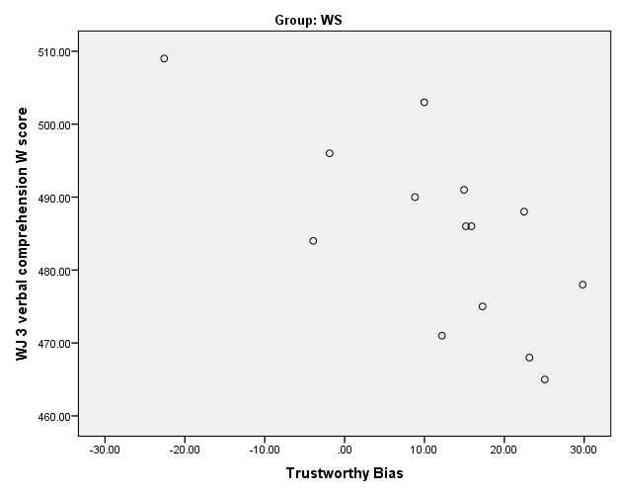
Figure B1. Relationship between verbal IQ and trustworthy bias before removal of outlier (outlier circled on scatter plot). r = -.667, p = .009

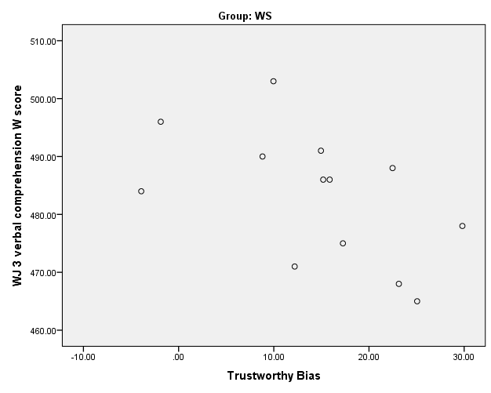
Figure B2. Relationship between verbal IQ and trustworthy bias after removal of outlier. r = -.531, p = .062

