Appendix Table 1. Description of indicators for wealth in adulthood
Wealth | SGA (n = 109) | AGA (n = 329)
Receives social benefitsª | 3.7% | 0.6%
Receives allowance from parents or othersª | 13.8% | 20.7%
Being unemployed at present or in the past or being without occupationª | 46.8% | 34.7%
Working less than 17 hours per week, excluding studentsª | 0.9% | 0.9%
Having had more than five jobsª | 4.6% | 5.2%
Lives at parents’/grandparents’ house, in a home, or in a sheltered accommodationª | 37.6% | 30.4%
No secondary school or profession oriented educational qualificationsª | 58.7% | 38.6%
Sometimes or often fails to pay debts or meet other financial responsibilities^{b} | 4.7% | 3.0%
Relative poverty (lower threshold net income: €981) (Grabka, Goebel, & Schupp, 2012)ª | 27.5% | 28.9%
Health limits work or leisure activities OR has just about enough money to be able to afford things one needs^{c} | 35.2% | 28.4%
ª Derived from Life Course Interview
^{b} derived from Young Adult Self Report (YASR) (Achenbach, 1997)
^{c} derived from the London Handicap Scale (Harwood, Rogers, Dickinson, & Ebrahim, 1994)

Appendix Figure 1. Sample flow diagram of BLS participants from birth to 26 years of age
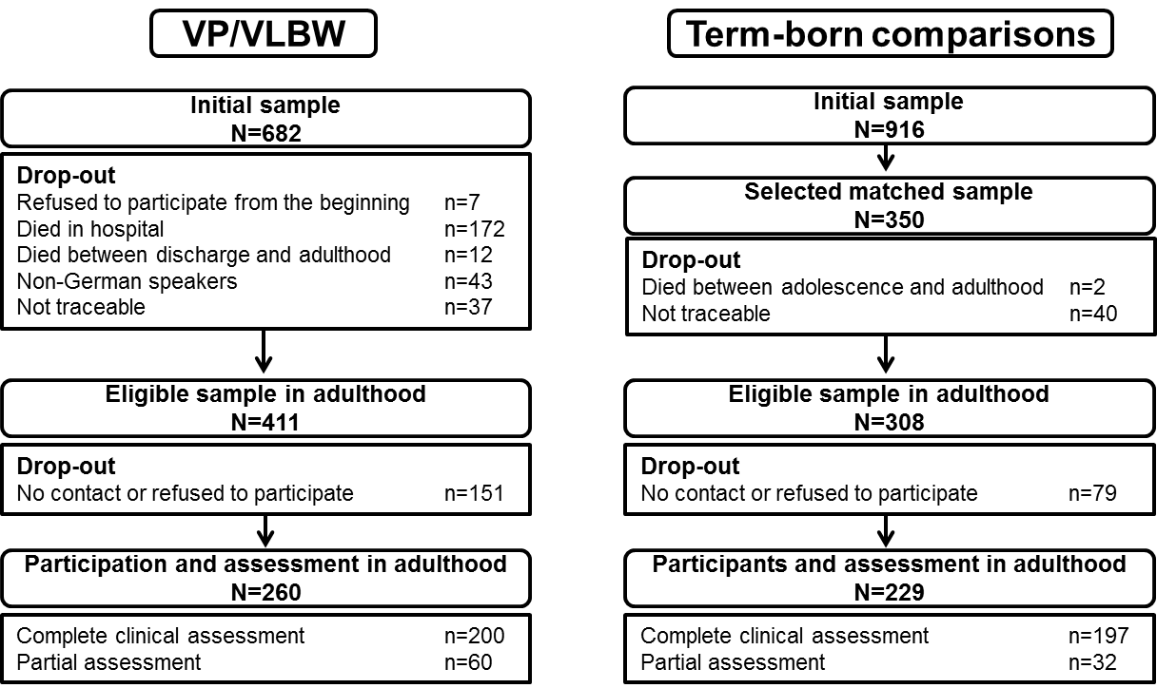
References

Achenbach, T. M. (1997). Manual for the Young Adult Selt-Report and Young Adult Behavior Checklist. Burlington, VT: University of Vermont, Department of Psychiatry.
Grabka, M. M., Goebel, J., & Schupp, J. (2012). Höhepunkt der Einkommensungleichheit in Deutschland überschritten? [Has income inequality spiked in Germany?]. Retrieved from Berlin:
Harwood, R. H., Rogers, A., Dickinson, E., & Ebrahim, S. (1994). Measuring handicap: the London Handicap Scale, a new outcome measure for chronic disease. Quality in Health Care, 3(1), 11-16. doi:10.1136/qshc.3.1.11

