Gene × Environment contributions to autonomic stress reactivity in youth

Andrea G. Allegriniª, Brittany E. Evans^{b}, Susanne de Rooij^{a,d}, Kirstin Greaves-Lord^{c} & Anja C. Huizink^{a*}

ªVrije Universiteit Amsterdam, Dept. Devlopmental Psychology, Sections of Clinical Developmental Psychology and Clinical Child and Family Studies,
Amsterdam, The Netherlands
^{b}Radboud University, Behavioral Science Institute,
Nijmegen, The Netherlands
^{c}Erasmus University Medical Center, Dept. Child and Adolescent Psychiatry/Psychology, Rotterdam, The Netherlands
^{d}Academic Medical Center of the University of Amsterdam, Dept. Clinical Epidemiology & Biostatistics and Public Health, Amsterdam, The Netherlands

Supplementary material

Table S.1.
Regression estimates of main analysis for two age groups.
 |  | 8-12 years |  |  |  |  |  | 13 – 20 years
HR |  | N = 146 |  |  |  |  |  | N = 273
 |  | coefficients |  |  |  |  |  | coefficients
Variable |  | B | SE B | β | p | ΔR² |  | B | SE B | β | p | ΔR²
Adversity score |  | -0.18 | 0.45 | -.04 | 0.677 |  |  | -1.05 | 0.39 | -.16 | 0.008 | .026
Genetic score |  | -0.42 | 0.44 | -.09 | 0.343 |  |  | 0.05 | 0.42 | .008 | 0.895
Interaction |  | 0.19 | 0.45 | .03 | 0.674 |  |  | -0.04 | 0.39 | -.01 | 0.910
HRV |  | N = 96 |  |  |  |  |  | N = 237
Adversity score |  | -201.78 | 331.54 | -.06 | 0.554 |  |  | -354.50 | 204.64 | -.12 | 0.085
Genetic score |  | -309.65 | 293.56 | -.10 | 0.294 |  |  | 330.44 | 205.39 | .11 | 0.109
Interaction |  | -8.42 | 350.49 | -.01 | 0.980 |  |  | -451.49 | 208.97 | -.14 | 0.032 | .019
Note. Control variables not shown.

Table S.2.
Frequency distribution for age groups of N=638 individuals participating in the stress procedure.
Age | N | %
8-9 | 56 | 8.8
9-10 | 71 | 11.2
10-11 | 63 | 10
11-12 | 66 | 10.4
12-13 | 79 | 12.5
13-14 | 11 | 1.7
14-15 | 54 | 8.5
15-16 | 67 | 10.6
16-17 | 96 | 15.2
17-18 | 48 | 7.6
19-20 | 22 | 3.5

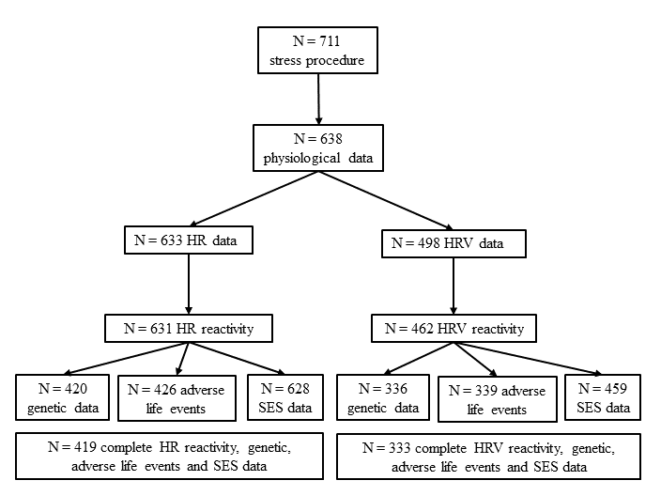
Figure S.1. Flow-chart of available data.

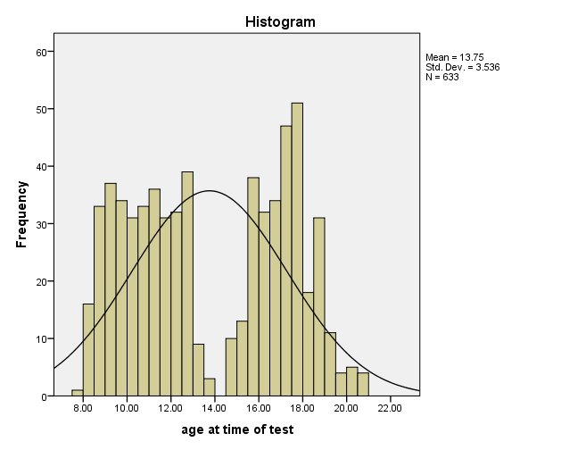
Figure S.2. Frequency distribution of age at time of test (N = 638).

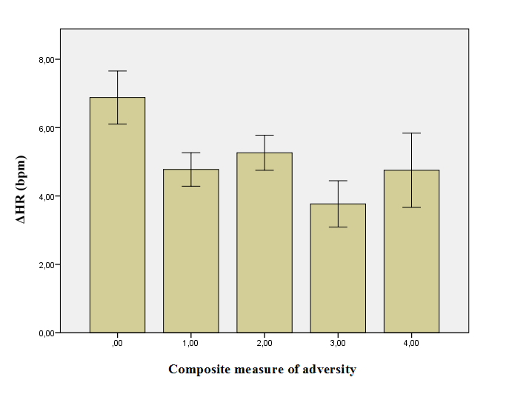
Figure S.3. Main effects of composite measure of adversity on ΔHR.
Note. Error bars: ± 1 standard error.

