.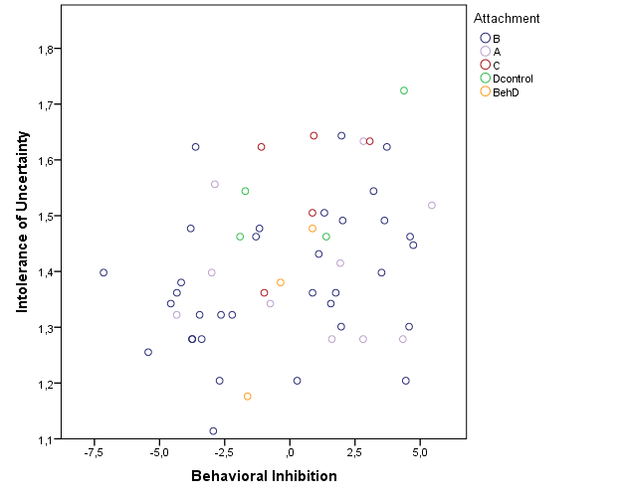

Figure S.1. Scatterplot of intolerance of uncertainty and behavioral inhibition by attachment type.

