Table S.1. Correlation matrix with means and SDs for 14 cytokines used to create the inflammatory index
 | 1 |  | 2 |  | 3 |  | 4 |  | 5 |  | 6 |  | 7 |  | 8 |  | 9 |  | 10 |  | 11 |  | 12 |  | 13 |  | 14
1. IL-1β (Interleukin 1 beta) | ──
2. IL-4 (Interleukin 4) | .301 | ** | ──
3. IL-5 (Interleukin 5) | -.096 | † | .081 |  | ──
4. IL-6 (Interleukin 6) | .113 | * | .073 |  | .106 | * | ──
5. IL-7 (Interleukin 7) | .045 |  | .004 |  | .065 |  | .136 | ** | ──
6. IL-8 (Interleukin 8) | .043 |  | .026 |  | -.006 |  | .089 | † | .184 | ** | ──
7. IL-10 (Interleukin 10) | .070 |  | .061 |  | .266 | ** | .228 | ** | .073 |  | .064 |  | ──
8. IL-12 (Interleukin 12) | .196 | ** | .163 | ** | .101 | * | .422 | ** | .196 | ** | .125 | * | .460 | ** | ──
9. IL-13 (Interleukin 13) | .355 | ** | .170 | ** | .084 | † | .223 | ** | .214 | ** | .008 |  | .310 | ** | .456 | ** | ──
10. IL-17 (Interleukin 17) | .143 | ** | .240 | ** | .099 | * | .192 | ** | .125 | * | .148 | ** | .224 | ** | .494 | ** | .349 | ** | ──
11. G-CSF | .078 |  | .161 | ** | .198 | ** | .185 | ** | .200 | ** | .148 | ** | .146 | ** | .320 | ** | .285 | ** | .462 | ** | ──
12. IFN-γ (Interferon gamma) | .277 | ** | .182 | ** | .060 |  | .296 | ** | .141 | ** | .053 |  | .078 |  | .212 | ** | .263 | ** | .078 |  | .185 | ** | ──
13. MIP-1β | .064 |  | .005 |  | .064 |  | .057 |  | .092 | † | .233 | ** | .174 | ** | .103 | * | .110 | * | .111 | * | .140 | ** | .002 |  | ──
14. TNF-α | .200 | ** | .141 | ** | .093 | † | .294 | ** | .118 | * | -.001 |  | .401 | ** | .348 | ** | .317 | ** | .276 | ** | .227 | ** | .298 | ** | .001 |  | ──
Mean | 1.525 |  | 1.090 |  | 1.245 |  | 1.213 |  | 1.990 |  | 2.136 |  | 2.017 |  | 1.354 |  | 1.656 |  | 1.162 |  | 1.380 |  | 1.102 |  | 2.235 |  | 1.823
SD | .677 |  | .340 |  | .527 |  | .501 |  | .638 |  | .550 |  | .629 |  | .608 |  | .702 |  | .446 |  | .618 |  | .361 |  | .452 |  | .686
**p ≤ .01; *p ≤.05; †p<.10 (two-tailed tests); N = 413. G-CSF: Granulocyte-colony stimulating factor; MIP-1β : Macrophage inflammatory protein 1 beta; TNF-α: Tumor necrosis factor alpha

Figure S.1. Effect of the Parent-child relationship through Romantic Partner Support Alone

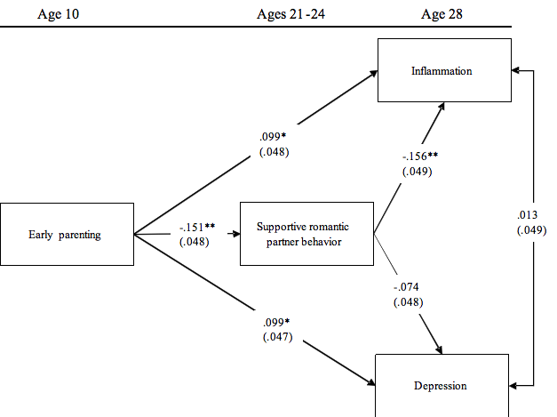

Chi-square = .000, df = 0, p = .000; CFI = 1.000. Values are standardized parameter estimates and standard errors are in parentheses. Gender, insurance, diet, exercise, binge drinking, cigarette use, high school, and married or cohabited are controlled in these analyses. N = 413.

Using bootstrap methods with 1,000 replications, the test of the indirect effect of early parenting on INF through supportive romantic partner relationship is significant [indirect effect = .024, 95%CI (.006, .059), 19.512% of the total variance], p < .05].

Using bootstrap methods with 1,000 replications, the test of the indirect effect of parent-child relationship on depression through supportive romantic partner relationship is not significant [indirect effect = .011, 95%CI (-.004, .030)].

**p ≤ .01; *p ≤.05; †p<.10 (two-tailed tests).

Figure S.2. Effect of Parent-child relationship through Romantic Partner Hostility Alone
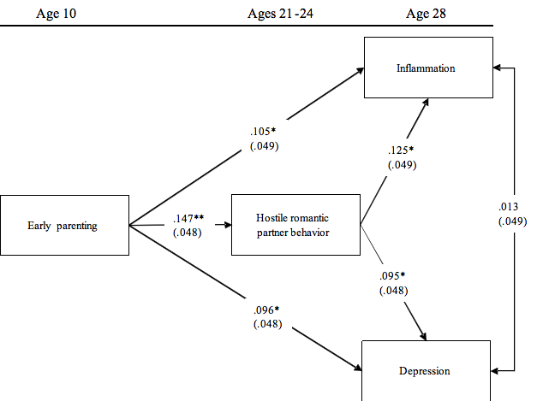

Chi-square = .000, df = 0, p = .000; CFI = 1.000. Values are standardized parameter estimates and standard errors are in parentheses. Gender, insurance, diet, exercise, binge drinking, cigarette use, high school, and married or cohabited are controlled in these analyses. N = 413.

Using bootstrap methods with 1,000 replications, the test of the indirect effect of parent-child relationship on INF through hostile romantic partner relationship is significant [indirect effect = .018, 95%CI (.003, .062), 14.634% of the total variance], p < .05].

Using bootstrap methods with 1,000 replications, the test of the indirect effect of parent-child relationship on depression through hostile romantic partner relationship is not significant [indirect effect = .014, 95%CI (.000, .041)].

**p ≤ .01; *p ≤.05; †p<.10 (two-tailed tests).

