Supplementary Material

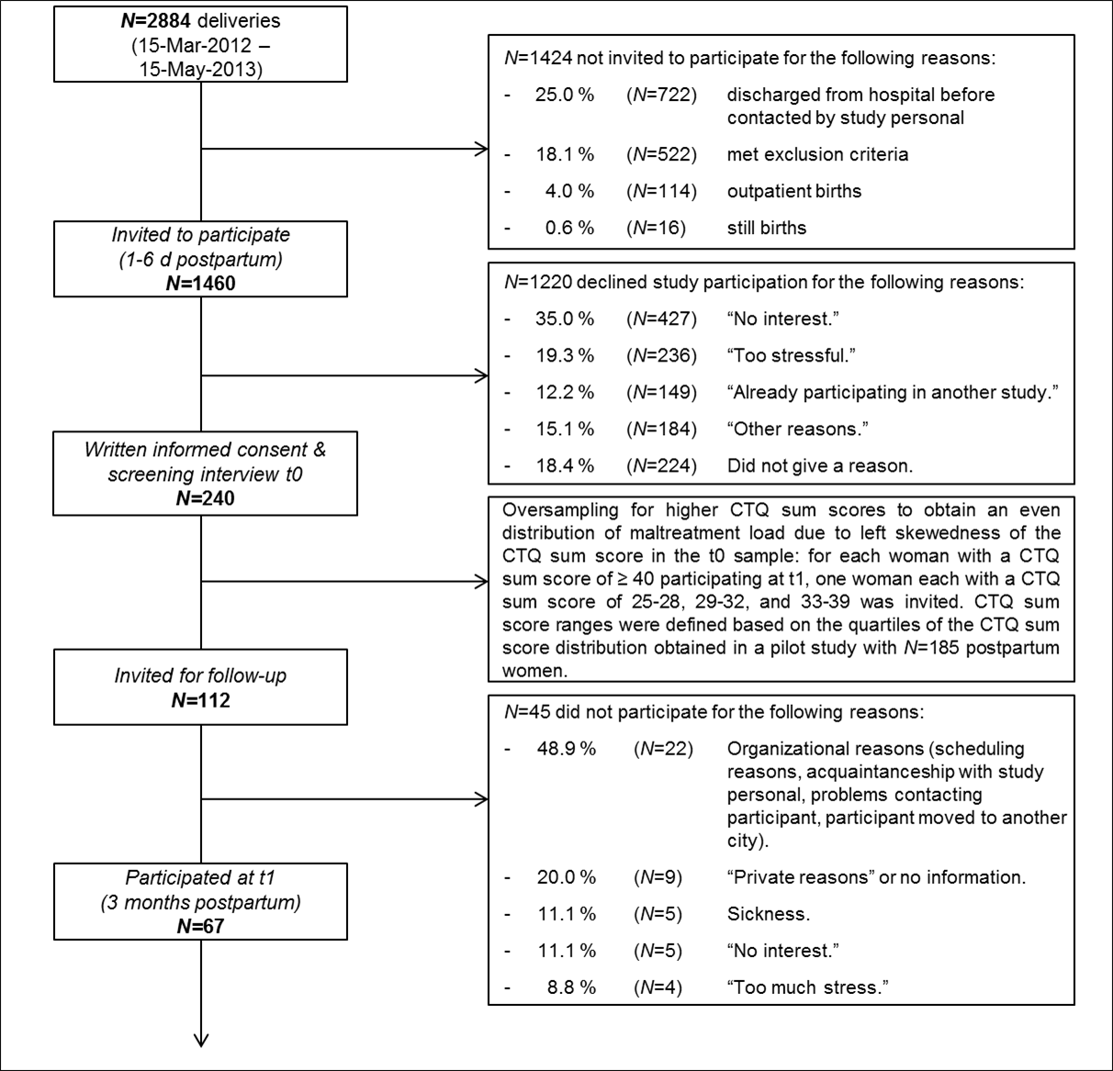
Figure S.1. Overview over study flow, recruitment procedure, and withdrawal rates.

Table S.1. Linear regression models analyzing the influence of CM and cortisol levels on TL in PBMC, monocytes, and naive cytotoxic T cells
Dependent Variable | Predictors | β | p | F | df1,df2 | p | R²_{(adj)}
PBMC TL
 | Full model |  |  | 1.19 | 2,27 | .32 | .01
 | Group | -.25 | .18
 | Serum cortisol level | -.15 | .41
Monocyte TL
 | Full model |  |  | 1.53 | 2,27 | .24 | .04
 | Group | .07 | .71
 | Serum cortisol level | .32 | .09
Naive cytotoxic T cell TL
 | Full model |  |  | 0.04 | 2,27 | .96 | -.07
 | Group | .02 | .93
 | Serum cortisol level | .06 | .78

Table S.2. Linear regression models analyzing the influence of CM and oxytocin levels on TL in PBMC, monocytes, and naive cytotoxic T cells.
Dependent Variable | Predictors | β | p | F | df1,df2 | p | R²_{(adj)}
PBMC TL
 | Full model |  |  | 2.40 | 2,24 | .11 | .10
 | Group | -.12 | .53
 | Plasma oxytocin level | -.37 | .06
Monocyte TL
 | Full model |  |  | 0.53 | 2,24 | .60 | -.04
 | Group | .04 | .85
 | Plasma oxytocin level | .20 | .34
Naive cytotoxic T cell TL
 | Full model |  |  | 0.52 | 2,24 | .60 | -.04
 | Group | -.06 | .78
 | Plasma oxytocin level | .20 | .32

