Supplementary Materials

Table S.1. List of items included in the prenatal cumulative adversity measures
 | N. items | Range | M (SD) | Items
Life events | 22 | 0-8 | 2.48 (1.71) | Your partner died | You lost your job
 |  |  |  | One of your children died | You moved house
 |  |  |  | A friend or relative died | You were bleeding and thought you might miscarry
 |  |  |  | One of your children was ill | You started a new job
 |  |  |  | Your partner was ill | You had a test to see if your baby was abnormal
 |  |  |  | A friend or relative was ill | Result on a test that suggested your baby might not be normal
 |  |  |  | You were admitted to hospital | You were told that you were going to have twins
 |  |  |  | You were very ill | You heard something that happened might be harmful to the baby
 |  |  |  | Your partner lost his job | You took an examination
 |  |  |  | Your partner had problems at work | Your house or car was burgled
 |  |  |  | You had problems at work | You had an accident
Contextual Risks | 7 | 0-3 | .53 (.78) | You had a major financial problem | Housing adequacy
 |  |  |  | You became homeless | Housing Basic Living
 |  |  |  | Your income was reduced | Housing Defects
 |  |  |  | Financial difficulties
Parental Risks | 9 | 0-5 | .51 (84) | You were in trouble with the law | Psychopathology of mother
 |  |  |  | Your partner was in trouble with the law | Substance abuse
 |  |  |  | You were convicted of an offence | Crime trouble with police
 |  |  |  | Early parenthood | Crime convictions
 |  |  |  | Maternal education
Interpersonal Risks | 18 | 0-7 | 1.19 (1.41) | You were divorced | You found that your partner didn't want your child
 |  |  |  | Your partner went away | You argued with your partner
 |  |  |  | You and your partner separated | You had arguments with your family or friends
 |  |  |  | Partner Status | Your partner hurt you physically
 |  |  |  | Partner Affection | Your partner hurt your children physically
 |  |  |  | Partner Affection | Your partner hurt your children physically
 |  |  |  | Partner cruelty | Your partner was emotionally cruel to you
 |  |  |  | Family Size | Your partner was emotionally cruel to your children
 |  |  |  | Family Major problems | Social Network - Emotional
 |  |  |  | Partner Support | Social Network - Practical

Optimized gene ontology method
A logistic regression approach was used to test if genes in the test list predicted pathway membership while controlling for the number probes annotated to each gene. Pathways were downloaded from the Gene Ontology website and all genes annotated to parent terms were also included. Illumina UCSC gene annotation was used to create a test gene list from probes that were associated with early-onset vs low conduct problems at birth (p< 0.001). All genes with at least one methylation probe annotated and annotated to at least one GO pathway were considered. Pathways were filtered to those with between 10 and 2000 genes in. After applying this method to all pathways, significant pathways (p < 0.05) were taken and grouped where overlapping genes explained the signal. This was achieved by taking the most significant pathway, and retesting all remaining significant pathways while controlling additionally for the best term. If genes in the test list no longer predicted the pathway, the term was said to be explained by the most significant pathway, and hence these pathways were grouped together. This algorithm was repeated, taking the next most significant term, until all pathways had been considered as the most significant or found to be explained by a more significant term. GO terms were interpreted exclusively if they if they contained at least 2 genes.

Table S.2. Intercorrelations between DNAm levels across the identified sites
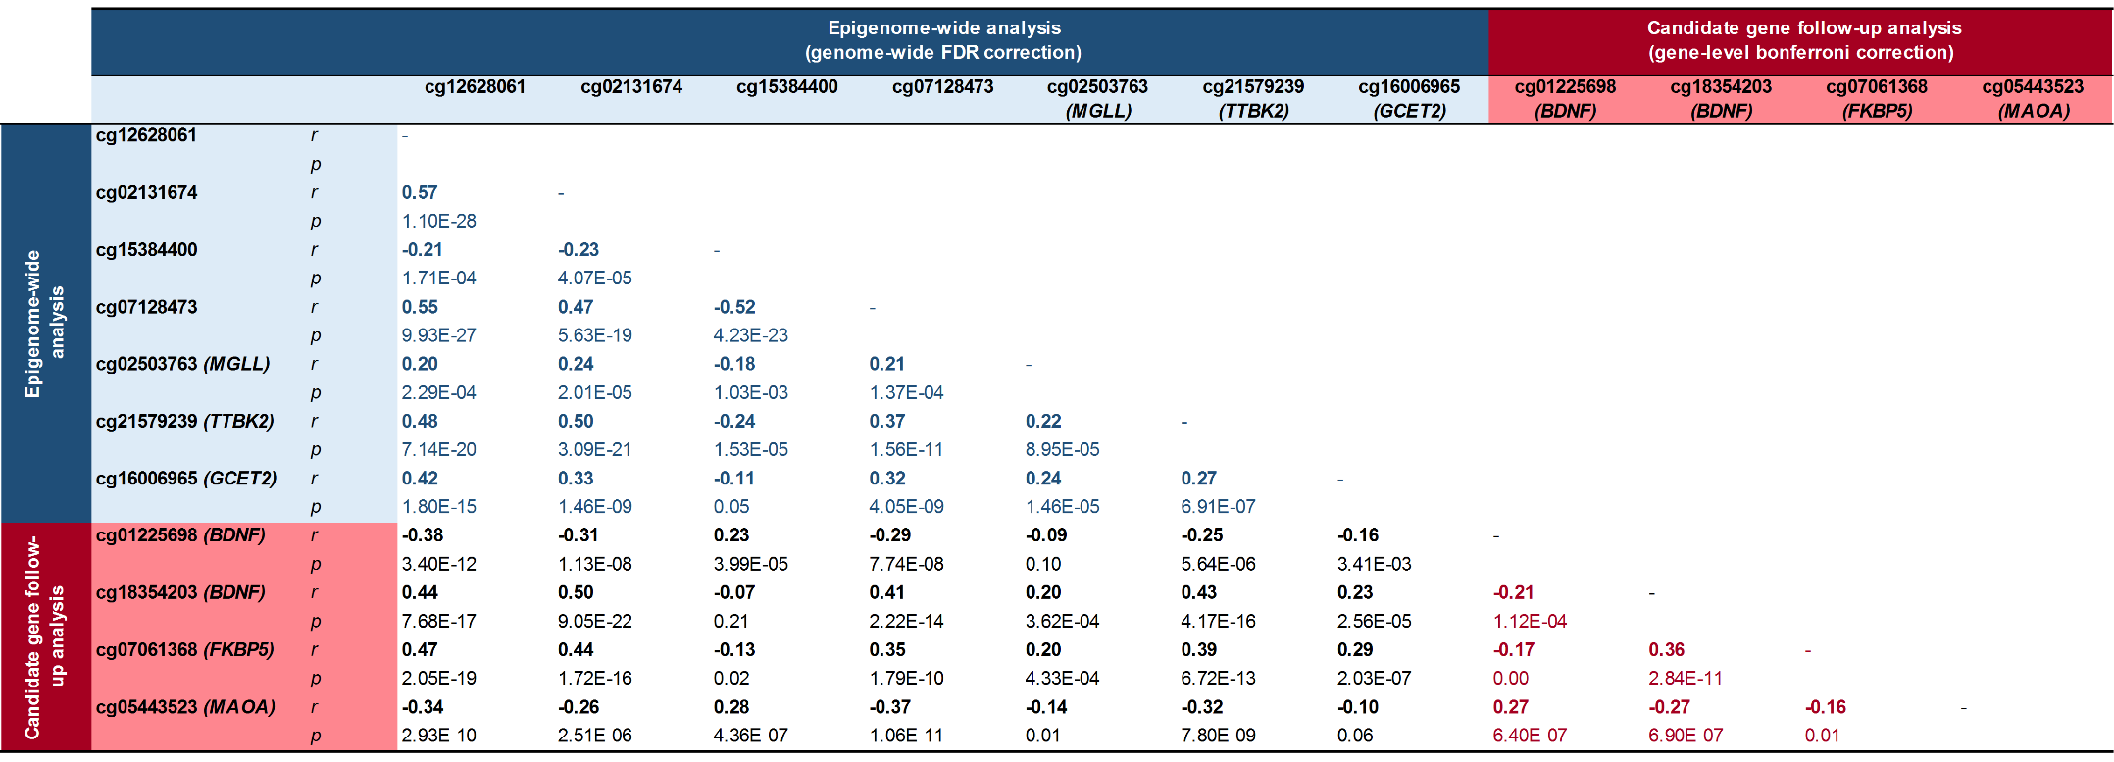

Figure S.1. Boxplots of mean methylation differences between CP groups across four genome-wide significant probes (q<0.05) that are distal to annotated transcripts.
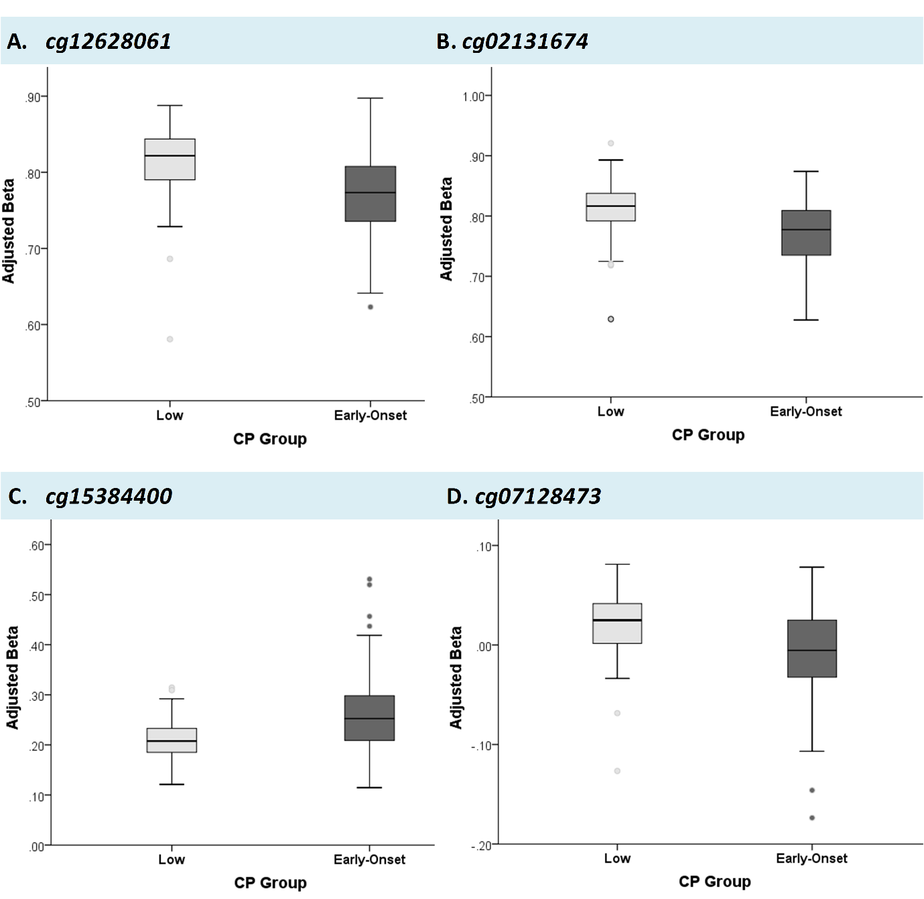

Table S.3. Top 20 enriched biological processes at birth differentiating early-onset vs low CP children based on GO pathway analysis

 | GO Pathway | N genes in study | Total N genes in pathway | % | P-value | Genes
1 | Negative regulation of fat cell differentiation | 12 | 37 | 32.43% | 2.95E-15 | WNT3A;GATA2;WWTR1;BBS12;ID4;SOD2;ZFPM2;TCF7L2;NCOR2;FOXO1;JDP2;ZFPM1
2 | Vesicle transport along microtubule | 6 | 17 | 35.29% | 3.33E-09 | PRKCZ;FYCO1;HTT;KIF13A;NDE1;KIF3B
3 | Regulation of cell differentiation | 95 | 1186 | 8.01% | 6.93E-07 | ITPKB;PRDM16;WNT3A;ARHGEF2;PRKCZ;TRIM11;RPS6KA1;DISC1;IL6R;TGFB2;CDC42;ID3;IGFBP5;CTNNA2;ZFP36L2;HDAC4;PAX8;CFLAR;CASP8;ZAP70;NCOA1;CTLA4;FNDC3B;FOXP1;TKT;GATA2;WWTR1;BCL6;ETV5;INPP4B;MSX1;TLR3;SFRP2;PROM1;PHOX2B;HTT;RAPGEF2;BBS12;GHR;C5orf13;ZSWIM6;OTP;MEGF10;TFAP2B;NR2E1;TFAP2A;ID4;PRDM1;NOTCH4;SOX4;SOD2;MAPK14;GLI3;INHBA;HDAC9;LIMK1;ASB4;LRRC17;HGF;ZFPM2;GDF6;PLAG1;TRPS1;MYST3;TCF7L2;VAX1;FGFR2;BMPR1A;IL15RA;BDNF;HCCA2;BAD;NCOR2;FGF23;SSH1;WIF1;PTPN6;STK24;FOXO1;JDP2;RGS6;RCOR1;NKX2-1;NEDD4;GREM1;ZFPM1;MED24;HOXB8;DCC;PRMT1;PRKACA;HPN;ZBTB46;OLIG2;RBM9
4 | Negative regulation of neural precursor cell proliferation | 5 | 17 | 29.41% | 1.47E-06 | GATA2;HTT;NR2E1;VAX1;BDNF
5 | Response to epinephrine | 4 | 10 | 40.00% | 1.48E-06 | PDE4B;PDE4D;RNLS;PRKACA
6 | Response to superoxide | 4 | 14 | 28.57% | 1.56E-06 | PRDX1;SOD2;ERCC6;MPO
7 | Negative regulation of cell differentiation | 48 | 487 | 9.86% | 1.58E-06 | PRDM16;WNT3A;ARHGEF2;TRIM11;ID3;IGFBP5;ZFP36L2;HDAC4;CTLA4;FOXP1;GATA2;WWTR1;BCL6;INPP4B;MSX1;TLR3;SFRP2;PHOX2B;HTT;RAPGEF2;BBS12;NR2E1;ID4;NOTCH4;SOX4;SOD2;GLI3;INHBA;LRRC17;ZFPM2;MYST3;TCF7L2;VAX1;BMPR1A;BDNF;NCOR2;FGF23;FOXO1;JDP2;NKX2-1;ZFPM1;MED24;HOXB8;DCC;PRMT1;HPN;ZBTB46;OLIG2
8 | Hemopoiesis | 41 | 431 | 9.51% | 1.86E-06 | HIPK1;ITPKB;MFAP2;PRG4;WNT3A;PIK3CD;TGFB2;CDC42;CASP9;CD1D;SPTA1;IFI16;TPO;ZFP36L2;HDAC4;CASP8;ZAP70;TTC7A;MECOM;FOXP1;GATA2;BCL6;SFRP2;TXK;NOTCH4;SOX4;SOD2;MAPK14;GLI3;INHBA;HDAC9;ZFAT;ASH2L;TPD52;ANGPT1;MYST3;FGFR2;RCOR1;IREB2;CBFA2T3;ZFPM1
9 | Negative regulation of myeloid leukocyte differentiation | 8 | 35 | 22.86% | 3.73E-06 | PRDM16;GATA2;INPP4B;TLR3;INHBA;LRRC17;ZFPM1;ZBTB46
10 | Regulation of macrophage differentiation | 5 | 20 | 25.00% | 4.47E-06 | CASP8;GATA2;INHBA;PRKACA;ZBTB46
11 | Neutrophil migration | 7 | 37 | 18.92% | 5.48E-06 | PDE4B;PIK3CD;TGFB2;FCER1G;PDE4D;PRKACA;ITGB2
12 | Positive regulation of immune system process | 49 | 626 | 7.83% | 5.89E-06 | ITPKB;PDE4B;WNT3A;PRKCZ;PIK3CD;RPS6KA1;IL6R;TGFB2;CDC42;CD1D;MAPKAPK2;FCER1G;SPTA1;IFI16;WIPF1;CASP8;ZAP70;IGFBP2;CTLA4;FOXP1;BCL6;NCKIPSD;TLR3;EDNRA;CXCL13;TXK;PDE4D;RPS6KA2;C6orf150;PRDM1;MAPK14;ELMO1;GLI3;LIMK1;TRIL;IL15RA;IGF2;CD5;BAD;CADM1;BIRC3;IRAK4;PTPN6;C3AR1;THBS1;PRKCB;GRB2;ELANE;ITGB2
13 | Response to wounding | 74 | 1022 | 7.24% | 6.70E-06 | WNT3A;PRKCZ;GNAI3;PIK3CD;CNR2;IL6R;TGFB2;CDC42;ID3;MAPKAPK2;PLA2G4A;FCER1G;IFI16;HDAC4;RAPGEF4;CFLAR;FN1;IL18RAP;MECOM;GP5;MGLL;GATA2;ATP2B2;DGKG;BCL6;CXCR6;TLR3;CNO;CXCL13;ARHGAP24;C5orf13;DST;DSP;SOD2;MAPK14;HIST1H3D;PRKAR1B;GLI3;HDAC9;TRIL;HGF;ZFPM2;PGCP;ANGPT1;KCNMA1;ALOX5;HPS6;SYT7;IGF2;BDNF;KRAS;CBX5;PTPN6;C3AR1;RACGAP1;SLC8A3;RCOR1;ITPK1;SLC7A7;THBS1;ZFPM1;PRKCB;GRB2;RPS6KB1;RAD51C;CCL16;CABLES1;PRKACA;GNA15;ELANE;PLAUR;KIF3B;IL10RB;ITGB2
14 | Retina layer formation | 4 | 13 | 30.77% | 7.84E-06 | HIPK1;PROM1;TFAP2B;TFAP2A
15 | Regulation of gastrulation | 6 | 27 | 22.22% | 1.12E-05 | WNT3A;SFRP2;OSR2;BMPR1A;OTX2;MAP2K5
16 | Regulation of ossification | 21 | 172 | 12.21% | 1.17E-05 | IL6R;MATN1;TGFB2;ID3;IGFBP5;HDAC4;TKT;SFRP2;TFAP2A;ID4;GLI3;HGF;OSR2;EGR2;FGFR2;BMPR1A;CREB3L1;FGF23;MGP;GREM1;PRKACA
17 | Forebrain generation of neurons | 10 | 60 | 16.67% | 1.81E-05 | WNT3A;RAPGEF2;OTP;NR2E1;TFAP2A;GLI3;LHX6;FGFR2;LHX5;NKX2-1
18 | Immune system process | 113 | 1842 | 6.13% | 3.81E-05 | HIPK1;ITPKB;MFAP2;PDE4B;PRG4;WNT3A;ARHGEF2;CD1C;TRIM11;PIK3CD;RPS6KA1;SNX27;CNR2;IL6R;TGFB2;YTHDF2;CDC42;CASP9;PRDX1;CD1D;MAPKAPK2;FCER1G;SPTA1;ILF2;IFI16;TPO;ZFP36L2;HDAC4;WIPF1;CASP8;ZAP70;TTC7A;FN1;IL18RAP;CTLA4;MECOM;FOXP1;GATA2;BCL6;ST6GAL1;NCKIPSD;UBA7;TLR3;PITX2;SFRP2;CXCL13;TXK;PDE4D;NRG2;RPS6KA2;TAPBP;GNL1;C6orf150;PSMB8;HLA-DMB;NOTCH4;SOX4;SOD2;RNF8;MAPK14;ELMO1;PRKAR1B;GLI3;INHBA;HDAC9;LIMK1;TRIL;LRRC17;ZFAT;EIF2C2;ASH2L;TPD52;ANGPT1;MYST3;PSMB7;FGFR2;BMPR1A;CD5;BAD;IL18BP;MRE11A;BIRC3;PAN2;FGF23;KRAS;IRAK4;OAS3;PTPN6;C3AR1;RACGAP1;FLT1;FOXO1;RCOR1;SLC7A7;THBS1;SMAD6;IREB2;NEDD4;CBFA2T3;ZFPM1;PHLPP2;PRKCB;GRB2;MPO;CCL16;RPL13A;PRKACA;ELANE;KIF3B;CST7;IL10RB;ITGB2;POLR3H
19 | Regulation of protein export from nucleus | 5 | 24 | 20.83% | 4.23E-05 | XPO1;HTT;SOX4;TCF7L2;PRKACA
20 | Cell differentiation in spinal cord | 9 | 53 | 16.98% | 4.64E-05 | WNT3A;LHX4;IFT172;GATA2;SOX4;GLI3;DBX1;LHX5;OLIG2

N.b. GO pathways highlighted in orange are visually depicted in Figure 1D of the article.

OS6. Detailed functional characterization of MGLL DNA methylation sites associated with early-onset conduct problems

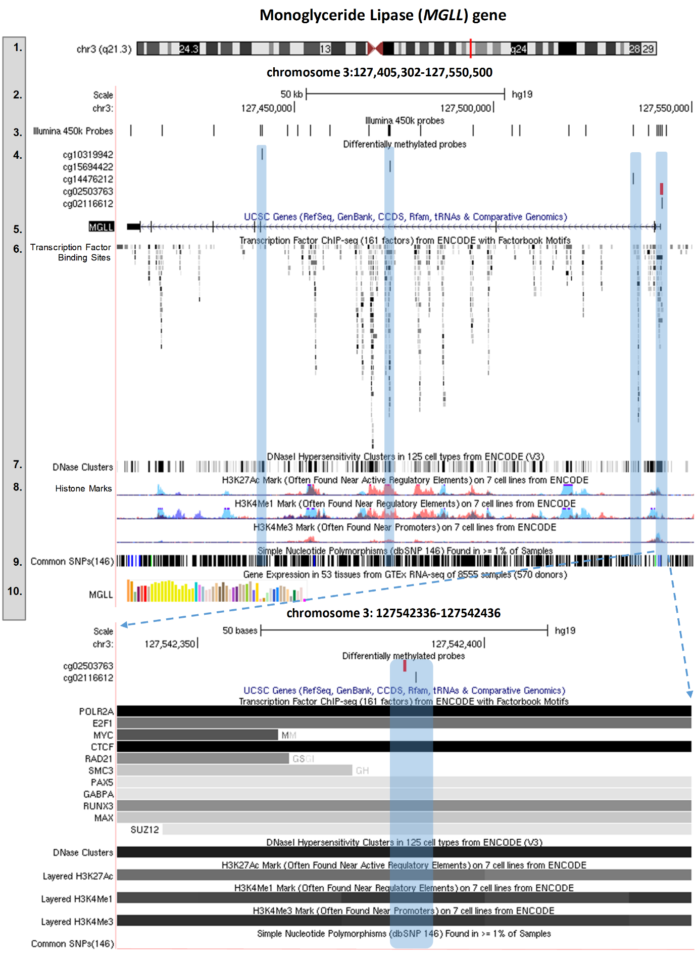

Expanded views from the UCSC genome browser of the MGLL gene showing the position of the DNAm sites associated with early-onset CP relative to ENCODE regulatory elements. The top panel shows functional characterization of the entire MGLL gene. Track numbers are displayed on the left-hand site, and represent the following (1) genomic positon of MGLL in chromosome 3; (2) genomic coordinates and scale; (3) location of all Illumina 450k probes that map onto the MGLL gene (n = 26); (4) location of differentially methylated probes associated with early-onset vs low conduct problems (n = 5). These are highlighted in blue to facilitate comparison with the regulatory elements displayed in lower tracks (track 6-8). In red is the probe that survived genome-wide correction (MGLL_{cg02503763}; all other probes significant at p<0.05); (5) schematic representation of the MGLL gene; (6) location of transcription factors (based on ChIP-seq data from 91 cell types), where darker shades indicate a stronger signal occupancy; (7) DNaseI hypersensitivity clusters (based on ChIP-seq data from 125 cell types), where darker shades also indicate a stronger signal; (8) levels of enrichment of three histone marks (H3K27Ac, H3K4Me1, and H3K4Me3) across three cell-types, including blood (GM12878 [red], K562 [purple]) and umbilical vein endothelial (HUVEC [blue]) cells; (9) location of common single-nucleotide polymorphisms (SNPs); and (10) median levels of MGLL expression across 51 tissues, based on RNA-seq data from the NIH Genotype-Tissue Expression (GTEx) project (midpoint milestone data release (V6, October 2015). Each bar represents a tissue, and the height of the bar indicates level of expression. Of note, yellow bars represent expression levels in brain tissue across multiple regions. These tracks are shown again in the lower panel of the figure, but this time specifically within the promoter region of MGLL, where our genome-wide significant DNAm site (in red) was located. Here, specific transcription factors binding to these regions are also shown.
Table S.4. Candidate gene follow-up analyses
Gene name | Chr | Total N probes |  | Probes significant at p<0.05 (uncorrected) |  |  | Gene-level significant (Bonferroni-corrected)
 |  |  |  | N | ProbeID |  | N | ProbeID
Dopaminergic pathway
COMT | 22 | 30 |  | 3 | cg03724721, cg08289189, cg21919834 |  | -- | --
DRD2 | 11 | 22 |  | 3 | cg12758687, cg14809166, cg18248586 |  | -- | --
DRD4 | 11 | 21 |  | 1 | cg08726248 |  | -- | --
MAOA | X | 14 |  | 2 | cg05443523, cg18138788 |  | 1 | cg05443523 (↑)
SLC6A3 | 5 | 52 |  | 3 | cg14502484, cg16703956, cg19440506 |  | -- | --
Serotonergic pathway
HTR1A | 5 | 14 |  | 2 | cg11615755, cg13666507 |  | -- | --
HTR2A | 13 | 25 |  | 6 | cg02027079, cg06476131, cg09361691, cg14059288, cg16188532, cg20102280 |  | -- | --
SLC6A4 | 17 | 14 |  | 2 | cg12074493, cg25725890 |  | -- | --
TPH1 | 11 | 4 |  | 1 | cg08400935 |  | -- | --
TPH2 | 12 | 18 |  | 2 | cg12017635, cg19530293 |  | -- | --
Neuroendocrine and neurodevelopmental pathway
AVP | 20 | 14 |  | 1 | cg11491381 |  | -- | --
BDNF | 11 | 73 |  | 8 | cg01225698, cg01418645, cg02527472, cg03747251, cg07159484, cg18354203, cg20954537, cg25412831 |  | 2 | cg01225698 (↑), cg18354203 (↓)
FKBP5 | 6 | 32 |  | 4 | cg01294490, cg03546163, cg03591753, cg07061368 |  | 1 | cg07061368 (↓)
NR3C1 | 5 | 35 |  | 7 | cg03857453, cg08818984, cg10847032,cg13648501, cg14558428, cg17860381, cg27122725 |  | -- | --
OXTR | 3 | 17 |  | 1 | cg19619174 |  | -- | --

Table S.5. Comparison of DNAm levels across the identified loci between early-onset children who persist (i.e. EOP) vs desist (i.e. CL) in conduct problems over time.
 | Early-Onset CP children (n = 174) |  |  |  |  | F | p
 | CL trajectory (n = 83) |  |  | EOP trajectory (n= 91)
 | Mean | SD |  | Mean | SD
Genome-wide analyses
cg12628061 | 0.77 | 0.06 |  | 0.77 | 0.05 | 0.24 | 0.62
cg02131674 | 0.77 | 0.06 |  | 0.77 | 0.05 | 0.15 | 0.70
cg15384400 | 0.27 | 0.07 |  | 0.25 | 0.08 | 2.00 | 0.16
cg07128473 | 0.83 | 0.04 |  | 0.84 | 0.04 | 0.46 | 0.50
cg02503763 (MGLL) | 0.38 | 0.11 |  | 0.38 | 0.10 | 0.00 | 0.99
cg21579239 (TTBK2) | 0.74 | 0.07 |  | 0.75 | 0.06 | 0.13 | 0.72
cg16006965 (GCET2) | 0.57 | 0.06 |  | 0.56 | 0.06 | 3.11 | 0.08
Candidate gene follow-up analyses
cg01225698 (BDNF) | 0.16 | 0.04 |  | 0.17 | 0.04 | 1.32 | 0.25
cg18354203 (BDNF) | 0.71 | 0.07 |  | 0.72 | 0.07 | 0.74 | 0.39
cg07061368 (FKBP5) | 0.81 | 0.06 |  | 0.81 | 0.04 | 0.87 | 0.35
cg05443523 (MAOA) | 0.37 | 0.06 |  | 0.35 | 0.05 | 1.57 | 0.21

