Supplemental Methods
Comparing Included vs. Excluded Participants
AFDP. Compared to those excluded, those included were younger at T1 (t = 2.75, p = 0.01), had higher parental education (i.e., t = -4.78, p < 0.001) and lower levels of Hispanic ancestry (t = -16.38, p < 0.001). Included and excluded participants did not differ on any other study variables. The younger ages, lower levels of Hispanic ancestry, and higher levels of parental education of included vs. excluded participants were due to the age and ethnicity inclusion criteria.
CDP. Compared to those excluded, included participants had higher parental education (t = -6.85, p < 0.001) and lower T1 conduct problems (t = 2.79, p < 0.01). Included and excluded participants did not differ on any other study variables. The differences in parental education likely reflect the inclusion of only non-Hispanic Caucasians.
Creating Ancestry Informative Markers in AFDP
In AFDP, 37 SNPs distinguished between non-Hispanic Caucasian and Mexican/Mexican-American ancestry (Tian, Gregersen, & Seldin, 2008), which are the most represented ethnic groups in AFDP and the geographic region of data collection. A principal components analysis was performed on these SNPs. The first component explained 18.99% of the variance (eigenvalue = 7.03), the second explained 3.36% (eigenvalue = 1.24), and the third explained 3.11% (eigenvalue = 1.02). 32 SNPs that had loadings greater than 0.30 on the first principal component were used as indicators of a one-factor model. The model fit the data well: χ²(464) = 824.99, p < 0.001, RMSEA = 0.03, CFI = 0.94, SRMR = 0.03. Factor scores were saved and used as a covariate. These scores were highly correlated with self-reported ethnicity (r = -0.83, p < 0.001), confirming their validity.
Creating Ancestry Principal Components (PCs) in CDP
First, regions with high LD were excluded (Price et al., 2008)_ENREF_5. Then, this set of SNPs was pruned (r² < 0.1) using PLINK 1.9 (--indep-pairwise 1500 150 0.1; Chang et al., 2015; Purcell et at., 2007), yielding 109,259 variants for ancestry analyses. Principal components analyses were conducted using EIGENSOFT/SmartPCA using only the 1000 Genomes phase 3 reference panel (Patterson, Price, & Reich, 2006; Price et al., 2006). The SNP weights for each eigenvector were projected onto CDP data to generate 10 PCs.
Item Overlap
Temperament/personality and psychopathology measures often contain item overlap (Lemery, Essex, & Smider, 2002). Overlap in temperament and psychopathology measures was determined using previously established methods (see Eisenberg et al., 2004). Sixteen experts (8 faculty members, 6 post-doctoral fellows and 2 graduate students) rated each problem behavior and temperament item [1 = Much better measure of temperament than symptoms, 3 = Not a better measure of temperament or symptoms, substantial content for both, 5 = Much better measure of symptoms than temperament]. Scores were averaged across each item. Effortful control/conscientiousness and problem behavior items with an average score greater than 3 (rated as a better measure of symptoms than temperament, or vice versa) were deleted. We found that no items should be deleted.
Supplemental Results
Removing autoregressive paths
Separate analyses tested the final models except without the autoregressive paths of T2 symptoms on T1 symptoms and of T3 alcohol use on T2 alcohol use. The purpose of these analyses was to examine whether genetic influences on change in symptoms over time (with autoregressives) differed from genetic influences on more trait-like measures of symptoms (without autoregressives). It was not of interest whether effects of other predictors changed after removing autoregressive paths. The 5-HT polygenic risk score did not predict any AFDP or CDP outcomes differently after removing autoregressive paths.
Moderated Mediation
An example is described here to illustrate how we probed moderated mediation. The mediated effect of 5-HT polygenic riskT2 aggression/antisocialityT3 alcohol use was moderated by two variables. That is, 5-HT polygenic risk predicted T2 aggression/antisociality, but only at certain levels of parental education, and T2 aggression/antisociality subsequently predicted T3 alcohol use, but only for males. To examine at which combinations of parental education and gender this mediational chain was significant, a polygenic risk-by-gender interaction term was included in predicting T2 aggression/antisociality and an aggression/antisociality-by- parental education interaction term was included in predicting T3 alcohol use in the final models. By assigning males a code of ‘0’ and centering parental education at 1 SD below the mean, both main effect paths in the mediational chain now refer to the effect for males with low parental education. This was conducted for all possible mediation effects and moderator combinations.

Table S.1
Single Nucleotide Polymorphisms (SNPs) Included in the AFDP and CDP Polygenic Risk Scores
SNP | Gene | p-valueª
rs4863731 | MAML3 | 0.001815
rs1544623 | NRXN3 | 0.003153
rs9847748 | FAM19A4 | 0.003487
rs5753625 | EIF4ENIF1 | 0.01117
rs7219247 | GRIN2C | 0.01206
rs6494212 | CHRNA7 | 0.01219
rs2823662 | MIR99AHG | 0.01595
rs4953262 | PRKCE | 0.01805
rs135757 | CSNK1E | 0.0192
rs636842 | AVEN | 0.0192
rs2611605 | CHRNA7 | 0.01929
rs1799971 | OPRM1 | 0.0225
rs760288 | NRXN3 | 0.02268
rs2236256 | IPFCEF1 | 0.02273
rs2272381 | OPRM1 | 0.02965
rs1931059 | DLGAP3 | 0.03011
rs782444 | MGLL | 0.03569
rs1869237 | NRP1 | 0.03846
rs4782262 | GRIN2A | 0.04626
rs1861957 | NRXN3 | 0.04736
rs1426223 | GABRB3 | 0.04805
rs1151523 | FOSL1 | 0.04948
Note. ªThe p-value of each SNP in the discovery GWAS (i.e., Luykx et al., 2014).

Table S.2
Comparison of the Relative Model Fit Indices to Determine the Appropriate Modeling Strategy for Alcohol Use Outcomes
 | AFDP Alcohol Use Outcome
 | Categorical | Continuous | Zero-Inflated Negative Binomial | Zero-Inflated Poisson
Akaike Information Criteria | 3357.05 | 3684.53 | 3388.92 | 3392.03
Bayesian Information Criteria | 3470.24 | 3780.04 | 3487.97 | 3487.54
Loglikelihood | -1646.52 | -1815.27 | -1666.46 | -1669.02
 | CDP Alcohol Use Outcome
 | Categorical | Continuous | Zero-Inflated Negative Binomial | Zero-Inflated Poisson
Akaike Information Criteria | 3669.14 | 3841.41 | 3878.43 | 3876.42
Bayesian Information Criteria | 3711.45 | 3876.03 | 3916.89 | 3911.04
Loglikelihood | -1823.57 | -1911.71 | -1929.21 | -1929.21

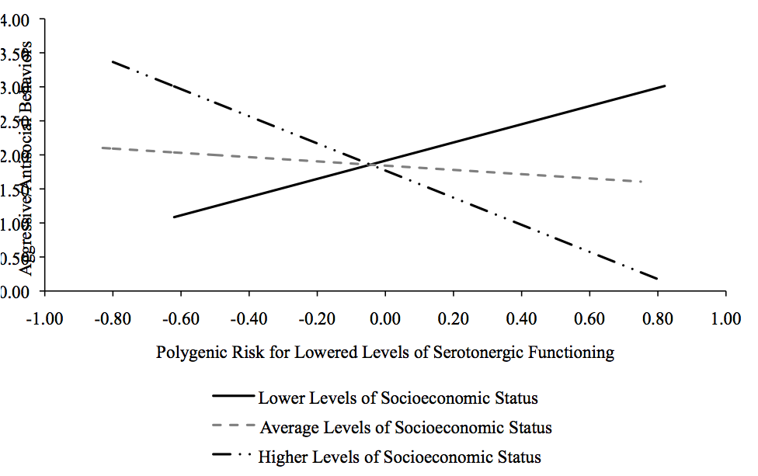

Figure S.1. CDP Interaction between Polygenic Risk and Socioeconomic Status in Predicting Aggressive/Antisocial Behaviors. Black lines indicate statistically significant simple slopes. Slopes probed at low and high levels of socioeconomic status are statistically significant. Lower Levels refers to the simple slope at 1 SD below the mean, Average Levels refers to the simple slope at the mean, and Higher Levels refers to the simple slope at 1 SD above the mean.

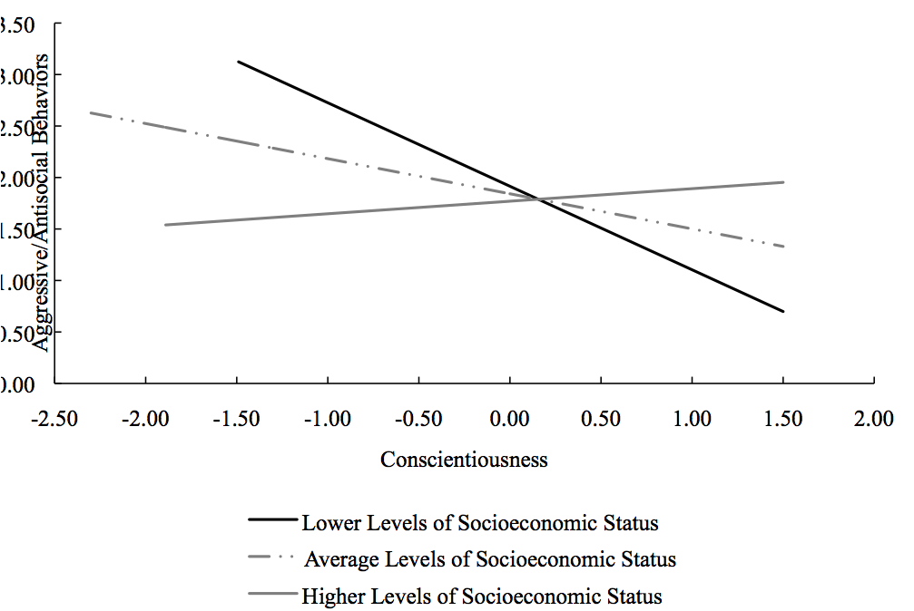
Figure S.2. CDP Interaction between Conscientiousness and Socioeconomic Status in Predicting Aggressive/Antisocial Behaviors. Black lines indicate statistically significant simple slopes. Slope probed at low levels of socioeconomic status are statistically significant. Lower Levels refers to the simple slope at 1 SD below the mean, Average Levels refers to the simple slope at the mean, and Higher Levels refers to the simple slope at 1 SD above the mean.
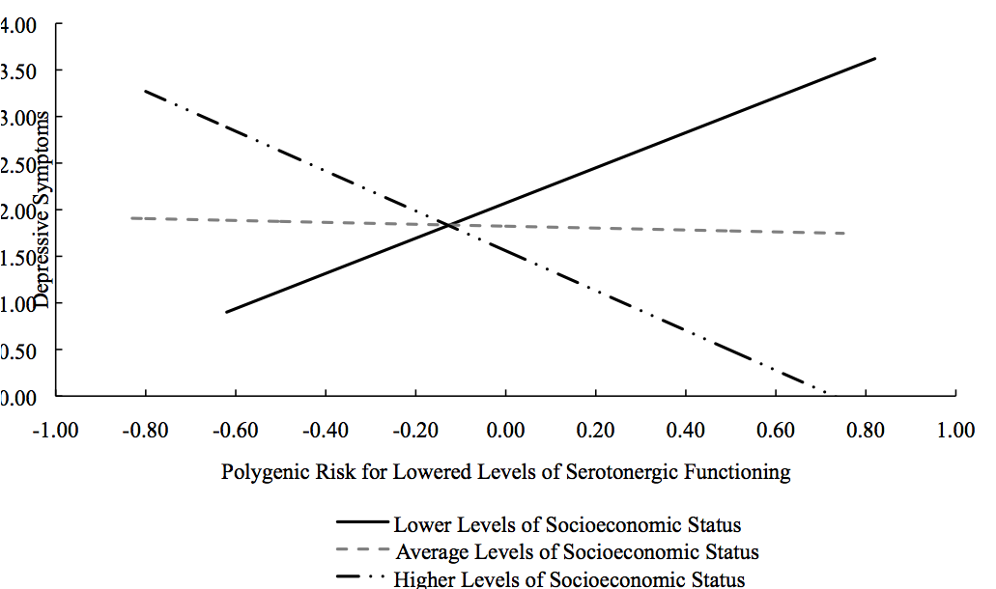
Figure S.3. CDP Interaction between Polygenic Risk and Socioeconomic Status in Predicting Depressive Symptoms. Black lines indicate statistically significant simple slopes. Slopes probed at low and high levels of socioeconomic status are statistically significant. Lower Levels refers to the simple slope at 1 SD below the mean, Average Levels refers to the simple slope at the mean, and Higher Levels refers to the simple slope at 1 SD above the mean.

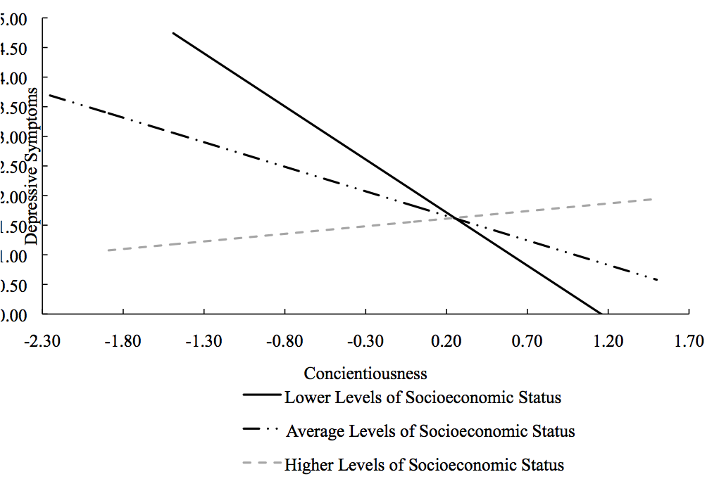
Figure S.4. CDP Interaction between Conscientiousness and Socioeconomic Status in Predicting Depressive Symptoms. Black lines indicate statistically significant simple slopes. Slopes probed at low and mean levels of socioeconomic status are statistically significant. Lower Levels refers to the simple slope at 1 SD below the mean, Average Levels refers to the simple slope at the mean, and Higher Levels refers to the simple slope at 1 SD above the mean.

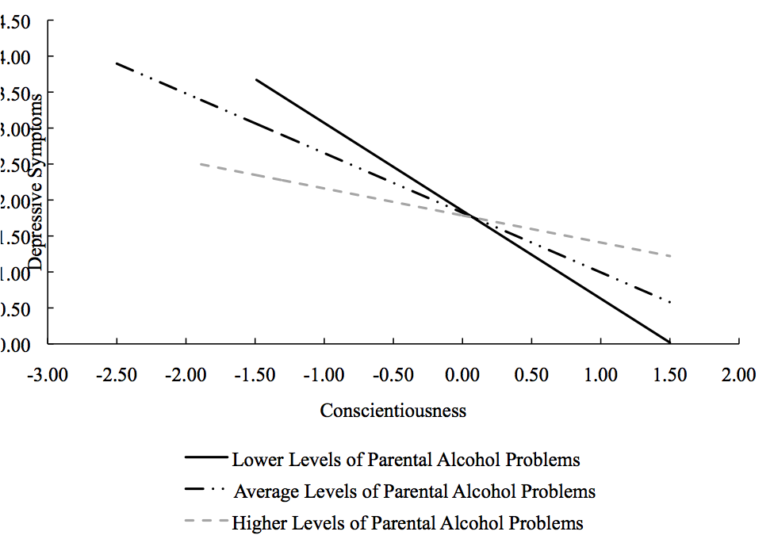
Figure S.5. CDP Interaction between Conscientiousness and Parental Alcohol Problems in Predicting Depressive Symptoms. Black lines indicate statistically significant simple slopes. Slopes probed at low and mean levels of parental alcohol problems are statistically significant. Lower Levels refers to the simple slope at 1 SD below the mean, Average Levels refers to the simple slope at the mean, and Higher Levels refers to the simple slope at 1 SD above the mean.

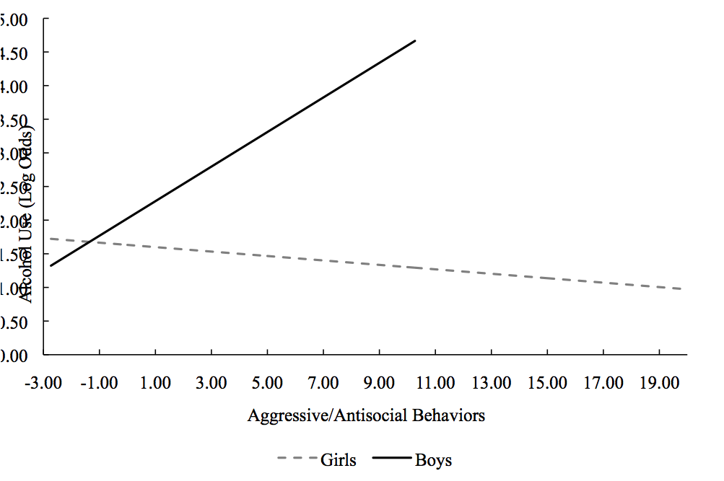
Figure S.6. CDP Interaction between Aggressive/Antisocial Behaviors and Gender in Predicting Alcohol Use. Black line indicates statistically significant simple slope. The simple slope for boys is statistically significant.

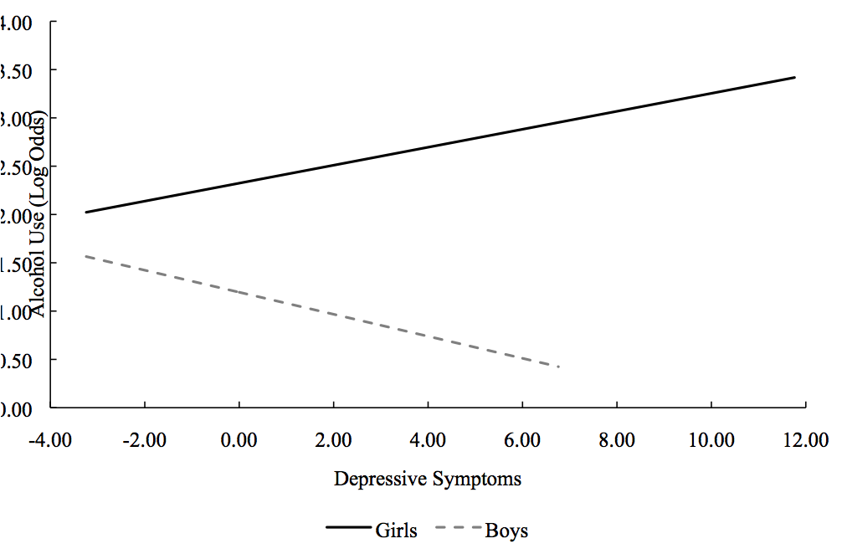
Figure S.7. CDP Interaction between Depressive Symptoms and Gender in Predicting Alcohol Use. Black line indicates statistically significant simple slope. The simple slope for girls is statistically significant.

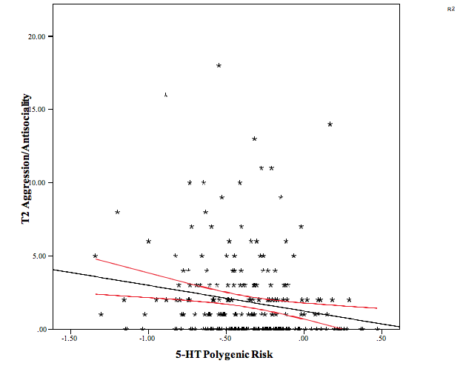

Figure S.8. Scatterplot of the Relation Between 5-HT Polygenic Risk and T2 Aggression/Antisociality in AFDP with 95% Confidence Intervals. Curved red lines indicate the 95% confidence intervals.

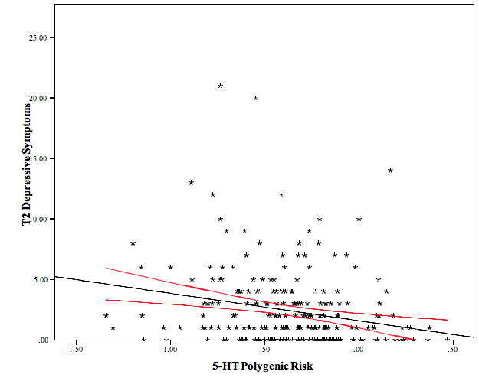
Figure S.9. Scatterplot of the Relation Between 5-HT Polygenic Risk and T2 Depressive Symptoms in AFDP with 95% Confidence Intervals. Curved red lines indicate the 95% confidence intervals.

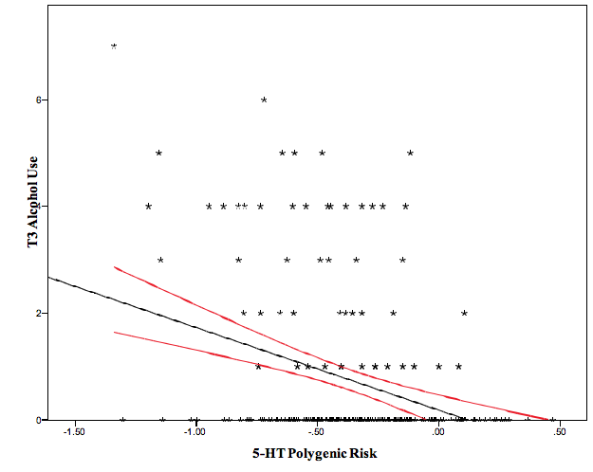
Figure S.10. Scatterplot of the Relation Between 5-HT Polygenic Risk and T3 Alcohol Use in AFDP with 95% Confidence Intervals. Curved red lines indicate the 95% confidence intervals.

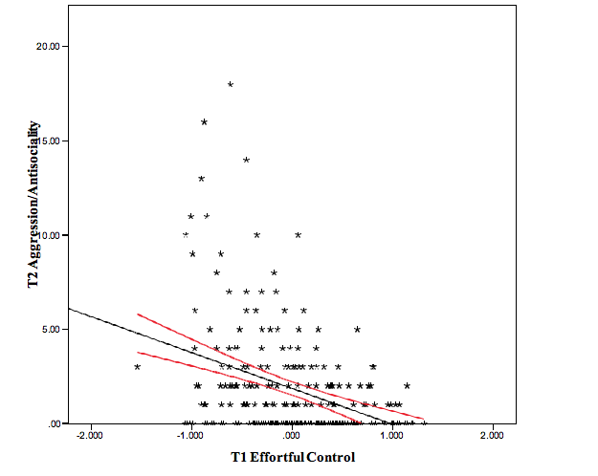
Figure S.11. Scatterplot of the Relation Between T1 Effortful Control and T2 Aggression/Antisociality in AFDP with 95% Confidence Intervals. Curved red lines indicate the 95% confidence intervals.

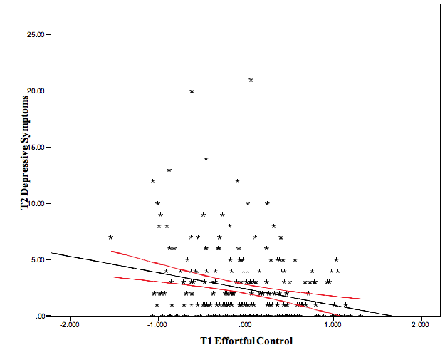
Figure S.12. Scatterplot of the Relation Between T1 Effortful Control and T2 Depressive Symptoms in AFDP with 95% Confidence Intervals. Curved red lines indicate the 95% confidence intervals.

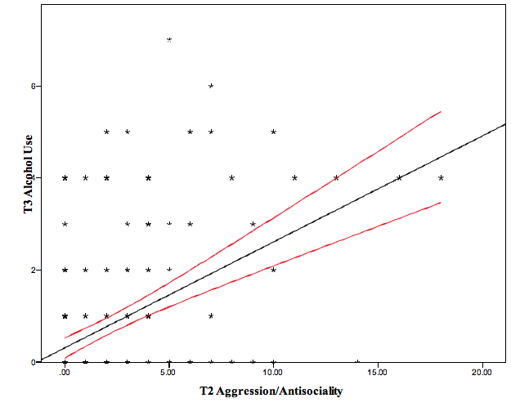
Figure S.12. Scatterplot of the Relation Between T2 Aggression/Antisociality and T3 Alcohol Use in AFDP with 95% Confidence Intervals. Curved red lines indicate the 95% confidence intervals.

References
Chang, C. C., Chow, C. C., Tellier, L. C., Vattikuti, S., Purcell, S. M., & Lee, J. J. (2015). Second-generation PLINK: rising to the challenge of larger and richer datasets. Gigascience, 4, 1-16.
Eisenberg, N., Spinrad, T. L., Fabes, R. A., Reiser, M., Cumberland, A., Shepard, S. A., . . . Thompson, M. (2004). The relations of effortful control and impulsivity to children's resiliency and adjustment. Child Development, 75, 25-46.
Lemery, K. S., Essex, M. J., & Smider, N. A. (2002). Revealing the relation between temperament and behavior problem symptoms by eliminating measurement confounding: Expert ratings and factor analyses. Child Development, 73, 867-882.
Luykx, J. J., Bakker, S. C., Lentjes, E., Neeleman, M., Strengman, E., Mentink, L., . . . van Eijk, K. (2014). Genome-wide association study of monoamine metabolite levels in human cerebrospinal fluid. Molecular Psychiatry, 19, 228-234.
Patterson, N., Price, A. L., & Reich, D. (2006). Population structure and eigenanalysis. PLOS Genetics, 2, e190.
Price, A. L., Patterson, N. J., Plenge, R. M., Weinblatt, M. E., Shadick, N. A., & Reich, D. (2006). Principal components analysis corrects for stratification in genome-wide association studies. Nature Genetics, 38, 904-909.
Price, A. L., Weale, M. E., Patterson, N., Myers, S. R., Need, A. C., Shianna, K. V., . . . Goldstein, D. B. (2008). Long-range LD can confound genome scans in admixed populations. American Journal of Human Genetics, 83, 132-135.
Purcell, S., Neale, B., Todd-Brown, K., Thomas, L., Ferreira, M. A., Bender, D., . . . Sham, P. C. (2007). PLINK: a tool set for whole-genome association and population-based linkage analyses. American Journal of Human Genetics, 81, 559-575.
Tian, C., Gregersen, P. K., & Seldin, M. F. (2008). Accounting for ancestry: population substructure and genome-wide association studies. Human Molecular Genetics(R2), R143-R150.

