Supplemental materials

Table S.1. Descriptive statistics of OXTR methylation
CpG sites | Mean | SD | Minimum | Maximum
cg00078085 | .0699 | .02402 | .02 | .18
cg02192228 | .1926 | .04780 | .11 | .43
cg03987506 | .0697 | .02304 | .02 | .14
cg04523291 | .2239 | .05296 | .11 | .41
cg08535600 | .1444 | .03810 | .08 | .29
cg09353063 | .0741 | .00977 | .05 | .11
cg12695586 | .0896 | .02665 | .04 | .28
cg15317815 | .2506 | .05960 | .13 | .45
cg17285225 | .1179 | .02728 | .08 | .20
cg19619174 | .0641 | .01889 | .05 | .22
cg23391006 | .0669 | .00888 | .05 | .09
cg27501759 | .1237 | .04843 | .05 | .31

Table S.2. Correlation between OXTR methylation and study variables
OXTR methylation | Adult adversity  (W2-W4) |  | Distrust  (W5) |  | Pessimism (W5) |  | Depression (W5)
Factor 1 | .052 |  | -.011 |  | .067 |  | -.020
Factor 2 | .262 | ** | .213 | * | .225 | * | .113
Factor 3 | -.044 |  | -.135 |  | .112 |  | -.053
Factor 4 | .166 |  | .256 | * | .076 |  | .153

Table S.3. Summary of Indirect Effects for Figure S2
Paths | Total effect | Indirect effect | The portion of the variance for mediator
Adult adversity OXTR methylation  Distrust Depression | .619*  [.118; 1.175] | .057*  [.010; .215] | 9.208%
Adult adversity OXTR methylation  Pessimism Depression | .619*  [.118; 1.175] | .024*  [.001; .119] | 3.877%
Note. The values presented are unstandardized parameters. Bootstrapping with 1,000 replications.
*p ≤ .05, (two-tailed test).

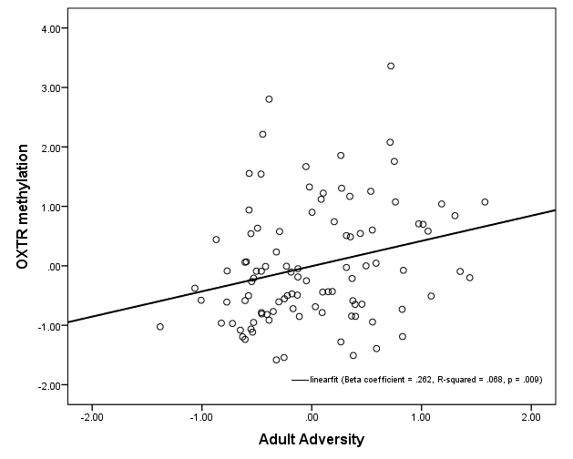
Figure S.1. Scatter plot representing the association between adult adversity (waves 2, 3, and 4) and OXTR methylation. The solid line displays the predicted regression line, and each dot represents one participant (N = 100).

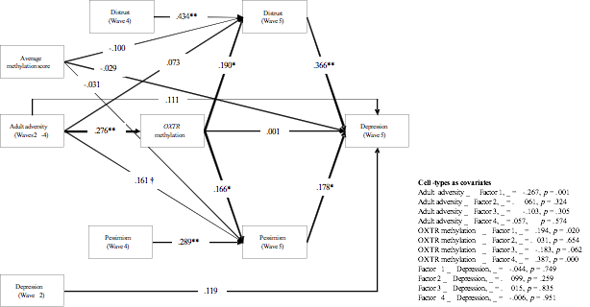
Figure S.2. OXTR methylation as a mediator of the effect of stressful environment on depression controlling for average methylation score.
Note: χ² = 36.075, df = 58, p = .998. Values presented are standardized parameter estimates. An average methylation score was calculated across all CpG sites (485,577). Childhood trauma, chronological age, and relationship status are controlled. The bold words indicate that the test of indirect effect is significant. N = 100. **p ≤ .01; *p ≤ .05, †p < .10 (two-tailed tests).

